Bulk-Powder Raman Reference Bands of NAM, LPS and LTA
What each band is, why it appears, why it was chosen as a target, and where it comes from in the original spectra
SERS Sepsis project, bulk-powder Raman spectral library. Version 1.0, 27 October 2026. Prepared for the project lead and the funding company. Data: library v3.3 (NAM final, LPS established, LTA preliminary).
This document describes the Raman bands used as targets for NAM, LPS and LTA. All of them were measured on neat powder on a glass slide with the B&W Tek i-Raman Plus at 785 nm. The assignments are tentative: they indicate what a band is consistent with and do not establish identity on their own. Bands for which no suitable literature source was found are left unassigned. The 1308-1455 cm-1 region comes from the glass slide and is left out of all correlations. Laser power is given as a percentage of the maximum.

1. Why a bulk reference library is needed
SERS (surface-enhanced Raman scattering) work on sepsis biomarkers needs a clean answer to one question: what does the neat molecule look like, with no metal surface involved? Bands seen later in SERS can then be traced back to the molecule itself, and bands that belong to the substrate, the glass or the instrument can be recognised and discarded. This library provides that answer for three sepsis-related molecules.
Molecule | What it is (general background) | Why it matters for sepsis work | Library status
NAM (N-acetylmuramic acid) | An amino sugar. Together with N-acetylglucosamine it forms the repeating sugar backbone of peptidoglycan, the bacterial cell-wall mesh. | A cell-wall component that can serve as a marker of bacterial presence. | FINAL. 15 spectra, 90 % / 30 s / 5 acc, validated by 21 independent spots (24 Sep 2026).
LPS (lipopolysaccharide, E. coli O111:B4) | A large glycolipid of the Gram-negative outer membrane: a lipid A anchor, a core oligosaccharide and a repeating O-antigen sugar chain. Sigma L2630, lot 0000442391. | Endotoxin released by Gram-negative bacteria; a main trigger of the septic response. | ESTABLISHED (28 Sep 2026). 10 spectra, 60 % / 40 s / 5 acc.
LTA (lipoteichoic acid) | A Gram-positive cell-wall amphiphile: a glycolipid anchor attached to a chain of glycerol-phosphate units. | The Gram-positive counterpart of LPS as a bacterial surface marker. | PRELIMINARY. 4 spectra (3 Apr 2026, 80 to 95 % / 45 s / 2 acc). Re-acquisition pending.

1.1 Why does a band appear at all?
When 785 nm laser light hits a molecule, a very small fraction of it is scattered with a different energy. The energy lost equals the energy of a vibration of the molecule: a bond stretching (written as nu), a bending (delta), or a ring flexing. The difference is plotted as Raman shift in cm-1. Each chemical group vibrates in a characteristic range, so the set of band positions works as a fingerprint of the molecule.
Raman shift (cm-1) | Typical origin in these molecules (general group frequencies)
400-600 | Skeletal and ring deformations of sugars; low-frequency modes of the whole molecule (region I of carbohydrate Raman spectra).
800-950 | C-O-C and C-C stretching around the sugar ring, the "anomeric" region.
1000-1200 | C-O and C-C stretching of sugar rings; symmetric stretch of phosphate (PO2-) groups; C-C of acyl chains.
1300-1470 | CH2 and CH3 bending. On glass slides this zone is swamped by the glass band near 1367 cm-1, so it is excluded.
Above 1800 | Not measured. The usable range ends at 2842 cm-1, so the C-H stretching region is not available.

1.2 How a band was chosen as a target
Target bands are picked from the measured spectra themselves, not from literature tables. The reference spectrum is the mean of all spectra that passed quality control (QC), and each band in it is ranked with the criteria below. The same criteria are used for all three molecules.
Class | Rule | Meaning
C1 / Primary marker | Detected in every reference spectrum, high signal-to-noise (SNR), position and height reproducible (low CV), outside the glass zone, absent from glass blanks. | The band used first to recognise the molecule.
C2 / Supporting | Detected in most or all spectra, clear but weaker or broader. | Strengthens the identification; not used alone.
C3 / Glass or background | Inside the 1308-1455 zone, or present in the glass blanks. | Never reported as an analyte marker.
C4 / Uncertain | Weak, detected in only some spectra, or unassigned. | Listed for completeness; not used for identification.

Before any band is read, each spectrum must pass the QC checks: no saturation (65535 counts) in 400-1800 cm-1; ripple 50 counts or less; SNR of at least 10; glass-dominated spots excluded (glass-zone to 800-1000 area ratio above 8). Every excluded spectrum is logged with its reason in 07_QC_and_Exclusions/Excluded_and_Flagged_Spectra.csv.

1.3 From raw file to reference spectrum (pipeline v3)
- Dark-subtracted signal = raw - dark (recomputed when the software had smoothed it).
- Two defective detector pixels (about 1095.7 and 1189.5 cm-1) are repaired.
- Spectrum cropped to 400-1800 cm-1; spikes removed (MAD z above 6, width 2 pixels or less).
- Savitzky-Golay smoothing (window 11, order 3), then asymmetric least-squares baseline removal (lambda 1e5, p 0.01, 10 iterations).
- Noise = 1.4826 x MAD of (despiked - smoothed). Min-max normalisation is used for shape comparison only.
- The reference is the mean +/- SD of the passing spectra. Original raw files are never altered; the library holds MD5-verified copies.

2. NAM (N-acetylmuramic acid): FINAL reference

2.1 The molecule and what was measured
NAM is an N-acetylated amino sugar with a lactic-acid (lactyl) ether group on the ring. Its Raman spectrum is expected to show sugar-ring skeletal modes (400-600 cm-1), C-O-C and C-C stretches (800-1200 cm-1) and methyl modes from the N-acetyl and lactyl groups. The reference is the mean of 15 spectra recorded on 30 May 2026 at 90 % power, 30 s, 5 accumulations, on a glass slide: 5 independent points plus 10 repeats of one spot. The median agrees with the mean (r = 0.9991).
Independent confirmation: on 24 Sep 2026, 21 spectra that passed QC (60, 70, 80 % power) correlated with the reference at r = 0.982 to 0.994 (glass zone excluded). All primary and supporting bands were detected in 21 of 21 spectra, with positions within 1.5 cm-1 (less than one detector pixel).

2.2 Annotated reference spectrum
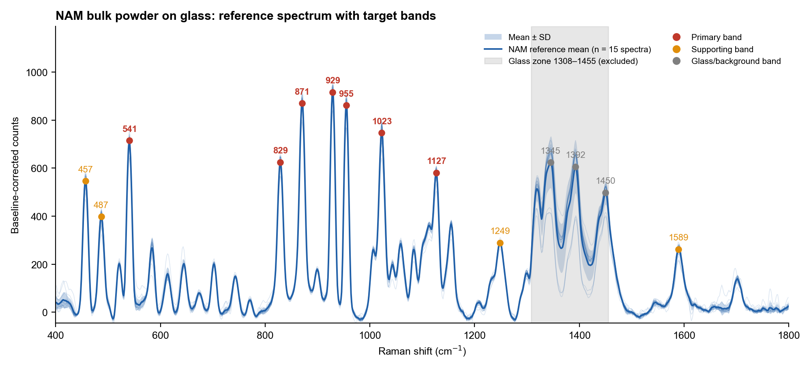
Figure 1. NAM reference (mean +/- SD of 15 spectra; thin lines = individual spectra). Red dots = primary bands, orange = supporting, grey = glass or background. Grey block = glass zone, excluded from correlations.

2.3 Which bands are targeted and why
The seven primary bands (541, 829, 870.5, 929, 955, 1023 and 1127 cm-1) were chosen because each is present in 15 of 15 spectra, has an SNR between 32 and 51, a height CV of 4 to 6 %, a position SD of 0.5 cm-1 or less, and lies outside the glass zone. The 929 cm-1 band is the strongest (919 +/- 36 counts) and is used as the intensity reference for NAM.
Band (cm-1) | Class | Detected | SNR | CV % | Tentative assignment | Literature region (cm-1) | Source | Confidence
457.0 | Supporting peak | 15/15 | 30 | 5.8 | pyranose-ring skeletal deformation | 400–600 (region) | L6 | Low
487.0 | Supporting peak | 15/15 | 22 | 8.3 | skeletal deformation | 400–600 (region) | L6 | Low
541.0 | Primary marker | 15/15 | 40 | 4.6 | pyranose-ring skeletal deformation δ(C-C-O)/δ(C-C-C) | 400–600 (region) | L6 | Low
829.0 | Primary marker | 15/15 | 35 | 4.8 | ν(C-O-C)/ring mode in the carbohydrate anomeric region | 800–950 (region) | L6 | Low
870.5 | Primary marker | 15/15 | 49 | 4.3 | ν(C-O-C)/ν(C-C) ring mode (anomeric region) | 800–950 (region) | L6 | Low
929.0 | Primary marker | 15/15 | 51 | 4.0 | ν(C-O-C)/ν(C-C); possible lactyl C-COOH contribution | 800–950 (region) | L6, L5 | Low
955.0 | Primary marker | 15/15 | 48 | 5.1 | ν(C-C) / CH3 rocking (N-acetyl or lactyl methyl) – tentative | 800–950 (upper edge) | L5, L6 | Low
1022.7 | Primary marker | 15/15 | 42 | 6.2 | ν(C-O)/ν(C-C) (C-OH stretching) of sugar ring | 1000–1200 (region) | L6 | Low
1127.0 | Primary marker | 15/15 | 32 | 5.2 | ν(C-O-C) (3-O-lactyl ether / ring) or ν(C-C) | 1000–1200 (region) | L6 | Low
1248.7 | Supporting peak | 15/15 | 16 | 3.7 | No assignment proposed (possible amide III / CH deformation region; not verified) | — | — | Uncertain
1589.5 | Supporting peak | 15/15 | 15 | 8.9 | No assignment proposed (unassigned; reproducible) | — | — | Uncertain

The assignments carry low confidence because no peer-reviewed normal-Raman spectrum of pure NAM powder was found in the literature search (23 Sep 2026). They rest on general carbohydrate group-frequency regions (Wiercigroch 2017) and remain tentative. Bands in the 800-950 cm-1 region are consistent with C-O-C and C-C stretching of the sugar ring; 541 and 457 cm-1 are consistent with ring skeletal deformation. The bands at 1248.7, 1589.5, 583.8, 1058.9 and 1155 cm-1 are reproducible but unassigned.
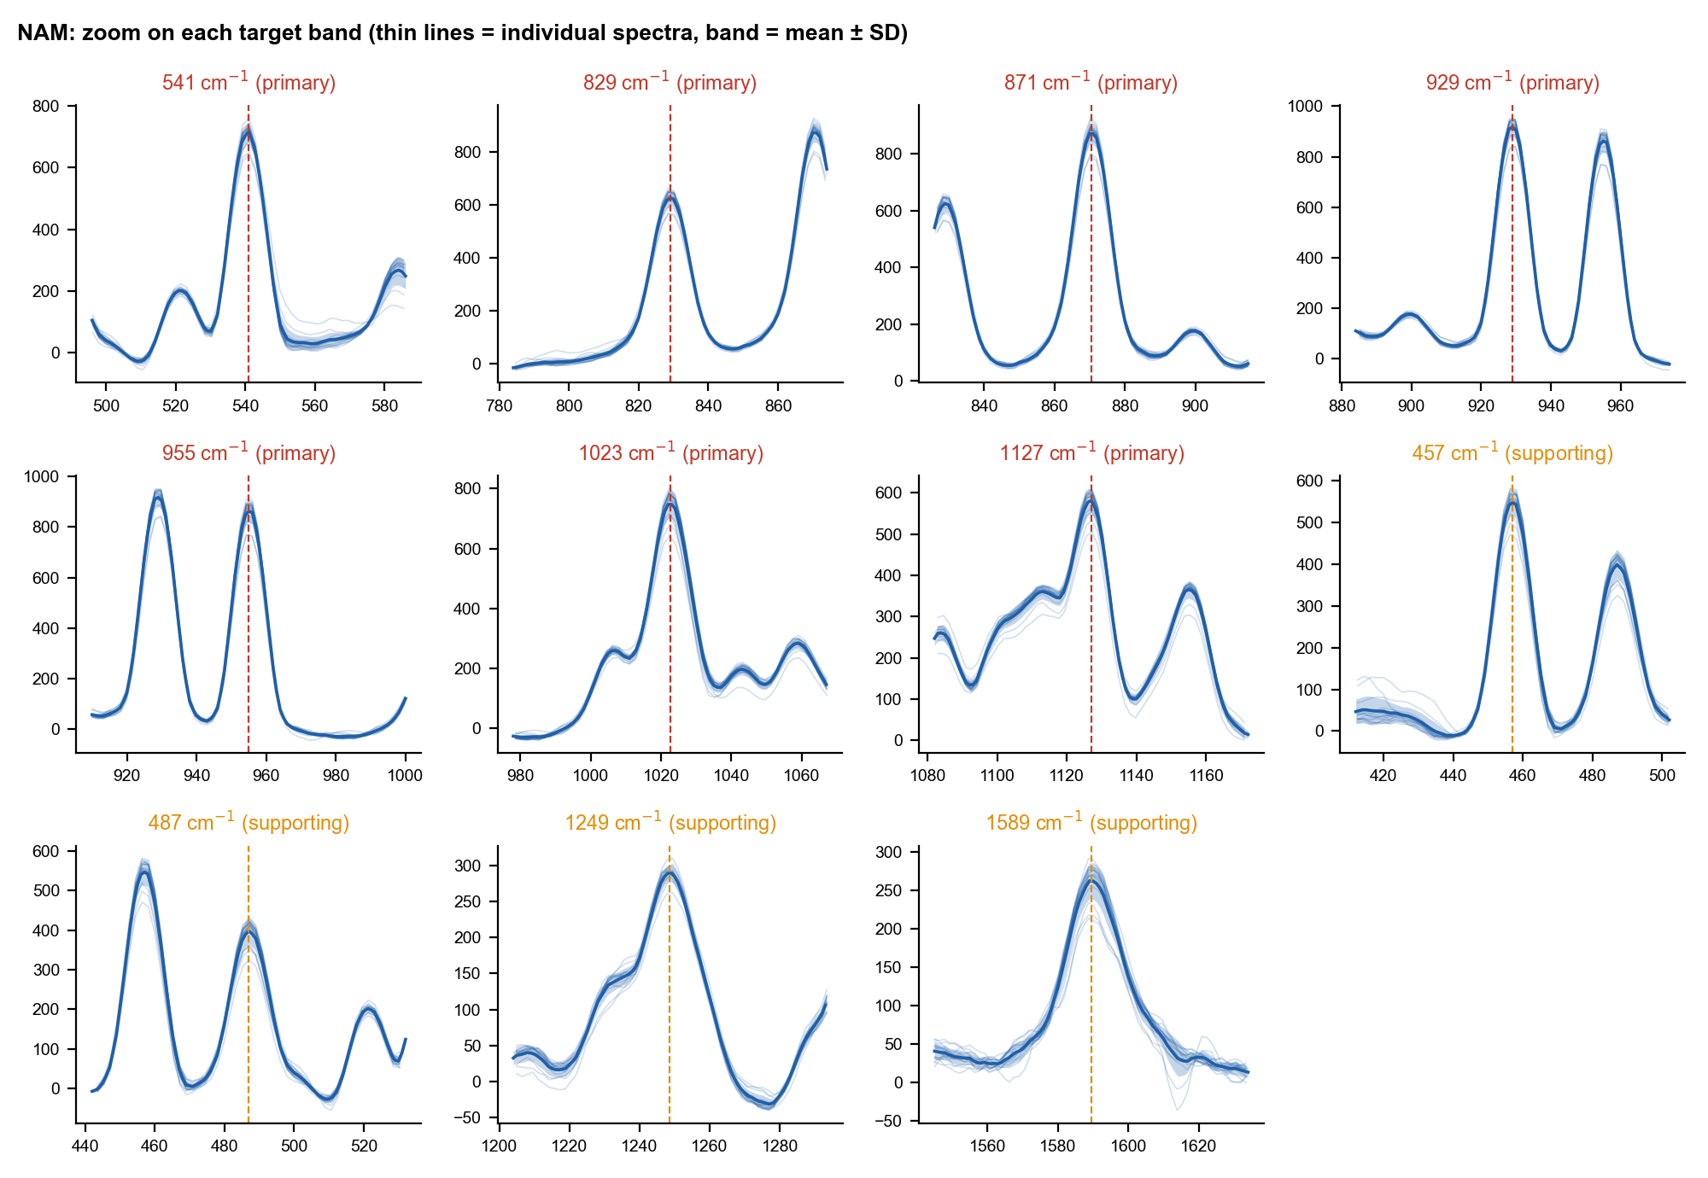
Figure 2. NAM: each target band in close-up. The dashed line is the band position; the shaded band is the spread across spectra.

2.4 Bands that are NOT used
- 1345, 1392 and 1450 cm-1: sharp bands inside the glass zone. Their heights vary by 10 to 18 % between spectra because the glass contribution varies. They are reported as glass-confounded, not as NAM markers.
- The 1450 cm-1 position is consistent with CH2/CH3 bending, but it cannot be separated from glass, so it is not used.

3. LPS (E. coli O111:B4 lipopolysaccharide): ESTABLISHED reference

3.1 The molecule and what was measured
LPS has three parts: a lipid A anchor (a phosphorylated glucosamine disaccharide carrying fatty-acid chains), a core oligosaccharide, and an O-antigen made of repeating sugars. Raman bands from sugar rings (skeletal, C-O-C, C-O) and from phosphate and acyl-chain groups are therefore expected. The sample is Sigma L2630, lot 0000442391 (vial photo in 03_Reference_Spectra/LPS).
The reference is 10 spectra at 60 % power, 40 s, 5 accumulations, 28 Sep 2026 (spots S10 to S12 and S14 to S20). Spot S13 was excluded as glass-dominated. Pairwise correlation among members is r = 0.916 and mean against median is r = 0.982. Absolute counts vary 3 to 5 times between spots, so intensities are compared as ratios to the 425 cm-1 band.

3.2 Annotated reference spectrum
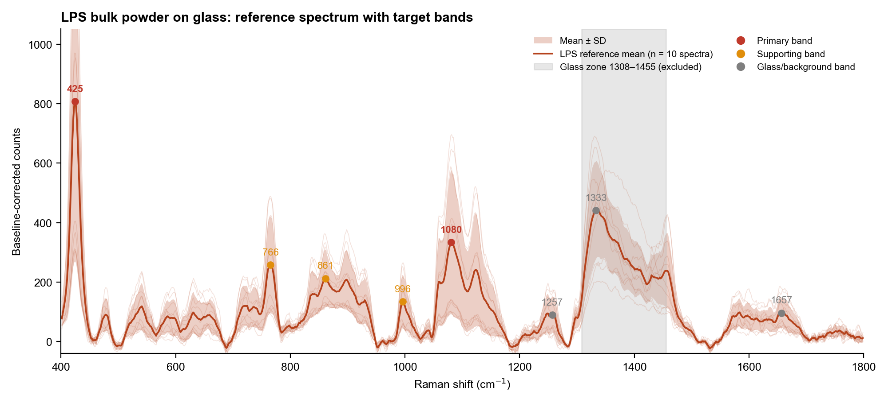
Figure 3. LPS reference (mean +/- SD of 10 spectra). The 425 cm-1 band is the strongest feature; 1080 cm-1 is broad. The grey block is the glass zone.

3.3 Which bands are targeted and why
Band (cm-1) | Class | Detected | SNR (median) | Height CV % | Tentative interpretation | LPS literature band(s) near the band | Glass share %
424.8 | Primary | 10/10 | 38 | 67 | Unassigned. Low-frequency skeletal region; consistent with sugar-ring deformation (tentative). No LPS literature band within 12 cm-1. | none within ±12 | 4
765.5 | Supporting | 8/10 | 17 | 52 | Unassigned (no literature match). | none within ±12 | 7
861.1 | Supporting | 8/10 | 13 | 40 | Consistent with glycosidic C-O-C and beta-anomeric sugar modes (tentative); position matches SERS bands at 850 and 855. | 850 ν(C-O-C) 1,4-glycosidic [LPS-1 SERS]; 855 δ(C-O-C) [LPS-1 SERS] | 4
995.8 | Supporting | 9/10 | 9 | 60 | Consistent with C-H bending or sugar C-O-C (tentative); SERS bands at 988 and 1003. | 988 β(CH) carbohydrates [LPS-1 SERS]; 1003 common LPS peak [LPS-2 SERS] | 2
1080.5 | Primary | 10/10 | 15 | 72 | Consistent with C-O stretching of sugars and/or symmetric PO2- stretch (tentative); best match 1075 in normal Raman of LPS powder. | 1075 O-antigen [LPS-3 normal Raman]; 1087 ν(C-O) lipid [LPS-1 SERS] | 14

The 425 cm-1 band is the primary marker because it is the strongest LPS band, present in 10 of 10 spectra (position 424.8 +/- 0.9 cm-1, SNR 38), absent from the glass blanks and from NAM, and also seen in the April 2026 data and in the 28 Sep screening data. It has no assignment in the checked literature, so it is used as an empirical fingerprint, not as a proven LPS vibration. The 1080 cm-1 band is the second primary marker; it is detected in 10 of 10 spectra (1080.5 +/- 1.1 cm-1, SNR 15). It is broad, and about 14 % of its height overlaps the glass Si-O feature near 1091 cm-1, which is why it ranks below 425.
Literature used in the table, from the library source list: LPS-1 Wu 2021 (SERS), LPS-2 Yang 2022 (SERS), LPS-3 Verde 2021 (normal Raman of LPS powder, E. coli O55:B5 on CaF2). SERS bands can shift relative to bulk, so a match is a position match only.
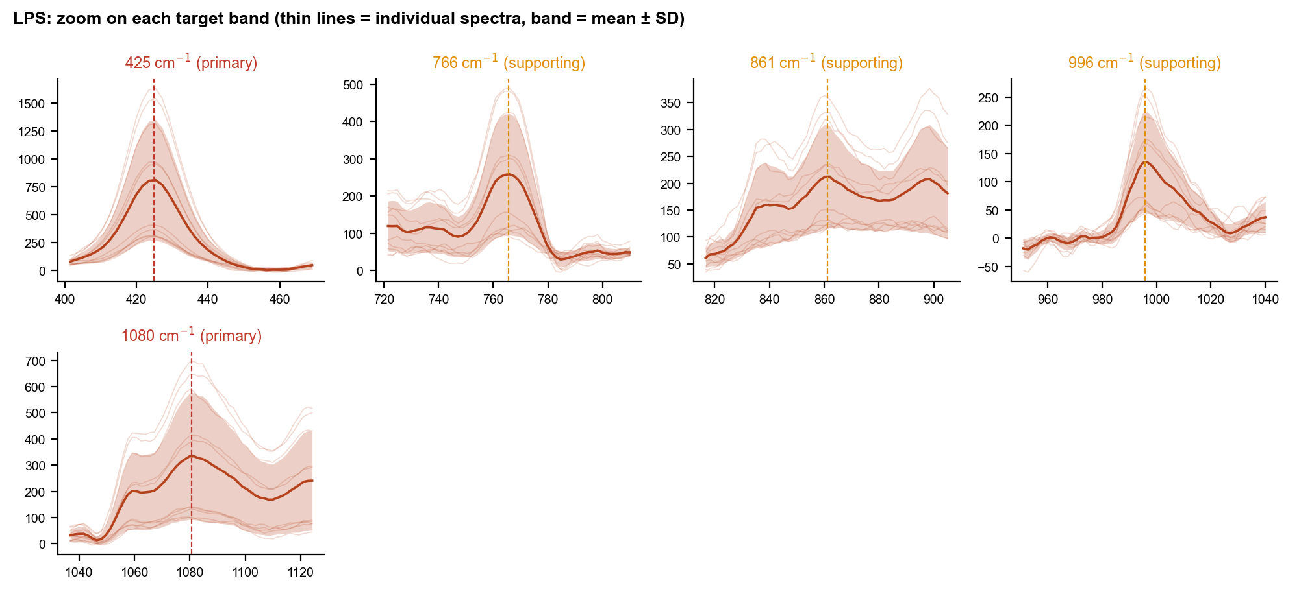
Figure 4. LPS: each target band in close-up.

3.4 Bands that are NOT used
- 1333 cm-1 and the surrounding 1308-1455 zone: LPS C-H bending bands are expected here, but they cannot be separated from glass on glass slides.
- 1257 and 1657 cm-1: background or glass features; the 1657 band is also seen in the glass blanks.
- C4 bands (478, 541, 631, 656, 1124, 1248, 1457): detected in only 4 to 8 of 10 spectra, or weak. The 541 and 1124 positions match SERS literature (glycosidic ring, acyl C-C) and 1457 is consistent with CH2/CH3 bending, but all are tentative and not used for identification.

3.5 Known limitation
Earlier darks in this session leaked sample light, so absolute intensities may be 3 to 34 % low. Band positions and ratios are not affected. This is documented in the LPS report.

4. LTA (lipoteichoic acid): PRELIMINARY reference

4.1 The molecule and what was measured
LTA is built from a glycolipid anchor and a chain of glycerol-phosphate repeating units. The phosphodiester groups should give a symmetric PO2- stretch near 1090 cm-1, the glycerol and sugar parts should add bands at 800-950 cm-1, and the acyl chains of the anchor should add CH2 bending near 1450 cm-1.
The reference is only 4 spectra from 3 Apr 2026: 80, 80, 90 and 95 % power, 45 s, 2 accumulations. Ripple at 80 % was 37 to 38 counts (passes). A 50 % / 30 s / 15 acc spectrum was distorted (ripple 154) and rejected, and the 9 Feb 2026 files labelled "LTA" are polystyrene-like and excluded. Four spectra are not enough for a final reference; 12 to 15 independent spots are planned.

4.2 Annotated reference spectrum
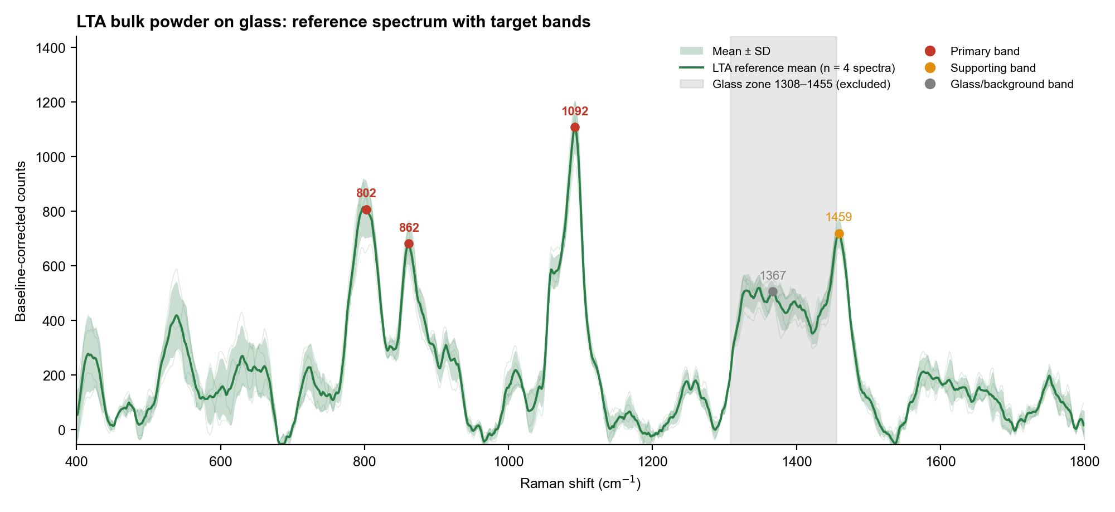
Figure 5. LTA preliminary reference (mean +/- SD of 4 spectra). The 1092 cm-1 band is the strongest; the 1367 cm-1 feature is glass-associated.

4.3 Which bands are targeted and why
The 1092 cm-1 band is the primary marker: present in 4 of 4 spectra, position 1091.8 +/- 0.5 cm-1, 1110 +/- 98 counts, SNR about 28, and consistent with the symmetric PO2- stretch of a phosphodiester backbone. The 802 and 861.5 cm-1 bands are also primary but less certain: 802 is broad (position SD 5 cm-1) and 861.5 has a height CV of 11 %.
Band (cm-1) | Class | Detected | SNR | CV % | Tentative assignment | Literature region (cm-1) | Source | Confidence
802.2 | Primary marker | 4/4 | 21 | 12.6 | ν(O-P-O) phosphodiester stretch | ~813 (ν O-P-O) | L5 | Low
861.5 | Primary marker | 4/4 | 18 | 10.8 | ν(C-C)/ν(C-O-C) of glycerol / sugar substituents | 800–950 (region) | L6 | Low
1091.8 | Primary marker | 4/4 | 28 | 8.8 | ν_s(PO2−) of phosphodiester (poly-glycerophosphate backbone) | 1090–1095 (ν_s PO2−) | L5, L7, L8 | Moderate
1367.2 | Glass/background | 1/4 | 13 | 6.8 | Glass-associated feature (inside glass zone; removed by glass-template correction; 2/9 detected) | — | — | Not applicable
1458.8 | Supporting peak | 4/4 | 18 | 7.4 | δ(CH2) scissoring (acyl chains of glycolipid anchor); non-specific | 1440–1460 (δ CH2) | L7 | Low

Confidence is low or moderate because no peer-reviewed Raman spectrum of isolated LTA powder was found; the PO2- assignment rests on group-frequency compilations (Movasaghi 2007, Czamara 2015) and an FTIR study of the related wall teichoic acid (Grunert 2018). The 1367 cm-1 feature lies in the glass zone, was detected in only 1 of 4 spectra, and is a glass-associated band, never an LTA marker.
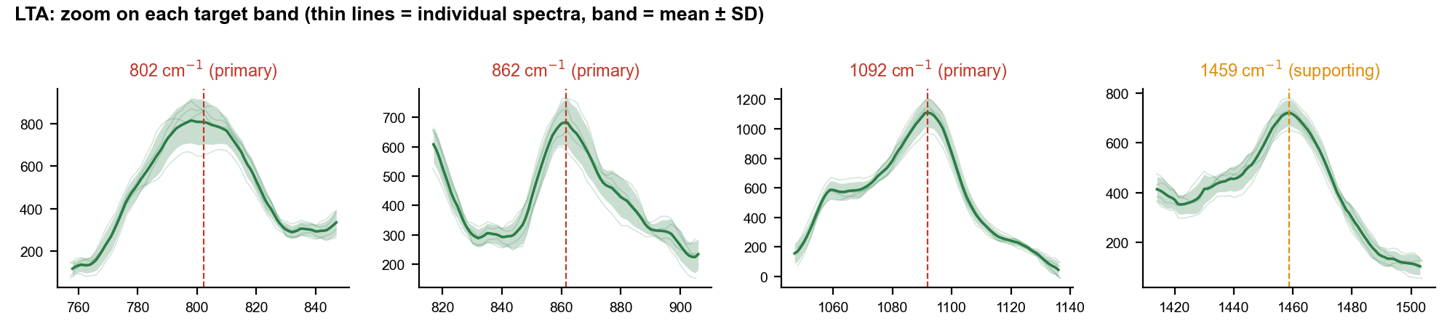
Figure 6. LTA: each target band in close-up (n = 4).

4.4 What must be done to finalise LTA
- Acquire 12 to 15 independent spots at 80 % / 45 s / 2 acc on a glass slide, with 2 to 3 matched glass blanks and a hand-closed dark at the start and end.
- Check the ripple of the first spot (50 counts or less).
- Re-run the pipeline, rebuild the reference and confirm that 802, 861.5, 1092 and 1459 cm-1 reproduce.

5. Telling the three molecules apart
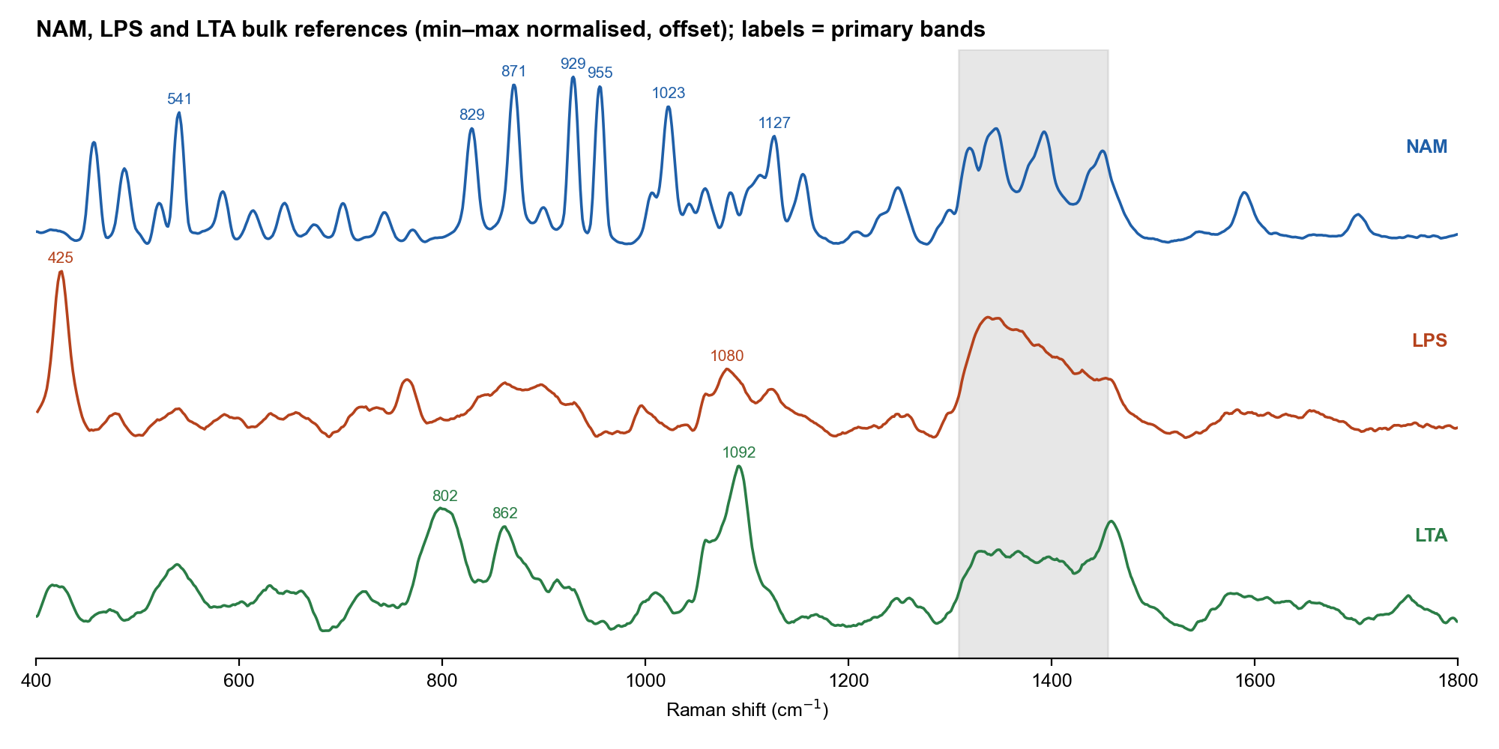
Figure 7. The three bulk references, normalised and offset. Labels mark primary bands.
Pair | Correlation of reference spectra (r, glass zone excluded)
NAM vs LPS | 0.15
NAM vs LTA | 0.21
LPS vs LTA | 0.49

Low correlations mean the three references have different shapes, which is what discrimination needs. LPS is recognised by 425 cm-1 (absent in NAM and LTA) and a broad 1080 cm-1 band; NAM by the cluster of sharp bands at 829 to 955 cm-1 and 541 cm-1; LTA by 1092 cm-1 together with 802 and 861.5 cm-1. LTA and LPS both have a band near 1080 to 1092 cm-1, and NAM and LTA both have bands near 860 to 870 cm-1, so no single band is enough; the combination is used. The LTA conclusion remains provisional until re-acquisition.
Identity check recorded for LPS (28 Sep 2026): r = 0.98 against the screening data, 0.80 against April data, 0.52 against LTA and 0.17 against NAM.

6. Limitations
- All assignments are tentative and describe what a band is consistent with; none of them establishes identity on its own.
- The 1308-1455 cm-1 zone and the ~1367 cm-1 band are glass; they are not analyte markers.
- The range ends at 2842 cm-1, so C-H stretching bands are not available.
- Ripple appears at 70 to 90 % power and depends on the analyte.
- LTA has 4 spectra only. LPS absolute intensities may be 3 to 34 % low (dark leak). NAM has 6 independent spots at the reference condition, supported by 21 spots on 24 Sep.
- The 44 spectra from 7 Oct 2026 are on etched silicon (SERS work) and are excluded from this library.

7. References
[L1] Wu X., Zhao Y., Zughaier S.M. Highly sensitive detection and differentiation of endotoxins derived from bacterial pathogens by surface-enhanced Raman scattering. Biosensors 2021, 11(7), 234. https://doi.org/10.3390/bios11070234
[L2] Yang Y., Xu B., Haverstick J., Ibtehaz N., Muszyński A., Chen X., Chowdhury M.E.H., Zughaier S.M., Zhao Y. Differentiation and classification of bacterial endotoxins based on surface enhanced Raman scattering and advanced machine learning. Nanoscale 2022, 14(24), 8806–8817. https://doi.org/10.1039/d2nr01277d
[L3] Saikia D., Tanan C.B., Dhananjaya G., Hungund B.S., Mahanta N., Singh S.P. Validating phosphoethanolamine modification as a potential spectral marker of colistin resistance. Analyst 2025, 150, 281–289. https://doi.org/10.1039/d4an01228c
[L4] Kumar A., Islam M.R., Zughaier S.M., Chen X., Zhao Y. Precision classification and quantitative analysis of bacteria biomarkers via surface-enhanced Raman spectroscopy and machine learning. Spectrochim. Acta A 2024, 320, 124627. https://doi.org/10.1016/j.saa.2024.124627
[L5] Movasaghi Z., Rehman S., Rehman I.U. Raman spectroscopy of biological tissues. Appl. Spectrosc. Rev. 2007, 42(5), 493–541. https://doi.org/10.1080/05704920701551530
[L6] Wiercigroch E., Szafraniec E., Czamara K., Pacia M.Z., Majzner K., Kochan K., Kaczor A., Baranska M., Malek K. Raman and infrared spectroscopy of carbohydrates: a review. Spectrochim. Acta A 2017, 185, 317–335. https://doi.org/10.1016/j.saa.2017.05.045
[L8] Grunert T., Jovanovic D., Sirisarn W., et al. Analysis of Staphylococcus aureus wall teichoic acid glycoepitopes by Fourier Transform Infrared Spectroscopy provides novel insights into the staphylococcal glycocode. Sci. Rep. 2018, 8, 1889. https://doi.org/10.1038/s41598-018-20222-6
[L9] Zou B., Zhao X., Liao J., Zhao Y. Near-infrared activity analysis and identification of fungal and bacterial markers. Microchem. J. 2025, 208, 112552. https://doi.org/10.1016/j.microc.2024.112552
[L7] Czamara K., Majzner K., Pacia M.Z., Kochan K., Kaczor A., Baranska M. Raman spectroscopy of lipids: a review. J. Raman Spectrosc. 2015, 46, 4–20. https://doi.org/10.1002/jrs.4607
[L10] Bansil R., Yannas I.V., Stanley H.E. Raman spectroscopy: a structural probe of glycosaminoglycans. Biochim. Biophys. Acta 1978, 541, 535–542. https://doi.org/10.1016/0304-4165(78)90163-0
[L11] Study of N-acetylamino saccharides with synchrotron-based ultraviolet resonance Raman spectroscopy: in combination with ATR far-ultraviolet spectroscopy. J. Phys. Chem. Lett. 2025, 16(7), 1769–. https://doi.org/10.1021/acs.jpclett.4c03435
LPS source LPS-3 (Verde et al., Front. Immunol. 2021, 12, 758410, doi 10.3389/fimmu.2021.758410) is also used. Sources in the LPS list whose DOI could not be verified (LPS-4, LPS-5, LPS-6, LPS-8, LPS-9, GEN-2, GEN-3, GEN-5, GEN-7) are not used as support. The literature search did not find a peer-reviewed normal-Raman spectrum of pure NAM or of isolated LTA powder.

