SERS SEPSIS BIOMARKER PROJECT — BULK SPECTRAL LIBRARY
LPS Bulk-Powder Raman Reference Spectrum
Acquisition, troubleshooting, processing, marker bands and literature comparison (28 Sep 2026)
Sample | Lipopolysaccharide from Escherichia coli O111:B4, Sigma-Aldrich L2630-10MG, lot 0000442391 (phenol-extracted, smooth LPS); bulk powder directly on a glass slide
Instrument | B&W Tek i-Raman Plus, BWS465-785H, 785 nm; BWRam 4.15
Reference condition | 60 % laser power (instrument setting, not mW) / 40 s / 5 accumulations
Reference set | n = 10 independent spots (S10–S12, S14–S20); 1 excluded (S13)
Processing | Library pipeline v3 (identical to NAM and LTA)
Report date | 28 Sep 2026

Outcome. An LPS bulk reference spectrum has been established from 10 independent spots. The spectrum is reproducible (pairwise r = 0.92) and matches earlier LPS measurements (r = 0.98 and 0.80). It is clearly different from NAM (r = 0.17) and LTA (r = 0.52). Two primary marker bands are identified: 425 cm⁻¹ (strongest, SNR ≈ 38, not assigned in the literature) and 1080 cm⁻¹ (broad, SNR ≈ 15, consistent with sugar C–O stretching). LPS is a weak Raman scatterer, so the supporting bands have modest SNR and the glass band dominates 1308–1455 cm⁻¹.

Executive summary
Band (cm⁻¹) | Category | Found in | Position ± SD | SNR (median) | Literature
425 | C1 primary | 10/10 | 424.8 ± 0.9 | 38.2 | none
766 | C2 supporting | 8/10 | 765.5 ± 1.2 | 16.7 | none
861 | C2 supporting | 8/10 | 861.1 ± 0.9 | 12.7 | 850 ν(C-O-C) 1,4-glycosidic [LPS-1 SERS]; 855 δ(C-O-C) [LPS-1 SERS]
997 | C2 supporting | 9/10 | 995.8 ± 0.9 | 8.7 | 988 β(CH) carbohydrates [LPS-1 SERS]; 1003 common LPS peak [LPS-2 SERS]
1081 | C1 primary | 10/10 | 1080.5 ± 1.1 | 15.3 | 1075 O-antigen [LPS-3 normal Raman]; 1087 ν(C-O) lipid [LPS-1 SERS]

- Why 60 % / 40 s / 5 acc: at 70–90 % the instrument produced a fixed-pattern ripple within the collected light, which a dark cannot remove. At 60 % the spectra were clean. Increasing the integration from 30 to 40 s raised the SNR of the 425 cm⁻¹ band to 19–63 without saturation.
- Dark handling: the software dark step lets some sample light through unless the shutter is closed by hand. Shutter-closed check frames give a true dark of ≈ 1 480–1 525 counts (40 s × 5). The darks recorded with the reference spectra were 1 845–2 090 counts, so absolute intensities are under-estimated by an estimated 3–34 %. Band positions and spectral shape are unaffected.
- Bulk intensity: 425 cm⁻¹ band median 680 counts (range 302–1631). The 3–5× spread between spots comes from focus and powder packing; relative band intensities are stable (CV ≈ 11–12 % for 1080/425 and 766/425).
- Glass: a short (unsaturated) blank records the full glass band. An exploratory glass subtraction shows that glass accounts for < 4 % of the 425 cm⁻¹ band, ~14 % of the 1080 cm⁻¹ band and ~77 % of the 1334 cm⁻¹ feature.

1. Sample
Product | Lipopolysaccharides from Escherichia coli O111:B4, Sigma-Aldrich L2630-10MG
Lot | 0000442391 (label photo in 03_Reference_Spectra/LPS; source number partly legible, to be confirmed on the CoA)
Purification | Phenol extraction (label)
Supplier specification | Lyophilised powder, off-white to faint yellow; ≤ 3.00 % protein (Lowry-TCA); smooth (S-type) LPS containing lipid A, core oligosaccharide and O-antigen; lot-to-lot variability noted by supplier
Storage | +2 to +8 °C
Presentation | Bulk powder placed directly on a glass slide (no other substrate)

2. How the reference condition was reached
Date / step | What was measured | Finding → decision
13 Apr 2026 | LPS at 10–20 % power | Weak signal dominated by the glass band; no reference possible
24 Sep 2026 | Folder labelled "LPS" (60–90 %) | Spectra were NAM (bottle checked by operator); reassigned to the NAM library
28 Sep screening | 60 / 70 / 80 % × 30 s × 5 acc | 60 %: 8 good; 70 %: 4 good; 80 %: 0/5 (ripple). Identity confirmed as LPS (matches April data; strongest band 425 cm⁻¹)
28 Sep troubleshooting | 70 % spectra, laser-off tests, shutter-closed darks | Ripple at 70 % lies in the collected light; the software dark contained sample light (≈ 3 400 vs true ≈ 1 470 counts) → use 60 % and close the shutter by hand for the dark
28 Sep test | 60 % / 30 s and 60 % / 40 s | Ripple-free; 40 s raised the SNR of the 425 band to ≈ 19 → condition fixed at 60 % / 40 s / 5 acc
28 Sep reference | 11 spots + 3 blanks + 2 short blanks + check frames | 10 spots accepted; S13 excluded (glass-dominated)

3. Data organisation and traceability
The original folder 28-9-26-lps-bulk is unchanged. Every file used was copied byte-for-byte, and the MD5 checksums were verified, into:
Location (SERS_Sepsis_Spectral_Library) | Content
01_Raw_Data_Renamed/LPS_Bulk/LPS_Bulk_20260928_P060pct_T40s_A05_S10…S20 | Reference set (11 spots; S13 excluded)
01_Raw_Data_Renamed/LPS_Bulk/…P060pct_T40s_A05_S06/S07, …T30s… | Supporting and troubleshooting LPS spectra (not in the reference)
01_Raw_Data_Renamed/Glass_Blank/Glass_Blank_20260928_P060pct_T40s_A05_S01–S03, …T05s_A01_S01/S02_short | Matched blanks and short (unsaturated) blanks
01_Raw_Data_Renamed/Instrument_Checks/Check_20260928_… | Shutter-closed frames, shutter-closed dark, laser-off tests, TXTR duplicates
02_Processed_Spectra/LPS, Glass_Blank, Instrument_Checks | Every pipeline stage plus a QC header
03_Reference_Spectra/LPS/LPS_Bulk_Reference_Mean_SD.csv, …Members.csv, …Marker_Peaks.csv, README_LPS_reference_status.txt | The LPS reference
04_Figures/LPS_Reference_20260928/FigR1–R5 | Figures in this report
05_Tables/Spectral_Library_Metadata_and_Peaks.xlsx, sheets 38–42 | Inventory, QC, bands, members, final status
07_QC_and_Exclusions/LPS_Reference_Session_20260928_QC_Log.csv | Per-file QC
08_Methodology/code/lr1–lr9.py | Scripts that produced every number

4. Processing and quality control
Pipeline v3: hot-pixel correction (px 640, 700) → crop 400–1800 cm⁻¹ → MAD spike removal (z > 6, ≤ 2 px) → Savitzky–Golay 11/3 → ALS baseline (λ = 1e5, p = 0.01) → noise = 1.4826·MAD(despiked − smoothed) → min–max normalisation. QC rules (project conventions): no saturation in 400–1800 cm⁻¹; residual fixed-pattern ripple ≤ 50 counts (1550–1800 cm⁻¹); SNR of the 425 cm⁻¹ band ≥ 10; spots dominated by the glass band (glass-zone/800–1000 area ratio > 8) are excluded from the mean.
Spectrum | Dark | Ripple | Noise | 425 SNR | Glass ratio | r others | QC
LPS_Bulk_20260928_P060pct_T40s_A05_S10 | 2090 | 22 | 17.1 | 21.4 | 3.7 | 0.900 | PASS
LPS_Bulk_20260928_P060pct_T40s_A05_S11 | 2055 | 16 | 15.5 | 26.0 | 1.9 | 0.924 | PASS
LPS_Bulk_20260928_P060pct_T40s_A05_S12 | 1968 | 15 | 16.0 | 19.5 | 2.0 | 0.913 | PASS
LPS_Bulk_20260928_P060pct_T40s_A05_S13 | 1927 | 22 | 20.7 | 16.8 | 12.8 | — | EXCLUDE
LPS_Bulk_20260928_P060pct_T40s_A05_S14 | 2052 | 16 | 15.1 | 20.2 | 1.7 | 0.911 | PASS
LPS_Bulk_20260928_P060pct_T40s_A05_S15 | 1937 | 18 | 19.3 | 50.3 | 1.8 | 0.939 | PASS
LPS_Bulk_20260928_P060pct_T40s_A05_S16 | 1904 | 23 | 25.0 | 61.6 | 1.6 | 0.928 | PASS
LPS_Bulk_20260928_P060pct_T40s_A05_S17 | 1922 | 23 | 25.9 | 62.9 | 1.6 | 0.933 | PASS
LPS_Bulk_20260928_P060pct_T40s_A05_S18 | 1862 | 18 | 23.1 | 56.8 | 1.5 | 0.930 | PASS
LPS_Bulk_20260928_P060pct_T40s_A05_S19 | 1845 | 18 | 17.4 | 54.8 | 1.8 | 0.939 | PASS
LPS_Bulk_20260928_P060pct_T40s_A05_S20 | 1845 | 18 | 15.6 | 19.4 | 4.8 | 0.846 | PASS

S13 is a valid acquisition, but the glass band dominates it (glass ratio 12.8; r = 0.57 with the LPS screening mean). It is kept in the raw data and excluded from the mean.
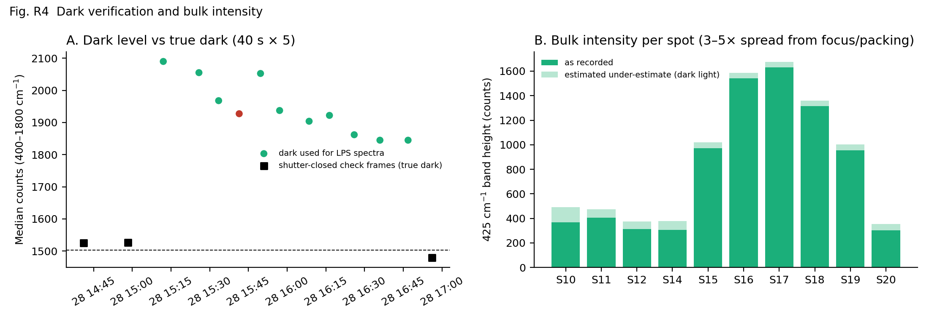
Fig. R4 (A) Dark level recorded with each LPS spectrum versus shutter-closed check frames (true dark); (B) 425 cm⁻¹ band height per spot, with the estimated under-estimate caused by light in the dark.

5. Reference spectrum
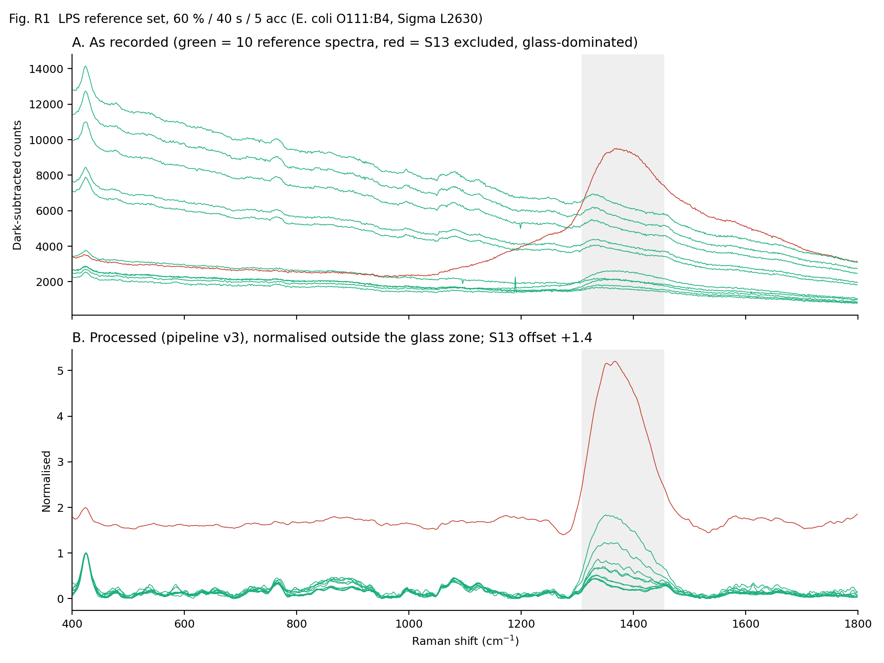
Fig. R1 All 11 spectra recorded at 60 % / 40 s / 5 acc: as recorded (A) and processed (B).
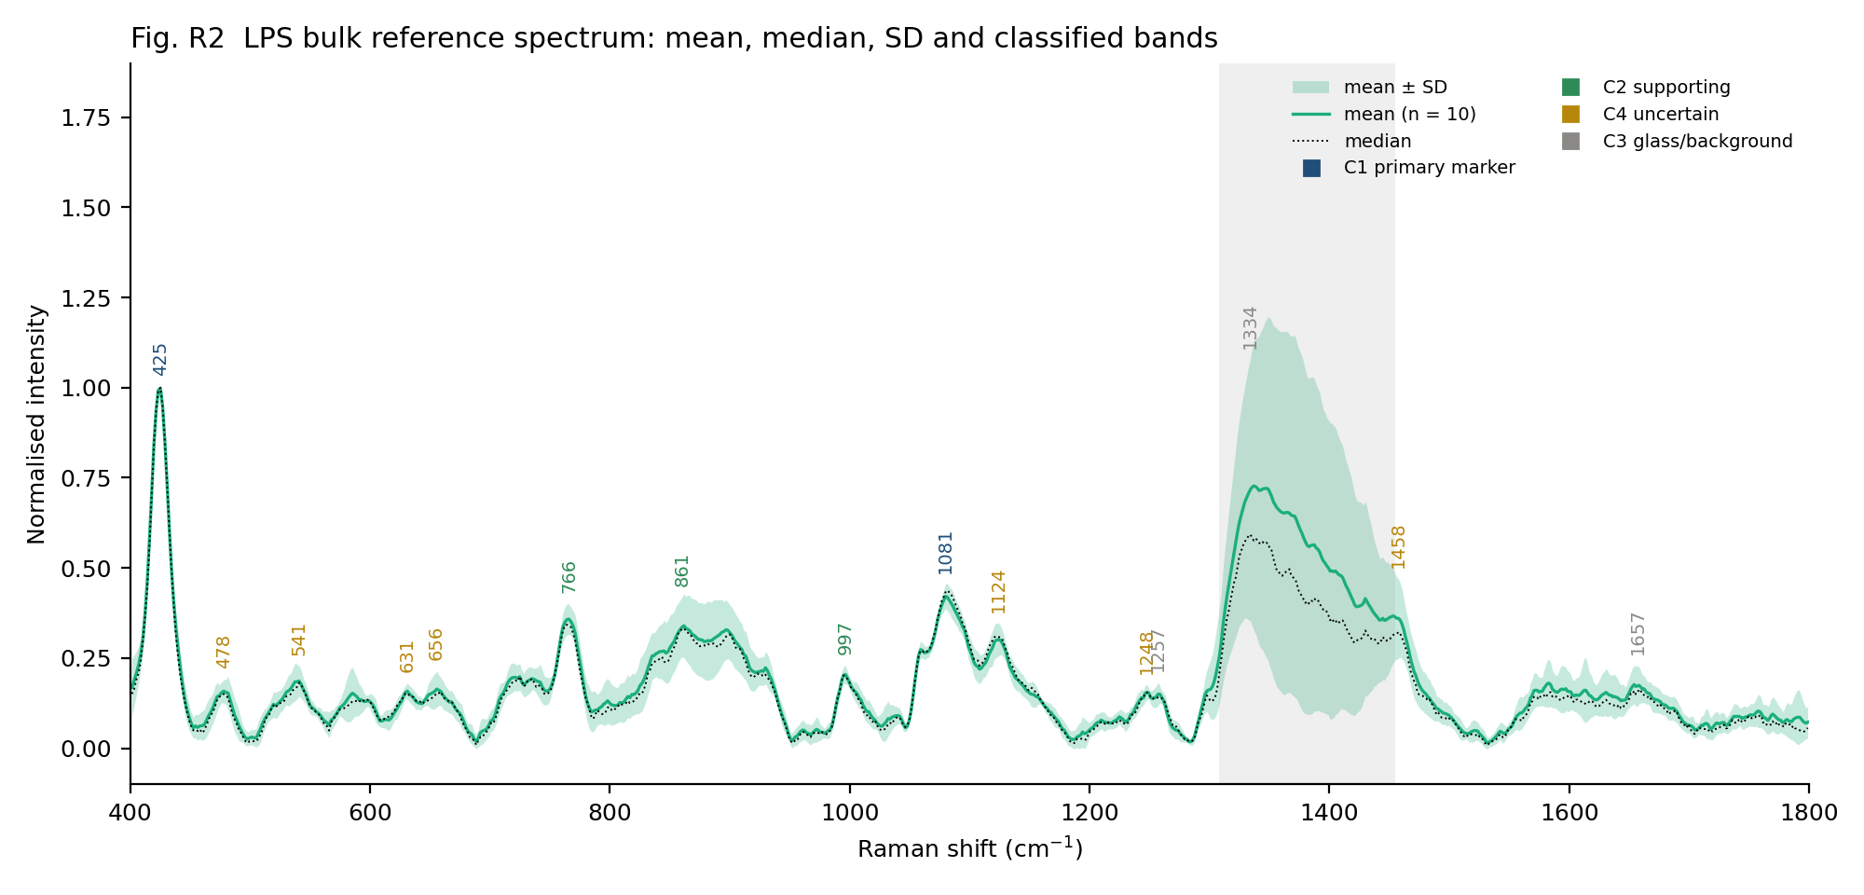
Fig. R2 LPS reference: mean (n = 10), median and ± SD, with bands coloured by category.
The mean and median agree (r = 0.982, and |mean − median| < 1 SD at every wavenumber), so the mean is used as the representative spectrum. The large SD inside 1308–1455 cm⁻¹ reflects the variable glass contribution between spots.

6. Glass background
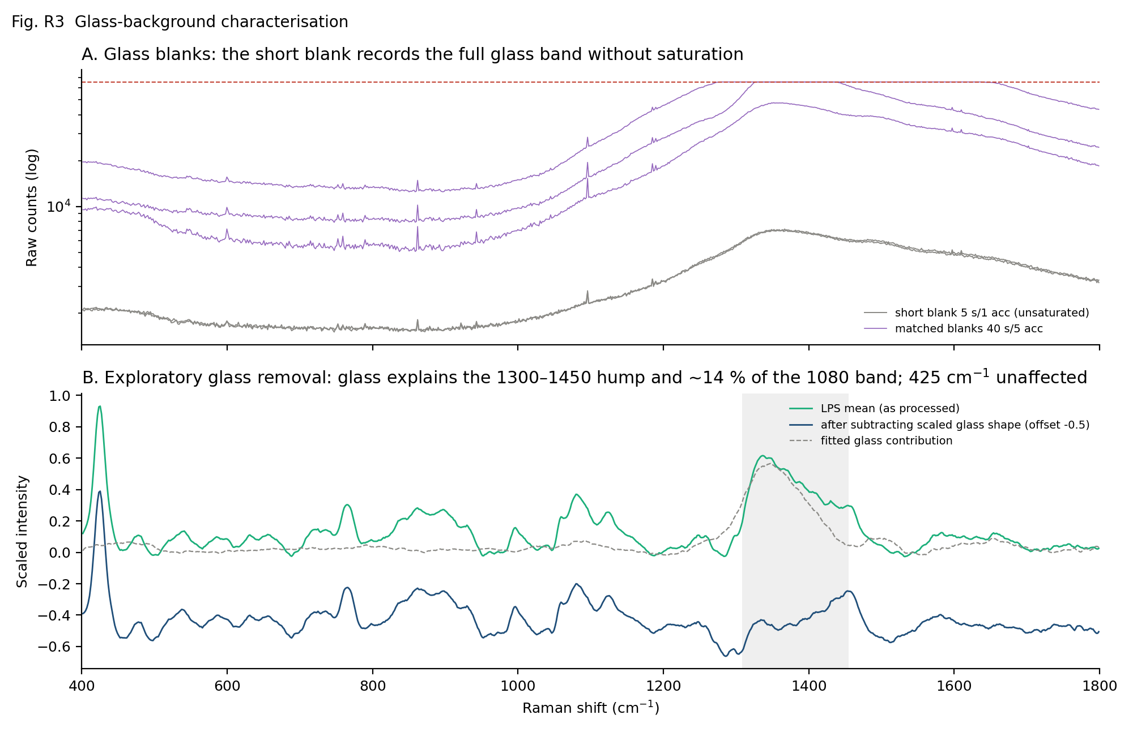
Fig. R3 (A) Matched blanks (40 s, partly saturated) and short blanks (5 s, unsaturated); (B) exploratory subtraction of the scaled short-blank glass shape from the LPS mean.
Glass features in the unsaturated blanks lie at ≈ 467, 791–798, 1091–1093 (broad), 1347 (dominant), 1484–1498 and 1653–1658 cm⁻¹. The glass shape, scaled to each spectrum in 1290–1520 cm⁻¹, accounts for 3.5 % of the 425 cm⁻¹ band, 14 % of the 1080 cm⁻¹ band, 28 % of the weak 478 cm⁻¹ band, 77 % of the 1334 cm⁻¹ feature and 54 % of the 1657 cm⁻¹ feature. After subtraction, a band near 1456 cm⁻¹ remains in 8/10 spectra (exploratory; consistent with CH₂/CH₃ deformation). This subtraction is exploratory and is not used for the reference spectrum itself.

7. Band table
Categories (project criteria): C1 primary = found in 10/10 spectra, median SNR ≥ 15, glass share < 25 %, relative-intensity CV ≤ 30 %; C2 supporting = found in ≥ 8/10, SNR ≥ 5 after glass removal, glass share < 25 %; C3 = glass zone or > 50 % glass; C4 = uncertain or weak. Intensity is compared as a ratio to the 425 cm⁻¹ band, because absolute counts vary 3–5× between spots.
Cat. | Found | Position ± SD | SNR | I/I₄₂₅ (CV) | Glass % | FWHM | Literature (±12 cm⁻¹)
C1 | 10/10 | 424.8 ± 0.9 | 38.2 | 1.00 (0 %) | 4 | 15 | —
C4 | 8/10 | 478.8 ± 2.1 | 6.0 | 0.13 (28 %) | 28 | 14 | —
C4 | 6/10 | 540.1 ± 1.5 | 8.3 | 0.16 (27 %) | 3 | 34 | 550 β(CH2) in ring [LPS-1 SERS]; 543 δ(C-O-C) glycosidic ring [LPS-1 SERS]
C4 | 4/10 | 631.2 ± 0.0 | 7.0 | 0.12 (14 %) | 8 | 44 | —
C4 | 5/10 | 656.7 ± 2.3 | 3.8 | 0.13 (29 %) | 13 | 13 | —
C2 | 8/10 | 765.5 ± 1.2 | 16.7 | 0.34 (12 %) | 7 | 22 | —
C2 | 8/10 | 861.1 ± 0.9 | 12.7 | 0.31 (27 %) | 4 | 97 | 850 ν(C-O-C) 1,4-glycosidic [LPS-1 SERS]; 855 δ(C-O-C) [LPS-1 SERS]
C2 | 9/10 | 995.8 ± 0.9 | 8.7 | 0.17 (12 %) | 2 | 20 | 988 β(CH) carbohydrates [LPS-1 SERS]; 1003 common LPS peak [LPS-2 SERS]
C1 | 10/10 | 1080.5 ± 1.1 | 15.3 | 0.40 (11 %) | 14 | 79 | 1075 O-antigen [LPS-3 normal Raman]; 1087 ν(C-O) lipid [LPS-1 SERS]
C4 | 5/10 | 1123.7 ± 1.3 | 18.8 | 0.28 (19 %) | 10 | 14 | 1131 ν(C-C) fatty acid [LPS-1 SERS]
C4 | 4/10 | 1247.9 ± 1.2 | 6.9 | 0.12 (18 %) | 30 | 33 | —
C3 | 5/10 | 1256.7 ± 0.7 | 3.5 | 0.12 (19 %) | 51 | 4 | —
C3 | 7/10 | 1333.1 ± 2.7 | 25.3 | 0.73 (58 %) | 77 | 111 | 1330 δ(CH) phospholipid [LPS-1 SERS]; 1333 common LPS peak (C-H def.) [LPS-2 SERS]
C4 | 5/10 | 1456.4 ± 1.9 | 14.9 | 0.35 (37 %) | 12 | 15 | 1450 CH2/CH3 deformation [LPS-1 SERS]
C3 | 5/10 | 1656.6 ± 3.0 | 7.0 | 0.15 (29 %) | 54 | 134 | —

Tentative interpretation of the marker bands
- 425 cm⁻¹ (C1): the strongest and most reproducible LPS band. It is present in the April and September LPS data, absent from the glass blanks, and nearly absent from NAM. No LPS band near 425 cm⁻¹ is reported in the SERS or normal-Raman literature found. It lies in the region of skeletal sugar-ring deformations δ(C-C-O)/δ(C-O-C) and O-P-O bending. Assignment: unassigned (tentative skeletal/phosphate deformation).
- 1080 cm⁻¹ (C1): broad band. Its best literature match is the O-antigen band at 1075 cm⁻¹ in the only normal-Raman LPS powder spectrum (Verde et al. 2021) and 1087 cm⁻¹ ν(C-O) in SERS (Wu et al. 2021). It is consistent with sugar C–O stretching and/or symmetric PO₂⁻ stretching (tentative). Glass contributes ≈ 14 %.
- 766, 861, 997 cm⁻¹ (C2): 861 is consistent with glycosidic C–O–C modes (850/855 cm⁻¹ in SERS). 997 is consistent with sugar C–H bending (973 normal Raman; 981–1003 SERS); a minor phenylalanine contribution from ≤ 3 % protein cannot be excluded. 766 has no literature match.

8. Identity and comparison
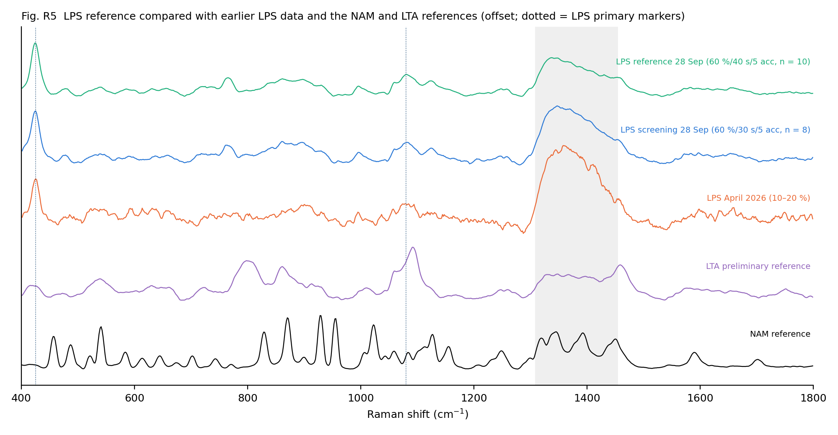
Fig. R5 LPS reference against earlier LPS data and the NAM and LTA references (offset).
Comparison (glass zone excluded) | r (mean) | Meaning
LPS screening 28 Sep (60 % / 30 s) | 0.98 | Same material and spectrum
LPS April 2026 (10–20 %) | 0.80 | Same pattern, noisier
LTA preliminary reference | 0.52 | Different material (shared broad cell-wall features)
NAM reference | 0.17 | Not NAM; NAM markers 929/955/1022 absent

9. Limitations
- LPS is a weak Raman scatterer. Only two bands reach SNR ≥ 15; the supporting bands have SNR 5–17.
- Absolute intensities vary 3–5× between spots (focus/packing) and are under-estimated by an estimated 3–34 % because the darks contained some sample light. Use band positions and relative intensities for identification.
- The glass band dominates 1308–1455 cm⁻¹. The C–H deformation bands reported for LPS at 1300–1370 cm⁻¹ (normal Raman) cannot be confirmed on glass slides.
- No normal-Raman literature exists for E. coli O111:B4 LPS powder. The only normal-Raman LPS spectrum found is for O55:B5 (gel-filtered). All assignments are tentative.
- Single session, single lot (0000442391). Lot-to-lot variability is noted by the supplier.
- Instrument: fixed-pattern ripple at ≥ 70 % power, and light leaks into the software dark unless the shutter is closed by hand. Both should be reported to the service engineer.

10. Final status
Biomarker | Reference condition | n | Primary markers | Status | Next
NAM | 90 % / 30 s / 5 acc | 15 | 541, 829, 870.5, 929, 955, 1023, 1127 | FINAL | Optional extra 90 % spots later
LPS | 60 % / 40 s / 5 acc | 10 | 425, 1080 | ESTABLISHED (28 Sep 2026) | Optional: second lot/session
LTA | 80 % / 45 s / 2 acc (preliminary) | 4 | 802, 861.5, 1092 | Preliminary | Re-acquire 10–15 spots; check for ripple at 80 %, fallback 60–70 %; shutter-closed dark

