SERS SEPSIS BIOMARKER PROJECT — BULK SPECTRAL LIBRARY
NAM Bulk-Powder Raman Validation Session (24 Sep 2026)
Data processing, quality control and comparison with the existing NAM reference
Sample | N-acetylmuramic acid (NAM / MurNAc), bulk powder placed directly on a glass slide
Instrument | B&W Tek i-Raman Plus, BWS465-785H (system BTC665N-785H-SYS), 785 nm laser; software BWRam 4.15
Acquisition | Laser power 60 / 70 / 80 / 90 % (instrument setting, not mW) × 30 s × 5 accumulations; independent spots
Data | 41 NAM spectra + 16 matched empty-glass blanks
Compared with | Existing NAM interim reference: 90 % / 30 s / 5 acc, 30 May 2026, n = 15 (5 independent spots + 10 same-spot repeats)
Report date | 27 Sep 2026 (status updated 28 Sep 2026: NAM reference FINAL)

Outcome. The 21 new spectra that pass QC confirm the existing NAM reference: every primary and supporting marker band was found in 21/21 spectra, at the same position (shift ≤ 1.5 cm⁻¹, less than one detector pixel) and with the same relative intensity (primary markers within ±7 %). The reference condition (90 % / 30 s / 5 acc) is unchanged. On 28 Sep 2026 the existing data were judged sufficient and the NAM reference was declared FINAL; the limitation (6 independent spots at the reference condition) is documented.

Sample-identity correction. These files were saved in a folder named "bulk-lps-24-09-26" with sub-folders labelled "lps". The first analysis (report of 24 Sep 2026) found that the spectra matched NAM, not LPS. On 27 Sep 2026 the operator checked the bottle and confirmed the powder was NAM. The library copies were renamed from LPS_Bulk_… to NAM_Bulk_…, the LPS screening report and its tables and figures were withdrawn, and the original folder was left unchanged with an identity note added.

Executive summary
Set | n (pass) | r vs reference | Pairwise r (mean) | 929 cm⁻¹ height (CV) | Role
Reference 30 May, 90 % | 15 | 1.000 | 0.994 | 919 (3.9 %) | Existing interim reference
New 60 % | 11 / 11 | 0.982 | 0.987 | 473 (15.9 %) | Validation (largest clean set)
New 70 % | 5 / 8 | 0.991 | 0.992 | 569 (10.6 %) | Validation
New 80 % | 4 / 9 | 0.990 | 0.958 | 718 (10.4 %) | Validation
New 90 % | 1 / 13 | 0.994 | — | 709 (n = 1) | Top-up at reference condition

- Validation: the mean of each new set correlates with the reference mean at r = 0.982–0.994 (glass zone excluded). All 7 primary markers (541, 829, 870.5, 929, 955, 1023, 1127 cm⁻¹) and 4 supporting peaks (457, 487, 1249, 1589 cm⁻¹) were detected in 21/21 spectra.
- Positions and relative intensities: every marker is within 1.5 cm⁻¹ of the reference position (detector pixel ≈ 1.8 cm⁻¹). Relative intensities I/I₉₂₉ agree within ±7 % for the primary markers and within ±11 % for the other bands outside the glass zone.
- Data quality: 21/41 spectra pass QC. All 20 failures are caused by dark-reference ripple: the dark level rose from about 1 420 to 4 470 counts during the roughly 10-hour session. No spectrum saturated.
- Bulk intensity: the 929 cm⁻¹ band increases with power: 473 counts at 60 %, 569 at 70 %, 718 at 80 % and 709 at 90 % (n = 1). The 90 % value is about 23 % below the 30 May reference (919 counts). Relative intensities agree, so this is a difference in overall signal level between sessions (e.g. focus or powder packing), not in the spectrum.
- Decision: the reference is confirmed and the condition stays 90 % / 30 s / 5 acc. Status (28 Sep 2026): FINAL by operator decision, with no further NAM acquisition. Limitation: 6 independent spots at 90 %, supported by 31 independent spots at other conditions.

1. Purpose
The NAM reference in library v3 was built from 15 spectra at 90 % / 30 s / 5 acc on 30 May 2026, but only 5 of them were independent spots (the other 10 were repeats of one spot). The planned next step was to collect at least 10 more independent spots and check whether they confirm the reference. This session recorded 41 independent NAM spots at four laser powers, plus matched glass blanks. This report checks every spectrum (QC), compares the clean spectra with the reference, and decides whether the reference is confirmed or needs revising.

2. Acquisition
Original sub-folder | Power | Int. × acc. | NAM / blanks | Acquisition time (instrument clock)
60 power | 60 % | 30 s × 5 | 11 / 4 | 03:10 – 04:13
lps-diffrent power-70 | 70 % | 30 s × 5 | 8 / 3 | 04:28 – 08:23
lps-diffrent-80 power | 80 % | 30 s × 5 | 9 / 5 | 10:38 – 11:47
lps-diffrent-90-power | 90 % | 30 s × 5 | 13 / 4 | 11:58 – 13:01

Metadata. Power, integration time and accumulations in every file header agree with the folder names. The objective, operator, product, batch/lot and supplier fields are empty in the headers and are reported as "Not recorded". Laser power is kept as the instrument % setting.
Notes. (i) Two 80 % files named "class4" and "class5" behave exactly like glass blanks (saturated glass band, no NAM bands) and were filed as Glass_Blank S04/S05, pending the operator's confirmation. (ii) The dark reference was re-acquired several times during the session (§4). (iii) The earlier LPS report stated 19 blanks; the correct number is 16 (57 files = 41 NAM + 16 blanks).

3. Data organisation
The original folder bulk-lps-24-09-26 is unchanged apart from an added README_SAMPLE_IDENTITY.txt. The renamed copies are byte-identical to the originals: all 57 MD5 checksums match. The new files follow the library's existing folder layout.
Location (inside SERS_Sepsis_Spectral_Library) | Content
01_Raw_Data_Renamed/NAM_Bulk/NAM_Bulk_20260924_*.csv | 41 NAM spectra (renamed copies)
01_Raw_Data_Renamed/Glass_Blank/Glass_Blank_20260924_*.csv | 16 matched blanks
02_Processed_Spectra/NAM, …/Glass_Blank (…_20260924_*_processed.csv) | Every pipeline stage + QC header
03_Reference_Spectra/NAM/NAM_Validation_20260924_*.csv | Mean/median/SD per power; marker comparison
03_Reference_Spectra/NAM/README_NAM_reference_status.txt | Status updated (validation added)
04_Figures/NAM_Session_20260924/FigN1–N9 | Figures in this report
05_Tables/Spectral_Library_Metadata_and_Peaks.xlsx | New sheets 26–32 (inventory, QC, set statistics, old vs new, bands, bulk intensity vs power, decision)
07_QC_and_Exclusions/NAM_Session_20260924_QC_Log.csv | Per-spectrum QC; exclusions also appended to Excluded_and_Flagged_Spectra.csv
08_Methodology/code/ln0–ln5 | Scripts that produced every number here
_to_delete/LPS_mislabel_20260924_superseded | Withdrawn LPS-labelled outputs (kept until you delete them)

4. Processing and quality control
The unchanged library pipeline v3 was used: hot-pixel correction (pixels 640 and 700) → crop 400–1800 cm⁻¹ → MAD spike removal (z > 6, ≤ 2 px) → Savitzky–Golay 11/3 → ALS baseline (λ = 1e5, p = 0.01) → noise (1.4826 × MAD of despiked − smoothed) → min–max normalisation. Correlations exclude the glass zone 1308–1455 cm⁻¹.
QC criterion (project convention) | Rule
Saturation | No raw count at 65 535 inside 400–1800 cm⁻¹
Dark-reference ripple | High-pass residual SD in 1550–1800 cm⁻¹ ≤ 50 counts (clean spectra: 14–25)
Signal | SNR of the 929 cm⁻¹ band ≥ 10
Retention | All spectra kept; failed spectra excluded from averages only, with the reason recorded

Why spectra failed. The detector has a fixed pixel-to-pixel pattern that the dark frame normally cancels (Fig. N4, left). During this session the dark level rose from about 1 420 counts (03:00–07:00) to about 1 820, then 3 600–4 470 counts (08:00–13:00) (Fig. N1). When the dark frame and the sample frame no longer match, the pattern remains as ripple (Fig. N4, right). The likely causes are stray or room light during dark acquisition, or detector temperature drift over the long session. Failures therefore say nothing about the sample or the laser power.
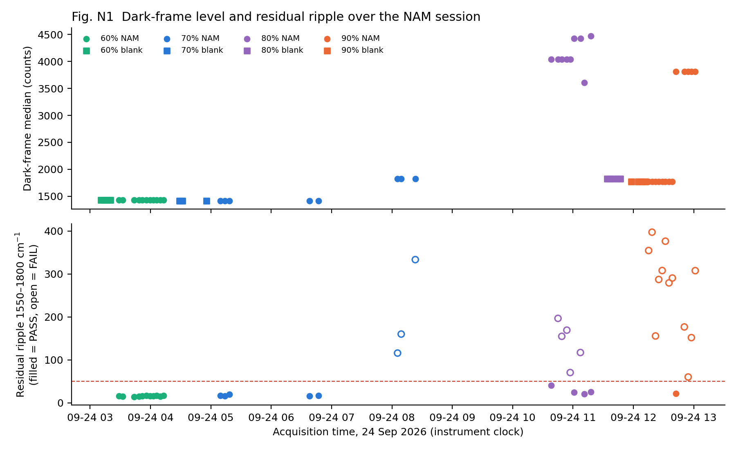
Fig. N1 Dark-frame median (top) and residual ripple (bottom) versus acquisition time; open symbols = failed spectra.
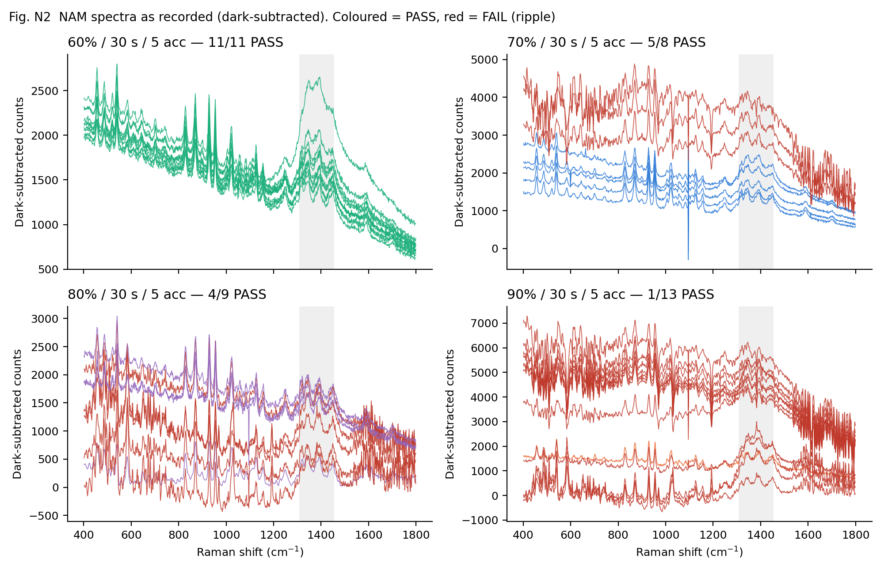
Fig. N2 All NAM spectra as recorded (dark-subtracted counts). Coloured = PASS, red = FAIL.
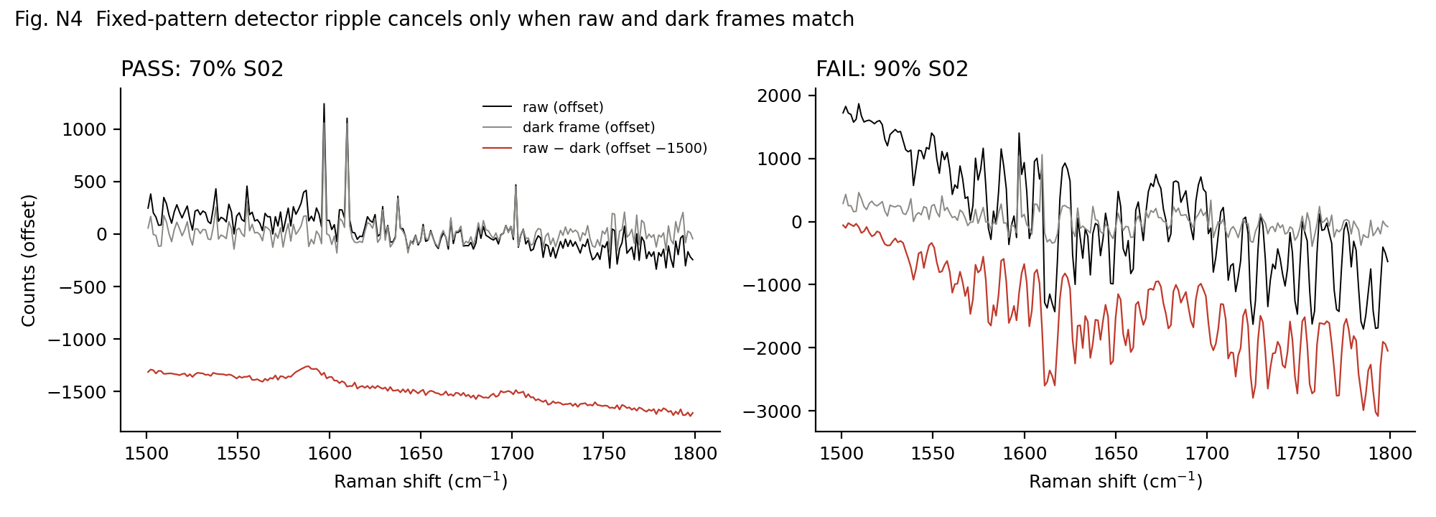
Fig. N4 Ripple diagnostic in 1500–1800 cm⁻¹ for a passing (70 % S02) and a failing (90 % S02) spectrum.

Excluded spectra
Library file | Power | Ripple | Reason
NAM_Bulk_20260924_P070pct_T30s_A05_S06.csv | 70 % | 116 | Dark-reference ripple > 50 counts
NAM_Bulk_20260924_P070pct_T30s_A05_S07.csv | 70 % | 160 | Dark-reference ripple > 50 counts
NAM_Bulk_20260924_P070pct_T30s_A05_S08.csv | 70 % | 333 | Dark-reference ripple > 50 counts
NAM_Bulk_20260924_P080pct_T30s_A05_S02.csv | 80 % | 197 | Dark-reference ripple > 50 counts
NAM_Bulk_20260924_P080pct_T30s_A05_S03.csv | 80 % | 155 | Dark-reference ripple > 50 counts
NAM_Bulk_20260924_P080pct_T30s_A05_S04.csv | 80 % | 169 | Dark-reference ripple > 50 counts
NAM_Bulk_20260924_P080pct_T30s_A05_S05.csv | 80 % | 71 | Dark-reference ripple > 50 counts
NAM_Bulk_20260924_P080pct_T30s_A05_S07.csv | 80 % | 117 | Dark-reference ripple > 50 counts
NAM_Bulk_20260924_P090pct_T30s_A05_S01.csv | 90 % | 354 | Dark-reference ripple > 50 counts
NAM_Bulk_20260924_P090pct_T30s_A05_S02.csv | 90 % | 397 | Dark-reference ripple > 50 counts
NAM_Bulk_20260924_P090pct_T30s_A05_S03.csv | 90 % | 156 | Dark-reference ripple > 50 counts
NAM_Bulk_20260924_P090pct_T30s_A05_S04.csv | 90 % | 287 | Dark-reference ripple > 50 counts
NAM_Bulk_20260924_P090pct_T30s_A05_S05.csv | 90 % | 308 | Dark-reference ripple > 50 counts
NAM_Bulk_20260924_P090pct_T30s_A05_S06.csv | 90 % | 376 | Dark-reference ripple > 50 counts
NAM_Bulk_20260924_P090pct_T30s_A05_S07.csv | 90 % | 279 | Dark-reference ripple > 50 counts
NAM_Bulk_20260924_P090pct_T30s_A05_S08.csv | 90 % | 290 | Dark-reference ripple > 50 counts
NAM_Bulk_20260924_P090pct_T30s_A05_S10.csv | 90 % | 177 | Dark-reference ripple > 50 counts
NAM_Bulk_20260924_P090pct_T30s_A05_S11.csv | 90 % | 60 | Dark-reference ripple > 50 counts
NAM_Bulk_20260924_P090pct_T30s_A05_S12.csv | 90 % | 152 | Dark-reference ripple > 50 counts
NAM_Bulk_20260924_P090pct_T30s_A05_S13.csv | 90 % | 308 | Dark-reference ripple > 50 counts

5. Glass blanks
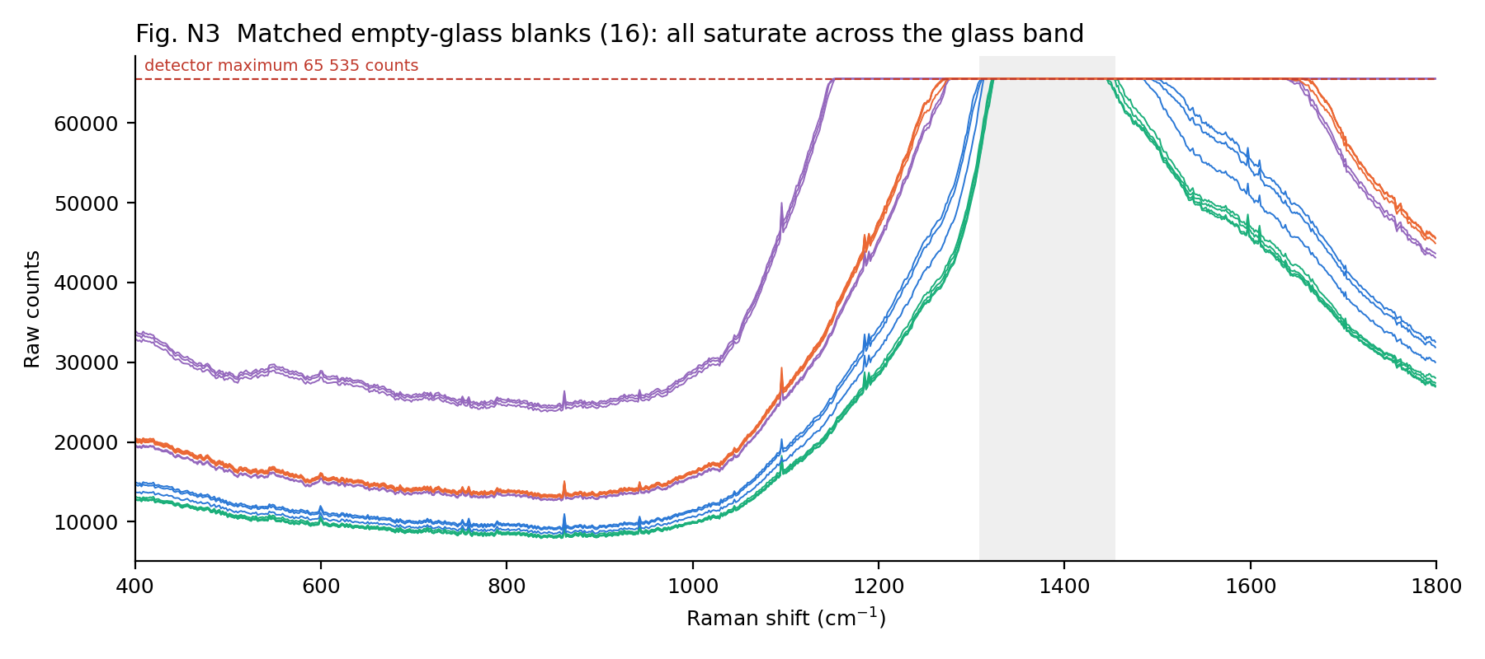
Fig. N3 Raw counts of all 16 empty-glass blanks. The dashed line is the detector maximum.
All 16 blanks saturate across the glass band (60 %: 1323–1455; 70 %: 1311–1498; 80 %: 1152–1799; 90 %: 1269–1662 cm⁻¹). With NAM powder on the slide, the background is only about 2–25 % of the blank level, so the powder layer shields most of the glass signal. Because the blanks are saturated, the sharp NAM bands inside the glass zone (1345, 1392, 1450 cm⁻¹) cannot be separated from glass, and they stay "uncertain – inside glass zone" as in v3. Their relative intensities vary between sessions (+1 to +13 %) and between spots, consistent with a variable glass contribution. The ~1367 cm⁻¹ band remains classified as glass.

6. Comparison with the existing NAM reference
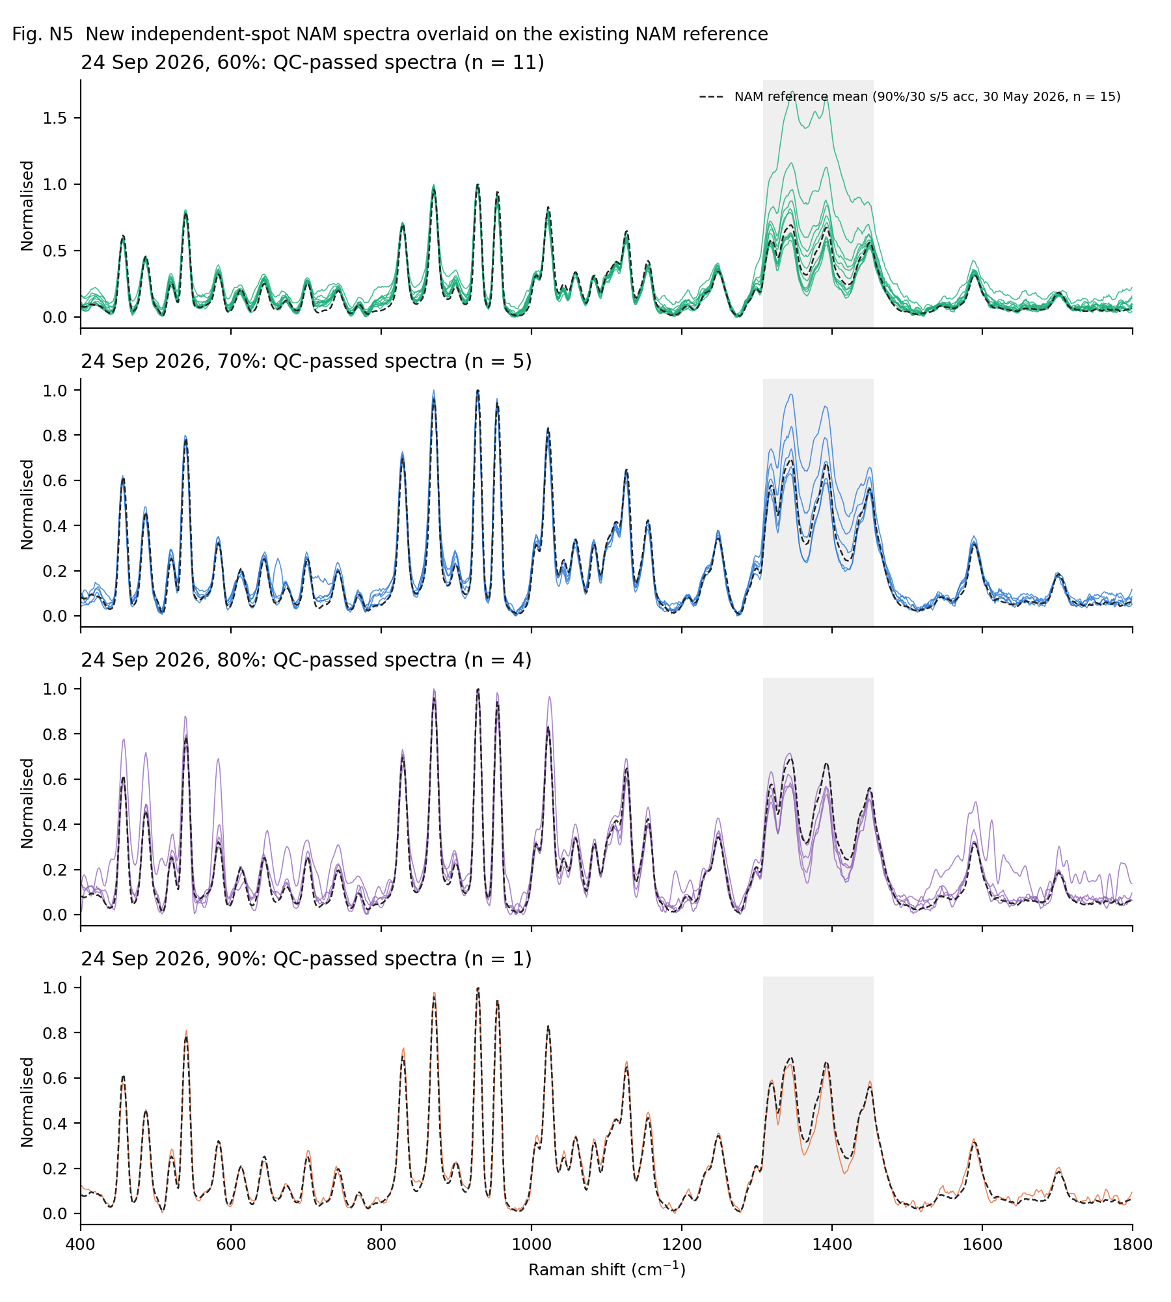
Fig. N5 New QC-passed spectra at each power (coloured) overlaid on the reference mean (dashed).
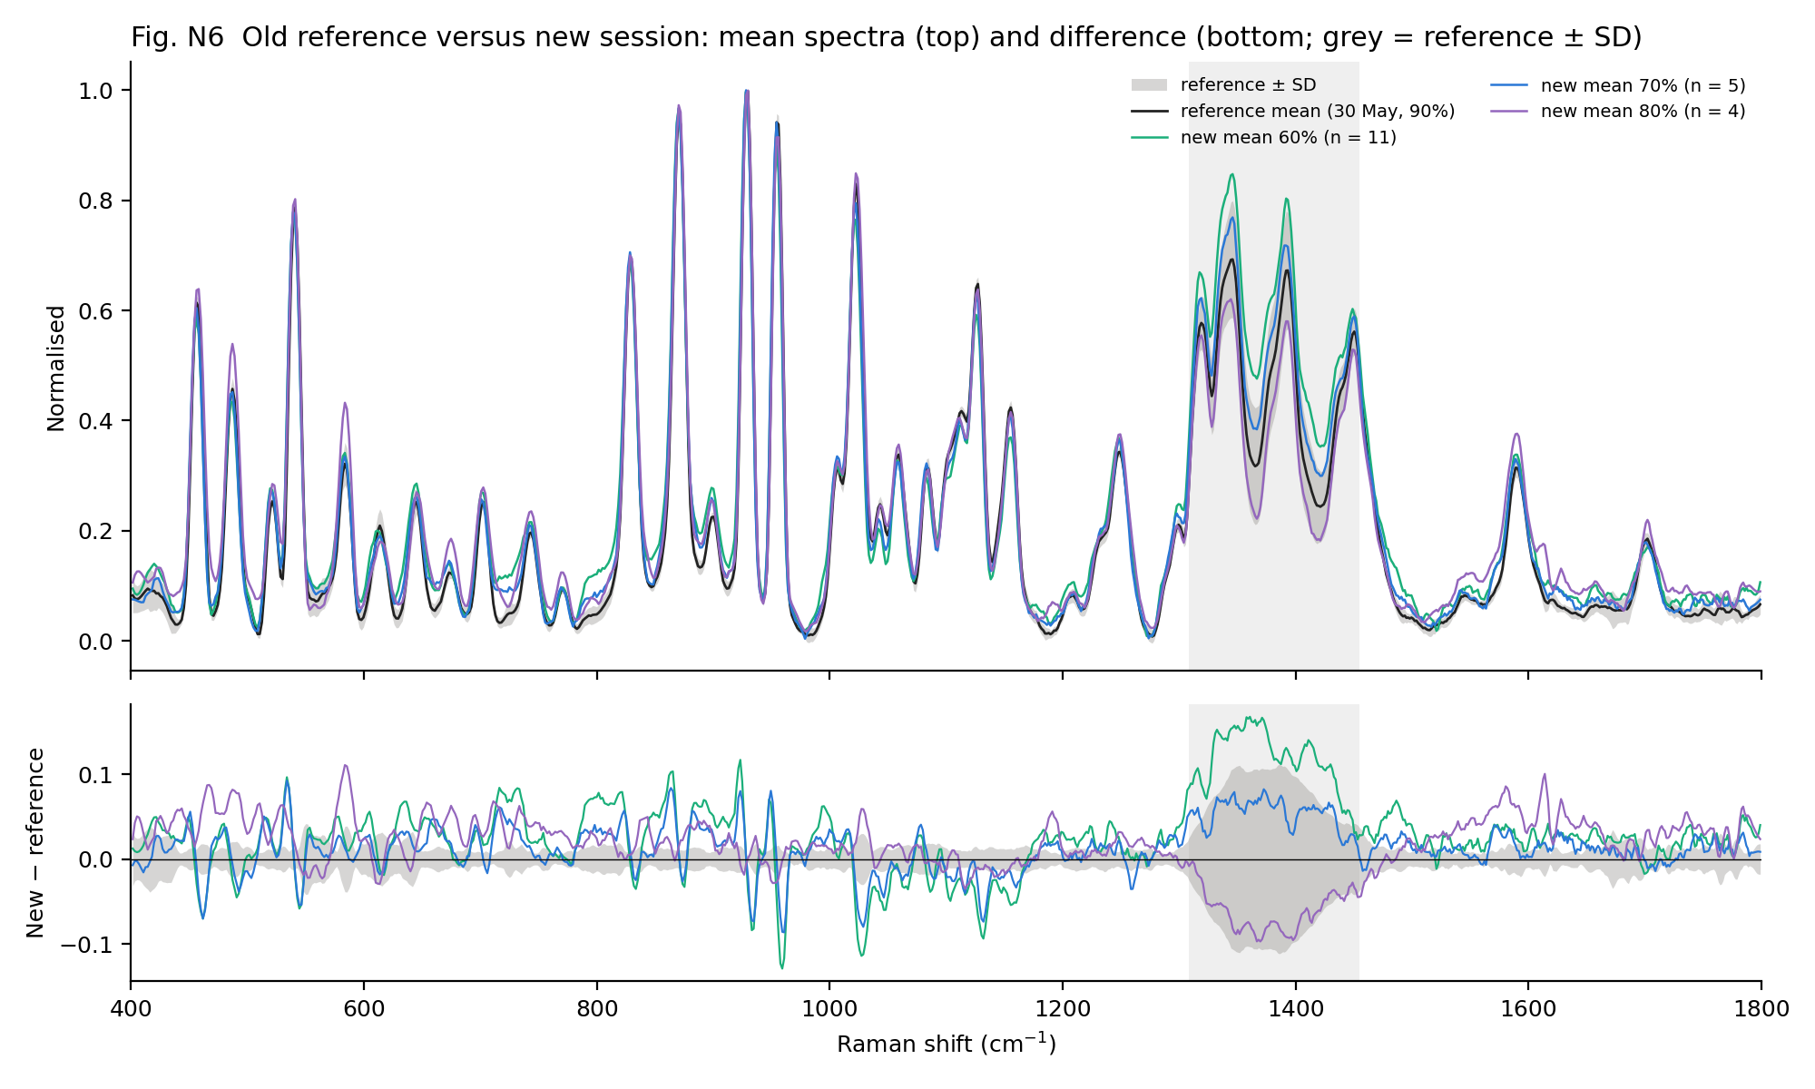
Fig. N6 Reference mean ± SD versus the new 60/70/80 % means (top) and their differences (bottom). Outside the glass zone the differences are mostly within ±0.1 of normalised intensity.
Set | n | r vs reference mean | Pairwise r (mean / min) | r (mean, median) | Noise (counts)
REF 90 30May all15 | 15 | 1.000 | 0.994 / 0.975 | 0.9992 | 18.1
REF 90 30May indep5 | 5 | 0.999 | 0.989 / 0.975 | 0.9903 | 18.9
NEW 60 24Sep | 11 | 0.982 | 0.987 / 0.951 | 0.9956 | 15.8
NEW 70 24Sep | 5 | 0.991 | 0.992 / 0.983 | 0.9989 | 16.7
NEW 80 24Sep | 4 | 0.990 | 0.958 / 0.923 | 0.9969 | 22.8
NEW 90 24Sep | 1 | 0.994 | — | — | 25.8
NEW all pass 24Sep | 21 | 0.992 | 0.976 / 0.855 | 0.9912 | 17.8

7. Marker validation
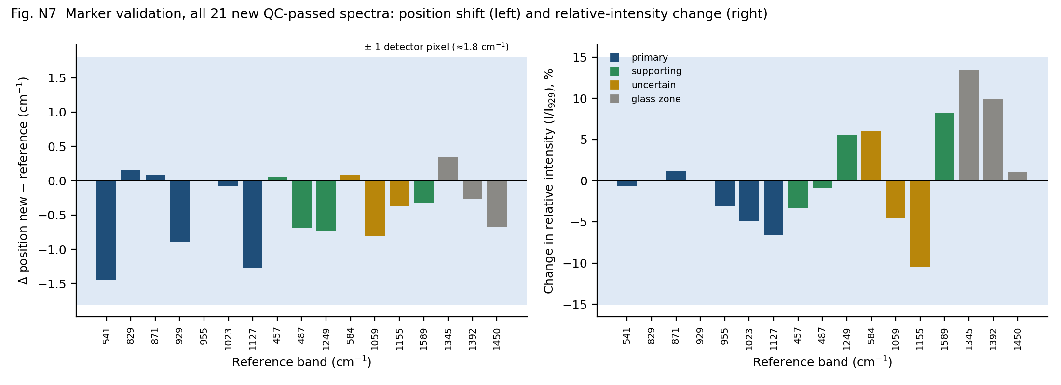
Fig. N7 Marker positions (left) and relative intensities I/I₉₂₉ (right): all 21 new QC-passed spectra versus the reference. The shaded band is ±1 detector pixel (left) and ±15 % (right).
Role (v3) | Ref. band | Ref. pos.* | New pos. | Δ | Detected | I/I₉₂₉ ref → new | Change
Primary marker | 541.0 | 541.0 | 539.6 | -1.4 | 21/21 | 0.78 → 0.77 | -0.6 %
Primary marker | 829.0 | 828.5 | 828.6 | 0.2 | 21/21 | 0.68 → 0.68 | 0.1 %
Primary marker | 870.5 | 870.3 | 870.3 | 0.1 | 21/21 | 0.96 → 0.97 | 1.2 %
Primary marker | 929.0 | 929.3 | 928.4 | -0.9 | 21/21 | 1.00 → 1.00 | 0.0 %
Primary marker | 955.0 | 954.5 | 954.5 | 0.0 | 21/21 | 0.94 → 0.91 | -3.1 %
Primary marker | 1022.7 | 1022.4 | 1022.3 | -0.1 | 21/21 | 0.82 → 0.78 | -4.9 %
Primary marker | 1127.0 | 1127.2 | 1125.9 | -1.3 | 21/21 | 0.63 → 0.59 | -6.6 %
Supporting peak | 457.0 | 456.5 | 456.5 | 0.1 | 21/21 | 0.60 → 0.58 | -3.3 %
Supporting peak | 487.0 | 487.1 | 486.5 | -0.7 | 21/21 | 0.43 → 0.43 | -0.9 %
Supporting peak | 1248.7 | 1248.9 | 1248.2 | -0.7 | 21/21 | 0.32 → 0.33 | 5.5 %
Uncertain | 583.8 | 583.7 | 583.8 | 0.1 | 21/21 | 0.30 → 0.32 | 6.0 %
Uncertain | 1058.9 | 1059.1 | 1058.3 | -0.8 | 21/21 | 0.31 → 0.30 | -4.5 %
Uncertain | 1155.0 | 1155.4 | 1155.0 | -0.4 | 21/21 | 0.40 → 0.36 | -10.5 %
Supporting peak | 1589.5 | 1589.4 | 1589.1 | -0.3 | 21/21 | 0.29 → 0.31 | 8.3 %
Uncertain (glass zone) | 1344.9 | 1344.7 | 1345.0 | 0.3 | 21/21 | 0.68 → 0.77 | 13.4 %
Uncertain (glass zone) | 1392.5 | 1392.5 | 1392.2 | -0.3 | 21/21 | 0.66 → 0.72 | 9.9 %
Uncertain (glass zone) | 1450.0 | 1450.1 | 1449.4 | -0.7 | 20/21 | 0.54 → 0.55 | 1.0 %

* Reference positions recalculated on the native detector axis with the same peak-finding method as the new data. The wavelength-calibration coefficients in the file headers are identical for 30 May and 24 Sep, so positions are directly comparable.
Result. The marker hierarchy of library v3 (primary, supporting, uncertain, glass zone) is fully reproduced by independent spots measured four months later, at four different powers. No new band appeared and no marker disappeared. The tentative chemical assignments in the Traceability_Table are therefore unchanged.

8. Bulk intensity versus laser power
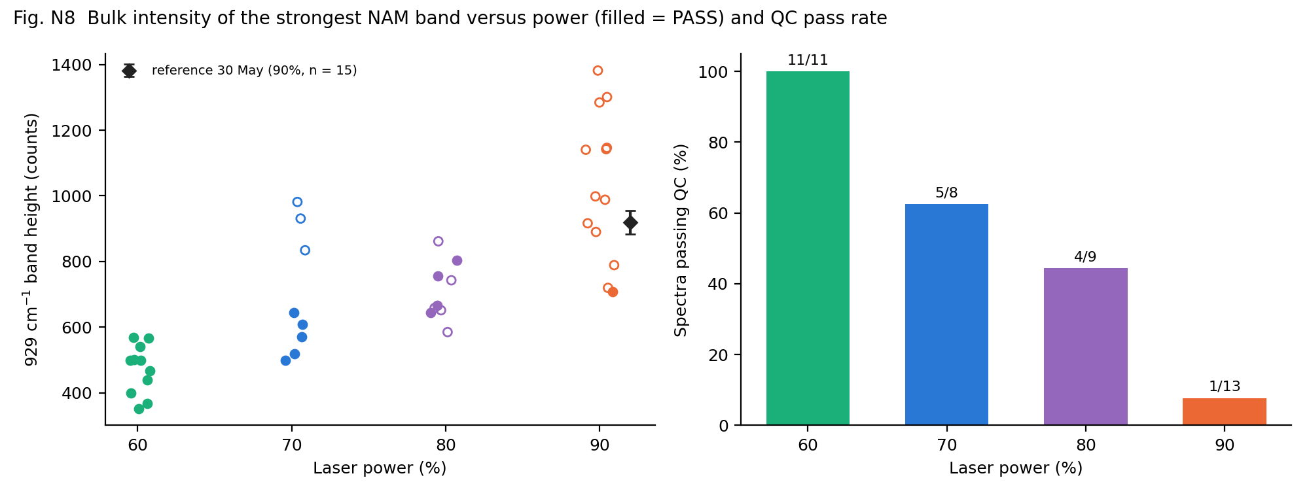
Fig. N8 929 cm⁻¹ band height per spectrum versus power (filled = PASS; diamond = 30 May reference ± SD), and QC pass rate.
Session | Power | n | 929 cm⁻¹ height (counts) | CV | SNR | 870 / 955 / 541 heights
30 May 2026 | 90 % | 15 | 919 | 3.9 % | 51.2 | 880 / 864 / 715
30 May 2026 (independent only) | 90 % | 5 | 888 | 5.3 % | 47.6 | 842 / 818 / 684
24 Sep 2026 | 60 % | 11 | 473 | 15.9 % | 29.9 | 456 / 424 / 362
24 Sep 2026 | 70 % | 5 | 569 | 10.6 % | 34.1 | 549 / 534 / 436
24 Sep 2026 | 80 % | 4 | 718 | 10.4 % | 33.4 | 696 / 655 / 568
24 Sep 2026 | 90 % | 1 | 709 | — | 27.5 | 692 / 667 / 568

All conditions are 30 s × 5 accumulations. Intensities are baseline-corrected counts ("bulk intensity") after pipeline v3. Within the session, intensity rises with power (roughly 7.9–9.0 counts per % for the 929 cm⁻¹ band). Spot-to-spot variation was larger on 24 Sep (CV 6–21 % for the main bands) than for the 5 independent reference spots on 30 May (CV 5–7 %). Because relative intensities are unchanged, this variation comes from the overall signal level (local focus and powder packing), not from the spectral shape. Following the project rule, the reference condition is not changed because of a difference in absolute intensity.

9. Representative spectrum of the largest clean set: mean versus median
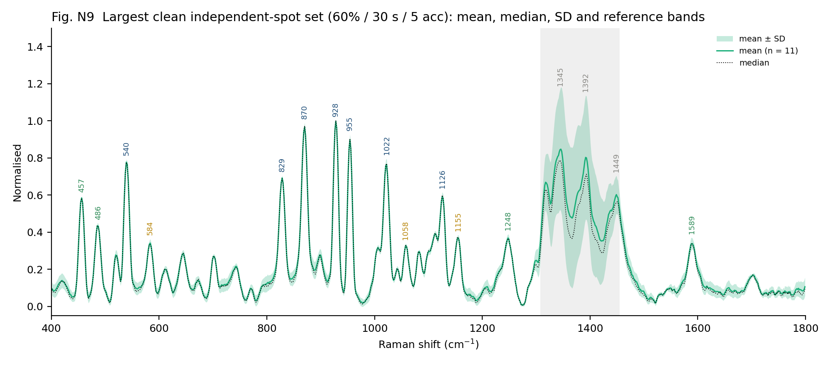
Fig. N9 60 % / 30 s / 5 acc, 11 independent spots: mean, median and ± SD, with the reference bands marked.
Mean and median agree closely for every new set (r = 0.9956 at 60 %, 0.9989 at 70 %, 0.9969 at 80 %; the difference is below 1 SD at every wavenumber). This shows a consistent population without influential outliers. The SD is largest inside the glass zone, as expected from a variable glass contribution.

10. Decision and final status
Question | Answer
Do the new data support the existing reference? | Yes: shape (r = 0.98–0.99), marker positions (≤ 1.5 cm⁻¹), relative intensities (primary ±7 %), 100 % marker detection in 21 independent spots.
Does the reference condition need revision? | No. 90 % / 30 s / 5 acc is kept. The lower absolute intensity on 24 Sep is a session-level difference, not a spectral one.
Are the reference files changed? | No. The reference mean, median, SD and members (30 May, n = 15) are unchanged; validation files were added beside them.
Final set at the reference condition | Reference set unchanged: 5 independent spots + 10 same-spot repeats (30 May). The new 90 % spot (24 Sep, S09, r = 0.994) agrees, but it is kept as validation and not averaged in, because it comes from a different session.
Validation sets | 60 %: 11, 70 %: 5, 80 %: 4 independent spots (24 Sep), plus the earlier 70 % / 10 s / 5 acc set (10 spots). All confirm the marker set.
Final status | FINAL (28 Sep 2026, operator decision). Documented limitation: 6 independent spots at the reference condition (target 10). Band positions and relative intensities are robust; absolute counts are indicative for this instrument and condition.

Biomarker | Acquisition condition | New n | Final valid n | Reference status | Re-acquisition needed?
NAM | Reference 90 % / 30 s / 5 acc; validation at 60/70/80 % | 41 | 21 (1 at 90 %) | FINAL (28 Sep 2026) | No – closed by decision
LTA | 80 % / 45 s / 2 acc | 0 | 4 (existing) | Preliminary | Yes: 10–15 spots
LPS | 70/80/90 % × 30 s × 5 acc screening | 0 | 0 | Not established | Yes: screening, then 10–15 spots

LPS note. The "70 % provisional" LPS condition proposed in the withdrawn LPS report was derived from these NAM data and no longer applies. LPS still needs the planned 70/80/90 % screening with matched blanks, on material confirmed as LPS.

11. Actions for the next session
☐ Acquire a fresh dark reference immediately before every spectrum (same 30 s × 5), with the laser off and the compartment covered. Stop if the dark median exceeds about 2 000 counts or ripple is visible.
☐ Add one clearly labelled short-integration glass blank per session to record the unsaturated shape of the glass band.
☐ Label folders and vials before measuring. Name blank files "glass…" consistently. Fill in the BWRam header fields and the recording sheet (SOP-RAMAN-BULK-01).
☐ Confirm whether "class4/class5" (80 %) were glass blanks.
☐ LTA: 10–15 spots at 80 % / 45 s / 2 acc. LPS: 70/80/90 % screening with matched blanks, then 10–15 spots at the selected condition.

Appendix A. Per-spectrum QC table
Library file | Power | Dark median | Ripple | Noise | SNR | r NAM ref | QC
Glass_Blank_20260924_P060pct_T30s_A05_S01.csv | 60 % | 1431 | — | 41.9 | — | -0.009 | BLANK (sat.)
Glass_Blank_20260924_P060pct_T30s_A05_S02.csv | 60 % | 1431 | — | 41.2 | — | 0.013 | BLANK (sat.)
Glass_Blank_20260924_P060pct_T30s_A05_S03.csv | 60 % | 1431 | — | 40.4 | — | -0.000 | BLANK (sat.)
Glass_Blank_20260924_P060pct_T30s_A05_S04.csv | 60 % | 1431 | — | 42.8 | — | -0.007 | BLANK (sat.)
NAM_Bulk_20260924_P060pct_T30s_A05_S01.csv | 60 % | 1431 | 16 | 16.0 | 35.5 | 0.985 | PASS
NAM_Bulk_20260924_P060pct_T30s_A05_S02.csv | 60 % | 1431 | 15 | 16.8 | 33.9 | 0.990 | PASS
NAM_Bulk_20260924_P060pct_T30s_A05_S03.csv | 60 % | 1431 | 14 | 14.8 | 33.6 | 0.986 | PASS
NAM_Bulk_20260924_P060pct_T30s_A05_S04.csv | 60 % | 1431 | 15 | 16.8 | 29.8 | 0.982 | PASS
NAM_Bulk_20260924_P060pct_T30s_A05_S05.csv | 60 % | 1431 | 16 | 16.4 | 28.5 | 0.983 | PASS
NAM_Bulk_20260924_P060pct_T30s_A05_S06.csv | 60 % | 1431 | 17 | 15.5 | 32.4 | 0.984 | PASS
NAM_Bulk_20260924_P060pct_T30s_A05_S07.csv | 60 % | 1431 | 16 | 15.5 | 23.8 | 0.935 | PASS
NAM_Bulk_20260924_P060pct_T30s_A05_S08.csv | 60 % | 1431 | 16 | 15.5 | 28.3 | 0.974 | PASS
NAM_Bulk_20260924_P060pct_T30s_A05_S09.csv | 60 % | 1431 | 17 | 15.4 | 35.1 | 0.985 | PASS
NAM_Bulk_20260924_P060pct_T30s_A05_S10.csv | 60 % | 1431 | 15 | 14.4 | 24.5 | 0.967 | PASS
NAM_Bulk_20260924_P060pct_T30s_A05_S11.csv | 60 % | 1431 | 17 | 17.1 | 23.3 | 0.967 | PASS
Glass_Blank_20260924_P070pct_T30s_A05_S01.csv | 70 % | 1418 | — | 44.3 | — | -0.058 | BLANK (sat.)
Glass_Blank_20260924_P070pct_T30s_A05_S02.csv | 70 % | 1418 | — | 45.0 | — | -0.046 | BLANK (sat.)
Glass_Blank_20260924_P070pct_T30s_A05_S03.csv | 70 % | 1418 | — | 46.6 | — | -0.063 | BLANK (sat.)
NAM_Bulk_20260924_P070pct_T30s_A05_S01.csv | 70 % | 1418 | 17 | 17.1 | 29.2 | 0.976 | PASS
NAM_Bulk_20260924_P070pct_T30s_A05_S02.csv | 70 % | 1418 | 16 | 16.0 | 35.7 | 0.991 | PASS
NAM_Bulk_20260924_P070pct_T30s_A05_S03.csv | 70 % | 1418 | 20 | 17.7 | 36.4 | 0.993 | PASS
NAM_Bulk_20260924_P070pct_T30s_A05_S04.csv | 70 % | 1418 | 16 | 16.1 | 32.3 | 0.990 | PASS
NAM_Bulk_20260924_P070pct_T30s_A05_S05.csv | 70 % | 1418 | 17 | 16.6 | 36.7 | 0.988 | PASS
NAM_Bulk_20260924_P070pct_T30s_A05_S06.csv | 70 % | 1824 | 116 | 47.3 | 17.6 | 0.767 | FAIL
NAM_Bulk_20260924_P070pct_T30s_A05_S07.csv | 70 % | 1824 | 160 | 55.7 | 16.7 | 0.682 | FAIL
NAM_Bulk_20260924_P070pct_T30s_A05_S08.csv | 70 % | 1824 | 333 | 89.8 | 10.9 | 0.293 | FAIL
NAM_Bulk_20260924_P080pct_T30s_A05_S01.csv | 80 % | 4043 | 41 | 13.7 | 47.2 | 0.926 | PASS
NAM_Bulk_20260924_P080pct_T30s_A05_S02.csv | 80 % | 4043 | 197 | 64.1 | 9.1 | 0.458 | FAIL
NAM_Bulk_20260924_P080pct_T30s_A05_S03.csv | 80 % | 4043 | 155 | 58.1 | 11.3 | 0.621 | FAIL
NAM_Bulk_20260924_P080pct_T30s_A05_S04.csv | 80 % | 4043 | 169 | 58.2 | 11.2 | 0.575 | FAIL
NAM_Bulk_20260924_P080pct_T30s_A05_S05.csv | 80 % | 4043 | 71 | 45.2 | 19.1 | 0.977 | FAIL
NAM_Bulk_20260924_P080pct_T30s_A05_S06.csv | 80 % | 4427 | 25 | 27.8 | 27.2 | 0.990 | PASS
NAM_Bulk_20260924_P080pct_T30s_A05_S07.csv | 80 % | 4427 | 117 | 48.2 | 15.4 | 0.769 | FAIL
NAM_Bulk_20260924_P080pct_T30s_A05_S08.csv | 80 % | 3606 | 21 | 23.3 | 28.5 | 0.991 | PASS
NAM_Bulk_20260924_P080pct_T30s_A05_S09.csv | 80 % | 4474 | 25 | 26.4 | 30.5 | 0.994 | PASS
Glass_Blank_20260924_P080pct_T30s_A05_S01.csv | 80 % | 1822 | — | 70.0 | — | 0.113 | BLANK (sat.)
Glass_Blank_20260924_P080pct_T30s_A05_S02.csv | 80 % | 1822 | — | 68.0 | — | 0.118 | BLANK (sat.)
Glass_Blank_20260924_P080pct_T30s_A05_S03.csv | 80 % | 1822 | — | 70.9 | — | 0.123 | BLANK (sat.)
Glass_Blank_20260924_P080pct_T30s_A05_S04.csv | 80 % | 1822 | — | 53.3 | — | -0.119 | BLANK (sat.)
Glass_Blank_20260924_P080pct_T30s_A05_S05.csv | 80 % | 1822 | — | 56.6 | — | -0.117 | BLANK (sat.)
Glass_Blank_20260924_P090pct_T30s_A05_S01.csv | 90 % | 1772 | — | 55.1 | — | -0.103 | BLANK (sat.)
Glass_Blank_20260924_P090pct_T30s_A05_S02.csv | 90 % | 1772 | — | 53.1 | — | -0.103 | BLANK (sat.)
Glass_Blank_20260924_P090pct_T30s_A05_S03.csv | 90 % | 1772 | — | 57.5 | — | -0.107 | BLANK (sat.)
Glass_Blank_20260924_P090pct_T30s_A05_S04.csv | 90 % | 1772 | — | 51.3 | — | -0.104 | BLANK (sat.)
NAM_Bulk_20260924_P090pct_T30s_A05_S01.csv | 90 % | 1772 | 354 | 94.0 | 14.7 | 0.492 | FAIL
NAM_Bulk_20260924_P090pct_T30s_A05_S02.csv | 90 % | 1772 | 397 | 101.1 | 12.9 | 0.380 | FAIL
NAM_Bulk_20260924_P090pct_T30s_A05_S03.csv | 90 % | 1772 | 156 | 52.0 | 17.1 | 0.685 | FAIL
NAM_Bulk_20260924_P090pct_T30s_A05_S04.csv | 90 % | 1772 | 287 | 73.5 | 15.6 | 0.501 | FAIL
NAM_Bulk_20260924_P090pct_T30s_A05_S05.csv | 90 % | 1772 | 308 | 80.8 | 14.1 | 0.450 | FAIL
NAM_Bulk_20260924_P090pct_T30s_A05_S06.csv | 90 % | 1772 | 376 | 92.4 | 13.9 | 0.408 | FAIL
NAM_Bulk_20260924_P090pct_T30s_A05_S07.csv | 90 % | 1772 | 279 | 74.0 | 15.4 | 0.504 | FAIL
NAM_Bulk_20260924_P090pct_T30s_A05_S08.csv | 90 % | 1772 | 290 | 72.4 | 13.6 | 0.414 | FAIL
NAM_Bulk_20260924_P090pct_T30s_A05_S09.csv | 90 % | 3814 | 22 | 25.8 | 27.5 | 0.994 | PASS
NAM_Bulk_20260924_P090pct_T30s_A05_S10.csv | 90 % | 3814 | 177 | 58.7 | 17.0 | 0.700 | FAIL
NAM_Bulk_20260924_P090pct_T30s_A05_S11.csv | 90 % | 3814 | 60 | 34.1 | 21.1 | 0.916 | FAIL
NAM_Bulk_20260924_P090pct_T30s_A05_S12.csv | 90 % | 3814 | 152 | 51.7 | 15.3 | 0.673 | FAIL
NAM_Bulk_20260924_P090pct_T30s_A05_S13.csv | 90 % | 3814 | 308 | 80.9 | 11.3 | 0.433 | FAIL

