Supplementary Information
Raman reference spectra and DFT-assisted band assignment of bacterial LPS and LTA at 785 nm

1. Calculated models
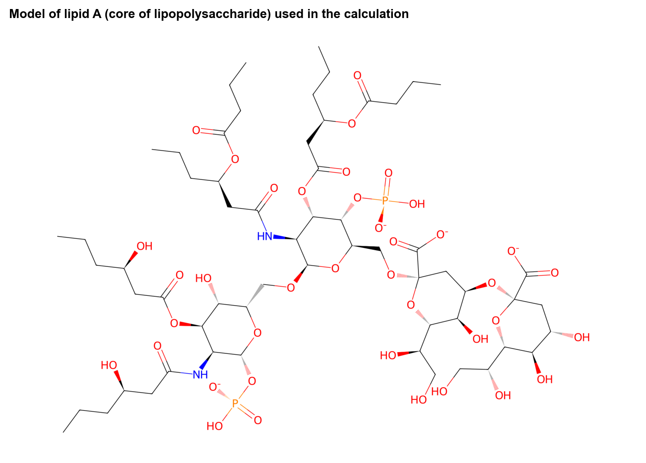
Figure 1. Model of lipopolysaccharide (LPS, E. coli O111:B4) used in the calculation.
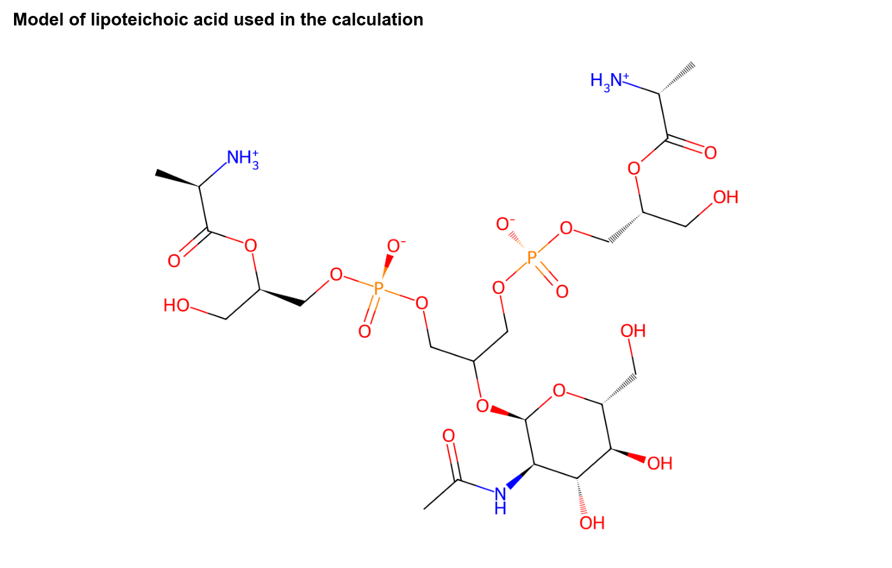
Figure 2. Model of lipoteichoic acid (LTA, S. aureus) used in the calculation.
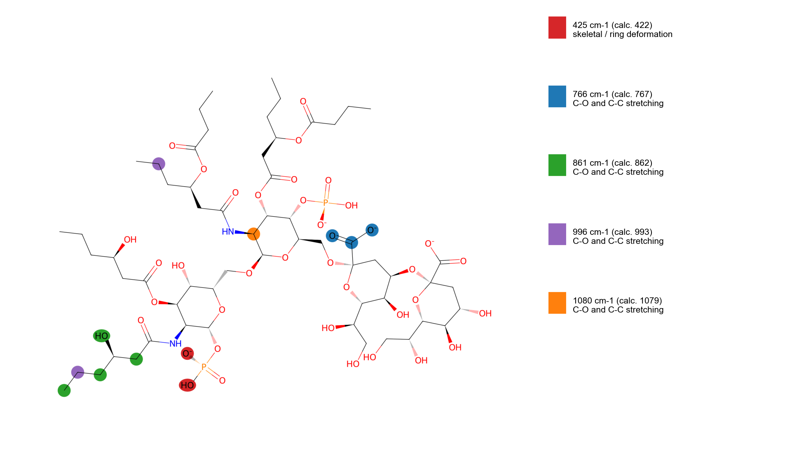
Figure 3. Atoms that carry the assigned LPS vibrations in the lipid A model.

2. Quality control
Table 1. Quality-control classes of all LTA spectra.
QC class | LTA spectra
EXCLUDE | 3
FAIL | 8
FLAG-DARK | 55
PASS | 20
REVIEW | 13

Per-spectrum QC logs: tables/SI_LPS_QC_log.csv and tables/SI_LTA_QC_log.csv. Calculated modes 400-1800 cm-1: tables/SI_<molecule>_all_calculated_modes_400_1800.csv. Reference spectra: tables/SI_<molecule>_reference_mean_sd.csv.

3. Chance test
Table 2. Agreement within 10 cm-1 against randomly shifted calculated spectra.
Molecule | Bands | Agree (modes) | Chance mean | p | Agree (visible peaks) | Chance mean | p
LPS | 5 | 5 | 4.6 | 0.56 | 3 | 1.9 | 0.33
LTA | 9 | 8 | 6.1 | 0.06 | 3 | 2.4 | 0.44

