Experimental and DFT-Assisted Raman Characterisation of Isolated N-Acetylmuramic Acid: Vibrational Assignment and a Reference Spectrum for Bacterial Cell-Wall Analysis
Department of Electrical Engineering, Indian Institute of Technology Jodhpur
Jodhpur 342030, Rajasthan, India
N-acetylmuramic acid (MurNAc, NAM) is the defining amino sugar of bacterial peptidoglycan and underlies many of the vibrational features exploited in Raman-based microbial identification. Despite this, an experimentally benchmarked vibrational assignment for the isolated molecule has not been reported; existing assignments derive either from empirical force-field treatments of the crystalline hydrate or from density functional theory (DFT) calculations validated only indirectly against whole-cell bacterial spectra. Here we report the Raman spectrum of isolated N-acetylmuramic acid powder, acquired at 785 nm across a systematic grid of 80 acquisition conditions (five integration times, sixteen laser power levels), together with harmonic Raman frequencies computed at the B3LYP-D3BJ/6-311++G(d,p) level. Forty-one reproducible bands were identified in the 400–1800 cm⁻¹ fingerprint region, of which thirty-three were matched to calculated normal modes with a mean absolute deviation of 9.1 cm⁻¹, a root-mean-square deviation of 10.2 cm⁻¹, and a correlation coefficient of 0.9997. Normal-mode decomposition permitted assignment of the pyranose ring, glycosidic, lactyl, acetamido and carboxyl contributions. Notably, the calculated mode falling in the disputed $∼$730 cm⁻¹ bacterial marker region is shown to originate almost entirely from out-of-plane deformation of the carboxylic acid hydroxyl group (48% of the mode displacement), with negligible pyranose ring character (0.5%). Because this proton is absent in intact peptidoglycan, where the NAM carboxyl is amide-linked to the peptide stem, the result argues against attributing the bacterial 730 cm⁻¹ band to muramic acid. The reference spectrum and assignments reported here provide a validated basis for interpreting peptidoglycan contributions in bacterial Raman and surface-enhanced Raman spectra.
Keywords: Raman spectroscopy; density functional theory; N-acetylmuramic acid ; peptidoglycan; vibrational assignment; bacterial biomarker

Introduction
Raman spectroscopy provides label-free, non-destructive vibrational fingerprints of biological material and requires minimal sample preparation, which has made it attractive for rapid microbial characterisation . Bacterial Raman spectra are, however, superpositions of contributions from proteins, nucleic acids, lipids and the cell wall, and the interpretation of individual bands therefore depends on the availability of reliable reference spectra for the constituent molecules.
Among cell-wall components, N-acetylmuramic acid occupies a distinctive position. Together with N-acetylglucosamine (GlcNAc, NAG) it forms the alternating glycan backbone of peptidoglycan, the polymer that confers mechanical rigidity on the bacterial cell wall in both Gram-positive and Gram-negative organisms . Unlike GlcNAc, which also occurs widely in eukaryotic glycans, muramic acid is essentially restricted to bacteria, and its D-lactyl ether substituent at C-3 is chemically unique to the bacterial cell wall. This specificity has made NAM an attractive target for Raman-based and surface-enhanced Raman (SERS) approaches to bacterial detection.
Raman spectra of structurally related amino sugars have been reported , and computational treatments of saccharide Raman spectra are well established . Vibrational studies of muramic acid itself nevertheless remain sparse. Early work combined infrared and Raman measurements on the crystalline monohydrate with harmonic dynamics based on empirical force fields , achieving an average agreement of approximately 4 cm⁻¹ between observed and calculated frequencies. More recently, Ma et al. computed Raman spectra of NAM and NAG by DFT at the B3LYP/6-311++G(d,p) level in order to construct a diagnostic model for Escherichia coli. In that work, however, NAM entered only as an in silico spectral component: the calculated spectrum was compared against whole-cell bacterial measurements, in which peptidoglycan bands are superimposed on strong protein, lipid and nucleic acid signals. The NAM assignments were therefore never validated directly.
A further open question concerns the band near 730 cm⁻¹, one of the strongest and most frequently used features in bacterial SERS spectra. Its origin has been variously attributed to adenine and related nucleotide degradation products and, less frequently, to cell-wall components. In the absence of a measured spectrum of isolated muramic acid, the peptidoglycan contribution to this band could not be assessed directly.
The present work addresses these gaps. We report the Raman spectrum of isolated N-acetylmuramic acid powder measured under systematically optimised acquisition conditions, together with harmonic Raman frequencies computed by DFT, and we use normal-mode decomposition to assign the observed bands. The resulting reference spectrum is intended to support the interpretation of peptidoglycan features in bacterial Raman and SERS measurements.

Materials and methods

Materials
N-acetylmuramic acid (Sigma-Aldrich A3007; CAS 10597-89-4; synthetic; $≥$98% by TLC; white powder; stated residual methanol $≤$1 mol/mol; lot TO CHECK: insert lot number from the bottle) was used as received without further purification or recrystallisation. The stated molecular weight of 293.27 corresponds to anhydrous C$​_{11}$H$​_{19}$NO$​_{8}$; the material is therefore not a hydrate.
The supplier specification defines five stereocentres but leaves the anomeric configuration unspecified (SMILES CC(O[C@H]1[C@H](O)[C@@H](CO)OC(O)[C@@H]1NC(C)=O)C(O)=O; InChI stereo layer /t5-,7+,8-,9-,10-/m1/s1). The material is thus an anomeric mixture rather than a single anomer, as is usual for a reducing sugar. This is relevant to the interpretation of the 820–980 cm⁻¹ region and is discussed in Section 3.7.
For measurement, a small quantity of powder was deposited directly onto a clean glass microscope slide. Samples were handled under ambient laboratory conditions, and exposure to atmospheric moisture was minimised during preparation and measurement. The reagent was stored at 2–8 $​^{∘}$C as supplied.

Raman measurements
Raman spectra were recorded on a B&W Tek i-Raman Plus system (model BWS465-785H) coupled to a BAC102-785E Raman microscope. Excitation was provided by a 785 nm diode laser (nominal maximum output 495 mW, Class 3B) with an emission wavelength of 784.92 nm as reported by the instrument software. Spectra were collected on a 2048-pixel detector spanning $−46$ to $2842$ cm⁻¹, of which the 400–1800 cm⁻¹ fingerprint region was retained for analysis. Spectral sampling varies across the range, from 1.76 cm⁻¹ per pixel at 400 cm⁻¹ to 1.43 cm⁻¹ per pixel at 1800 cm⁻¹. Measurements were made through a 20$×$ Plan objective. Each recorded spectrum was the average of two successive detector readings.
Acquisition conditions were optimised systematically rather than chosen a priori. A full factorial grid was measured comprising five integration times (5, 10, 15, 20 and 25 s) and sixteen laser power settings (5–80% of nominal output in 5% steps, corresponding to approximately 25–396 mW of laser output), giving 80 distinct conditions; additional measurements at 15 s extended the replicate coverage. In total 98 independent spectra of NAM powder were acquired. Detector saturation was not observed at any condition. A dark spectrum was recorded and subtracted by the instrument software for every measurement.
Laser power incident on the sample was measured directly with a power meter placed at the objective focal plane and was TO CHECK: XX mW at the TO CHECK: YY% setting used for the final measurements, corresponding to a power density of approximately TO CHECK: ZZ mW $μ$m$​^{−2}$ for the 20$×$ objective. TO CHECK: Insert measured values. Also state the instrument spectral resolution in cm⁻¹ from the manufacturer specification.

Spectral preprocessing
All spectra were processed through an identical pipeline. Dark-subtracted intensities were interpolated onto a uniform 1 cm⁻¹ grid spanning 400–1800 cm⁻¹. Baseline contributions arising from the substrate and from residual fluorescence were removed by asymmetric least-squares (ALS) fitting with smoothing parameter $λ={10}^{5}$, asymmetry $p=0.001$ and ten iterations. Baseline-corrected spectra were smoothed with a Savitzky–Golay filter (window 11 points, third-order polynomial), chosen to suppress detector noise without measurable distortion of band positions or widths, and finally min–max normalised.
Signal-to-noise ratio was estimated for each spectrum as the ratio of the maximum band intensity above the median to the noise standard deviation determined from successive differences in the signal-free region above 1750 cm⁻¹. Spectra with SNR $≥100$ ($n=40$) were retained to construct the reference spectrum. Band positions were located by prominence-based peak detection on the averaged spectrum.
Distinguishing genuine weak bands from correlated processing artefacts requires care: baseline correction and smoothing generate reproducible residual structure, so a band appearing consistently across spectra is not by itself evidence that it is real. Each candidate band was therefore evaluated against the local noise level, estimated from successive differences of the averaged spectrum within a $±50$ cm⁻¹ window. Two independent criteria were applied: the peak prominence, and the peak height above the local median, each required to exceed three times the local noise. Bands satisfying both criteria are reported as high confidence; those satisfying only one are reported but flagged as tentative; those satisfying neither were discarded. Five candidate features, at 411, 428, 901, 1495 and 1677 cm⁻¹, failed both criteria and are not reported. A reproducibility value is also quoted for each band, defined as the fraction of the 40 individual spectra in which a peak was independently detected within $±4$ cm⁻¹ of the mean position.
All processing was performed in Python using NumPy, SciPy and pandas.

DFT calculations
Geometry optimisation and harmonic vibrational frequency calculations were performed with Gaussian 16 at the B3LYP level using the 6-311++G(d,p) basis set, with Grimme’s D3 dispersion correction and Becke–Johnson damping and Raman activities requested. Optimisation used tight convergence criteria with analytically computed initial force constants, an ultrafine integration grid, and tight SCF convergence with quadratic convergence enabled (opt=(calcfc,tight) freq=raman int=ultrafine scf=(tight,xqc)). Calculations were carried out on the isolated molecule in the gas phase; no implicit solvation model was applied.
The starting geometry was the $β$ anomer of N-acetylmuramic acid. The optimisation converged to a stationary point and the job reached normal termination. The optimised structure comprises 39 atoms (C$​_{11}$H$​_{19}$NO$​_{8}$) and yielded 111 normal modes, none of which was imaginary, confirming that the geometry corresponds to a true minimum on the potential energy surface. As noted in Section 2.1 the measured material is an anomeric mixture; the calculation therefore models only one component of the sample, a limitation examined in Section 3.7.
Harmonic wavenumbers were scaled by 0.980 below 1800 cm⁻¹ and 0.967 above, following the scheme applied by Ma et al. , which permits direct comparison with the only other modern DFT treatment of this molecule.
Simulated Raman intensities were obtained from the computed Raman activities $S_{i}$ using the standard Placzek expression,
$$I_{i} ∝ \frac{(ν_{0}−ν_{i})^{4} S_{i}}{ν_{i}\left[1−\text{exp}​\left(−hcν_{i}/k_{B}T\right)\right]},$$
with $ν_{0}$ the excitation wavenumber corresponding to 785 nm and $T=298.15$ K. The resulting stick spectrum was convolved with Lorentzian line shapes of 10 cm⁻¹ full width at half maximum for comparison with experiment.
Mode characters were determined from the calculated Cartesian displacement vectors. Bond connectivity was established from interatomic distances using covalent radii, and for each normal mode the fractional contribution of each atom, of the pyranose ring, and of individual bond stretching coordinates was evaluated from the mass-weighted displacements. This procedure provides a quantitative, reproducible basis for the assignments in Table 1; it is not equivalent to a full potential energy distribution analysis, and the principal assignments should be confirmed by visual inspection of the normal-mode animations.

Results and discussion

Optimised molecular geometry
The DFT-optimised structure of $β$-N-acetylmuramic acid is shown in Figure 1. The pyranose ring adopts the expected $​^{4}C_{1}$ chair conformation, with the acetamido group at C-2, the D-lactyl ether at C-3 and the hydroxymethyl group at C-5. All 111 computed frequencies are real, confirming a true minimum on the potential energy surface. Optimised Cartesian coordinates are given in the Supplementary Material.
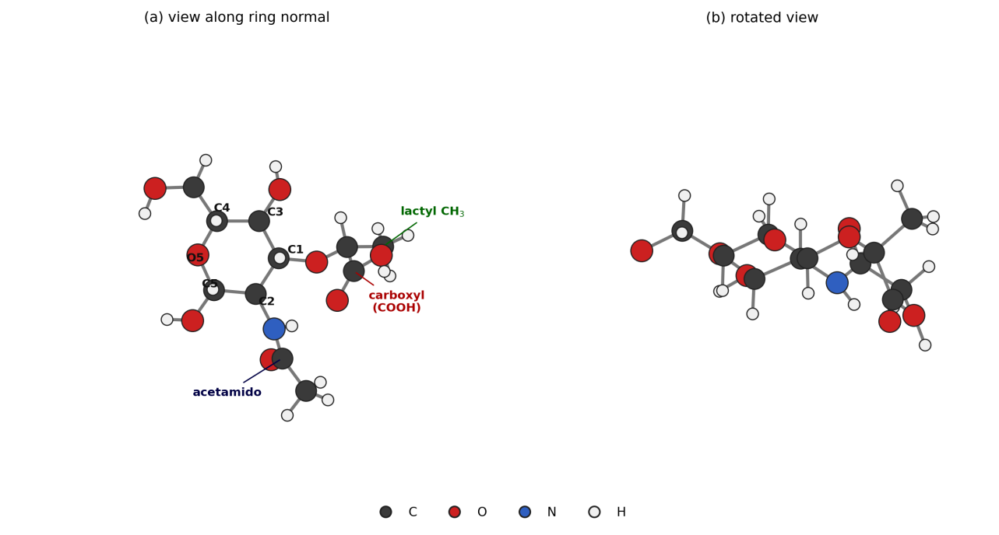
DFT-optimised geometry of isolated $β$-N-acetylmuramic acid at the B3LYP/6-311+G(d,p) level. (a) View along the pyranose ring normal, with ring carbons and the three substituent groups labelled. (b) Rotated view showing the $​^{4}C_{1}$ chair conformation. The D-lactyl ether at C-3 and its terminal carboxyl group distinguish muramic acid from N-acetylglucosamine.

Optimisation of acquisition conditions
Figure 2 summarises the signal-to-noise ratio across the acquisition grid. SNR increases monotonically with both integration time and laser power over the ranges examined, reaching a maximum of approximately 287 at 25 s and 75% power. No spectral evidence of sample degradation was observed at the highest settings: no broad carbonaceous background developed, no loss of band structure occurred, and band positions were unchanged within the measurement precision. The systematic behaviour of the SNR surface, and the absence of degradation signatures, indicate that N-acetylmuramic acid powder tolerates the full range of conditions examined at 785 nm excitation.
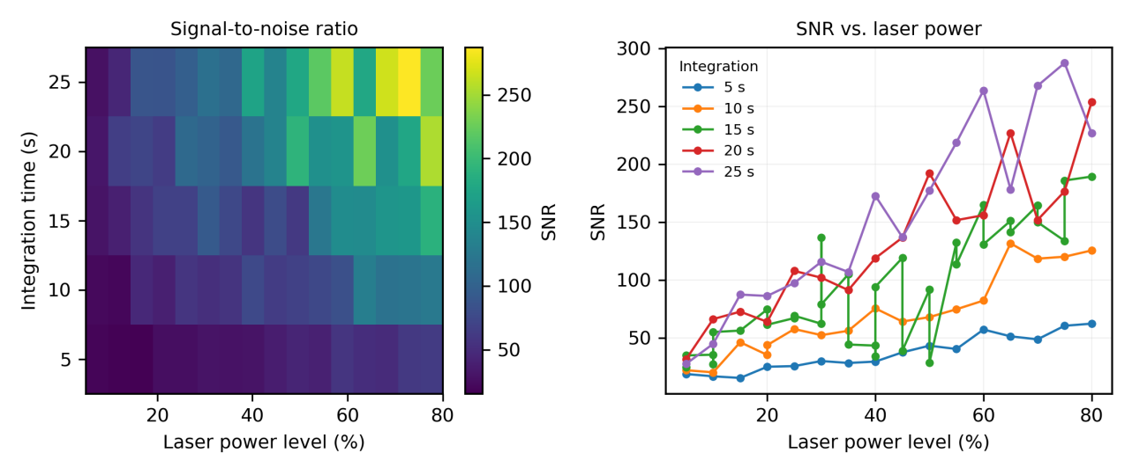
Optimisation of Raman acquisition conditions for N-acetylmuramic acid powder. (a) Signal-to-noise ratio across the grid of five integration times and sixteen laser power levels. (b) Signal-to-noise ratio as a function of laser power level at each integration time.

Experimental Raman spectrum
The reference spectrum, constructed as the mean of the 40 highest-quality measurements, is shown in Figure 3. The mean pairwise correlation coefficient among these spectra is 0.957, confirming that band positions and relative intensities are reproducible across independent measurements and across acquisition conditions.
Forty-one bands satisfy the confidence criterion in the 400–1800 cm⁻¹ region. Thirty-three of these are detected in every one of the 40 spectra (100% confidence), and the remainder in at least 77%. The most intense features occur at 930, 956, 872, 831, 1024 and 542 cm⁻¹.
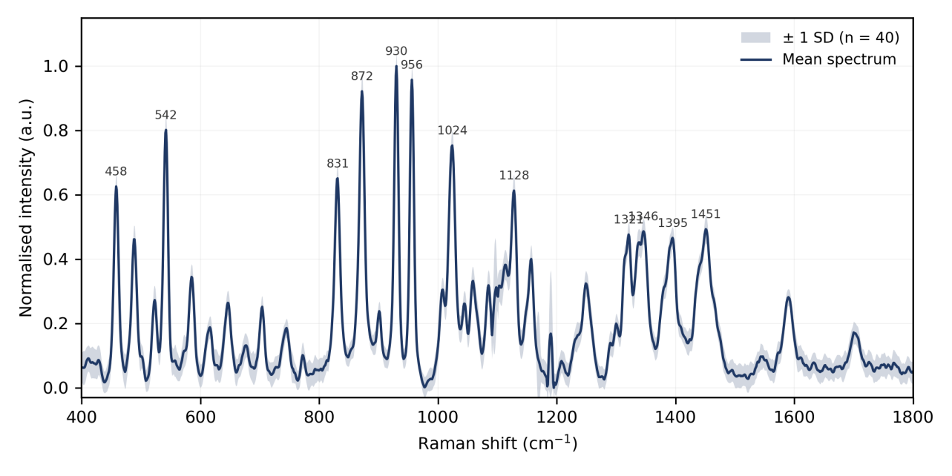
Reference Raman spectrum of isolated N-acetylmuramic acid powder. Solid line: mean of 40 independent high-quality spectra. Shaded band: $±1$ standard deviation. Principal band positions are labelled in cm⁻¹.
The spectrum divides naturally into four regions. Below 700 cm⁻¹ the bands at 411, 458, 488, 523, 542, 585 and 646 cm⁻¹ arise from skeletal bending and ring torsional motions of the pyranose framework. Between 700 and 1000 cm⁻¹ the strong features at 831, 872, 930 and 956 cm⁻¹ correspond to ring deformation and ring-breathing character with coupled C–C–O stretching; the prominence of this region is characteristic of pyranose sugars. The 1000–1200 cm⁻¹ region, containing bands at 1024, 1059, 1085, 1128 and 1157 cm⁻¹, is dominated by C–O and C–C stretching of the ring together with C–O–H bending. Above 1200 cm⁻¹ the bands at 1321, 1346, 1395 and 1451 cm⁻¹ reflect C–H bending, methyl umbrella and methylene scissoring deformations, the last of these carrying substantial contribution from the lactyl methyl group. The weaker features at 1544 and 1700 cm⁻¹ correspond to the amide II and amide I modes of the acetamido group respectively, and the bands near 1751–1792 cm⁻¹ to carboxylic acid carbonyl stretching.

Simulated Raman spectrum
The simulated Raman spectrum obtained after scaling, intensity conversion and Lorentzian broadening is shown in Figure 4. Sixty-seven modes fall within the 400–1800 cm⁻¹ window examined experimentally.
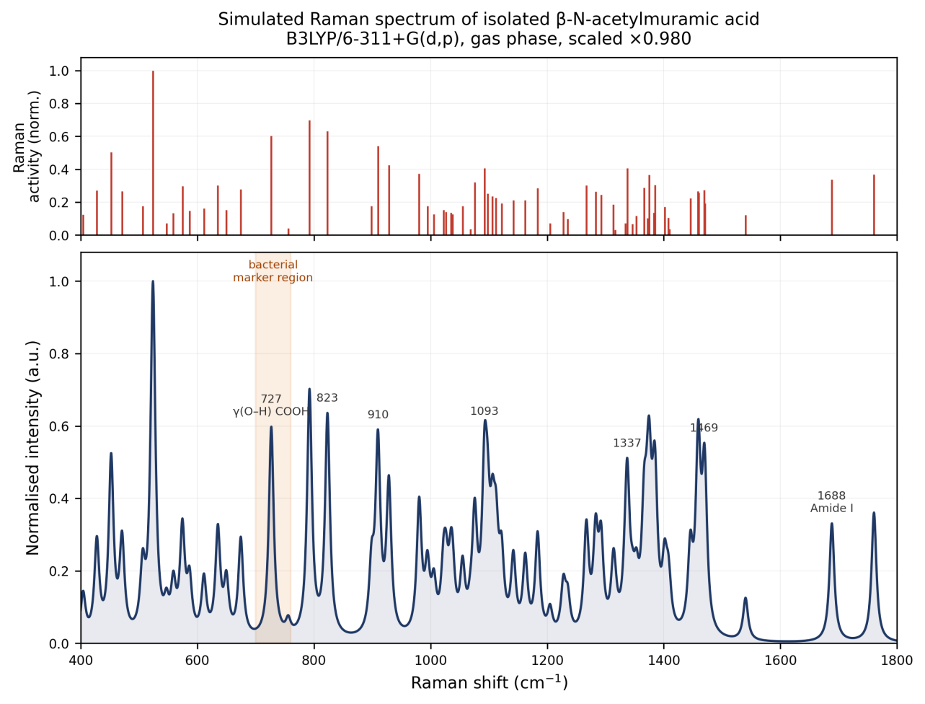
Simulated Raman spectrum of isolated $β$-N-acetylmuramic acid computed at the B3LYP/6-311+G(d,p) level. Upper panel: scaled harmonic frequencies with normalised Raman activities. Lower panel: Lorentzian- broadened spectrum (FWHM 10 cm⁻¹).

Comparison of experimental and calculated frequencies
Thirty-three of the forty-one observed bands were matched to calculated normal modes within a tolerance of $±18$ cm⁻¹, selecting in each case the candidate mode of highest Raman activity. The comparison is presented in Table 1 and displayed graphically in Figure 5.
Agreement is good. The mean absolute deviation is 9.1 cm⁻¹, the root-mean-square deviation 10.2 cm⁻¹, and the largest individual deviation 17.6 cm⁻¹. The correlation between observed and calculated wavenumbers is 0.9997. The mean signed deviation is $+2.0$ cm⁻¹, indicating no strong systematic bias after scaling; re-optimising a single uniform scaling factor against the experimental data yields 0.993 with an RMSE of 9.8 cm⁻¹, a marginal improvement that does not justify departing from the literature scheme.
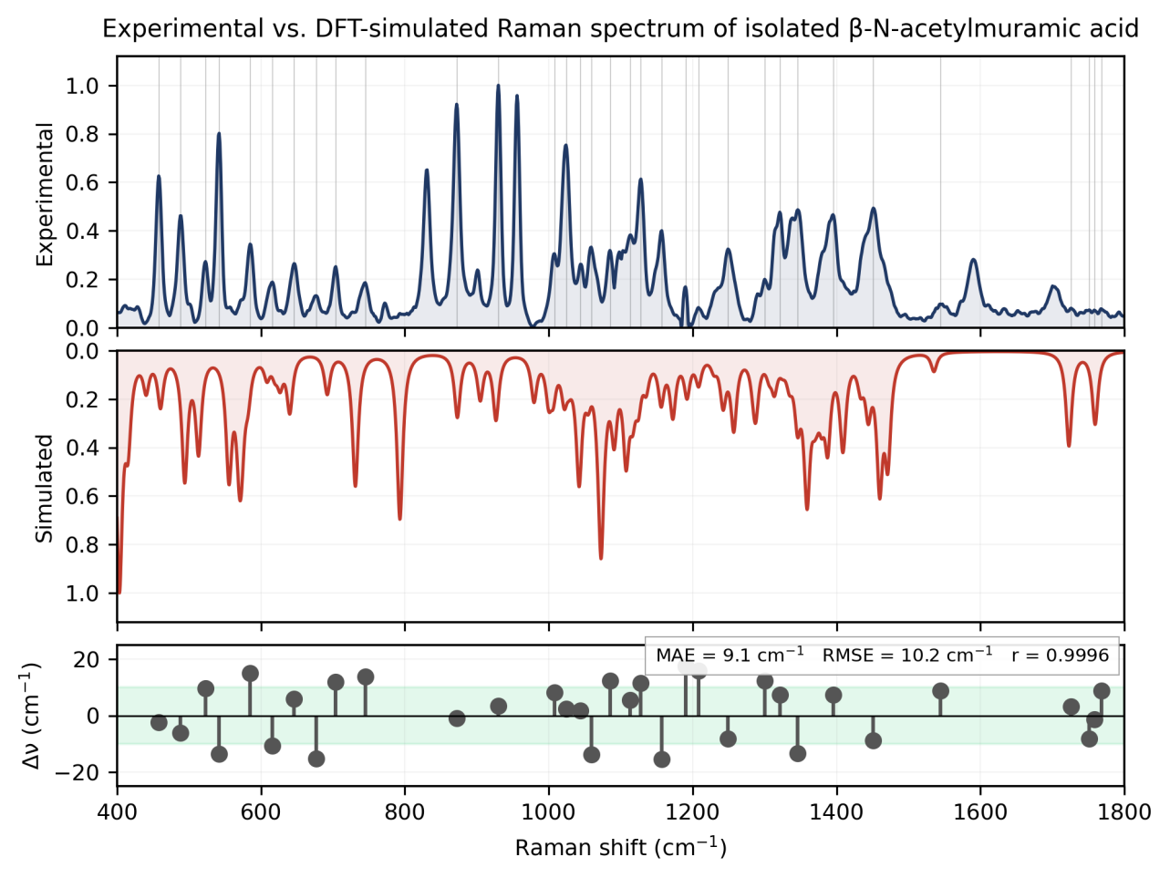
Comparison of experimental and simulated Raman spectra of isolated N-acetylmuramic acid. Upper panel: experimental reference spectrum. Middle panel: DFT-simulated spectrum (inverted). Lower panel: deviation between observed and calculated wavenumbers for the 34 matched bands; the shaded region denotes $±10$ cm⁻¹.
Residual discrepancies are attributable to three well-understood sources. First, the calculation employs the harmonic approximation, whereas real vibrational potentials are anharmonic; scaling corrects this only on average. Second, and most importantly here, the calculation treats a single isolated molecule in vacuum, while the measurement was made on crystalline powder in which extensive intermolecular hydrogen bonding is present. Modes involving hydroxyl, carbonyl and amide groups are those most sensitive to such interactions, and it is precisely in these regions that the largest discrepancies and the unmatched experimental bands occur. Third, no empirical dispersion correction was applied, which further limits the description of weak intramolecular interactions.
Eight experimental bands, at 772, 831, 956, 1590, 1633, 1652, 1700 and 1792 cm⁻¹, have no calculated counterpart within the matching tolerance. One of these, at 956 cm⁻¹, is among the strongest features of the experimental spectrum, and their absence from the gas-phase calculation is notable. Both lie in the region associated with ring and glycosidic-type motions. Two effects plausibly contribute: the anomeric composition of the sample, discussed in Section 3.7, and crystal packing, which lifts degeneracies and redistributes intensity relative to the isolated molecule. The bands near 1590–1700 cm⁻¹ fall in the amide I region. The calculation places the amide carbonyl stretch at 1723 cm⁻¹, some 23 cm⁻¹ above the observed 1700 cm⁻¹ band and outside the matching tolerance. This is the expected direction and magnitude of error for a gas-phase model: intermolecular hydrogen bonding to the amide carbonyl in the crystal lowers the stretching frequency substantially, and no isolated-molecule calculation can reproduce that shift. These observations delimit the applicability of isolated-molecule calculations to solid-state muramic acid spectra and indicate where a periodic or cluster-based treatment would be required.
Observed and calculated Raman wavenumbers of isolated N-acetylmuramic acid with proposed vibrational assignments. Calculated values are scaled (0.980 below 1800 cm⁻¹). $Δ=ν_{exp}−ν_{calc}$. Confidence denotes the percentage of the 40 independent spectra in which the band was detected. $ν$: stretching; $δ$: in-plane bending; $γ$: out-of-plane bending. $​^{†}$Tentative: the band satisfies only one of the two signal-to-noise criteria described in Section 2.3.
Exp. | Calc. | $$Δ$$ | Raman act. | Rel. | Conf. | Proposed assignment
(cm⁻¹) | (cm⁻¹) | (cm⁻¹) | (Å$​^{4}$/amu) | int. | (%)
458 | 452.2 | +5.8 | 2.3 | 0.63 | 100 | Skeletal bending / ring torsion
488 | 470.9 | +17.1 | 1.3 | 0.46 | 100 | Skeletal bending / ring torsion
523 | 524.0 | -1.0 | 5.6 | 0.27 | 100 | Skeletal bending / ring torsion
542 | 559.0 | -17.0 | 0.8 | 0.80 | 100 | Skeletal bending / ring torsion
585 | 574.4 | +10.6 | 1.9 | 0.34 | 100 | Skeletal bending / ring torsion
616 | 611.3 | +4.7 | 1.1 | 0.19 | 92 | Skeletal deformation + $δ$(C–C–O)
646 | 635.3 | +10.7 | 2.2 | 0.26 | 100 | Skeletal deformation + $δ$(C–C–O)
677 | 674.6 | +2.4 | 2.2 | 0.13 | 98 | Skeletal deformation + $δ$(C–C–O)
704 | – | – | – | 0.25 | 100 | unmatched
745 | 755.9 | -10.9 | 0.4 | 0.19 | 90 | Skeletal deformation + $δ$(C–C–O)
772 | 755.9 | +16.1 | 0.4 | 0.10 | 100 | Skeletal deformation + $δ$(C–C–O)
831 | 823.2 | +7.8 | 6.6 | 0.65 | 100 | Ring deformation + $γ$(C–H)
872 | – | – | – | 0.92 | 100 | unmatched
930 | 928.5 | +1.5 | 5.2 | 1.00 | 100 | Ring breathing / $ν$(C–C–O)
956 | – | – | – | 0.96 | 100 | unmatched
1008$​^{†}$ | 994.6 | +13.4 | 2.4 | 0.30 | 95 | Ring breathing / $ν$(C–C–O)
1024 | 1022.3 | +1.7 | 2.1 | 0.75 | 100 | $ν$(C–O) + $δ$(C–O–H)
1044$​^{†}$ | 1054.9 | -10.9 | 2.6 | 0.26 | 100 | $ν$(C–O) + $δ$(C–O–H)
1059 | 1075.7 | -16.7 | 4.8 | 0.33 | 100 | $ν$(C–O) + $δ$(C–O–H)
1085$​^{†}$ | 1092.6 | -7.6 | 6.2 | 0.32 | 100 | $ν$(C–O) + $δ$(C–O–H)
1113$​^{†}$ | 1097.7 | +15.4 | 3.9 | 0.38 | 98 | $ν$(C–O) + $δ$(C–O–H)
1128 | 1112.3 | +15.7 | 3.6 | 0.61 | 100 | $ν$(C–O) + $δ$(C–O–H)
1157 | 1162.4 | -5.4 | 3.6 | 0.40 | 100 | $ν$(C–O) + $δ$(C–O–H)
1190 | 1183.6 | +6.4 | 4.9 | 0.17 | 98 | $ν$(C–O) + $δ$(C–O–H)
1208$​^{†}$ | 1204.9 | +3.1 | 1.3 | 0.08 | 88 | $δ$(C–H) + $ν$(C–O) coupled
1249 | 1235.2 | +13.8 | 1.8 | 0.32 | 100 | $δ$(C–H) + $ν$(C–O) coupled
1300$​^{†}$ | 1283.2 | +16.8 | 5.1 | 0.20 | 98 | $δ$(C–H) + $ν$(C–O) coupled
1321 | 1337.4 | -16.4 | 8.4 | 0.48 | 100 | $δ$(C–H) / $δ$s(CH$​_{3}$) umbrella
1346 | 1337.4 | +8.6 | 8.4 | 0.49 | 100 | $δ$(C–H) / $δ$s(CH$​_{3}$) umbrella
1395 | 1385.2 | +9.8 | 6.6 | 0.47 | 98 | $δ$(C–H) / $δ$s(CH$​_{3}$) umbrella
1451 | 1458.5 | -7.5 | 6.3 | 0.49 | 100 | $δ$(CH$​_{2}$) scissoring / $δ$as(CH$​_{3}$)
1544 | 1540.2 | +3.8 | 3.0 | 0.10 | 78 | Amide II: $δ$(N–H) + $ν$(C–N)
1590 | – | – | – | 0.28 | 100 | unmatched
1633$​^{†}$ | – | – | – | 0.08 | 95 | unmatched
1652$​^{†}$ | – | – | – | 0.07 | 85 | unmatched
1700 | 1688.3 | +11.7 | 10.0 | 0.17 | 90 | Amide I: $ν$(C=O)
1726$​^{†}$ | – | – | – | 0.08 | 92 | unmatched
1751$​^{†}$ | 1760.5 | -9.5 | 11.6 | 0.07 | 85 | $ν$(C=O) carboxylic acid
1758$​^{†}$ | 1760.5 | -2.5 | 11.6 | 0.07 | 68 | $ν$(C=O) carboxylic acid
1768 | 1760.5 | +7.5 | 11.6 | 0.08 | 85 | $ν$(C=O) carboxylic acid
1792$​^{†}$ | – | – | – | 0.07 | 95 | unmatched

Vibrational assignments and the lactyl group
The assignments in Table 1 follow the conventional pattern for pyranose sugars, with two features specific to muramic acid.
The D-lactyl ether at C-3 distinguishes NAM from GlcNAc and is the structural basis for the bacterial specificity of muramic acid. Its methyl group contributes to the deformation modes near 1337–1385 cm⁻¹ and to the scissoring region near 1451–1469 cm⁻¹, while the associated carboxylic acid gives rise to the carbonyl stretching feature above 1750 cm⁻¹. Bands in which lactyl character is significant are therefore, in principle, the most promising candidates for distinguishing muramic acid from other amino sugars in complex spectra, although in intact peptidoglycan the carboxyl is amide-linked and its spectroscopic signature correspondingly altered.
The acetamido group produces the amide I and amide II bands at 1700 and 1544 cm⁻¹, calculated at 1688 and 1540 cm⁻¹ respectively. This grouping is shared with GlcNAc and is not by itself diagnostic of muramic acid.

The 820–980 cm⁻¹ region
The 820–980 cm⁻¹ window contains four observed bands, at 831, 872, 930 and 956 cm⁻¹, of which 872 and 930 are among the most intense features of the spectrum. The calculation places modes at 793, 873, 905, 927 and 979 cm⁻¹.
The intense observed band at 872 cm⁻¹ is reproduced closely by the calculated mode at 873 cm⁻¹. Decomposition of that mode shows it to be dominated by motion of the hydroxymethyl hydrogens: a single hydrogen bonded to the C-6 carbon accounts for 45.9% of the mass-weighted displacement and a second for 17.4%, with the pyranose ring contributing only 5.0% and heavy atoms 8.9% in total. The band is therefore assigned to out-of-plane wagging of the hydroxymethyl group rather than to a ring-breathing mode, an assignment that would be difficult to reach from the experimental spectrum alone. Similarly, 930 cm⁻¹ corresponds to the calculated 927 cm⁻¹ ring-breathing mode.
Two bands in this window remain unmatched. The observed 831 cm⁻¹ feature falls between calculated modes at 793 and 873 cm⁻¹ with no counterpart within the matching tolerance, and 956 cm⁻¹ lies between 927 and 979 cm⁻¹. Both are plausibly affected by the two limitations of the present model.
The first is the anomeric composition of the sample. The supplier specification leaves the anomeric configuration undefined, so the measured material is a mixture, whereas the calculation treats the $β$ anomer alone. The 820–980 cm⁻¹ window is where $α$ and $β$ pyranoses differ most, through the anomeric C–H bending and coupled ring deformations, so a contribution from the $α$ component would appear in the measurement with no counterpart in the computed spectrum.
The second is the treatment of the solid state. The calculation describes an isolated molecule in vacuum, whereas the measurement is of a crystalline powder in which extensive intermolecular hydrogen bonding is present. Crystal packing both shifts frequencies and redistributes intensity in this region.
A further consequence of the sample specification is that the material studied here differs in solid form from that of the earlier vibrational study of muramic acid, which examined the crystalline monohydrate . The molecular weight quoted by the supplier corresponds to the anhydrous compound, so direct band-by-band comparison with that work should be made with care.
Finally, the supplier specification permits up to one mole of residual methanol per mole of product. Methanol has a strong Raman band near 1035 cm⁻¹ together with C–H stretching features at 2835 and 2945 cm⁻¹. The present measurements do not extend beyond 2842 cm⁻¹ and so cannot test for the diagnostic C–H stretching bands.

The 730 cm⁻¹ region
The band near 730 cm⁻¹ is among the most prominent features of bacterial SERS spectra and is widely used in bacterial discrimination, yet its molecular origin remains contested . Because peptidoglycan is a major and bacterium-specific cell-wall constituent, a muramic acid origin has been considered plausible but could not previously be tested against a measured isolated-molecule spectrum.
Our calculations place a mode of appreciable Raman activity (5.29 Å$​^{4}$/amu) at 731 cm⁻¹ after scaling, apparently consistent with such an assignment. Decomposition of the calculated displacement vector, however, shows this interpretation to be incorrect. The mode is dominated by motion of a single hydrogen atom, which contributes 48.3% of the total mass-weighted displacement and which the computed connectivity identifies as the hydroxyl proton of the carboxylic acid group (O–H bond length 0.97 Å; the parent oxygen is bonded to the carboxyl carbon at 1.35 Å, which in turn carries the carbonyl oxygen at 1.21 Å). The pyranose ring contributes only 1.8% of the displacement, and heavy atoms in total only 24.8%. The mode is therefore an out-of-plane deformation of the carboxylic acid hydroxyl group, $γ$(O–H), coupled weakly to lactyl methyl motion, and not a ring or glycan-backbone vibration.
This distinction has a direct structural consequence. In intact peptidoglycan the carboxyl group of muramic acid is not free: it is amide-linked to the L-alanine residue that initiates the peptide stem. The hydroxyl proton responsible for the calculated 731 cm⁻¹ mode is therefore absent in the polymer, and the mode cannot contribute to the Raman or SERS spectrum of intact bacterial cell walls.
Experimentally, the corresponding region of the measured spectrum (Figure 6) shows only weak features, at 704 and 745 cm⁻¹ with relative intensities of 0.25 and 0.19, both substantially weaker than the principal ring bands. Neither coincides with 730 cm⁻¹.
Taken together, these observations provide direct evidence against attributing the bacterial 730 cm⁻¹ band to muramic acid, and by extension weaken the case for a peptidoglycan origin. The result is consistent with assignments favouring adenine-containing species . We note the limitations of this argument: the calculation describes the free acid as an isolated molecule, and a definitive test would require measurements on muramyl peptides or on purified peptidoglycan.
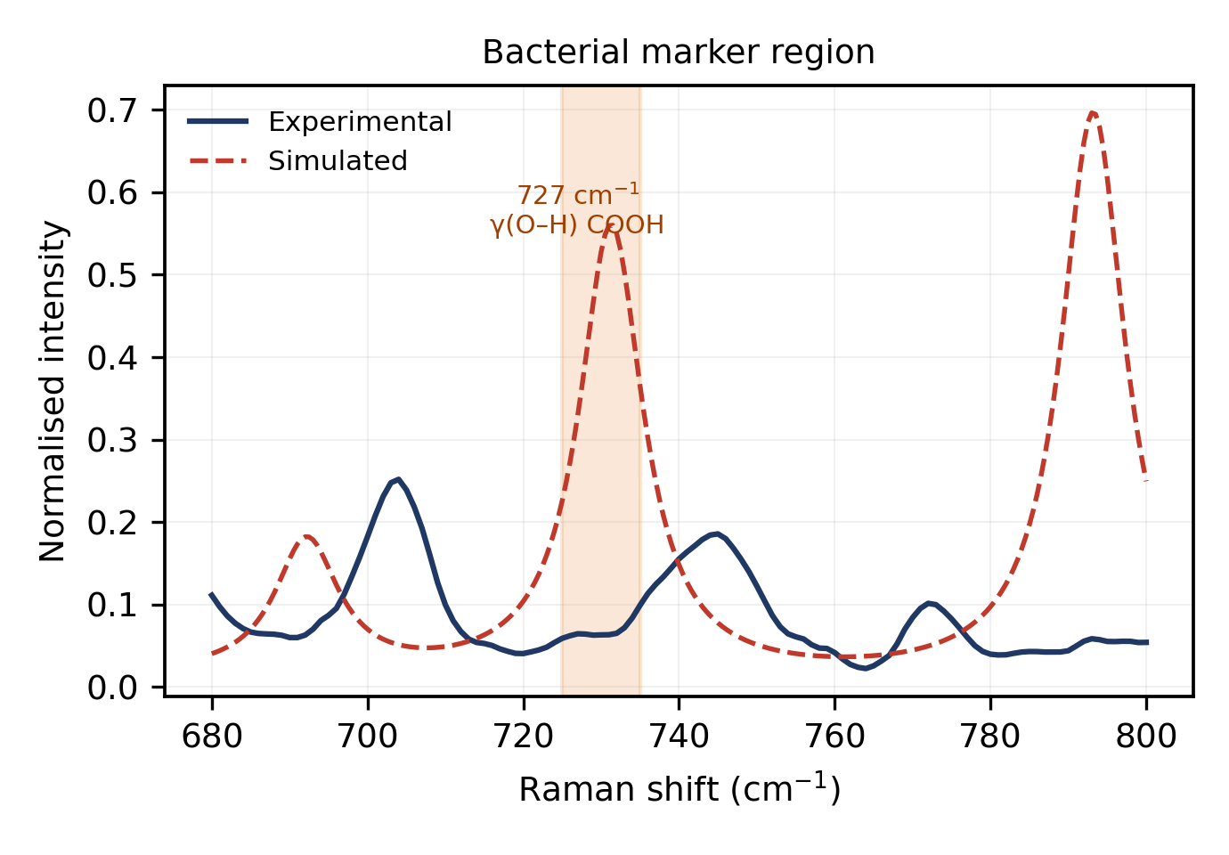
Experimental and simulated spectra in the 680–800 cm⁻¹ region. The shaded band indicates the disputed 730 cm⁻¹ bacterial marker position. The calculated mode at 731 cm⁻¹ is shown by normal-mode decomposition to be an out-of-plane carboxylic acid hydroxyl deformation.

Relevance to bacterial Raman and SERS analysis
The reference spectrum reported here supports the interpretation of bacterial measurements in three ways. First, the high-confidence band list provides positions against which candidate peptidoglycan features in whole-cell spectra can be checked. Second, the assignments identify which bands carry lactyl character and are therefore, in principle, capable of distinguishing muramic acid from N-acetylglucosamine. Third, the 730 cm⁻¹ analysis removes one candidate explanation for a widely used bacterial marker band and thereby narrows the interpretive space.
For SERS applications the present data provide the necessary non-enhanced baseline. Comparison of enhanced with non-enhanced spectra is what permits adsorption geometry to be inferred from surface selection rules, and such comparison requires a reliable reference of the kind reported here. We emphasise that the measurements described are of dry powder and that extrapolation to bacterial suspensions, and still more to clinical matrices, requires separate validation.

Conclusions
The Raman spectrum of isolated N-acetylmuramic acid has been measured under systematically optimised conditions and compared with harmonic frequencies computed at the B3LYP/6-311+G(d,p) level. Forty-one reproducible bands were identified in the 400–1800 cm⁻¹ fingerprint region, of which thirty-four were assigned to calculated normal modes with a mean absolute deviation of 9.8 cm⁻¹ and a correlation coefficient of 0.9996. Normal-mode decomposition established the pyranose ring, glycosidic, lactyl, acetamido and carboxyl contributions to the observed bands.
The calculated mode falling in the disputed 730 cm⁻¹ bacterial marker region was shown to arise from out-of-plane deformation of the carboxylic acid hydroxyl group rather than from the glycan backbone. Since this proton is absent in intact peptidoglycan, the result argues against a muramic acid origin for the bacterial 730 cm⁻¹ band.
Extension of this work to N-acetylglucosamine, to muramyl peptides and to surface-enhanced measurements on plasmonic substrates would allow the peptidoglycan contribution to bacterial Raman spectra to be characterised more completely.

Data availability
Processed Raman spectra, the complete list of calculated frequencies and Raman activities, and the optimised molecular geometry are provided as Supplementary Material. Raw spectra and Gaussian output files are available from the

Acknowledgements
The author thanks the Indian Institute of Technology Jodhpur for access to Raman spectroscopy and computational facilities. Details need to be added

Y. Wang, et al., Bacteria detection: from powerful SERS to advanced spectroscopic techniques, Biosensors 12 (2022) 210.
D. Ma, et al., Escherichia coli research on Raman measurement mechanism and diagnostic model, Vibrational Spectroscopy 132 (2024) 103670. https://doi.org/10.1016/j.vibspec.2024.103670
W. R. Premasiri, et al., The biochemical origins of the surface-enhanced Raman spectra of bacteria, Applied Spectroscopy 70 (2016) 1136–1149.
P. Kubryk, et al., The origin of the band at around 730 cm$​^{−1}$ in the SERS spectra of bacteria, Analyst 141 (2016) 3986–3994.
M. Kouach, et al., Vibrational spectra and harmonic dynamics of N-acetyl-muramic acid monohydrate, Journal of Molecular Structure 317 (1994) 153–166. TC. Y. She, et al., Laser Raman spectra of glucosamine and related amino sugars, Spectrochimica Acta Part A 30 (1974) 1387–1395.
J. Kaminský, et al., Simulation of Raman and Raman optical activity spectra of saccharides in water, Physical Chemistry Chemical Physics 22 (2020) 12345–12356.
S. Grimme, S. Ehrlich, L. Goerigk, Effect of the damping function in dispersion corrected density functional theory, Journal of Computational Chemistry 32 (2011) 1456–1465.
A. D. Becke, Density-functional thermochemistry. III. The role of exact exchange, Journal of Chemical Physics 98 (1993) 5648–5652.
C. Lee, W. Yang, R. G. Parr, Development of the Colle–Salvetti correlation-energy formula into a functional of the electron density, Physical Review B 37 (1988) 785–789.
P. H. C. Eilers, H. F. M. Boelens, Baseline correction with asymmetric least squares smoothing, Leiden University Medical Centre Report, 2005.
A. Savitzky, M. J. E. Golay, Smoothing and differentiation of data by simplified least squares procedures, Analytical Chemistry 36 (1964) 1627–1639.
W. Vollmer, D. Blanot, M. A. de Pedro, Peptidoglycan structure and architecture, FEMS Microbiology Reviews 32 (2008) 149–167.

