NAM SERS Analysis — Short Report
N-Acetylmuramic Acid on Ag/Si SERS Substrate
Data acquired 2026-07-04 | B&W Tek BWS465-785H (785 nm) | Report generated 2026-08-10

1. Dataset Identified
Seven CSV files in the namon5hf6mgagno3/ folder correspond to N-acetylmuramic acid (NAM) deposited on the same Ag-nanoparticle-on-Si SERS substrate used elsewhere in this dataset, at two concentrations encoded in the filenames:
- 0.1mgml-nam-1/2/3.csv — 0.1 mg/mL NAM, 3 spectra
- 1mgml-nam-1/2/3/4.csv — 1 mg/mL NAM, 4 spectra
All 7 files were acquired within a 12-minute window (15:44–15:56) with identical instrument settings (10 s integration × 4 accumulations, 785 nm, same detector calibration coefficients as the rest of the session), so the two groups are directly comparable. The substarte/ folder (5 files, same settings, acquired 15:22–15:29) is used as the blank Si/Ag-Si reference — no separate "raw NAM off-substrate" spectrum (e.g., powder or solution alone) exists in the uploaded data.

2. Concentration Conversion
N-acetylmuramic acid (C11H19NO8) has a molecular weight of 293.27 g/mol. Converting the stated mg/mL concentrations to molarity (mM = (mg/mL ÷ MW) × 1000):
- 0.1 mg/mL → 0.341 mM
- 1 mg/mL → 3.410 mM

3. Deposition Volume
The volume of NAM solution deposited on the SERS substrate is not recorded anywhere in the CSV metadata (Sample Notes, Batch No, Lot No, and all other descriptive fields are blank in every file). This value is not reported here rather than assumed.

4. Spectra Overlay — All NAM Replicates
Figure 1 shows all 7 individual NAM spectra (fingerprint region, 100–1800 cm⁻¹) colored by concentration. The Si substrate peak at 520 cm⁻¹ is present in all traces. A reproducible broad feature centered near 243 cm⁻¹ rises well above the noise floor in every replicate of both concentrations.
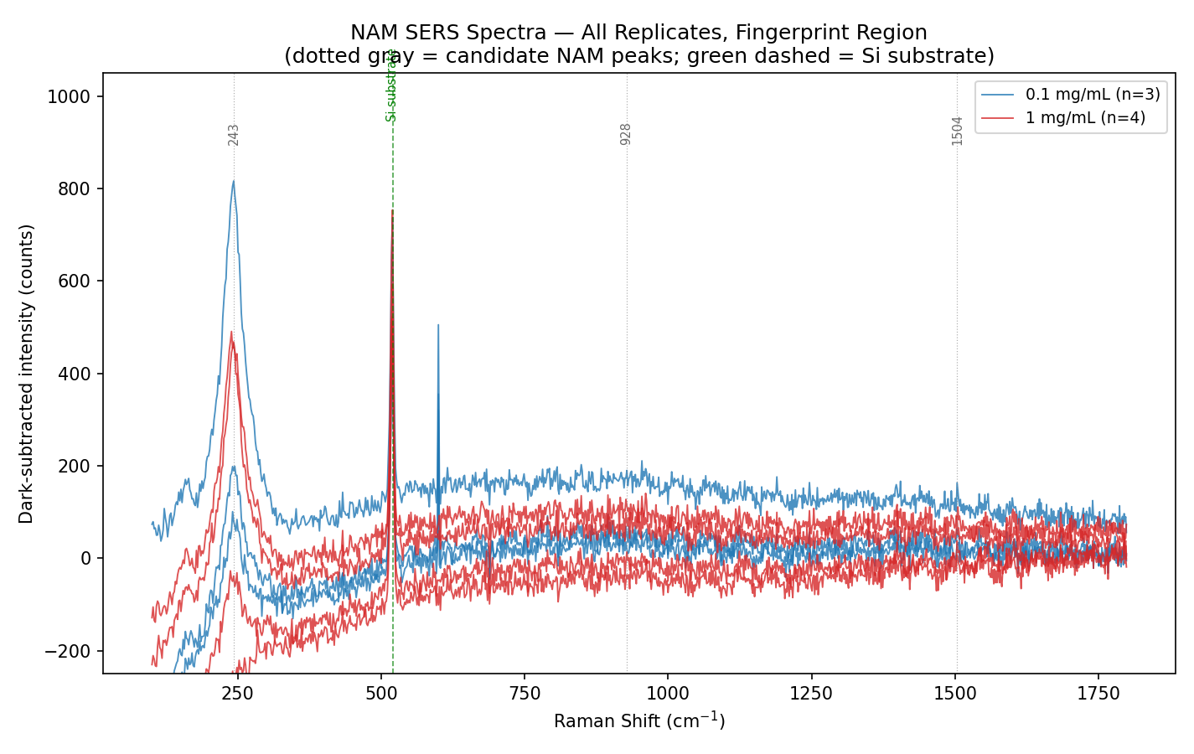
Figure 1. All 7 NAM replicate spectra, fingerprint region. Dotted lines mark the 243, 928, and 1504 cm⁻¹ candidate positions; green dashed line marks the Si substrate peak.

5. Comparison with Blank Substrate
Figure 2 overlays the average NAM spectra (0.1 and 1 mg/mL) against the average blank Si substrate spectrum. The blank shows only the 520 cm⁻¹ Si peak and a flat baseline; both NAM concentrations additionally show the ~243 cm⁻¹ feature that is absent from the blank, indicating it is associated with the NAM-covered substrate rather than the Si wafer or generic background.
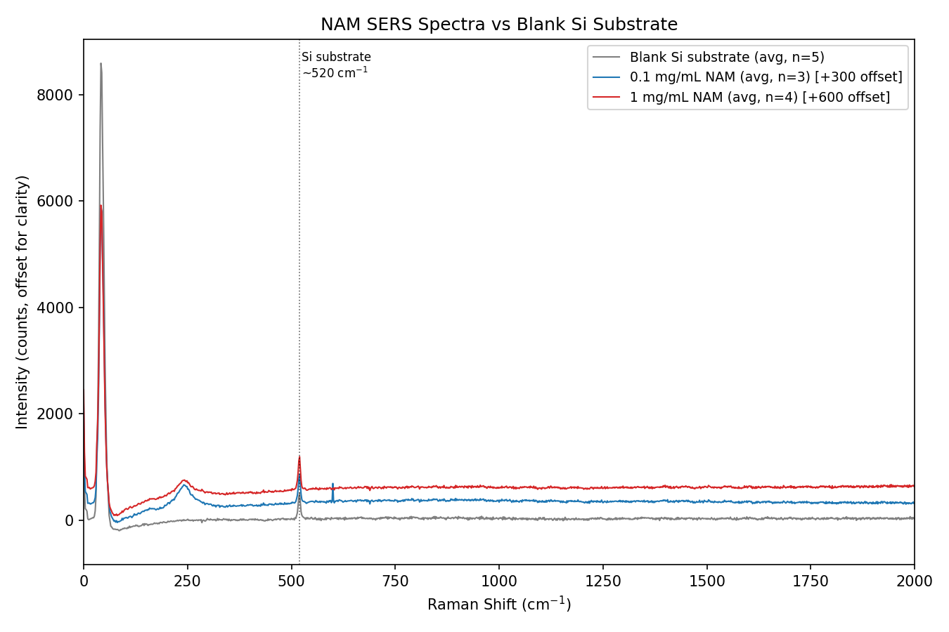
Figure 2. Average NAM spectra (0.1 and 1 mg/mL, offset for clarity) vs average blank Si substrate spectrum (n=5).

6. Peak Identification and Confidence
Peaks were identified from difference spectra (NAM average − blank average) and then checked for reproducibility and signal-to-noise ratio (SNR = peak height ÷ noise standard deviation from a flat 700–900 cm⁻¹ reference window) in every individual replicate, not just the average:
- ~243 cm⁻¹ — present in all 7/7 replicates, SNR 5.8–39 (well above a 3× noise threshold in every file). This is the only peak in the dataset that is clearly and reproducibly identifiable as NAM-substrate-associated and distinguishable from noise and from the Si peak. Tentatively consistent with a metal–analyte surface mode (e.g., Ag–O/Ag–N charge-transfer band commonly seen for molecules in direct contact with a Ag SERS surface), but no NAM-specific literature reference was found to confirm this assignment with certainty.
- ~928 cm⁻¹ and ~1504 cm⁻¹ — detected above the blank baseline in most replicates, but SNR is only ~1.1–3.0 (essentially at the noise level). These are reported as weak, tentative candidate features only, not confirmed peaks.
- ~520 cm⁻¹ — confirmed Si substrate phonon mode, not NAM-related (also dominant in the blank).
- ~600 cm⁻¹ — a sharp, narrow spike appears in this region, but it is strong and consistent only in the 0.1 mg/mL batch (SNR 19–23) and is weak/absent in the 1 mg/mL batch (SNR 1.0–2.6) despite both being NAM samples on the same substrate type. This inconsistency, combined with its narrow single-pixel width, is more consistent with a detector artifact (e.g., a hot pixel or cosmic-ray hit affecting that acquisition run) than a genuine NAM Raman band, so it is excluded from the peak list.
No specific published Raman/SERS peak table for NAM was found during this analysis; the tentative assignment above is based on generic SERS surface-mode behavior, not confirmed NAM reference spectra. Peak identity should be verified against a reference NAM Raman spectrum before being used for identification claims.

7. Peak Intensity vs. Concentration
Only the 243 cm⁻¹ peak is reliably measurable, so it is the only peak plotted against concentration (Figure 3). The mean baseline-corrected intensity is 366 ± 207 counts (n=3) at 0.1 mg/mL and 281 ± 171 counts (n=4) at 1 mg/mL. An unpaired t-test gives t=0.58, p=0.60 — the two groups are not statistically distinguishable given the sample size and within-group (replicate-to-replicate) variability, which is typical of SERS "hot-spot" heterogeneity. With only two concentration levels and this much scatter, these data do not support a calibration curve, a trend direction (increasing or decreasing with concentration), or a limit of detection.
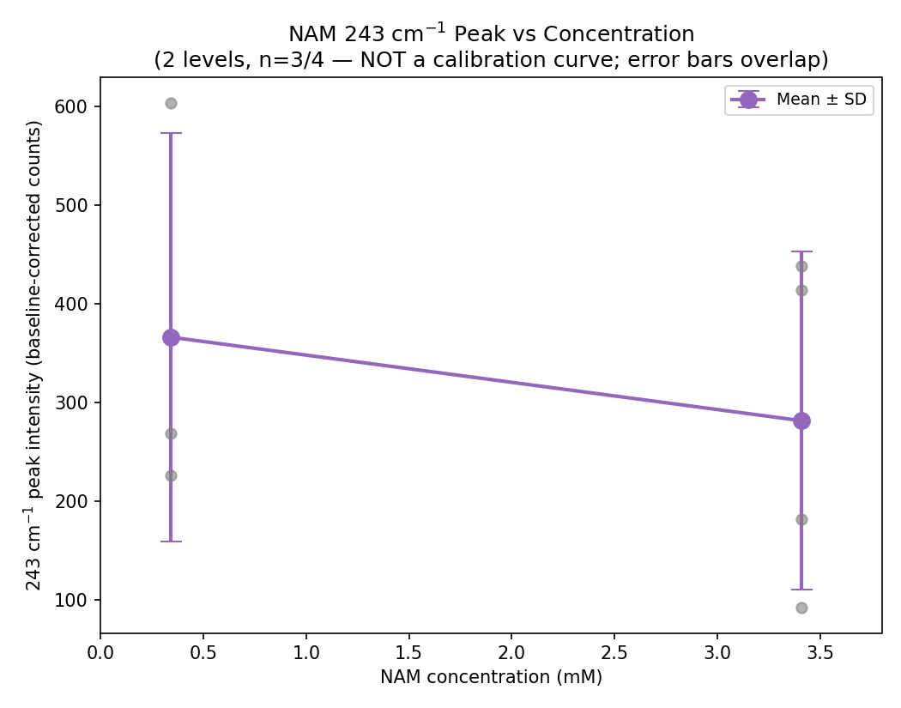
Figure 3. 243 cm⁻¹ peak intensity by concentration (mean ± SD, gray dots = individual replicates). Overlapping error bars show the two concentrations are not statistically distinguishable.

8. Summary Table
Sample | Conc. | Conc. (mM) | n spectra | Deposit vol. | Major peak(s) identified
Blank Si substrate | — | — | 5 | n/a | 520 cm⁻¹ (Si); no NAM-associated features
NAM on Ag/Si SERS substrate | 0.1 mg/mL | 0.341 | 3 | not recorded in data | ~243 cm⁻¹ (strong, reproducible); ~928, ~1504 cm⁻¹ (weak, SNR≈2, tentative)
NAM on Ag/Si SERS substrate | 1 mg/mL | 3.410 | 4 | not recorded in data | ~243 cm⁻¹ (strong, reproducible); ~928, ~1504 cm⁻¹ (weak, SNR≈2, tentative)

9. Limitations
- Only two concentration levels (0.1 and 1 mg/mL) with 3–4 replicates each — insufficient for a calibration curve, LOD estimate, selectivity assessment, or statistical significance testing beyond a basic comparison.
- No off-substrate/raw NAM reference spectrum (e.g., solid NAM or NAM in solution without the SERS substrate) is present in the uploaded data, so it cannot be confirmed whether 243 cm⁻¹ matches a NAM bulk Raman band or is purely a surface-enhancement/adsorption artifact.
- Deposition volume is not recorded, so surface density (mass or moles of NAM per unit substrate area) cannot be calculated — only bulk solution concentration is known.
- Peak intensities show large replicate-to-replicate variability (SD ~50–75% of the mean at 243 cm⁻¹), consistent with typical SERS substrate hot-spot heterogeneity rather than concentration effects.
- No literature-confirmed NAM-specific Raman/SERS peak assignments were located; the 243 cm⁻¹ assignment is tentative.

10. Recommendations for Further Measurements
- Acquire at least 5–6 concentration levels spanning a wider range (e.g., 0.01–10 mg/mL) with ≥5 replicates each to support a real calibration curve and LOD estimate.
- Include a raw/bulk NAM reference spectrum (powder or concentrated solution, no SERS substrate) to confirm which peaks are intrinsic to NAM versus surface-induced.
- Record and log the deposition volume and substrate spot for every measurement, so surface density (not just bulk concentration) can be computed and hot-spot variability can be tracked.
- Add a NAM-free Ag/Si substrate control processed identically to each NAM batch (not just one shared blank set) to rule out batch-to-batch substrate variability.
- Investigate the ~600 cm⁻¹ artifact (repeat acquisitions, check for detector hot pixels) before including it in any future peak analysis.

11. Conclusion
The available data show one reproducible, high-SNR spectral feature (~243 cm⁻¹) that appears in every NAM-treated spectrum and is absent from the blank Si/Ag-Si substrate, which is consistent with — but not definitive proof of — NAM detection on the Ag/Si SERS substrate, since no bulk/raw NAM reference spectrum was available to confirm the assignment and no NAM-specific literature match was found. Two additional weak candidate features (~928, ~1504 cm⁻¹) are present but too close to the noise floor (SNR ≈ 2) to be considered confirmed. The two tested concentrations (0.341 and 3.410 mM) do not show a statistically distinguishable difference in signal, so the dataset provides evidence of SERS-active detection at the sub-millimolar/millimolar level tested, but not a validated concentration response. A larger concentration series, replicate count, and a raw-NAM reference spectrum are needed before stronger claims (identification confidence, sensitivity, or LOD) can be made.

