Proposed Future Work Report

Development of an Ag-Coated Black-Silicon SERS Sensor with Boronic-Acid Surface Chemistry for N-Acetylmuramic Acid (NAM) Detection
Project Area: Surface-Enhanced Raman Scattering (SERS) Target Analyte: N-Acetylmuramic Acid (NAM) Substrate: Silver-coated black silicon Proposed Recognition Chemistry: 4-Mercaptophenylboronic Acid (4-MPBA) Excitation: 785 nm Raman spectroscopy Computational Support: DFT/Gaussian Raman calculations

1. Introduction
The present research is focused on the development of a silver-coated black-silicon Surface-Enhanced Raman Scattering (SERS) platform for the detection of N-acetylmuramic acid (NAM), a component of bacterial peptidoglycan.
The work completed to date has established the basic SERS platform and its Raman characterization. NAM has been investigated using conventional Raman spectroscopy, and theoretical Raman calculations have been performed using DFT/Gaussian methods. In parallel, silver-coated black-silicon substrates have been fabricated and evaluated using Rhodamine 6G (R6G) as a SERS-active reference molecule.
The R6G experiments demonstrated that the fabricated Ag/black-silicon substrate is capable of producing enhanced Raman signals. This provides an important foundation for the next stage of the project.
However, direct detection of NAM on the Ag/black-silicon substrate remains challenging because the NAM signal is comparatively weak and may not be sufficiently reproducible.
Therefore, the next stage will investigate whether surface functionalization using boronic-acid chemistry can improve the interaction and localization of NAM near the SERS-active silver surface.
The proposed sensing architecture is:
Black silicon → Ag nanostructures → 4-MPBA recognition layer → NAM → SERS detection
The purpose of this approach is not to replace the existing substrate, but to add a molecular-recognition layer to the already established SERS platform.

2. Current Status of the Project
The project has already established several important components.

Completed work
- Fabrication of black-silicon/Ag SERS substrates.
- Raman characterization of NAM.
- NAM DFT/Gaussian calculations.
- Comparison of theoretical and experimental Raman features.
- R6G SERS measurements on the fabricated substrate.
- Optimization of substrate fabrication parameters using R6G.
- Development of a Raman data-processing and validation workflow.
- Initial NAM measurements on the Ag/black-silicon substrate.
The current challenge is therefore no longer simply:
“Can the substrate produce SERS?”
The R6G experiments have already demonstrated that the substrate can produce enhanced Raman signals.
The new question is:
“How can NAM be brought into the SERS-active region of the substrate in a controlled and reproducible manner?”
This leads to the proposed surface-chemistry approach.

3. Current Problem in NAM Detection
The present sensing architecture can be represented as:
Silicon
↓
Black silicon
↓
Ag nanostructures
↓
NAM
↓
Raman measurement
The major limitation is the interaction between NAM and the Ag surface.
R6G and NAM behave very differently.
R6G is a strong Raman/SERS reporter and has well-established characteristic Raman bands. NAM is a small carbohydrate-derived molecule and does not provide the same strong SERS response under the current conditions.
Therefore, even when the substrate contains strong electromagnetic hotspots, NAM molecules may not be sufficiently concentrated or positioned within these regions.
The problem can be visualized as:
NAM
↓
↓
Ag surface
● ●
NAM may not be located
inside the strongest
SERS hotspot
The proposed solution is to introduce a thin chemical recognition layer between the Ag surface and NAM.

4. Proposed Solution
The proposed next-generation sensor will use:
Ag-coated black silicon + 4-MPBA + NAM
The conceptual structure is shown in Figure 1.
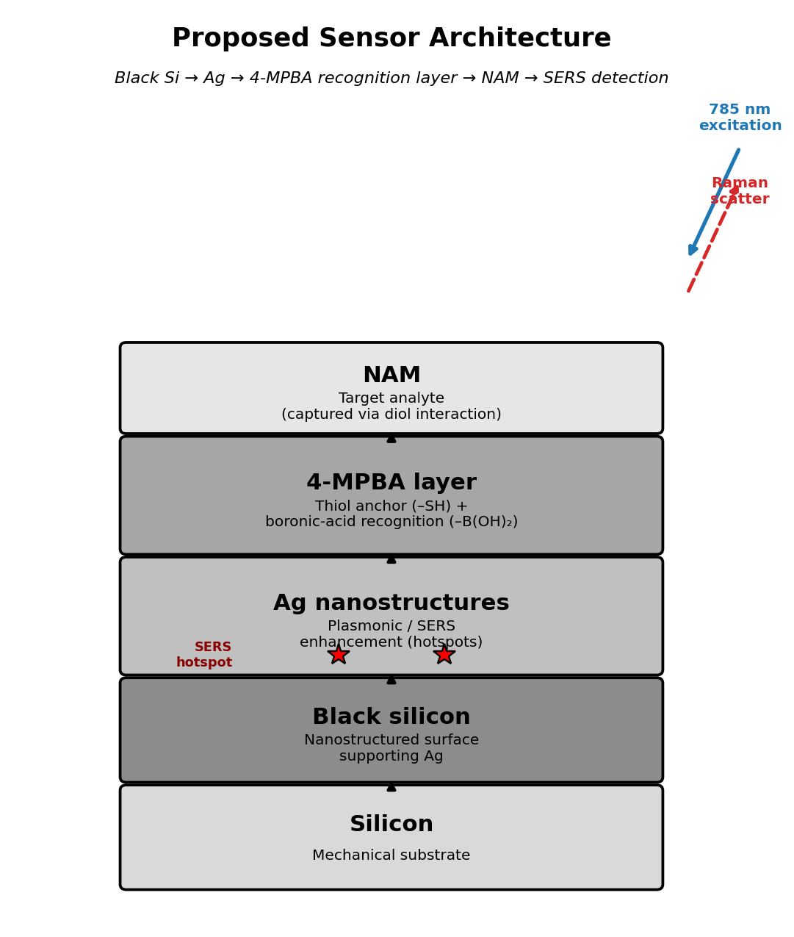
Figure 1. Proposed sensor architecture: black silicon supports Ag nanostructures, which are functionalized with a 4-MPBA recognition layer that captures NAM near the SERS-active hotspots for 785 nm Raman detection.
The proposed roles are:
Component | Proposed function
Silicon | Mechanical substrate
Black silicon | Nanostructured surface supporting Ag
Ag | Plasmonic/SERS enhancement
4-MPBA | Surface anchoring and molecular recognition
NAM | Target analyte
Raman spectroscopy | Detection
DFT/Gaussian | Molecular vibration assignment
The basic concept is:
Ag provides Raman enhancement, while 4-MPBA is intended to improve molecular capture/localization of NAM near the Ag surface.

5. Why Surface Chemistry Is Required
SERS enhancement is highly localized.
The electromagnetic field surrounding nanostructured Ag is not uniform across the entire substrate. Particularly strong enhancement occurs around nanoscale features and junctions commonly referred to as hotspots.
Therefore, simply depositing NAM on the substrate does not guarantee that a sufficient number of NAM molecules will occupy these hotspots.
The proposed recognition layer attempts to improve this situation:

Without recognition chemistry
NAM
↓
Ag surface
Low probability of NAM
being located at hotspots

With recognition chemistry
NAM
↓
4-MPBA
↓
Ag hotspot
↓
Stronger SERS response
The objective is therefore to increase the probability that NAM molecules are positioned close to the SERS-active Ag surface.

6. Why Boronic-Acid Chemistry?
Boronic acids are widely investigated for the recognition of molecules containing suitable diol/hydroxyl functionalities.
NAM contains multiple hydroxyl-containing structural features associated with its carbohydrate portion. Therefore, boronic-acid chemistry is being considered as a possible mechanism for increasing NAM interaction with the functionalized Ag surface.
The proposed interaction is:
NAM hydroxyl groups
↓
Boronic-acid group
↓
4-MPBA surface
↓
Ag surface
This provides a possible molecular bridge between the analyte and the SERS substrate.
However, it is important to emphasize that:
Boronic-acid chemistry is not inherently NAM-specific.
Other carbohydrates and amino sugars can also potentially interact with boronic-acid functionalities.
Therefore, the ability of 4-MPBA to capture and enhance NAM must be experimentally demonstrated.

7. Selection of 4-Mercaptophenylboronic Acid
The proposed recognition molecule is:

4-Mercaptophenylboronic acid (4-MPBA)
4-MPBA is attractive because it contains two chemically useful groups.

7.1 Thiol group
The molecule contains a thiol group:
–SH
This provides a strong surface-anchoring mechanism for noble-metal surfaces such as Ag.
The proposed arrangement is:
Ag
│
S
│
4-MPBA

7.2 Boronic-acid group
The opposite end contains:
–B(OH)₂
which can participate in interactions with suitable diol-containing molecules.
Therefore, 4-MPBA can potentially perform two functions simultaneously:
Ag surface anchoring + carbohydrate recognition
This dual functionality makes 4-MPBA a logical candidate for the proposed sensor.
Commercial 4-MPBA is available as CAS 237429-33-3, and the Sigma-Aldrich product information identifies it as 4-mercaptophenylboronic acid [1].

8. Literature Basis for Selecting 4-MPBA
The choice of 4-MPBA is supported by previous SERS research involving Ag/Au surfaces and carbohydrate recognition.

8.1 Li et al., 2015 — MPBA on silver nanoparticles
Li et al. investigated the SERS behaviour of 4-MPBA on assembled silver nanoparticles and its interaction with D-glucose.
The study is particularly important because it directly demonstrates:
4-MPBA + Ag + carbohydrate + SERS
The authors also demonstrated that the orientation and chemical state of surface-bound MPBA depend strongly on pH [2].
Reference: Li, S.; Zhou, Q.; Chu, W.; Zhao, W.; Zheng, J. Surface-enhanced Raman scattering behaviour of 4-mercaptophenyl boronic acid on assembled silver nanoparticles. Physical Chemistry Chemical Physics, 2015, 17, 17638–17645. DOI: 10.1039/C5CP02409A. [2]

8.2 Pham et al., 2017 — MPBA-functionalized Ag SERS substrate
Pham et al. developed a SERS substrate containing silver nanoparticles and 4-MPBA for glucose detection.
The work demonstrated the use of:
Ag nanoparticles + 4-MPBA + SERS + carbohydrate detection
This provides direct methodological precedent for investigating MPBA-functionalized Ag-based SERS platforms [3].
Reference: Pham, X.-H. et al. Glucose detection using 4-mercaptophenyl boronic acid-incorporated silver nanoparticles-embedded silica-coated graphene oxide as a SERS substrate. BioChip Journal, 2017, 11, 46–56. DOI: 10.1007/s13206-016-1107-6.

8.3 Pham et al., 2021 — Au–Ag/4-MPBA SERS
A later study investigated a 4-MPBA-functionalized Au–Ag SERS architecture for glucose detection.
The study demonstrated quantitative and selective glucose detection using a 4-MPBA-functionalized metal SERS substrate [4].
Reference: Pham et al. Glucose Detection of 4-Mercaptophenylboronic Acid-Immobilized Gold-Silver Core-Shell Assembled Silica Nanostructure by Surface Enhanced Raman Scattering. Nanomaterials, 2021, 11, 948. DOI: 10.3390/nano11040948.

8.4 Gao et al., 2021 — 4-MPBA in biological SERS sensing
Another relevant study developed a SERS system incorporating:
Graphene oxide + Ag nanoparticles + 4-MPBA
for glucose detection in cerebrospinal fluid.
The work demonstrates that MPBA-based SERS chemistry can be extended beyond simple laboratory solutions toward biological sensing environments [5].
Reference: Gao et al. Surface-Enhanced Raman Spectroscopy Detection of Cerebrospinal Fluid Glucose Based on the Optofluidic In-Fiber-Integrated Composites of Graphene Oxide, Silver Nanoparticles, and 4-Mercaptophenylboronic Acid. ACS Applied Nano Materials, 2021. DOI: 10.1021/acsanm.1c02216.

8.5 Sun et al., 2016 — 4-MPBA/Ag carbohydrate sensing
Sun et al. reported a 4-MPBA-decorated silver nanoparticle SERS sensor for glucose detection.
The study further supports the general concept of combining 4-MPBA molecular recognition with Ag-based SERS enhancement [6].
Reference: Sun, D.; Qi, G.; Xu, S.; Xu, W. Construction of highly sensitive surface-enhanced Raman scattering (SERS) nanosensor aimed for the testing of glucose in urine. RSC Advances, 2016, 6, 53800–53803. DOI: 10.1039/C6RA06223G.

9. Research Gap
Although the above literature demonstrates that 4-MPBA can be used for carbohydrate-related SERS sensing, there is an important distinction.
The literature does not establish that 4-MPBA is a NAM-specific receptor on the exact Ag-coated black-silicon substrate used in this project.
Therefore, the proposed research question is:
Can 4-MPBA functionalization improve NAM localization and SERS detection on an Ag-coated black-silicon substrate?
This represents the experimental research gap.
The project will therefore treat MPBA as a candidate recognition chemistry, rather than claiming that NAM detection using MPBA has already been established.

10. Proposed Sensor Architecture
The proposed final architecture is the same layered structure introduced in Section 4 (see Figure 1).
The functions are:
Black silicon: provides a nanostructured support. Ag: produces electromagnetic SERS enhancement. 4-MPBA: anchors to Ag and provides candidate carbohydrate recognition. NAM: target analyte. Raman: optical detection. DFT: supports molecular assignment.

11. Experimental Development Strategy
The experimental program will be divided into sequential stages.

Stage 1 — Reproduce the Optimized Ag/Black-Silicon Substrate
The first step will be to reproduce the substrate condition that performed best during the existing R6G optimization.
The 10HF–6 min condition will be used as the starting substrate condition based on the present R6G optimization dataset.
However:
This condition should be considered the starting point for NAM, not automatically the final NAM-optimized substrate.
NAM may interact differently with the substrate from R6G.

12. Stage 2 — Bare Substrate Characterization
Before adding any surface chemistry, the Ag/black-silicon substrate should be characterized.
Recommended techniques include:
- SEM
- EDS
- AFM, where available
- UV-Vis spectroscopy
- Raman/SERS blank measurements

Objectives
The characterization should determine:
- Ag distribution
- surface morphology
- nanostructure geometry
- surface roughness
- elemental composition
- approximate Ag coverage
- substrate-to-substrate variation
This is important because the existing SERS experiments establish optical performance, but morphological characterization will provide physical evidence explaining the SERS behaviour.

13. Stage 3 — Direct NAM Detection
Before introducing MPBA, direct NAM detection should be established as the baseline.
The existing NAM concentration series is:
NAM concentration
1 mg/mL
0.1 mg/mL
0.01 mg/mL
0.001 mg/mL
0.0001 mg/mL
These concentrations should initially be measured directly on the Ag/black-silicon substrate.
The objective is to determine:
What is the baseline NAM response of the existing substrate before surface functionalization?

14. Stage 4 — Establish a NAM Raman Reference
A reliable NAM reference spectrum must be established before interpreting SERS peaks.
The reference should include:

Experimental reference
NAM Raman spectrum.

Computational reference
NAM DFT/Gaussian Raman spectrum.
The workflow is:
NAM molecular structure
↓
DFT calculation
↓
Theoretical vibrational modes
↓
Experimental NAM Raman
↓
Peak assignment
↓
NAM reference spectrum
This will prevent arbitrary assignment of peaks to NAM.

15. Stage 5 — Functionalization With 4-MPBA
The next stage will introduce 4-MPBA onto the Ag surface.
The general procedure is:
Ag/black-silicon
↓
4-MPBA solution
↓
Surface incubation
↓
MPBA adsorption/self-assembly
↓
Controlled washing
↓
MPBA-functionalized Ag/black-silicon
The exact:
- MPBA concentration
- incubation time
- solvent
- pH
- washing conditions
should be optimized experimentally.
They should not simply be copied from a glucose SERS study because the substrate architecture and target molecule are different.

16. Stage 6 — Optimization of MPBA Surface Coverage
The amount of MPBA on the Ag surface is expected to be important.
Too little MPBA may result in insufficient NAM capture.
Too much MPBA may create an overly dense organic layer that can interfere with the electromagnetic interaction between the Ag surface and NAM.
The desired architecture is:
NAM
↓
thin recognition layer
↓
Ag hotspot
rather than:
NAM
↓
thick organic layer
↓
Ag
Therefore, MPBA concentration and incubation time will be treated as optimization variables.
Literature studies demonstrate that MPBA surface behaviour and molecular orientation are sensitive to experimental conditions, particularly pH [2].

17. Proposed MPBA Optimization
The initial study should use a small concentration matrix rather than assuming a single optimum.
For example:
Parameter | Initial optimization
MPBA concentration | Low → medium → high range
Incubation time | Short → intermediate → longer
pH | Multiple controlled conditions
Washing | Standardized
NAM concentration | Fixed during initial optimization
The exact concentration range should be selected according to the available MPBA stock solution and laboratory SOP.
The purpose of this first experiment is to determine:
Which MPBA condition gives a strong and reproducible MPBA SERS response without suppressing the underlying Ag substrate activity?

18. Stage 7 — Verify MPBA Functionalization
This step is essential.
Before introducing NAM, measure:

A. Bare Ag/black-silicon
Ag/black-Si

B. MPBA-functionalized substrate
Ag/black-Si + MPBA
The difference between A and B confirms that MPBA has produced a measurable surface-associated Raman/SERS response.
Only after establishing this should NAM be introduced.
This avoids ambiguity.
If the final NAM experiment fails, we can then distinguish between:
- substrate failure,
- MPBA functionalization failure,
- NAM binding failure,
- or insufficient SERS enhancement.

19. Stage 8 — NAM Binding Experiment
After successful MPBA functionalization, NAM will be introduced.
The target structure follows the same stack as Figure 1, with NAM captured at the outer MPBA layer.
The hypothesis is:
Interaction between the boronic-acid functionality of MPBA and suitable hydroxyl/diol functionality of NAM will increase NAM localization near the Ag surface and alter the Raman/SERS response of the functionalized layer.
This can potentially be measured either through:
- direct NAM-associated Raman bands, or
- changes in the SERS spectrum of the surface-bound MPBA layer.

20. Direct and Indirect Detection Strategies
Two complementary approaches should therefore be investigated.

20.1 Direct NAM SERS
Ag/black-Si
↓
NAM
↓
NAM Raman bands

Advantages
- Simple
- No additional recognition chemistry
- Direct molecular fingerprint

Limitation
NAM may produce insufficient signal.

20.2 MPBA-Assisted NAM Detection
Ag/black-Si
↓
4-MPBA
↓
NAM
↓
Change in Raman/SERS response

Advantages
- Candidate molecular enrichment
- Strong MPBA Raman reporter
- Potential improvement in sensitivity

Limitations
- MPBA itself produces Raman bands
- Other carbohydrates may interact with boronic acid
- pH-dependent chemistry
- Need for selectivity validation
Both approaches should therefore be compared experimentally.

21. Stage 9 — pH Optimization
pH is a particularly important variable in this system.
The published Ag/MPBA study demonstrated that the orientation and chemical state of surface-bound MPBA are strongly dependent on pH. The authors also observed processes that can interfere with glucose recognition at unsuitable conditions [2].
Therefore, the project should investigate pH systematically.
For each pH condition, evaluate:
- MPBA peak intensity
- MPBA peak position
- spectral background
- peak ratios
- substrate stability
- NAM response
- reproducibility
The literature pH should therefore be treated as a starting reference, not as the guaranteed optimum for NAM.

22. Stage 10 — NAM Concentration Optimization
After identifying an effective surface-functionalization condition, the NAM concentration series should be repeated.
The current concentration series is:
Concentration | Experimental purpose
1 mg/mL | High-concentration reference
0.1 mg/mL | Concentration response
0.01 mg/mL | Concentration response
0.001 mg/mL | Sensitivity
0.0001 mg/mL | Low-concentration response
The resulting data can be used to investigate:
- concentration dependence
- peak intensity
- peak-area response
- peak-position changes
- MPBA peak-ratio changes
- signal-to-background ratio
- reproducibility
The final objective will be to determine whether a calibration relationship can be established.

23. Experimental Controls
The sensing study must contain appropriate controls.
The minimum experimental matrix should include:
Sample | Ag/black-Si | 4-MPBA | NAM | Purpose
A | Y | N | N | Substrate blank
B | Y | N | Y | Direct NAM detection
C | Y | Y | N | MPBA-functionalized blank
D | Y | Y | Y | MPBA-assisted NAM detection
The most important comparison is:
B versus D
If NAM produces a weak response on bare Ag/black-silicon but a stronger and more reproducible response after MPBA functionalization, this would support the surface-capture hypothesis.

24. Selectivity Problem
A major limitation of boronic-acid recognition is that it is not automatically specific to NAM.
Other molecules containing suitable diol functionality may also interact with boronic acid.
Therefore, a positive NAM response alone will not be sufficient to demonstrate selectivity.
The future experiments should include structurally relevant controls such as:
- N-acetylglucosamine (GlcNAc)
- glucosamine
- glucose
- other relevant amino sugars
- adenine/purine-related controls where spectrally appropriate
- LPS
- LTA
This is especially important because NAM and GlcNAc are structurally related.

25. NAM Versus NAG
The NAM–NAG comparison will be particularly important.
A boronic-acid layer may recognize carbohydrate functionality in both molecules.
Therefore, NAM and NAG responses on the 4-MPBA-functionalized surface must be experimentally compared.
The objective is to determine whether:
- their Raman fingerprints are distinguishable,
- their MPBA responses differ,
- multivariate analysis can separate them,
- or an additional recognition mechanism will be required.

26. Future Development Toward Dual Recognition
If 4-MPBA successfully captures carbohydrate molecules but does not provide sufficient NAM selectivity, the next development could involve dual-recognition chemistry.
NAM contains both carbohydrate functionality and a carboxylate-containing structural region.
Therefore, a future recognition layer could potentially combine:
diol recognition + carboxylate recognition
This could provide better differentiation between NAM and structurally related sugars.
However, this should be considered a second-generation strategy.
The first experiment should establish whether simple 4-MPBA functionalization provides any measurable benefit.

27. Raman Measurement Strategy
The existing 785-nm Raman system will be used for the initial studies.
Each experimental condition should include multiple measurement locations.
The analysis should not depend on one representative spectrum. Instead, multiple spots (Spot 1, Spot 2, Spot 3, … Spot N) should be collected for every condition.
The following parameters should be evaluated:
- Raman peak position
- peak intensity
- peak area
- signal-to-background ratio
- SNR
- coefficient of variation
- spot-to-spot reproducibility
- substrate-to-substrate reproducibility
Where feasible, Raman mapping should be performed to visualize spatial uniformity.

28. NAM Peak Identification Strategy
A peak should not be assigned to NAM simply because it occurs near a literature-reported value.
Peak assignment should be supported using multiple sources of evidence:
- NAM reference Raman spectrum
- NAM DFT/Gaussian calculation
- NAM concentration response
- MPBA control
- Bare substrate control
- Structurally related analyte controls
- Reproducibility across multiple spots/substrates
The final interpretation should therefore combine experimental NAM Raman data, NAM DFT calculations, NAM SERS spectra, and the above controls to reach a reliable peak assignment.

29. DFT and Experimental Correlation
The existing NAM DFT work will be a major component of the final study.
The theoretical spectrum can be compared with:
- NAM powder Raman,
- NAM on Ag/black silicon,
- NAM on MPBA/Ag/black silicon.
The comparison can identify:
- Raman-shift agreement
- relative spectral features
- molecular vibrational assignments
- changes after adsorption
- possible interaction-induced shifts
The proposed comparison workflow is: NAM DFT calculation → theoretical vibrational modes → compared against NAM powder Raman and NAM SERS → compared against MPBA + NAM SERS.
This provides a much stronger basis for molecular identification than peak matching alone.

30. Important Caution Regarding Individual NAM Peaks
Particular peaks, especially in regions that overlap with common biological metabolites, should not automatically be assigned to NAM.
For example, bacterial SERS literature has demonstrated that spectral features around the ~730–735 cm⁻¹ region can have contributions from purine-related compounds and should therefore be interpreted carefully.
Consequently:
A single peak should never be used as the sole evidence for NAM detection.
Peak assignments should be supported by the NAM reference, DFT, concentration dependence, controls and reproducibility.

31. Proposed Complete Experimental Workflow
The complete future workflow is summarized in Figure 2.
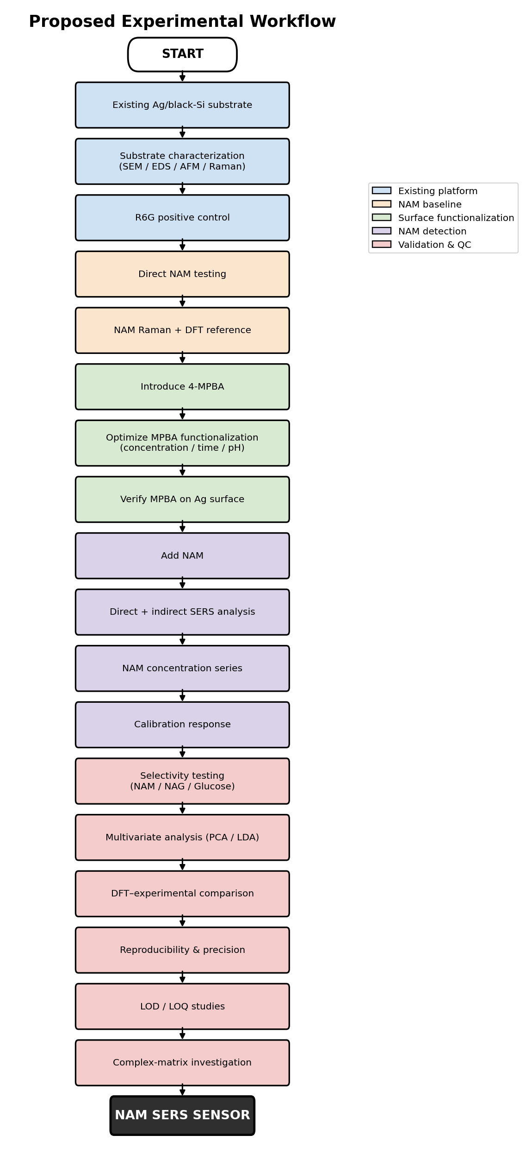
Figure 2. Proposed complete experimental workflow, from the existing Ag/black-silicon substrate through surface functionalization, NAM detection, selectivity testing, and analytical validation.

32. Data That Must Be Generated
For the final research paper, the following datasets should be generated.

A. Substrate characterization
- SEM images
- EDS elemental composition
- AFM surface morphology, if available
- UV-Vis spectra
- bare-substrate Raman/SERS

B. R6G validation
- R6G SERS spectra
- peak positions
- SNR
- reproducibility
- optimized substrate condition

C. NAM baseline
- NAM powder Raman
- NAM/Ag SERS
- NAM concentration series

D. MPBA characterization
- MPBA/Ag SERS
- MPBA peak positions
- MPBA intensity
- MPBA concentration dependence
- pH dependence

E. NAM recognition
- MPBA + NAM SERS
- concentration response
- peak shifts
- peak-area changes
- intensity changes
- MPBA peak-ratio changes

F. Selectivity
- NAM
- NAG
- glucose
- relevant amino sugars
- relevant biological interferents

G. Computational validation
- NAM DFT spectrum
- experimental Raman spectrum
- experimental SERS spectrum
- theoretical/experimental peak assignment

H. Analytical validation
- calibration curve
- linear range
- LOD
- LOQ
- repeatability
- reproducibility
- selectivity

33. Proposed Performance Metrics
The future sensor should ultimately be evaluated using quantitative metrics.

Sensitivity
Relationship between NAM concentration and measured SERS response.

Limit of Detection
Lowest NAM concentration that can be reliably distinguished from the blank.

Limit of Quantification
Lowest concentration that can be quantitatively measured with acceptable precision.

Reproducibility
Variation between different spots on the same substrate.

Repeatability
Variation between repeated measurements under the same conditions.

Selectivity
Ability to distinguish NAM from structurally similar molecules.

Stability
Ability of the functionalized substrate to maintain its SERS response over time.

34. What Would Constitute a Successful Result?
A strong positive result would show a weak/inconsistent signal for bare Ag/black-Si + NAM, but a stronger and reproducible signal for MPBA/Ag/black-Si + NAM, with the SERS response increasing systematically as NAM concentration increases. In addition, the NAM DFT calculation should agree with the experimental NAM features, and NAM should be distinguishable from the structural controls.
This would provide evidence that surface functionalization improves NAM detection.

35. Possible Experimental Outcomes

Outcome 1 — Strong improvement
If Ag/black-Si + NAM gives a weak response, but MPBA/Ag/black-Si + NAM gives a strong and reproducible response, then the surface-recognition hypothesis is supported.

Outcome 2 — Moderate improvement
If MPBA improves the signal but the response remains weak, optimization should continue with:
- MPBA surface density
- pH
- incubation time
- NAM concentration
- Ag morphology
- hotspot density
- measurement conditions

Outcome 3 — No improvement
If MPBA does not improve NAM detection, possible explanations include:
- insufficient NAM–MPBA interaction,
- unsuitable pH,
- unfavorable MPBA orientation,
- excessive organic surface coverage,
- insufficient Ag hotspot density,
- NAM remaining outside the strongest SERS regions,
- or the need for a different recognition chemistry.
This would still provide useful mechanistic information for the project.

36. Long-Term Development
If the MPBA approach demonstrates successful NAM enrichment, the project can progress toward:

Phase 1
Ag/black-silicon + 4-MPBA + NAM

Phase 2
NAM concentration calibration

Phase 3
Selectivity against NAG and other carbohydrates

Phase 4
Improved recognition chemistry

Phase 5
Complex biological matrix

Phase 6
Real-sample validation

Phase 7
Portable SERS sensing platform
The final long-term objective is to develop a reproducible SERS-based platform capable of detecting NAM as a bacterial-associated molecular biomarker.

37. Relationship Between R6G and NAM Studies
The existing R6G work forms the foundation of the NAM project.
The overall research progression moves from SERS substrate fabrication, through R6G validation and substrate optimization, to the NAM baseline, surface chemistry (the 4-MPBA layer), NAM capture, NAM SERS detection, DFT and experimental matching, selectivity testing, LOD/reproducibility studies, and finally sensor validation.
Therefore, the R6G experiments are not a separate project. They establish the SERS activity and optimization of the substrate platform required before attempting the more difficult NAM detection problem.

38. Scientific Significance
The proposed study has significance at three levels.

38.1 Materials level
Development of an Ag-coated black-silicon SERS platform.

38.2 Surface-chemistry level
Investigation of 4-MPBA as a molecular-recognition layer on the Ag surface.

38.3 Biosensing level
Evaluation of NAM as a target bacterial biomarker using SERS.
The combination:
Black silicon + Ag + 4-MPBA + NAM + Raman + DFT
provides a coherent research pathway connecting nanostructured materials, surface chemistry, molecular spectroscopy and biosensing.

39. Major Limitations and Risks
Several limitations must be recognized from the beginning.

1. MPBA is not NAM-specific
It can potentially recognize other diol-containing molecules.

2. NAM detection may remain weak
Surface capture does not guarantee sufficient SERS enhancement.

3. MPBA produces its own Raman spectrum
Therefore, MPBA and NAM signals must be separated carefully.

4. pH affects MPBA chemistry
The published literature demonstrates significant pH-dependent changes in MPBA behaviour on Ag [2].

5. Substrate morphology affects SERS
Variations in Ag distribution and black-silicon morphology can produce spot-to-spot variation.

6. Biological matrices are more complicated
Proteins and other molecules can compete for the surface and interfere with SERS.

7. DFT does not prove experimental detection
DFT supports vibrational assignment but must be combined with experimental controls and concentration-dependent evidence.

40. Immediate Experimental Plan
The recommended order of experiments is therefore:

Experiment 1 — Baseline
Ag/black-Si + NAM
Use the existing 1 mg/mL, 0.1 mg/mL, 0.01 mg/mL, 0.001 mg/mL, and 0.0001 mg/mL series.

Experiment 2 — MPBA characterization
Ag/black-Si + 4-MPBA
Determine the MPBA SERS fingerprint.

Experiment 3 — MPBA + NAM
Ag/black-Si + 4-MPBA + NAM
Determine whether NAM produces a measurable change.

Experiment 4 — Optimization
Optimize MPBA concentration, incubation time, pH, NAM incubation, and washing conditions.

Experiment 5 — Selectivity
Compare NAM, NAG, glucose, relevant amino sugars, and appropriate biological interferents.

Experiment 6 — Quantification
Develop the NAM concentration-response curve.

Experiment 7 — Computational validation
Compare NAM DFT, NAM Raman, and NAM SERS.

Experiment 8 — Reproducibility
Perform measurements across multiple spots, multiple substrates, and multiple fabrication batches.

41. Final Proposed Research Hypothesis
The central hypothesis of the future work is:
Functionalization of an Ag-coated black-silicon SERS substrate with 4-mercaptophenylboronic acid will increase the localization of N-acetylmuramic acid near the Ag SERS-active surface and thereby improve the intensity and reproducibility of NAM-associated Raman signals compared with the unfunctionalized Ag/black-silicon substrate.
A secondary hypothesis is:
The resulting NAM response can be distinguished from structurally related carbohydrate molecules using characteristic Raman features, concentration dependence, DFT-supported assignments and multivariate spectral analysis.

42. Final Conclusion
The current project has established a functional Ag-coated black-silicon SERS platform using R6G as a validation molecule and has developed an experimental and computational foundation for studying NAM.
The major remaining challenge is the weak and potentially non-reproducible SERS response of NAM.
Rather than immediately redesigning the entire substrate, the proposed future work will investigate surface chemistry as a means of improving NAM localization at the Ag SERS-active surface.
4-Mercaptophenylboronic acid has been selected as the initial recognition molecule because it combines a thiol group capable of anchoring to Ag with a boronic-acid group capable of interacting with suitable carbohydrate/diol functionalities. Published SERS studies have demonstrated MPBA-functionalized Ag/Au systems for carbohydrate detection and have also shown that MPBA behaviour is strongly dependent on experimental conditions such as pH [2].
However, the proposed research must clearly distinguish between literature-supported carbohydrate recognition and experimentally demonstrated NAM recognition. There is no basis at this stage to claim that 4-MPBA is inherently selective for NAM.
The immediate research objective is therefore to experimentally establish the response of Ag/black-Si substrates functionalized with 4-MPBA to NAM, and compare this with the corresponding unfunctionalized Ag/black-silicon substrate.
The study will subsequently evaluate concentration response, reproducibility, selectivity, DFT-supported molecular assignments and analytical performance.
If successful, the work will establish a scientifically defensible progression from R6G substrate validation, through NAM baseline detection, surface functionalization, NAM molecular capture, SERS detection, computational validation, and selectivity testing, to quantitative sensing.
This approach preserves the successful work already completed on the Ag/black-silicon substrate while addressing the central unresolved problem in NAM detection: how to efficiently and reproducibly bring NAM into the SERS-active region of the silver surface.

References
- Sigma-Aldrich. 4-Mercaptophenylboronic acid, 90%, CAS 237429-33-3. Product no. 524018. https://www.sigmaaldrich.com/US/en/product/aldrich/524018
- Li, S.; Zhou, Q.; Chu, W.; Zhao, W.; Zheng, J. Surface-enhanced Raman scattering behaviour of 4-mercaptophenyl boronic acid on assembled silver nanoparticles. Physical Chemistry Chemical Physics, 2015, 17, 17638–17645. DOI: 10.1039/C5CP02409A.
- Pham, X.-H. et al. Glucose detection using 4-mercaptophenyl boronic acid-incorporated silver nanoparticles-embedded silica-coated graphene oxide as a SERS substrate. BioChip Journal, 2017, 11, 46–56. DOI: 10.1007/s13206-016-1107-6.
- Pham, X.-H. et al. Glucose Detection of 4-Mercaptophenylboronic Acid-Immobilized Gold-Silver Core-Shell Assembled Silica Nanostructure by Surface Enhanced Raman Scattering. Nanomaterials, 2021, 11, 948. DOI: 10.3390/nano11040948.
- Gao, X. et al. Surface-Enhanced Raman Spectroscopy Detection of Cerebrospinal Fluid Glucose Based on the Optofluidic In-Fiber-Integrated Composites of Graphene Oxide, Silver Nanoparticles, and 4-Mercaptophenylboronic Acid. ACS Applied Nano Materials, 2021. DOI: 10.1021/acsanm.1c02216.
- Sun, D.; Qi, G.; Xu, S.; Xu, W. Construction of highly sensitive surface-enhanced Raman scattering (SERS) nanosensor aimed for the testing of glucose in urine. RSC Advances, 2016, 6, 53800–53803. DOI: 10.1039/C6RA06223G.

