Proposed Future Work Report

Development of an Ag-Coated Black-Silicon SERS Sensor with Boronic-Acid Surface Chemistry for N-Acetylmuramic Acid (NAM) Detection
Project Area: Surface-Enhanced Raman Scattering (SERS) Target Analyte: N-Acetylmuramic Acid (NAM) Substrate: Silver-coated black silicon Proposed Recognition Chemistry: 4-Mercaptophenylboronic Acid (4-MPBA) Excitation: 785 nm Raman spectroscopy Computational Support: DFT/Gaussian Raman calculations

1. Introduction and Current Status
The present research is focused on the development of a silver-coated black-silicon Surface-Enhanced Raman Scattering (SERS) platform for the detection of N-acetylmuramic acid (NAM), a component of bacterial peptidoglycan.
The project has already established: fabrication of black-silicon/Ag SERS substrates; Raman characterization of NAM; NAM DFT/Gaussian calculations and comparison with experimental features; R6G SERS measurements and substrate-fabrication optimization using R6G as a reference molecule; a Raman data-processing and validation workflow; and initial NAM measurements on the Ag/black-silicon substrate.
The R6G experiments demonstrated that the fabricated substrate is capable of producing enhanced Raman signals, so the question is no longer “can the substrate produce SERS?” but rather:
“How can NAM be brought into the SERS-active region of the substrate in a controlled and reproducible manner?”
Direct detection of NAM on the bare Ag/black-silicon substrate remains challenging because the NAM signal is comparatively weak and may not be sufficiently reproducible — R6G is a strong, well-characterized SERS reporter, while NAM is a small carbohydrate-derived molecule that does not provide the same strong response under the current conditions. Even where the substrate contains strong electromagnetic “hotspots,” NAM molecules may not be sufficiently concentrated or positioned within them.
The next stage will therefore investigate whether surface functionalization using boronic-acid chemistry can improve the interaction and localization of NAM near the SERS-active silver surface — adding a molecular-recognition layer to the already-established platform, not replacing it.

2. Proposed Solution and Sensor Architecture
The proposed next-generation sensor uses Ag-coated black silicon + 4-MPBA + NAM, with a thin chemical recognition layer introduced between the Ag surface and NAM to increase the probability that NAM molecules are positioned close to a hotspot (Figure 1).
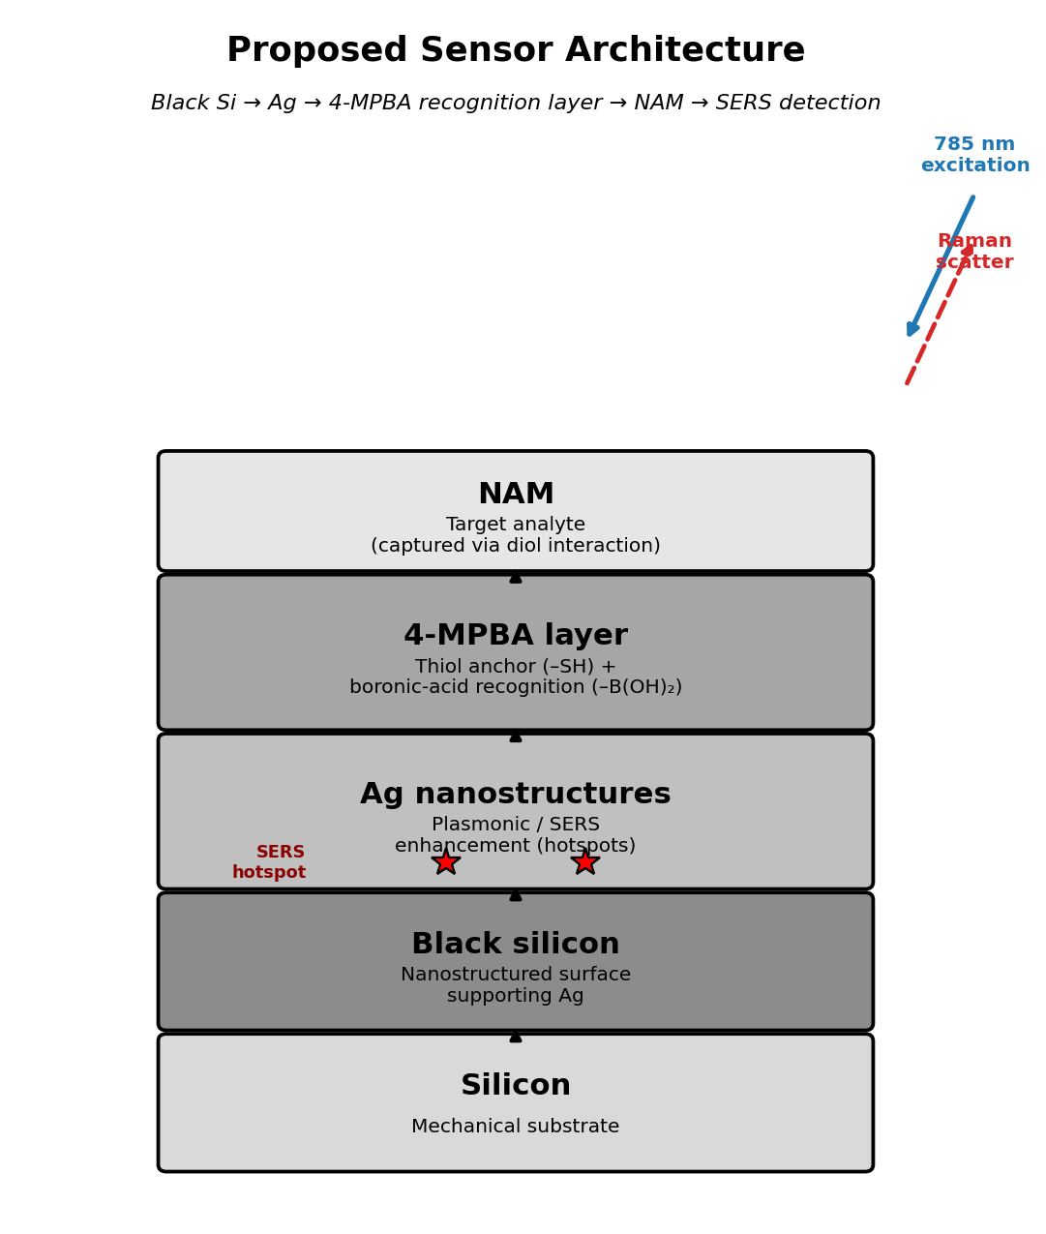
Figure 1. Proposed sensor architecture: black silicon supports Ag nanostructures, functionalized with a 4-MPBA recognition layer that captures NAM near the SERS-active hotspots for 785 nm Raman detection.
Component | Proposed function
Silicon | Mechanical substrate
Black silicon | Nanostructured surface supporting Ag
Ag | Plasmonic/SERS enhancement
4-MPBA | Surface anchoring and molecular recognition
NAM | Target analyte
Raman spectroscopy | Detection
DFT/Gaussian | Molecular vibration assignment
Ag provides Raman enhancement, while 4-MPBA is intended to improve molecular capture/localization of NAM near the Ag surface.

3. Why 4-Mercaptophenylboronic Acid (4-MPBA)
Boronic acids are widely investigated for recognition of molecules with suitable diol/hydroxyl functionalities, and NAM contains multiple hydroxyl-containing structural features in its carbohydrate portion. 4-MPBA is attractive because it combines two useful groups: a thiol (–SH), which anchors strongly to noble-metal surfaces such as Ag, and a boronic-acid group (–B(OH)₂) at the opposite end, which can interact with diol-containing molecules. Together these give 4-MPBA two simultaneous functions — Ag surface anchoring + carbohydrate recognition — making it a logical initial candidate. Commercial 4-MPBA is available as CAS 237429-33-3 [1].
It must be emphasized, however, that boronic-acid chemistry is not inherently NAM-specific: other carbohydrates and amino sugars can also interact with boronic-acid functionalities, so 4-MPBA’s ability to capture and enhance NAM specifically must be experimentally demonstrated, not assumed.

Literature basis
Study | System | Relevance
Li et al., 2015, PCCP [2] | 4-MPBA on Ag nanoparticles + D-glucose | Direct precedent: 4-MPBA + Ag + carbohydrate + SERS; shows MPBA orientation/state is strongly pH-dependent
Pham et al., 2017, BioChip Journal [3] | Ag NP + 4-MPBA + silica-coated graphene oxide | MPBA-functionalized Ag SERS substrate for glucose
Pham et al., 2021, Nanomaterials [4] | Au–Ag core-shell + 4-MPBA | Quantitative, selective glucose detection
Gao et al., 2021, ACS Appl. Nano Mater. [5] | Graphene oxide + Ag NP + 4-MPBA | Extends MPBA-SERS chemistry to a biological fluid (cerebrospinal fluid)
Sun et al., 2016, RSC Advances [6] | 4-MPBA-decorated Ag NP | MPBA/Ag carbohydrate sensing, glucose in urine
None of these studies establish 4-MPBA as a NAM-specific receptor on an Ag-coated black-silicon substrate — that is the experimental gap this project addresses. MPBA will therefore be treated as a candidate recognition chemistry, not a proven one.

4. Research Hypothesis
Primary: Functionalization of an Ag-coated black-silicon SERS substrate with 4-mercaptophenylboronic acid will increase the localization of N-acetylmuramic acid near the Ag SERS-active surface, thereby improving the intensity and reproducibility of NAM-associated Raman signals compared with the unfunctionalized substrate.
Secondary: The resulting NAM response can be distinguished from structurally related carbohydrate molecules (e.g., N-acetylglucosamine, glucose) using characteristic Raman features, concentration dependence, DFT-supported assignments, and multivariate spectral analysis.

5. Proposed Experimental Workflow
The experimental program (Figure 2) proceeds in five phases: (1) re-establishing the existing Ag/black-Si platform and characterizing it (SEM/EDS/AFM/Raman) alongside an R6G positive control; (2) establishing a NAM baseline — direct NAM testing on the bare substrate plus a combined NAM Raman + DFT reference spectrum, so peaks are never assigned from a literature value alone; (3) surface functionalization — introducing 4-MPBA, optimizing its concentration/incubation time/pH, and verifying its presence on the Ag surface before NAM is ever introduced, so substrate failure, MPBA failure, and NAM-binding failure can be told apart; (4) NAM detection — adding NAM, comparing direct NAM SERS against MPBA-assisted SERS, repeating the NAM concentration series (1 mg/mL down to 0.0001 mg/mL), and evaluating whether a calibration response emerges; and (5) validation — selectivity testing against NAG and glucose, multivariate analysis (PCA/LDA), DFT–experimental comparison, reproducibility/precision, and LOD/LOQ studies.
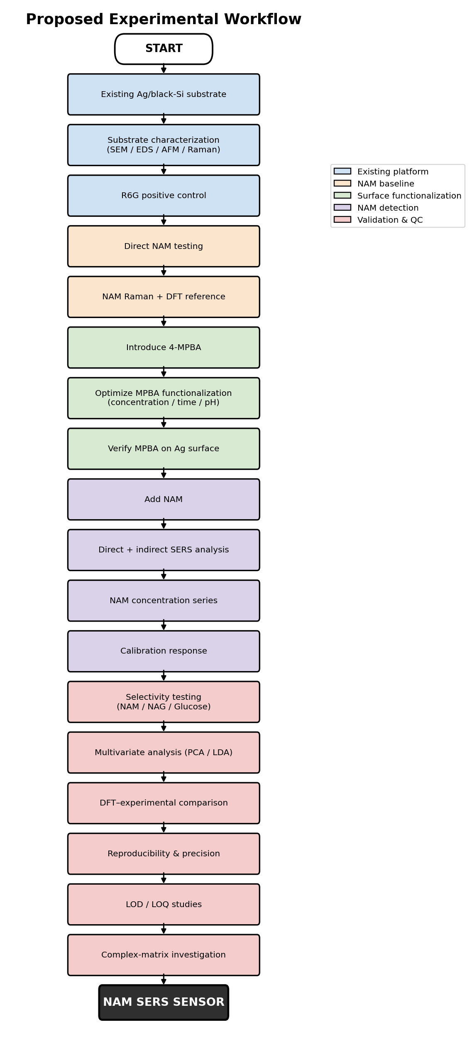
Figure 2. Proposed complete experimental workflow, from the existing Ag/black-silicon substrate through surface functionalization, NAM detection, selectivity testing, and analytical validation.
The essential control matrix for isolating the effect of MPBA is:
Sample | Ag/black-Si | 4-MPBA | NAM | Purpose
A | Y | N | N | Substrate blank
B | Y | N | Y | Direct NAM detection
C | Y | Y | N | MPBA-functionalized blank
D | Y | Y | Y | MPBA-assisted NAM detection
The key comparison is B vs. D: if NAM gives a weak response on bare Ag/black-Si but a stronger, more reproducible response after MPBA functionalization, the surface-capture hypothesis is supported. Because NAM and N-acetylglucosamine (NAG) are structurally related, NAM-vs-NAG selectivity must be tested explicitly rather than assumed from a positive NAM signal alone.

6. Expected Outcomes and Peak-Assignment Discipline
A strong positive result would show a weak/inconsistent signal for bare Ag/black-Si + NAM but a stronger, reproducible, concentration-dependent signal for MPBA/Ag/black-Si + NAM, with the NAM DFT calculation agreeing with the experimental features and NAM distinguishable from NAG/glucose controls. A moderate result (some improvement, still weak) would point to further optimization of MPBA density, pH, incubation time, or Ag hotspot density. No improvement would still be informative, pointing to insufficient NAM–MPBA interaction, unfavorable orientation, or the need for a different recognition chemistry.
In all cases, no single peak will be used as sole evidence of NAM detection — peak assignment will require agreement between the NAM DFT calculation, the NAM Raman/SERS reference, concentration dependence, the MPBA and bare-substrate controls, and reproducibility across spots and substrates.

7. Limitations
- 4-MPBA is not NAM-specific — it may recognize other diol-containing molecules, so selectivity must be demonstrated, not assumed.
- NAM detection may remain weak even with surface capture, since capture does not guarantee sufficient SERS enhancement.
- MPBA has its own Raman spectrum, so MPBA and NAM signals must be carefully separated.
- pH strongly affects MPBA chemistry — published data show pH-dependent changes in MPBA orientation/state on Ag [2].
- Substrate morphology affects SERS — variation in Ag distribution and black-silicon morphology can cause spot-to-spot variability.
- DFT does not prove experimental detection — it supports vibrational assignment but must be combined with experimental controls and concentration-dependent evidence.

8. Conclusion
The current project has established a functional Ag-coated black-silicon SERS platform, validated with R6G, and has developed an experimental and computational foundation for studying NAM. The major remaining challenge is the weak and potentially non-reproducible SERS response of NAM on the bare substrate.
Rather than redesigning the substrate, the proposed future work investigates surface chemistry as a means of improving NAM localization at the Ag SERS-active surface, using 4-mercaptophenylboronic acid as the initial recognition molecule for the reasons given in Section 3. The research must clearly distinguish between literature-supported carbohydrate recognition and experimentally demonstrated NAM recognition — there is no basis at this stage to claim 4-MPBA is inherently selective for NAM.
The immediate objective is to experimentally establish the response of 4-MPBA-functionalized Ag/black-Si substrates to NAM and compare it with the unfunctionalized substrate (Sample B vs. D), then evaluate concentration response, reproducibility, selectivity, and DFT-supported molecular assignments. This preserves the substrate work already completed while addressing the central unresolved problem in NAM detection: how to efficiently and reproducibly bring NAM into the SERS-active region of the silver surface.

References
- Sigma-Aldrich. 4-Mercaptophenylboronic acid, 90%, CAS 237429-33-3. Product no. 524018. https://www.sigmaaldrich.com/US/en/product/aldrich/524018
- Li, S.; Zhou, Q.; Chu, W.; Zhao, W.; Zheng, J. Surface-enhanced Raman scattering behaviour of 4-mercaptophenyl boronic acid on assembled silver nanoparticles. Physical Chemistry Chemical Physics, 2015, 17, 17638–17645. DOI: 10.1039/C5CP02409A.
- Pham, X.-H. et al. Glucose detection using 4-mercaptophenyl boronic acid-incorporated silver nanoparticles-embedded silica-coated graphene oxide as a SERS substrate. BioChip Journal, 2017, 11, 46–56. DOI: 10.1007/s13206-016-1107-6.
- Pham, X.-H. et al. Glucose Detection of 4-Mercaptophenylboronic Acid-Immobilized Gold-Silver Core-Shell Assembled Silica Nanostructure by Surface Enhanced Raman Scattering. Nanomaterials, 2021, 11, 948. DOI: 10.3390/nano11040948.
- Gao, X. et al. Surface-Enhanced Raman Spectroscopy Detection of Cerebrospinal Fluid Glucose Based on the Optofluidic In-Fiber-Integrated Composites of Graphene Oxide, Silver Nanoparticles, and 4-Mercaptophenylboronic Acid. ACS Applied Nano Materials, 2021. DOI: 10.1021/acsanm.1c02216.
- Sun, D.; Qi, G.; Xu, S.; Xu, W. Construction of highly sensitive surface-enhanced Raman scattering (SERS) nanosensor aimed for the testing of glucose in urine. RSC Advances, 2016, 6, 53800–53803. DOI: 10.1039/C6RA06223G.

