SERS Raman Data Analysis Report
R6G Sensor Development — Silver Nanoparticle SERS Substrate
Data acquired 2026-07-04 | B&W Tek BWS465-785H Raman spectrometer (785 nm) | Report generated 2026-08-10

1. Overview
The selected folder contains 78 Raman spectroscopy CSV files (16 MB total) collected in a single session on 2026-07-04 with a B&W Tek BWS465-785H portable Raman spectrometer (785 nm excitation, 2048-pixel detector, Raman shift range − 46 to 2842 cm⁻¹). The files document development of a surface-enhanced Raman scattering (SERS) sensor: silver nanoparticles are synthesized on a substrate via nicotinamide (NAM) reduction of AgNO3, and rhodamine 6G (R6G) is used as the test analyte to characterize sensitivity across a six-decade concentration range (1 nM to 1 mM).
Every file shares the same BWRam4.15_8 export format: an instrument metadata header (~70 fields) followed by a per-pixel table (Pixel, Wavelength, Wavenumber, Raman Shift, Dark, Reference, Raw data, Dark Subtracted, plus derived columns). All analysis below uses the Dark Subtracted trace.
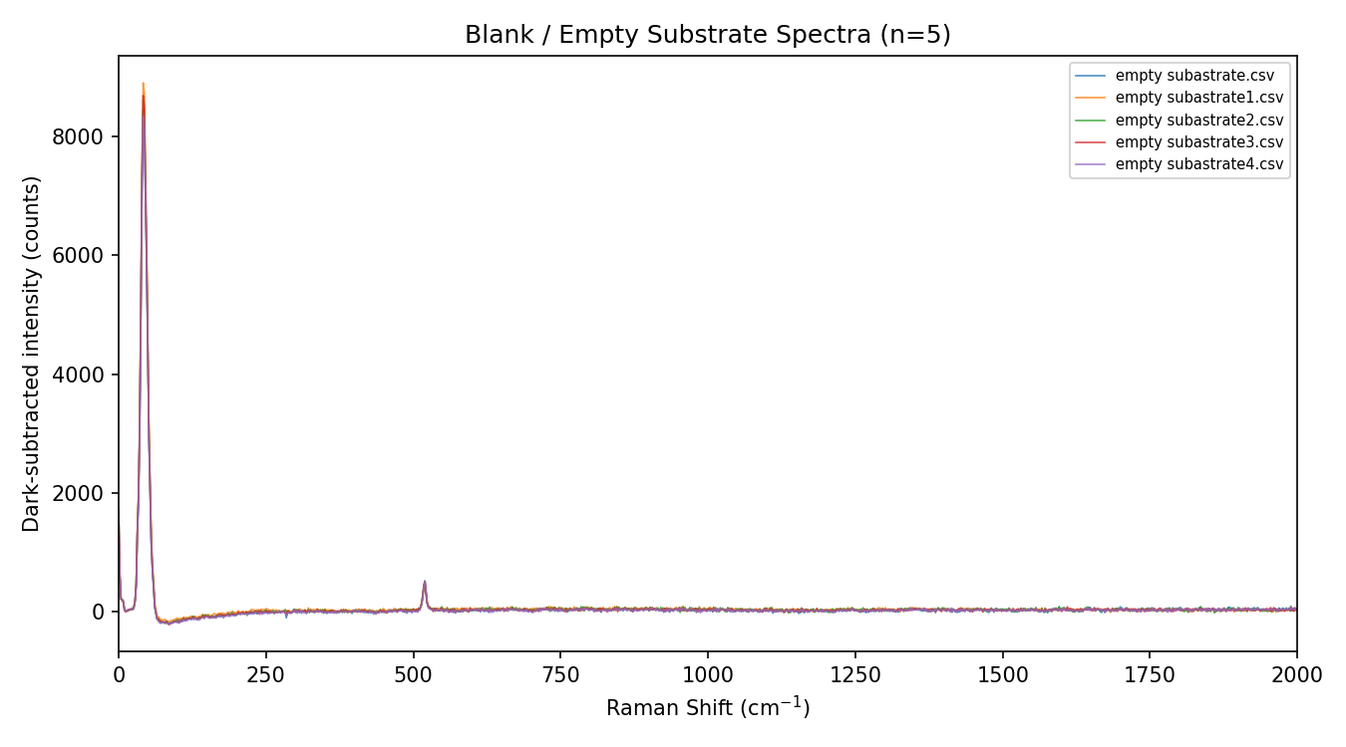
Figure 1. Five blank Si-substrate spectra overlaid, showing the reproducible 520 cm⁻¹ silicon peak and flat baseline.

2. Folder-by-Folder Summary
Folder | Files | Description | Integration
substarte/ | 5 | Blank Si substrate, no analyte, no NP coating | 10 s x4 acc
namon5hf6mgagno3/ | 7 | Ag nanoparticle synthesis test: nicotinamide (NAM) reduction of AgNO3 at 0.1 and 1 mg/mL NAM | 10 s x4 acc
r6g/ | 6 | Early R6G-on-substrate trials (6 single spots) | 10 s x4 acc
r6g-sensor/ | 17 | R6G concentration series: 1 nM – 1 mM, replicate spectra per level | 10 s x4 acc
rawr6g/ | 39 | Sequential single-spot acquisitions on one R6G sample while sweeping accumulation count (1–15) and integration time | 1–15 s, 1–15 acc
SP_13–SP_16.csv (root) | 4 | Earliest measurements of the session (10:58–11:09 AM), likely preliminary/setup scans | 20 s x2 acc

3. Key Findings

3.1 Blank substrate is clean and reproducible
The five blank substrate scans overlay almost perfectly (see Figure 1 above), with a flat near-zero baseline and a single sharp peak at ~520 cm⁻¹. This is the characteristic first-order phonon mode of crystalline silicon, confirming the measurements were taken on a Si wafer substrate. Low run-to-run variability in the blanks indicates good instrument stability and a suitable reference for background subtraction.

3.2 R6G is clearly detected down to 1 nM, with a non-monotonic concentration response
Average spectra for each of the six R6G concentration levels (1 nM – 1 mM) show the diagnostic R6G SERS bands — in-plane ring modes near 612 and 774 cm⁻¹, C–C stretching modes at 1310, 1360, and 1509 cm⁻¹, and the ring-stretch mode near 1650 cm⁻¹ — superimposed on the silicon 520 cm⁻¹ substrate line.
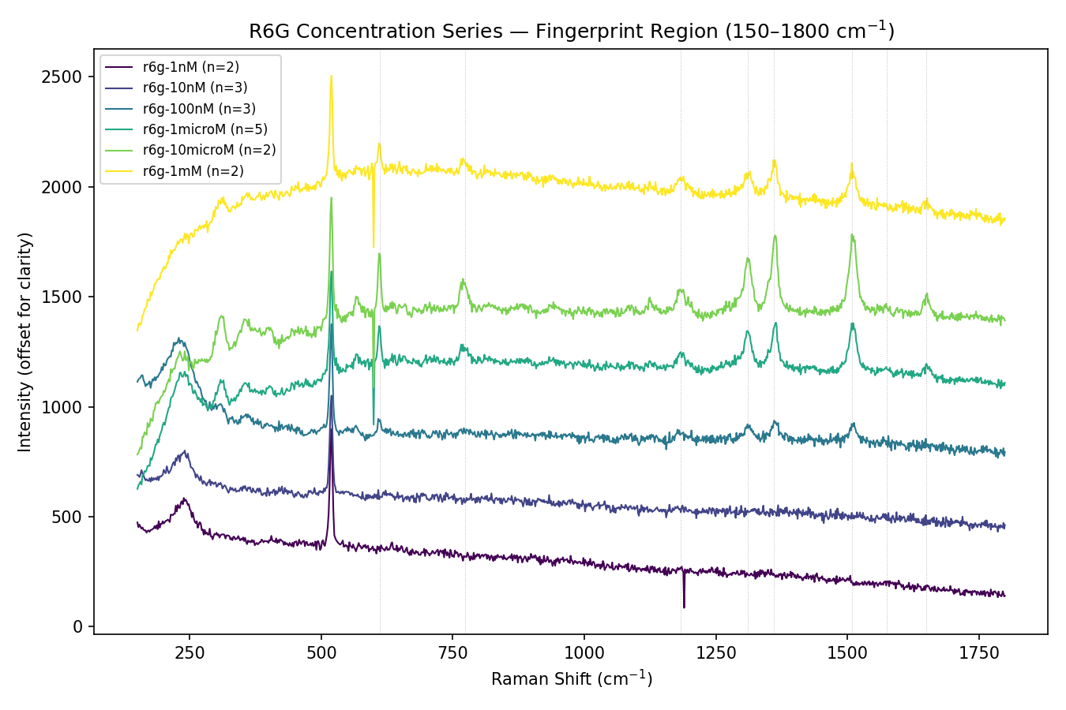
Figure 2. Average R6G spectra by concentration, fingerprint region (traces offset for clarity). Dotted lines mark reference R6G SERS peak positions.
Baseline-corrected peak heights (table below, Figure 3) increase monotonically from 1 nM through 10 µM, then drop at 1 mM. This is a well-documented SERS behavior: at high analyte concentration, molecules can form multilayers or aggregates on the enhancing surface, so molecules beyond the first layer sit outside the ~1–10 nm electromagnetic “hot-zone” and no longer contribute proportionally to signal, while self-quenching/reabsorption can further reduce yield. Practically, this indicates 10 µM is close to the substrate's optimal working concentration for this NP batch, and the usable dynamic range for a monotonic calibration curve is roughly 1 nM – 10 µM (4 orders of magnitude).
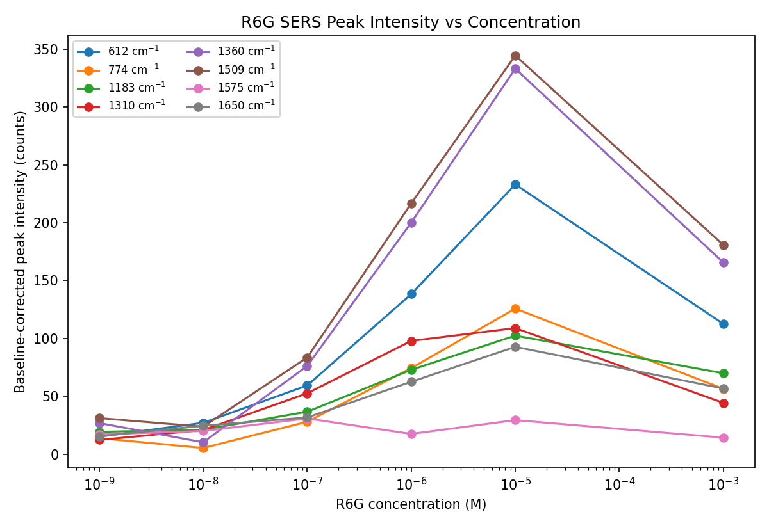
Figure 3. Baseline-corrected intensity of eight R6G marker peaks vs. concentration (log x-axis).

3.2.1 Peak intensity data (baseline-corrected counts)
Sample | Conc. (M) | n | 612 | 774 | 1183 | 1310 | 1360 | 1509 | 1575 | 1650
r6g-1nM | 1e-9 | 2 | 15 | 14 | 19 | 12 | 27 | 31 | 17 | 16
r6g-10nM | 1e-8 | 3 | 27 | 5 | 21 | 21 | 10 | 24 | 20 | 25
r6g-100nM | 1e-7 | 3 | 59 | 28 | 37 | 53 | 76 | 84 | 31 | 32
r6g-1microM | 1e-6 | 5 | 138 | 74 | 73 | 98 | 200 | 217 | 18 | 63
r6g-10microM | 1e-5 | 2 | 233 | 126 | 103 | 109 | 333 | 345 | 30 | 93
r6g-1mM | 1e-3 | 2 | 113 | 57 | 70 | 44 | 166 | 181 | 14 | 57

3.3 Lower NAM concentration gives a stronger nanoparticle SERS signature
Comparing the two NAM/AgNO3 substrate-synthesis conditions, the 0.1 mg/mL NAM batch shows a distinctly stronger, broader feature around 230–250 cm⁻¹ than the 1 mg/mL batch (Figure 4). This low-wavenumber region is where Ag–ligand / Ag–N stretching modes typically appear for molecules bound to freshly formed silver nanoparticle surfaces, so its greater intensity at the lower NAM concentration suggests more/better-exposed nanoparticle surface sites — i.e., 0.1 mg/mL NAM may be the more effective reducing-agent concentration for this substrate recipe. Both conditions still show the underlying 520 cm⁻¹ Si peak, confirming both were measured on the same substrate type.
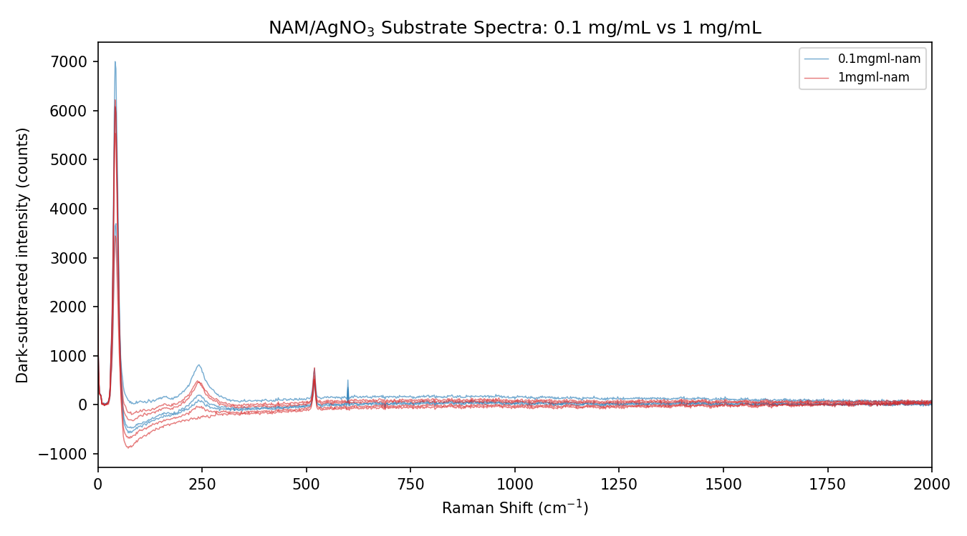
Figure 4. NAM/AgNO3 substrate spectra, 0.1 mg/mL (blue) vs 1 mg/mL (red).

3.4 rawr6g/ is a parameter-sweep, not a clean replicate set
The 39 rawr6g files were captured back-to-back over about 15 minutes (20:02–20:17) on what appears to be a single R6G spot, while the operator swept accumulation count (“average number”) from 1 up to 15 and integration time from 1 to 15 s. Max peak intensity jumps in discrete steps rather than drifting smoothly (Figure 5), which lines up with parameter changes rather than sample or laser instability, though a genuine spot-to-spot or photobleaching effect cannot be ruled out without the full parameter log. This set is best read as an acquisition-settings optimization run rather than a concentration or time-series dataset, and its intensities should not be directly compared to r6g-sensor/ without normalizing for accumulation count and integration time.
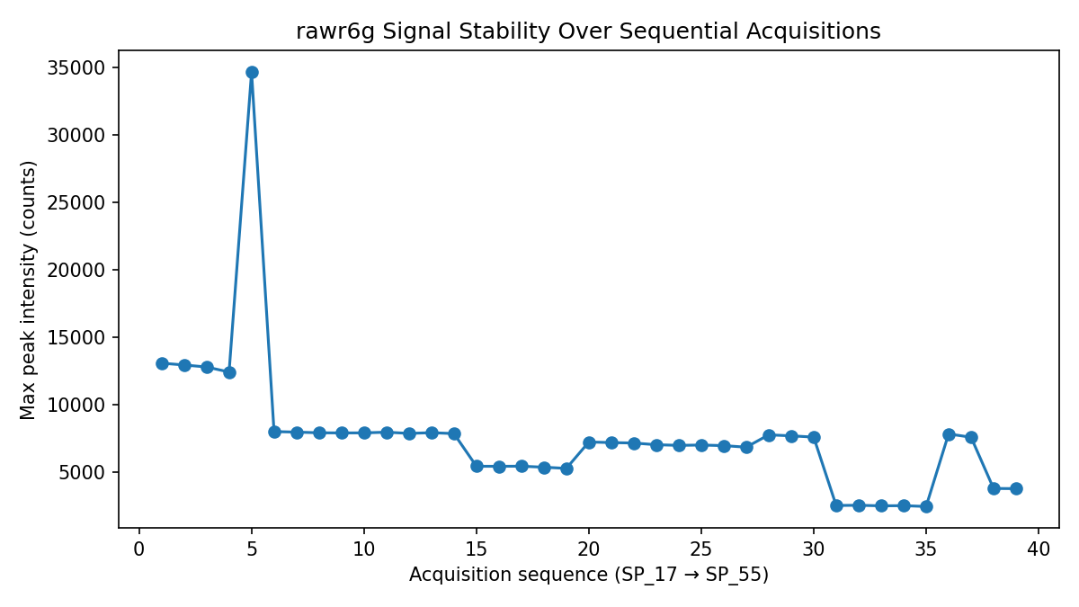
Figure 5. Max peak intensity across the 39 sequential rawr6g acquisitions, showing step changes consistent with parameter sweeps.

4. Recommendations
- Use the r6g-sensor/ series (1 nM–10 µM) as the calibration set for any LOD/sensitivity claims — it is the only concentration series with a monotonic, physically interpretable trend.
- Flag 1 mM as outside the linear/monotonic range; if higher-concentration data is needed, consider diluting or reporting it separately with an aggregation/multilayer caveat.
- For substrate fabrication, prioritize repeating the 0.1 mg/mL NAM condition with more replicates — it shows the stronger Ag-related SERS feature versus 1 mg/mL, but currently only 3 vs 4 files support the comparison.
- Re-run or clearly relabel rawr6g/ with the accumulation/integration parameter for each file so it can be used quantitatively; as named, file order is the only clue to acquisition settings.
- Increase replicate counts for the thinner groups (1 nM n=2, 10 µM n=2, 1 mM n=2) to strengthen the calibration curve's statistical confidence.

5. Files Produced
Supporting analysis outputs (peak intensity table, summary JSON, and all figures) accompany this report. Raw parsing used the Dark Subtracted column from each CSV; peak heights are local maxima within ±8 cm⁻¹ of literature R6G band positions, minus a local median baseline from ±(40–48) cm⁻¹ flanking windows.

