SERS Substrate Development and Preliminary
N-Acetylmuramic Acid Detection
Research Progress Report
Project: Development of Ag/Si SERS substrate for molecular detection | Instrument: B&W Tek BWS465-785H | Laser: 785 nm
Data acquisition: 4 July 2026 | Analysis/report date: 10 August 2026

1. Objective
The objective of the present work was to develop and evaluate a silver nanoparticle-coated silicon (Ag/Si) SERS substrate and subsequently investigate its ability to detect N-acetylmuramic acid (NAM).
The experimental work was divided into two major stages:
- Rhodamine 6G (R6G) detection to verify the SERS activity and sensitivity of the fabricated substrate.
- N-acetylmuramic acid (NAM) detection as the target application of the developed SERS substrate.
R6G was selected as a standard SERS analyte because its Raman/SERS bands are well established and allow evaluation of substrate performance before moving to the target biomarker.

2. SERS Substrate Development
The substrate used in this work consisted of a silicon substrate with silver nanoparticles deposited on the surface. Ag nanoparticles were formed by reduction of AgNO₃ (the silver precursor) on the silicon surface; the resulting Ag/Si construct is referred to throughout this report as the Ag/Si SERS substrate.
In this report, N-acetylmuramic acid (NAM) refers exclusively to the target analyte used for detection testing (Sections 11–17) and is not part of the Ag nanoparticle-formation chemistry. The exact reducing conditions used for AgNO₃ are not fully documented in the analyzed Raman metadata and should be confirmed against the original fabrication notes/lab records before this section is finalized.
Blank silicon substrate measurements (Section 4) were acquired as a reference prior to any analyte deposition.

3. Raman Instrumentation
All measurements were performed using a B&W Tek BWS465-785H Raman spectrometer. Experimental parameters:
Parameter | Value
Laser wavelength | 785 nm
Detector | 2048 pixel
Raman range | Approximately −46 to 2842 cm⁻¹
Typical integration | 10 s
Accumulations | 4
Substrate | Silicon / Ag nanoparticle-coated silicon

The exported CSV files contained the instrument metadata and Raman spectral data. The Dark Subtracted signal was used for the main spectral analysis.

4. Stage I — Blank Silicon Substrate Characterization
Before testing the SERS substrate with an analyte, blank silicon substrate spectra were recorded.

Measurements
5 blank substrate spectra were obtained. The spectra showed a strong and reproducible peak around 520 cm⁻¹, corresponding to the characteristic first-order Raman phonon mode of crystalline silicon.
The blank spectra showed: a reproducible 520 cm⁻¹ peak, a relatively flat baseline, low variation between measurements, and no significant analyte-related peaks. This established the silicon substrate as a reference for subsequent SERS measurements.
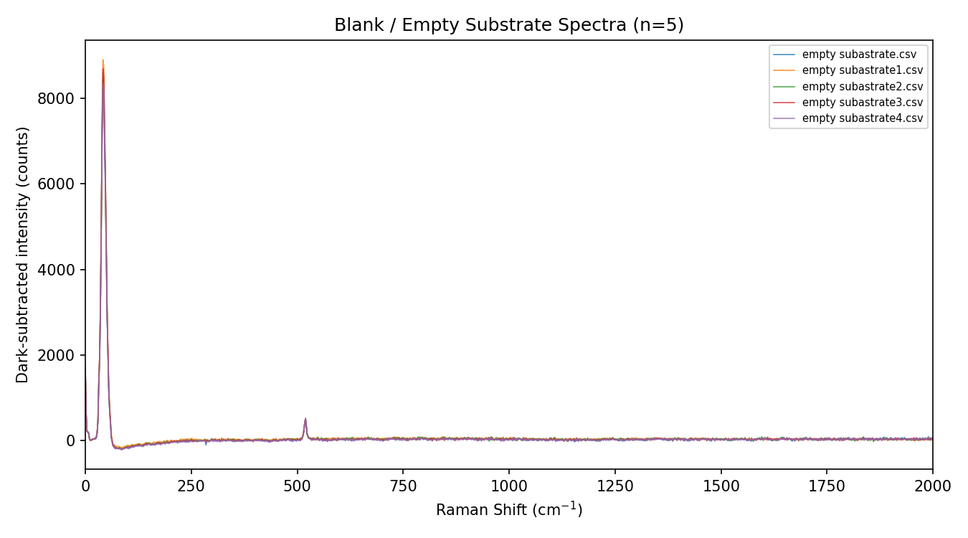
Figure 1. Five blank Si-substrate spectra overlaid, showing the reproducible 520 cm⁻¹ peak and flat baseline.

5. Note on an Earlier Mislabeled Comparison
An earlier draft of this report included a “Stage II” comparison describing two NAM concentrations (0.1 and 1 mg/mL) as if they were reducing-agent conditions tested during Ag nanoparticle synthesis. That framing was incorrect: the 0.1 and 1 mg/mL measurements are NAM analyte spectra collected on the completed Ag/Si substrate, not a nanoparticle-synthesis parameter sweep. This is the same dataset analyzed as the primary NAM detection result in Sections 11–17, including the ~243 cm⁻¹ feature discussed there. It is not repeated here to avoid double-counting the same seven spectra as two separate experiments.
The substrate-fabrication parameters that were genuinely varied during this project (e.g., HF-etch time and AgNO₃ treatment used to optimize the R6G response) are summarized qualitatively in Section 20 and should be documented with exact reagent concentrations, etch times, and volumes in the next revision.

6. Stage III — R6G SERS Validation
After substrate preparation, Rhodamine 6G (R6G) was used as the standard SERS analyte. The purpose was to determine whether the Ag/Si substrate could generate an enhanced Raman response and to investigate its concentration-dependent sensitivity.
The R6G experiment included concentrations ranging from 1 nM to 1 mM. The main concentration series analyzed was:
R6G concentration
1 nM
10 nM
100 nM
1 µM
10 µM
1 mM

7. R6G Raman/SERS Results
Characteristic R6G Raman/SERS bands were observed. Important bands included approximately: 612, 774, 1183, 1310, 1360, 1509, 1575, and 1650 cm⁻¹. The silicon substrate peak around 520 cm⁻¹ was also visible.
The R6G spectra demonstrated that the Ag/Si substrate was capable of producing a measurable SERS response.
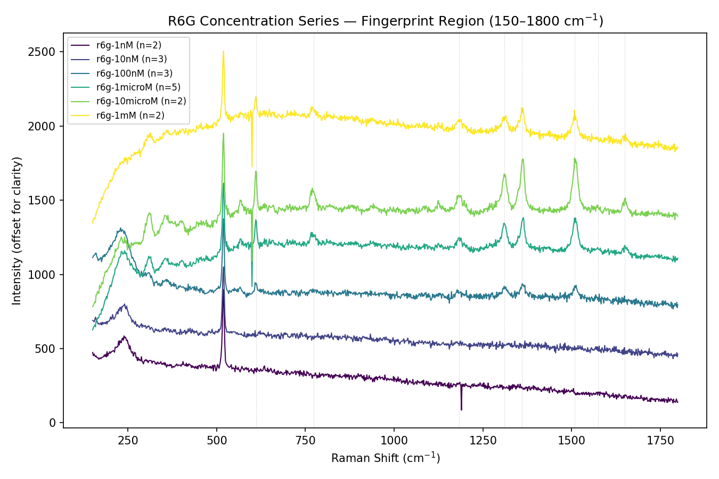
Figure 2. Average R6G spectra by concentration, fingerprint region (traces offset for clarity).

8. R6G Concentration Response
The baseline-corrected R6G peak intensities generally increased from 1 nM → 10 nM → 100 nM → 1 µM → 10 µM. The strongest response was observed around 10 µM. At 1 mM, the signal decreased compared with 10 µM, indicating that the response was not simply proportional to concentration over the entire tested range.
Possible explanations include: multilayer formation, molecular aggregation, saturation of active surface sites, molecules outside the strongest electromagnetic hot spots, and fluorescence/self-absorption effects. Therefore, the most useful monotonic concentration range in the current dataset was approximately 1 nM – 10 µM.
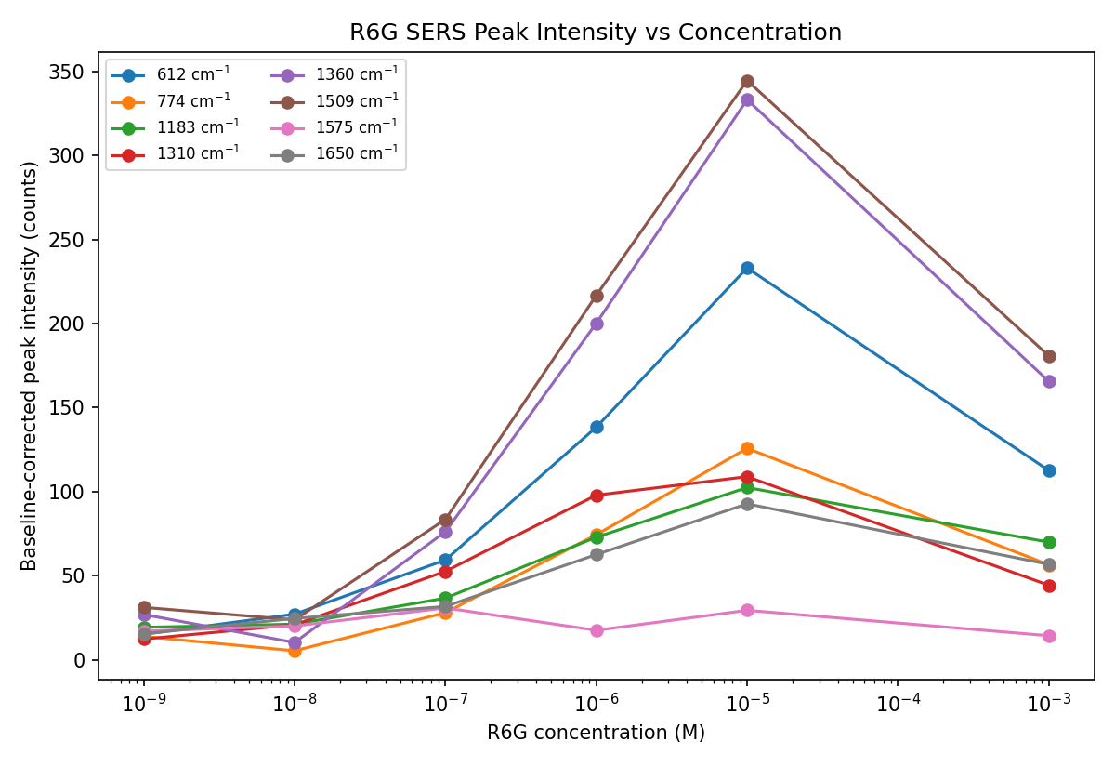
Figure 3. Baseline-corrected intensity of eight R6G marker peaks vs. concentration (log x-axis).

9. R6G Detection Limit — Current Status
R6G Raman/SERS features were experimentally observed down to 1 nM. However, this should not yet be reported as the formal LOD.
The current data demonstrate experimental detection of R6G down to 1 nM under the present measurement conditions. A formal LOD requires statistical analysis using blank variability and a properly established calibration relationship.

10. Acquisition Parameter Optimization
Additional R6G measurements were performed in the rawr6g dataset. This dataset contained approximately 39 sequential measurements in which integration time and accumulation number were varied, to investigate the effect of acquisition parameters on Raman signal intensity.
The signal changed in discrete steps corresponding to changes in acquisition settings. Therefore, these measurements were treated as an instrument/acquisition optimization experiment, rather than as concentration-dependent measurements, and were not directly combined with the R6G concentration series.
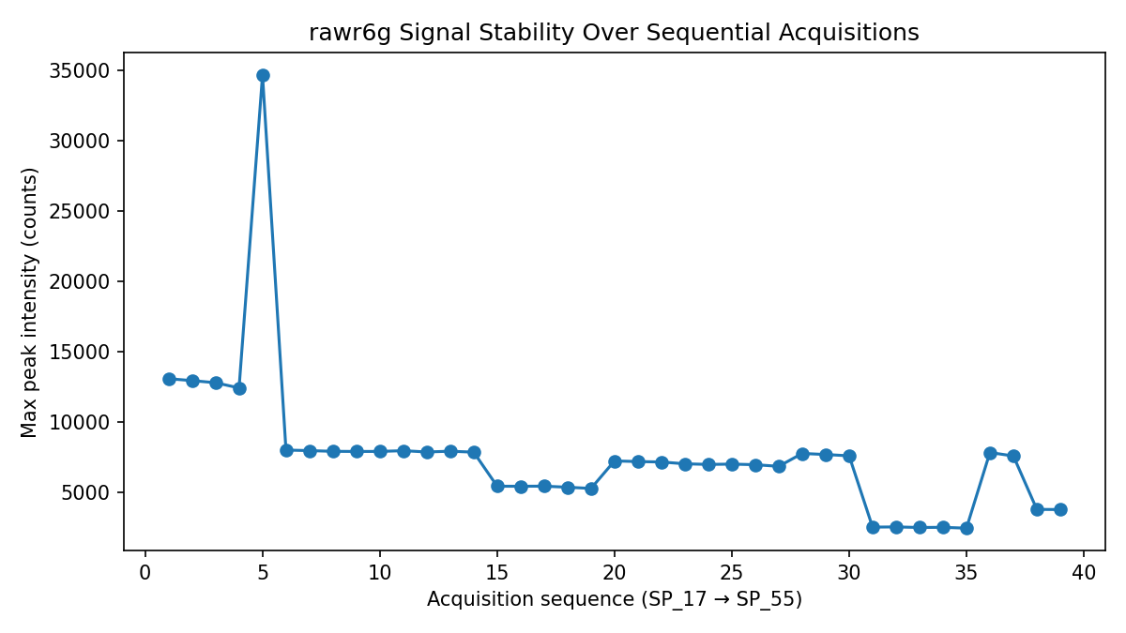
Figure 4. Max peak intensity across the 39 sequential rawr6g acquisitions, showing step changes consistent with parameter sweeps.

11. Stage IV — N-Acetylmuramic Acid Detection
After establishing that the Ag/Si substrate was SERS active using R6G, the next stage was to investigate the target molecule: N-acetylmuramic acid (NAM).
The available NAM dataset contained seven measurements: 0.1 mg/mL NAM (3 spectra) and 1 mg/mL NAM (4 spectra). All measurements were acquired under the same Raman conditions (10 s integration × 4 accumulations, 785 nm), allowing the two NAM concentrations to be compared directly.

12. NAM Concentration Conversion
The molecular weight used for NAM was 293.27 g/mol. The experimental concentrations were converted as follows:
NAM solution | Molar concentration
0.1 mg/mL | 0.341 mM
1 mg/mL | 3.410 mM

The volume of NAM solution deposited onto the substrate was not recorded in the available Raman metadata, so the total amount of NAM deposited on the sensor could not be calculated.

13. NAM Raman/SERS Results
The NAM spectra (7 spectra total: 0.1 mg/mL, n = 3; 1 mg/mL, n = 4) were compared with the blank Si/Ag-Si substrate (n = 5).
A reproducible feature around ~243 cm⁻¹ was observed in all NAM-treated spectra and was absent from the blank substrate; however, its assignment to NAM remains tentative until confirmed using a raw/bulk NAM reference spectrum. The feature appeared in 7/7 NAM spectra and was reproducible between the two NAM concentrations, with a measured SNR of approximately 5.8–39, making it the strongest and most reproducible NAM-associated feature in the current dataset.
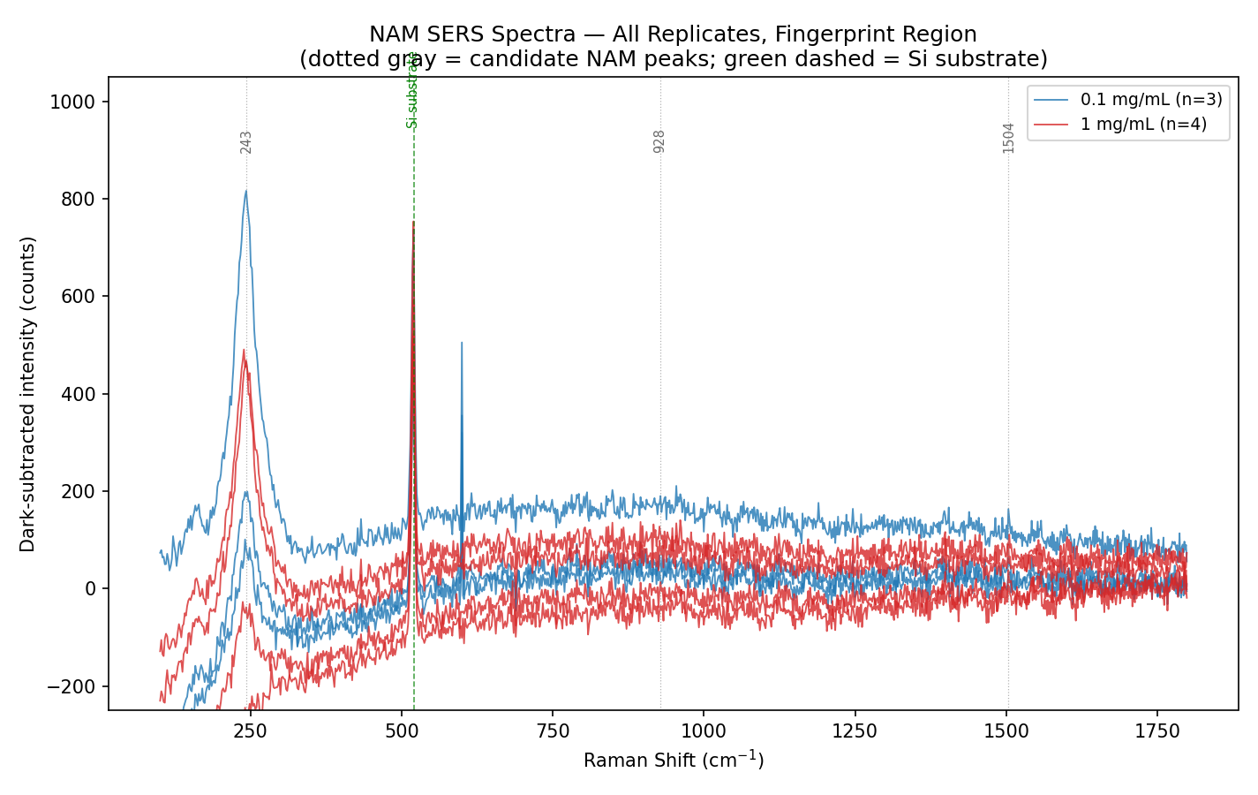
Figure 5. All 7 NAM replicate spectra, fingerprint region, with candidate peak positions marked.
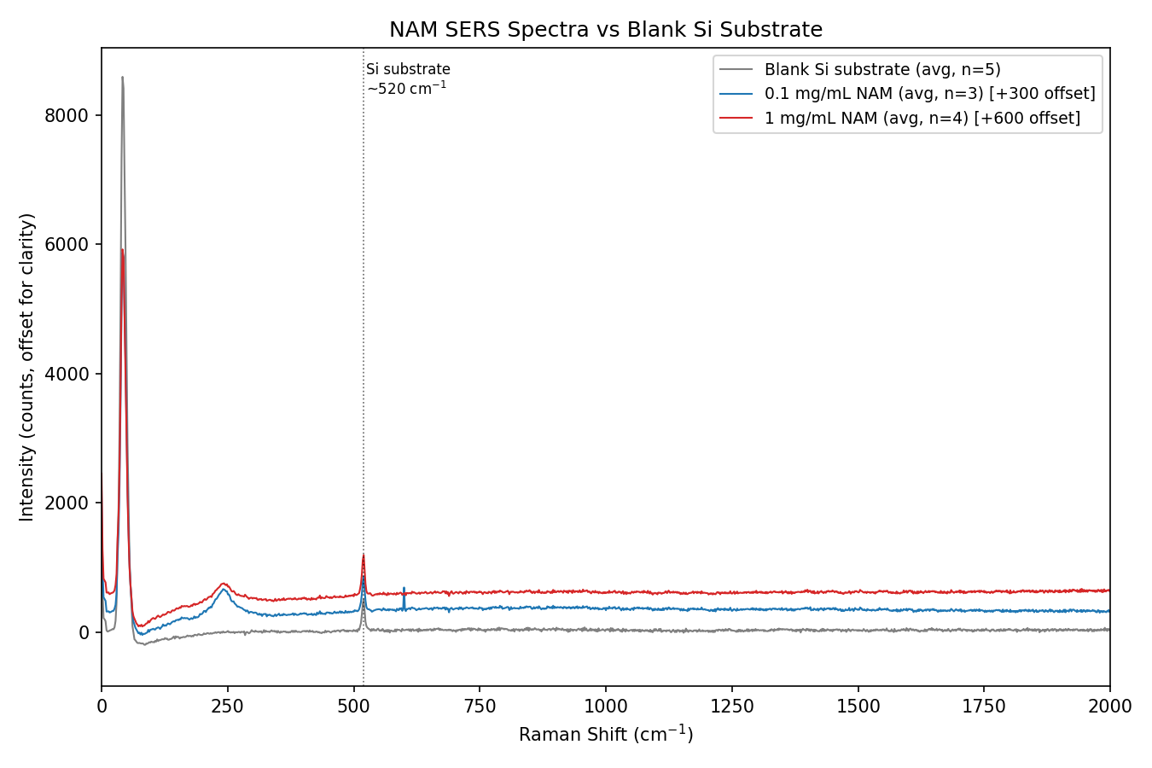
Figure 6. Average NAM spectra (0.1 and 1 mg/mL) vs average blank Si substrate spectrum.

14. Other NAM Spectral Features
Additional features were observed around ~928 cm⁻¹ and ~1504 cm⁻¹. However, these features were weak and close to the noise level, with approximate SNR around ~1–3. Therefore, these peaks are currently considered tentative, rather than confirmed NAM Raman bands.
A sharp feature around ~600 cm⁻¹ was also observed in some measurements, but its inconsistent behavior between batches and narrow appearance suggested a possible detector artifact rather than a true NAM Raman band. It was therefore excluded from the confirmed NAM peak list.

15. Silicon Substrate Peak
The characteristic ~520 cm⁻¹ peak was present in the NAM spectra. Because the same peak was present in the blank silicon substrate, it was identified as the silicon substrate Raman peak rather than a NAM peak. This distinction was important when identifying possible NAM-related features.

16. NAM Concentration Comparison
The ~243 cm⁻¹ peak was quantified for the two NAM concentrations:
NAM concentration | n | Mean intensity | SD
0.1 mg/mL (0.341 mM) | 3 | 366 | 207
1 mg/mL (3.410 mM) | 4 | 281 | 171

Although the 0.1 mg/mL group showed a higher average intensity, the variation between individual SERS measurements was large. Therefore, the current data do not establish a reliable concentration-dependent trend.
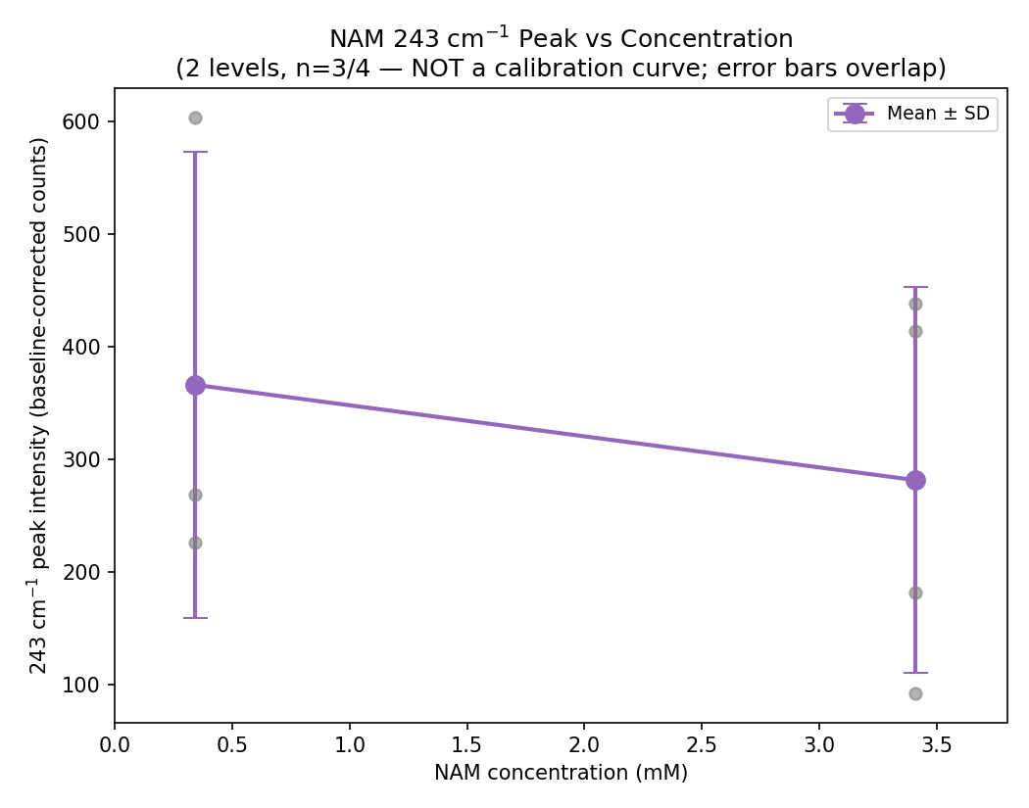
Figure 7. 243 cm⁻¹ peak intensity by concentration (mean ± SD). Overlapping error bars indicate no statistically distinguishable trend.

17. Current NAM Detection Status
A reproducible feature around ~243 cm⁻¹ was observed in all NAM-treated spectra and was absent from the blank substrate; however, its assignment to NAM remains tentative until confirmed using a raw/bulk NAM reference spectrum.
This cannot yet be considered definitive NAM identification because:
- A pure/raw NAM Raman spectrum was not measured.
- A literature-confirmed NAM Raman peak assignment for the ~243 cm⁻¹ feature was not established.
- Only two NAM concentrations were tested.
- The number of replicates was small.
- The deposited volume was not recorded.
Therefore, the current result should be described as: preliminary detection of a reproducible NAM-associated spectral feature on the Ag/Si SERS substrate.

18. Comparison of R6G and NAM Experiments
Parameter | R6G | NAM
Purpose | SERS substrate validation | Target analyte detection
Concentration range | 1 nM–1 mM | 0.341–3.410 mM
Main result | Strong R6G SERS response | ~243 cm⁻¹ NAM-associated feature
Lowest tested | 1 nM | 0.341 mM
Replicates | Multiple | 3–4 per concentration
Concentration trend | Observed up to 10 µM | Not established
Formal LOD | Not established | Not established
Raw analyte reference | Not required for initial R6G validation | Needed
Main limitation | High-concentration response decreases | No raw NAM reference + only 2 concentrations

19. Overall Progress
The progression of the project to date, from the bare Si substrate through preliminary NAM detection, is summarized in Figure 8 and the status table below.
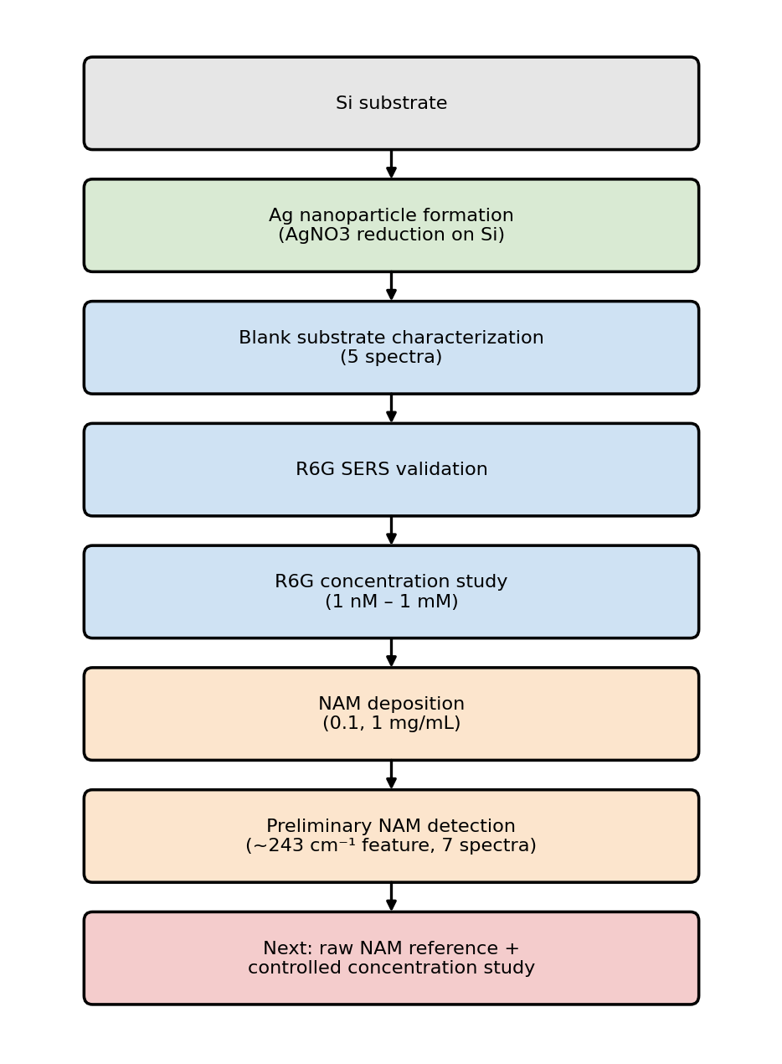
Figure 8. Project workflow to date, with the next planned experiment shown in red.
Step | Status
1. Silicon substrate characterization | Completed
2. Ag nanoparticle/SERS substrate preparation | Completed / under optimization
3. R6G SERS validation | Successfully demonstrated
4. R6G concentration-dependent testing | Completed from 1 nM to 1 mM
5. Acquisition parameter optimization | Completed as preliminary optimization
6. Initial NAM detection | Completed
7. NAM concentration comparison | Preliminary; insufficient for calibration
8. Raw NAM reference measurement | Next experiment

20. Next Experimental Work
The immediate next step should be to measure pure/raw NAM without the Ag/Si SERS substrate. Three measurements should be compared: Ag/Si blank, pure NAM without Ag/Si, and NAM deposited on Ag/Si. This will help determine whether the ~243 cm⁻¹ feature is an intrinsic NAM Raman band, an Ag–NAM surface interaction, or a substrate-related feature.
After confirming the NAM spectral fingerprints, a larger concentration series should be performed. A suitable next-stage concentration series could cover approximately 0.01–10 mg/mL, with at least 5 replicates per concentration, while keeping the Raman acquisition conditions constant. The deposited volume should also be recorded for every measurement.

21. Conclusion
The work completed to date demonstrates the successful development and preliminary characterization of an Ag nanoparticle-coated silicon (Ag/Si) SERS substrate.
Rhodamine 6G was first used to validate the substrate. Characteristic R6G SERS bands were observed over a wide concentration range, with measurable detection down to 1 nM. The strongest response occurred around 10 µM, while the response decreased at 1 mM, indicating that the substrate does not exhibit a simple linear response across the complete concentration range.
Following R6G validation, the substrate was applied to N-acetylmuramic acid (NAM) detection. NAM concentrations of 0.341 mM and 3.410 mM were tested (7 spectra: n = 3 and n = 4). A reproducible feature around ~243 cm⁻¹ was observed in all NAM-treated spectra and was absent from the blank substrate; however, its assignment to NAM remains tentative until confirmed using a raw/bulk NAM reference spectrum.
The current NAM dataset is not sufficient to establish a quantitative calibration curve, formal detection limit, selectivity, or definitive peak assignment, and no such claims are made here.
Next experiment: acquire a raw N-acetylmuramic acid Raman spectrum and compare it with the Ag/Si SERS spectrum, followed by a controlled NAM concentration series with known deposition volume and increased replicates.
Overall status: R6G SERS substrate validation completed → preliminary NAM detection demonstrated → NAM reference and quantitative validation are the next stage.

