Raw Silicon Reference Dataset
Pre-MACE Baseline — Power/Integration Time Calibration Sweep
____________________________________________________________

Sukesh P (M24IM1007) | IIT Jodhpur & AIIMS Jodhpur Joint IDRP | 13 August 2026
Substrate: unetched (raw) Si — Sensor 1 in the Phase 1 baseline plan

CONFIRMED — Purpose: this is the pre-MACE reference — what bare, unetched silicon looks like under Raman before any Ag deposition or etching. Keep this file set for every future comparison: it's what tells you whether a feature in an etched-substrate spectrum is coming from the Si itself versus from the Ag nanostructure or an analyte.

1. Data Organization
45 raw spectra were recorded on 13 Aug 2026 (16:10-17:56) on a single raw-Si piece, sweeping laser power level and integration time systematically at the same physical spot within each setting group.

1.1 File naming
Original instrument file names (SP_1.csv ... SP_45.csv) carried no information about the settings used. Files were copied (originals untouched) into a new folder with self-describing names:
Original | Renamed | Meaning
SP_1.csv | raw-si-p1-t1-acc3-spot1.csv | Power level 1, 1s integration, 3 accumulations, spot 1 of that setting
SP_29.csv | raw-si-p10-t25-acc3-spot1.csv | Power level 10, 25s integration, 3 accumulations, spot 1 — the reference condition (Section 4)

Location: 13-08-2026-raw-si/organized/, plus a mapping file _rawsi_naming_log.csv in the same folder recording original name, new name, date, and settings for every file — use this if you ever need to trace a renamed file back to the instrument's original export.

1.2 Settings sweep summary
Power level | Integration times tested (s) | Spots per condition
1 | 1, 2, 3 | 3 each
5 | 5, 10, 15, 20, 25 | 3-5 each
10 | 5, 10, 15, 20, 25 | 3-4 each

13 distinct (power, integration) conditions, 45 spectra total, all 3 accumulations, all on the same raw-Si piece.

2. Silicon TO Phonon Peak — Consistency Check Across All Conditions
Crystalline silicon has one dominant, well-known Raman band — the transverse-optical (TO) phonon mode, textbook position ~520-521 cm⁻¹. Finding it at a consistent position across every single one of the 13 conditions tested is a good instrument/calibration sanity check, independent of anything else in this dataset.
Power | Integration | Spots avg. | Peak position (cm⁻¹) | Height | SNR
P1 | 1s | 3 | 517.8 | 32.8 | 2.9
P1 | 2s | 3 | 517.8 | 54.5 | 4.6
P1 | 3s | 3 | 517.8 | 72.1 | 7.8
P5 | 5s | 3 | 517.8 | 194.7 | 15.3
P5 | 10s | 5 | 517.8 | 350.5 | 28.7
P5 | 15s | 4 | 517.8 | 535.5 | 42.0
P5 | 20s | 4 | 517.8 | 728.3 | 54.0
P5 | 25s | 3 | 517.8 | 1084.7 | 91.0
P10 | 5s | 4 | 517.8 | 332.7 | 29.3
P10 | 10s | 3 | 517.8 | 633.0 | 50.0
P10 | 15s | 3 | 517.8 | 789.1 | 79.6
P10 | 20s | 4 | 517.8 | 1135.3 | 120.7
P10 | 25s | 3 | 517.8 | 1727.4 | 152.1

CONFIRMED — The peak lands at 517.8 cm⁻1 in every single condition — a ~2-3 cm⁻1 offset from the textbook 520-521 cm⁻1 value, consistent and systematic rather than random, most likely a small, fixed wavelength-calibration offset in this instrument. Worth noting for future work: when checking other peak positions (NAM, R6G) against literature/reference values, a similar small systematic offset may apply.

SNR rises smoothly and monotonically with both power and integration time, exactly as expected (more collected signal → better SNR) — this confirms the instrument and detector are behaving normally across the whole tested range, with no anomalies or dead zones.

3. Spectra
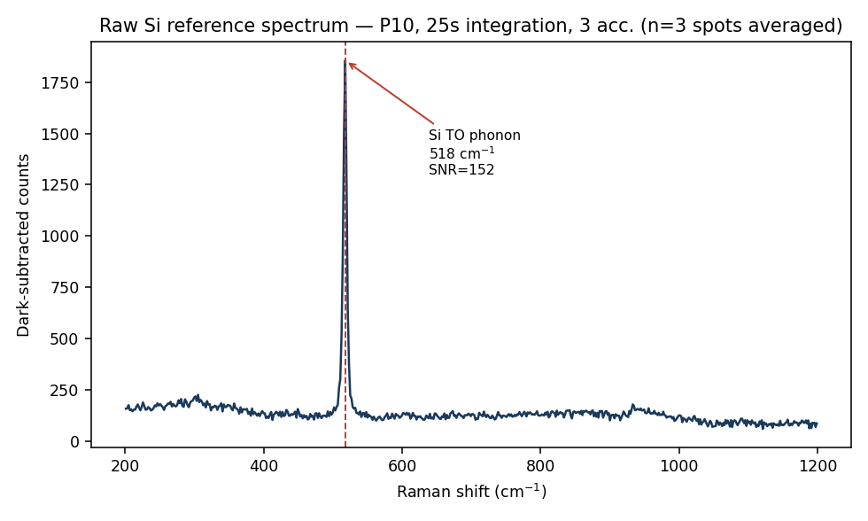
Reference spectrum: power 10, 25s integration, 3 spots averaged. Highest-SNR condition tested (SNR=152) — use this as the default "what does bare Si look like" comparison for future etched-substrate spectra.
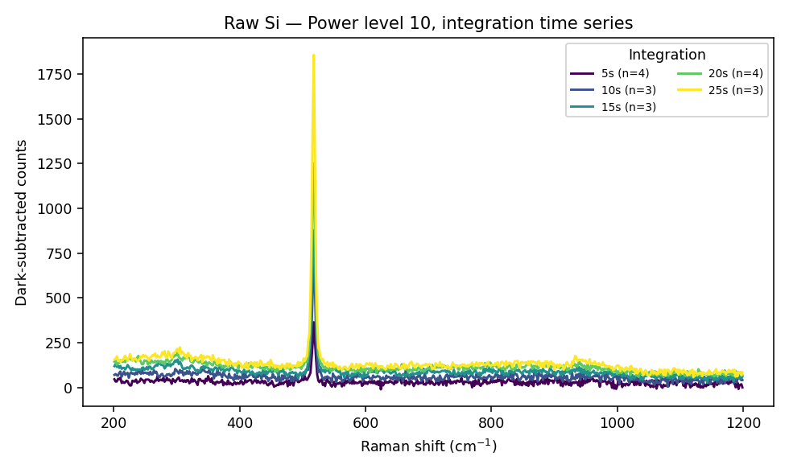
Power level 10 — integration-time series. Peak height grows smoothly from 5s to 25s.
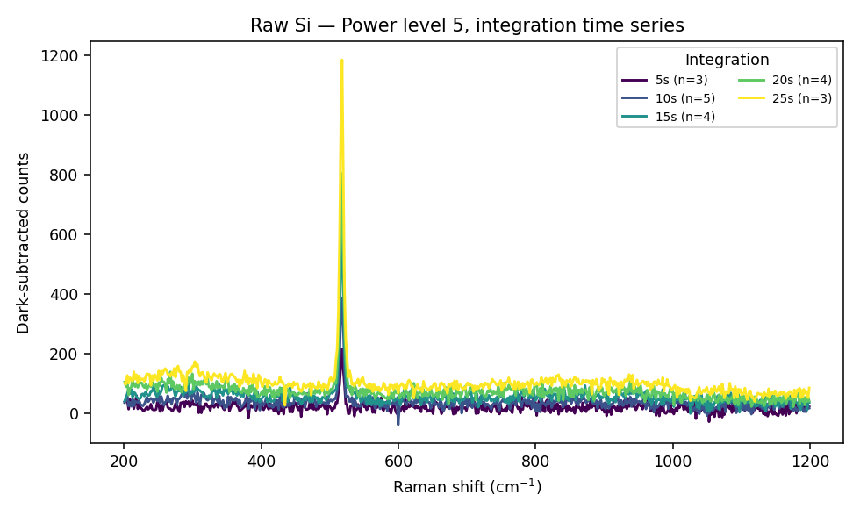
Power level 5 — integration-time series. Same monotonic growth pattern, lower absolute intensity than P10.
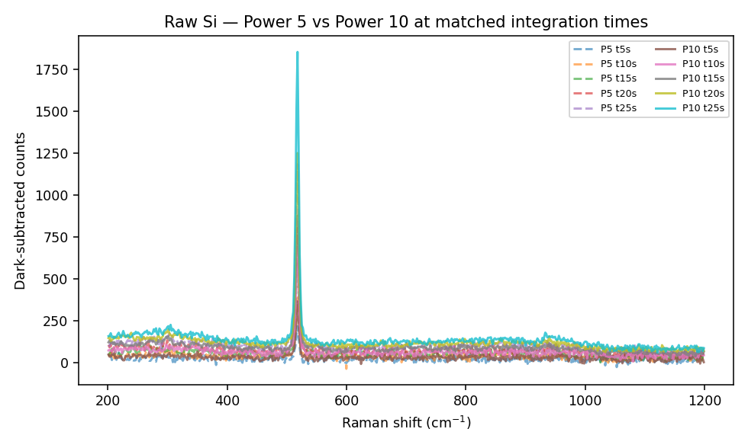
Power 5 (dashed) vs Power 10 (solid) at matched integration times — P10 consistently gives roughly 1.5-2x the P5 signal at the same integration time, useful for deciding which power level to standardize on.

4. Recommended Reference Condition
CONFIRMED — Use P10 / 25s integration / 3 accumulations as the standing raw-Si reference condition (file group raw-si-p10-t25-acc3-*). It has the highest SNR of everything tested (152) and matches the higher end of settings you've been using on etched substrates.

However, for quick day-to-day checks where 25s per spot is too slow, P5/10s (SNR≈29) or P10/10s (SNR≈50) are reasonable faster alternatives — still enough to confirm the Si peak is present and roughly where expected, without needing the full 25s acquisition.

4.1 How to use this dataset going forward
- As a substrate-only control. Before interpreting any peak on a future etched/functionalized substrate, check it isn't just the Si 517.8 cm⁻1 phonon (or one of its shoulders) — this is far from any of the R6G or NAM target peaks used elsewhere in this project, so overlap risk is low, but it's a fast sanity check.
- As an instrument-health check. If a future raw-Si measurement (fresh unetched piece, same settings) gives a substantially different SNR or peak position than the table in Section 2, that's a signal something changed in the instrument/alignment — not the sample.
- As a Si-signature tracker across fabrication. The Si TO phonon is expected to attenuate or broaden once black-Si nanostructuring and Ag deposition are applied (increased surface roughness/light trapping changes the effective sampling volume). Comparing the 517.8 cm⁻1 peak's height/shape before and after MACE on matched settings is a simple, literature-independent way to gauge how much the etch has changed the near-surface Si — worth doing on your next etched batch.
- As the definitive "is this a real analyte peak" gate. Any candidate NAM or R6G peak that happens to fall near 517.8 cm⁻1 needs extra scrutiny, since bare Si alone can produce a strong signal right there.

