Sepsis Biomarkers Analysis Using SERS-Based Sensor

A Project Report submitted by

SUKESH P

in partial fulfillment of the requirements for the award of the degree of

Masters in Medical Technologies


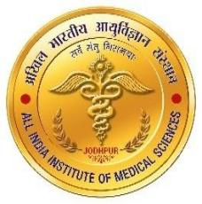

Indian Institute of Technology Jodhpur All India Institute of Medical Sciences Jodhpur
Joint Programmes in Medical Technologies
April 2026

Declaration
I hereby declare that the work presented in this Project Report titled “Sepsis Biomarkers Analysis Using SERS-Based Sensor” –Masters in Medical Technologies submitted to the Indian Institute of Technology Jodhpur and All India Institute of Medical Sciences Jodhpur in partial fulfilment of the requirements for the award of the degree of Masters in Medical Technologies, is a bonafide record of the research work carried out under the supervision of Prof. Ajay Agarwal . The contents of this Project Report in full or in parts, have not been submitted to, and will not be submitted by me to, any other Institute or University in India or abroad for the award of any degree or diploma.

Signature

SUKESH P

M24IM1007
Certificate
This is to certify that the Project Report titled “Sepsis Biomarkers Analysis Using SERS-Based Sensor”, submitted by SUKESH P (M24IM1007) to the Indian Institute of Technology Jodhpur and All India Institute of Medical Sciences Jodhpur for the award of the degree of Masters in Medical Technologies, is a bonafide record of the research work done by him under my supervision. To the best of my knowledge, the contents of this report, in full or in parts, have not been submitted to any other Institute or University for the award of any degree or diploma.

Signature  Prof. Ajay Agarwal | Signature  Dr. Neeraj Gupta

