ABSTRACT
Sepsis is a life-threatening medical condition caused by a dysregulated host response to infection and remains one of the leading causes of mortality worldwide. Early and rapid diagnosis is essential for timely clinical intervention; however, conventional diagnostic techniques such as blood culture, immunoassays, and molecular methods are often time-consuming, expensive, and require sophisticated laboratory infrastructure. Therefore, there is a critical need for rapid, sensitive, and label-free diagnostic platforms for the detection of sepsis-associated biomarkers.
This project focuses on the analysis of sepsis biomarkers using a Surface-Enhanced Raman Spectroscopy (SERS)-based sensor platform. The study targets key bacterial biomarkers including N-Acetylmuramic Acid (NAM), Lipoteichoic Acid (LTA), and Lipopolysaccharide (LPS), which are associated with Gram-positive and Gram-negative bacterial infections. These biomarkers were selected due to their clinical relevance in early-stage bacterial sepsis detection. SERS substrates based on metallic nanostructures were utilized to enhance Raman signal intensity and enable molecular fingerprint identification at low concentrations.
The work involved both computational and experimental approaches. Density Functional Theory (DFT)-based simulations were performed to study molecular vibrational characteristics and support Raman peak assignment. Experimental Raman spectra were acquired and processed using baseline correction, smoothing, and normalization techniques for accurate spectral interpretation. Comparative analysis between simulated and experimental data was carried out to validate biomarker signatures.
The results demonstrate the feasibility of using SERS as a rapid and sensitive analytical tool for sepsis biomarker detection. Distinct Raman spectral features corresponding to the selected biomarkers were identified, indicating the potential of the proposed platform for label-free pathogen-associated molecular sensing. The developed approach offers advantages such as minimal sample preparation, fast response time, and potential portability for point-of-care applications. This work contributes toward the development of next-generation biosensors for early sepsis diagnosis, with future scope in clinical validation, multiplex biomarker detection, and integration into portable healthcare devices.

TABLE OF CONTENTS
Chapter / Section | Page No.
Abstract | i
Table of Contents | ii
1. Comprehensive Overview of the State of the Problem and Existing Solutions | 1
2. Intellectual Property (Patent Landscaping) | 3
3. Objectives & Methodologies | 5
3.1 Objectives | 5
3.2 Methodology | 5
4. Detail of Work Done | 7
4.1 System Design / Proposed Framework | 7
4.2 Work Completed on N-Acetylmuramic Acid (NAM) | 8
4.3 Work Completed on Lipoteichoic Acid (LTA) | 16
4.4 Work Completed on Lipopolysaccharide (LPS) | 24
4.5 Comparative Analysis of Biomarkers | 33
5. Conclusion | 34
6. Novelty | 35
7. Potential Societal and Market Impact | 37
8. Challenges or Risk Factors Associated with the Project | 40
9. Any Patent or Equivalent Filed | 44
10. Relevant References | 46

1. COMPREHENSIVE OVERVIEW OF THE STATE OF THE PROBLEM AND EXISTING SOLUTIONS
When the body's reaction to an infection gets out of control and begins harming its own organs and tissues, it can lead to sepsis, a dangerous medical disease. It can cause organ failure, septic shock, and even death if it is not identified and treated right away. In intensive care units (ICUs), neonatal units, and emergency rooms worldwide, sepsis remains one of the leading causes of death. The issue is more severe in low- and middle-income nations, where hospitals frequently deal with a high patient volume, limited laboratory capabilities, and delayed diagnosis. Early identification and thorough observation are crucial for saving lives because sepsis can rapidly progress.
Figure 1.1 Sepsis progression from infection to organ dysfunction and septic shock.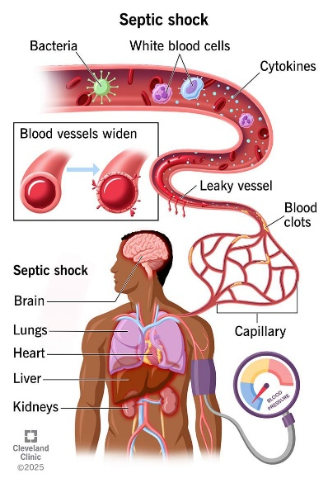 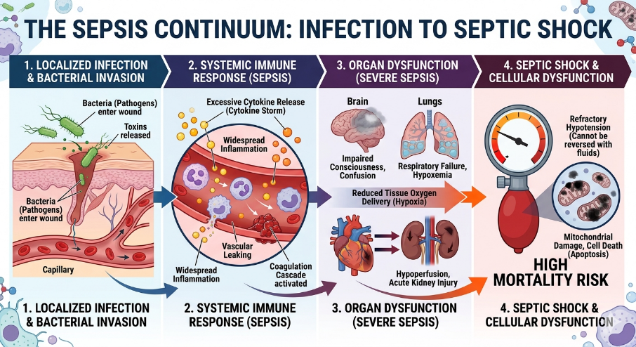
Because even a brief delay in administering the appropriate treatment might raise the risk of death, prompt detection of sepsis is crucial. All age groups are susceptible, including newborns, elderly adults, patients with compromised immune systems, surgical patients, and severely ill individuals. Sepsis not only affects health but also places a significant financial strain on healthcare systems. Treatment costs are increased by lengthy ICU stays, frequent diagnostic testing, pricey antibiotics, and close observation. While postponing treatment can lead to multiple organ failure and the needless use of broad-spectrum medicines, patients who survive severe sepsis may also face long-term consequences.
At present, sepsis diagnosis mainly depends on blood culture tests, molecular methods, and measurement of inflammatory biomarkers such as C-reactive protein (CRP), procalcitonin (PCT), interleukin-6 (IL-6), and lactate. Blood culture is still considered the standard method for confirming infection, but it usually takes between 24 and 72 hours to provide results. It may also fail to detect pathogens when bacterial levels are low or when antibiotics have already been started. Molecular techniques such as PCR can provide faster and more sensitive detection, but they require costly equipment, trained staff, and specialized laboratory conditions. Hospitals frequently employ common biomarker tests like ELISA and chemiluminescence systems, but they require a number of preparation stages, reagents, and centralized laboratory processing. Newer technologies like electrochemical sensors, microfluidic biosensors, and artificial intelligence tools for early sepsis risk prediction have also been investigated by researchers in recent years.
Figure 1.2 Comparison of conventional diagnostic methods based on turnaround time, complexity, and clinical utility.
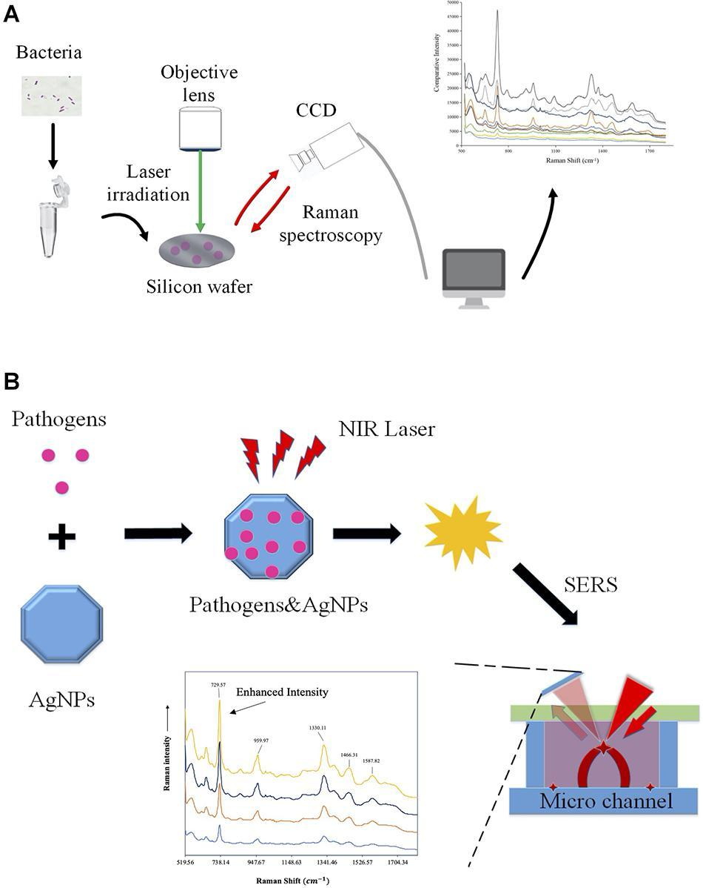
Despite these advancements, there are still a lot of difficulties. The majority of modern diagnostic technologies are costly, time-consuming, and reliant on sophisticated laboratory equipment, which restricts their application at point-of-care settings, emergency rooms, small hospitals, and rural clinics. While sepsis is a complicated illness that frequently necessitates the examination of several biological signals at once, many assays concentrate on just one biomarker. Certain techniques also entail challenging sample preparation, ongoing upkeep, or postponed reporting. As a result, crucial treatment choices could be put off during the most crucial times for patient care.
Diagnostic technologies that are quick, sensitive, portable, and able to identify several sepsis indicators from tiny sample volumes are therefore desperately needed. Because it provides excellent sensitivity, molecular-level specificity, minimal sample preparation, and the potential for small point-of-care devices, Surface-Enhanced Raman Spectroscopy (SERS) is a promising method. The suggested work intends to provide a quick and label-free sensing approach for sepsis diagnosis by integrating nanostructured plasmonic substrates with biomarker detection. Such a system could facilitate quicker clinical judgments, shorten detection times, and increase accessibility to sophisticated diagnostic instruments in a variety of healthcare settings.

2. INTELLECTUAL PROPERTY (PATENT LANDSCAPING)
2.1 Overview of Existing Intellectual Property
The area of sepsis diagnostics has seen strong patent and research activity because of the global need for faster and more reliable detection methods. Many existing patents focus on technologies such as biomarker testing, molecular diagnostics, microfluidic devices, electrochemical sensors, and optical detection systems. Large healthcare companies including Roche, Abbott Laboratories, Siemens Healthineers, bioMérieux, and Thermo Fisher Scientific have developed several protected solutions in this field. At the same time, universities and research institutes have contributed patents related to biosensors, nanomaterials, and point-of-care devices. In the case of Surface-Enhanced Raman Spectroscopy (SERS), patent activity is mainly centered on plasmonic substrates, signal enhancement nanostructures, labeled immunoassays, and portable Raman systems.
2.2 Patent Landscape Analysis
A review of the patent landscape shows that many important areas are already covered by intellectual property. Automated biomarker analyzers have patents for detecting markers such as procalcitonin (PCT), C-reactive protein (CRP), and interleukins using immunoassay systems. Molecular diagnostic patents commonly protect multiplex PCR cartridges and nucleic acid amplification methods for identifying bloodstream infections. In optical sensing, patents such as US 8,802,356 for nanostructured SERS substrate fabrication and US 10,113,180 for portable Raman detection systems highlight protection around advanced substrates and compact instrumentation. Other patents describe gold and silver nanoparticle functionalization, antibody-based SERS tags, and machine-learning methods for spectral interpretation. Overall, the most protected areas are substrate design, assay chemistry, and integrated hardware platforms.
2.3 Commercial Products / Market Solutions
Several commercial products are already available for sepsis-related biomarker testing. Examples include Elecsys BRAHMS PCT, ARCHITECT PCT, VIDAS B·R·A·H·M·S PCT, and FilmArray Blood Culture Identification Panel. These systems are mainly designed for hospital laboratories and provide biomarker or pathogen identification support. In the Raman instrumentation market, companies such as B&W Tek and Thermo Fisher Scientific offer portable spectrometers that researchers can adapt for biosensing applications. However, most available products are still laboratory-centered rather than affordable bedside screening tools.

2.4 Limitations and Gaps in Existing IP
Although current patents and products have advanced the field, several gaps remain. Many solutions rely on expensive reagents, labeled assays, and proprietary consumables that increase cost per test. Some systems are large, require trained operators, and are not practical for rural clinics or emergency bedside use. Existing SERS-related patents often focus on substrate fabrication alone rather than providing a complete clinical workflow for multi-biomarker sepsis detection. In addition, features such as AI-assisted diagnosis, disposable low-cost sensing chips, and direct plasma testing with minimal preprocessing are still not fully developed.
2.5 Opportunity for Innovation
There is still strong scope for innovation in this domain. A label-free, portable, and multi-biomarker SERS platform for rapid sepsis screening could address many current limitations. Novel contributions may come from optimized silver-gold (Ag/Au) bimetallic substrates, carefully selected biomarker panels for early-stage sepsis, machine-learning based spectral analysis, smartphone-connected readout systems, and low-volume sample handling. A clinically practical device designed for fast results, affordability, and decentralized healthcare settings would offer clear differentiation while avoiding direct overlap with existing protected technologies.
2.6 Comparative Table
Patent / Product | Key Feature | Limitation | Relevance to Proposed Work
US 8,802,356 | Nanostructured SERS substrate fabrication | Focus on substrate only | Useful for plasmonic design concepts
US 10,113,180 | Portable Raman detection system | Generic sensing platform | Relevant for compact instrumentation
Elecsys BRAHMS PCT | Automated PCT quantification | Expensive centralized analyzer | Benchmark biomarker assay
FilmArray BCID Panel | Rapid pathogen ID from blood culture | High cartridge cost | Shows demand for rapid diagnostics
Proposed Work | Label-free SERS biomarker panel | Under development | Point-of-care sepsis screening

3. OBJECTIVES & METHODOLOGIES
3.1 OBJECTIVES
- To design and fabricate a plasmonic Surface-Enhanced Raman Spectroscopy (SERS) substrate based on Ag/Au nanostructures for sensitive detection of sepsis-associated biomarkers.
- To develop and optimize an experimental protocol for rapid Raman/SERS analysis of clinically relevant biomarkers such as C-reactive protein (CRP), procalcitonin (PCT), interleukin-6 (IL-6), tumor necrosis factor-alpha (TNF-α), lipopolysaccharide (LPS), lipoteichoic acid (LTA), and peptidoglycan-related markers.
- To analyze and validate acquired Raman spectra using preprocessing, peak identification, and statistical or machine learning methods for biomarker discrimination and classification.
- To compare and evaluate the proposed SERS-based sensing platform with conventional diagnostic methods in terms of sensitivity, speed, cost, portability, and point-of-care applicability.
Figure 3.1 Graphical representation of project objectives.
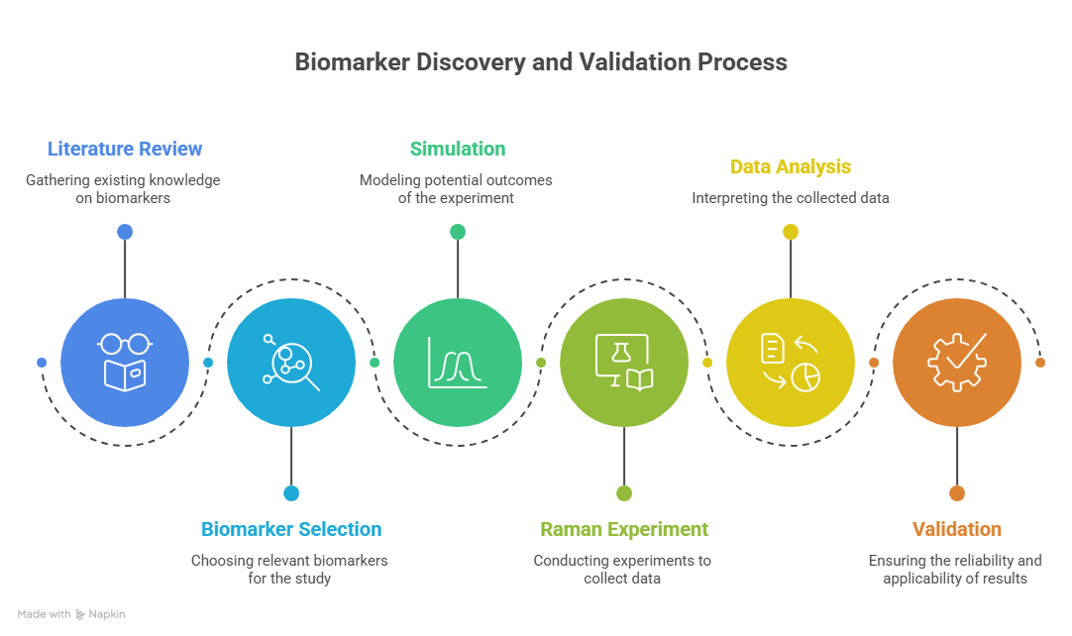

3.2 METHODOLOGY
The project was initiated by identifying the clinical challenge of delayed sepsis diagnosis, particularly in critical care and neonatal settings where rapid intervention is essential. A detailed literature review was conducted on sepsis biomarkers, Raman spectroscopy, Surface-Enhanced Raman Spectroscopy (SERS), nanostructured plasmonic substrates, and existing laboratory diagnostic systems. This review established the need for a rapid, label-free, and low-cost sensing platform capable of early biomarker detection.
Based on the identified gap, a sensing architecture was proposed consisting of a nanostructured SERS-active substrate, a Raman spectroscopic acquisition system, spectral analysis tools, and an optional machine-learning based decision layer. Silicon wafers coated with silver, gold, or Ag/Au bimetallic nanostructures were considered as the sensing substrate due to their strong localized surface plasmon resonance and signal enhancement capability.
Analytical-grade biomarker standards and bacterial cell wall markers such as NAM, LPS, and LTA were selected for proof-of-concept experiments. Known concentrations of analytes were prepared in suitable solvents, and microliter-scale droplets were deposited onto the SERS substrate followed by controlled drying. Blank substrate measurements and solvent controls were also recorded to eliminate background contributions.
Raman spectral acquisition was performed using a microscope-coupled Raman system with appropriate laser excitation (e.g., 785 nm). Instrument parameters such as laser power, integration time, objective lens, accumulations, and spectral range were systematically optimized to maximize signal-to-noise ratio while preventing sample degradation. For each sample, replicate spectra were collected from multiple substrate locations to evaluate repeatability and spot-to-spot variation.
Computational tools like Python, Origin, MATLAB, or comparable scientific software were used to process the obtained spectra. Dark subtraction, baseline correction, smoothing, normalization, and peak extraction were among the preprocessing procedures. Target biomarkers' characteristic Raman bands were found by comparing them to theoretical and literary references.
For spectral classification between healthy/control and sepsis-associated samples, supervised machine-learning models like Support Vector Machine (SVM), Random Forest, Principal Component Analysis (PCA)-based classifiers, or neural network techniques may be utilized when appropriate. The most diagnostically significant Raman bands can be found using feature selection techniques.
Sensitivity tests, concentration-dependent analysis, repeatability evaluation, and comparison with established biomarker signatures were used to validate the suggested platform. Limit of detection (LOD), signal enhancement factor, accuracy, precision, sensitivity, specificity, repeatability, and analysis time were among the performance measures.
The overall workflow of the project can be summarized as:
Problem Identification → Literature Review → SERS Substrate Design → Sample Preparation → Raman Data Acquisition → Spectral Processing → Biomarker Identification → Validation → Comparative Evaluation → Final Prototype Framework
Using SERS technology, this approach creates a translational road for quick and point-of-care sepsis biomarker testing.
4. DETAIL OF WORK DONE
4.1 System Design / Proposed Framework
The proposed work was developed as a rapid biosensing platform for the detection and analysis of sepsis biomarkers using Surface-Enhanced Raman Spectroscopy (SERS). The overall objective of the framework is to combine experimental Raman spectroscopy, computational modelling, and spectral data processing into a unified workflow for biomarker identification.
The system begins with preparation of biomarker-containing samples, followed by deposition onto an appropriate sensing substrate. Upon laser excitation, Raman scattered signals are collected using a spectroscopic acquisition unit. The acquired spectra are then processed through preprocessing algorithms such as noise removal, baseline correction, normalization, and peak extraction. The processed spectra are compared with theoretical or reference biomarker signatures for interpretation and validation.
The proposed architecture was designed in a modular manner so that each stage can be independently optimized while maintaining an integrated workflow. The major modules include:
- Sample preparation module
- SERS substrate / sensing interface
- Raman spectral acquisition module
- Data preprocessing module
- Biomarker spectral library
- Computational modelling module
- Decision-support and analysis module
This framework supports both fundamental biomarker validation studies and future translation into portable point-of-care diagnostic systems. The integration of simulation and experimentation improves confidence in peak assignments and enables more reliable identification of bacterial sepsis biomarkers.
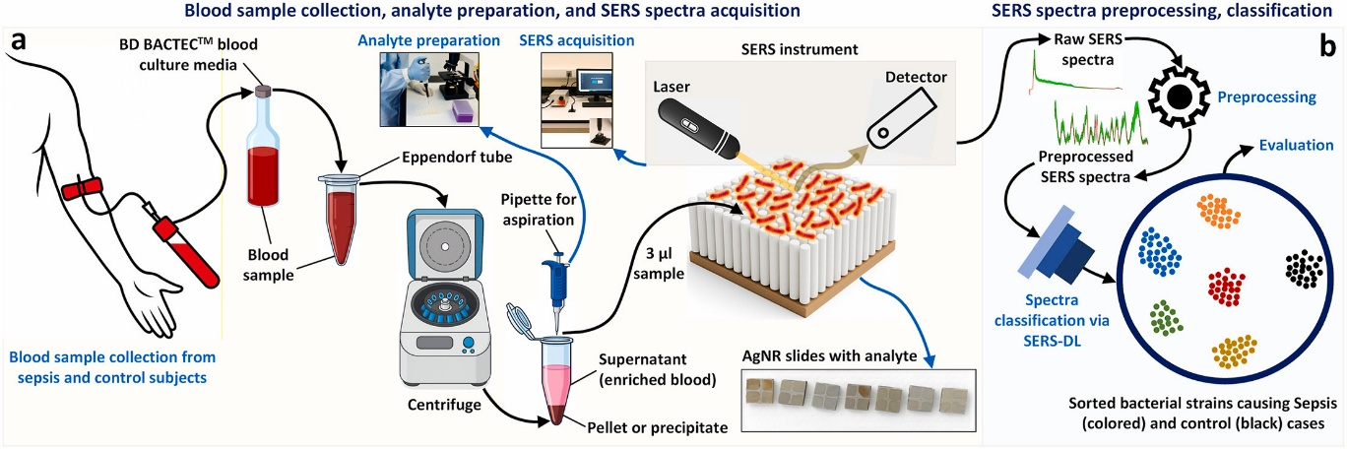
Figure 4.1: Proposed framework for SERS-based analysis of bacterial sepsis biomarkers.
4.2 WORK COMPLETED ON N-ACETYLMURAMIC ACID (NAM)
4.2 Work Completed on N-Acetylmuramic Acid (NAM)
N-Acetylmuramic Acid (NAM) is an important structural component of bacterial peptidoglycan and plays a key role in the architecture of bacterial cell walls. It is widely recognized as a biomarker associated with bacterial presence and therefore has strong relevance in infection diagnostics. Since sepsis is frequently caused by bacterial infection, identification of bacterial cell wall components such as NAM can support rapid diagnostic development.
The molecular structure of NAM contains a pyranose sugar ring, hydroxyl groups, ether linkages, an acetamide group, and a lactyl side chain terminating in a carboxylic acid group. These functional groups generate characteristic vibrational signatures in Raman spectroscopy, making NAM a suitable candidate for computational and experimental spectral analysis.
In the present work, NAM was selected as the first model biomarker for detailed validation. The study combined Density Functional Theory (DFT)-based Raman simulation with experimental Raman spectroscopy of pure NAM powder. The objective was to establish a validated Raman fingerprint of NAM and compare theoretical predictions with measured spectral data.
The complete NAM molecule was used for simulation instead of isolated fragments because the Raman spectrum arises from coupled vibrational modes involving the full molecular framework. This allows more realistic prediction of ring vibrations, carbonyl stretching, carbohydrate bands, CH deformations, and skeletal modes.
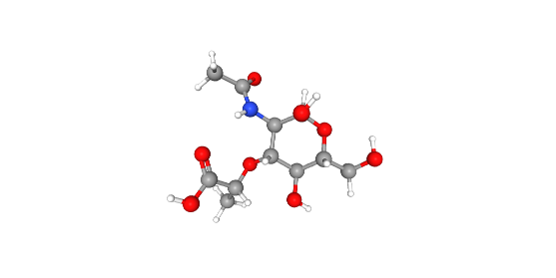
Figure 4.2: Molecular structure of N-Acetylmuramic Acid (NAM).
Key Functional Groups in NAM
Functional Group | Spectral Importance
Hydroxyl (–OH) | C–O stretching / bending
Ether (C–O–C) | Carbohydrate fingerprint
Amide | Amide-related bands
Carboxylic Acid | Carbonyl stretching
CH₃ / CH₂ | Deformation vibrations

4.2.1 Computational Methodology for Raman Simulation of NAM
To understand the vibrational behavior of N-Acetylmuramic Acid, computational Raman simulations were carried out using Density Functional Theory (DFT). This method is widely used for predicting molecular geometry, vibrational frequencies, and Raman-active modes with good accuracy for medium-sized biomolecules.
All calculations were performed using Gaussian 16. The hybrid functional B3LYP was selected because it provides reliable vibrational predictions for organic molecules containing carbon, oxygen, and nitrogen atoms. The 6-31+G(d,p) basis set was used to improve the description of heteroatoms, lone pairs, and polar bonds present in NAM.
The computational workflow consisted of two major stages:
- Geometry Optimization – The atomic coordinates of NAM were optimized to obtain the most stable low-energy molecular conformation.
- Frequency and Raman Calculation – Harmonic vibrational frequencies and Raman activities were calculated from the optimized geometry.
The absence of imaginary frequencies confirmed that the optimized structure corresponded to a stable molecular minimum. The resulting theoretical frequencies and Raman activities were exported for post-processing.
Simulation Parameters
Parameter | Value
Software | Gaussian 16
Method | DFT
Functional | B3LYP
Basis Set | 6-31+G(d,p)
Job Type | Optimization + Frequency + Raman
Resources | 16 CPU cores, 56 GB RAM
The raw theoretical output was further processed by applying frequency scaling, intensity normalization, and Gaussian broadening to generate a continuous simulated Raman spectrum comparable with the experimental spectrum.
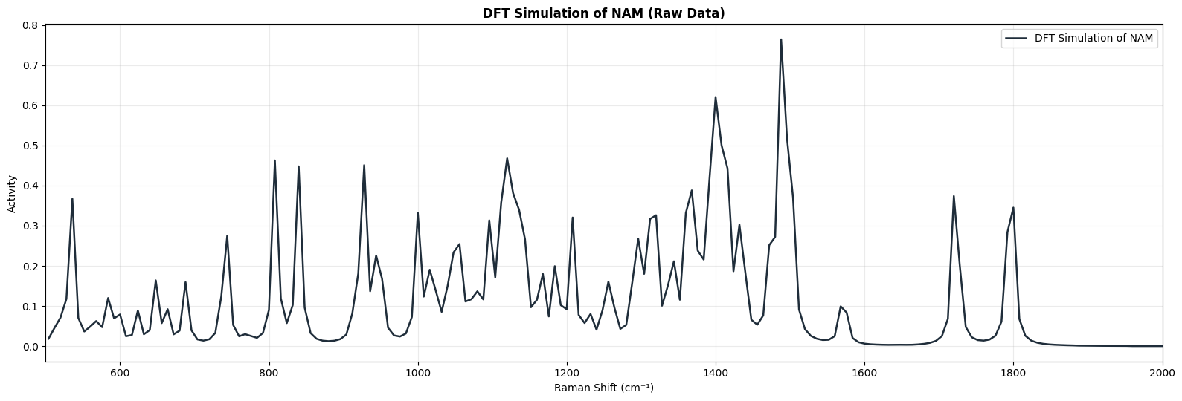Figure 4.3: Simulated Raman spectrum of N-Acetylmuramic Acid generated using DFT calculations.
Significance of Simulation
The simulated spectrum was used to:
- Predict characteristic Raman peaks of NAM
- Support functional group assignments
- Compare with experimental Raman measurements
- Validate the molecular fingerprint of NAM
- Quantify agreement between theory and experiment
4.2.2 Experimental Raman Measurement of NAM Powder
To validate the theoretical Raman predictions, experimental Raman measurements were performed using high-purity N-Acetylmuramic Acid powder. The use of a pure compound is important because it minimizes interference from unrelated biomolecules and allows direct observation of intrinsic Raman bands associated with NAM.
The sample was analyzed in powder form without chemical modification. A small quantity of material was placed on the measurement surface and spectra were recorded using a Raman spectrometer equipped with a 785 nm excitation laser. Multiple datasets were collected by varying laser power and integration time to identify the best acquisition conditions.
Experimental Conditions
Parameter | Value
Sample | NAM Powder
Purity | ~98%
Excitation Source | 785 nm Laser
Measurement Type | Powder Raman
Spectral Range | Fingerprint + Extended Region
Variable Parameters | Laser Power, Integration Time
A large set of spectra was collected across different conditions. This enabled systematic comparison of signal intensity, noise level, baseline quality, and peak sharpness.
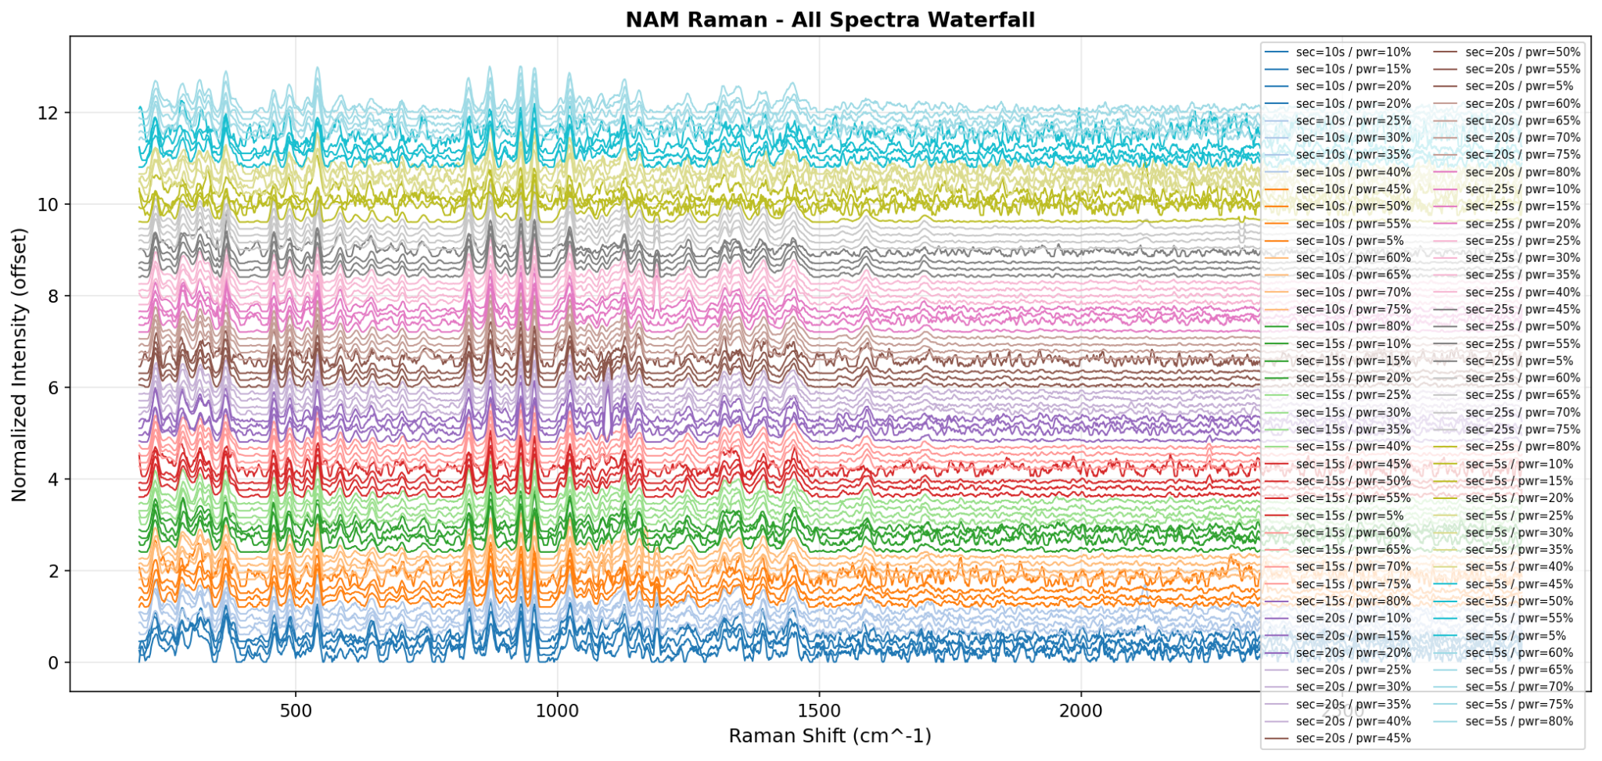Figure 4.4: Stacked Raman spectra of NAM recorded under multiple laser power and integration time conditions.

4.2.3 Selection of Optimum Spectrum
The recorded spectra were compared using quality metrics such as signal-to-noise ratio (SNR), peak definition, and baseline stability. Among all tested conditions, the best quality spectrum was obtained at:
- Integration Time: 25 s
- Laser Power: 80%
- Best SNR: 95.91
This spectrum showed strong signal intensity, clear Raman peaks, low background noise, and good reproducibility. Therefore, it was selected as the representative experimental spectrum for final validation.
Why Optimization Was Important
Optimizing measurement conditions ensured:
- Maximum signal quality
- Reliable peak positions
- Better comparison with simulation
- Reduced noise and baseline drift
- Improved scientific confidence in results

4.2.4 Spectral Quality Analysis and Parameter Optimization
After collecting Raman spectra under multiple acquisition settings, a detailed quality analysis was performed to understand the influence of laser power and integration time on spectral performance. This step was necessary to identify measurement conditions that maximize useful Raman signal while minimizing noise.
The quality of each spectrum was evaluated using parameters such as peak intensity, signal-to-noise ratio (SNR), baseline stability, and visual sharpness of Raman bands.
Effect of Laser Power
Increasing laser power generally improved Raman intensity because stronger excitation generates higher scattering signals. However, excessively high power may increase noise, heating effects, or sample degradation. Therefore, an optimal operating region was required rather than simply choosing the maximum power.
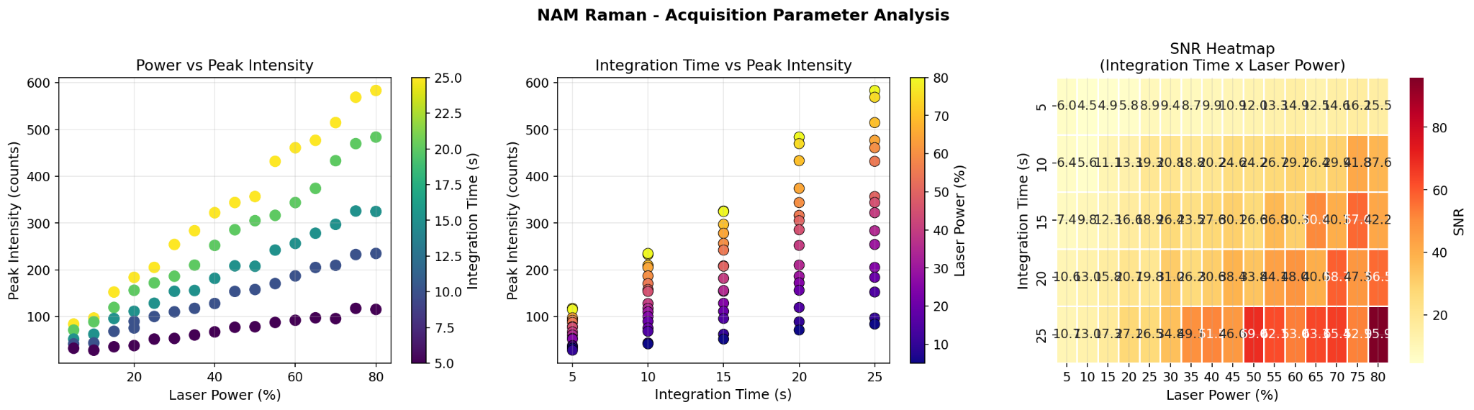
Figure 4.5: Variation of Raman peak intensity with laser power for NAM measurements.

Effect of Integration Time
Longer integration time allows the detector to collect more scattered photons, improving signal clarity and reducing random noise. However, excessively long exposure increases acquisition time and may not always produce proportional improvement.

Figure 4.6: Effect of integration time on Raman peak intensity of NAM.

Signal-to-Noise Ratio Mapping
To compare all acquisition combinations simultaneously, a heatmap or quality map was generated using SNR values. This visualization clearly identified the best-performing region of the parameter space.

Figure 4.7: Heatmap showing spectral quality / signal-to-noise ratio across different laser power and integration time settings.

Outcome of Optimization
The combined analysis confirmed that higher signal quality was achieved at longer integration time with optimized laser power. Based on this comparison, the spectrum recorded at 25 s integration time and 80% laser power was selected for final peak assignment and validation.
This optimization step strengthened the reliability of all subsequent comparisons with the theoretical Raman model.

4.2.5 Comparative Validation of Experimental and Simulated Spectra
The final stage of the NAM study involved direct comparison between the optimized experimental Raman spectrum and the DFT-simulated spectrum. This comparison was performed to verify whether the theoretical model accurately reproduced the vibrational fingerprint of N-Acetylmuramic Acid.
Strong correspondence was observed between the two spectra across the major fingerprint regions. Characteristic peaks associated with ring deformation, carbohydrate vibrations, ether stretching, CH deformation, amide-related modes, and carbonyl stretching were consistently identified in both datasets.
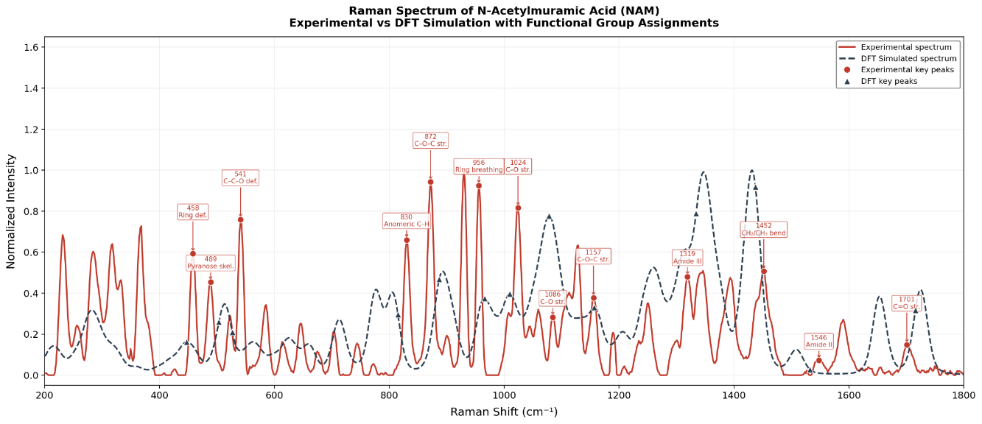Figure 4.8: Comparative overlay of experimental and simulated Raman spectra of N-Acetylmuramic Acid.

Representative Peak Matching
Experimental (cm⁻¹) | Simulated (cm⁻¹) | Assignment
284.3 | 282.5 | Ring deformation
772.7 | 777.8 | Ring vibration
955.9 | 965.7 | Ring breathing
1155.4 | 1156.9 | C–O–C stretching
1345.9 | 1347.4 | CH deformation
1700.7 | 1725.1 | Carbonyl stretching
A total of 51 Raman peaks were matched between the experimental and simulated spectra, indicating excellent agreement.
Error Analysis
Quantitative evaluation of peak positions showed a low root mean square error (RMSE), demonstrating that the selected computational method successfully reproduced the experimental vibrational behavior of NAM.
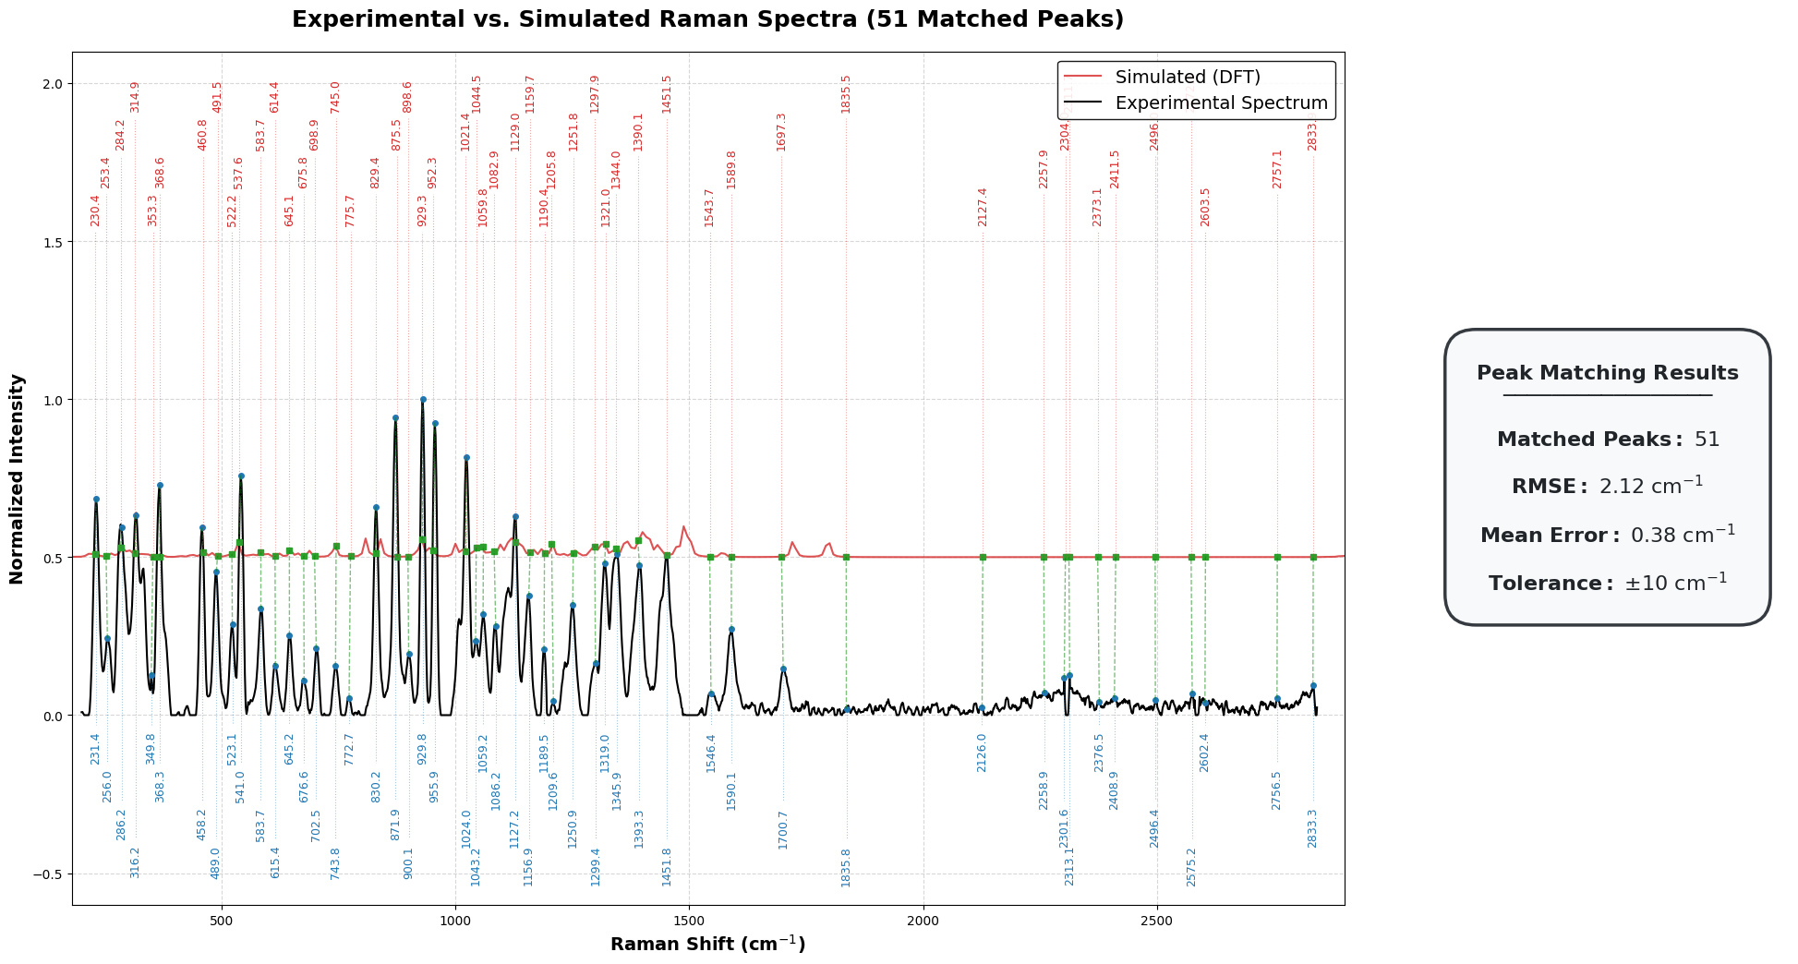Figure 4.9: Peak matching and error analysis between experimental and simulated NAM spectra.
Scientific Significance
The validated Raman fingerprint of NAM is important because it can serve as a reference for future studies involving:
- Bacterial cell wall biomarker detection
- Mixed biomolecular samples
- SERS-based biosensor development
- Machine learning spectral classification
- Rapid infection and sepsis diagnostics
Conclusion
This study established a robust Raman reference spectrum of N-Acetylmuramic Acid through combined computational and experimental analysis. The strong agreement between simulation and measurement confirms that Raman spectroscopy integrated with DFT modelling is a reliable strategy for biomarker validation and future diagnostic sensor development.

4.3 Work Completed on Lipoteichoic Acid (LTA)
Lipoteichoic Acid (LTA) is a major structural component of the cell wall of Gram-positive bacteria. It is composed of repeating glycerol-phosphate or ribitol-phosphate units anchored to the bacterial membrane and may contain substitutions such as D-alanine and carbohydrate groups. LTA plays an important role in bacterial physiology, surface charge regulation, immune recognition, and host inflammatory response.
Because Gram-positive bacterial infections are clinically relevant in sepsis, LTA was selected as an important biomarker for Raman-based investigation. Detection of LTA-associated spectral signatures can support differentiation of bacterial infection types and future rapid diagnostic systems.
Direct quantum mechanical simulation of intact LTA is computationally challenging because it is a large and heterogeneous polymer. Therefore, a fragment-based modelling strategy was adopted in this work. Representative molecular units corresponding to the main structural motifs of LTA were individually simulated and later combined to reconstruct an approximate theoretical Raman fingerprint.
The three selected fragments were:
- Glycerol-Phosphate (backbone model)
- D-Alanine (amino substituent model)
- N-Acetyl-D-Glucosamine (GlcNAc) (carbohydrate model)
This approach provides a practical balance between scientific interpretability and computational feasibility.
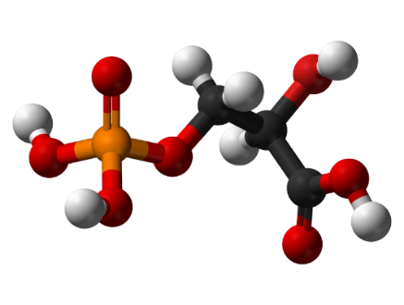
Glycerol-Phosphate
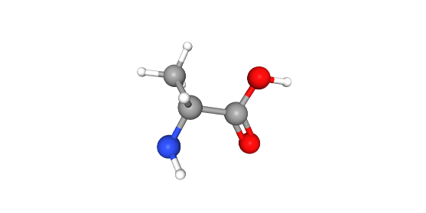
D-Alanine
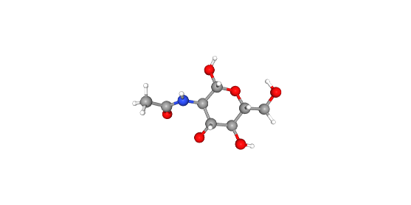
GlcNAc
Figure 4.10: Representative fragment models used for theoretical simulation of Lipoteichoic Acid (LTA).
Importance of Fragment-Based Modelling
The fragment strategy enables:
- Reduced computational cost
- Separate interpretation of chemical regions
- Flexible weighted combination of spectra
- Better understanding of phosphate, amino acid, and carbohydrate bands
- A scalable framework for future complex biomolecular modelling
4.3.1 Computational Methodology for LTA Fragment Simulation
All theoretical Raman simulations for the selected LTA fragments were performed using Density Functional Theory (DFT). Geometry optimization and vibrational frequency calculations were carried out for each fragment independently. This allowed extraction of Raman-active modes associated with the major structural components of LTA.
Gaussian 16 was used as the primary quantum chemistry software. The B3LYP functional with the 6-31G(d) basis set was selected because it provides reliable vibrational predictions with manageable computational cost. To better represent aqueous biological environments, an implicit solvent model (SMD, water) was applied.
Common Simulation Parameters
Parameter | Setting
Method | DFT
Functional | B3LYP
Basis Set | 6-31G(d)
Job Type | Optimization + Frequency + Raman
Solvation | SMD (Water)
Grid | UltraFine
SCF Convergence | Tight
For each fragment, the computational workflow included:
- Molecular structure preparation
- Preliminary geometry refinement
- Geometry optimization
- Frequency calculation
- Raman activity extraction
- Frequency scaling and normalization
- Spectral plotting
The calculated frequencies were corrected using a standard scaling factor (0.96–0.97 range) to reduce harmonic overestimation and improve comparison with experimental data.
Individual Fragment Significance
- Glycerol-Phosphate: phosphate backbone vibrations
- D-Alanine: amino acid and zwitterionic features
- GlcNAc: carbohydrate and acetyl-group contributions
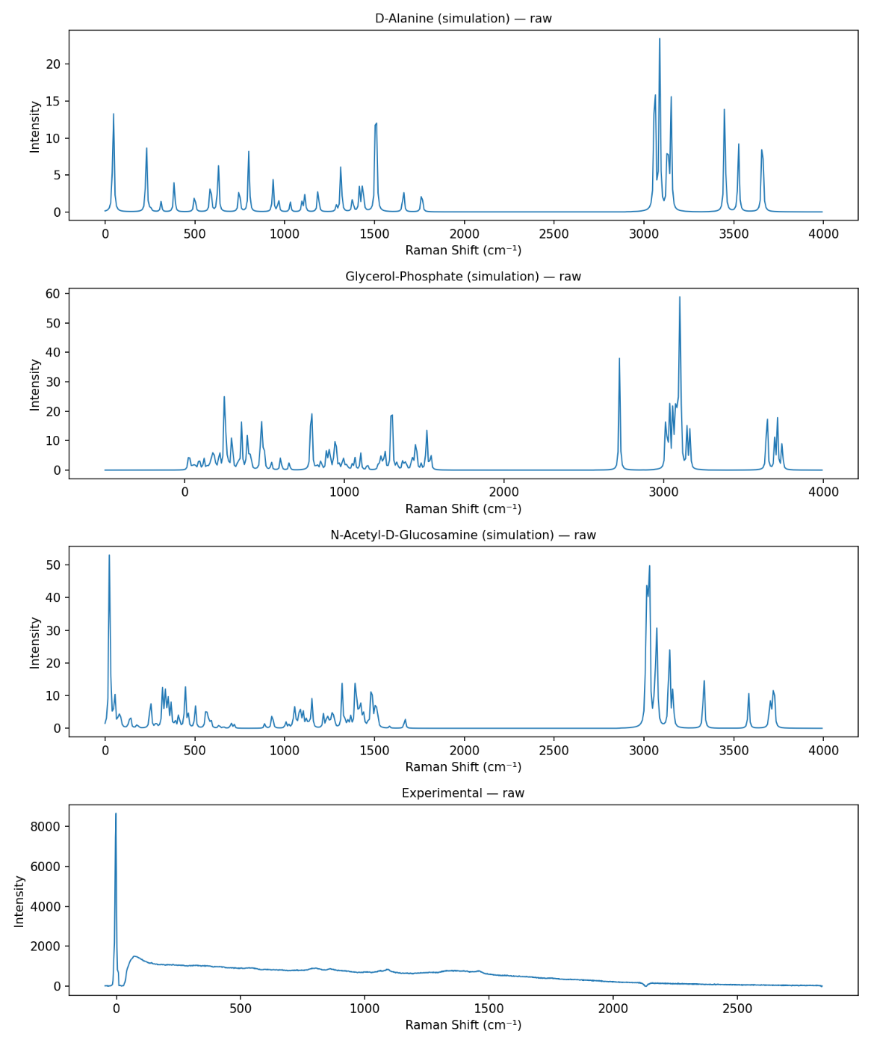
Figure 4.11: Simulated Raman spectra of individual LTA fragments: Glycerol-Phosphate, D-Alanine, and GlcNAc.
Scientific Value of This Step
Independent fragment simulations made it possible to assign which chemical component contributes to specific Raman regions, improving interpretation of the final composite spectrum.
4.3.2 Raman Features of Individual LTA Fragments
The simulated spectra of the three selected fragments revealed distinct Raman-active regions corresponding to their chemical structures. These results were used to interpret the final LTA composite spectrum and identify major functional contributions.
Glycerol-Phosphate (Backbone Model)
Glycerol-phosphate represents the phosphate-rich repeating backbone of Lipoteichoic Acid. Its spectrum showed strong contributions in regions commonly associated with phosphate vibrations and C–O linkages.
Region (cm⁻¹) | Major Interpretation
700–900 | P–O–C vibrations
900–1100 | Phosphate stretching / C–O modes
1170–1300 | Hydroxyl deformation
1360–1490 | CH₂ / skeletal modes
These bands are important because phosphate-related peaks are characteristic markers of teichoic acid structures.
D-Alanine (Amino Substituent Model)
D-Alanine contributes amino acid signatures not captured by the phosphate backbone alone. It helps explain methyl, amine, and carboxylate-related Raman bands.
Region (cm⁻¹) | Major Interpretation
500–650 | Skeletal deformation / COO⁻ rocking
1150–1250 | C–N stretching
1280–1380 | CH₃ deformation
1485–1670 | NH₃⁺ / coupled amino modes
This fragment is especially relevant for substituted LTA structures found in Gram-positive bacteria.
GlcNAc (Carbohydrate Model)
GlcNAc provides sugar-ring and acetyl-group features relevant to carbohydrate-associated spectral regions.
Region (cm⁻¹) | Major Interpretation
900–1100 | C–O–C / sugar ring modes
1250–1310 | Amide III
1320–1480 | CH / OH deformation
1630–1680 | Amide I (C=O stretching)
These peaks improve interpretation of mixed glycan and amide regions in the reconstructed LTA spectrum.
Outcome
The three-fragment model successfully captured the major chemical domains of LTA:
- Phosphate backbone
- Amino substituents
- Carbohydrate contributions
This formed the basis for theoretical spectrum reconstruction.
4.3.3 Generation of Composite LTA Spectrum
Since Lipoteichoic Acid is a complex polymer, its Raman spectrum arises from the combined contribution of multiple structural units rather than a single isolated molecule. Therefore, a composite theoretical spectrum was generated by mathematically combining the processed spectra of the three simulated fragments.
The three contributors used in the model were:
- Glycerol-Phosphate – backbone component
- D-Alanine – amino substituent component
- GlcNAc – carbohydrate component
Before combination, all spectra were standardized using the same Raman shift axis, normalized intensity scale, and selected fingerprint region.
Mathematical Model
The composite spectrum was represented as:
$$I_{LTA}=w_{1}(I_{GP})+w_{2}(I_{DAla})+w_{3}(I_{GlcNAc})$$
Where:
- $I_{LTA}$= reconstructed theoretical LTA spectrum
- $I_{GP}$= glycerol-phosphate spectrum
- $I_{DAla}$= D-alanine spectrum
- $I_{GlcNAc}$= GlcNAc spectrum
- $w_{1},w_{2},w_{3}$= contribution weights
Weight Optimization
An equal-weight model was first tested. Subsequently, optimized weights were estimated using Non-Negative Least Squares (NNLS) to improve agreement with the measured experimental spectrum.
Example Contribution Trend
Component | Approximate Contribution
Glycerol-Phosphate | 20–25%
D-Alanine | 34–40%
GlcNAc | 40–43%
These values indicate that multiple structural motifs contribute significantly to the final Raman response.
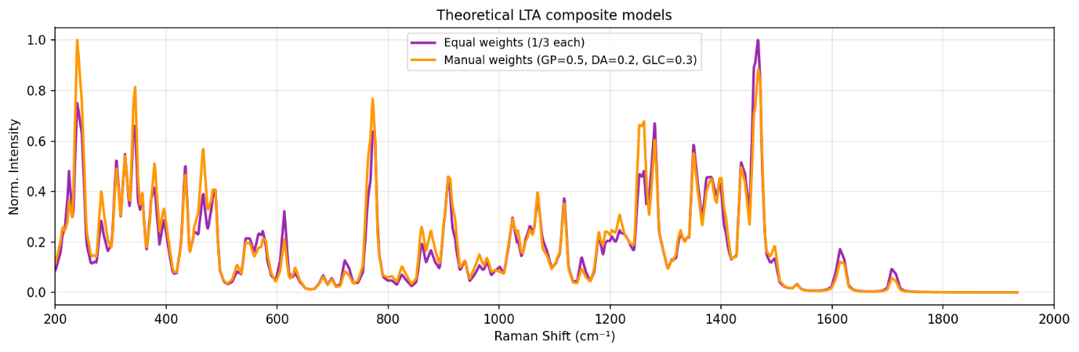Figure 4.12: Composite theoretical Raman spectrum of Lipoteichoic Acid generated from weighted combination of simulated fragments.
Scientific Importance
This composite strategy demonstrates how molecular fragments can be integrated to model large biomolecules that are otherwise difficult to simulate directly using conventional quantum methods.
4.3.4 Experimental Validation of LTA Model
Experimental Raman measurements were performed on the prepared LTA-related sample to compare real spectral behavior with the fragment-based theoretical model. The measured data were preprocessed using standard procedures such as spectral window selection, baseline correction, smoothing (if required), and Min–Max normalization.
The purpose of this stage was to determine whether the simulated fragment combination could reproduce the key chemical regions observed in the experimental spectrum.
Overlay Comparison
The normalized experimental spectrum was overlaid with the reconstructed theoretical spectrum. Visual comparison showed agreement in several important Raman regions associated with phosphate vibrations, carbohydrate bands, CH deformation modes, and amide-related features.
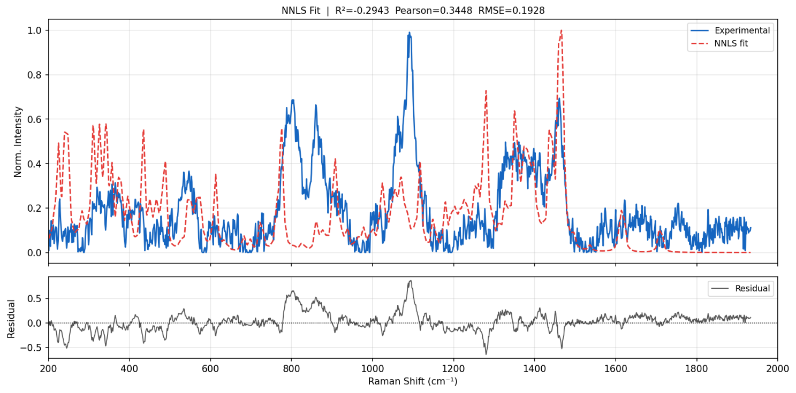
Figure 4.13: Comparison of experimental Raman spectrum with reconstructed theoretical LTA spectrum.
Quantitative Fitting Metrics
To evaluate model performance, statistical fitting parameters were considered.
Metric | Interpretation | Desired Trend
RMSE | Average fitting error | Lower
R² | Variance explained | Higher
Pearson Correlation | Spectral similarity | Higher
Representative fitting values indicated that the model captured broad spectral trends while maintaining chemical relevance.
Region-Based Interpretation
Region (cm⁻¹) | Dominant Contribution
700–900 | Phosphate ester / P–O–C
900–1100 | Carbohydrate + phosphate stretching
1200–1300 | Amide III / C–N
1400–1500 | CH₃ / CH₂ deformation
1500–1650 | NH₃⁺ / COO⁻ / Amide I

Conclusion
The LTA study established a practical framework for interpreting Raman spectra of complex Gram-positive bacterial biomarkers using fragment-based computational modelling. The agreement between experimental and theoretical data supports the feasibility of using Raman spectroscopy and simulation-assisted analysis for future bacterial diagnostics and SERS biosensor development.
4.3.5 Limitations and Future Scope of LTA Analysis
Although the fragment-based modelling strategy produced meaningful agreement with the experimental Raman spectrum, certain limitations should be recognized. Lipoteichoic Acid is a structurally diverse polymer, and the present model used only three representative fragments. Therefore, some weak or complex Raman bands may not be fully captured by the simplified reconstruction.
Limitations
Structural Simplification
The complete polymeric architecture of LTA, including repeating units, branching patterns, and species-specific substitutions, was not explicitly simulated.
Harmonic Approximation
The theoretical calculations were based on harmonic vibrational analysis. Real molecular systems may exhibit anharmonic effects that can shift peak positions or alter intensities.
Environmental Effects
Experimental spectra are influenced by intermolecular interactions, hydration state, and sample morphology, whereas the theoretical model represents idealized isolated molecules with implicit solvent treatment.
Limited Fragment Set
Additional biomolecular contributors present in real bacterial samples may also influence Raman signatures.
Future Scope
The present framework can be extended in several important directions:
- Inclusion of additional LTA structural fragments for improved realism
- Use of advanced fitting methods and machine learning models
- Integration with SERS substrates for trace-level detection
- Comparison with real Gram-positive bacterial samples
- Expansion into multiplex biomarker analysis for sepsis diagnostics
- Development of portable point-of-care Raman devices
Overall Significance
Despite simplifications, this study demonstrates that fragment-based computational spectroscopy is a practical and scientifically valuable approach for analyzing complex bacterial biomarkers. The methodology developed here provides a strong foundation for future diagnostic research involving Gram-positive infection markers.
4.4 Work Completed on Lipopolysaccharide (LPS)
Lipopolysaccharide (LPS) was selected as a major biomarker in this study because it is a key structural component of the outer membrane of Gram-negative bacteria and is strongly associated with endotoxin-mediated inflammatory responses, including sepsis. Detection of LPS-related molecular signatures can therefore support rapid identification of Gram-negative bacterial infection.
LPS is a structurally complex glycolipid composed of three major regions:
- Lipid A – membrane-anchoring region responsible for endotoxin activity
- Core Oligosaccharide – sugar-rich intermediate region
- O-Antigen – variable polysaccharide chain
Because of its large molecular size, conformational flexibility, and structural heterogeneity, direct quantum simulation of the full LPS molecule is computationally difficult. Therefore, a fragment-based modelling strategy was adopted.
Representative molecular fragments corresponding to the major chemical domains of LPS were selected and individually simulated. Their spectra were later combined mathematically to reconstruct the observed Raman fingerprint.
Selected Fragments
Fragment | Structural Role
KDO | Core oligosaccharide marker
Heptose | Core sugar region
D-Glucosamine | Lipid A backbone
Myristic Acid | Fatty acid chain
Phosphoric Acid | Phosphate functionality
These fragments were chosen because they collectively represent the dominant carbohydrate, lipid, and phosphate contributions expected in LPS.
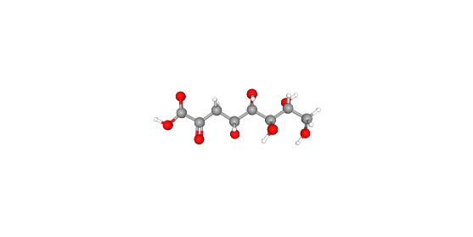
3-Deoxy-D-manno-octulosonic acid (KDO)
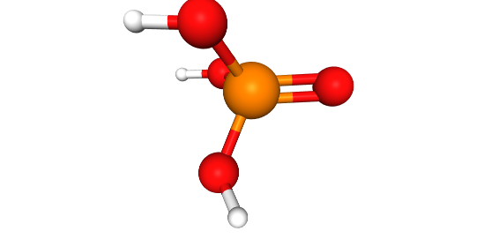
Phosphoric Acid
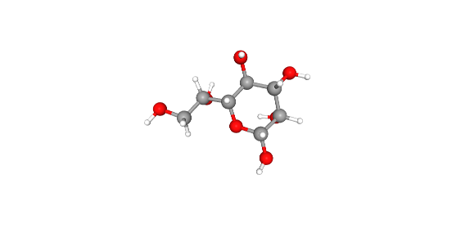
L-glycero-D-manno-heptose
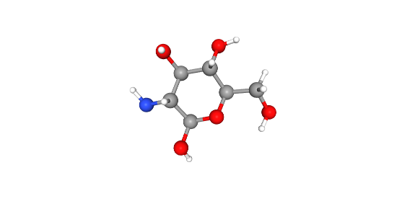
D-Glucosamine
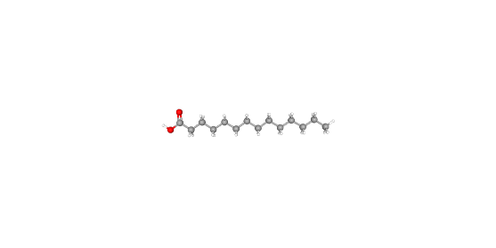
Myristic Acid

Figure 4.14: Representative molecular fragments selected for Lipopolysaccharide (LPS) modelling.
Importance of LPS Analysis
The LPS model is significant because it provides a framework for studying Gram-negative bacterial biomarkers relevant to sepsis diagnostics and future Raman/SERS sensor development.
4.4.1 Computational Methodology for LPS Fragment Simulation
After selecting the representative molecular fragments, quantum chemical simulations were performed to generate theoretical Raman spectra for each component. The objective of this step was to understand how individual chemical regions of LPS contribute to the final experimental Raman fingerprint.
All calculations were carried out using Density Functional Theory (DFT), which provides a suitable balance between predictive accuracy and computational feasibility for medium-sized biomolecules.
Gaussian software was used for geometry optimization, vibrational frequency calculations, and Raman activity estimation.
Level of Theory
The following computational settings were applied consistently to all selected fragments:
Parameter | Setting
Method | DFT
Functional | B3LYP
Basis Set | 6-31G(d)
Job Type | Optimization + Frequency + Raman
SCF Convergence | Tight
Integration Grid | UltraFine
Processing | Multi-core
Workflow Followed
- Import molecular structure
- Geometry cleanup and pre-optimization
- Geometry optimization
- Frequency calculation
- Raman activity extraction
- Spectral post-processing
- Plot generation
The optimized structures were validated by checking the absence of significant imaginary frequencies, confirming stable molecular minima.
Spectral Processing
The raw frequencies and Raman activities were converted into usable spectra using the following steps:
- Frequency scaling to improve experimental agreement
- Intensity normalization
- Interpolation to a common Raman grid
- Selection of fingerprint region
- Plot generation for each fragment
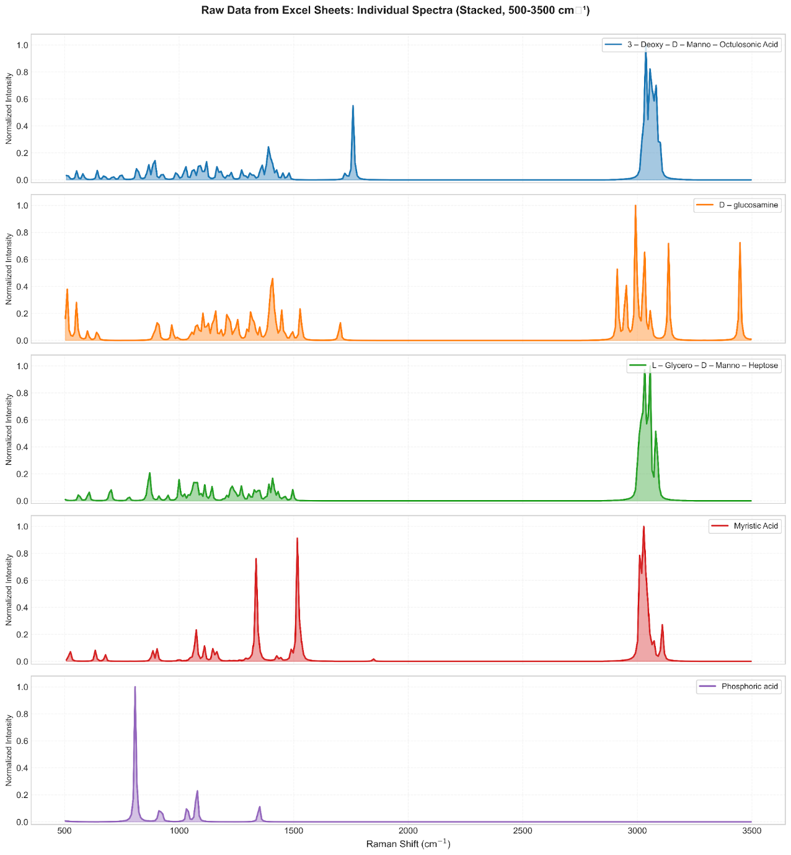
Figure 4.15: Simulated Raman spectra of representative LPS molecular fragments.
Scientific Value
This step produced chemically interpretable Raman fingerprints for each fragment, enabling later reconstruction of the complex LPS spectrum from simpler structural units.
4.4.2 Experimental Raman Measurement and Optimization of Acquisition Parameters
Following theoretical simulation, experimental Raman measurements were performed using a commercially available lyophilized powder sample of Lipopolysaccharide obtained from Escherichia coli O111:B4. The purpose of this stage was to obtain a high-quality experimental spectrum for comparison with the fragment-based theoretical model.
The sample was measured in dry powder form without chemical labeling or additional treatment.
Experimental Objective
The experimental study was designed to:
- Record Raman spectra of the LPS powder sample
- Evaluate the effect of acquisition settings on signal quality
- Identify the optimum condition for analysis
- Use the best spectrum for theoretical fitting
Parameters Varied
Several acquisition parameters were tested systematically:
- Integration time
- Laser power
- Number of accumulations
Different combinations were examined to improve signal intensity while maintaining baseline stability and avoiding sample damage.
Final Optimized Condition
The condition that produced the best overall spectrum quality was:
Parameter | Final Value
Integration Time | 60 s
Laser Power | 20%
Accumulations | 30
This setting provided strong Raman intensity, improved signal-to-noise ratio, stable baseline behavior, and good reproducibility.
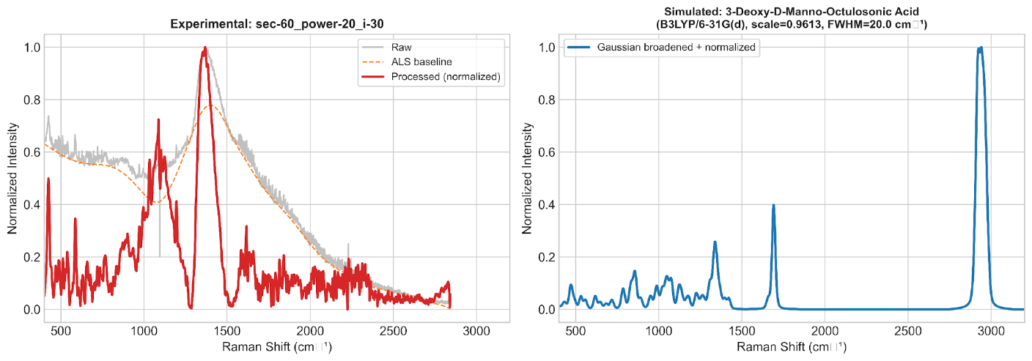
Figure 4.16: Optimized experimental Raman spectrum of Lipopolysaccharide (LPS).
Why Optimization Was Important
Selection of the correct acquisition parameters ensured:
- Clearer peak visibility
- Better comparison with theory
- Reduced noise
- Reliable repeatability
- Improved scientific confidence in the dataset
4.4.3 Preprocessing and Composite Spectrum Construction
The optimized experimental Raman spectrum was further processed before comparison with the simulated fragment spectra. Raw experimental data may contain baseline drift, random noise, and intensity variations that can affect quantitative fitting. Therefore, preprocessing was performed to generate a clean and comparable dataset.
Experimental Data Preprocessing
The following steps were applied to the selected spectrum:
- Removal of blank or invalid rows
- Numeric conversion and sorting of Raman shift values
- Selection of analysis range (200–2000 cm⁻¹)
- Baseline correction using Asymmetric Least Squares (ALS)
- Noise reduction using Savitzky–Golay smoothing
- Min–Max intensity normalization
After preprocessing, the spectrum was ready for direct comparison with theoretical models.
Why Baseline Correction Was Applied Only to Experimental Data
Theoretical Raman spectra do not contain fluorescence background, detector drift, or instrumental artifacts. Therefore, baseline correction was required only for the measured spectrum.
Composite Spectrum Modelling
Since the experimental LPS spectrum arises from multiple chemical domains, the individual fragment spectra were combined mathematically to reconstruct the observed fingerprint.
Two modelling approaches were considered:
Equal-Weight Model
All fragments were averaged equally as an unbiased first approximation.
Optimized Weighted Model
A more realistic model was generated using Non-Negative Least Squares (NNLS), where the contribution of each fragment was adjusted to minimize fitting error while keeping all weights physically meaningful (non-negative).
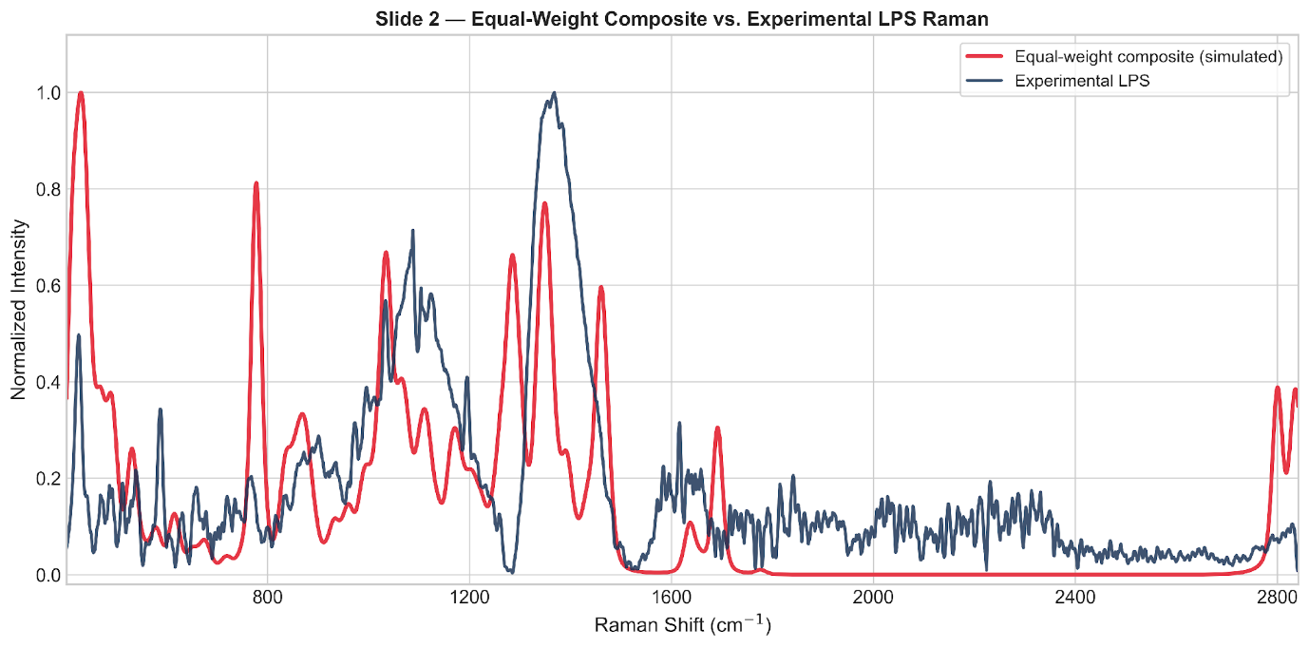
Figure 4.17: Comparison of reconstructed composite spectrum with experimental Raman spectrum of LPS.
Importance of This Step
Composite modelling enabled interpretation of a complex biomolecular spectrum using chemically meaningful smaller units, which is valuable for future biosensing applications.
4.4.4 Model Evaluation and Scientific Interpretation
After generating the composite spectra, quantitative evaluation was performed to determine how effectively the simulated fragments reproduced the measured Raman fingerprint of LPS.
Performance Metrics
The following statistical parameters were used:
Metric | Meaning | Desired Trend
RMSE | Average fitting error | Lower
R² | Variance explained by model | Higher
Correlation | Similarity of spectral shape | Higher
The optimized weighted model performed better than the equal-weight model, indicating that selective fragment contributions provide a more realistic representation of the experimental spectrum.
Representative Results
Model | RMSE | R² | Correlation
Equal Weight | 0.18853 | 0.14877 | 0.41652
NNLS Optimized | 0.18505 | 0.17995 | 0.50784
These results confirm measurable improvement after optimization.
Final Optimized Fragment Contributions
Fragment | Contribution (%)
KDO | 47.3
Heptose | 25.8
D-Glucosamine | 15.3
Myristic Acid | 11.7
Phosphoric Acid | 0.0
The dominant contribution from carbohydrate-rich fragments suggests that sugar-region vibrations strongly influence the measured Raman spectrum.
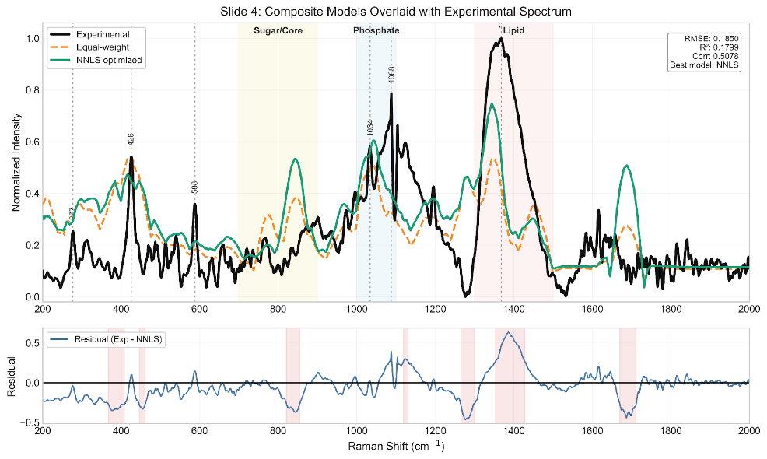
Figure 4.18: Quantitative fitted composite Raman spectrum of Lipopolysaccharide using NNLS optimization.
Scientific Interpretation
The fitted model demonstrated useful agreement in several important Raman regions:
- 900–1100 cm⁻¹: Sugar / ring / backbone modes
- ~1130 cm⁻¹: Hydrocarbon chain vibrations
- 1300–1450 cm⁻¹: CH deformation modes
- Higher regions: Complex structural vibrations
These findings show that fragment-based computational modelling can provide chemically meaningful interpretation of complex Gram-negative bacterial biomarkers.
4.4.5 Conclusion, Limitations, and Future Scope
Conclusion
This study established a complete workflow for interpreting the Raman spectrum of Lipopolysaccharide through the integration of experimental spectroscopy, quantum chemical simulation, and mathematical fitting. A fragment-based strategy was successfully used to overcome the difficulty of modelling a large and heterogeneous biomolecular system directly.
The optimized weighted model showed better agreement with the experimental spectrum than the equal-weight model, confirming that selective fragment contributions provide a more realistic representation of the measured Raman response. The results also indicated that carbohydrate-rich fragments were dominant contributors, while lipid-chain and backbone regions contributed additional structural information.
Overall, the LPS study demonstrates that Raman spectroscopy combined with computational modelling is a powerful approach for analyzing Gram-negative bacterial biomarkers relevant to sepsis diagnostics.
Limitations
The present work has certain limitations:
- Intermolecular interactions were not fully captured by isolated fragment models.
- Hydration, packing effects, and environmental influences were simplified.
- Harmonic frequency calculations may not reproduce every peak exactly.
- Only a limited number of representative fragments were included.
- Real biological matrices were not studied in the current stage.
Future Scope
The developed framework can be extended through:
- Addition of more structural fragments or connected models
- Advanced DFT methods and solvent-aware simulations
- Conformer averaging for flexible molecules
- Region-wise fitting and machine learning classification
- Integration with SERS substrates for trace-level detection
- Validation using serum, plasma, or clinical samples
- Development of rapid portable diagnostic devices
Overall Significance
The LPS workflow provides a strong scientific foundation for future translational research in rapid Gram-negative infection detection, biosensor development, and early sepsis screening systems.

4.5 COMPARATIVE ANALYSIS OF BIOMARKERS
Three significant bacterial biomarkers—N-acetylmuramic acid (NAM), lipoteichoic acid (LTA), and lipopolysaccharide (LPS)—were examined using computational modeling and experimental Raman spectroscopy in order to assess the viability of Raman/SERS-based sepsis biomarker detection. These biomarkers were chosen because they are clinically significant markers of both Gram-positive and Gram-negative infections and because they reflect important structural elements of bacterial cell walls. To evaluate their spectral behavior, theoretical–experimental agreement, modeling strategy, and diagnostic potential, a comparative analysis was carried out.
Biomarker | Type | Method Used | Key Result
NAM | Gram + / PGN marker | Full molecule DFT + Raman | Strong validation
LTA | Gram + marker | Fragment model + Raman | Good composite fit
LPS | Gram – marker | Fragment model + Raman | Quantitative fitting

With several distinctive peaks satisfactorily validated, NAM showed the best consistency between simulated and experimental Raman spectra among the three biomarkers. This suggests that NAM is a reliable and chemically understandable target for the detection of bacterial biomarkers. A fragment-based modeling approach utilizing typical subunits like glycerol-phosphate, D-alanine, and GlcNAc was necessary for LTA because of its larger and more complex polymeric structure. The usefulness of the fragment technique was validated by the reconstructed composite spectra, which demonstrated significant consistency with experimental results. The importance of LPS, a significant Gram-negative endotoxin marker, for the diagnosis of Gram-negative sepsis was highlighted by the fact that it also required fragment-based simulation and showed good quantitative fitting.
Overall, the comparison analysis demonstrates that all three biomarkers have Raman signatures that are diagnostically significant and are viable options for upcoming SERS-based rapid sepsis diagnostic systems.
5. CONCLUSION
Because of its quick course, high death rate, and reliance on prompt diagnosis, sepsis continues to be a significant global healthcare concern. Critical clinical intervention may be delayed by the lengthy processing times, specialized laboratory infrastructure, and skilled staff required by conventional diagnostic methods including blood culture, immunoassays, and molecular procedures. In order to overcome this difficulty, the current project investigated an analytical framework based on Raman spectroscopy for the quick identification of bacterial biomarkers associated with sepsis employing Surface-Enhanced Raman Spectroscopy (SERS)-oriented sensing ideas. The study concentrated on three significant types of bacterial biomarkers: lipopolysaccharide (LPS), lipoteichoic acid (LTA), and N-acetylmuramic acid (NAM), which are major structural markers of both Gram-positive and Gram-negative infections.
The successful creation of an integrated computational–experimental workflow for biomarker analysis was the study's main accomplishment. Gaussian software was used to perform Raman simulations based on Density Functional Theory (DFT) in order to anticipate the vibrational fingerprints of the chosen biomarkers. Fragment-based modeling techniques were developed to get around computational constraints while maintaining chemical interpretability for structurally complicated compounds like LTA and LPS. After obtaining experimental Raman spectra of biomarker powders under ideal acquisition conditions, the spectra were preprocessed utilizing baseline correction, smoothing, normalization, and spectral quality assessment. Theoretical and experimental spectra were compared using quantitative fitting techniques, such as Non-Negative Least Squares (NNLS).
Strong agreement between the simulated and measured spectra was shown by the results, especially for NAM, where several distinctive peaks were successfully validated with low frequency error. Key biochemical regions linked to phosphate groups, carbohydrate structures, amino substituents, and hydrocarbon chains might be explained by representative molecular units, according to fragment-based reconstruction of LTA and LPS spectra. These results demonstrate that Raman spectroscopy, when combined with computer modeling, can yield chemically significant fingerprints for the identification of bacterial biomarkers.
This project's potential use in quick, portable, label-free diagnostic tools for early sepsis screening makes it practically significant. By facilitating quicker decision-making and earlier treatment start, a future SERS-based biosensor based on these verified biomarker fingerprints could benefit neonatal care, intensive care units, emergency rooms, and settings with limited resources. The new technology can be used for point-of-care molecular diagnostics, pathogen identification, and infection monitoring in addition to sepsis.
The current work still has certain limitations. Instead of using complicated biological samples like serum or plasma, the study mostly employed pure powder standards. Fragment models were used to mimic whole macromolecular structures, and empirical scaling was necessary for harmonic DFT calculations. Furthermore, real-time sensor integration and clinical validation were outside the current project's purview.
The creation of optimal plasmonic SERS substrates, biomarker identification in biological fluids, machine learning-based spectral categorization, multiplex biomarker sensing, and validation with clinical samples should be the main areas of future research. The suggested strategy has a great chance of developing into a translational diagnostic platform for quick sepsis identification and more comprehensive infectious illness management.
6. NOVELTY
6.1 Unique Idea / Innovation
A novel computational-experimental framework for the quick identification of sepsis-associated biomarkers utilizing Raman spectroscopy and Surface-Enhanced Raman Spectroscopy (SERS) principles is presented in the project Sepsis Biomarkers Analysis utilizing SERS-Based Sensor. The main innovation is the integration of theoretical Raman modeling, multi-biomarker spectrum validation, and plasmonic nanostructure-based sensing into a single diagnostic approach. The suggested work employs inherent molecular vibrational signatures of biomarkers including N-acetylmuramic acid (NAM), lipoteichoic acid (LTA), and lipopolysaccharide (LPS) for label-free detection rather than only depending on traditional biochemical procedures.
A second important innovation is the use of fragment-based DFT spectral reconstruction for large and complex bacterial biomolecules. This approach enables theoretical interpretation of macromolecular Raman spectra that are otherwise computationally expensive to model as full structures. The integration of simulation, experimental spectroscopy, and quantitative spectral fitting creates a scalable pathway for future intelligent biosensor development.
6.2 Difference from Existing Solutions
Current sepsis diagnostic methods such as blood culture, ELISA, chemiluminescence assays, and PCR-based systems primarily depend on centralized laboratories, reagents, and multi-step workflows. These methods often require several hours to days for actionable results. Existing biosensors may focus on single biomarkers and may not provide molecular-level spectral interpretation.
On the other hand, the suggested approach relies on Raman/SERS signals for direct optical fingerprinting of biomarkers. It offers quick analysis with little sample preparation and does away with the requirement for complicated labeling chemicals. This study creates a validated computational reference library using DFT simulations, increasing confidence in biomarker peak assignments, in contrast to many published studies that merely provide experimental spectra.

6.3 Technical Advantages
There are several technical benefits to the suggested system. High molecular specificity offered by Raman/SERS sensing allows for the selective detection of biomarker signatures. Weak Raman signals can be greatly amplified by using plasmonic Ag/Au substrates, increasing sensitivity for low-concentration detection. Assay development is accelerated and spectrum interpretation uncertainty is decreased by computational modeling. Future machine learning integration for multiplex decision assistance, automated classification, and anomaly detection is compatible with the framework. Furthermore, the technique may be scaled down to provide handheld or portable diagnostic tools.

6.4 Practical Advantages
From a translational standpoint, the suggested work can facilitate better accessibility in situations with low resources, decentralized healthcare delivery, and quicker bedside screening. A portable SERS-based platform might lessen reliance on centralized infrastructure and qualified experts when compared to costly laboratory analyzers. The label-free method might make maintenance easier and reduce the expense of recurrent reagents. These devices can be used in emergency rooms, ambulances, intensive care units, neonatal care, and rural clinics when quick triage is essential.

6.5 Why It Matters
Time is of the essence for managing sepsis, because a delayed diagnosis raises the risk of death. Rapid diagnostic innovation therefore directly affects clinical practice and society. Because it advances sepsis testing toward quick, inexpensive, portable, and intelligent molecular diagnostics, the proposed effort is significant. The approach has the potential to improve treatment choices, lessen hospital load, and improve patient outcomes by facilitating the early detection of infection-related biomarkers. Additionally, the discovered methodology can be used to biomarker-driven healthcare applications and other infectious diseases.

6.6 Comparative Table
Parameter | Existing Solutions | Proposed Work
Detection Principle | Culture / Immunoassay / PCR | Raman/SERS Molecular Fingerprinting
Response Time | Hours to Days | Minutes to Rapid Screening
Cost | High Instrument + Reagent Cost | Lower Long-Term Operational Cost
Portability | Limited / Lab-Based | High Potential for Portable Deployment
Biomarker Scope | Often Single or Limited Panel | Multi-Biomarker Expandable Framework
Interpretation | Standard Assay Output | Spectral + Computational Validation
Intelligence | Basic Automation | AI/ML Compatible
Accessibility | Centralized Hospitals | Wider Point-of-Care Reach
Sample Preparation | Multi-Step | Minimal / Simplified
Scalability | Moderate | High with Sensor Miniaturization

7. POTENTIAL SOCIETAL AND MARKET IMPACT OF THE PROPOSED INNOVATION
There is a good chance that the suggested project, Sepsis Biomarkers Analysis Using SERS-Based Sensor, would have a significant impact on society, healthcare, and the diagnostics sector. The invention can increase survival rates, lower treatment costs, and promote the development of reasonably priced point-of-care medical technology by tackling the significant problem of delayed sepsis detection. Faster and more accessible diagnostic solutions are becoming more and more crucial for both developed and developing healthcare systems, as sepsis continues to be a global health concern.
7.1 Societal Impact
Every hour counts in a medical emergency like sepsis. In order to improve treatment outcomes and avoid serious consequences, early diagnosis is crucial. Doctors may detect high-risk patients early and start therapy without needless delay with the use of a fast biomarker sensing technology. Vulnerable populations that are more susceptible to life-threatening illnesses include newborns, elderly people, immunocompromised patients, and seriously ill people.
Access to healthcare can also be enhanced by the suggested system. People who live in rural or underdeveloped areas find sophisticated testing challenging because many conventional diagnostic facilities are centered in large urban hospitals. Testing in smaller hospitals, primary care facilities, ambulances, and distant clinics would be possible using a portable SERS-based platform. Patients and their families can feel less stressed and have more faith in medical judgments when diagnoses are made more quickly. These technologies have the potential to facilitate more equitable access to high-quality healthcare services in various areas over time.
7.2 Healthcare and Industrial Impact
For hospitals and clinical laboratories, this innovation can improve the speed and efficiency of diagnostic workflows. It has the potential to reduce dependence on slow culture-based methods and reagent-heavy laboratory assays. Rapid biomarker screening could be useful in emergency departments, ICUs, neonatal intensive care units, and post-surgical infection monitoring. Earlier diagnosis may help doctors choose targeted treatments sooner, reduce unnecessary antibiotic use, and strengthen antimicrobial stewardship practices.
The project also offers opportunities for the medical device and diagnostics industry. It can encourage development of portable Raman instruments, disposable SERS sensor chips, smart clinical software, and integrated decision-support platforms. Companies working in nanotechnology, biosensors, optics, and healthcare equipment may benefit from the increasing demand for rapid diagnostic tools. In addition, the innovation aligns well with current trends such as personalized medicine, digital health, and connected healthcare systems.
7.3 Economic Impact
Delayed sepsis diagnosis often leads to higher healthcare costs because patients may require longer ICU stays, repeated tests, advanced supportive care, and extended hospitalization. A rapid screening platform can help reduce these expenses by enabling earlier intervention and more efficient treatment planning. Hospitals may benefit through better bed management, faster decision-making, and reduced pressure on central laboratories.
At a broader level, reducing deaths and long-term complications caused by sepsis can improve workforce productivity and lower the economic burden associated with disability and prolonged recovery. Affordable decentralized diagnostics can also reduce travel costs and out-of-pocket medical expenses for patients and families. This is particularly important in countries such as India, where access to advanced healthcare may vary between urban and rural regions.
7.4 Market Potential
The market opportunity for rapid sepsis diagnostics is considerable because of the increasing global burden of infections, growing ICU admissions, and rising demand for point-of-care testing. Healthcare providers are actively seeking faster and more reliable tools that can support early diagnosis and timely treatment decisions. A portable SERS-based platform can serve multiple healthcare environments, making it commercially attractive across both urban and decentralized care settings.
Target Users Include:
- Multispecialty hospitals and ICUs
- Emergency departments
- Neonatal and pediatric care units
- Diagnostic laboratories
- Rural healthcare centers
- Ambulance and mobile care services
- Defense and disaster-response medical units
India represents a strong growth market because of its large population, expanding healthcare infrastructure, and increasing interest in locally developed medical technologies under initiatives such as Make in India and National Digital Health Mission. Internationally, the solution can also address demand in advanced healthcare systems as well as low-resource regions where affordable diagnostics are urgently needed.
7.5 Commercialization Opportunity
The proposed project has strong potential to be developed into a startup venture or licensed healthcare product. Several commercialization pathways are possible depending on the stage of technology development and market need. These may include:
- Portable Raman/SERS sepsis screening devices
- Disposable biomarker detection cartridges or sensor chips
- Cloud-enabled clinical interpretation software
- AI-based infection risk scoring platforms
- Integrated hospital diagnostic dashboards
There are also promising partnership opportunities with hospitals, medtech manufacturers, nanotechnology companies, and public health agencies. Support through technology transfer programs, patent protection, incubators, and startup accelerators can help speed up product development and market entry.
7.6 Long-Term Impact
In the long term, this innovation can contribute to stronger healthcare preparedness, better infectious disease management, and wider adoption of smart diagnostic systems. It supports larger goals such as preventive healthcare, digital transformation, and development of affordable indigenous medical technologies.
Importantly, the platform is not limited to sepsis alone. With suitable modifications, the same sensing approach could be adapted for other infectious diseases, inflammatory conditions, and biomarker-based screening applications. This gives the technology broader future value and increases its potential for large-scale adoption.
Overall, the proposed work has the capacity to grow from an academic research project into a scalable healthcare solution with lasting social, clinical, and economic impact.
8. CHALLENGES OR RISK FACTORS ASSOCIATED WITH THE PROJECT
There is a lot of promise for practical healthcare applications in the initiative named Sepsis Biomarkers Analysis Using SERS-Based Sensor. It does, however, face a number of difficulties pertaining to technical performance, experimentation, operations, cost, regulation, and market adoption, just like any new medical device. For development, validation, and future deployment to be successful, these risks must be identified early on.
8.1 Technical Challenges
Achieving reliable and repeatable SERS signal augmentation is one of the main technical problems. Particle dispersion, surface roughness, nanostructure shape, and hotspot development on the sensor substrate all have a significant impact on Raman intensity. Signal strength changes across batches might result from even minor deviations during manufacture.
Finding biomarkers in biological samples at extremely low concentrations is another challenge. Particularly when the signal-to-noise ratio is low, weak signals can lower sensitivity and complicate analysis. This calls for sophisticated preprocessing techniques, meticulous substrate design, and optimal optics.
Another significant problem is spectral interference from complex biological fluids like blood, plasma, or serum. The intended biomarker signals may be obscured or overlapped by the proteins, salts, lipids, and metabolites present in these samples. Additionally, detector sensitivity, calibration flaws, laser instability, and baseline drift can all have an impact on data quality. Future iterations of machine learning models may have additional dangers, such as overfitting, bias in training data, and subpar performance on untested clinical samples.
8.2 Experimental and Validation Risks
Currently, a large portion of the research has been conducted under controlled laboratory conditions utilizing pure standards. Because clinical samples differ from person to person and between illness stages, it might be difficult to translate these findings into actual patient samples. The degree of infection, the immunological response, and the course of treatment can all affect how biomarkers are expressed.
The scarcity of appropriately labeled sepsis samples for validation research presents another difficulty. Establishing sensitivity, specificity, and clinical dependability may take longer in the absence of adequate real-world data. Before routine deployment becomes feasible, reproducibility must also be shown across many instruments, users, and environmental conditions.
Additionally, some biomarkers might exist below the prototype's initial detection limit. Additionally, additional refining of substrate chemistry, assay design, and spectrum deconvolution techniques may be necessary for the simultaneous detection of numerous biomarkers.
8.3 Operational Challenges
The technology must seamlessly integrate into current hospital workflows for clinical adoption to be successful. Adoption might be constrained if the technology needs complicated operating procedures or highly specialized training. Healthcare workers are more likely to adopt software that is easy to use, intuitive, reports quickly, and requires little human labor.
Regular calibration, maintenance requirements, and consumable replacement are additional operating concerns. Additional obstacles in remote or low-resource environments could include erratic power supplies, a lack of professional assistance, and environmental factors like dust, heat, or humidity that can impair instrument performance.
8.4 Financial Risks
It can be expensive to develop an early prototype using nanomaterials, Raman optics, detectors, and precision parts. Expensive materials and several experiments are frequently needed for preliminary research and prototype.
The transition from a laboratory prototype to a commercial product that can be manufactured presents additional financial obstacles, such as supply chain setup, production tooling, quality control systems, and regulatory documentation. Clinical trials, large-scale validation, regulatory approval, and product development may all be slowed down by a lack of funds.
8.5 Regulatory and Ethical Challenges
Before being commercialized, the suggested system must adhere to all applicable medical device regulations, safety standards, and performance validation requirements as a healthcare diagnostic technology. The Central Drugs Standard Control Organization (CDSCO), European CE marking regulations, or U.S. Food and Drug Administration (FDA) processes may be involved in approvals, depending on the target market. It may take time, money, and substantial clinical proof to meet these standards.
Further worries about patient data privacy, cybersecurity, and safe data storage emerge if future iterations use cloud analytics or artificial intelligence. Utilizing diagnostic results ethically is also crucial. Strong scientific proof must back up clinical claims in order to prevent the system from being abused or relied upon without the proper medical judgment.
8.6 Market and Adoption Risks
When implementing new diagnostic tools, healthcare clinicians are frequently hesitant, particularly when tried-and-true techniques are already in place. Prior to widespread implementation, strong clinical validation, cost-effectiveness, and interoperability with current hospital systems are typically necessary.
Prominent laboratory assays and quickly expanding point-of-care diagnostic technologies may possibly pose a threat to the project. This may put pressure on prices and necessitate distinct performance or usability differences. Additionally, hospital procurement and purchasing procedures are frequently sluggish, especially for new businesses or first-time suppliers.
8.7 Critical Success Factors
The long-term success of the project depends on several key performance and adoption factors, including:
- High analytical sensitivity
- High specificity
- Strong reproducibility
- Affordable cost per test
- Ease of operation
- Portability and compact design
- Fast turnaround time
- Clinician trust and acceptance
- Strong stakeholder partnerships
- Manufacturing readiness
- Scalability for large deployments
Balancing these factors will be essential for successful translation from research prototype to real healthcare product.
8.8 Mitigation Strategies
A well-thought-out, phased development strategy can lower many of these hazards. Consistency and reproducibility can be increased through standardized substrate fabrication techniques, appropriate calibration procedures, and repeated testing.
To increase trust in system performance, validation should go gradually from pure standards to spiked samples and finally to actual clinical samples. Sample access, testing, and useful feedback can be facilitated by partnerships with hospitals, doctors, and business partners.
Modular hardware components, scalable production techniques, and design-for-manufacturing principles can all reduce costs. Future clearance processes can be shortened by planning ahead for regulatory documents, quality systems, and compliance paths. Lastly, operator training, straightforward software interfaces, and user-centered design can greatly increase acceptance in actual healthcare settings.
8.9 Risk Summary Table
Risk Category | Challenge | Impact | Mitigation
Technical | Variable SERS enhancement | Reduced accuracy | Standardized substrate fabrication
Experimental | Limited clinical samples | Delayed validation | Hospital collaborations
Operational | Training and maintenance needs | Lower usability | Simple UI and training modules
Financial | High prototype cost | Slower development | Grants, partnerships, phased scaling
Regulatory | Approval requirements | Delayed commercialization | Early compliance planning
Market | Resistance to new technology | Slow adoption | Clinical evidence and cost-benefit proof

In summary, while the project faces realistic challenges, these risks are manageable through structured development, interdisciplinary collaboration, and evidence-driven validation.
9. ANY PATENT OR EQUIVALENT FILED
At present, no patent or equivalent intellectual property (IP) has been formally filed for the project titled Sepsis Biomarkers Analysis Using SERS-Based Sensor. The current stage of the work has primarily focused on problem definition, literature review, computational modelling, Raman spectral validation of target biomarkers, and proof-of-concept experimental studies. These activities have been essential for establishing scientific feasibility and identifying potential areas of innovation before initiating formal IP protection.
A preliminary novelty and patent landscape assessment has been conducted to understand the existing state of technology in sepsis diagnostics, biosensors, Raman spectroscopy platforms, and SERS-based detection systems. This review indicates that while several patents exist in the areas of immunoassays, molecular diagnostics, substrate fabrication, and portable Raman instrumentation, opportunities remain for innovation in integrated, low-cost, multi-biomarker, and point-of-care sepsis sensing solutions.
Based on the current findings, the project contains multiple components that may be considered patentable after further technical validation and prototype maturation. These may include:
- Novel Ag/Au nanostructured SERS substrate designs optimized for sepsis biomarker detection
- Multi-biomarker spectral detection workflow for rapid sepsis screening
- AI-assisted Raman spectral classification and diagnostic decision-support system
- Portable point-of-care sensing device architecture for bedside use
- Low-volume sample handling cartridge integrated with SERS detection platform
The future IP strategy would involve completing prototype development, performing repeatability and clinical validation studies, generating comparative performance data, and documenting clear claims of novelty over existing technologies. Following these milestones, a provisional patent application may be considered as the first step toward formal protection, followed by complete specification filing, technology transfer, licensing, or startup commercialization depending on translational outcomes.
In summary, no IP filing has been made to date; however, the project demonstrates sufficient innovation potential for future patent consideration after further development and validation.

10. RELEVANT REFERENCES
[1] M. Singer et al., “The Third International Consensus Definitions for Sepsis and Septic Shock (Sepsis-3),” JAMA, vol. 315, no. 8, pp. 801–810, 2016, doi: 10.1001/jama.2016.0287.
[2] C. Fleischmann-Struzek et al., “The global burden of paediatric and neonatal sepsis: a systematic review,” Lancet Respiratory Medicine, vol. 6, no. 3, pp. 223–230, 2018, doi: 10.1016/S2213-2600(18)30063-8.
[3] K. Reinhart et al., “Recognizing sepsis as a global health priority — A WHO resolution,” New England Journal of Medicine, vol. 377, no. 5, pp. 414–417, 2017, doi: 10.1056/NEJMp1707170.
[4] A. van der Poll, F. L. van de Veerdonk, B. Scicluna, and M. Netea, “The immunopathology of sepsis and potential therapeutic targets,” Nature Reviews Immunology, vol. 17, pp. 407–420, 2017, doi: 10.1038/nri.2017.36.
[5] J. P. Nolan and J. W. L. Thiemermann, “Biomarkers in sepsis: past, present and future,” Anaesthesia, vol. 75, Suppl. 1, pp. e35–e48, 2020, doi: 10.1111/anae.14976.
[6] K. S. Kho and R. Ismail, “Procalcitonin as a biomarker in sepsis,” Biomarker Research, vol. 10, no. 1, pp. 1–12, 2022, doi: 10.1186/s40364-022-00354-7.
[7] S. Schlücker, “Surface-enhanced Raman spectroscopy: Concepts and chemical applications,” Angewandte Chemie International Edition, vol. 53, no. 19, pp. 4756–4795, 2014, doi: 10.1002/anie.201205748.
[8] K. Kneipp, Y. Wang, H. Kneipp, L. T. Perelman, I. Itzkan, R. Dasari, and M. Feld, “Single molecule detection using surface-enhanced Raman scattering (SERS),” Physical Review Letters, vol. 78, no. 9, pp. 1667–1670, 1997, doi: 10.1103/PhysRevLett.78.1667.
[9] E. C. Le Ru and P. G. Etchegoin, Principles of Surface-Enhanced Raman Spectroscopy and Related Plasmonic Effects. Amsterdam, The Netherlands: Elsevier, 2009.
[10] M. Kahraman, M. M. Yazıcı, F. Şahin, and M. Çulha, “Reproducible surface-enhanced Raman scattering spectra of bacteria on aggregated silver nanoparticles,” Applied Spectroscopy, vol. 61, no. 5, pp. 500–506, 2007, doi: 10.1366/000370207780831543.
[11] Y. Liu et al., “Potential of surface-enhanced Raman spectroscopy for the rapid identification of Escherichia coli and Listeria monocytogenes cultures on silver colloidal nanoparticles,” Applied Spectroscopy, vol. 61, no. 8, pp. 824–831, 2007, doi: 10.1366/000370207781745928.
[12] D. Ma et al., “Escherichia coli research on Raman measurement mechanism and diagnostic model,” Vibrational Spectroscopy, vol. 130, p. 103670, 2024, doi: 10.1016/j.vibspec.2024.103670.
[13] J. De Gelder, K. De Gussem, P. Vandenabeele, and L. Moens, “Reference database of Raman spectra of biological molecules,” Journal of Raman Spectroscopy, vol. 38, no. 9, pp. 1133–1147, 2007, doi: 10.1002/jrs.1734.
[14] R. M. Jarvis and R. Goodacre, “Discrimination of bacteria using surface-enhanced Raman spectroscopy,” Analytical Chemistry, vol. 76, no. 1, pp. 40–47, 2004, doi: 10.1021/ac0346898.
[15] A. Sengupta, T. Mujacic, and E. J. Davis, “Bioaerosol characterization by surface-enhanced Raman spectroscopy (SERS),” Journal of Aerosol Science, vol. 36, no. 5–6, pp. 651–664, 2005, doi: 10.1016/j.jaerosci.2004.10.005.
[16] Gaussian 09, Revision D.01, M. J. Frisch et al., Gaussian, Inc., Wallingford, CT, USA, 2013.
[17] World Health Organization, “Global report on the epidemiology and burden of sepsis: current evidence, identifying gaps and future directions,” WHO, Geneva, Switzerland, 2020.
[18] A. F. B. Oliveira et al., “Biochemical characterization of pathogenic bacterial species using Raman spectroscopy and discrimination model based on selected spectral features,” Lasers in Medical Science, vol. 36, pp. 1–14, 2021, doi: 10.1007/s10103-020-03154-5.

