Experiment Report
R6G Validation & NAM Detection Test — 2 min / 5 min / 10 min Etched Black-Si/Ag Sensors
____________________________________________________________

Sukesh P (M24IM1007) | IIT Jodhpur & AIIMS Jodhpur Joint IDRP | 12 August 2026
Substrate: one-step MACE (AgNO3/HF) black-Si, 785 nm Raman, BWS465-785H spectrometer

1. Bottom Line
✓ R6G is clearly SERS-active on all three etched sensors (2 min, 5 min, 10 min). All 8 standard R6G bands are present with high signal-to-noise (SNR up to ~450). The substrate fabrication and Raman setup are working correctly.

⚠ NAM was NOT detected above the noise threshold on any sensor, at either laser power tested. No peak reached the SNR ≥ 3 confidence bar, and no NAM diagnostic peak (930, 871 cm⁻¹) showed a consistent signature. This matches the expected result for bare-Ag with no capture chemistry — see Section 7.

✓ The 2-minute-etched sensor gave R6G signal roughly 10-70x stronger than the 5-minute and 10-minute sensors. This is the single most useful finding from today's data — it points to 2 min as the etch time to prioritize going forward.

⚠ No blank/empty-substrate spectrum exists for the 2-min sensor, so its NAM result cannot be background-subtracted. The blanks that do exist for 5 min and 10 min were recorded during an earlier power-calibration session, hours before the actual NAM/R6G run — not an immediately-adjacent paired blank. Both issues are addressed in Section 6.

What was analyzed
177 spectrometer CSV files across three etched-substrate sessions were parsed and grouped by sensor, sample (blank / R6G / NAM), and laser power level. Replicate spectra within each group were averaged, then checked against fixed target peak lists — the standard R6G SERS bands, and your own reference NAM peak positions from the manuscript. A peak counts as detected only if its height above local baseline exceeds 3x the spectrum's noise level (SNR ≥ 3).

2. Data Inventory
All files were recorded on a BWS465-785H (785 nm) spectrometer, 3 accumulations per spectrum. The naming/folder convention (etch time + "nam"/"r6g" subfolders) let every file be matched to a sensor and sample type unambiguously.
Sensor | Sample | Power level(s) tested | # spectra averaged
2 min | NAM | 5, 10 | 26 @P5, 17 @P10
2 min | R6G | 5, 10 | 17 @P5, 7 @P10
2 min | Blank | — | NONE RECORDED
5 min | NAM | 5 | 4 @P5
5 min | R6G | 5 | 8 @P5
5 min | Blank | 5 | 1 @P5 (settings-matched)
10 min | NAM | 5, 10 | 11 @P5, 9 @P10
10 min | R6G | 5, 10 | 8 @P5, 4 @P10
10 min | Blank | 5, 10 | 1 @P5, 1 @P10, +5 different-spot repeats @P5

Integration time was 5 s for all NAM/R6G measurements shown here. A small number of files used 10 s integration and were kept in a separate group rather than mixed in (settings must match for a fair comparison).

2.1 Instrument settings actually used
- Laser: 784.9 nm, spectrometer model BTC665N-785H-SYS
- Integration time: 5 s (main dataset); a 10 s subset exists for 2m/10m and was analyzed separately
- Accumulations: 3, averaged in-instrument
- Power levels tested: 5 and 10 (arbitrary instrument scale) — both retained since NAM/R6G were measured at both on the 2m and 10m sensors

3. R6G Validation Results
✓ Verdict: R6G SERS signal is unambiguous on all three sensors. All 8 target bands detected with SNR well above the confidence threshold.

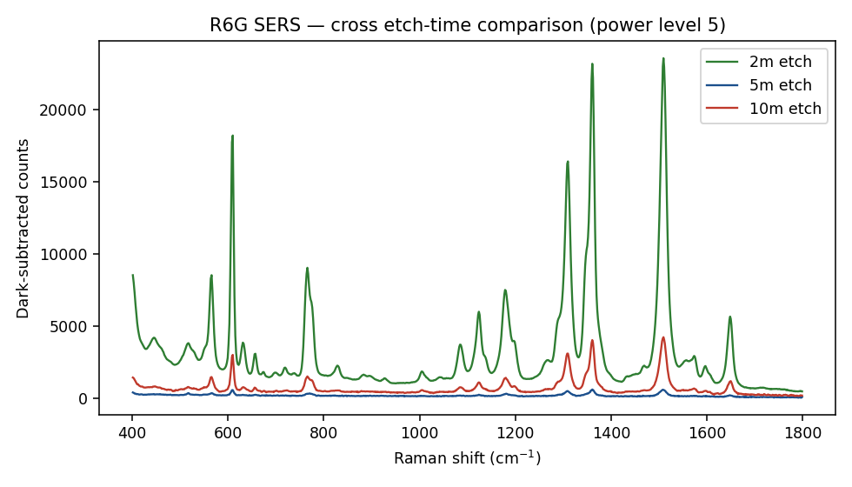
R6G spectra, power level 5, all three etch times overlaid on the same intensity scale. The 2-min sensor's peaks are far taller than 5-min or 10-min.

3.1 2-min sensor
Power | Target cm⁻¹ | Found @ | Height | SNR | Hit (≥3)
P5 | 612 | 610.2 | 15768.7 | 336.1 | YES
P5 | 774 | 765.9 | 7386.1 | 157.4 | YES
P5 | 1183 | 1178.7 | 5548.3 | 118.3 | YES
P5 | 1310 | 1310.0 | 12581.3 | 268.2 | YES
P5 | 1362 | 1360.8 | 20071.9 | 427.8 | YES
P5 | 1509 | 1509.4 | 21117.7 | 450.1 | YES
P5 | 1575 | 1573.3 | 731.1 | 15.6 | YES
P5 | 1650 | 1648.6 | 4597.7 | 98.0 | YES
P10 | 612 | 610.2 | 18077.7 | 317.5 | YES
P10 | 774 | 765.9 | 8591.4 | 150.9 | YES
P10 | 1183 | 1178.7 | 6423.6 | 112.8 | YES
P10 | 1310 | 1310.0 | 14613.3 | 256.7 | YES
P10 | 1362 | 1360.8 | 23452.9 | 411.9 | YES
P10 | 1509 | 1509.4 | 24742.1 | 434.5 | YES
P10 | 1575 | 1573.3 | 852.9 | 15.0 | YES
P10 | 1650 | 1648.6 | 5384.0 | 94.6 | YES

3.2 5-min sensor
Power | Target cm⁻¹ | Found @ | Height | SNR | Hit (≥3)
P5 | 612 | 610.2 | 350.1 | 24.9 | YES
P5 | 774 | 771.0 | 158.8 | 11.3 | YES
P5 | 1183 | 1181.8 | 157.5 | 11.2 | YES
P5 | 1310 | 1308.5 | 297.8 | 21.2 | YES
P5 | 1362 | 1360.8 | 428.7 | 30.5 | YES
P5 | 1509 | 1508.0 | 435.6 | 31.0 | YES
P5 | 1575 | 1574.7 | 32.8 | 2.3 | no
P5 | 1650 | 1647.2 | 101.2 | 7.2 | YES

3.3 10-min sensor
Power | Target cm⁻¹ | Found @ | Height | SNR | Hit (≥3)
P5 | 612 | 610.2 | 2412.1 | 144.2 | YES
P5 | 774 | 765.9 | 1015.9 | 60.7 | YES
P5 | 1183 | 1180.2 | 899.1 | 53.7 | YES
P5 | 1310 | 1310.0 | 2246.2 | 134.2 | YES
P5 | 1362 | 1360.8 | 3340.4 | 199.6 | YES
P5 | 1509 | 1509.4 | 3678.7 | 219.9 | YES
P5 | 1575 | 1573.3 | 168.4 | 10.1 | YES
P5 | 1650 | 1650.0 | 877.7 | 52.5 | YES
P10 | 612 | 610.2 | 4282.3 | 175.8 | YES
P10 | 774 | 765.9 | 1809.5 | 74.3 | YES
P10 | 1183 | 1180.2 | 1599.7 | 65.7 | YES
P10 | 1310 | 1310.0 | 3989.1 | 163.8 | YES
P10 | 1362 | 1360.8 | 5861.7 | 240.6 | YES
P10 | 1509 | 1509.4 | 6447.3 | 264.7 | YES
P10 | 1575 | 1573.3 | 275.2 | 11.3 | YES
P10 | 1650 | 1648.6 | 1541.8 | 63.3 | YES

4. NAM Detection Results
⚠ Verdict: NAM was not detected with confidence on any sensor or power setting, raw or blank-subtracted. No peak reached SNR ≥ 3 consistently, and the two isolated peaks that touched the threshold (930 cm⁻¹ on 10m@P5, 1023 cm⁻¹ on 2m@P10) did not repeat together or across conditions — a single borderline peak is not read as a positive result.

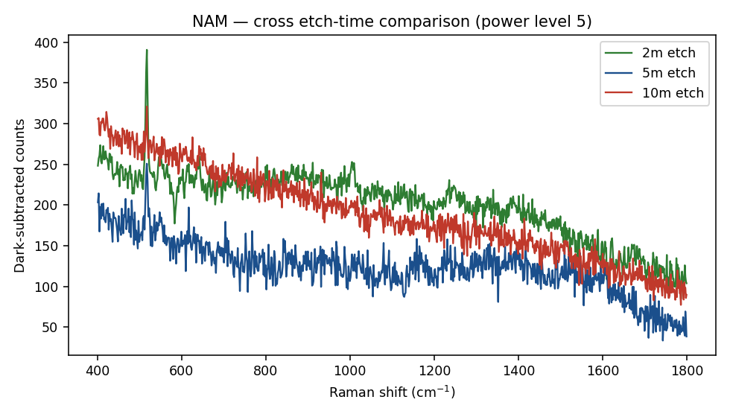
NAM spectra, power level 5, all three etch times. No sharp analyte peaks are visible above the sloping fluorescence-like background. The small spike near 520 cm⁻¹ on the 2-min trace is the crystalline silicon phonon mode (a known substrate feature, not NAM) — it actually confirms the instrument and focus were working correctly.

4.1 2-min sensor (raw, no blank available)
Power | Target cm⁻¹ | Found @ | Height | SNR | Hit (≥3)
P5 | 458 | 447.3 | 12.8 | 1.4 | no
P5 | 488 | 478.1 | 9.1 | 1.0 | no
P5 | 541 | 546.4 | 22.1 | 2.4 | no
P5 | 871 | 861.9 | 18.6 | 2.0 | no
P5 | 930 | 933.0 | 13.3 | 1.4 | no
P5 | 1023 | 1011.1 | 19.6 | 2.1 | no
P5 | 1347 | 1339.9 | 20.2 | 2.2 | no
P5 | 1394 | 1400.6 | 20.9 | 2.2 | no
P10 | 458 | 461.8 | 27.8 | 2.3 | no
P10 | 488 | 483.5 | 27.3 | 2.2 | no
P10 | 541 | 539.2 | 9.0 | 0.7 | no
P10 | 871 | 871.9 | 17.7 | 1.4 | no
P10 | 930 | 933.0 | 16.8 | 1.4 | no
P10 | 1023 | 1028.8 | 37.0 | 3.0 | YES
P10 | 1347 | 1356.3 | 35.7 | 2.9 | no
P10 | 1394 | 1399.2 | 23.9 | 2.0 | no

4.2 5-min sensor (raw)
Power | Target cm⁻¹ | Found @ | Height | SNR | Hit (≥3)
P5 | 458 | 467.2 | 26.4 | 2.2 | no
P5 | 488 | 481.7 | 26.1 | 2.2 | no
P5 | 541 | 548.2 | 30.9 | 2.6 | no
P5 | 871 | 870.3 | 25.1 | 2.1 | no
P5 | 930 | 929.8 | 21.2 | 1.8 | no
P5 | 1023 | 1020.8 | 30.2 | 2.6 | no
P5 | 1347 | 1342.9 | 17.4 | 1.5 | no
P5 | 1394 | 1396.2 | 20.7 | 1.8 | no

4.3 10-min sensor (raw)
Power | Target cm⁻¹ | Found @ | Height | SNR | Hit (≥3)
P5 | 458 | 460.0 | 11.0 | 1.0 | no
P5 | 488 | 483.5 | 14.2 | 1.3 | no
P5 | 541 | 533.9 | 16.3 | 1.5 | no
P5 | 871 | 860.3 | 14.7 | 1.4 | no
P5 | 930 | 931.4 | 35.3 | 3.3 | YES
P5 | 1023 | 1017.5 | 19.8 | 1.8 | no
P5 | 1347 | 1342.9 | 23.9 | 2.2 | no
P5 | 1394 | 1388.9 | 13.3 | 1.2 | no
P10 | 458 | 467.2 | 2.3 | 0.2 | no
P10 | 488 | 485.3 | 18.5 | 1.3 | no
P10 | 541 | 539.2 | 10.0 | 0.7 | no
P10 | 871 | 863.6 | 25.1 | 1.7 | no
P10 | 930 | 938.0 | 29.7 | 2.0 | no
P10 | 1023 | 1019.1 | 34.6 | 2.3 | no
P10 | 1347 | 1335.4 | 34.8 | 2.4 | no
P10 | 1394 | 1393.3 | 36.0 | 2.4 | no

4.4 Blank-subtracted NAM (5-min and 10-min only)
Subtracting the settings-matched blank from the NAM spectrum isolates signal that isn't just substrate/fluorescence background. Even with this subtraction, no peak reaches SNR ≥ 3 across both sensors and both power levels — the result holds up either way.

5m, power 5
Target cm⁻¹ | Found @ | Height | SNR | Hit (≥3)
458 | 467.2 | 23.6 | 1.2 | no
488 | 483.5 | 25.2 | 1.3 | no
541 | 548.2 | 50.3 | 2.6 | no
871 | 870.3 | 43.4 | 2.2 | no
930 | 933.0 | 42.1 | 2.2 | no
1023 | 1030.4 | 33.5 | 1.7 | no
1347 | 1353.3 | 33.4 | 1.7 | no
1394 | 1396.2 | 44.5 | 2.3 | no

10m, power 5
Target cm⁻¹ | Found @ | Height | SNR | Hit (≥3)
458 | 449.1 | 35.9 | 2.2 | no
488 | 476.3 | 17.5 | 1.1 | no
541 | 533.9 | 19.8 | 1.2 | no
871 | 873.6 | 26.7 | 1.6 | no
930 | 931.4 | 19.8 | 1.2 | no
1023 | 1011.1 | 27.7 | 1.7 | no
1347 | 1356.3 | 27.4 | 1.7 | no
1394 | 1388.9 | 18.8 | 1.1 | no

10m, power 10
Target cm⁻¹ | Found @ | Height | SNR | Hit (≥3)
458 | 458.2 | 49.2 | 2.6 | no
488 | 485.3 | 36.6 | 1.9 | no
541 | 533.9 | 11.4 | 0.6 | no
871 | 863.6 | 35.3 | 1.8 | no
930 | 924.8 | 33.6 | 1.7 | no
1023 | 1025.6 | 55.7 | 2.9 | no
1347 | 1354.8 | 22.1 | 1.2 | no
1394 | 1405.0 | 44.0 | 2.3 | no

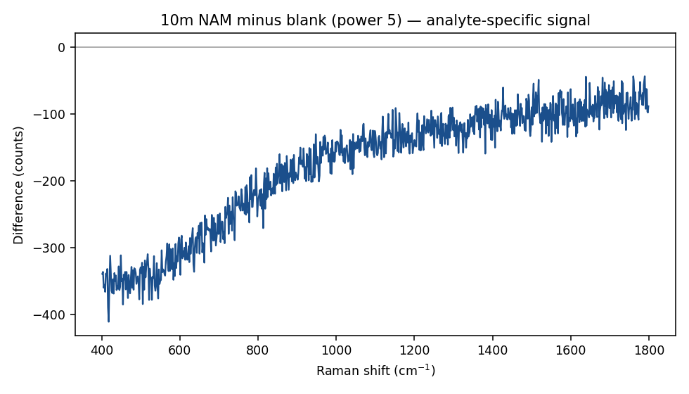
10-min sensor, NAM minus blank (power 5). The steady downward slope across the whole range is the background mismatch discussed in Section 6 — it reflects the blank being recorded in a separate, earlier session, not a NAM feature.

5. Etch Time vs. SERS Enhancement
R6G gives a clean, high-signal way to compare the three etch times against each other, independent of whether NAM capture works. Using the strongest R6G band (1509 cm⁻¹) as the yardstick:
Etch time | 1509 cm⁻¹ height | 1509 cm⁻¹ SNR | Relative to 5-min
2 min | 21117.7 | 450.1 | 48x
5 min | 435.6 | 31.0 | 1x (reference)
10 min | 3678.7 | 219.9 | 8x

Same power level (5), same molecule, same concentration, same integration time — so this is a fair comparison of substrate enhancement only.
The 2-minute etch outperforms both longer etch times by a wide margin, and 10-minute outperforms 5-minute. This is not a small effect — it's over an order of magnitude between the best and worst condition. A plausible explanation, consistent with the DOE strategy report from earlier this month: shorter MACE etching tends to leave smaller, more closely-packed Ag nanoparticles with a higher density of sub-5 nm gaps ("hotspots"), while longer etching can coarsen particles and widen gaps beyond the electromagnetic-enhancement sweet spot. The non-monotonic 5-min vs 10-min result (10-min beating 5-min) suggests etch time alone doesn't tell the whole story — spot-to-spot variation on a single piece, or differences in exactly which nanostructure regime each time falls into, are also likely contributing.
Caveat: this is one substrate piece per etch time (n=1 at the substrate level), so it shows a real, large signal difference today but not yet proof of reproducibility. Repeating the 2-min etch on a fresh piece is the natural next check.

6. Blank Data — What's Missing and Why It Matters

6.1 2-min sensor: no blank at all
⚠ Confirmed by file search — there is no empty/bare-substrate spectrum anywhere in today's data for the 2-min sensor. Every NAM and R6G reading on this piece is raw, with no substrate-only reference to subtract.

This doesn't invalidate the R6G result (the peaks are so far above any plausible background that no blank is needed to see them). It does mean the NAM result on this sensor can't be checked against its own background — only the raw peak table in Section 4.1 is available, not the more rigorous blank-subtracted version done for 5-min and 10-min.

6.2 5-min and 10-min: blanks exist, but are not time-matched
The blanks used for Section 4.4 were pulled from an early-morning power-level calibration scan (around 05:00-08:30), filtered down to the one file at each sensor that happens to match today's final settings exactly (5 s integration, power 5, or power 10 for 10-min). The actual NAM/R6G measurements were taken later the same day, roughly 15:20-16:10. That's a same-day but not same-session blank.
The effect shows up directly in Figure (Section 4.4): the NAM-minus-blank difference has a large, steady downward slope across the whole spectral range rather than sitting flat around zero. That slope is background drift between the two sessions — different ambient light, slightly different focus/alignment, or fluorescence differences — not a real spectral feature. The SNR values reported use a local baseline around each peak (not the sloping global offset), so the peak-detection conclusion in Section 4 is not compromised by this, but it does mean the blank subtraction is weaker evidence than a true back-to-back paired blank would be.

6.3 Fix for next time
This is exactly what the measurement worksheet already built for today recommends: take the blank immediately before the sample, at the exact settings you'll use for the sample, on the same visit. Two concrete actions:
- Get a same-session blank for the 2-min piece before it's used again — even a quick one at power 5, 5 s integration would let today's NAM result be background-subtracted retroactively for comparison.
- Going forward, always bracket a sample measurement with a blank at the same settings taken right before it, not reused from an earlier calibration run.

7. Why NAM Likely Wasn't Detected Today
This result is not surprising, and is consistent with what the DOE strategy report and technology-comparison report (both built earlier this month) predicted for a bare-Ag substrate:
- Weak, non-resonant Raman cross-section: NAM has no thiol, no aromatic ring, and its nitrogen is blocked as an amide — none of the strong-scattering or Ag-affinity features R6G has. Its Raman signal is intrinsically far weaker even before any SERS enhancement is applied.
- No capture chemistry on the surface today: per the run sheet, today's substrates were bare Ag — no MPBA/boronic-acid layer to pull NAM's diol groups onto the metal surface and hold it in the hotspot region. Without a capture layer, NAM molecules simply aren't concentrated at the enhancement sites the way R6G (which adsorbs directly and strongly to Ag) is.
- This is the expected bare-Ag control result: the technology-comparison report identified bare-Ag + free NAM as the condition most likely to fail, and flagged boronic-acid functionalization as the top-ranked fix. Today's result is consistent with, not contrary to, that prediction — it's a valid negative control, not a fabrication failure.
✓ Read together with Section 3, today's data separates the two possible failure modes cleanly: the substrate itself is SERS-active (R6G proves this), so if NAM continues to be undetectable after adding capture chemistry, the substrate won't be the suspect — the capture step will be.

8. Recommended Next Steps
- Adopt 2-min etch as the primary condition. It gave the strongest R6G SERS signal by a wide margin. Repeat it on a fresh piece to confirm reproducibility before locking it in as the standard recipe.
- Get a matched blank for the 2-min sensor so its NAM data can be background-subtracted like the other two.
- Move to boronic-acid (MPBA) functionalized Ag for the next NAM attempt. Bare-Ag has now been tested at all three etch times with a consistent negative result — the next variable to change is the capture chemistry, not the etch time.
- Bracket every future sample with a same-session blank at identical settings, taken immediately before the sample — per the measurement worksheet already prepared.
- If NAM is still undetectable after adding capture chemistry, consider raising the NAM concentration and/or integration time, since its cross-section is weak enough that even a working capture layer may need more integration time than R6G to reach a comparable SNR.

