Biomarker Raman/SERS Imaging Report
Pure-Standard, Experiment and Merged Spectra — NAM, LPS and LTA
____________________________________________________________

Sukesh P (M24IM1007) | M.Tech, Joint IDRP, IIT Jodhpur & AIIMS Jodhpur
Work package within: "Intelligent Sensor System for Early Prediction of Sepsis in Neonates and High-Risk Adults" | PI: Prof. Ajay Agarwal, IITJ | Co-PI: Prof. (Dr.) Neeraj, AIIMS Jodhpur

Introduction
This report collects, biomarker by biomarker, the pure-standard (off-substrate) reference image, the SERS experiment image, and a merged/overlay image comparing the two, for each of the three bacterial biomarkers targeted in this project — NAM, LPS and LTA — followed by a general experiments section covering the sensor-validation images (R6G, blank substrate, instrument reference). Where an image does not yet exist, this is stated explicitly rather than left blank, so that outstanding imaging needs are clear.

1. N-Acetylmuramic Acid (NAM)

1.1 Pure NAM — reference images
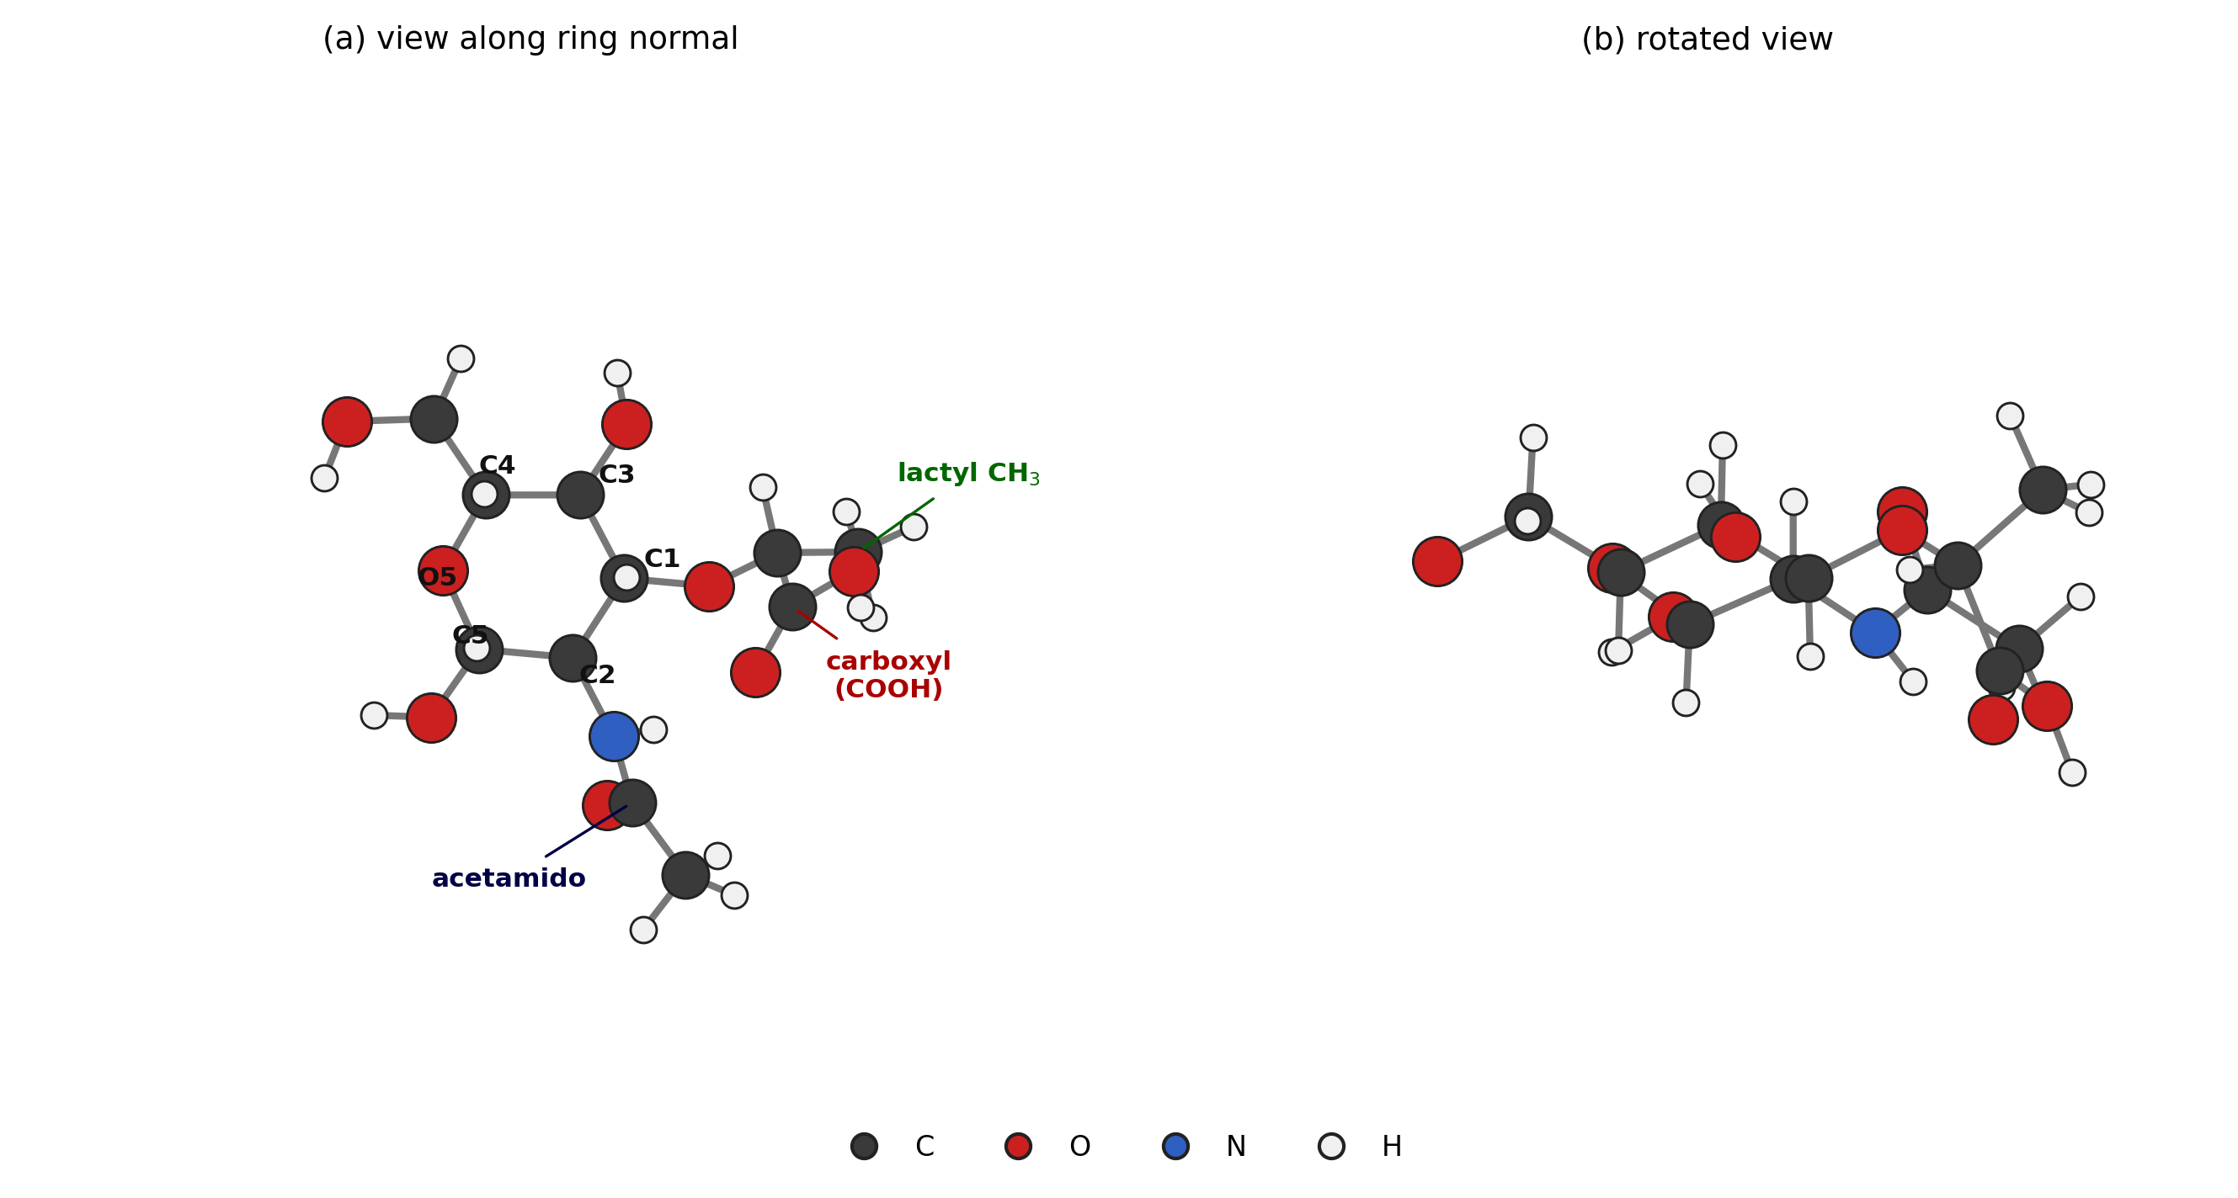
Figure 1a. DFT-optimised molecular structure of NAM (β anomer), two views.
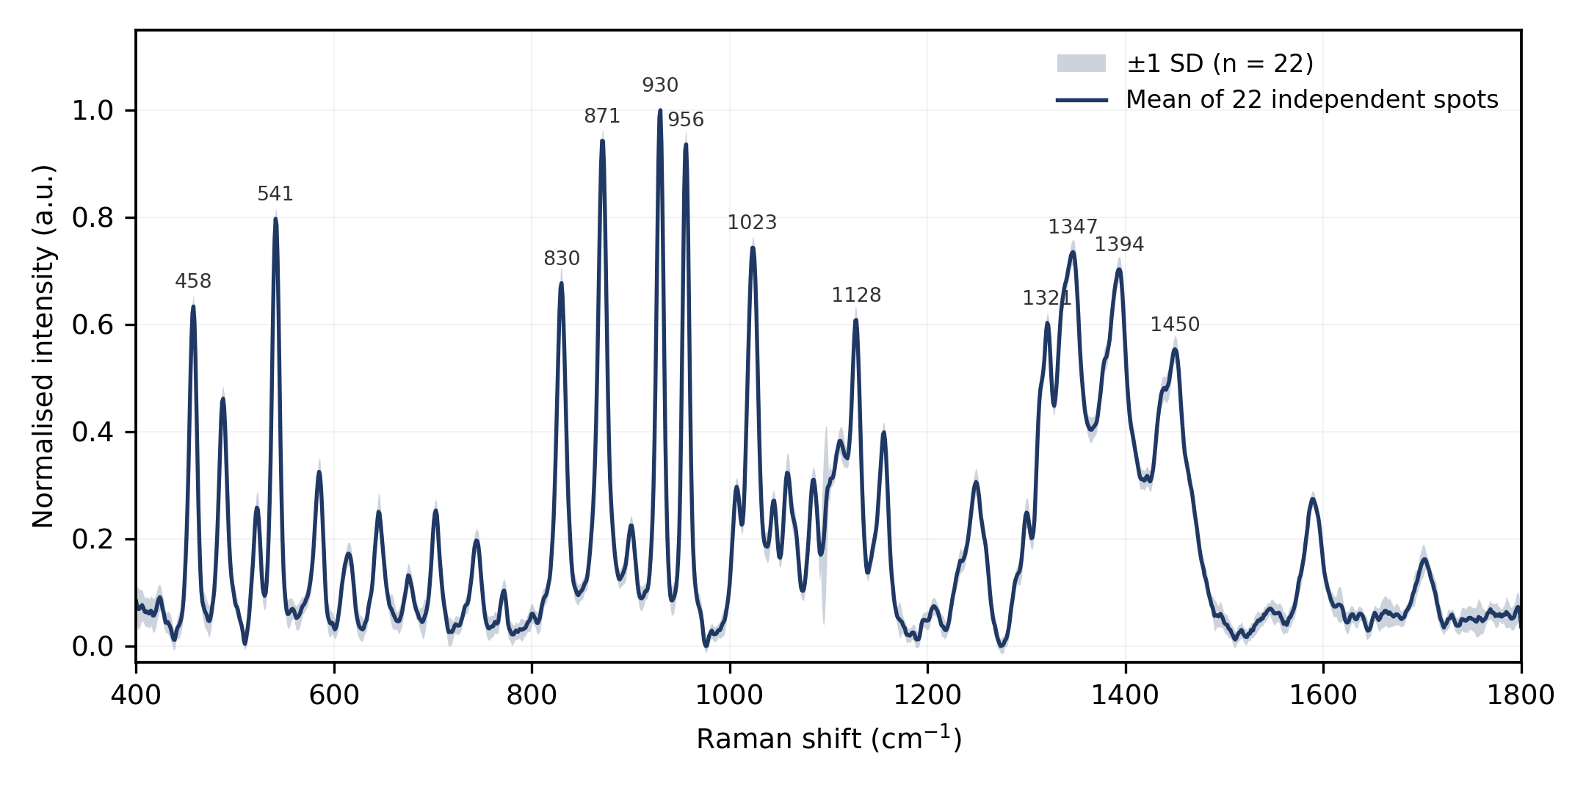
Figure 1b. Pure NAM reference Raman spectrum (off-substrate, powder on glass), mean ± SD from 22 independent measurements.

1.2 NAM — SERS experiment images
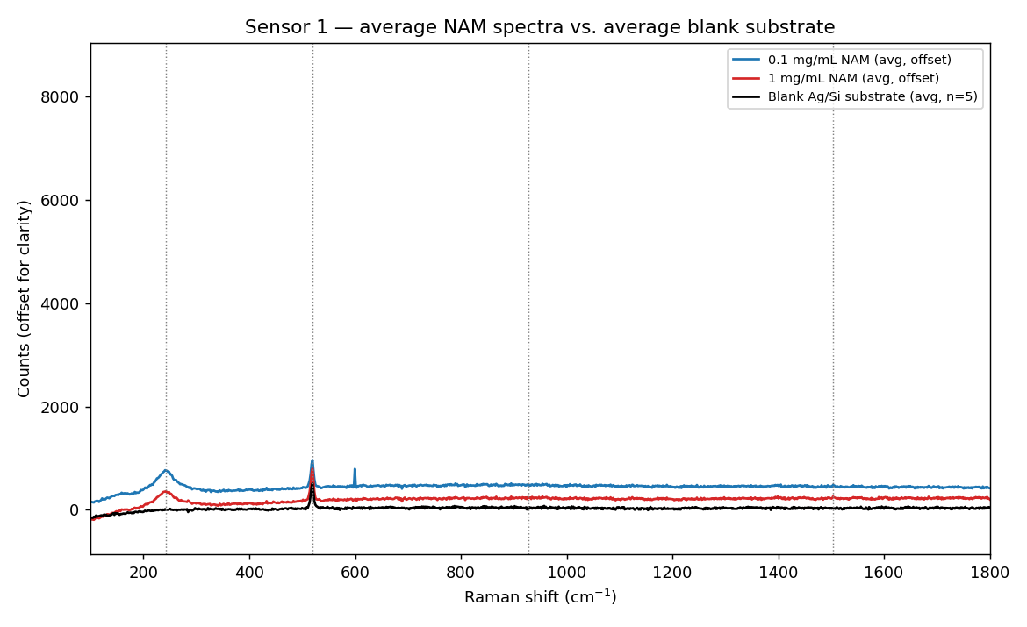
Figure 1c. NAM on Sensor 1 (Ag/Si, early substrate) vs. blank substrate.
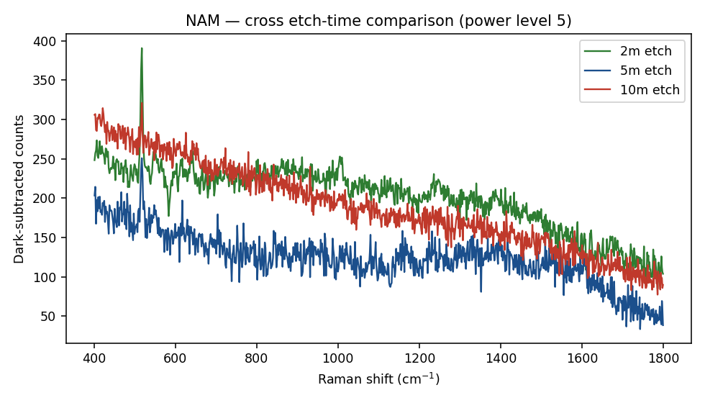
Figure 1d. NAM on Sensor 2 (Ag/black-Si, MACE) — compared across all three etch-time substrates.

1.3 NAM — merged (pure reference vs. experiment) images
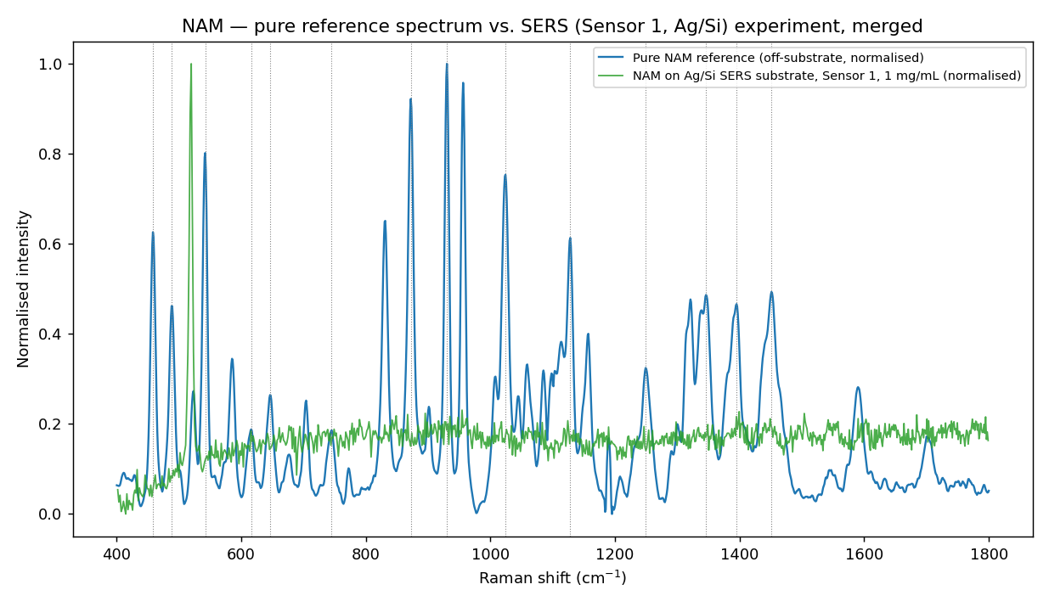
Figure 1e. Merged overlay — pure NAM reference spectrum vs. Sensor 1 SERS experiment (1 mg/mL NAM), both normalised.
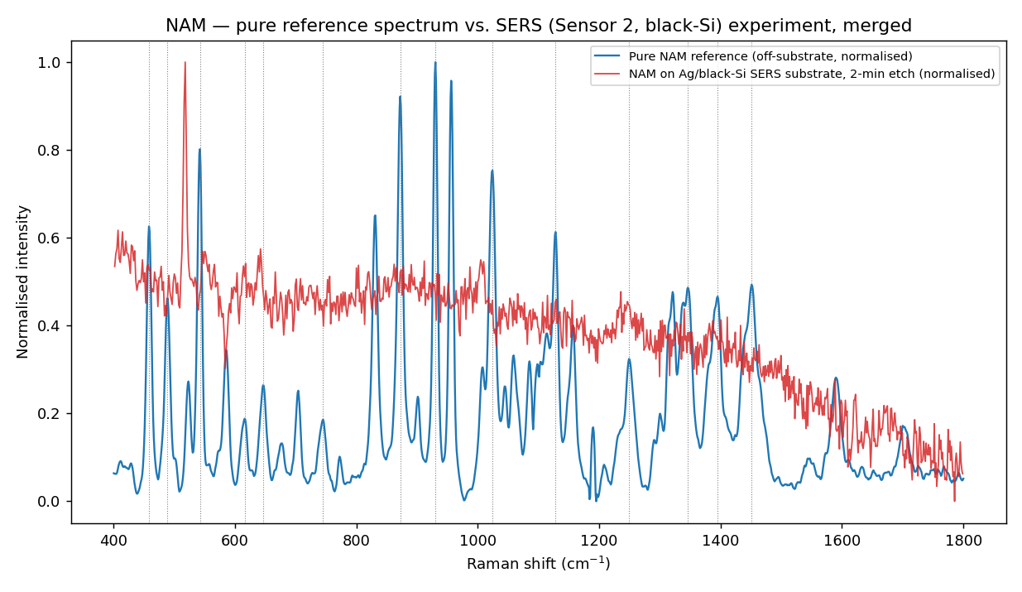
Figure 1f. Merged overlay — pure NAM reference spectrum vs. Sensor 2 SERS experiment (2-min black-Si substrate), both normalised.
The merged views make the result visually explicit: the pure reference spectrum (blue) shows many sharp, well-defined bands, while the corresponding SERS traces (green/red) show no matching structure at the same positions — only noise and, on Sensor 2, the silicon substrate phonon near 520 cm⁻¹.

1.4 Result
Sensor | Result
Sensor 1 (Ag/Si) | One reproducible, tentative candidate feature at ~243 cm⁻¹ (7/7 replicates, SNR 5.8–39), outside the range covered by the pure reference spectrum (400–1800 cm⁻¹) and therefore not confirmable against it. Weak ~928/~1504 cm⁻¹ candidates at SNR ≈ 1–3, not accepted.
Sensor 2 (Ag/black-Si, MACE) | No target band from the validated reference list (458, 488, 542, 616, 646, 745, 872, 930, 1024, 1128, 1249, 1346, 1395, 1451 cm⁻¹) reached SNR ≥ 3 reproducibly on any of the three etch-time substrates, at either laser power, raw or blank-subtracted.
Overall | NAM not yet reproducibly detected on either sensor generation. R6G control confirms both sensors are SERS-active, so the null result is attributed to NAM's intrinsic Raman/adsorption properties (Part V of the Consolidated NAM Report), not instrument or substrate failure.

2. Lipopolysaccharide (LPS)

2.1 Pure LPS — reference image
NOT CONFIRMED — Not yet available. No pure/off-substrate LPS Raman spectrum has been experimentally recorded in this project. LPS has been investigated only at the literature/planning level so far (Experiment_Plan_LPS, LPS_Substrate_Strategy documents). This slot will be filled once pure-LPS Raman data is acquired.

2.2 LPS — SERS experiment image
NOT CONFIRMED — Not yet available. No LPS has been deposited on a SERS substrate in this project to date.

2.3 LPS — merged image
NOT CONFIRMED — Not applicable until 2.1 and 2.2 exist.

2.4 Result
LPS remains at the biomarker-selection / literature-review stage (Phase 1(a) of the parent project). No experimental Raman or SERS data has been collected for LPS. This section will be completed once pure-standard and SERS measurements are available — flag for guidance on which LPS source/preparation to image first.

3. Lipoteichoic Acid (LTA)

3.1 Pure LTA — reference image
NOT CONFIRMED — Not yet available. No pure/off-substrate LTA Raman spectrum has been recorded. Only a SERS-substrate attempt exists (Section 3.2). This slot will be filled once pure-LTA Raman data is acquired, following the same protocol used for the NAM reference study.

3.2 LTA — SERS experiment images
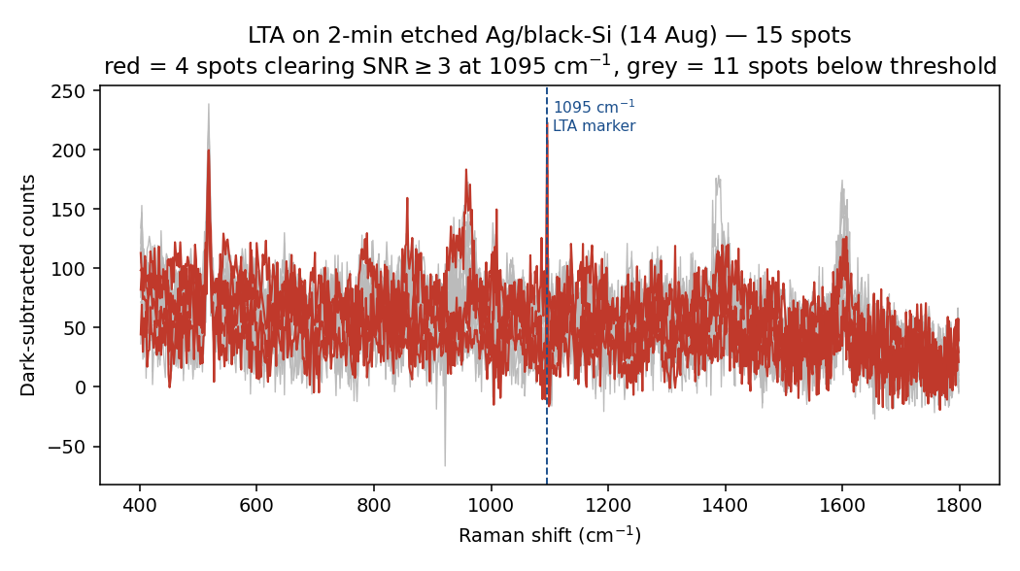
Figure 3a. LTA on Sensor 2 (2-min black-Si substrate) — all 15 measurement spots overlaid.
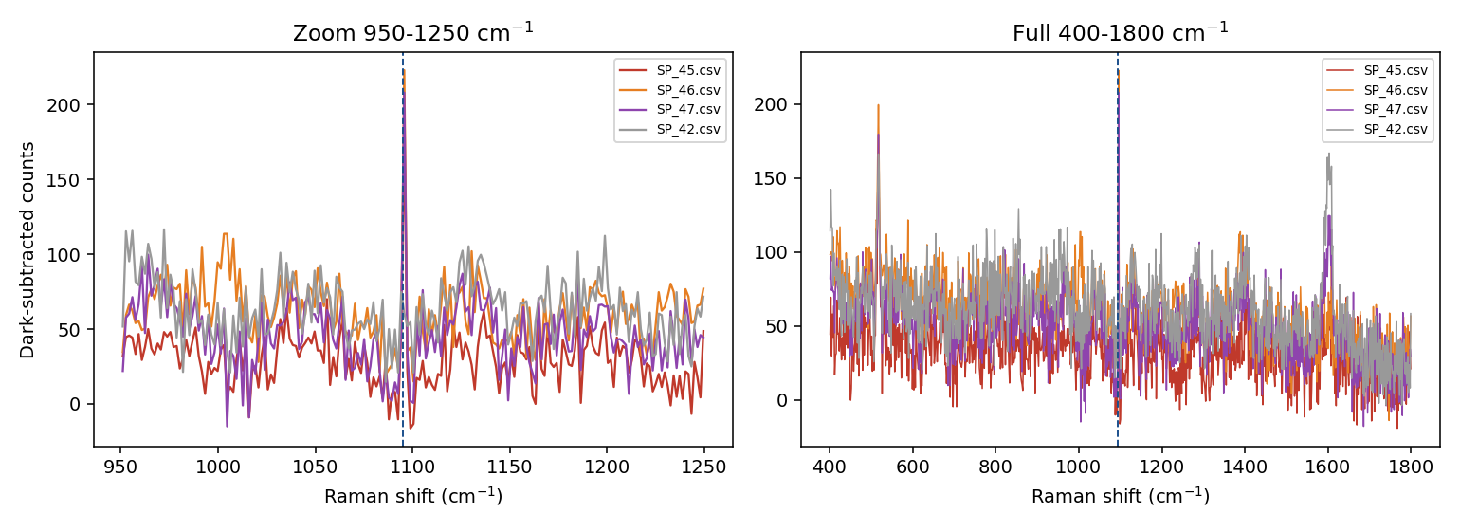
Figure 3b. Pixel-level zoom of the apparent 1095 cm⁻¹ LTA feature (candidate spectra SP_45/46/47), showing the single-detector-pixel origin.

3.3 LTA — merged image
NOT CONFIRMED — Not applicable until a pure LTA reference spectrum (3.1) exists.

3.4 Result
CAUTION — An initial apparent LTA signal (SNR 7–9, 3 of 15 spots) at 1095 cm⁻¹ was traced, on pixel-level inspection, to a single fixed detector pixel rather than a genuine Raman band (real bands span 4–5 pixels on this instrument). Reclassified as NOT DETECTED. This finding produced the minimum 3–5 pixel peak-width criterion now applied to all peak analysis in this project.

4. Experiments — Sensor and Instrument Images
General SERS-sensor validation and instrument-characterisation images, supporting the biomarker-specific results above.

4.1 R6G substrate validation
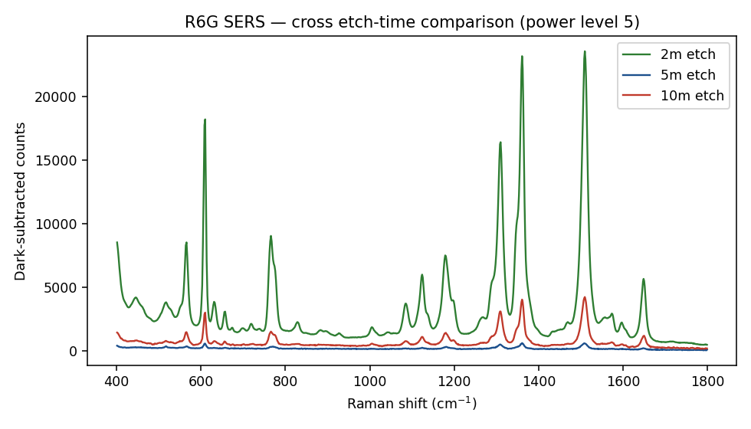
Figure 4a. R6G response, Sensor 2 (black-Si), compared across the 2/5/10-minute etch-time substrates.
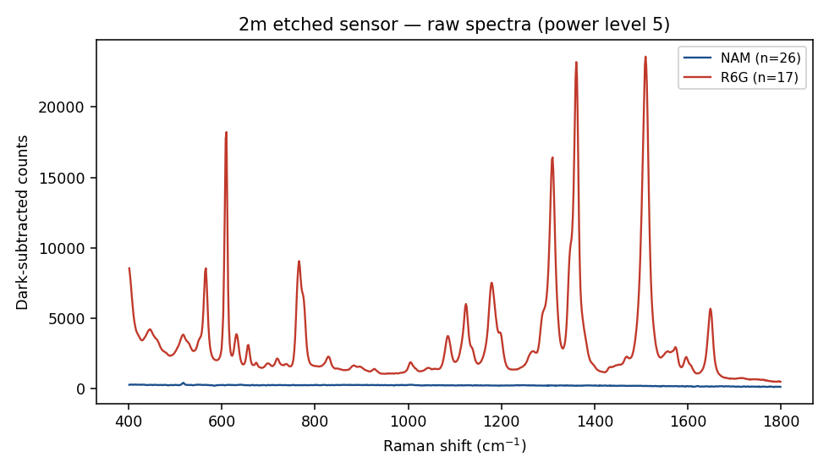
Figure 4b. R6G and NAM spectra overlaid on the best-performing substrate (2-min etch, Sensor 2).
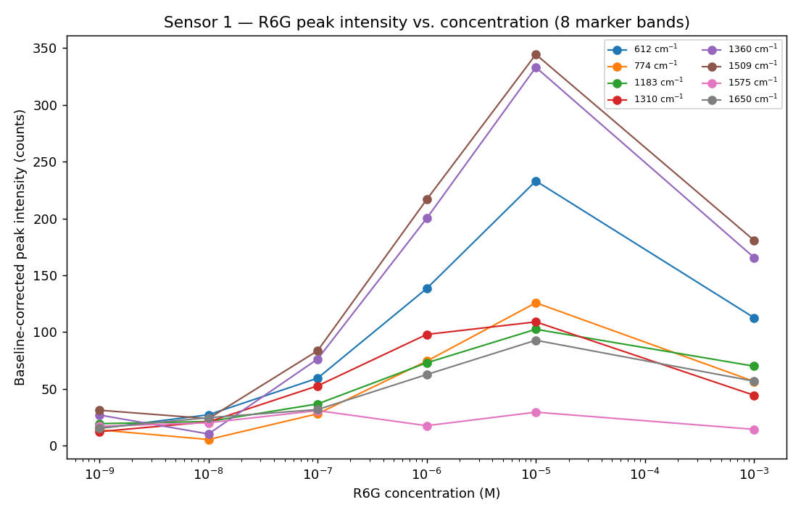
Figure 4c. R6G concentration response, Sensor 1 (Ag/Si), 1 nM–1 mM.

4.2 Blank substrate
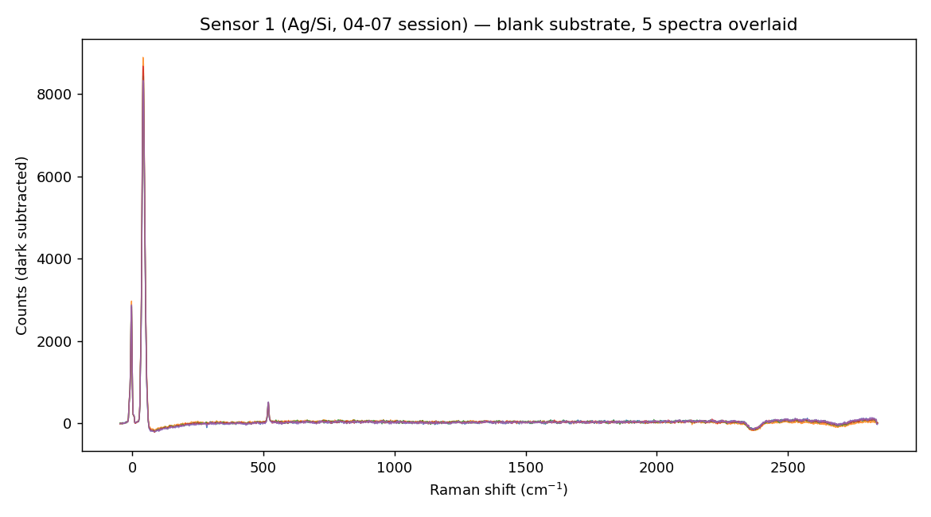
Figure 4d. Sensor 1 — five blank-substrate spectra overlaid.

4.3 Instrument / silicon reference
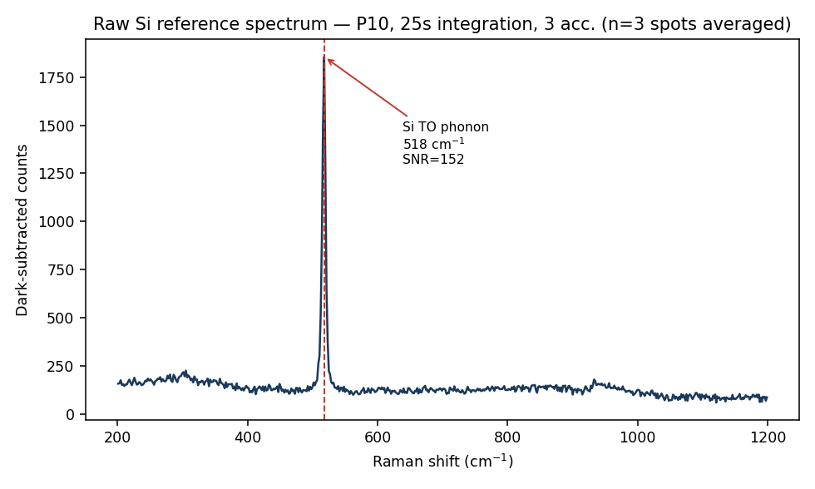
Figure 4e. Unetched-silicon reference spectrum (highest-signal condition), used for wavenumber calibration and peak-width criteria.
NOT CONFIRMED — Not yet available: substrate fabrication photographs, SEM/AFM morphology images, and any device/chip photographs. These are not Raman-spectral outputs and were not part of the datasets processed so far — please point me to the relevant files, or let me know if these still need to be captured, and I will add them here.

5. Image Inventory Status
Biomarker / item | Pure reference image | Experiment (SERS) image | Merged image
NAM | Available (structure + reference spectrum) | Available (Sensor 1 and Sensor 2) | Available (both sensors)
LPS | Not available | Not available | Not applicable
LTA | Not available | Available (overlay + pixel-artefact zoom) | Not applicable (no pure reference yet)
R6G (validation analyte) | N/A — reference compound, not a biomarker | Available (both sensors) | N/A
Substrate morphology (SEM/AFM/photo) | Not available | — | —

This table is intended as a working checklist. Please guide me to any additional images (raw data, photographs, or instrument screenshots) you would like added, and I will incorporate them into this document without altering the other project reports.

