Fabrication and Evaluation of Ag/Black-Silicon SERS Substrates for Detection of Bacterial Cell-Wall Biomarkers
Consolidated Experimental Report — All Sessions, Observations, Graphs and Results
____________________________________________________________

Sukesh P (M24IM1007) | M.Tech, Joint IDRP, IIT Jodhpur & AIIMS Jodhpur
Supervisor: Prof. Ajay Agarwal

1. Introduction and Objectives
Sepsis diagnosis would benefit substantially from rapid, label-free detection of bacterial cell-wall biomarkers in clinical samples. N-acetylmuramic acid (NAM, MurNAc) is a peptidoglycan component common to essentially all bacteria and absent from human cells, making it an attractive target marker. Lipopolysaccharide (LPS, from Gram-negative bacteria) and lipoteichoic acid (LTA, from Gram-positive bacteria) are being pursued in parallel as complementary markers. Surface-enhanced Raman spectroscopy (SERS) offers a route to label-free molecular detection with high sensitivity, provided a suitable plasmonic substrate is available.
This report consolidates all experimental work carried out to date on silver-decorated black-silicon SERS substrates fabricated by metal-assisted chemical etching (MACE), across three measurement sessions. It presents the observations, graphs and quantitative results from each session and draws the resulting conclusions.
- Fabricate silver-decorated black-silicon SERS substrates by one-step MACE and determine the effect of etch time on SERS enhancement.
- Validate the fabricated substrates using Rhodamine 6G (R6G) as a reference analyte.
- Attempt label-free detection of NAM on these substrates.
- Establish an instrument reference/calibration dataset using unetched silicon.
- Attempt a first detection of LTA as a second biomarker.
- Where detection was not achieved, determine the cause rigorously and establish whether the limitation lies in the substrate, the measurement, or the analyte.
KEY — Principal outcome across all sessions: the substrates were confirmed to be strongly SERS-active (R6G signal-to-noise ratios up to 450), the instrument and analysis procedure were independently validated on unetched silicon, but NAM was not reproducibly detected and an initial apparent LTA signal was traced to a detector artefact rather than a real band. Section 8 sets out why, on the evidence gathered, this is attributable to the molecular properties of NAM rather than to a non-functional substrate or instrument.

2. Materials and Methods

2.1 Substrate fabrication
Silicon pieces were cleaned sequentially in acetone, 2-propanol and deionised water (5 min ultrasonic agitation in each), then dried. Immediately before etching, the native oxide was removed by a brief immersion in dilute hydrofluoric acid (approximately 10% HF, 30–60 s), followed by a deionised water rinse.
Substrates were fabricated by one-step MACE: silver nitrate (0.170 g) was dissolved in deionised water, concentrated hydrofluoric acid (8.6 mL) was added, and the solution was made up to a final volume of 50 mL, giving nominal concentrations of approximately 20 mM AgNO₃ and 4.8 M HF. In this single-step process silver is galvanically reduced onto the silicon surface while the underlying silicon is simultaneously oxidised and dissolved by HF, so silver deposition and silicon nanostructuring occur concurrently and are not independently controllable. Three etch times were investigated at room temperature: 2, 5 and 10 minutes. Substrates were rinsed thoroughly in deionised water and dried before use.
CAUTION — All work involving hydrofluoric acid was carried out in a fume hood using polypropylene or PTFE labware, with double gloves incorporating an HF-rated outer layer, face shield, calcium gluconate gel available on site, and never alone. Silver-bearing waste was segregated from the general acid waste stream.

2.2 Analyte preparation
Analyte | Preparation | Concentration(s) examined
Rhodamine 6G (R6G) | Aqueous solution | 0.1, 0.01, 0.001 mM
N-acetylmuramic acid (NAM) | Dissolved in deionised water | 1 mg/mL (3.41 mM; MW 293.27 g/mol)
Lipoteichoic acid (LTA) | Aqueous solution, S. aureus source | As prepared

Analyte solutions were deposited on the substrate surface as microlitre droplets and allowed to dry before measurement. The black-silicon surface is strongly hydrophilic, and droplet spreading during drying was noted as a methodological concern (Section 8.5).

2.3 Raman acquisition
Spectra were acquired using a 785 nm dispersive Raman spectrometer (B&W Tek i-Raman Plus, BWS465-785H spectrometer with BTC665N-785H-SYS probe; actual laser wavelength 784.92 nm). Unless stated otherwise, acquisition used 5 s integration with 3 accumulations averaged in the instrument, over the range 400–1800 cm⁻¹ (full-range scans to 3000 cm⁻¹ were also taken for the silicon reference dataset). Two instrument laser-power settings (nominally levels 5 and 10 on the instrument's arbitrary scale) were used for the substrate/analyte sessions; the silicon reference session additionally examined level 1. The absolute optical power in mW corresponding to these levels has not yet been confirmed and remains an open item. Multiple spatially separated spots were measured for every sample.

2.4 Data analysis and detection criteria
Replicate spectra within each condition were averaged after inspection. Peak identification was carried out against fixed target band lists (the standard R6G SERS bands; for NAM, band positions from a reference Raman study of the isolated molecule; for LTA, the literature phosphate-stretch marker near 1095 cm⁻¹). The following criteria were adopted and applied uniformly across all sessions:
- A peak is counted as detected only where its height above a local flanking baseline exceeds three times the noise standard deviation (SNR ≥ 3), noise being estimated from a peak-free spectral region.
- Detection additionally requires reproducibility across independent measurement spots; a feature appearing at a single spot only is not accepted.
- A substrate blank is recorded in the same session, immediately before each analyte measurement, using identical acquisition parameters, and blank subtraction is checked before accepting a candidate peak.
- A minimum peak-width criterion of three to five detector pixels is applied to reject fixed-pattern detector artefacts (introduced after the finding in Section 6.3).
- Because a systematic wavenumber calibration offset of −2 to −3 cm⁻¹ was found on this instrument (Section 5), a tolerance of ±5 cm⁻¹ is applied when comparing measured peak positions with literature/reference values.

3. Overview of Experiments Performed
Session | Description | Conditions examined | Spectra acquired
Session 1 | Substrate fabrication, R6G validation and NAM detection | 3 substrates (2/5/10 min etch) × R6G and NAM × 2 laser power levels, plus substrate blanks | 177
Session 2 | Unetched silicon reference and instrument characterisation | 13 combinations of laser power (levels 1, 5, 10) and integration time (1–25 s), 3–5 spots each | 45
Session 3 | Lipoteichoic acid (LTA) detection attempt | 2-min etched substrate, 15 spatially separated spots, fixed acquisition settings | 15

A total of 237 spectra were acquired across the three sessions to date. Each session is presented in full in Sections 4–6, followed by a consolidated cross-session analysis of the NAM result (Section 8).

4. Session 1: R6G Validation and NAM Detection

4.1 R6G validation and effect of etch time
All eight of the standard R6G SERS bands (612, 774, 1183, 1310, 1362, 1509, 1575 and 1650 cm⁻¹) were observed on all three substrates (2, 5 and 10 min etch), at both laser power levels, with high signal-to-noise ratios. This establishes that the MACE fabrication produced plasmonically active surfaces and that the Raman acquisition chain was functioning correctly.
Etch time strongly affected enhancement. Using the strongest R6G band (1509 cm⁻¹, laser level 5) as the metric:
Etch time | Peak height at 1509 cm⁻¹ (counts) | SNR | Relative to 5-min substrate
2 min | 21,118 | 450 | ≈48×
5 min | 436 | 31 | 1× (reference)
10 min | 3,679 | 220 | ≈8×

Full peak tables for all eight R6G bands, both power levels and all three etch times:
Etch, power | 612 | 774 | 1183 | 1310 | 1362 | 1509 | 1575 | 1650
2 min, L5 | 336 | 157 | 118 | 268 | 428 | 450 | 16 | 98
2 min, L10 | 318 | 151 | 113 | 257 | 412 | 435 | 15 | 95
5 min, L5 | 25 | 11 | 11 | 21 | 31 | 31 | 2 | 7
10 min, L5 | 144 | 61 | 54 | 134 | 200 | 220 | 10 | 53
10 min, L10 | 176 | 74 | 66 | 164 | 241 | 265 | 11 | 63

Values are signal-to-noise ratios at each R6G target band (cm⁻¹), power level 5 or 10.
The trend is not monotonic — the 10-minute substrate outperformed the 5-minute substrate — indicating that etch time alone does not determine enhancement, and that silver morphology varies in a more complex way with processing conditions than etch duration alone. As only one substrate was fabricated per condition, this establishes a large and reproducible within-substrate difference but does not yet establish fabrication reproducibility between nominally identical substrates.
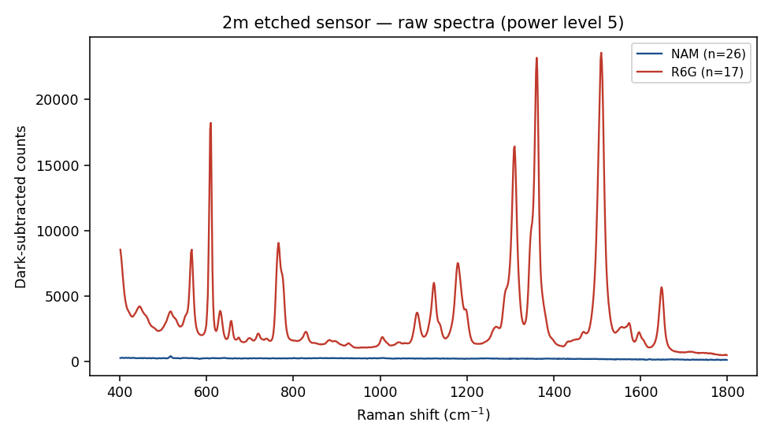
Figure 1. R6G and NAM spectra overlaid on the 2-minute-etched substrate, both laser power levels. R6G bands are prominent; no corresponding NAM features are visible above the baseline.
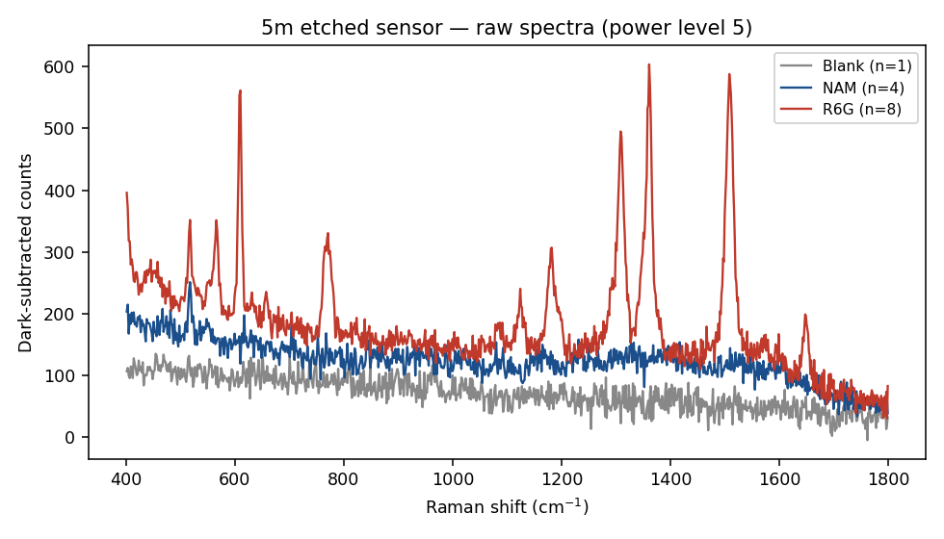
Figure 2. R6G and NAM spectra overlaid on the 5-minute-etched substrate. R6G response is markedly weaker than on the 2-minute substrate.
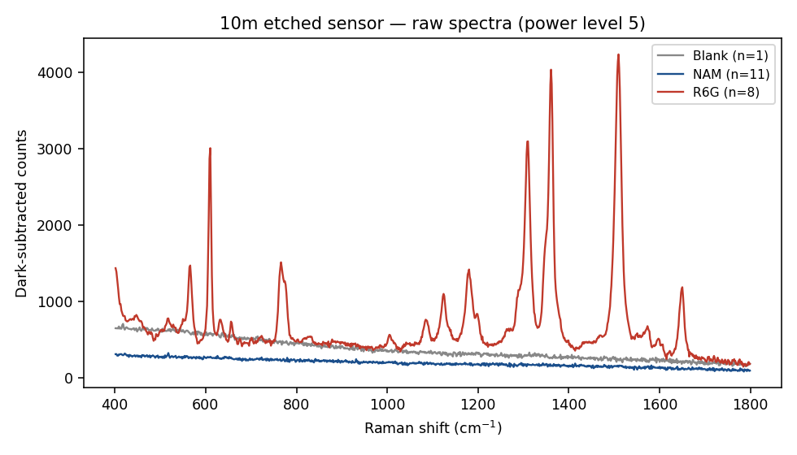
Figure 3. R6G and NAM spectra overlaid on the 10-minute-etched substrate.
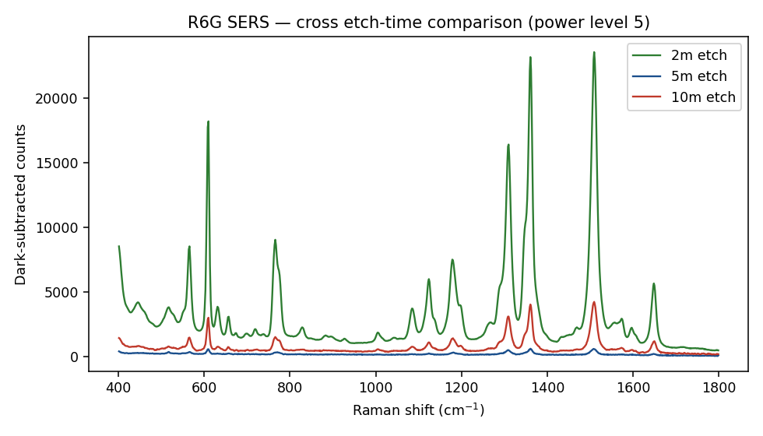
Figure 4. R6G response compared across all three substrates (2/5/10 min etch), showing the non-monotonic dependence on etch time.

4.2 NAM detection attempts
NAM (1 mg/mL, 3.41 mM) was deposited and measured on all three substrates, at both laser power settings, and analysed both as acquired and after subtraction of a substrate blank. Target bands were taken from a reference Raman spectrum of isolated NAM: the strongest and most reproducible features are at 930 cm⁻¹ (ring breathing — the most intense band in the reference spectrum) and 871 cm⁻¹ (CH₂ wagging), with secondary features at 458, 488, 541, 1023, 1347 and 1394 cm⁻¹.
Substrate / power | Highest SNR obtained at any NAM target band | Detection outcome
2 min, level 5 | 2.4 (541 cm⁻¹) | Not detected
2 min, level 10 | 3.0 (1023 cm⁻¹) | Isolated, not reproduced — not accepted
5 min, level 5 | 2.6 (541 and 1023 cm⁻¹) | Not detected
10 min, level 5 | 3.3 (930 cm⁻¹) | Isolated, not reproduced — not accepted
10 min, level 10 | 2.4 (1347 and 1394 cm⁻¹) | Not detected

Only two individual measurements marginally exceeded the SNR ≥ 3 threshold, at 930 cm⁻¹ (10 min, level 5) and 1023 cm⁻¹ (2 min, level 10). Neither was reproduced at other spots on the same substrate, at the other power setting, or on the other substrates — applying the reproducibility requirement, neither is accepted as a detection. Blank subtraction (Section 2.4) did not reveal any band that was absent from the raw spectra; the blank-subtracted peak tables gave the same sub-threshold or non-reproduced result at every NAM target position.
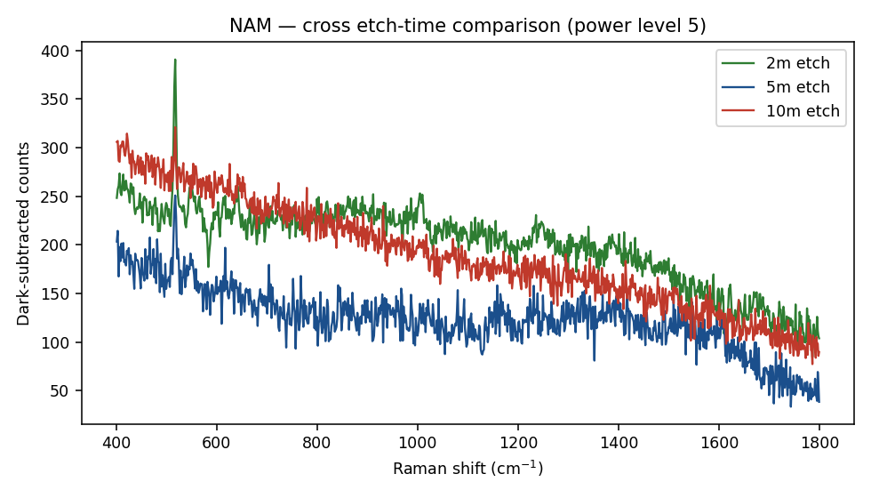
Figure 5. NAM spectra compared across all three substrates — no consistent, reproducible band is visible at any NAM target position.
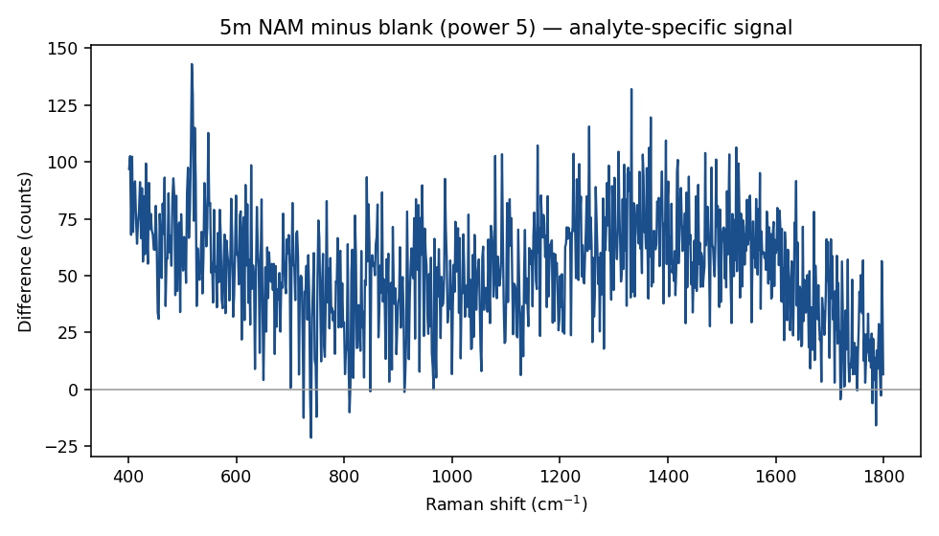
Figure 6. NAM signal on the 5-min substrate after substrate-blank subtraction (level 5). No feature exceeds the SNR ≥ 3 threshold reproducibly.
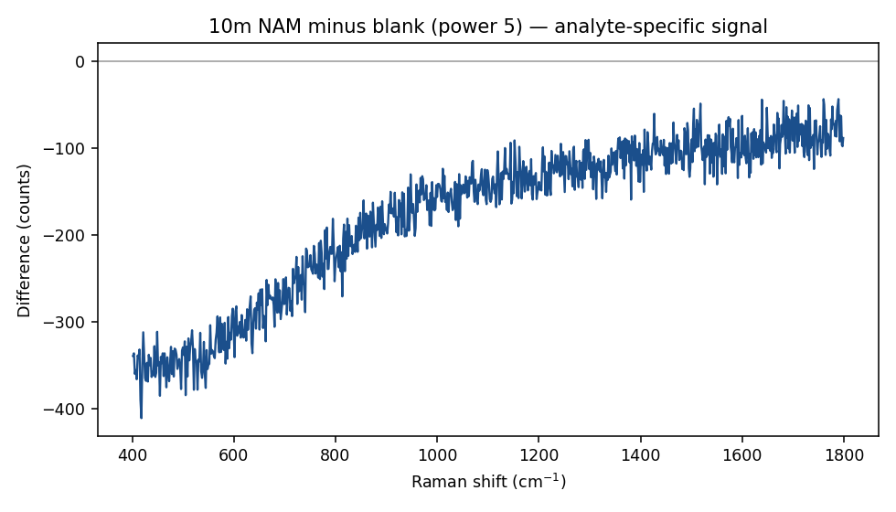
Figure 7. NAM signal on the 10-min substrate after blank subtraction (level 5).
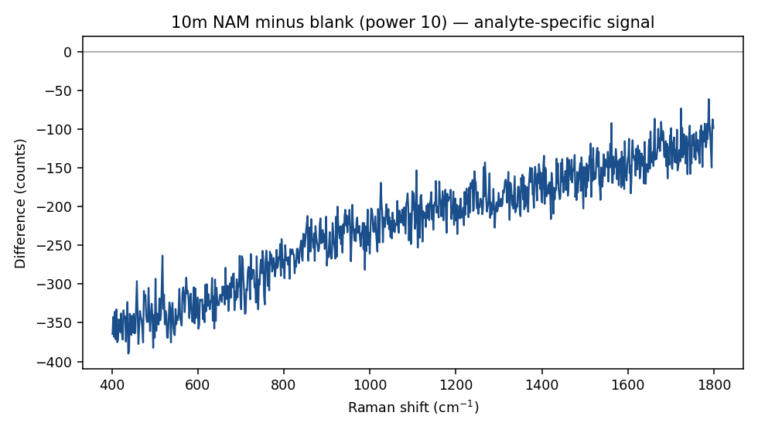
Figure 8. NAM signal on the 10-min substrate after blank subtraction (level 10).

5. Session 2: Unetched Silicon Reference and Instrument Characterisation
To separate substrate/analyte effects from instrument behaviour, a systematic reference dataset was collected on unetched (raw) silicon across 13 combinations of laser power level (1, 5, 10) and integration time (1–25 s), with 3–5 spots per condition (45 spectra total). The crystalline silicon transverse-optical (TO) phonon band, expected near 520–521 cm⁻¹, was used as the reference peak.
Power, integration | n spots | Peak position (cm⁻¹) | Height (counts) | SNR
L1, 1 s | 3 | 517.8 | 32.8 | 2.9
L1, 2 s | 3 | 517.8 | 54.5 | 4.6
L1, 3 s | 3 | 517.8 | 72.1 | 7.8
L5, 5 s | 3 | 517.8 | 194.7 | 15.3
L5, 10 s | 5 | 517.8 | 350.5 | 28.7
L5, 15 s | 4 | 517.8 | 535.5 | 42.0
L5, 20 s | 4 | 517.8 | 728.3 | 54.0
L5, 25 s | 3 | 517.8 | 1084.7 | 91.0
L10, 5 s | 4 | 517.8 | 332.7 | 29.3
L10, 10 s | 3 | 517.8 | 633.0 | 50.0
L10, 15 s | 3 | 517.8 | 789.1 | 79.6
L10, 20 s | 4 | 517.8 | 1135.3 | 120.7
L10, 25 s | 3 | 517.8 | 1727.4 | 152.1

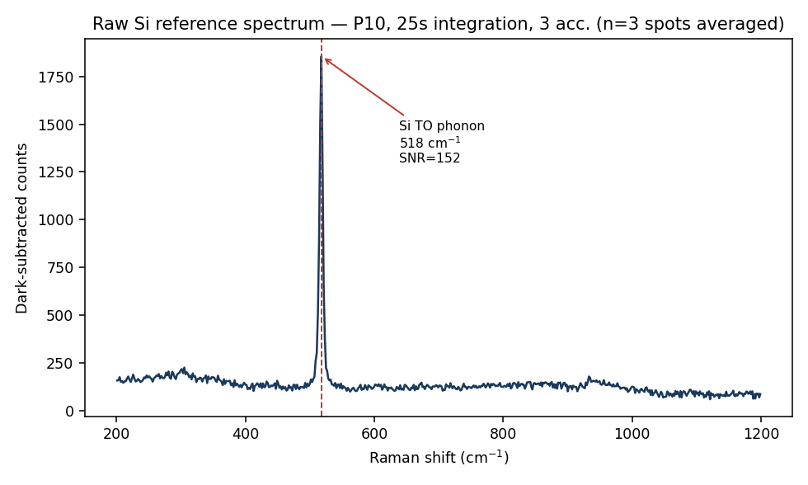
Figure 9. Reference raw-silicon spectrum (highest signal condition, L10/25s) with the TO phonon band annotated.
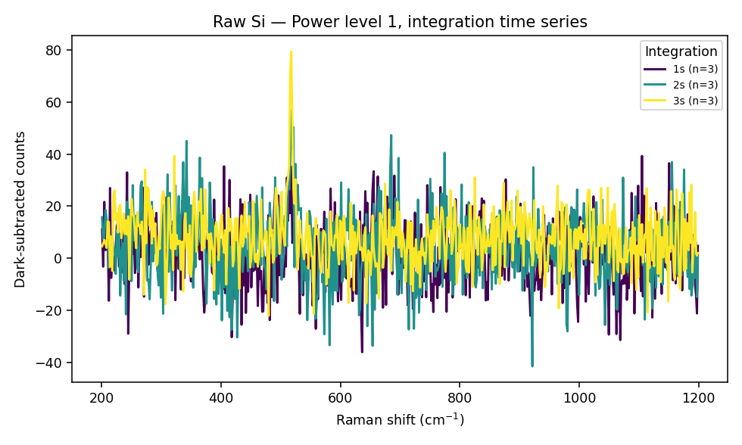
Figure 10. Integration-time series at laser power level 1.
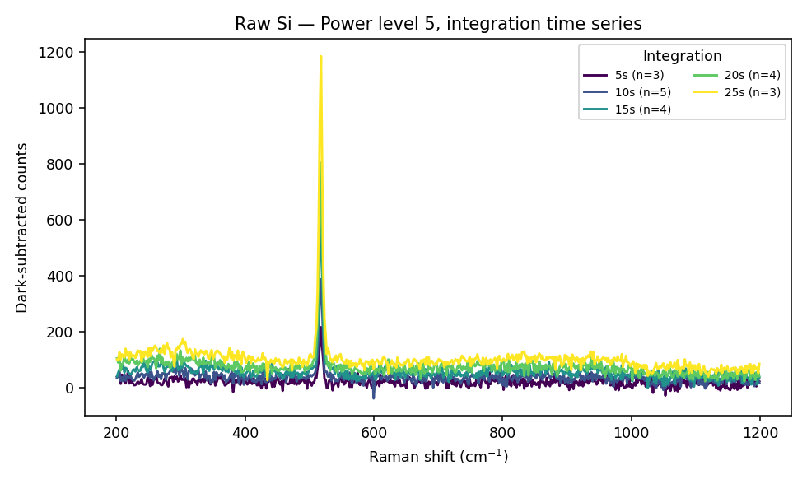
Figure 11. Integration-time series at laser power level 5.
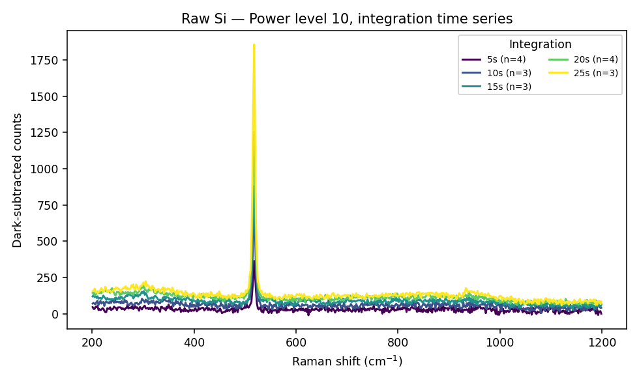
Figure 12. Integration-time series at laser power level 10.
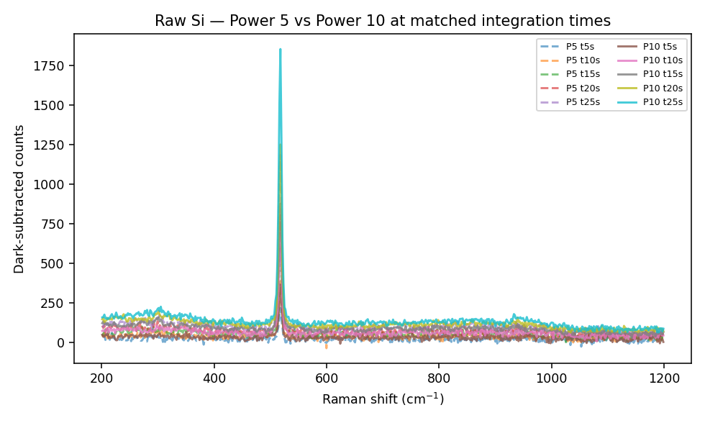
Figure 13. Direct comparison of laser power levels at matched integration time.

5.1 Wavenumber calibration offset
The silicon TO phonon band was found at 517.8 cm⁻¹ in every one of the 13 conditions examined, against an accepted literature value of 520–521 cm⁻¹. Because the offset (−2 to −3 cm⁻¹) is identical across every condition, it represents a fixed instrument calibration shift rather than random measurement error.
KEY — A tolerance of ±5 cm⁻¹ is applied when comparing all measured band positions (R6G, NAM, LTA) with literature or reference values, to account for this fixed offset.

5.2 Peak width and shape (used to define the artefact-rejection criterion)
On the highest-signal reference spectrum (L10, 25 s), the TO phonon band had a measured full width at half maximum (FWHM) of approximately 7.2 cm⁻¹, corresponding to roughly 4–5 detector pixels at this instrument's dispersion. This measurement is the basis for the minimum 3–5 pixel peak-width criterion applied throughout this work (Section 2.4) and used to identify the LTA artefact in Section 6.3.

5.3 Signal linearity and noise scaling with integration time
Peak height increased approximately linearly with integration time at each power level (R² = 0.996 at level 1; R² = 0.970 at level 5; R² = 0.948 at level 10), consistent with simple signal accumulation.
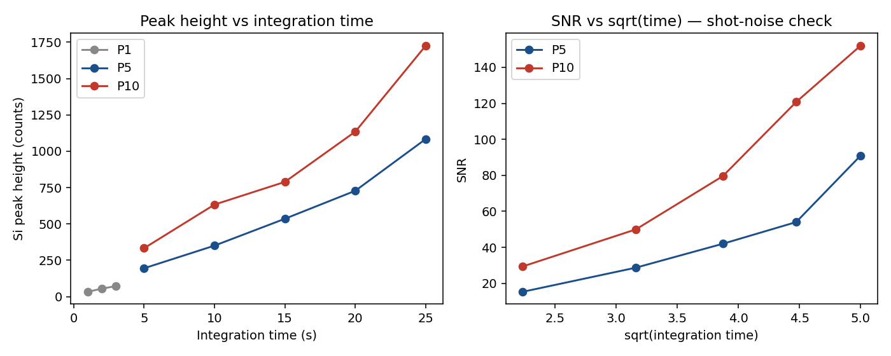
Figure 14. Peak height vs. integration time, all three power levels, with linear fits.
Signal-to-noise ratio, however, scaled faster than the square-root-of-time dependence expected for photon-shot-noise-limited detection. At level 5, SNR rose from 15.3 (5 s) to 91.0 (25 s) — a 5.9-fold increase against a 2.2-fold increase predicted by √t scaling. At level 10, SNR rose from 29.3 to 152.1 over the same integration-time range (5.2-fold vs. 2.2-fold predicted).
RESULT — This indicates a fixed noise floor rather than pure photon-shot-noise limits the SNR at these signal levels, and that extending integration time is an unusually effective strategy for recovering weak analyte signals on this instrument — directly relevant to the NAM and LTA measurements, which used only 5 s integration.

5.4 Full-range scan and second-order silicon bands
A full-range scan (L10, 25 s) was checked against the known second-order silicon Raman features. Weak, sub-threshold features were found near each expected position (305, 607, 956, 1445 and 1819 cm⁻¹; SNR 1.8–4.6), consistent with known second-order silicon scattering and not attributable to any analyte.
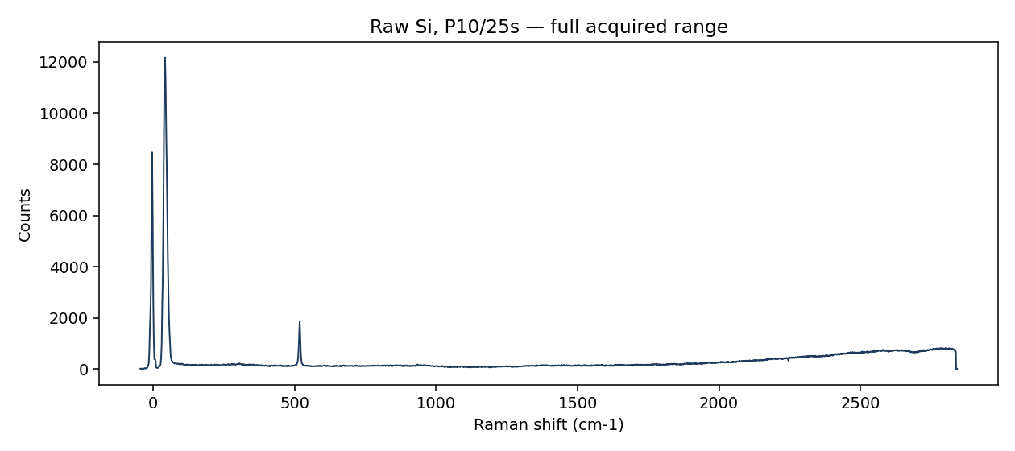
Figure 15. Full-range silicon reference scan (L10, 25 s) with second-order band positions marked.

6. Session 3: Lipoteichoic Acid (LTA) Detection Attempt
A first attempt was made to detect lipoteichoic acid (LTA) on a 2-minute-etched substrate. Fifteen spatially separated spots were measured at fixed acquisition settings, targeting the phosphate-stretch marker reported in the literature near 1095 cm⁻¹.
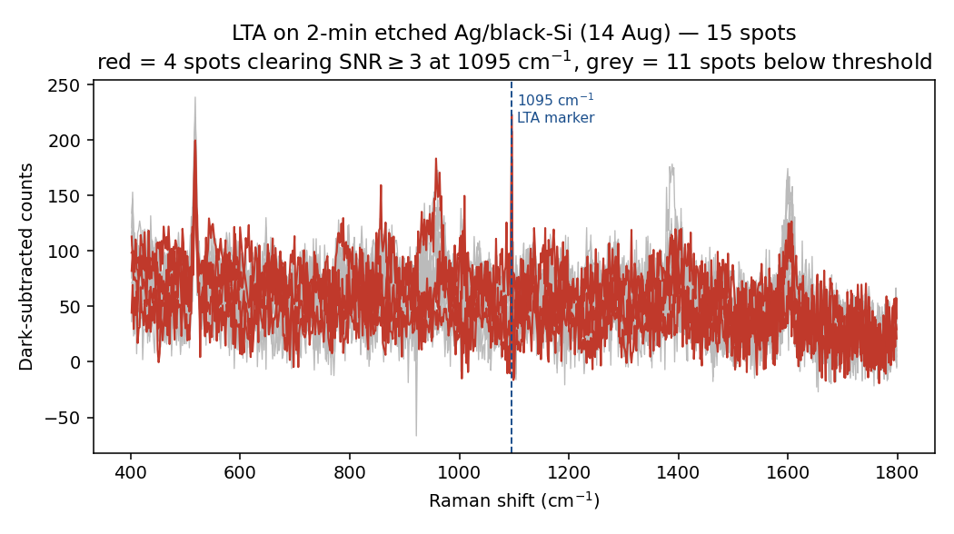
Figure 16. LTA spectra overlaid across all 15 measurement spots on the 2-minute substrate.

6.1 Initial observation
Averaged data appeared to show a feature at 1095 cm⁻¹ in 3 of the 15 spots, with apparent SNR of 7–9 — on first inspection, a plausible positive detection.

6.2 Pixel-level re-examination
Applying the peak-width criterion established in Section 5.2, the feature was examined at the level of individual detector pixels rather than as an averaged/smoothed curve.
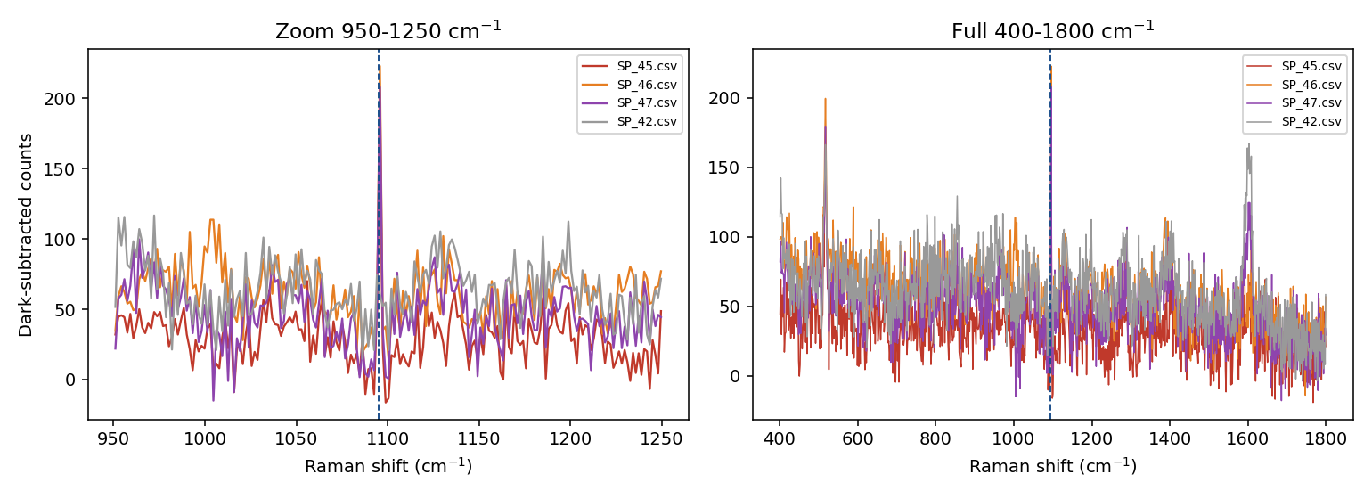
Figure 17. Pixel-level zoom of the apparent 1095 cm⁻¹ feature in the three candidate spectra (SP_45/46/47), showing the single-pixel spike at detector position 640 against normal-noise neighbouring pixels.
The feature occupied exactly one detector pixel (pixel index 640), at the identical detector position in all three spectra, with immediately adjacent pixels at ordinary noise levels. A genuine Raman band on this instrument spans 4–5 pixels (Section 5.2, demonstrated by the silicon TO phonon FWHM). A feature confined to one pixel at a fixed detector position, recurring identically across independent spectra, is the signature of a fixed-pattern detector artefact — not a molecular Raman signal.
CAUTION — The apparent LTA detection was reclassified as NOT DETECTED. This finding is the direct origin of the minimum 3–5 pixel peak-width criterion now applied to all analyses in this project (Section 2.4).

7. Consolidated Results Summary
Item | Result
Substrate fabrication | Successful; SERS-active at all three etch times tested (2/5/10 min)
R6G validation | All 8 standard bands detected on all substrates; SNR up to 450 (2-min substrate)
Best-performing substrate (R6G) | 2-minute etch (21,118 counts / SNR 450 at 1509 cm⁻¹)
NAM detection | Not reproducibly detected on any of 3 substrates, either power level, raw or blank-subtracted
Silicon reference / instrument check | TO phonon consistently at 517.8 cm⁻¹ across 13 conditions; instrument confirmed functioning correctly
Wavenumber calibration offset | −2 to −3 cm⁻¹ fixed offset; ±5 cm⁻¹ tolerance adopted
SNR vs. integration time | Scales faster than √t — fixed noise floor, not pure shot noise
LTA detection | Initial apparent signal (SNR 7-9, 3/15 spots) reclassified as single-pixel detector artefact — not detected
Total spectra acquired | 237, across 3 sessions

8. Analysis: Why NAM Was Not Detected
This section examines the possible explanations systematically, distinguishing those excluded by experimental evidence from those that remain plausible.

8.1 Substrate enhancement is not the limiting factor
The most important control in this work is the R6G result. R6G was measured on the same substrates, at the same spots, using the same acquisition settings and in the same sessions as NAM. It produced all eight expected bands with signal-to-noise ratios reaching 450. A substrate capable of enhancing R6G by that margin is unambiguously plasmonically active.
KEY — This eliminates the most obvious explanations. The substrates were SERS-active, the laser was reaching the sample, the spectrometer was correctly calibrated (within the known fixed offset, Section 5.1) and the analysis procedure was capable of identifying real bands. The NAM null result cannot be attributed to a non-functional substrate or a non-functional instrument.

8.2 Molecular structure of NAM
NAM is a pyranose amino-sugar acid: N-acetylglucosamine bearing a 3-O-lactyl ether substituent with a terminal carboxylic acid (molecular weight 293.27 g/mol). Examining this structure against the requirements for a strong SERS response identifies three independent deficiencies:
Requirement for strong SERS | R6G | NAM
Electronic resonance near the excitation wavelength | Yes — dye with absorption in the visible/near-IR, giving additional resonance enhancement | No chromophore; entirely non-resonant at 785 nm
Large intrinsic Raman cross-section | Yes — extended conjugated aromatic system | No; saturated sugar-acid with weak scattering
Functional group with affinity for silver | Yes — cationic, adsorbs readily to Ag surfaces | No thiol, no amine available (nitrogen is blocked as an amide), no aromatic ring

NAM therefore fails on all three counts simultaneously. R6G is close to a best-case analyte for SERS and NAM close to a worst case, which explains why a substrate that performs excellently for one may give no signal at all for the other.

8.3 The adsorption problem and the distance-dependence of SERS
Electromagnetic SERS enhancement is extremely short-ranged: the enhanced field is concentrated in nanometre-scale gaps between metal features and falls very steeply with distance, so a molecule even one or two nanometres further from the surface experiences enhancement smaller by orders of magnitude. Effective SERS therefore requires the analyte not merely to be present but to be held at the metal surface within these enhancement regions.
R6G satisfies this because it adsorbs onto silver. NAM has no comparable driving force. In a dried droplet, NAM molecules are distributed largely at random through the deposit — on the silicon, on the silver, and within bulk material away from the surface — with only a small, uncontrolled fraction occupying enhancement regions. This is the single most probable explanation for the observed result.

8.4 Concentration as a contributing factor
The NAM concentration examined (1 mg/mL, 3.41 mM) is not low by SERS standards, and is several orders of magnitude above concentrations at which R6G is routinely detected on comparable substrates. Insufficient analyte quantity is therefore unlikely to be the primary cause. Concentration cannot, however, be entirely excluded, because the effective quantity within enhancement regions depends on adsorption efficiency rather than bulk concentration — a concentration series is planned to separate these possibilities.

8.5 Deposition and droplet drying
Black silicon produced by MACE is strongly hydrophilic, and droplets were observed to spread across the substrate rather than remaining confined. On drying, solute is carried to the perimeter of the wetted area, producing a ring-shaped deposit with most material outside the region initially targeted for measurement. This is a genuine methodological weakness that may have reduced the quantity of NAM present within the measured volume. It is unlikely to be the sole explanation, since multiple spatially separated spots were examined, but it is a contributing factor and has been addressed in the revised deposition procedure (smaller, confined droplet volumes).

8.6 Absence of a directly comparable literature precedent
No published method for label-free SERS detection of isolated NAM at 785 nm on a MACE-type silicon substrate was located. Related literature on LPS and LTA detection by SERS (e.g. silver-nanorod substrates) provides useful peak references but does not use isolated NAM as the target analyte or the same substrate architecture, limiting the extent to which prior results can guide expectations for this specific system.

8.7 Ranked assessment of causes
Rank | Candidate cause | Assessment
1 | Weak/absent silver affinity and non-resonant, low-cross-section Raman response of NAM | Most probable primary cause — three independent deficiencies acting together (Section 8.2–8.3)
2 | Droplet spreading on hydrophilic surface reducing effective concentration in measured region | Likely contributing factor, unlikely to be sole cause (Section 8.5)
3 | Bulk NAM concentration too low | Unlikely to be primary cause given concentration is high by SERS standards, but not fully excluded (Section 8.4)
4 | Substrate not SERS-active | Excluded — R6G control confirms strong activity (Section 8.1)
5 | Instrument miscalibration or malfunction | Excluded — silicon reference dataset confirms correct, consistent operation (Section 5)

9. Methodological Issues Identified and Corrected
Issue | Risk if uncorrected | Correction applied
NAM molecular weight initially taken as 275.25 g/mol | All NAM molarity calculations off by ~6.5% (one H₂O unit, 18.02 g/mol) | Corrected to 293.27 g/mol (PubChem CID 5462244; Sigma A3007); all concentrations recalculated
Droplet spreading on hydrophilic black-silicon surface | Analyte carried outside the measured region during drying | Smaller, confined droplet volumes and drying protocol under review
Single-pixel detector artefact produced an apparently significant LTA peak | Risk of reporting a false positive | Minimum 3–5 pixel peak-width criterion now applied before any peak is accepted
No systematic blank-subtraction check in earliest measurements | Risk of misattributing substrate/background features to the analyte | Substrate blank now recorded in the same session immediately before every analyte measurement
Wavenumber positions compared without accounting for instrument offset | Risk of rejecting a real but shifted band, or accepting a coincidental one | ±5 cm⁻¹ tolerance adopted after quantifying the fixed −2 to −3 cm⁻¹ offset on silicon reference data

10. Conclusions
- Silver-decorated black-silicon substrates were successfully fabricated by one-step MACE and confirmed to be strongly SERS-active, validated using R6G with signal-to-noise ratios up to 450.
- SERS response depends on silver morphology in a way that is not simply monotonic with etch time; the 2-minute substrate substantially outperformed both the 5- and 10-minute substrates.
- NAM was not reproducibly detected under any condition tested (3 substrates, 2 power levels, with and without blank subtraction).
- A systematic silicon reference dataset (45 spectra, 13 conditions) confirmed correct and consistent instrument operation, identified a fixed −2 to −3 cm⁻¹ wavenumber calibration offset, and showed that SNR improves faster than shot-noise scaling with integration time — indicating extended integration is a viable strategy for weak analytes.
- An initial apparent LTA signal was identified, through pixel-level analysis, as a single-pixel detector artefact rather than a genuine Raman band, and was reclassified as not detected. This finding directly produced a new artefact-rejection criterion now applied throughout the project.
- The R6G control demonstrates that the NAM and LTA null results are not attributable to substrate or instrument failure. The most probable explanation for the NAM result is the combination of non-resonant, low-cross-section Raman scattering and weak silver-affinity intrinsic to the NAM molecule, compounded by droplet-spreading losses during sample deposition.

11. Forward Plan
The following steps are planned, in order of priority:
- Concentration series for NAM (across at least two orders of magnitude) to determine whether the null result is concentration-dependent.
- Controlled droplet deposition (fixed, small volume; confined drying) to reduce spreading losses and improve reproducibility across spots.
- Surface functionalisation with 4-mercaptophenylboronic acid (MPBA), which offers a boronic-acid group capable of binding NAM's diol/carboxylic-acid functionality and anchoring it within SERS-active regions. The MPBA-only spectrum will be recorded first to check for spectral interference before comparing NAM signal with and without functionalisation, since functionalisation may also occupy some SERS-active sites and must be evaluated by controlled comparison rather than assumed to help.
- Parallel LPS detection experiments, for which a stronger existing literature basis exists (silver-nanorod substrates, established peak positions).
- Repeat LTA measurements under the corrected artefact-rejection and blank-subtraction protocol, at longer integration time given the SNR-vs-time finding in Section 5.3.
- Independent substrate replicates at the 2-minute etch condition to establish fabrication (not just within-substrate) reproducibility.

