Project Progress Report — Updated with Post-Proposal Experimental Work
Intelligent Sensor System for Early Prediction of Sepsis in Neonates and High-Risk Adults
____________________________________________________________
PI: Prof. Ajay Agarwal, IIT Jodhpur | Co-PI: Prof. (Dr.) Neeraj, AIIMS Jodhpur | Additional Co-PIs: TCS

1. Project Overview
Sepsis is a life-threatening condition caused by a dysregulated host response to infection and is a major cause of mortality, particularly among neonates and critically ill or high-risk adults. This project develops a rapid, nanotechnology-enabled sensing platform for detecting bacterial cell-wall components associated with sepsis, using Surface-Enhanced Raman Spectroscopy (SERS) combined with nanostructured sensing substrates, Raman spectral analysis and (in later phases) artificial intelligence-assisted classification.
The work reported here spans two stages. The first stage — computational (DFT) and experimental pure-standard Raman characterization of three bacterial biomarkers (NAM, LTA, LPS) — was completed and documented in the original project report. The second stage, completed subsequently and reported here for the first time, covers fabrication and validation of Ag-coated silicon SERS substrates and their application to the same three biomarkers, testing whether the pure-standard Raman signatures established earlier can be reproduced under SERS conditions.

2. Background and Motivation
Sepsis remains a leading cause of mortality worldwide because of its rapid clinical course and its dependence on prompt diagnosis. Conventional diagnostic techniques — blood culture, immunoassays, and molecular methods such as PCR — are accurate but slow (24–72 hours for culture), require specialised laboratory infrastructure, and can miss low-burden or atypical infections. Host-response biomarkers such as CRP, procalcitonin and IL-6 provide faster turnaround but are indirect indicators of infection rather than direct evidence of bacterial presence.
This motivates a complementary approach: direct, label-free detection of bacterial structural components using Raman spectroscopy enhanced by plasmonic nanostructures (SERS). Because SERS can, in principle, detect trace quantities of a target molecule adsorbed on a metallic nanostructured surface, it offers a route to rapid, minimal-preparation, potentially point-of-care bacterial biomarker detection.

3. Problem Statement
There is no validated, rapid, label-free platform for direct detection of bacterial cell-wall biomarkers in a sepsis-relevant timeframe. Before such a platform can be built, two prerequisites must be established: (i) a validated Raman fingerprint library for the target biomarkers, obtained by combining theoretical (DFT) prediction with experimental pure-standard measurement, and (ii) a SERS-active sensing substrate that is itself demonstrated to enhance Raman signal before it is applied to the (much harder) problem of detecting a specific biomarker at low concentration. This report documents progress on both prerequisites.

4. Project Objectives
As defined in the parent project proposal, the work is structured around five objectives:
1. Objective 1 – Biomarker Discovery: identify bacterial biomarkers associated with Gram-positive and Gram-negative sepsis-causing bacteria using Raman spectroscopy and commercially available purified components (LPS, peptidoglycan/NAM, teichoic acids and other surface components).
2. Objective 2 – SERS-Based Sensing Technology: develop and optimize a SERS-enabled nanosensor chip capable of detecting bacterial biomarkers with enhanced Raman signals.
3. Objective 3 – AI-Integrated Raman Analysis: develop computational and machine-learning approaches for automated interpretation and classification of Raman spectra.
4. Objective 4 – Clinical Validation: evaluate the developed SERS sensor using clinical isolates and patient samples to determine sensitivity, specificity and accuracy.
5. Objective 5 – Point-of-Care Prototype: integrate the sensing and analysis components into a portable Raman-based point-of-care system suitable for rapid clinical testing.
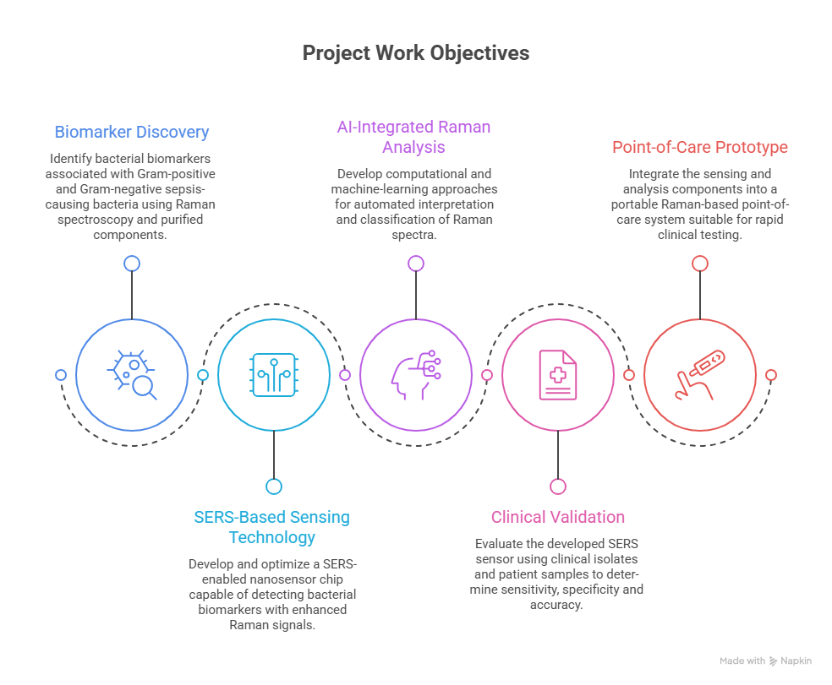
Figure 1. Graphical representation of project objectives
The work completed to date, both before and after the original report, addresses primarily Objectives 1 and 2, while generating the structured Raman datasets required for the future Objective 3 (AI-based classification). Objectives 4 and 5 remain future stages, as discussed in Section 20.

5. Proposed Methodology
The overall workflow proposed for the project is:
Problem Identification → Literature Review → SERS Substrate Design → Sample Preparation → Raman Data Acquisition → Spectral Processing → Biomarker Identification → Validation → Comparative Evaluation → Final Prototype Framework
Analytical-grade biomarker standards and bacterial cell-wall markers (NAM, LPS, LTA) were selected for proof-of-concept work. The proposed sensing substrate uses silicon wafers coated with silver, gold or Ag/Au bimetallic nanostructures for localized surface plasmon resonance-based signal enhancement. Raman spectral acquisition uses a microscope-coupled Raman system (785 nm excitation), with laser power, integration time and accumulation count optimized for signal-to-noise ratio. Preprocessing (dark subtraction, baseline correction, smoothing, normalization) and peak extraction are performed in Python prior to comparison against theoretical/literature references.
Density Functional Theory (DFT) calculations, used to predict the vibrational (Raman) signatures of each biomarker, were performed in Gaussian 16 as follows:
Table 1. DFT computational parameters used for each biomarker (as reported in the original project report).
Parameter | NAM (full molecule) | LTA fragments | LPS fragments
Functional | B3LYP | B3LYP | B3LYP
Basis set | 6-31+G(d,p) | 6-31G(d) | 6-31G(d)
Job type | Opt + Freq + Raman | Opt + Freq + Raman | Opt + Freq + Raman
Solvation | SMD (water) | SMD (water) | SMD (water)
Grid / SCF | UltraFine / Tight | UltraFine / Tight | UltraFine / Tight
Resources | 16 cores, 56 GB RAM | 16 cores, 56 GB RAM | 16 cores, 56 GB RAM

6. Expected Deliverables
The parent proposal defines four major deliverables:
1. Deliverable 1 – Structured Raman Spectral Library: a curated set of Raman fingerprints for the target bacterial biomarkers, cross-validated against DFT prediction.
2. Deliverable 2 – Optimized SERS Chip: a fabricated, validated SERS substrate with demonstrated signal enhancement, optimized for biomarker adsorption and detection sensitivity.
3. Deliverable 3 – AI-Based Raman Analysis Algorithm: a machine-learning system for automated classification of bacterial vs. non-bacterial Raman signatures.
4. Deliverable 4 – Point-of-Care Prototype: integration of sensor, acquisition system and AI classification into a portable clinical device.

7. Work Completed During the Project
The work completed to date falls into two stages, distinguished throughout this report:
Stage | Period | Summary | Status
Stage 1 — Pure-standard characterization | Reported in the original project report | DFT-based Raman simulation and experimental pure-powder Raman measurement of NAM, LTA and LPS; theory-vs-experiment comparison and fragment-based composite modelling for LTA/LPS. | Completed
Stage 2 — SERS substrate fabrication and biomarker detection trials | Performed after the original report | Fabrication of two generations of Ag-coated silicon SERS substrates (Sensor 1: Ag/Si; Sensor 2: Ag/black-Si via MACE); substrate validation using Rhodamine 6G (R6G); application of both substrates to NAM and LTA detection. | Trials completed — reproducible biomarker detection not yet achieved

Stage 1 addressed the prerequisite of establishing and experimentally characterizing pure-standard Raman reference fingerprints for NAM, LTA and LPS, with the strongest theory–experiment agreement obtained for NAM (supporting Objective 1). Stage 2 addressed the prerequisite of demonstrating a working SERS substrate and testing it against the Stage 1 fingerprints (supporting Objective 2). Both stages together provide the foundation on which Objective 3 (AI classification) can subsequently be built.

8. Materials and Methods

8.1 Pure-standard materials and Raman measurement (Stage 1)
Parameter | NAM | LTA | LPS
Sample form | High-purity powder (~98%) | Powder / prepared solution | Powder / prepared solution
Excitation source | 785 nm laser | 785 nm laser | 785 nm laser
Measurement type | Powder Raman, multiple laser power / integration-time settings | Powder Raman | Powder Raman, acquisition parameters optimized per sample
Optimum acquisition condition | 25 s integration, 80% power, best SNR = 95.91 | [DATA TO BE UPDATED — LTA acquisition parameter not available in the current report] | 60 s integration, 20% power, 30 accumulations

LTA acquisition parameters (laser power, integration time, accumulations, concentration/spot count for the pure-standard measurement) were not found stated explicitly in the source report and are not invented here; this cell will be updated if the values are located or re-measured.

8.2 SERS substrate fabrication (Stage 2)
Two generations of Ag-coated porous/textured silicon SERS substrates were fabricated using a wet-chemical route:
- Sensor 1 (Ag/Si): silver deposition onto planar silicon via a silver nitrate (AgNO₃)-assisted reduction step, without a preceding porosifying etch.
- Sensor 2 (Ag/black-Si, MACE): silver nanostructures formed via metal-assisted chemical etching (MACE) using hydrofluoric acid (HF) and AgNO₃ (representative formulation: ~170 g AgNO₃ and 8.6 mL HF in 50 mL DI water), with substrates prepared at three etch/dip times — 2, 5 and 10 minutes — to compare surface morphology and SERS performance.
Both substrate types were validated for SERS activity using Rhodamine 6G (R6G) as a standard probe molecule before any biomarker was applied (Section 15). Un-etched raw-silicon reference spectra were also recorded for wavenumber calibration and to establish the instrument's minimum resolvable peak-width (Section 15.3).

9. Experimental Work
The experimental programme proceeded in the following order, extending directly from the original report's proposed workflow:
1. DFT-based Raman simulation of NAM (full molecule) and of representative LTA and LPS structural fragments (Stage 1, previously reported).
2. Experimental Raman measurement of pure NAM, LTA and LPS powders under systematically varied laser power / integration time, with the optimum condition selected by signal-to-noise ratio (Stage 1, previously reported).
3. Comparison of experimental and simulated spectra for NAM (direct comparison) and for LTA/LPS (fragment-weighted composite reconstruction) (Stage 1, previously reported).
4. Fabrication of the Ag/Si (Sensor 1) SERS substrate (Stage 2, new).
5. Fabrication of the Ag/black-Si (Sensor 2, MACE) SERS substrate at 2, 5 and 10-minute etch times (Stage 2, new).
6. SERS activity validation of both sensor generations using R6G, including concentration-response and cross-etch-time comparison (Stage 2, new).
7. Application of both sensor generations to NAM, seeking reproduction of the Stage 1 Raman fingerprint under SERS conditions (Stage 2, new).
8. Application of Sensor 2 to LTA, including a pixel-level artifact investigation that led to a revised peak-validity criterion (Stage 2, new).
9. Consolidated peak/SNR analysis across all sensors and biomarkers to determine detection status and identify likely limiting factors (Stage 2, new).

10. Characterization and Measurements
Table 3. Summary of characterization stages completed for each biomarker, across both project stages.
Biomarker | DFT simulation | Pure-powder Raman | SERS — Sensor 1 (Ag/Si) | SERS — Sensor 2 (Ag/black-Si)
NAM | Done | Done (optimum SNR 95.91) | Done | Done
LTA | Done (3 fragments) | Done | Not attempted | Done
LPS | Done (5 fragments) | Done | Not attempted | Not attempted
R6G (validation probe) | N/A | N/A | Done | Done

11. Pure NAM Analysis
N-Acetylmuramic Acid (NAM) is a structural component of bacterial peptidoglycan and is absent from human biomolecules, making it a specific marker of bacterial presence. It was selected as the first model biomarker for detailed validation because its full-molecule DFT simulation is computationally tractable, unlike the larger LTA and LPS structures.

11.1 Pure / reference data
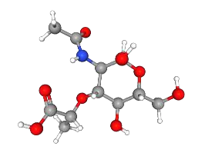
Figure 2. DFT-optimised molecular structure of N-Acetylmuramic Acid.
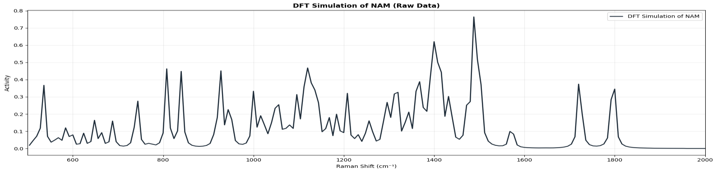
Figure 3. DFT-simulated Raman spectrum of NAM (full-molecule model).
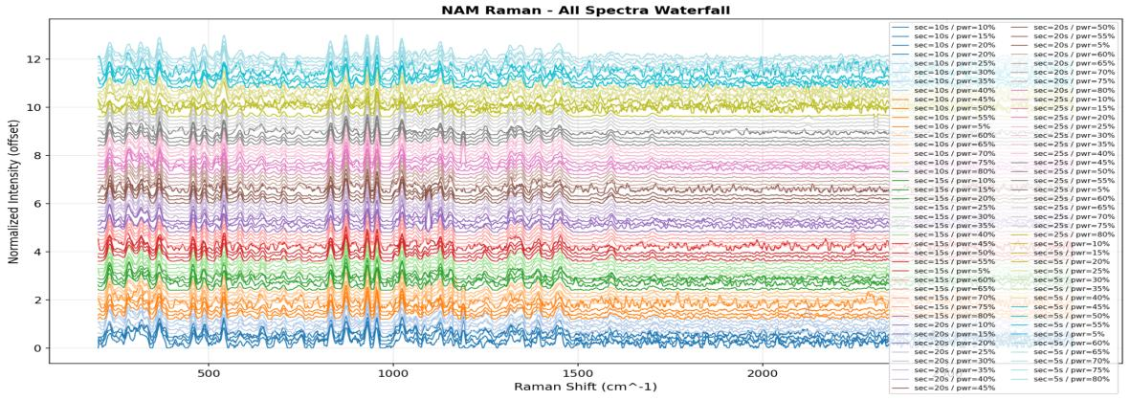
Figure 4. Experimental Raman spectra of pure NAM powder recorded under multiple laser power / integration-time conditions (off-substrate reference measurement).
The optimum acquisition condition (25 s integration, 80% laser power, SNR = 95.91) was selected from this series by comparing signal-to-noise ratio across all tested combinations (Figure 12 below).
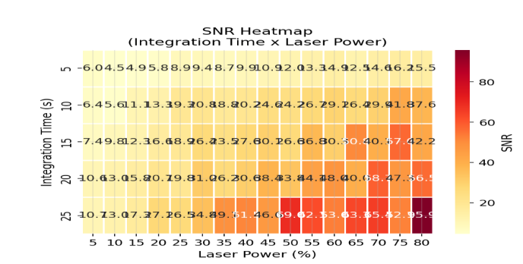
Figure 5. Signal-to-noise ratio map across the tested laser-power / integration-time combinations for NAM.
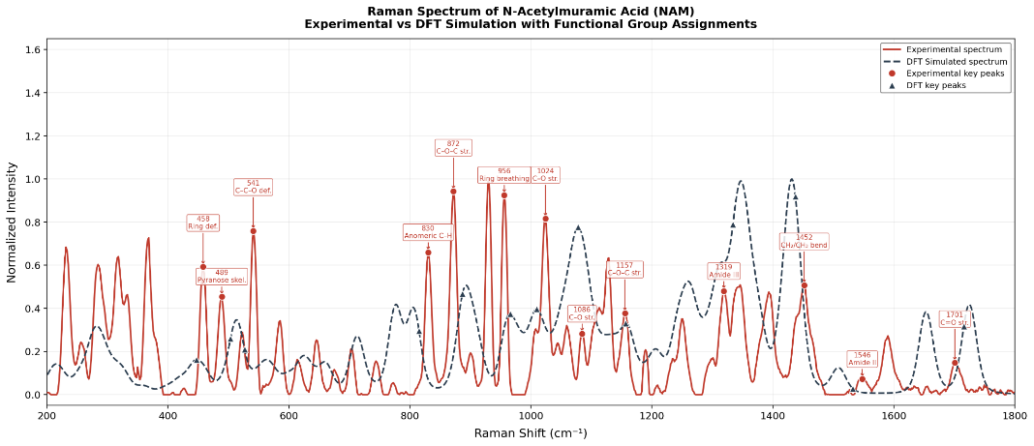
Figure 6. (a) Merged comparison — optimum experimental NAM spectrum overlaid with the DFT-simulated spectrum.
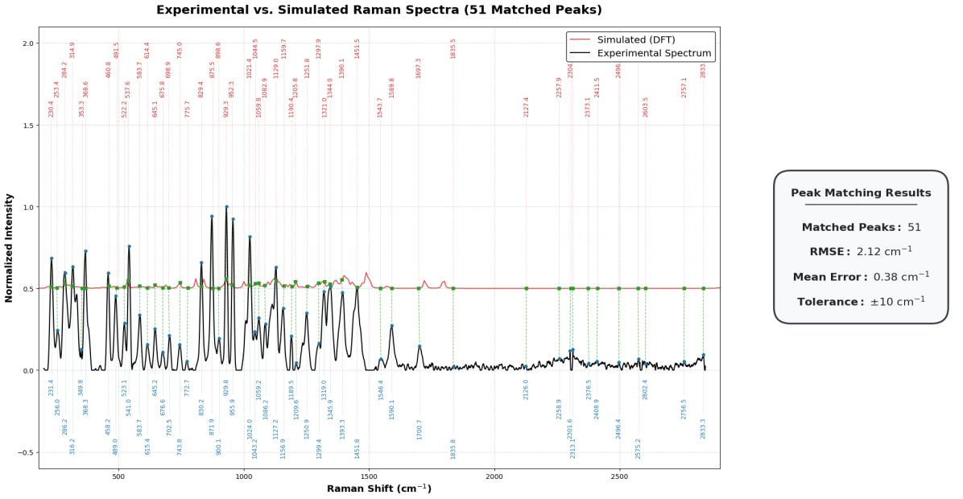
Figure 7. (b) Peak-matching and error analysis between the experimental and simulated NAM spectra — 51 peaks matched with low RMSE.
Table 4. Representative experimental-vs-simulated peak matches for NAM (6 of 51 matched peaks).
Experimental (cm⁻¹) | Simulated (cm⁻¹) | Assignment
284.3 | 282.5 | Ring deformation
772.7 | 777.8 | Ring vibration
955.9 | 965.7 | Ring breathing
1155.4 | 1156.9 | C–O–C stretching
1345.9 | 1347.4 | CH deformation
1700.7 | 1725.1 | Carbonyl stretching

This pure-standard, off-substrate characterization (DFT + optimized powder Raman, both completed before the SERS substrate work) established the validated NAM Raman fingerprint used as the reference against which the SERS experiments below are judged.

11.2 SERS experiment — Sensor 1 (Ag/Si)
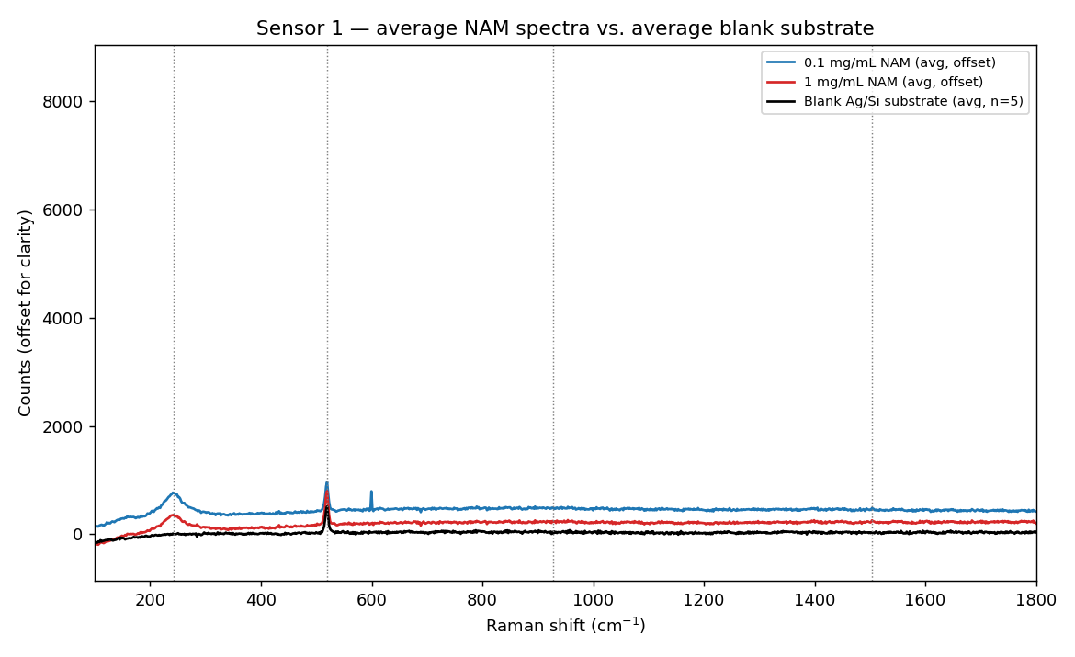
Figure 8. NAM (1 mg/mL) applied to Sensor 1 (Ag/Si), compared with the blank-substrate spectrum.
Seven replicate spectra were collected. A single reproducible, tentative candidate feature was observed at approximately 243 cm⁻¹ (SNR range 5.8–39 across replicates); this falls outside the 400–1800 cm⁻¹ range covered by the pure NAM reference spectrum above and could therefore not be confirmed against it. Weaker candidates near 928 and 1504 cm⁻¹ (SNR ≈ 1–3) were not accepted.
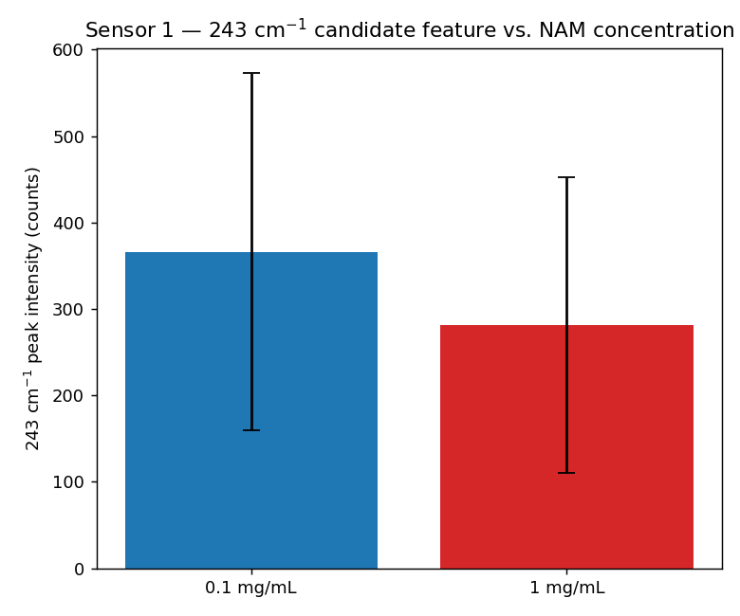
Figure 9. SNR of the ~243 cm⁻¹ candidate feature across the seven replicate measurements on Sensor 1.

11.3 SERS experiment — Sensor 2 (Ag/black-Si, MACE)
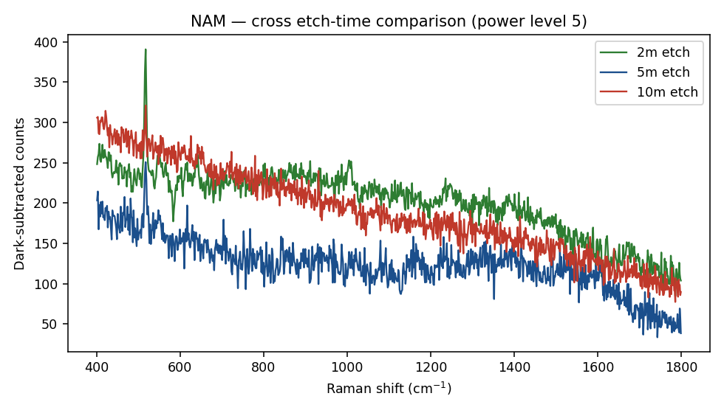
Figure 10. NAM Raman response on Sensor 2, compared across the 2, 5 and 10-minute etch-time substrates.
No target band from the validated pure-NAM reference list (458, 488, 542, 616, 646, 745, 872, 930, 1024, 1128, 1249, 1346, 1395, 1451 cm⁻¹) reached SNR ≥ 3 reproducibly on any of the three etch-time substrates, at either laser power, in raw or blank-subtracted spectra.

11.4 Merged comparison — pure reference vs. SERS experiment
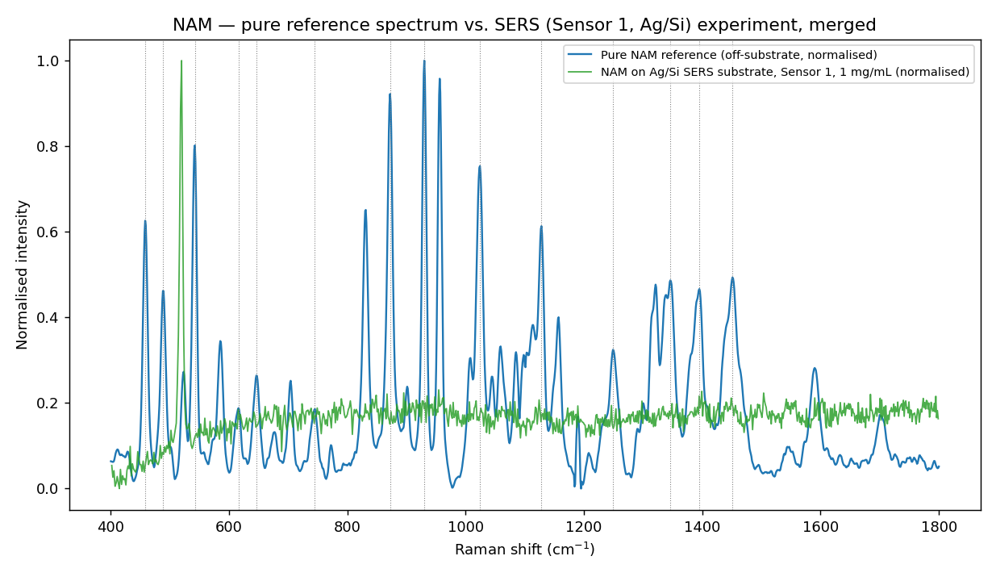
Figure 11. Merged overlay — pure NAM reference spectrum vs. Sensor 1 SERS experiment (1 mg/mL NAM), both normalised.
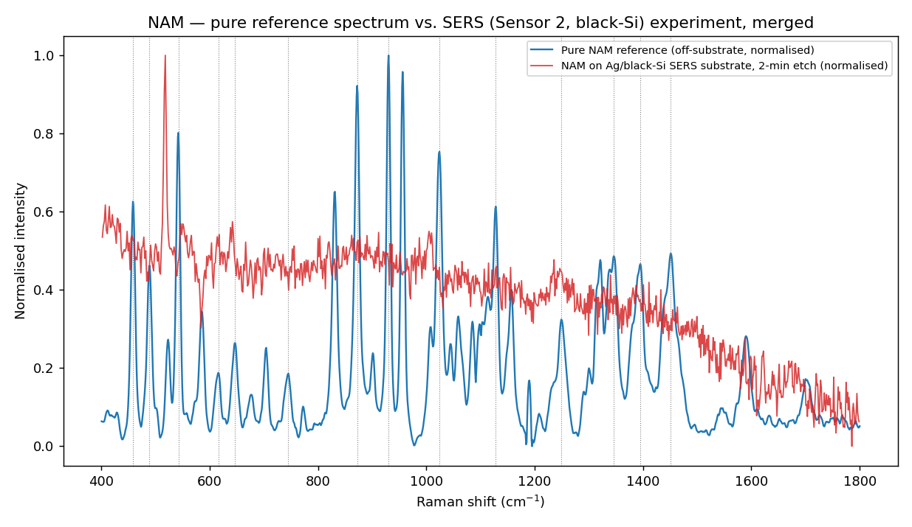
Figure 12. Merged overlay — pure NAM reference spectrum vs. Sensor 2 SERS experiment (2-minute etch substrate), both normalised.
The merged views make the outcome visually explicit: the pure reference spectrum shows many sharp, well-defined bands, while the corresponding SERS traces show no matching structure at the same positions, only noise and (on Sensor 2) the silicon substrate phonon near 520 cm⁻¹.

11.5 Result and interpretation
Substrate | Result
Sensor 1 (Ag/Si) | One reproducible, tentative candidate at ~243 cm⁻¹ (7/7 replicates), outside the range covered by the pure reference spectrum and therefore not confirmable against it.
Sensor 2 (Ag/black-Si, MACE) | No validated NAM reference band reached SNR ≥ 3 reproducibly on any etch-time substrate.
Overall | NAM not yet reproducibly detected by SERS on either sensor generation. The R6G results (Section 15) confirm that both substrates exhibit SERS activity under the tested conditions; the absence of a reproducible NAM signal is therefore more appropriately interpreted as a limitation of the current biomarker–substrate interaction and measurement protocol rather than as evidence of complete substrate inactivity.

This directly extends the original report's own stated future work — "integration with SERS substrates for trace-level detection" — from a proposed next step into a completed (negative) experimental result, discussed further in Section 17.

12. LPS Analysis
Lipopolysaccharide (LPS) is a major structural component of the Gram-negative bacterial outer membrane and a well-established endotoxin marker. Because full-molecule simulation of LPS is computationally impractical, a five-fragment DFT approach was used: Kdo (3-deoxy-D-manno-octulosonic acid), D-glucosamine, L-glycero-D-manno-heptose, myristic acid and phosphoric acid.

12.1 Pure / reference data
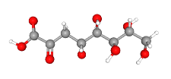
Figure 13. (a) LPS structural fragment — Kdo / phosphoric-acid group.
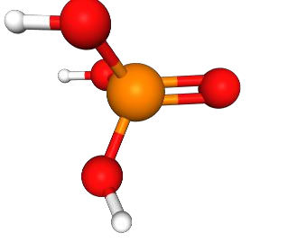
Figure 14. (b)–(d) Additional LPS structural fragments used for DFT simulation.
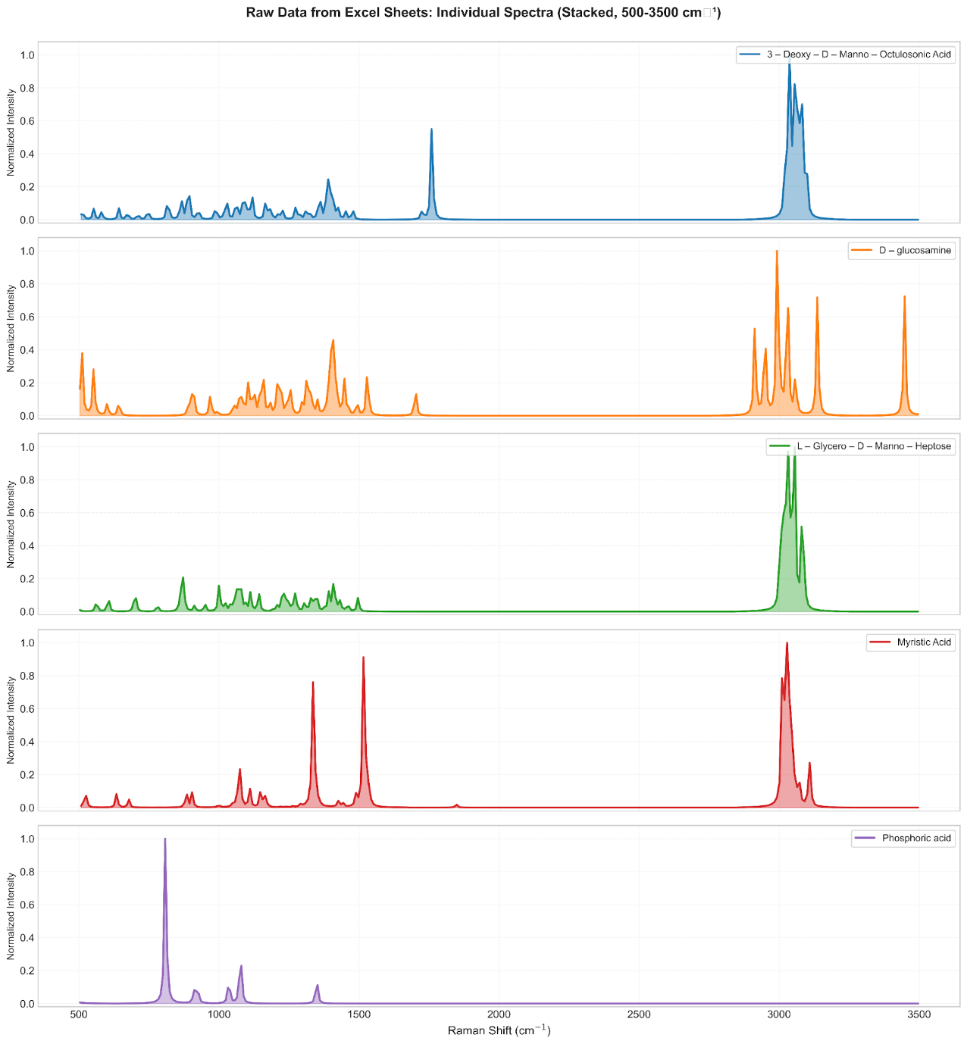
Figure 15. Simulated Raman spectra of the five LPS structural fragments (normalised, 500–3500 cm⁻¹).
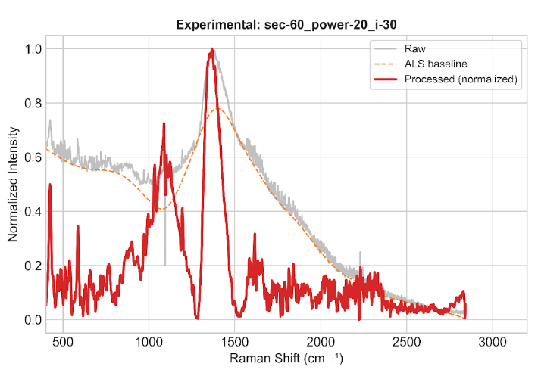
Figure 16. Experimental Raman spectrum of LPS powder at the optimized acquisition condition (60 s integration, 20% power, 30 accumulations) — an off-substrate, pure-standard measurement.
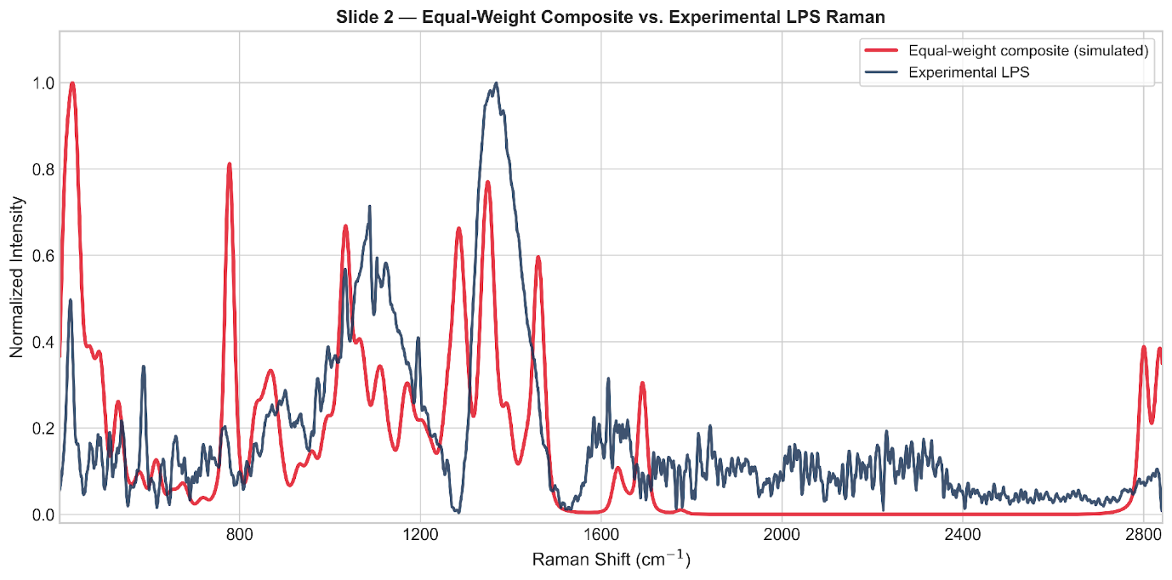
Figure 17. Equal-weight five-fragment composite (simulated) vs. experimental LPS Raman spectrum.
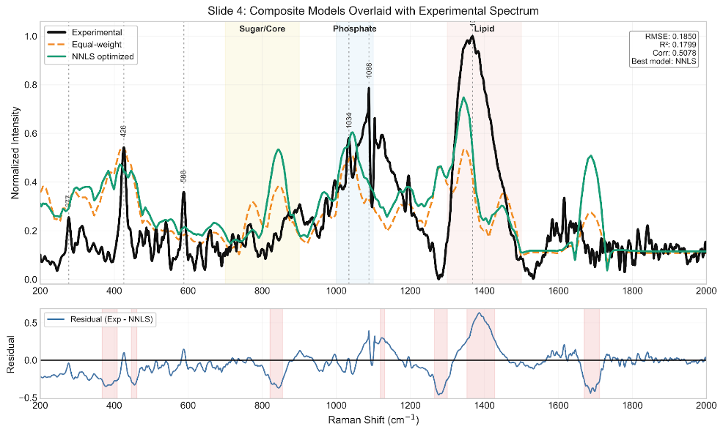
Figure 18. NNLS-optimized composite fit vs. experimental LPS spectrum, with residual structure.
Table 5. LPS fragment-composite model fit quality (from the original project report).
Model | RMSE | R² | Correlation
Equal weight | 0.189 | 0.149 | 0.417
NNLS optimized | 0.185 | 0.180 | 0.508

Table 6. Final optimized (NNLS) fragment contributions to the composite LPS spectrum.
Fragment | Contribution (%)
Kdo | 47.3
Heptose | 25.8
D-glucosamine | 15.3
Myristic acid | 11.7
Phosphoric acid | 0.0

The NNLS-optimized composite reproduces several diagnostic regions (notably 900–1100 cm⁻¹, sugar/ring/backbone modes) but the overall fit remains moderate (R² = 0.18), leaving clear residual structure unexplained by the five-fragment model — consistent with LPS being a large, heterogeneous molecule poorly represented by a small fragment set.

12.2 SERS experiment — Not yet performed
LPS SERS measurements have not yet been performed on either fabricated substrate. Therefore, no LPS SERS spectrum or pure-reference-versus-SERS comparison is available at this stage. LPS SERS detection remains a planned next experiment following optimization of the NAM and LTA substrate/adsorption conditions.
For clarity: the pure-standard data in Section 12.1 (DFT fragment spectra and the optimized off-substrate powder Raman measurement) are pure-standard/reference measurements, not SERS experiments — this distinction matters because the original report's Figure label "experimental" for the LPS powder spectrum refers to the pure-powder measurement, not a sensor experiment.

12.3 Merged comparison
No merged pure-reference-vs-SERS comparison is available because the LPS SERS experiment has not yet been performed.

12.4 Result and interpretation
Stage | Status
LPS pure-standard Raman | Completed
LPS DFT / fragment modelling | Completed
LPS pure-reference comparison (equal-weight and NNLS composite fits) | Completed
LPS SERS — Sensor 1 (Ag/Si) | Not performed
LPS SERS — Sensor 2 (Ag/black-Si, MACE) | Not performed
LPS SERS detection | Future work

LPS remains at the pure-standard / DFT-fragment characterization stage. No SERS measurement has yet been attempted for LPS on either fabricated substrate — this is planned as a next step (Section 21) once the NAM and LTA SERS trials have informed substrate/adsorption optimization.

13. LTA Analysis
Lipoteichoic Acid (LTA) is a characteristic component of Gram-positive bacterial cell walls, comprising a repeating glycerol–phosphate backbone with amino-acid and carbohydrate substituents. It was modelled using a three-fragment DFT approach: glycerol-phosphate (backbone), D-alanine (amino substituent) and N-acetyl-D-glucosamine / GlcNAc (carbohydrate substituent).

13.1 Pure / reference data
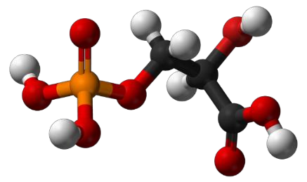
Figure 19. (a) Glycerol-phosphate backbone fragment.
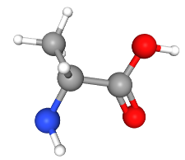
Figure 20. (b) D-alanine substituent.
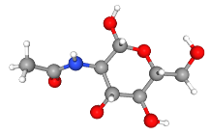
Figure 21. (c) GlcNAc substituent.
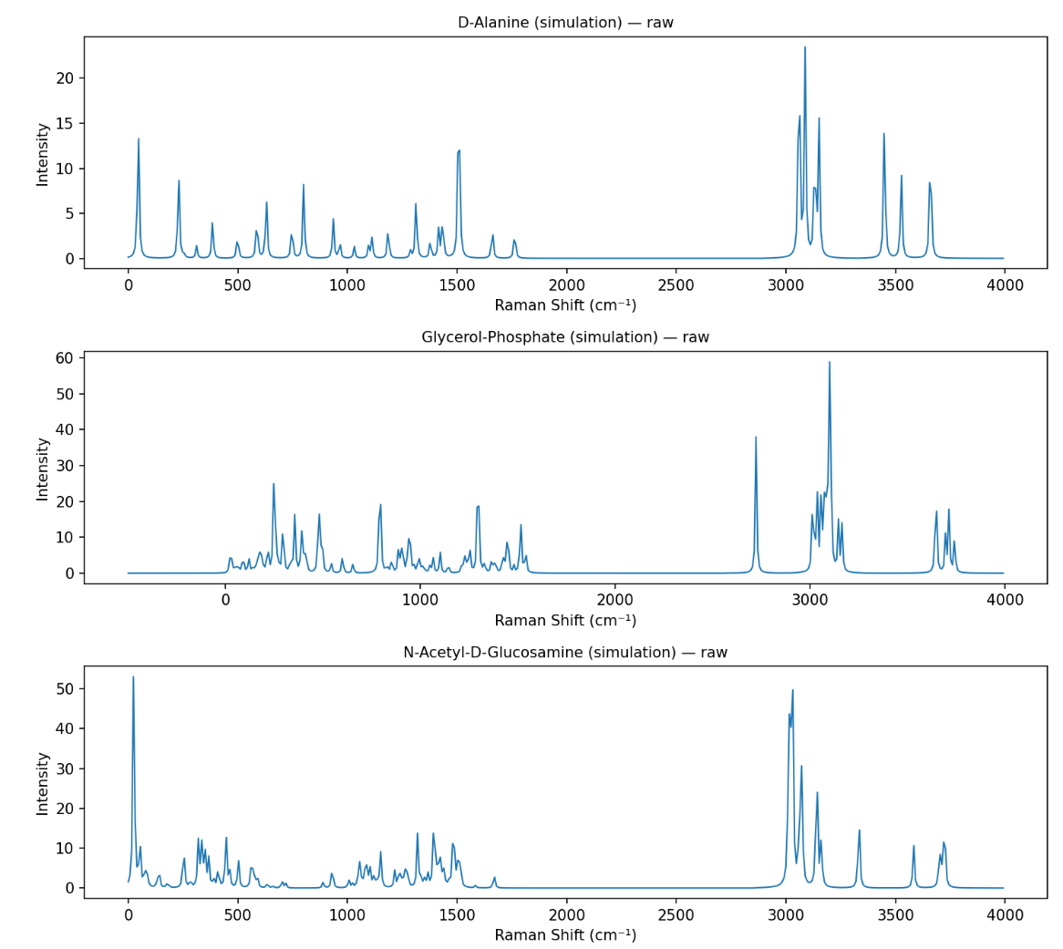
Figure 22. Simulated Raman spectra of the three individual LTA fragments.
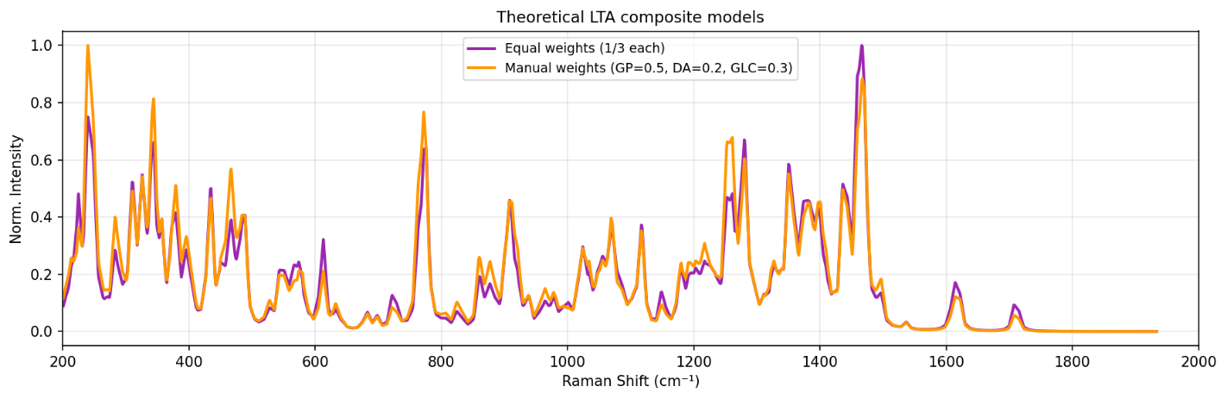
Figure 23. Weighted composite theoretical LTA spectrum generated from the three fragments.
Table 7. Fragment weighting in the composite theoretical LTA spectrum.
Component | Approximate contribution
Glycerol-phosphate | 20–25%
D-alanine | 34–40%
GlcNAc | 40–43%

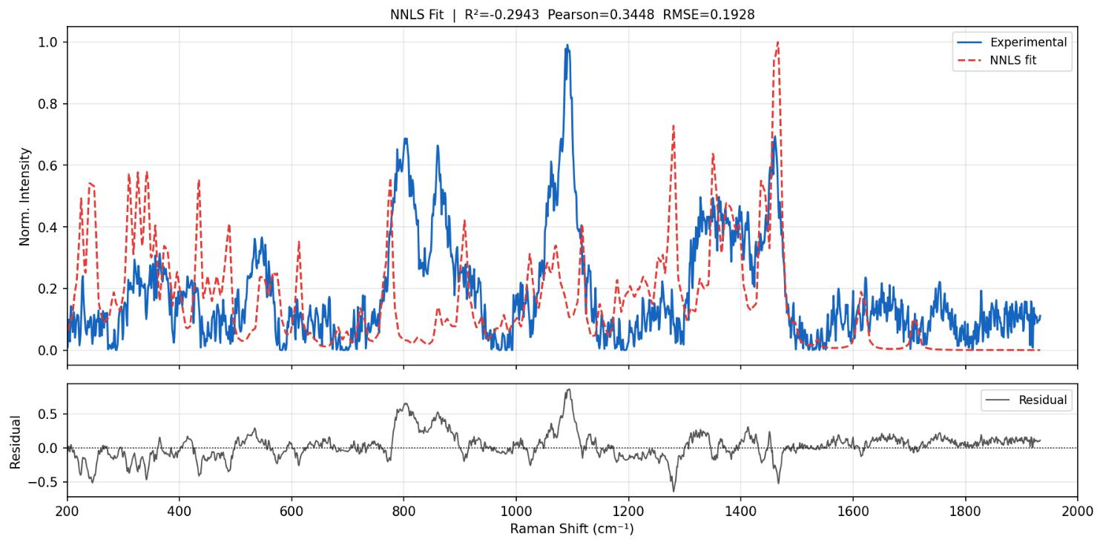
Figure 24. Off-substrate experimental LTA Raman spectrum vs. reconstructed theoretical (composite) spectrum.
This overlay showed agreement in several regions (phosphate vibrations, carbohydrate bands, CH deformation, amide-related features), supporting the fragment-based modelling strategy while acknowledging that LTA's full polymeric structure is not captured by a three-fragment model.

13.2 SERS experiment — Sensor 2 (Ag/black-Si, MACE)
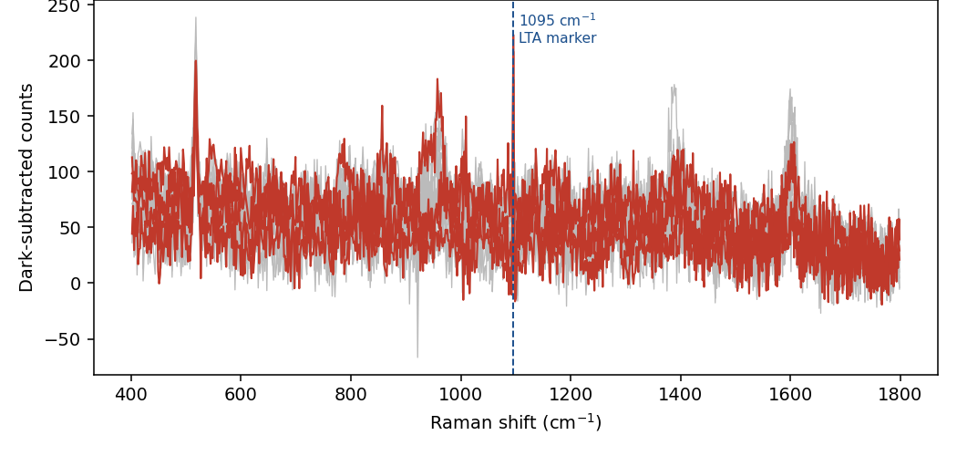
Figure 25. LTA on Sensor 2 (2-minute etch substrate) — all 15 measurement spots overlaid.
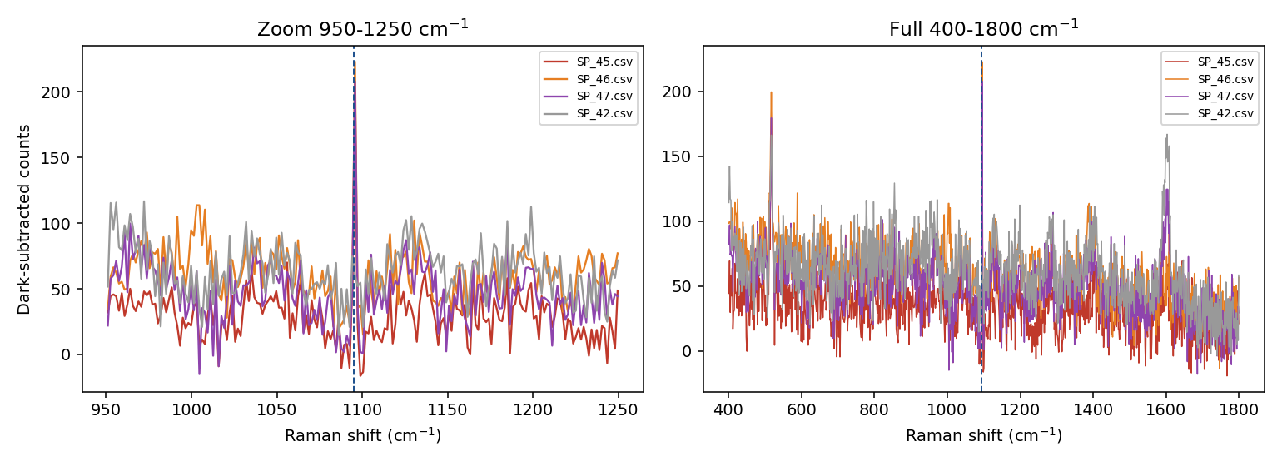
Figure 26. Pixel-level zoom of the apparent 1095 cm⁻¹ LTA feature (candidate spectra SP_45/46/47), showing the single-detector-pixel origin of the signal.
CAUTION — Fifteen LTA measurement spots were collected on Sensor 2. An apparent feature at 1095 cm⁻¹ initially appeared in some spectra, with 4 of the 15 spots meeting the SNR ≥ 3 acceptance threshold. Pixel-level inspection showed that this feature originated from a single fixed detector pixel rather than a genuine Raman band. A genuine Raman band on the instrument should exhibit a multi-pixel width consistent with the instrument response, whereas a single-pixel spike is treated as a detector artifact — on this basis the 1095 cm⁻¹ feature was rejected as an instrumental artifact and reclassified as NOT DETECTED. This criterion was established from the LTA pixel-level artifact investigation and was subsequently applied consistently to SERS peak validation (Section 15.3). Final LTA SERS status: NOT DETECTED.

13.3 Merged comparison
NOT CONFIRMED — No merged pure-reference-vs-SERS overlay is presented for LTA: the only SERS-stage candidate feature (1095 cm⁻¹) was invalidated at the pixel level before comparison against the pure reference spectrum was meaningful. The pixel-level zoom in Figure above serves as the relevant diagnostic image for this result.

13.4 Result and interpretation
LTA has, uniquely among the three biomarkers, both an established pure-standard reference spectrum (Section 13.1, qualitative theory–experiment agreement) and a completed SERS experiment (Section 13.2) — but the SERS experiment produced no confirmed detection after pixel-level artifact screening. The methodological outcome (the multi-pixel width validity criterion, Section 15.3) is itself a project result, now applied retroactively to the NAM and R6G analyses throughout this report.

14. Silicon-Based Experiments
Two generations of Ag-coated silicon SERS substrates were fabricated and validated using Rhodamine 6G (R6G), a well-characterized Raman probe, before biomarker measurements were attempted.

14.1 Sensor 1 (Ag/Si)
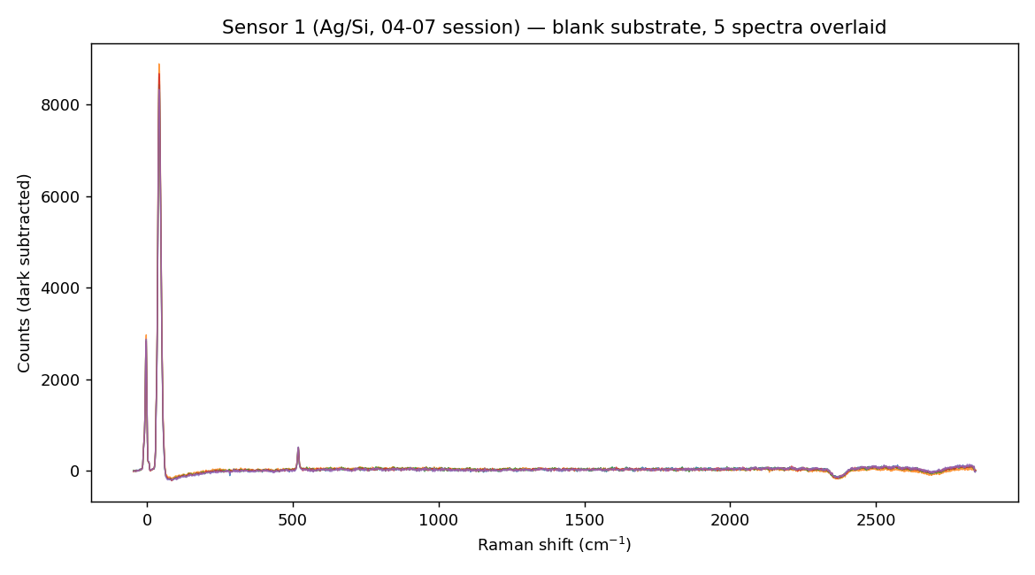
Figure 27. Sensor 1 — five blank-substrate spectra overlaid, establishing the substrate/background baseline.
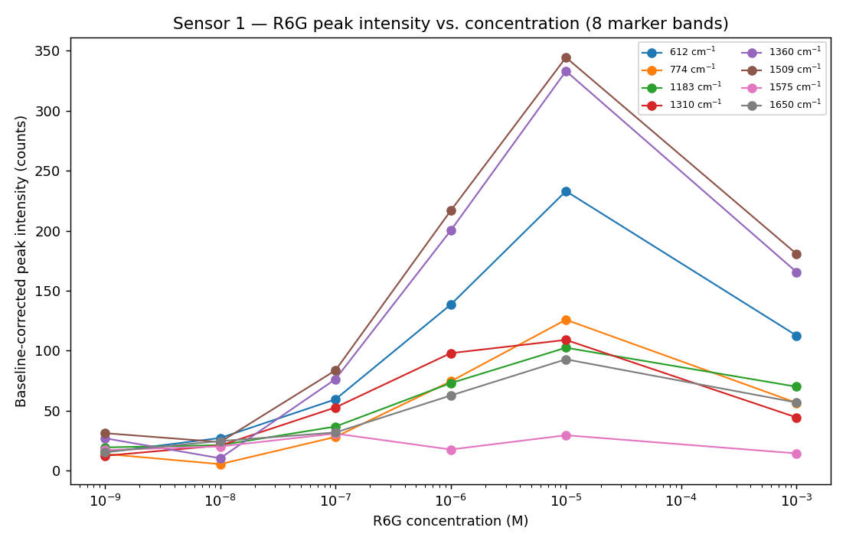
Figure 28. R6G concentration-response on Sensor 1, 1 nM–1 mM.
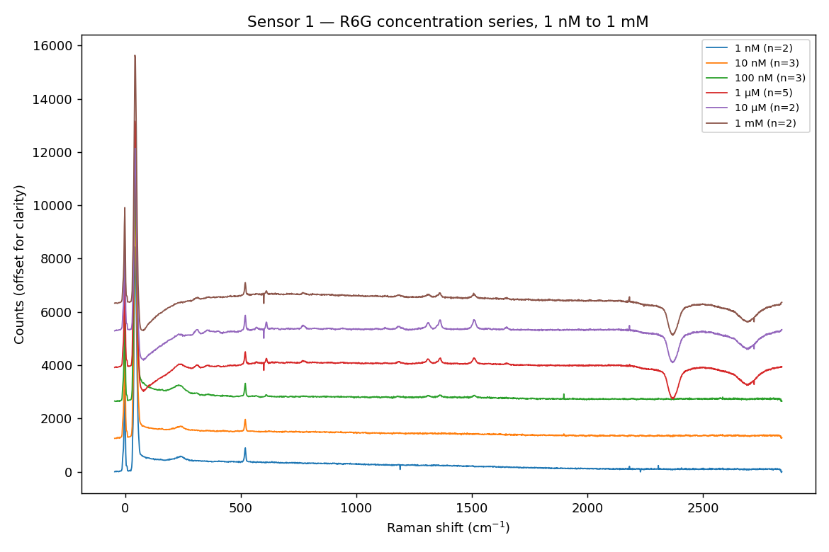
Figure 29. R6G concentration series — stacked spectra across the tested concentration range.
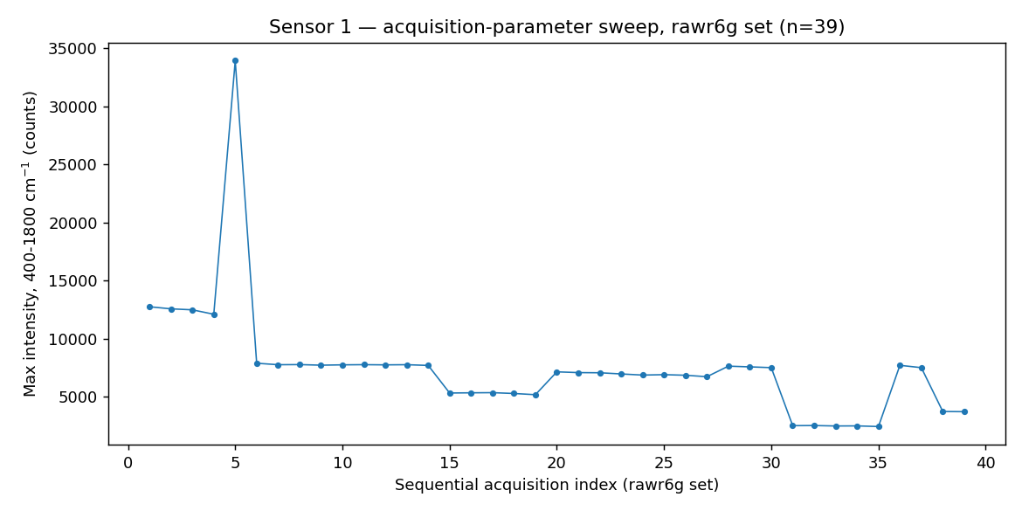
Figure 30. R6G — 39-spectrum acquisition sweep used for reproducibility assessment.

14.2 Sensor 2 (Ag/black-Si, MACE)
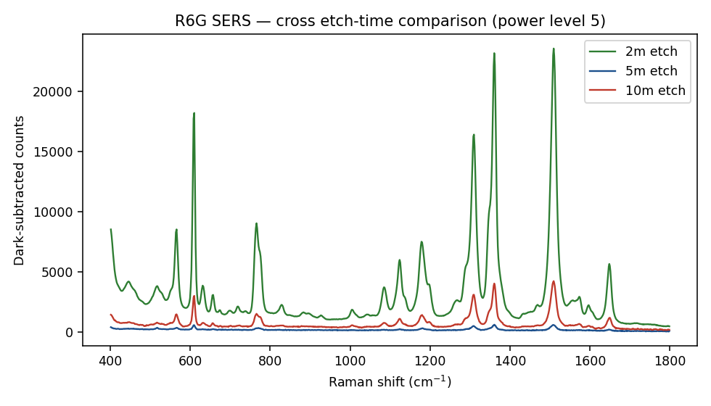
Figure 31. R6G response on Sensor 2, compared across the 2, 5 and 10-minute etch-time substrates.
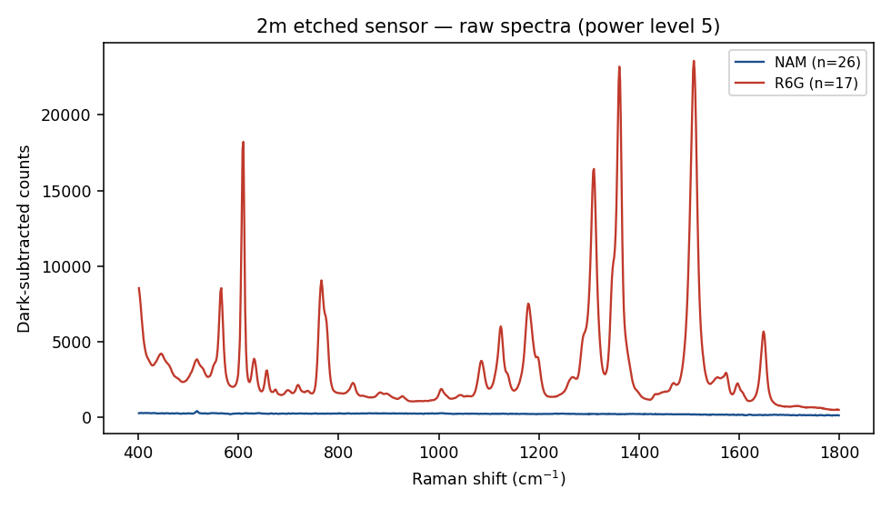
Figure 32. R6G and NAM spectra overlaid on the best-performing substrate (2-minute etch).
The 2-minute etch substrate was identified as the best-performing condition among the three etch times tested, and was used preferentially for subsequent NAM and LTA biomarker trials.

14.3 Raw-silicon (unetched) reference
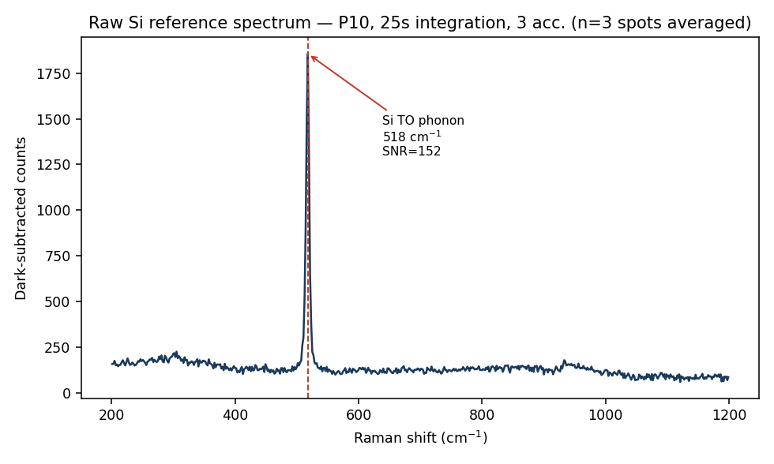
Figure 33. Unetched-silicon reference spectrum (highest-signal condition), used for wavenumber calibration and for establishing the minimum resolvable peak-width criterion.
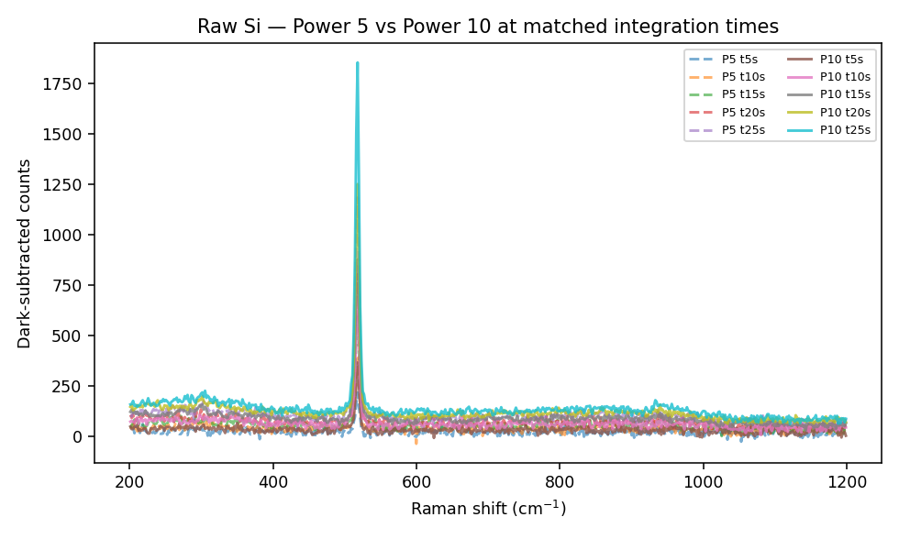
Figure 34. Unetched-silicon spectra across tested laser power settings.
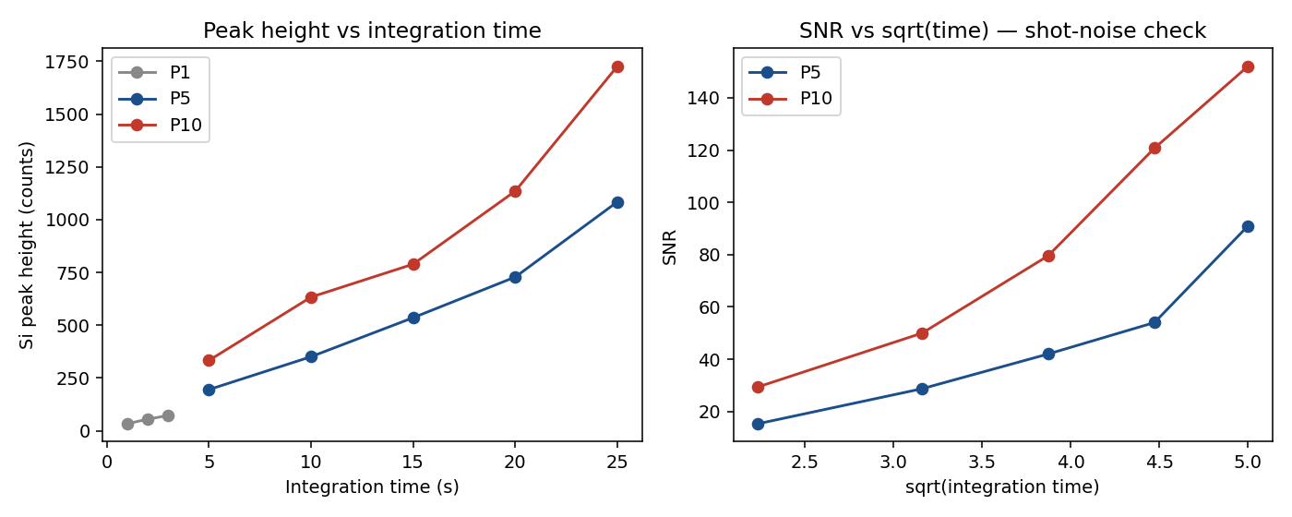
Figure 35. Linearity check of the silicon 520 cm⁻¹ phonon reference peak, used to validate wavenumber-axis calibration.
Both fabricated substrate generations demonstrated SERS activity using R6G under the tested conditions, with the 2-minute etch condition showing the best performance among the Sensor 2 variants tested. The R6G results confirm that both substrates exhibit SERS activity under the tested conditions; therefore, the absence of reproducible NAM/LTA signals (Sections 11–13) is more appropriately interpreted as a limitation of the current biomarker–substrate interaction and measurement protocol rather than as evidence of complete substrate inactivity.

15. Raman / Spectral / Peak Analysis
A consistent peak-analysis and quality-control methodology was applied across all measurements — both the pure-standard Stage 1 work and the SERS Stage 2 work:

15.1 Signal-quality optimization (NAM, pure-standard)
Laser power and integration time were varied systematically and each spectrum scored by signal-to-noise ratio (SNR), producing the parameter-space heatmap in Section 11.1 (Figure 12). The same SNR-based logic was subsequently applied to score SERS candidate peaks in Sections 11.2–11.3 and 13.2.

15.2 Theory-vs-experiment peak matching (NAM, LTA, LPS pure-standard)
NAM: 51 peaks matched between experimental and DFT-simulated spectra with low RMSE (Section 11.1). LTA and LPS: fragment-weighted composite reconstruction, evaluated by RMSE, R² and Pearson correlation (Sections 12.1, 13.1).

15.3 Peak-width validity criterion (SERS stage)
The LTA pixel-artifact investigation (Section 13.2) established that a genuine Raman band on the instrument should exhibit a multi-pixel width consistent with the instrument response, whereas a single-pixel spike is treated as a detector artifact. This criterion was established from the LTA pixel-level artifact investigation and was subsequently applied consistently to SERS peak validation throughout this document, including the Sensor 1 NAM ~243 cm⁻¹ candidate (Section 11.2), which exhibits multi-pixel width and is reported as a genuine, if unconfirmed, spectral feature.

15.4 SNR acceptance threshold
A minimum SNR of 3 (reproducible across replicate spots) is used as the acceptance threshold for a candidate SERS peak throughout Sections 11–14. This threshold, combined with the pixel-width criterion above, defines the peak-validation methodology used consistently across this report.

16. Experimental Results
Table 8. Consolidated experimental results across all sensors and biomarkers.
Biomarker | Sensor 1 (Ag/Si) | Sensor 2 (Ag/black-Si) | Pure-standard reference
NAM | Tentative candidate ~243 cm⁻¹ (unconfirmed against reference range) | No reference band reached SNR ≥ 3 | Established — strong agreement, 51 matched peaks, low RMSE
LTA | Not attempted | Candidate at 1095 cm⁻¹ reclassified as pixel artifact — NOT DETECTED | Established — fragment-based composite fit, qualitative agreement
LPS | Not attempted | Not attempted | Established — fragment-based NNLS composite fit, R² = 0.18
R6G (validation probe) | SERS-active, concentration-responsive | SERS-active, best at 2-min etch | N/A

17. Discussion and Interpretation
The pure-standard (Stage 1) results establish that all three biomarkers have chemically interpretable, theory-consistent Raman fingerprints: strongest for NAM (full-molecule DFT, low RMSE, 51 matched peaks), moderate for LPS (five-fragment NNLS fit, R² = 0.18), and qualitative for LTA (three-fragment composite, region-level agreement). This confirms Raman spectroscopy, combined with DFT modelling, as a valid strategy for biomarker fingerprint validation — directly supporting Objective 1.
The Stage 2 (SERS) results show that both fabricated substrate generations exhibit SERS activity under the tested conditions (confirmed via R6G), but that none of the three biomarkers has yet been reproducibly detected on either substrate. The R6G results confirm that both substrates exhibit SERS activity under the tested conditions. Therefore, the absence of reproducible NAM/LTA signals is more appropriately interpreted as a limitation of the current biomarker–substrate interaction and measurement protocol rather than as evidence of complete substrate inactivity. Several possible contributing factors were identified: low intrinsic Raman scattering strength of the targets, weak or non-specific adsorption onto the silver nanostructured surface, competition between target and background adsorption, concentration-dependence, and the difference between detecting a purified compound versus the same structural motif within a complex bacterial cell-wall environment. The absence of a detected signal should therefore not be read as evidence that the biomarker's SERS signature does not exist, but as delimiting the sensitivity/selectivity achieved by the current substrate generation and measurement protocol.
The LTA pixel-artifact finding (Section 13.2) is a methodologically important result in its own right: it demonstrates that apparent SNR-qualifying peaks can arise from detector artifacts rather than genuine Raman scattering, and it produced a peak-width validity criterion that is now applied project-wide.

18. Progress Against Original Objectives
Objective | Planned work | Work performed | Evidence | Status
1. Biomarker Discovery | Raman characterization of purified NAM, LPS, LTA; reference spectral library | DFT + optimized pure-powder Raman for all three biomarkers; theory-vs-experiment comparison | Sections 11.1, 12.1, 13.1 | Substantially complete for the selected NAM, LTA and LPS reference biomarkers; expansion of the Raman library to additional bacterial components remains pending.
2. SERS-Based Sensing Technology | Develop and optimize a SERS-enabled nanosensor chip | Two substrate generations fabricated (Ag/Si; Ag/black-Si MACE, 3 etch times); validated with R6G; applied to NAM and LTA | Sections 11.2–11.4, 13.2, 14 | In progress — SERS substrate activity demonstrated using R6G; reproducible NAM/LTA biomarker detection and further substrate/biomarker optimization remain pending, and LPS SERS has not yet been performed.
3. AI-Integrated Raman Analysis | Machine-learning classification of Raman spectra | Not started — structured datasets from Stage 1/2 provide the foundation | — | Not yet started — structured Raman datasets and preprocessing provide the foundation for future machine-learning classification.
4. Clinical Validation | Evaluate sensor on clinical isolates / patient samples | Not started | — | Not yet started — bacterial/clinical-isolate and patient-sample validation remain future work.
5. Point-of-Care Prototype | Portable integrated device | Not started | — | Not yet started — integration into a portable point-of-care system remains a future stage.

19. Deliverables Completed
Deliverable | Status | Basis
1. Structured Raman spectral library | In progress | Pure-standard Raman reference data for NAM, LTA and LPS established; expansion to additional bacterial biomarkers remains.
2. Optimized SERS chip | In progress | Two SERS substrate generations fabricated and shown to exhibit SERS activity using R6G (the validation probe, not a biomarker); reproducible NAM/LTA detection and biomarker-level optimization remain pending, and LPS SERS has not yet been performed.
3. AI-based Raman analysis algorithm | Preparatory stage | Raman datasets and preprocessing pipeline provide the foundation; no classification model has yet been developed.
4. Point-of-care prototype | Future stage | No integrated point-of-care prototype has yet been developed.

20. Key Findings
1. Full-molecule DFT simulation of NAM reproduces its experimental pure-powder Raman spectrum with high fidelity (51 matched peaks, low RMSE), validating this biomarker's Raman fingerprint.
2. Fragment-based DFT modelling provides chemically meaningful, though only moderately quantitative, reconstructions of the larger LTA (qualitative agreement) and LPS (R² = 0.18) spectra.
3. Both fabricated SERS substrate generations (Ag/Si and Ag/black-Si/MACE) are confirmed SERS-active using R6G as a standard probe; the 2-minute etch condition performed best among the Sensor 2 variants tested.
4. None of NAM, LTA or LPS has yet been reproducibly detected via SERS on the fabricated substrates under the conditions tested to date.
5. A single-detector-pixel artifact was identified and distinguished from a genuine Raman band during LTA analysis, producing a multi-pixel peak-width validity criterion now applied project-wide.

21. Limitations / Work Remaining
The principal limitation is the difficulty of obtaining a reproducible SERS signature for any of the three biomarkers on the current substrates. In addition, all Stage 1 (pure-standard) characterization was performed on purified powders, which does not by itself establish performance in whole bacterial cells or clinical samples. LPS remains at the pure-standard/reference characterization stage: SERS measurement of LPS on the fabricated substrates has not yet been attempted and remains a planned next step.

21.1 Alignment with the proposal's phase sequence
The original proposal defines the project methodology as five sequential phases. The remaining work below follows that sequence directly:
Phase 1 — Biomarker identification through pure standards (substantially underway for NAM, LTA and LPS) → SERS substrate optimization and reproducible biomarker detection (Phase 1/2 prerequisite, in progress) → Phase 2 — validation on cultured bacterial/clinical isolates (not yet started) → Phase 3 — clinical validation studies on patient samples (not yet started) → Phase 4 — AI-enabled SERS biosensor development (not yet started) → Phase 5 — prototype development of a point-of-care device (not yet started).
Consistent with this sequence, bacterial/clinical-isolate validation (Phase 2) is positioned before clinical patient-sample validation (Phase 3), and both precede AI-based classification (Phase 4) and point-of-care prototype development (Phase 5). None of Phases 2–5 has been started; the work completed to date corresponds to Phase 1 and the substrate-development prerequisite for Phase 2.
Remaining work required before the project's later objectives can be pursued:
1. Improve biomarker–SERS surface interaction.
2. Optimize silver deposition / surface functionalization and adsorption conditions.
3. Improve substrate reproducibility across fabrication batches.
4. Perform LPS SERS measurements on the fabricated substrates.
5. Establish concentration-dependent NAM detection.
6. Establish concentration-dependent LTA detection.
7. Expand the pure-standard Raman library to additional bacterial components.
8. Validate biomarker signatures using whole bacterial isolates rather than purified compounds (Phase 2).
9. Develop and validate machine-learning classification models (Objective 3, Phase 4).
10. Evaluate performance using clinical samples (Objective 4, Phase 3).
11. Develop the portable point-of-care prototype (Objective 5, Phase 5).

22. Conclusion
This report updates the project's original submission with the experimental work completed afterward. The original report established and experimentally characterized pure-standard Raman reference fingerprints for NAM, LTA and LPS, with the strongest theory–experiment agreement obtained for NAM, through combined DFT simulation and experimental powder measurement — work that directly addresses Objective 1 for the selected reference biomarkers and remains the reference basis for all subsequent SERS work.
Since that report, two generations of Ag-coated silicon SERS substrates have been fabricated and shown to exhibit SERS activity using Rhodamine 6G as the validation probe. Both substrates have been applied to NAM, and the second-generation substrate to LTA, in an attempt to reproduce the Stage 1 Raman fingerprints under SERS conditions. Neither biomarker has yet been reproducibly detected, and LPS SERS measurement has not yet been attempted and remains a planned next step; a detector-pixel artifact identified during the LTA trial — traced to a single fixed detector pixel rather than a genuine multi-pixel Raman band, and therefore rejected — produced a peak-validity criterion now applied throughout the project's SERS analysis.
These results should be read as delimiting the current substrate/protocol's sensitivity rather than as evidence against the feasibility of SERS-based biomarker detection. The R6G results confirm that both substrates exhibit SERS activity under the tested conditions; the absence of reproducible NAM/LTA signals is therefore more appropriately interpreted as a limitation of the current biomarker–substrate interaction and measurement protocol than as evidence of complete substrate inactivity. The established pure-standard fingerprints, the demonstrated SERS-active substrates, and the now-established peak-validation methodology together provide the foundation for the substrate optimization and biomarker-detection work that remain, following the sequence set out in the proposal: pure biomarker characterization (Phase 1, substantially underway) → SERS substrate optimization and reproducible biomarker detection (Phase 2 prerequisite, in progress) → validation using cultured bacterial/clinical isolates (Phase 2, not yet started) → clinical patient-sample validation (Phase 3, not yet started) → AI-enabled Raman classification (Phase 4, not yet started) → point-of-care prototype development (Phase 5, not yet started). No stage beyond pure-standard characterization and initial SERS substrate validation has been completed at the time of this report.
In summary: the work completed to date establishes Raman reference fingerprints for NAM, LTA and LPS, demonstrates SERS activity of two fabricated Ag-coated silicon substrate generations using R6G, and evaluates NAM and LTA under SERS conditions. Reproducible biomarker detection has not yet been achieved under the tested conditions. LPS SERS measurement remains to be performed. These findings define the current limitations of the substrate/biomarker interaction and provide the experimental foundation for subsequent substrate optimization, concentration-dependent biomarker detection, bacterial validation, AI-based classification, and point-of-care development.

23. References
1. M. Singer et al., "The Third International Consensus Definitions for Sepsis and Septic Shock (Sepsis-3)," JAMA, vol. 315, no. 8, pp. 801–810, 2016.
2. C. Fleischmann-Struzek et al., "The global burden of paediatric and neonatal sepsis: a systematic review," Lancet Respiratory Medicine, vol. 6, no. 3, pp. 223–230, 2018.
3. K. Reinhart et al., "Recognizing sepsis as a global health priority — A WHO resolution," New England Journal of Medicine, vol. 377, no. 5, pp. 414–417, 2017.
4. T. van der Poll, F. L. van de Veerdonk, B. Scicluna, and M. Netea, "The immunopathology of sepsis and potential therapeutic targets," Nature Reviews Immunology, vol. 17, pp. 407–420, 2017.
5. J. P. Nolan and J. W. L. Thiemermann, "Biomarkers in sepsis: past, present and future," Anaesthesia, vol. 75, Suppl. 1, pp. e35–e48, 2020.
6. K. S. Kho and R. Ismail, "Procalcitonin as a biomarker in sepsis," Biomarker Research, vol. 10, no. 1, pp. 1–12, 2022.
7. S. Schlücker, "Surface-enhanced Raman spectroscopy: Concepts and chemical applications," Angewandte Chemie International Edition, vol. 53, no. 19, pp. 4756–4795, 2014.
8. K. Kneipp et al., "Single molecule detection using surface-enhanced Raman scattering (SERS)," Physical Review Letters, vol. 78, no. 9, pp. 1667–1670, 1997.
9. E. C. Le Ru and P. G. Etchegoin, Principles of Surface-Enhanced Raman Spectroscopy and Related Plasmonic Effects. Amsterdam: Elsevier, 2009.
10. M. Kahraman, M. M. Yazıcı, F. Şahin, and M. Çulha, "Reproducible surface-enhanced Raman scattering spectra of bacteria on aggregated silver nanoparticles," Applied Spectroscopy, vol. 61, no. 5, pp. 500–506, 2007.
11. Y. Liu et al., "Potential of surface-enhanced Raman spectroscopy for the rapid identification of Escherichia coli and Listeria monocytogenes cultures on silver colloidal nanoparticles," Applied Spectroscopy, vol. 61, no. 8, pp. 824–831, 2007.
12. D. Ma et al., "Escherichia coli research on Raman measurement mechanism and diagnostic model," Vibrational Spectroscopy, vol. 130, p. 103670, 2024.
13. J. De Gelder, K. De Gussem, P. Vandenabeele, and L. Moens, "Reference database of Raman spectra of biological molecules," Journal of Raman Spectroscopy, vol. 38, no. 9, pp. 1133–1147, 2007.
14. R. M. Jarvis and R. Goodacre, "Discrimination of bacteria using surface-enhanced Raman spectroscopy," Analytical Chemistry, vol. 76, no. 1, pp. 40–47, 2004.
15. A. Sengupta, T. Mujacic, and E. J. Davis, "Bioaerosol characterization by surface-enhanced Raman spectroscopy (SERS)," Journal of Aerosol Science, vol. 36, no. 5–6, pp. 651–664, 2005.
16. Gaussian 16, Revision C.01, M. J. Frisch et al., Gaussian, Inc., Wallingford, CT, USA.
17. World Health Organization, "Global report on the epidemiology and burden of sepsis: current evidence, identifying gaps and future directions," WHO, Geneva, 2020.
18. A. F. B. Oliveira et al., "Biochemical characterization of pathogenic bacterial species using Raman spectroscopy and discrimination model based on selected spectral features," Lasers in Medical Science, vol. 36, pp. 1–14, 2021.
Reference list reproduced from the original project report.

24. Appendices

A. Raw data folders used in this report
Folder / dataset | Content
Original project report (uploaded) | DFT parameters, pure-powder Raman conditions, all Stage-1 figures and tables (Sections 4–19 source data)
04-07-2026 | Sensor 1 (Ag/Si): blank substrate, R6G concentration series, raw R6G sweep, NAM 1 mg/mL trials
12-08-26 | Sensor 2 (Ag/black-Si) fabrication series — 2/5/10-minute etch, multispot R6G/blank data
13-08-2026-raw-si | Unetched silicon reference measurements (calibration, power/integration series)
14-08-2026-sers-r6g-nam-2m-1700g-8.6-etched-si | Sensor 2, 2-minute etch — R6G and NAM cross-sensor trials
14-08-26-lta-2m-etched | Sensor 2, 2-minute etch — LTA 15-spot trial and pixel-artifact investigation
NAM_Raman_Archive | NAM DFT/manuscript archive — reference structure and reference spectrum figures
nam-final.pptx / LTA&LPS.pptx | Source slide decks for extracted structure and composite-fit figures used in Sections 11–13

This report was compiled from the materials listed above together with the originally submitted project report. No experimental values, images or conclusions have been invented; sections where an experiment has not yet been performed or a value could not be verified are marked accordingly (Section 12.2–12.3, LPS SERS not yet performed; Section 8.1, LTA acquisition parameter not available in the current report).

