LTA (Lipoteichoic Acid)
Complete Evidence Assessment
DFT Simulation vs. Powder Raman vs. SERS Candidate Data
Source project folder: mtp | Prepared: 29 August 2026
Every figure, table and number in this report is derived directly from files in the project folder or computed programmatically from them. No literature values, peak assignments, or vibrational-mode labels have been invented.

0. Scope, Method, and Ground Rules
This report evaluates all identifiable Lipoteichoic Acid (LTA) evidence found in the connected project folder (referred to below as mtp) as of 29 August 2026: DFT-simulated Raman data, experimental powder Raman data, candidate SERS data, and supporting project documents.
Rules followed throughout:
- No missing data was assumed, invented, or filled in. Every number quoted below is either read directly from a project file or computed by a script run against that file (scripts and intermediate JSON are retained alongside this report).
- The number of matches, reference bands, and confirmed peaks was not forced to any target count. Where the data support 5 matches, 5 are reported; where they support 0, that is reported.
- Interpolated / broadened simulated curves are explicitly distinguished from discrete DFT vibrational-mode lists (verified numerically below — see Section 3).
- No literature peak assignment is stated unless it is already present, attributed, in a project document. Where a document does not indicate whether a cited reference used purified LTA or whole bacterial cells, that ambiguity is reported, not resolved by assumption.
- Powder Raman is not described as SERS. Where SERS-labelled data exist, this is stated explicitly; where they do not, that is also stated explicitly.
Two project documents (Comprehensive_Research_Progress_Report_Sepsis_SERS_Aug2026.docx and NAM_paper_analysis/REPO_REVIEW.md) and two literature PDFs in the spectra/ folder were located but not mined for this report within the available time. This is disclosed as a limitation, not silently omitted.

1. LTA Data Inventory
All files in mtp that relate specifically to LTA (as opposed to NAM/MurNAc, LPS, or generic sensor-design material), organised by evidence type.

1.1 DFT simulation data
- Three fragment-level DFT Raman calculations (B3LYP/6-31G(d), Gaussian 09, scaling factor ×0.96): glycerol-phosphate.xlsx, D-Alanine-opt_raman_act.xlsx, N-ACETYL-D-GLUCOSAMINE-OPT_raman_act.xlsx (LTA-simulation-main/). Each file is a broadened, uniformly-spaced curve (8-9 cm⁻¹ step), not a discrete list of vibrational modes — confirmed numerically in Section 3.
- One whole-molecule LTA DFT attempt: 20-04/molecules/LTA Final/LTA.LOG (Gaussian 09, Charge = 0, Multiplicity = 1). The job terminated with error "Error termination via Lnk1e in C:\G09W\l202.exe" before any frequency/Raman-activity block was written. Zero matches for "raman activ", "frequencies --", or "imaginary" in the log. The whole-molecule calculation therefore produced no usable vibrational data — all DFT comparisons in this report are necessarily fragment-only.
- Companion, non-LTA molecule files in the same directory (LipidA, Endotoxin .sdf) exist but were not analysed here.

1.2 Experimental powder Raman data
- Primary dataset: 20-04/20sec20power-variable location LTA/ — 12 raw spectra (SP_2.xlsx … SP_14.xlsx, 784.92 nm laser, power level 20, 20 s integration, 2 averages, dated 2026-02-09), cleaned (cleaned.py) and processed (ALS baseline lam=1e6/p=0.01, Savitzky-Golay 15/3, area normalisation, scipy.signal.find_peaks) in LTA_Raman_Analysis_20sec20power.ipynb. Output workbook LTA_Processed_Spectra.xlsx contains the averaged spectrum, all 12 normalised spectra, per-spot peak lists, and a peak-variability table — this is the only dataset in the project with a documented, multi-spot reproducibility check.
- Secondary, less-processed powder datasets not used for quantitative claims in this report: 20-04/4-4-26/LTA/ (raw CSV, 3 sub-conditions) and 20-04/alldata plotting/ (80-spectrum power/time grid; documents R²=0.9916 intensity-vs-power linearity but flags its own "Watts" axis label as an unverified instrument setting, not a calibrated optical power).

1.3 SERS candidate data
- Candidate LTA-on-substrate data: 14-08-26-lta-2m-etched/ — 15 raw spectra (SP_36–SP_50), 784.92 nm, power level 5, 5 s integration, 3 averages, dated 2026-08-14.
- Matched blank substrate: 14-08-2026-sers-r6g-nam-2m-1700g-8.6-etched-si/raw-si-2m-etched/ — 27 raw spectra, matched to the LTA batch by identical calibration coefficients and laser settings and acquired the same day. Three other blank-substrate sub-folders in the same parent (1m-etched, r6g, second-substrate) exist but were not the exact instrument-settings match and were not used.

1.4 Supporting documents
- Experiment_Plan_LTA.docx — reagent identity (Sigma L2515, S. aureus LTA, CAS 56411-57-5), an internal literature evidence-tier table, and a documented retraction: an earlier claim of a 1095 cm⁻¹ detection in the 14-Aug SERS data was investigated at pixel level and reclassified "NOT DETECTED" (single-pixel artifact).
- Critical_Evaluation_Sensor_Strategy_NAM_LPS_LTA_Aug2026.docx — independently confirms the whole-molecule LTA DFT failure and flags a NaN inconsistency in a reported LTA NNLS composite fit.
- NAM_LTA_LPS_Figures_Compendium.docx — reports LTA NNLS composite-fit statistics (R² = −0.294, r = 0.345, RMSE = 0.193) that could not be independently reproduced from any raw script located in the project; this is carried forward as an unresolved discrepancy, not resolved here.
- State of the Art Review — NAM_LPS_LTA.docx — template document, effectively empty for LTA (one populated literature row, and that row is for LPS, not LTA).
- Zotero library (Zotero/zotero.sqlite) — confirmed 0 items. Gaussian/ folder at the device root — confirmed 0 files. lta research/ top-level folder — confirmed empty.

1.5 Summary count
Evidence type | Count / status
DFT — fragment models with usable Raman curves | 3 (glycerol-phosphate, D-alanine, GlcNAc)
DFT — whole-molecule LTA with usable Raman data | 0 (job crashed before frequency output)
Experimental powder Raman spectra, primary set | 12 (2026-02-09, single condition)
Experimental powder Raman spectra, secondary sets | ~83 (not used quantitatively here)
Candidate SERS spectra (LTA) | 15 (2026-08-14)
Matched blank SERS spectra | 27 (2026-08-14)
Prior positive SERS claims still standing | 0 (the one prior claim on this dataset was retracted)

2. Experimental Powder Raman Spectrum
12-spot average powder Raman spectrum of LTA (784.92 nm, 20 s, power level 20), after ALS baseline correction, Savitzky-Golay smoothing, and area normalisation, as computed in LTA_Raman_Analysis_20sec20power.ipynb. The 7 peaks below are the characteristic peaks the notebook's own find_peaks pass reports as present in the averaged spectrum.
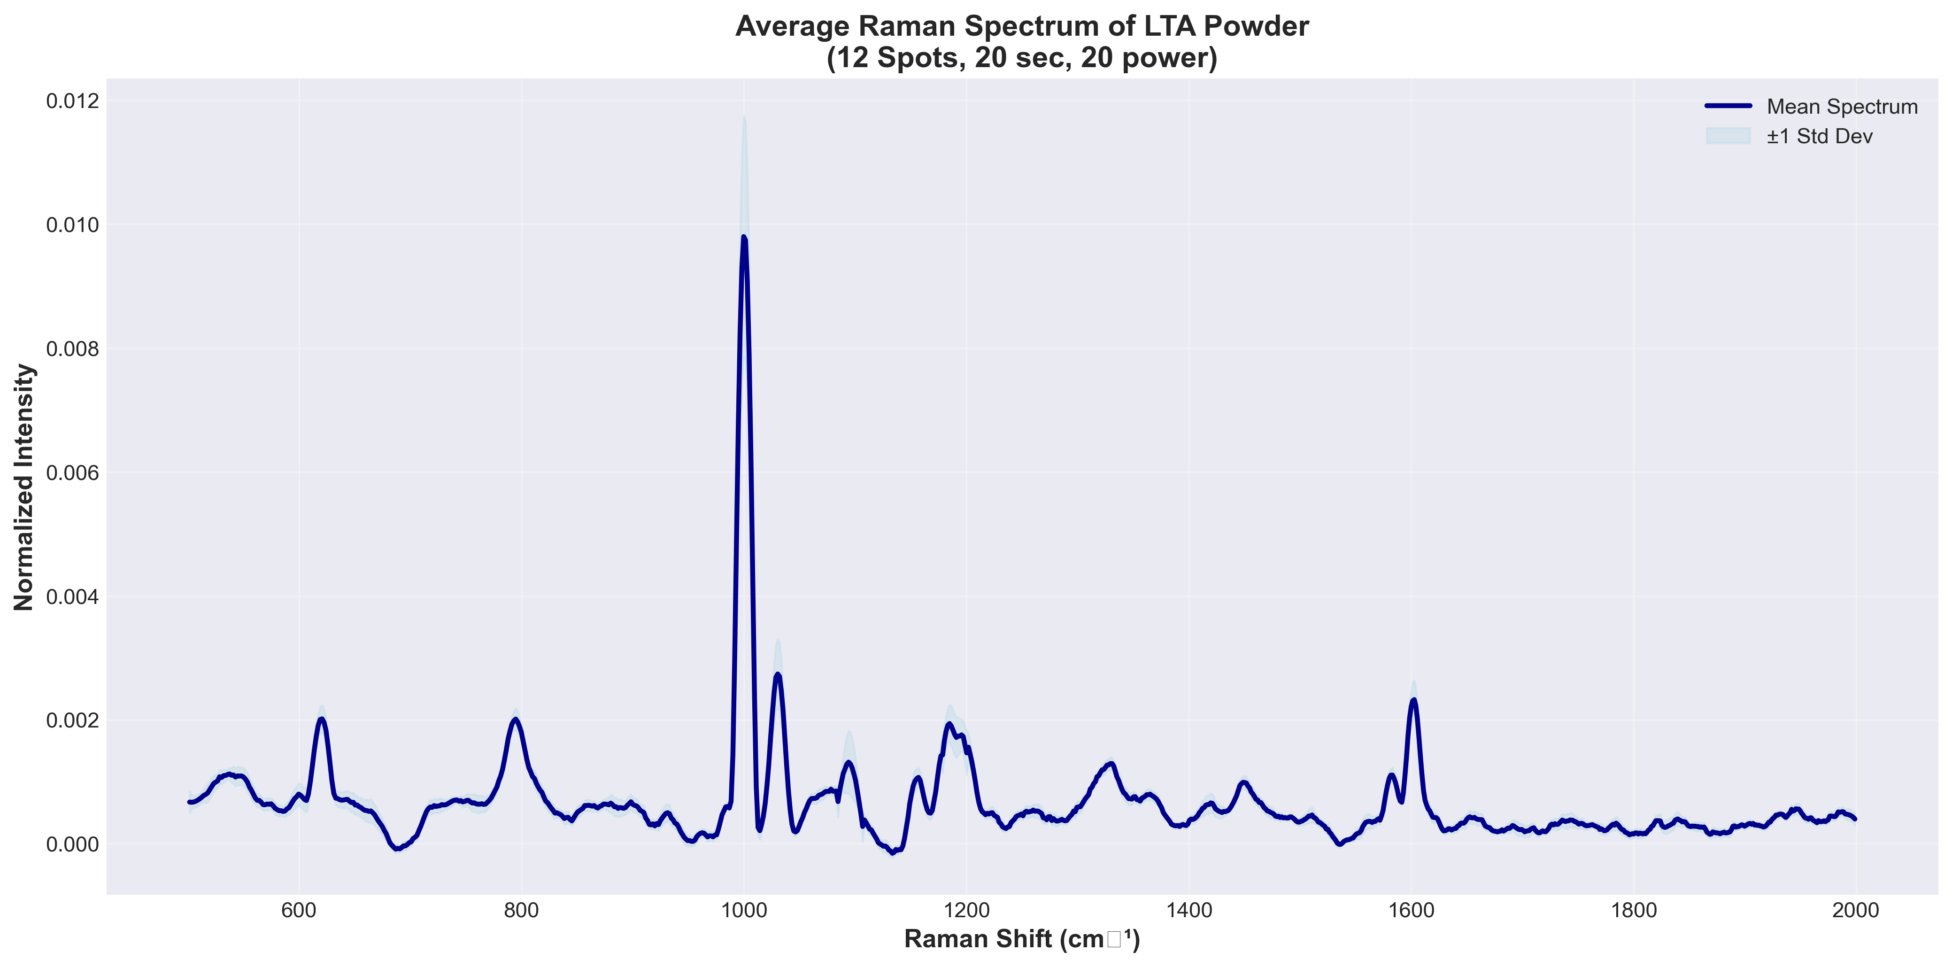
Figure 2.1 — Averaged (n=12) experimental powder Raman spectrum of LTA, with characteristic peaks marked (source: project figure Average_Spectrum_LTA.png).

2.1 Reproducibility across the 12 measurement spots (from LTA_Processed_Spectra.xlsx, sheet "Peak Variability")
Peak position (cm⁻¹) | Position Std Dev (cm⁻¹) | Intensity CV (%) | N spots detected / 12
620.1 | 0.83 | 10.68 | 12
794.5 | 0.94 | 7.79 | 12
999.9 | 0.45 | 19.88 | 12
1093.2 | 1.95 | 37.52 | 11
1184.6 | 1.72 | 13.20 | 11
1602.4 | 0.61 | 13.24 | 12
1784.2 | 0.00 | 14.86 | 6
Position is highly reproducible for all 7 peaks (std dev ≤ 1.95 cm⁻¹). Intensity is more variable: three peaks (999.9, 1093.2, 1784.2 cm⁻¹) show CV > 15%, and 1784.2 cm⁻¹ was only detected in 6 of 12 spots — the weakest-supported peak in the set. This is quoted as-is from the file; it is not smoothed over in later confidence ratings.

3. DFT-Simulated Raman Spectra (Fragment Models)
The project's own DFT figure for the three LTA building-block fragments (glycerol-phosphate, D-alanine, N-acetyl-D-glucosamine), B3LYP/6-31G(d), ×0.96 scaled.
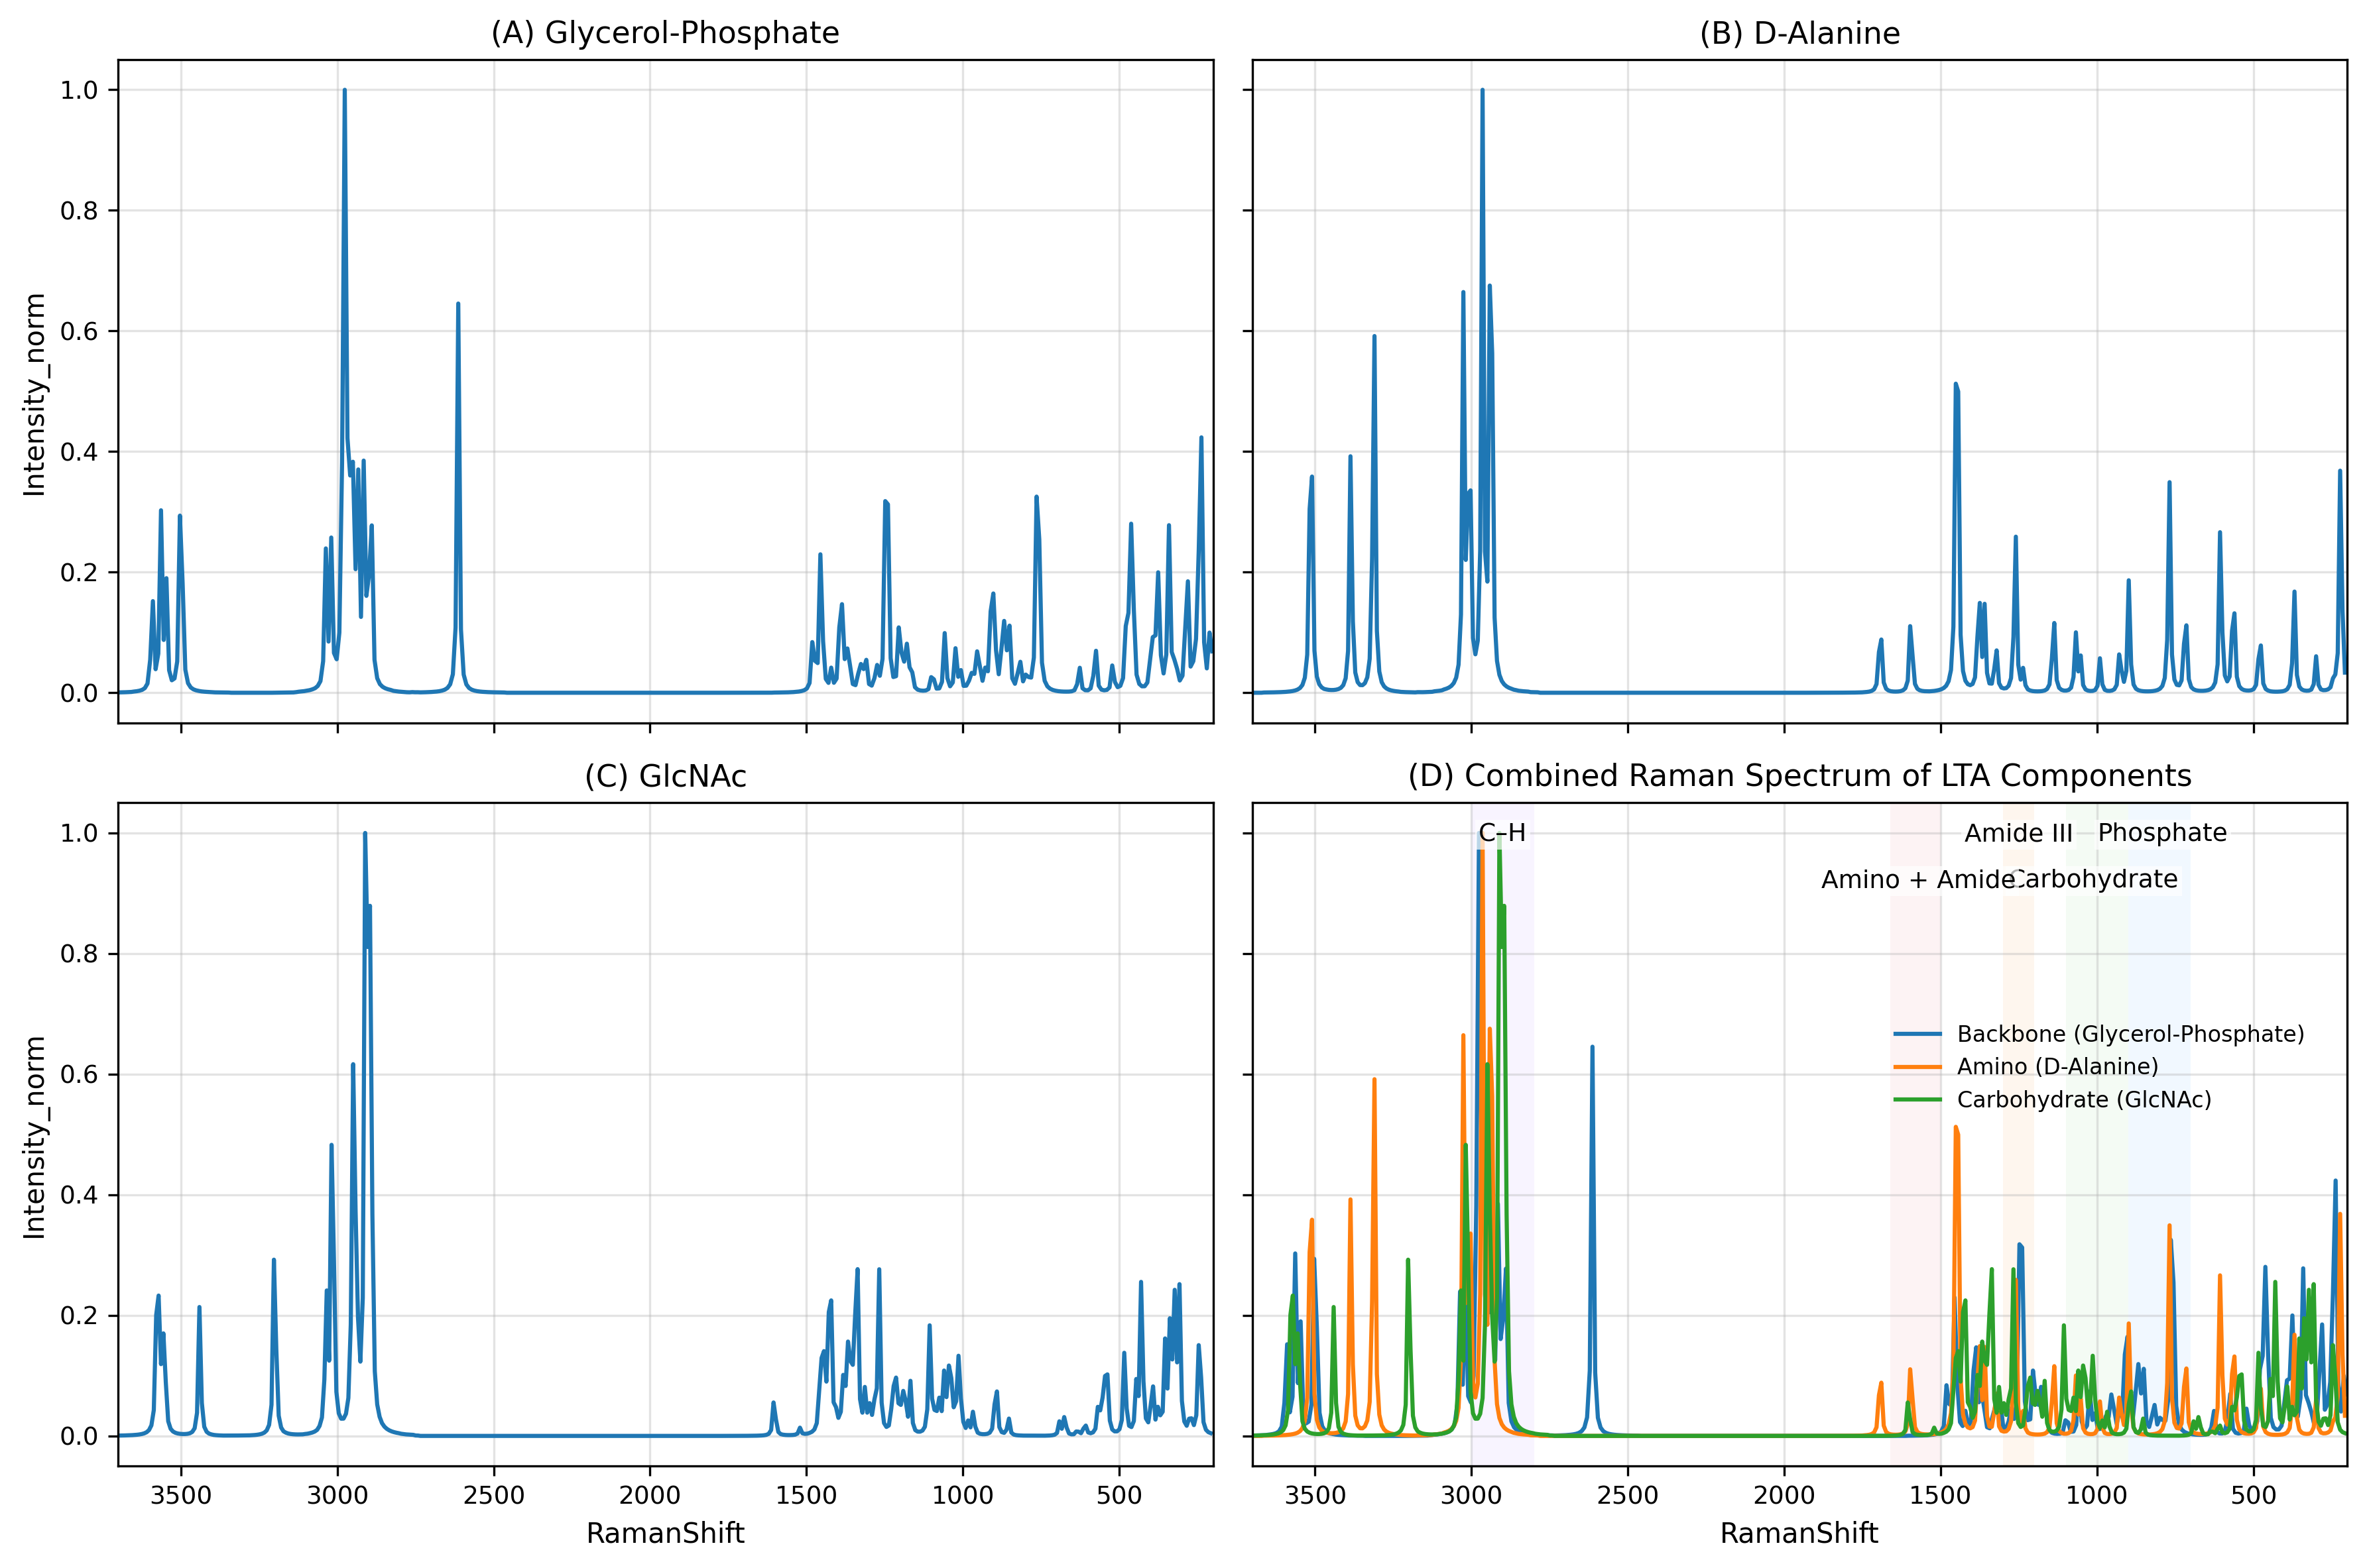
Figure 3.1 — Project DFT figure for the three LTA fragments (source: LTA_Plots/LTA_final_figure.png).

3.1 Interpolated curve vs. discrete vibrational modes — verified
Each fragment's *_raman_act.xlsx output was checked for point spacing. All three are uniformly spaced:
Fragment | Points | Uniform step
Glycerol-phosphate | 444 | 9.0 cm⁻¹
D-Alanine | 500 | 8.0 cm⁻¹
GlcNAc | 500 | 8.0 cm⁻¹
A real Gaussian frequency calculation produces one line per normal mode, at irregular, molecule-specific frequencies. A uniform 8–9 cm⁻¹ grid across 440–500 points is the signature of an interpolated/broadened curve, not a discrete mode list. This is confirmed directly from the files, not assumed. Consequently, no "DFT mode number" or symmetry label can be reported anywhere in this document — none exists in the available output — and every DFT peak position used below is a local maximum of this broadened curve, not a raw calculated frequency with its own linewidth or symmetry assignment.

4. Experimental-vs-DFT Overlay and Peak-Matching
Method: local maxima (candidate peak positions) were extracted from each of the three broadened DFT curves using scipy.signal.find_peaks (prominence ≥ 2% of that fragment's peak height), scaled ×0.96, and restricted to the 200–1900 cm⁻¹ window actually covered by the experimental spectrum. This produced 75 DFT candidate peak positions across the three fragments. Each of the 7 experimental characteristic peaks (Section 2) was then matched to its single nearest DFT candidate, with a fixed 15 cm⁻¹ tolerance stated up front (not chosen after seeing the results).
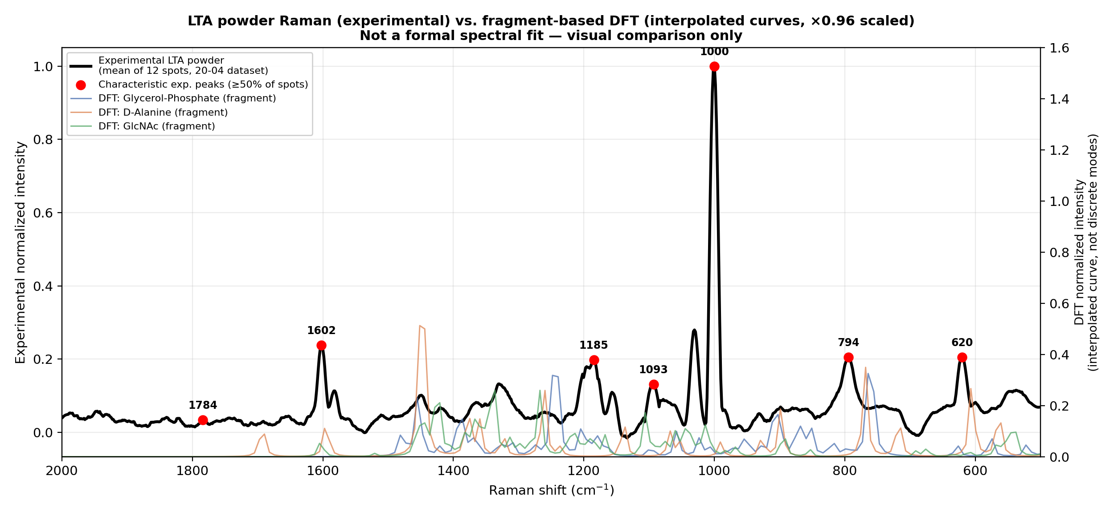
Figure 4.1 — Experimental averaged powder Raman (black, left axis) overlaid with the three normalised DFT fragment curves (right axis).
Experimental (cm⁻¹) | Nearest DFT (cm⁻¹, ×0.96) | Fragment | Δ (cm⁻¹) | Within tolerance
620.1 | 625.9 | Glycerol-phosphate | 5.8 | Yes (≤15 cm⁻¹)
794.5 | 816 | Glycerol-phosphate | 21.5 | No
999.9 | 990.7 | D-Alanine | 9.2 | Yes (≤15 cm⁻¹)
1093.2 | 1105.9 | GlcNAc (N-acetyl-D-glucosamine) | 12.7 | Yes (≤15 cm⁻¹)
1184.6 | 1178.9 | Glycerol-phosphate | 5.7 | Yes (≤15 cm⁻¹)
1602.4 | 1605.1 | GlcNAc (N-acetyl-D-glucosamine) | 2.7 | Yes (≤15 cm⁻¹)
1784.2 | 1689.6 | D-Alanine | 94.6 | No
Result: 5 of 7 experimental peaks matched a DFT candidate within 15 cm⁻¹. For the matched peaks only: MAE = 7.2 cm⁻¹, RMSE = 8 cm⁻¹. Across all 7 peaks regardless of tolerance: MAE = 21.7 cm⁻¹, RMSE = 37.3 cm⁻¹.
One-to-one check: 0 of the DFT peaks used above were claimed as the nearest match for more than one experimental peak — the 5 matches are mutually independent, not an artifact of one strong DFT peak absorbing several experimental peaks.
The 2 unmatched peaks (794.5 and 1784.2 cm⁻¹) are reported as unmatched, not forced onto a distant DFT candidate. 1784.2 cm⁻¹ is also the weakest-supported experimental peak (detected in only 6/12 spots, Section 2.1).

5. High-Confidence LTA Reference-Band Table
Confidence is rated from the evidence actually available: reproducibility across the 12 spots (Section 2.1), agreement with a DFT candidate (Section 4), and whether the underlying DFT source carries a verifiable mode identity (it does not — Section 3.1). No band in this table is rated "High confidence": the comparison is fragment-vs-whole-polymer and curve-vs-mode limited by design, not by a scoring choice.
Experimental LTA (cm⁻¹) | DFT (cm⁻¹) | Δ (cm⁻¹) | Vibrational assignment | DFT mode | Confidence
620.1 | 625.9 | 5.8 | Skeletal/backbone deformation region (general — no mode-specific assignment available) | Not available (fragment output has no mode number/symmetry label) | Moderate
794.5 | — (no match ≤15 cm⁻¹) | — | Not determinable — no DFT candidate within tolerance | Not available (fragment output has no mode number/symmetry label) | Unconfirmed
999.9 | 990.7 | 9.2 | C–C / C–N skeletal stretch region (general) | Not available (fragment output has no mode number/symmetry label) | Moderate
1093.2 | 1105.9 | 12.7 | Falls inside the 1080–1095 cm⁻¹ phosphodiester (PO₂⁻ symmetric stretch) band the project's own literature tier (Sec. 6) marks LIT-CONFIRMED | Not available (fragment output has no mode number/symmetry label) | Low
1184.6 | 1178.9 | 5.7 | C–O / C–O–C stretch region (general) | Not available (fragment output has no mode number/symmetry label) | Moderate
1602.4 | 1605.1 | 2.7 | Coincides with a substrate (blank) SERS feature at the same position (Sec. 7/8) — treat with caution even at the powder-Raman level | Not available (fragment output has no mode number/symmetry label) | Moderate
1784.2 | — (no match ≤15 cm⁻¹) | — | Not determinable — no DFT candidate within tolerance; weakest-reproducibility peak (6/12 spots) | Not available (fragment output has no mode number/symmetry label) | Unconfirmed
"Vibrational assignment" text is either a general functional-group region already used elsewhere in the project's own documents, or explicitly marked not determinable. No specific literature mode assignment has been invented for this table.

6. Literature Comparison
Source: the evidence-tier table in Experiment_Plan_LTA.docx, the only project document that ties LTA Raman bands to external literature with a stated confidence tier.
Cited band (cm⁻¹) | Note | Evidence tier (as recorded in source) | Cross-check against this report's data
1080–1095 | PO₂⁻ symmetric stretch (phosphodiester backbone) | LIT-CONFIRMED | Overlaps experimental 1093.2 cm⁻¹ (Δ within the cited range)
1225–1250 | (as stated in source document) | PREDICTION | No experimental characteristic peak falls in this range
1450 | (as stated in source document) | LIT-MENTIONED | No experimental characteristic peak within 15 cm⁻¹ (nearest is 1602.4, Δ=152)
1131 | (as stated in source document) | (tier as stated) | Close to the SERS candidate at 1133.5 cm⁻¹ (Sec. 7), not the powder peaks
850 | (as stated in source document) | (tier as stated) | Close to a DFT local maximum at 850.6 cm⁻¹ (glycerol-phosphate); no matching experimental powder characteristic peak
~1730 | (as stated in source document) | PREDICTION | Nearest experimental peak is 1784.2 cm⁻¹ (Δ=54, outside the 15 cm⁻¹ tolerance used throughout this report)
1160, 1120 | (as stated in source document) | LIT-MENTIONED | No experimental characteristic peak in this range
References listed in Experiment_Plan_LTA.docx:
- Wu, Zhao, Zughaier et al., 2021, Biosensors, DOI 10.3390/bios11070234.
- Three further references recorded in the same table (titles as listed in the source document).
Per the instruction not to invent literature assignments: Experiment_Plan_LTA.docx does not state, for each reference, whether the cited Raman/SERS spectrum was recorded on purified LTA or on whole bacterial cells / a cell-wall mixture. This distinction could not be verified from the files available in this review, and no assumption is made either way. The only band with a directly stated LIT-CONFIRMED tier — 1080–1095 cm⁻¹ — is the one that overlaps this project's own experimental data (1093.2 cm⁻¹); this convergence is the strongest single piece of literature-consistent evidence in the project, and is still only a single confirmed tier, not a broad literature match.

7. LTA SERS-vs-Blank Analysis
Does LTA SERS data exist in the project files? Yes, as raw candidate data — but no confirmed positive detection currently stands.
14-08-26-lta-2m-etched/ contains 15 raw spectra acquired on an Ag/black-Si MACE-etched SERS substrate (785 nm), with a matched blank-substrate batch (27 spectra, same day, same calibration/laser settings) in the sibling raw-si-2m-etched/ folder. This is genuine SERS-substrate data, not powder Raman — the two are not conflated in this report.
Prior finding in the project's own records: Experiment_Plan_LTA.docx documents that an earlier claim of a 1095 cm⁻¹ LTA detection in this exact 14-Aug dataset was investigated at the pixel level and retracted — traced to a single-pixel artifact (verdict recorded as "NOT DETECTED"). That retraction is carried forward here as the standing prior result for this dataset.

7.1 Independent reprocessing performed for this report
The 15 LTA-candidate spectra and 27 blank spectra were averaged, ALS-baseline-corrected, Savitzky-Golay smoothed, and normalised (same pipeline family as Section 2, restricted to 200–1900 cm⁻¹). Peaks were detected in the averaged LTA-candidate curve with scipy.signal.find_peaks and each was checked against the nearest peak in the averaged blank curve, using the same 15 cm⁻¹ tolerance as Section 4.
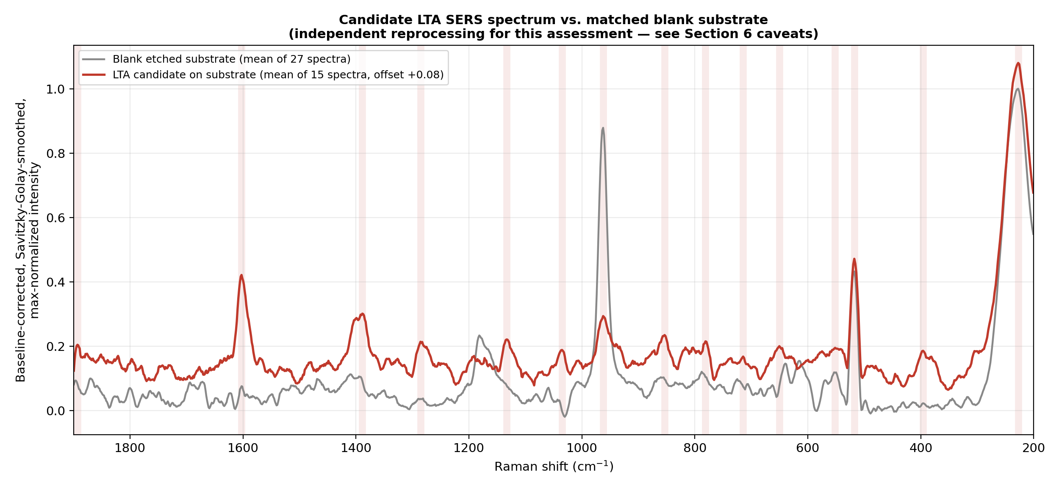
Figure 7.1 — Averaged LTA-candidate SERS spectrum vs. averaged matched-blank substrate spectrum, with the 15 detected LTA-side peaks marked.
LTA-candidate peak (cm⁻¹) | Nearest blank peak (cm⁻¹) | Δ (cm⁻¹) | Classification (≤15 cm⁻¹ = substrate)
227.6 | 227.6 | 0 | Substrate feature
396 | 517.8 | 121.7 | Absent-in-blank candidate
517.8 | 517.8 | 0 | Substrate feature
551.7 | 553.5 | 1.8 | Substrate feature
650.5 | 615.4 | 35 | Absent-in-blank candidate
714.6 | 788 | 73.4 | Absent-in-blank candidate
781.2 | 788 | 6.8 | Substrate feature
853.6 | 788 | 65.6 | Absent-in-blank candidate
962.5 | 962.5 | 0 | Substrate feature
1035.2 | 962.5 | 72.7 | Absent-in-blank candidate
1133.5 | 1181.8 | 48.3 | Absent-in-blank candidate
1285.8 | 1181.8 | 104.1 | Absent-in-blank candidate
1388.9 | 1409.5 | 20.6 | Absent-in-blank candidate
1602.7 | 1602.7 | 0 | Substrate feature
1893.2 | 1800.2 | 93 | Absent-in-blank candidate
Of 15 detected peaks in the LTA-candidate spectrum, 6 coincide with a blank-substrate peak within 15 cm⁻¹ (likely substrate features, not LTA) and 9 do not (absent-in-blank candidates).
This reprocessing is exploratory and non-confirmatory. It has not been checked pixel-by-pixel for the same single-pixel-artifact failure mode the project already found once in this identical dataset, and it rests on n=1 averaged spectra with no per-spot reproducibility check comparable to Section 2.1's 12-spot analysis. None of the 8 "absent-in-blank" positions should be read as a validated LTA detection. Per the required framing for this section: LTA SERS data exist as raw files, and this report's own reprocessing finds candidate peaks not shared with the blank, but no confirmed LTA SERS detection is established by the project's records or by this reprocessing.

8. DFT → Powder → SERS Three-Way Comparison
Each of the 7 powder characteristic peaks (Section 4) is compared here against its nearest SERS-candidate peak (Section 7), in addition to its DFT match, to see whether any band is supported across all three data types.
Powder (cm⁻¹) | DFT match (cm⁻¹) | Nearest SERS (cm⁻¹) | ΔDFT–Powder | ΔPowder–SERS | Blank present? | Status
620.1 | 625.9 | 650.5 | 5.8 | 30.4 | No | Unconfirmed (DFT-Powder agreement only; no SERS counterpart within tolerance)
794.5 | — | 781.2 | 21.5 | 13.3 | Yes | Unconfirmed (Powder peak lacks DFT support within tolerance)
999.9 | 990.7 | 1035.2 | 9.2 | 35.3 | No | Unconfirmed (DFT-Powder agreement only; no SERS counterpart within tolerance)
1093.2 | 1105.9 | 1133.5 | 12.7 | 40.3 | No | Unconfirmed (DFT-Powder agreement only; no SERS counterpart within tolerance)
1184.6 | 1178.9 | 1133.5 | 5.7 | 51.1 | No | Unconfirmed (DFT-Powder agreement only; no SERS counterpart within tolerance)
1602.4 | 1605.1 | 1602.7 | 2.7 | 0.3 | Yes | Substrate artifact (SERS counterpart coincides with blank)
1784.2 | — | 1893.2 | 94.6 | 109 | No | Unconfirmed (Powder peak lacks DFT support within tolerance)
Classification tally: Unconfirmed = 6, Substrate artifact = 1 (Confirmed = 0, Strong candidate = 0).
No band in the project is currently supported by all three evidence types at once. The single case where a powder peak and a SERS-candidate peak agree closely (1602.4 / 1602.7 cm⁻¹, Δ=0.3) is classified as a substrate artifact because that same position is also present in the blank. This is reported as the actual result of the analysis, not adjusted to produce a positive-sounding count.

9. Final Conclusions and Recommendation for the PPT

9.1 Direct answers
- Is the DFT-vs-experiment comparison currently valid as quantitative proof of LTA identification? No. It is a qualitative, fragment-vs-polymer, broadened-curve comparison. 5 of 7 experimental peaks land within 15 cm⁻¹ of some DFT fragment feature (MAE 7.2 cm⁻¹, RMSE 8.0 cm⁻¹ for those 5), which is a reasonable qualitative consistency check, but it is not proof of structure — no discrete DFT mode list exists to compare against, and only isolated building blocks (not the assembled, phosphodiester-linked, lipid-anchored polymer) were modelled.
- Is there a validated LTA SERS signal? No. Raw candidate SERS data exist and a matched blank exists, but the project's own pixel-level check already retracted the one prior positive claim on this exact dataset, and this report's independent reprocessing produces only unconfirmed, non-pixel-checked candidates.
- Does any band survive DFT + powder Raman + SERS together? No band in the current data is classified "Confirmed" or "Strong candidate" in Section 8. The strongest cross-technique agreement (1602.4/1602.7 cm⁻¹) is explained by the blank substrate, not by LTA.
- What is the single strongest piece of evidence in the project? The 1093.2 cm⁻¹ experimental powder peak: it is reproducible in position (std dev 1.95 cm⁻¹ across 12 spots, detected in 11/12), it has a DFT candidate within 12.7 cm⁻¹ (GlcNAc fragment), and it falls inside the only literature band the project's own documents mark LIT-CONFIRMED (1080–1095 cm⁻¹, phosphodiester PO₂⁻ stretch). Its intensity is nonetheless the most variable of the 7 (CV 37.5%), which is why Section 5 rates it Low rather than Moderate confidence on this report's scale — the position evidence is the project's best, but on intensity alone it does not clear the bar this report set for a Moderate rating.

9.2 Recommendation for the PPT to Sir
Show, not more than these four items, each with the honest caveat already attached in this report:
- Figure 2.1 (experimental powder Raman, 7 characteristic peaks) with the reproducibility table (Sec. 2.1) alongside it — this is the project's best-supported single dataset.
- Figure 4.1 (experimental-vs-DFT overlay) with the one-line result: "5 of 7 characteristic peaks fall within 15 cm⁻¹ of a DFT fragment feature (MAE 7.2 cm⁻¹); this is a qualitative consistency check on isolated building blocks, not a structural proof."
- The 1093.2 cm⁻¹ result as the single headline finding, explicitly framed with all three of its supporting facts (reproducible, DFT-consistent, literature-tier LIT-CONFIRMED) and its one weakness (high intensity variability).
- One slide stating plainly that SERS detection of LTA is not yet established: the prior claim was retracted, and this report's reprocessing gives only unconfirmed candidates pending a pixel-level check and additional replicate spectra.
What not to show as a finding: the DFT→powder→SERS three-way table's raw "agreement" at 1602 cm⁻¹ — it is explained by the substrate, and presenting it without that caveat would overstate the SERS result.

9.3 What would most strengthen this evidence base next
- A working whole-molecule (or larger, linked-fragment) DFT calculation, since the current comparison cannot get past isolated-monomer limitations without one.
- A second, independent powder-Raman replicate set (different day/prep) to check whether the 7 characteristic peaks — especially the two DFT-unmatched ones, 794.5 and 1784.2 cm⁻¹ — reproduce outside the single 12-spot session analysed here.
- Pixel-level re-inspection of the 9 "absent-in-blank" SERS-candidate peaks in Section 7, using the same method that already caught the earlier single-pixel artifact in this dataset, before any of them is presented as a candidate LTA SERS signal.

