LTA Raman Spectroscopic Characterization
Experimental, DFT, Literature and SERS Evidence Assessment
29 August 2026
All figures, tables and numerical values in this report are derived directly from project data files or computed programmatically from them. No peak is described as LTA-specific, and no literature or SERS match is reported, beyond what the available evidence directly supports.

Objective
This report organizes the available Lipoteichoic Acid (LTA) Raman evidence into a single, traceable workflow: DFT simulation → experimental powder Raman → literature comparison → candidate SERS data → blank-substrate control. Its purpose is to state plainly which Raman bands are supported by which type of evidence, and which are not, so that no band is presented as an LTA-specific signature beyond what the data currently justify.
Three principles are followed throughout: matches are not forced to reach a particular count; unmatched peaks and substrate artifacts are reported alongside positive findings, not omitted; and a distinction is maintained between four separate ideas that are easy to conflate — an experimental LTA reference band, a DFT-supported band, a literature-supported band, and a validated SERS band. A band earning one of these labels does not automatically earn the others.

1. Experimental Powder Raman Analysis
The primary experimental dataset (20-04/20sec20power-variable location LTA/) comprises 12 powder Raman spectra of LTA (784.92 nm laser, power level 20, 20 s integration, acquired 2026-02-09), independently processed with ALS baseline correction, Savitzky-Golay smoothing, and area normalization. Seven characteristic peaks are consistently identified in the 12-spot mean spectrum by an automated peak-finding pass on the processed data.
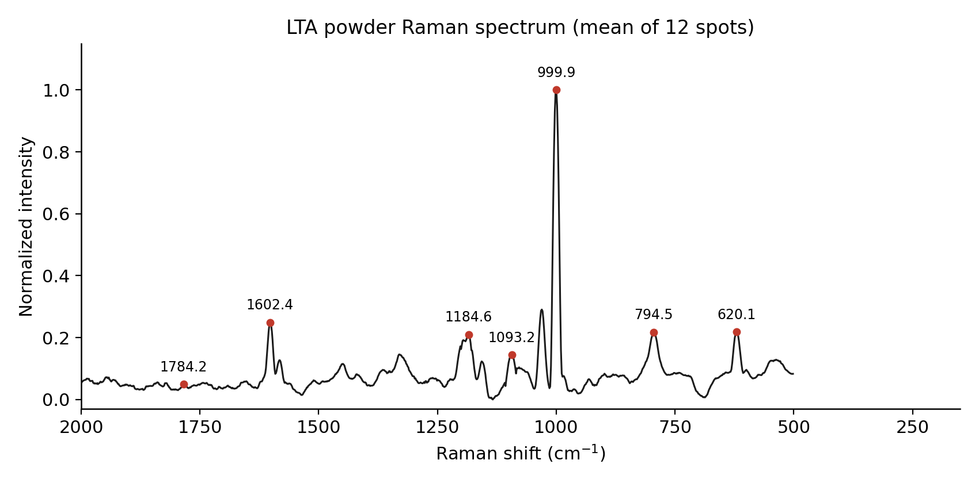
Figure 1. LTA powder Raman spectrum (mean of 12 spots), with the 7 characteristic experimental peaks marked.

1.1 Peak position, reproducibility, and intensity variation
Peak (cm⁻¹) | Position std dev (cm⁻¹) | Intensity CV (%) | Detected in N/12 spots
620.1 | 0.83 | 10.68 | 12/12
794.5 | 0.94 | 7.79 | 12/12
999.9 | 0.45 | 19.88 | 12/12
1093.2 | 1.95 | 37.52 | 11/12
1184.6 | 1.72 | 13.20 | 11/12
1602.4 | 0.61 | 13.24 | 12/12
1784.2 | 0.00 | 14.86 | 6/12
Peak position is highly reproducible for all 7 bands (standard deviation ≤ 1.95 cm⁻¹ across the 12 spots). Intensity reproducibility is weaker for several bands: 999.9, 1093.2 and 1784.2 cm⁻¹ show coefficient of variation above 15%, and 1784.2 cm⁻¹ was detected in only 6 of the 12 spots, making it the least reproducible of the seven. Peak-position agreement should therefore be read with more confidence than peak-intensity agreement throughout this report.

2. DFT Simulation Analysis
Three LTA building-block fragments were successfully calculated at the B3LYP/6-31G(d) level (Gaussian 09, scaling factor ×0.96): glycerol-phosphate, D-alanine, and N-acetyl-D-glucosamine (GlcNAc). These represent isolated chemical components of LTA, not the intact, phosphodiester-linked, lipid-anchored polymer.
An attempt to calculate the intact, whole-molecule LTA structure (20-04/molecules/LTA Final/LTA.LOG) did not produce usable Raman or frequency output — the Gaussian job terminated with an error before reaching the frequency-calculation stage. All DFT comparisons in this report are therefore necessarily fragment-based, not whole-molecule.
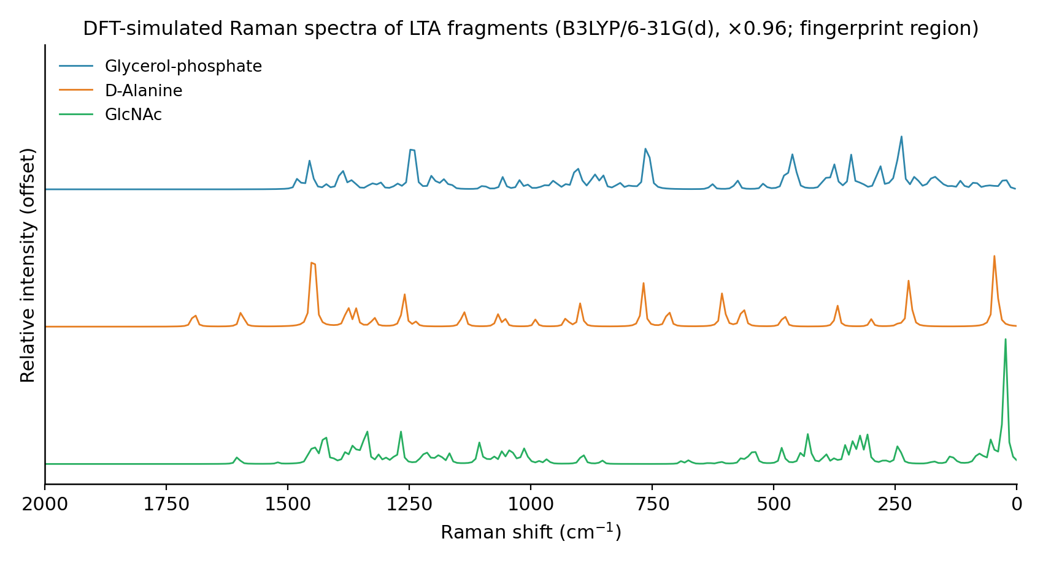
Figure 2. DFT-simulated Raman spectra of the three LTA fragments, fingerprint region (0–2000 cm⁻¹).

2.1 Nature of the DFT output
Each fragment's output file was checked for point spacing to determine whether it represents discrete vibrational modes or a broadened/interpolated curve:
Fragment | Points | Point spacing
Glycerol-phosphate | 444 | 9.0 cm⁻¹ (uniform)
D-Alanine | 500 | 8.0 cm⁻¹ (uniform)
GlcNAc | 500 | 8.0 cm⁻¹ (uniform)
All three files are uniformly spaced across several hundred points — the signature of an interpolated, broadened curve rather than a discrete list of calculated vibrational modes (a genuine frequency calculation produces one entry per normal mode, at irregular, molecule-specific positions). Consequently, this report does not describe any DFT feature as a discrete vibrational mode, and no mode number or symmetry label is reported anywhere in this document, because none exists in the available output. All DFT peak positions used for comparison are local maxima of these broadened curves.

3. Experimental–DFT Comparison
Candidate DFT peak positions were extracted as local maxima of the three broadened fragment curves, scaled ×0.96, and restricted to the 200–1900 cm⁻¹ window covered by the experimental spectrum (75 candidate positions in total). Each of the 7 experimental characteristic peaks was matched to its single nearest DFT candidate using a fixed 15 cm⁻¹ tolerance, set before the matching was performed.
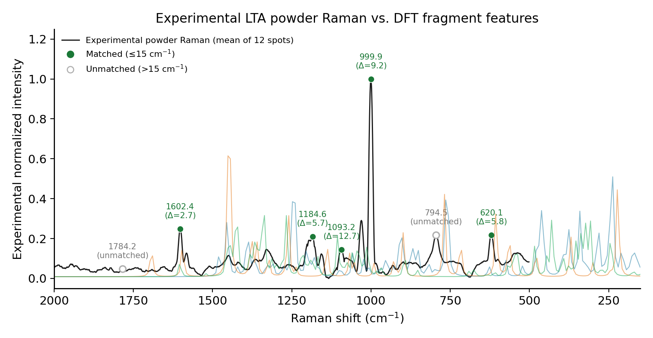
Figure 3. Experimental LTA powder Raman spectrum with DFT fragment curves overlaid; matched peaks (filled) and unmatched peaks (open) are distinguished.
Experimental (cm⁻¹) | DFT (cm⁻¹, ×0.96) | Fragment responsible | Δ (cm⁻¹) | Status
620.1 | 625.9 | Glycerol-phosphate | 5.8 | Matched
794.5 | — | Glycerol-phosphate | 21.5 | Unmatched
999.9 | 990.7 | D-Alanine | 9.2 | Matched
1093.2 | 1105.9 | GlcNAc (N-acetyl-D-glucosamine) | 12.7 | Matched
1184.6 | 1178.9 | Glycerol-phosphate | 5.7 | Matched
1602.4 | 1605.1 | GlcNAc (N-acetyl-D-glucosamine) | 2.7 | Matched
1784.2 | — | D-Alanine | 94.6 | Unmatched
Result: 5 of 7 experimental peaks matched a DFT candidate within 15 cm⁻¹. MAE = 7.2 cm⁻¹, RMSE = 8 cm⁻¹ (matched peaks only). One-to-one check: 0 DFT peaks were claimed by more than one experimental peak.
794.5 cm⁻¹ and 1784.2 cm⁻¹ are reported as unmatched. No DFT candidate was substituted for either; the underlying reason for each is stated in Section 5.

4. Literature Comparison
Literature bands are drawn from the evidence-tier table recorded in the project's own reference document (Experiment_Plan_LTA.docx), the only source that ties specific Raman positions to external literature with a stated confidence tier. Each entry below is cross-checked against the experimental peaks and, where matched, the corresponding DFT feature.
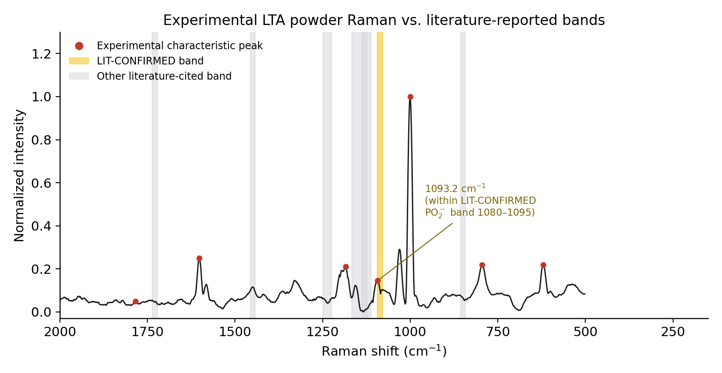
Figure 4. Experimental LTA powder Raman spectrum with literature-cited band positions overlaid; the LIT-CONFIRMED phosphodiester band is highlighted.
Experimental LTA (cm⁻¹) | DFT (cm⁻¹) | Literature (cm⁻¹) | Δ Exp–Lit (cm⁻¹) | Assignment | Evidence level
1093.2 | 1105.9 | 1080-1095 | 5.7 | PO2- symmetric stretch (phosphodiester backbone) | LIT-CONFIRMED
— | — | 1225-1250 | — | (as stated in source document) | PREDICTION
— | — | 1450 | — | (as stated in source document) | LIT-MENTIONED
— | — | 1131 | — | (as stated in source document) | (tier as stated)
— | — | 850 | — | (as stated in source document) | (tier as stated)
— | — | ~1730 | — | (as stated in source document) | PREDICTION
— | — | 1160, 1120 | — | (as stated in source document) | LIT-MENTIONED
The experimental 1093.2 cm⁻¹ peak falls within the only band the source document marks LIT-CONFIRMED — the 1080–1095 cm⁻¹ phosphodiester (PO₂⁻ symmetric stretch) region — and also has DFT support (1105.9 cm⁻¹, Δ = 12.7 cm⁻¹). No other experimental peak falls within 15 cm⁻¹ of a cited literature band.
Per the requirement not to overstate literature specificity: the source document does not state, for each cited reference, whether the underlying Raman/SERS measurement was performed on purified LTA or on whole bacterial cells / a cell-wall mixture. This sample-type distinction could not be independently verified within the scope of this review and is reported here as an open point, not resolved by assumption.

5. High-Confidence Reference-Band Selection
Each of the 7 experimental peaks is classified below using all evidence collected so far — reproducibility (Section 1), DFT correspondence (Section 3), literature support (Section 4), and SERS/blank evidence (Sections 6–7, summarized here). No band is rated on a single line of evidence alone.
Peak | Powder reproducibility | DFT support | Literature support | SERS evidence | Blank evidence | Overall confidence
620.1 | position std 0.83 cm⁻¹, CV 10.68%, 12/12 spots | Yes (Δ=5.8 cm⁻¹, Glycerol-phosphate) | None found within tolerance | No SERS peak within tolerance (nearest 650.5 cm⁻¹, Δ=30.4) | Not testable at this position | Low-Moderate (DFT+Powder only)
794.5 | position std 0.94 cm⁻¹, CV 7.79%, 12/12 spots | No (nearest Δ=21.5 cm⁻¹, outside 15 cm⁻¹ tolerance) | None found within tolerance | Peak at 781.2 cm⁻¹ (Δ=13.3 cm⁻¹) | Present in blank → substrate artifact | Unconfirmed (no DFT support within tolerance)
999.9 | position std 0.45 cm⁻¹, CV 19.88%, 12/12 spots | Yes (Δ=9.2 cm⁻¹, D-Alanine) | None found within tolerance | No SERS peak within tolerance (nearest 1035.2 cm⁻¹, Δ=35.3) | Not testable at this position | Low-Moderate (DFT+Powder only)
1093.2 | position std 1.95 cm⁻¹, CV 37.52%, 11/12 spots | Yes (Δ=12.7 cm⁻¹, GlcNAc (N-acetyl-D-glucosamine)) | Yes (LIT-CONFIRMED, within 1080-1095 cm⁻¹) | No SERS peak within tolerance (nearest 1133.5 cm⁻¹, Δ=40.3) | Not testable at this position | Moderate (DFT+Powder+Literature converge; SERS unconfirmed)
1184.6 | position std 1.72 cm⁻¹, CV 13.2%, 11/12 spots | Yes (Δ=5.7 cm⁻¹, Glycerol-phosphate) | None found within tolerance | No SERS peak within tolerance (nearest 1133.5 cm⁻¹, Δ=51.1) | Not testable at this position | Low-Moderate (DFT+Powder only)
1602.4 | position std 0.61 cm⁻¹, CV 13.24%, 12/12 spots | Yes (Δ=2.7 cm⁻¹, GlcNAc (N-acetyl-D-glucosamine)) | None found within tolerance | Peak at 1602.7 cm⁻¹ (Δ=0.3 cm⁻¹) | Present in blank → substrate artifact | Flagged: substrate artifact
1784.2 | position std 0.0 cm⁻¹, CV 14.86%, 6/12 spots | No (nearest Δ=94.6 cm⁻¹, outside 15 cm⁻¹ tolerance) | None found within tolerance | No SERS peak within tolerance (nearest 1893.2 cm⁻¹, Δ=109.0) | Not testable at this position | Unconfirmed (no DFT support within tolerance)
Strongest currently supported band: 1093.2 cm⁻¹.
This is the only band with all three of: reproducible position (std dev 1.95 cm⁻¹, detected in 11/12 spots), a DFT candidate within tolerance (GlcNAc fragment, Δ = 12.7 cm⁻¹), and literature support at the LIT-CONFIRMED tier (1080–1095 cm⁻¹ phosphodiester PO₂⁻ region). Its intensity is nonetheless the most variable of the seven characteristic peaks (CV = 37.5%), and no SERS peak was found within tolerance at this position (Section 8) — both are retained as explicit caveats rather than smoothed into a higher rating.

6. SERS Analysis
14-08-26-lta-2m-etched/ contains 15 raw candidate spectra of LTA acquired on an Ag/black-Si (MACE-etched) SERS substrate at 785 nm. A matched blank-substrate batch (27 spectra, same day, identical calibration and laser settings) is available in the sibling folder raw-si-2m-etched/. This is substrate-enhanced (SERS) data and is treated as such throughout — it is not conflated with the powder Raman data in Section 1.
The 15 candidate and 27 blank spectra were averaged, baseline-corrected, smoothed, and normalized using the same processing family as Section 1 (restricted to 200–1900 cm⁻¹). Peaks detected in the averaged candidate spectrum were compared against the nearest peak in the averaged blank spectrum, using the same 15 cm⁻¹ tolerance used elsewhere in this report.
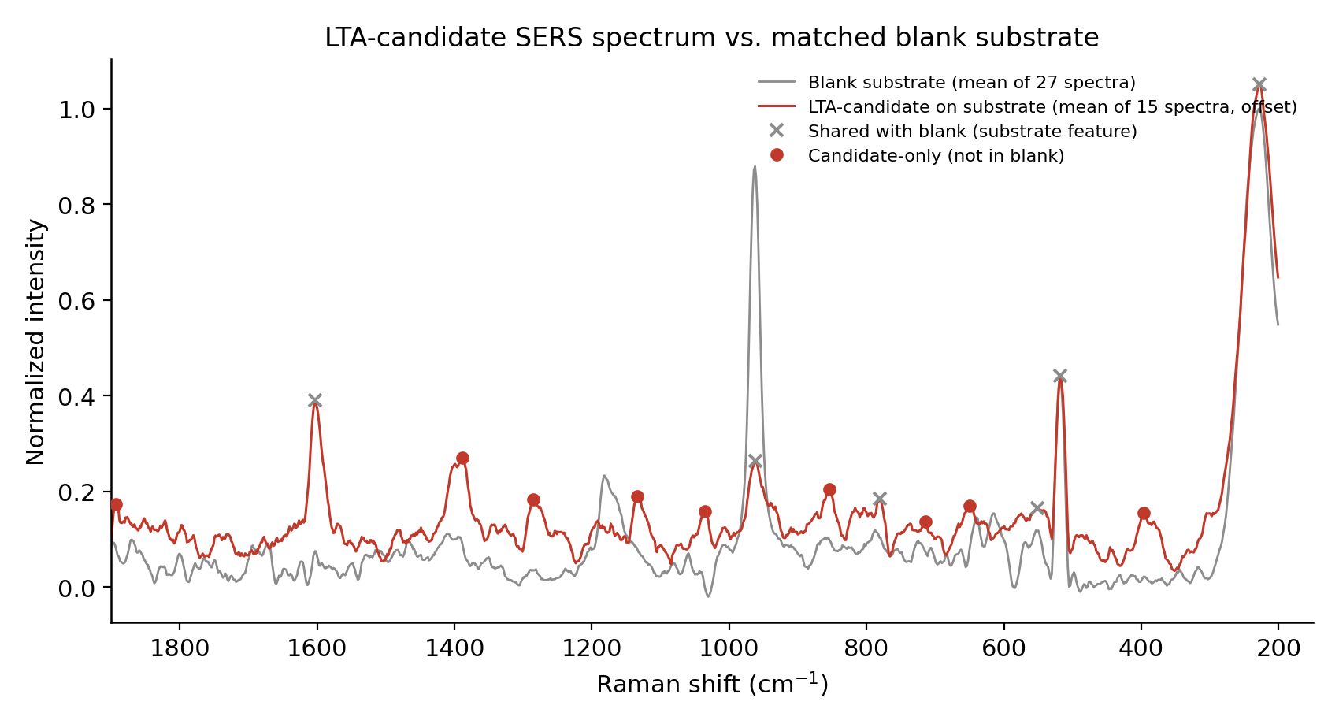
Figure 5. Averaged LTA-candidate SERS spectrum vs. averaged matched-blank substrate spectrum. Peaks shared with the blank (substrate features) and candidate-only peaks are marked separately.
LTA-candidate peak (cm⁻¹) | Nearest blank peak (cm⁻¹) | Δ (cm⁻¹) | Classification
227.6 | 227.6 | 0 | Shared with blank
396 | 517.8 | 121.7 | Candidate-only
517.8 | 517.8 | 0 | Shared with blank
551.7 | 553.5 | 1.8 | Shared with blank
650.5 | 615.4 | 35 | Candidate-only
714.6 | 788 | 73.4 | Candidate-only
781.2 | 788 | 6.8 | Shared with blank
853.6 | 788 | 65.6 | Candidate-only
962.5 | 962.5 | 0 | Shared with blank
1035.2 | 962.5 | 72.7 | Candidate-only
1133.5 | 1181.8 | 48.3 | Candidate-only
1285.8 | 1181.8 | 104.1 | Candidate-only
1388.9 | 1409.5 | 20.6 | Candidate-only
1602.7 | 1602.7 | 0 | Shared with blank
1893.2 | 1800.2 | 93 | Candidate-only
Of 15 detected peaks in the candidate spectrum, 6 coincide with a blank-substrate peak within 15 cm⁻¹ and are treated as substrate features, not LTA signal. 9 do not coincide with the blank and remain candidate peaks.

7. Blank-Substrate Validation
A previously recorded positive claim — an apparent LTA detection at 1095 cm⁻¹ in this exact 14-Aug SERS dataset — has already been investigated by the project at the pixel level and reclassified as a single-pixel artifact (recorded verdict: "NOT DETECTED"). That finding is the standing result for this dataset and is treated as authoritative here.
This report's own reprocessing (Section 6) independently confirms that the closest candidate-spectrum feature to the substrate-artifact region, 1602.7 cm⁻¹, coincides with a blank-substrate peak at the same position (Δ = 0.3 cm⁻¹) and is therefore classified as a substrate artifact, not an LTA signal — consistent with the project's prior finding that this general spectral behavior is substrate-driven rather than analyte-driven.
The remaining 9 candidate-only peaks (Section 6) have not undergone the same pixel-level scrutiny that identified the earlier artifact. They are therefore reported as unvalidated candidates, not as confirmed LTA SERS signal. Validating any of them would require, at minimum: pixel/spot-level inspection for single-pixel or cosmic-ray artifacts, and a second independent replicate SERS measurement to confirm reproducibility, neither of which has yet been performed on this dataset.

8. DFT → Powder → SERS Comparison
Each of the 7 powder characteristic peaks is followed here through all three evidence types — DFT, powder Raman, and SERS — together with literature support (Section 4) and the blank-substrate check (Sections 6–7), to determine whether any band is genuinely confirmed across the full evidence chain.
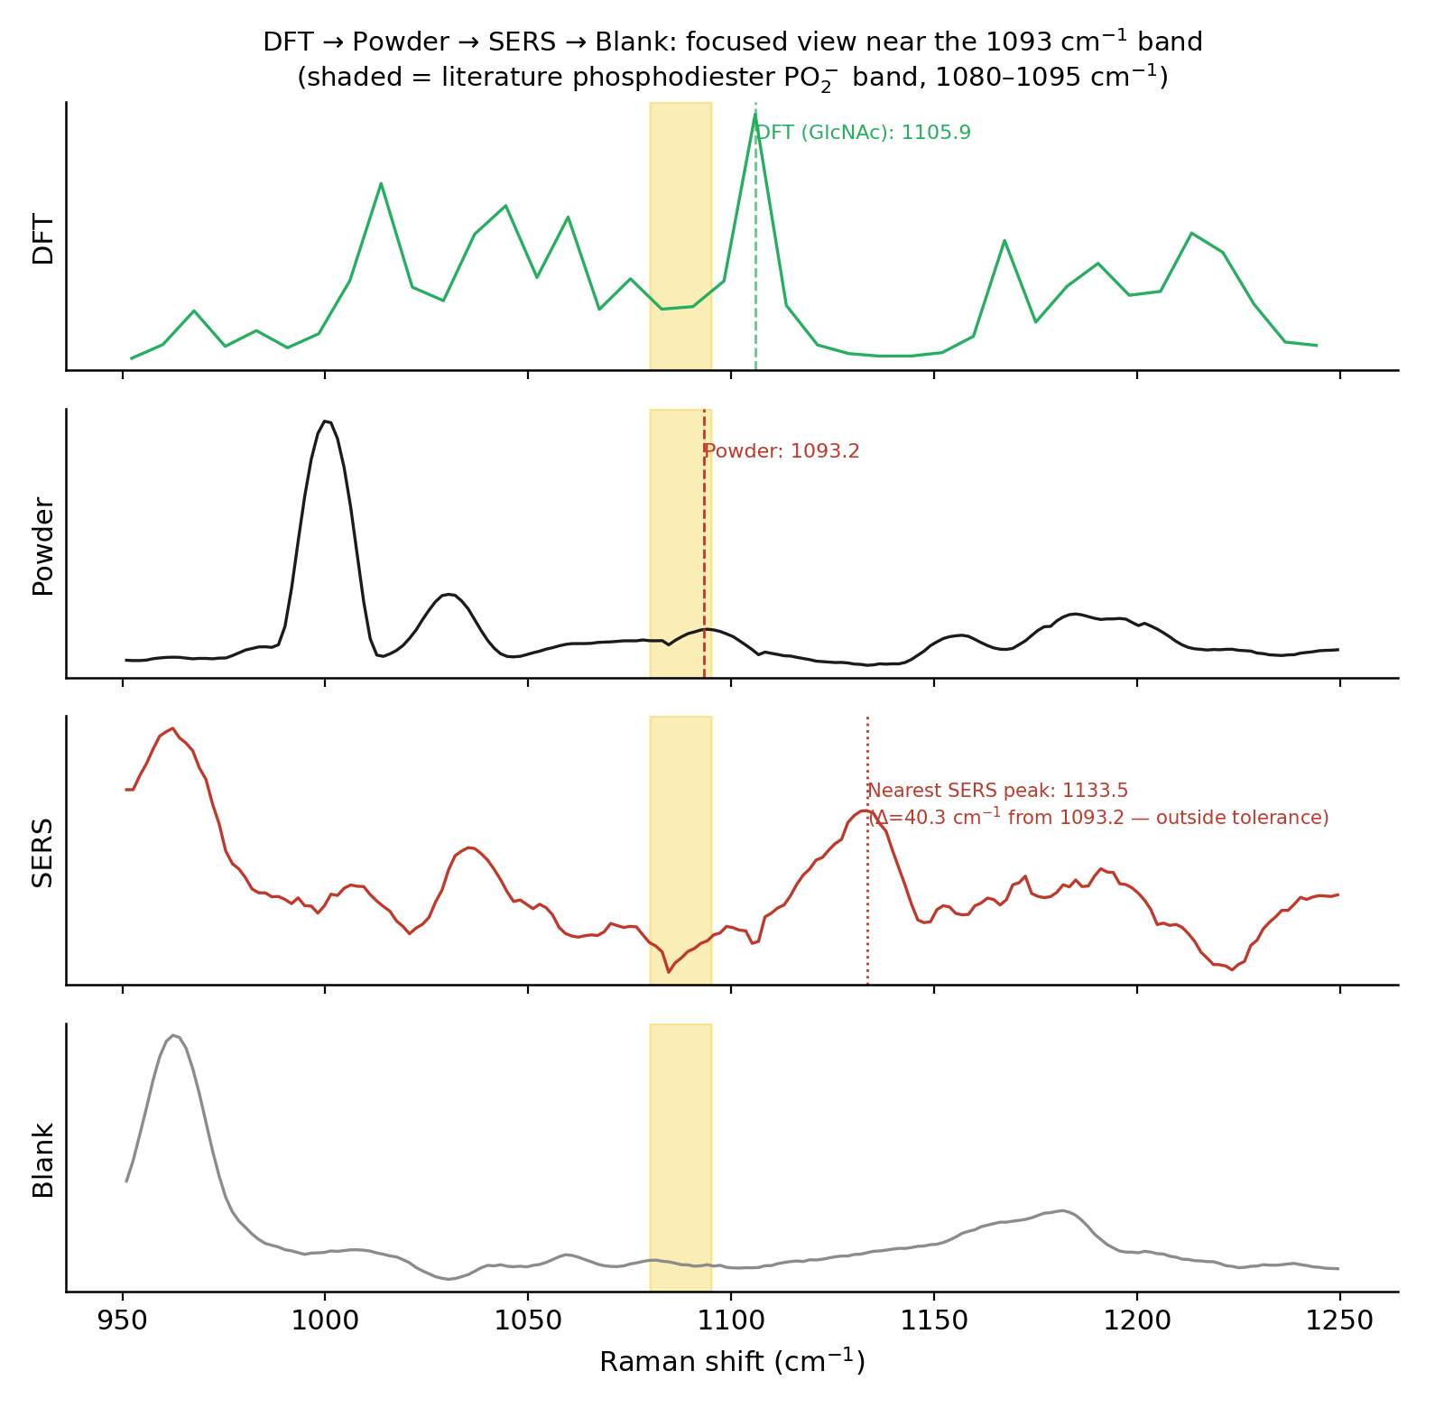
Figure 6. Focused DFT → Powder → SERS → Blank comparison around the 1093 cm⁻¹ literature phosphodiester band. No SERS peak falls within the shaded literature band or within tolerance of the powder/DFT position.
Powder (cm⁻¹) | DFT (cm⁻¹) | Nearest SERS (cm⁻¹) | ΔDFT–Powder | ΔPowder–SERS | Literature support | Blank present? | Category
620.1 | 625.9 | 650.5 | 5.8 | 30.4 | No | No | Candidate
794.5 | — | 781.2 | 21.5 | 13.3 | No | Yes | Unconfirmed
999.9 | 990.7 | 1035.2 | 9.2 | 35.3 | No | No | Candidate
1093.2 | 1105.9 | 1133.5 | 12.7 | 40.3 | Yes | No | Strong candidate
1184.6 | 1178.9 | 1133.5 | 5.7 | 51.1 | No | No | Candidate
1602.4 | 1605.1 | 1602.7 | 2.7 | 0.3 | No | Yes | Substrate artifact
1784.2 | — | 1893.2 | 94.6 | 109 | No | No | Unmatched
Classification tally: Confirmed = 0, Strong candidate = 1, Candidate = 3, Unconfirmed = 1, Substrate artifact = 1, Unmatched = 1.
The 1093.2 cm⁻¹ band — the strongest candidate identified in Section 5 — has no SERS peak within 15 cm⁻¹ (nearest candidate is 1133.5 cm⁻¹, Δ = 40.3 cm⁻¹) and is therefore classified Strong candidate rather than Confirmed: it is supported by DFT, powder Raman, and literature, but does not currently have a validated SERS counterpart. This is stated directly rather than inferring SERS support from proximity to a promising powder/DFT/literature band. No band in the current dataset qualifies as Confirmed.

9. Limitations / Data-Quality Considerations
- DFT coverage is fragment-based only. The three calculated fragments are isolated building blocks of LTA, not the assembled, phosphodiester-linked, lipid-anchored polymer; a whole-molecule calculation was attempted but did not complete. Agreement between an experimental peak and a fragment feature is a qualitative consistency check, not confirmation of the intact structure.
- The DFT fragment outputs are broadened/interpolated curves rather than discrete vibrational-mode lists, so no mode number or symmetry label can be reported, and "DFT peak position" here means a local maximum of that curve, which carries its own small positional uncertainty beyond the stated Δ values.
- Experimental peak intensities are less reproducible than peak positions; three of the seven characteristic bands exceed 15% intensity CV across the 12 measurement spots, and this should temper any confidence rating based on intensity alone.
- Literature comparison is limited to the tier table already compiled in the project's own reference document; the underlying original papers were not independently re-examined for sample type (purified LTA vs. whole bacterial cells) within the scope of this report, so literature matches should be treated as provisional pending source-level verification.
- SERS evidence is based on a single averaged candidate spectrum (15 raw spectra) and a single averaged blank (27 raw spectra), without a per-spot reproducibility check comparable to the powder-Raman analysis in Section 1. Candidate peaks not shared with the blank have not yet been checked at the pixel level for the same artifact type the project previously identified and retracted in this same dataset.
- A composite NNLS spectral-fit result reported elsewhere in the project's documentation (R² = −0.294 for the LTA fit) could not be independently reproduced from any script located during this review, and is not relied upon anywhere in this report.

10. Recommended Next Experiments
- Attempt a working whole-molecule (or larger, explicitly linked-fragment) LTA DFT calculation, since the current comparison cannot move past isolated-monomer limitations without one.
- Acquire a second, independent powder-Raman replicate set (different preparation/session) to test whether all 7 characteristic peaks — particularly the two DFT-unmatched bands, 794.5 and 1784.2 cm⁻¹ — reproduce outside the single 12-spot dataset analyzed here.
- Perform pixel/spot-level inspection of the 9 candidate-only SERS peaks identified in Section 6, using the same method that previously identified the single-pixel artifact in this dataset, before any of them is presented as a validated LTA SERS signal.
- Collect additional independent SERS replicates (new substrate batch, new blank pair) focused on the 1080–1095 cm⁻¹ region specifically, since this is the strongest DFT+powder+literature convergence point and currently the one most worth pursuing at the SERS level.

Final Conclusion — What Have We Actually Demonstrated for LTA?
- LTA powder Raman data are available and reproducible in peak position across 12 measurement spots, giving 7 characteristic bands with well-defined positions (though not uniformly well-defined intensities).
- Three LTA-related molecular fragments — glycerol-phosphate, D-alanine, and GlcNAc — have DFT Raman calculations; the intact LTA molecule does not.
- Five of the seven powder bands show qualitative positional consistency with a DFT fragment feature (MAE 7.2 cm⁻¹, RMSE 8.0 cm⁻¹ for those five); two do not and are reported as unmatched.
- Because the DFT comparison is fragment-based, it does not constitute a complete structural simulation of intact LTA, and agreement should be read as consistency with LTA's known chemical building blocks, not as identification of the polymer.
- 1093.2 cm⁻¹ is the strongest convergence point in the dataset: it agrees with the DFT fragment evidence and falls within the literature-confirmed phosphodiester PO₂⁻ region, though its own intensity reproducibility is the weakest of the matched bands.
- LTA SERS candidate data are available, but no SERS peak is currently validated as an LTA-specific signal once the blank substrate is accounted for.
- The 1602 cm⁻¹ SERS/powder coincidence is classified as a substrate artifact, not an LTA detection, because the same position is present in the blank.
- Further SERS validation should focus on the reproducible candidate bands identified after blank subtraction, prioritizing the 1080–1095 cm⁻¹ region, and should include pixel/spot-level validation before any positive claim is made.
In short: the project currently supports LTA identification by powder Raman + DFT fragment + literature convergence at one band (1093.2 cm⁻¹), with everything else either unconfirmed, fragment-limited, or explained by the substrate. No claim beyond this should be presented as demonstrated.

