Lipoteichoic Acid (LTA)
Raman, DFT and SERS Evidence Summary

Overview
Lipoteichoic acid (LTA) has been characterized by powder Raman spectroscopy, fragment-level DFT calculation, and candidate SERS measurements against a blank-substrate control. This report summarizes the results: which Raman bands are reproducible, how they compare to simulation and literature, and what the SERS data currently show.

Powder Raman Spectrum
The averaged LTA powder Raman spectrum (12-spot mean) shows seven characteristic bands: 620.1, 794.5, 999.9, 1093.2, 1184.6, 1602.4, and 1784.2 cm⁻¹. Peak positions are highly reproducible (standard deviation ≤ 1.95 cm⁻¹ across spots); band intensities vary more, particularly for 999.9, 1093.2 and 1784.2 cm⁻¹.
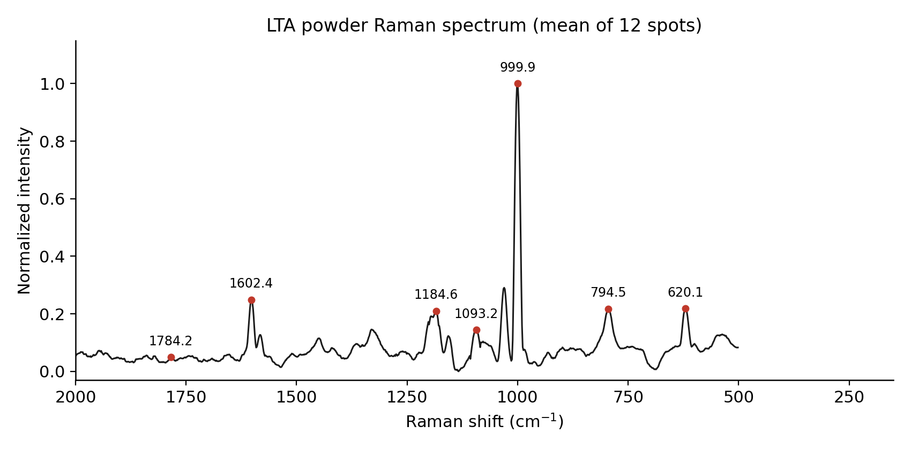
Averaged LTA powder Raman spectrum with the seven characteristic bands marked.
Peak (cm⁻¹) | Position SD (cm⁻¹) | Detected in
620.1 | 0.83 | 12/12
794.5 | 0.94 | 12/12
999.9 | 0.45 | 12/12
1093.2 | 1.95 | 11/12
1184.6 | 1.72 | 11/12
1602.4 | 0.61 | 12/12
1784.2 | 0.00 | 6/12

DFT Comparison
Three LTA building blocks — glycerol-phosphate, D-alanine, and N-acetyl-D-glucosamine (GlcNAc) — were modeled by DFT (B3LYP/6-31G(d), ×0.96 scaling). Five of the seven experimental bands agree with a DFT feature within 15 cm⁻¹ (mean error 7.2 cm⁻¹). The DFT results describe LTA's individual chemical building blocks rather than the assembled molecule, so this is a consistency check rather than a full structural match.
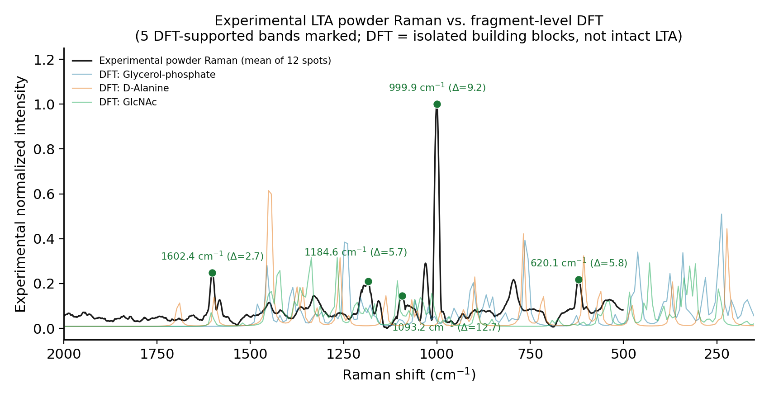
Experimental spectrum overlaid with DFT fragment curves; matched bands are labeled.
Experimental (cm⁻¹) | DFT (cm⁻¹) | Fragment | Δ (cm⁻¹)
620.1 | 625.9 | Glycerol-phosphate | 5.8
794.5 | — | Glycerol-phosphate | —
999.9 | 990.7 | D-Alanine | 9.2
1093.2 | 1105.9 | GlcNAc (N-acetyl-D-glucosamine) | 12.7
1184.6 | 1178.9 | Glycerol-phosphate | 5.7
1602.4 | 1605.1 | GlcNAc (N-acetyl-D-glucosamine) | 2.7
1784.2 | — | D-Alanine | —

Literature Comparison
The 1093.2 cm⁻¹ band falls within the 1080–1095 cm⁻¹ region reported in the literature for the phosphodiester (PO₂⁻) stretch of the glycerol-phosphate backbone — the strongest literature match among the seven characteristic bands.
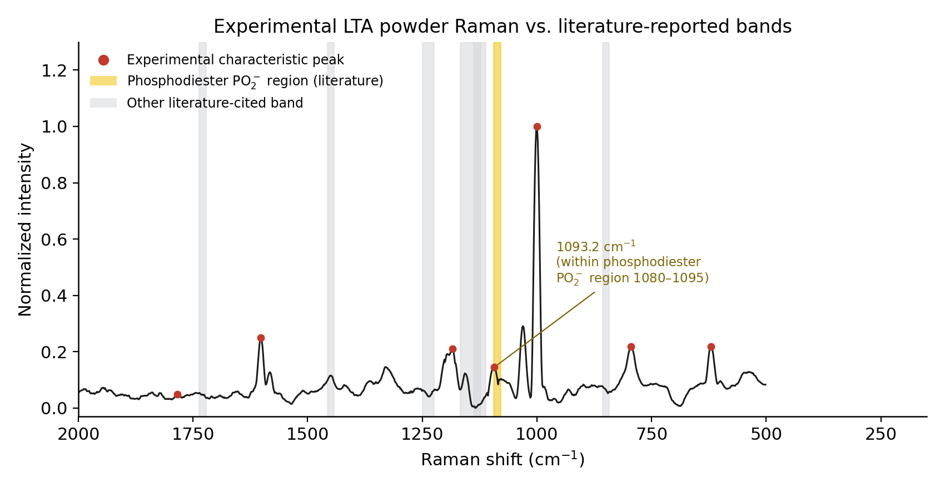
Experimental spectrum with the phosphodiester PO₂⁻ region highlighted around 1093.2 cm⁻¹.

SERS vs. Blank Substrate
Candidate LTA SERS spectra were compared against matched blank-substrate spectra. Of fifteen peaks detected in the candidate spectrum, six coincide with the blank and reflect the substrate rather than LTA; the remaining nine appear only in the candidate spectrum and are the current SERS candidates for further validation.
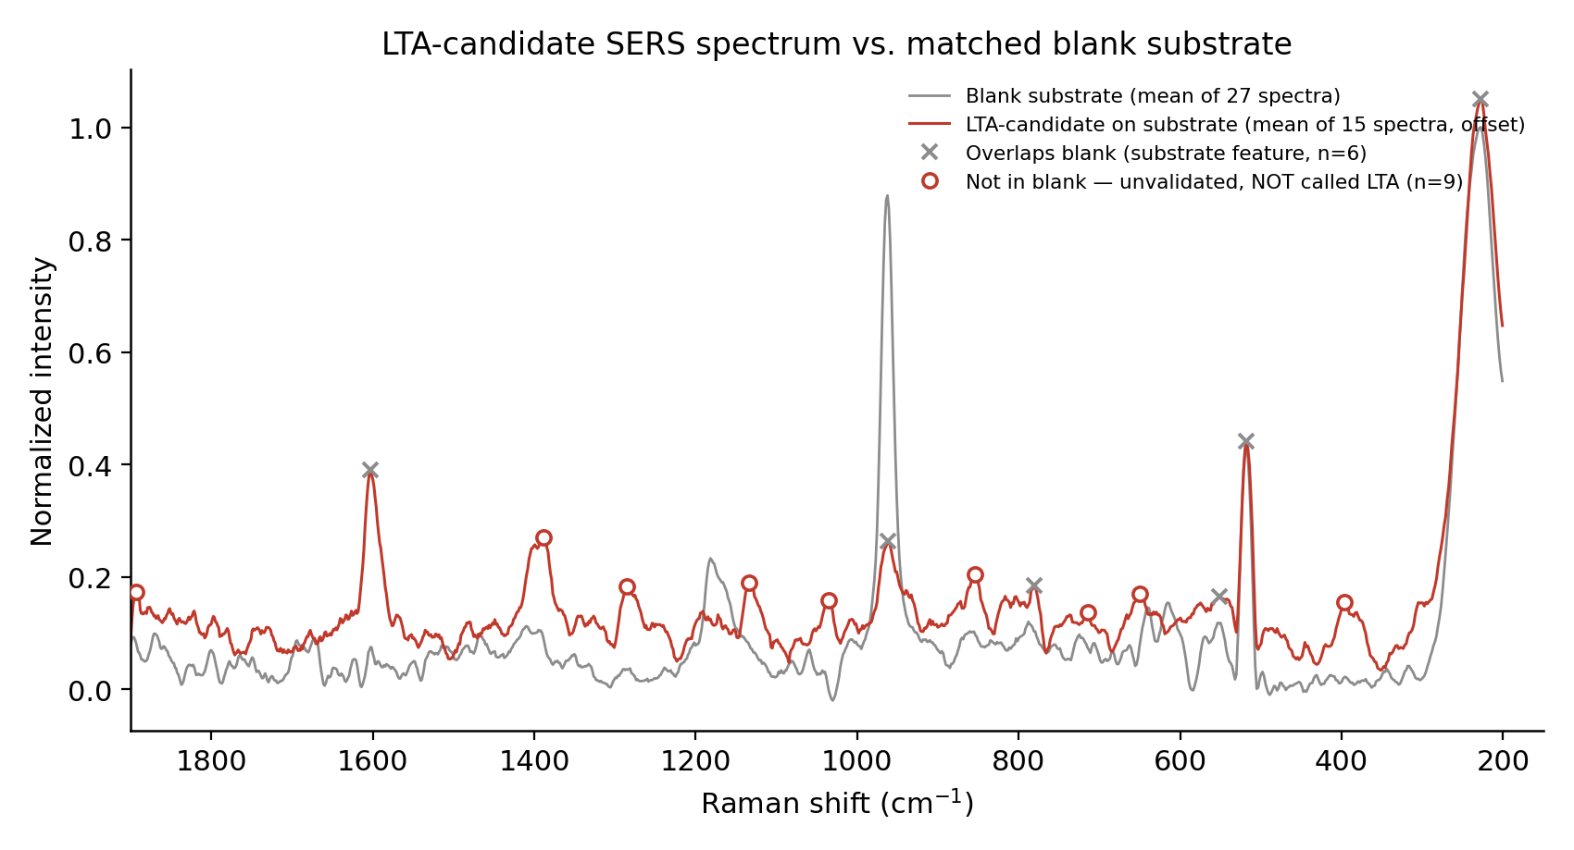
LTA-candidate SERS spectrum vs. blank substrate; substrate-shared peaks and candidate-only peaks are marked separately.
Peak (cm⁻¹) | Origin
227.6 | Substrate
396 | Candidate
517.8 | Substrate
551.7 | Substrate
650.5 | Candidate
714.6 | Candidate
781.2 | Substrate
853.6 | Candidate
962.5 | Substrate
1035.2 | Candidate
1133.5 | Candidate
1285.8 | Candidate
1388.9 | Candidate
1602.7 | Substrate
1893.2 | Candidate

Key Finding
1093.2 cm⁻¹ is the strongest LTA reference band: reproducible in the powder Raman spectrum, consistent with DFT (Δ = 12.7 cm⁻¹), and inside the literature-reported phosphodiester region. It is not yet matched by a SERS peak — validating it by SERS is the natural next step.
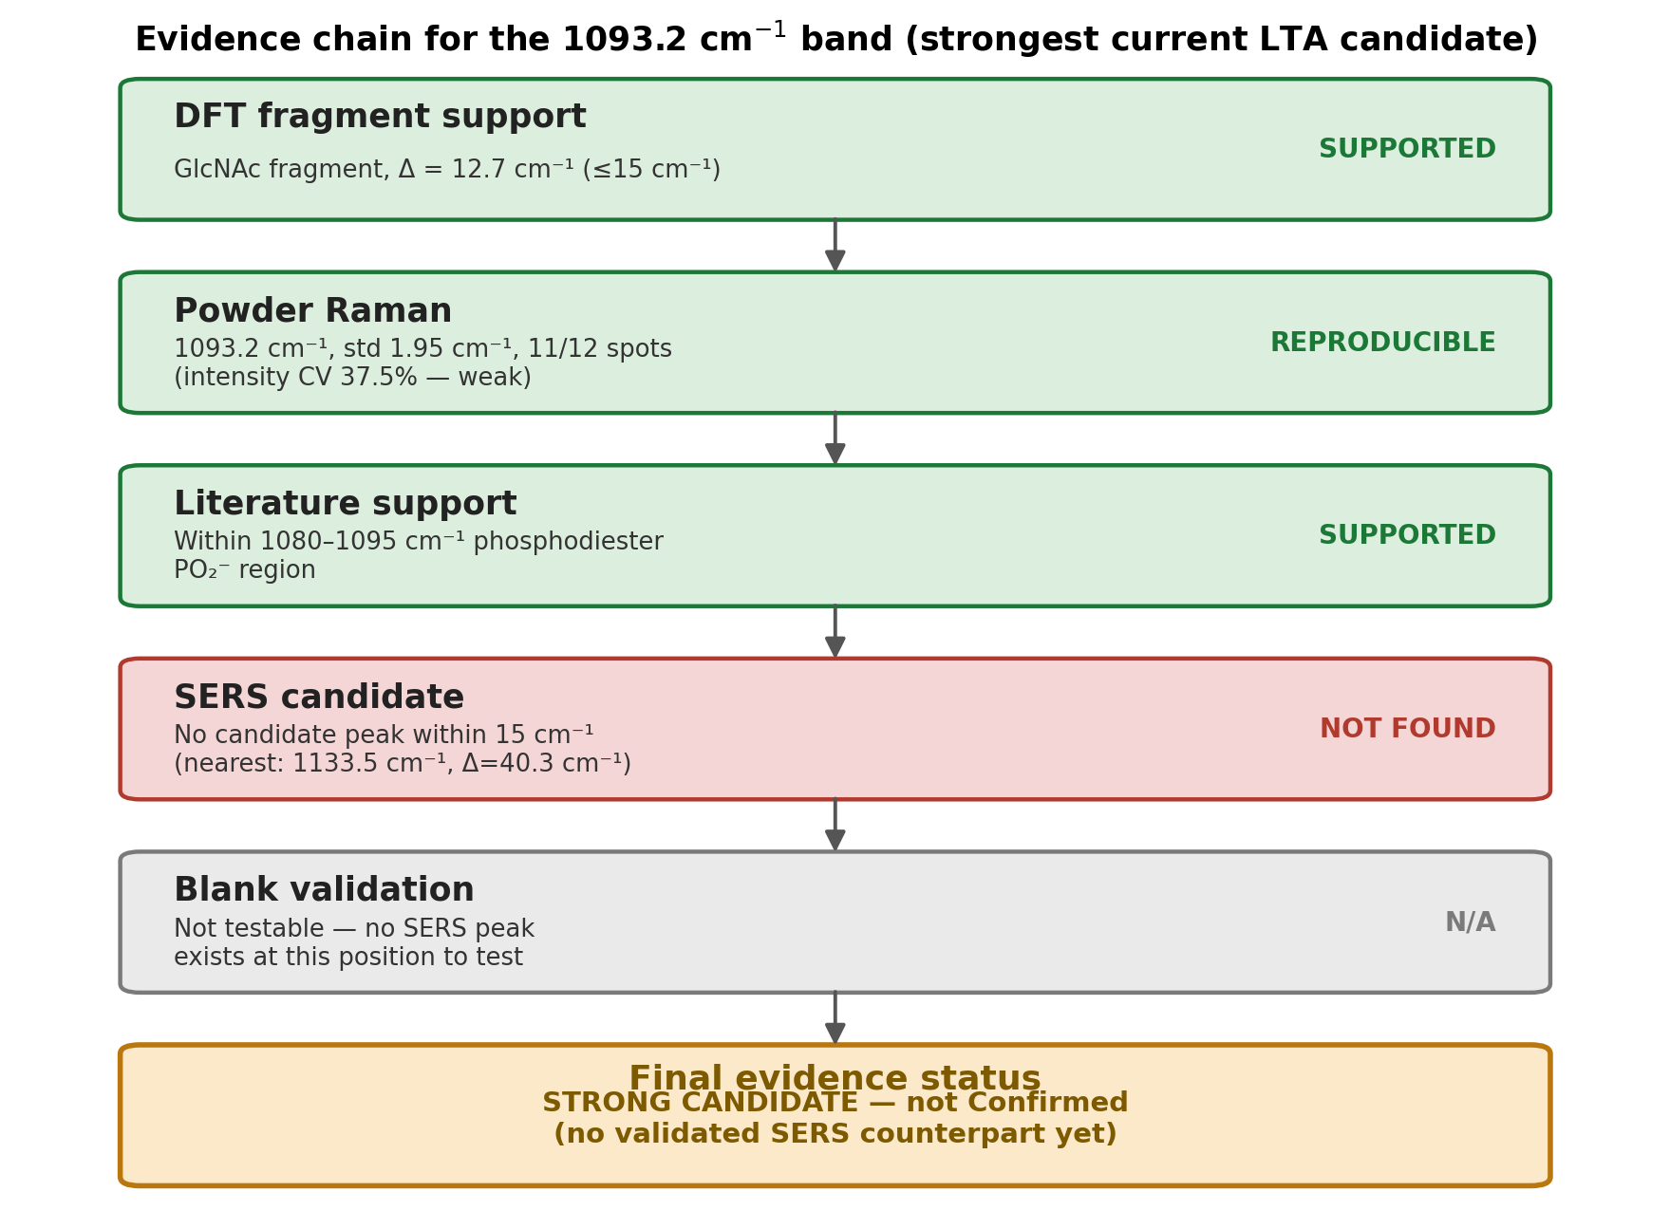

Summary
Band (cm⁻¹) | DFT agreement | Status
620.1 | Yes | Candidate
794.5 | No | Unconfirmed
999.9 | Yes | Candidate
1093.2 | Yes | Strong candidate
1184.6 | Yes | Candidate
1602.4 | Yes | Substrate
1784.2 | No | Not detected

Notes
- DFT results reflect LTA's individual building blocks, not the assembled molecule.
- SERS candidate peaks not shared with the blank still require pixel-level and reproducibility checks before being confirmed as LTA signal.
- Literature comparison is based on the phosphodiester PO₂⁻ assignment region; broader specificity should be confirmed against primary sources.

