NAM, LTA and LPS — Raman/DFT Figures Compendium
Extracted from Prior Analysis Decks (nam-final.pptx, LTA&LPS.pptx)
____________________________________________________________

Sukesh P (M24IM1007) | M.Tech, Joint IDRP, IIT Jodhpur & AIIMS Jodhpur
Work package within: "Intelligent Sensor System for Early Prediction of Sepsis in Neonates and High-Risk Adults" | PI: Prof. Ajay Agarwal, IITJ | Co-PI: Prof. (Dr.) Neeraj, AIIMS Jodhpur

Introduction
This document collects the key structure, pure-standard, experimental and merged/composite-fit figures for all three biomarkers investigated so far — NAM, LTA and LPS — extracted from two source presentations (nam-final.pptx and LTA&LPS.pptx, which share the same underlying image set). It is a standalone companion to the earlier Biomarker Imaging Report and does not replace or modify it.
KEY — These decks contain substantially more pure-standard and DFT-comparison data for LTA and LPS than had previously been located in the project's raw-data folders — in particular, multi-power experimental LTA spectra and a full 5-fragment DFT model with composite fits for LPS. This updates the "not yet available" status previously recorded for LTA and LPS pure/reference spectra.

1. N-Acetylmuramic Acid (NAM)

1.1 Structure and sample setup
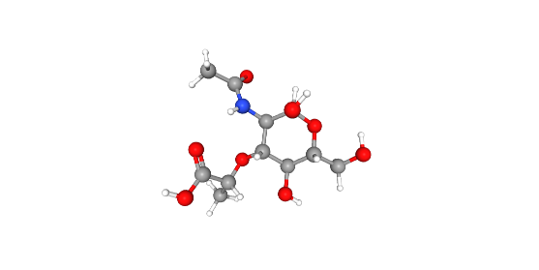
Figure N1. NAM — 3D ball-and-stick structure.
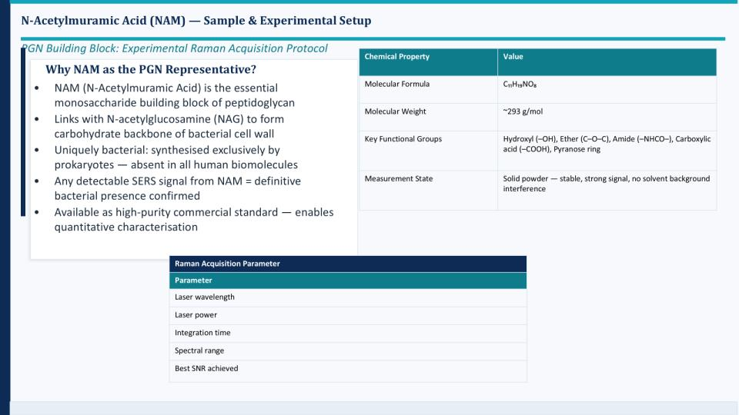
Figure N2. NAM — sample and experimental setup summary (formula C₁₁H₁₉NO₈, MW ≈293 g/mol, key functional groups, measurement state).
As noted on this slide: "Any detectable SERS signal from NAM = definitive bacterial presence confirmed" — NAM is synthesised exclusively by bacteria and is absent from all human biomolecules, which is the basis for treating it as a specific peptidoglycan marker.

1.2 Experiment vs. DFT — merged comparison
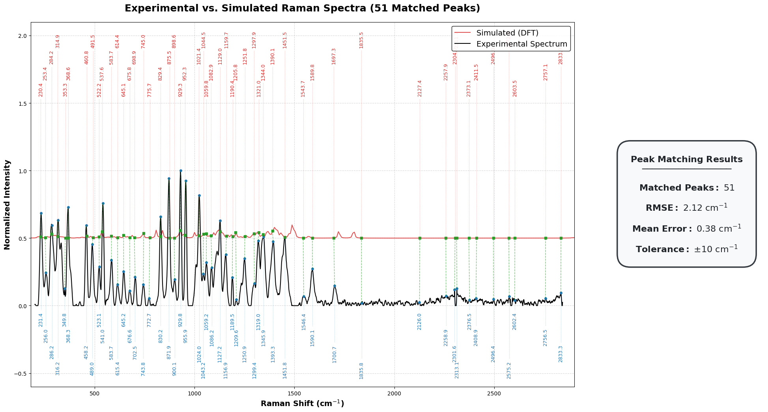
Figure N3. Experimental vs. simulated (DFT) Raman spectra of NAM — 51 matched peaks, RMSE 2.12 cm⁻¹, mean error 0.38 cm⁻¹, tolerance ±10 cm⁻¹.
Note: this is a separate, wider-range (up to ~2840 cm⁻¹) peak-matching analysis from the earlier 400–1800 cm⁻¹ / ±18 cm⁻¹-tolerance DFT study reported in the Consolidated NAM Report (30/41 bands, RMSE 10.3 cm⁻¹) — the two used different matching windows and should not be numerically combined, but both independently confirm strong agreement between the experimental and calculated NAM spectrum.

2. Lipoteichoic Acid (LTA)
LTA (backbone: repeating glycerol–phosphate units, lipid-anchored) was modelled using a fragment-based DFT approach, since full-molecule simulation of the polymeric structure is computationally impractical. Two representative substituents were modelled: D-alanine (amino substituent, surface-charge regulation) and GlcNAc (carbohydrate component, strong Raman-active sugar signal).

2.1 Structures (pure components)
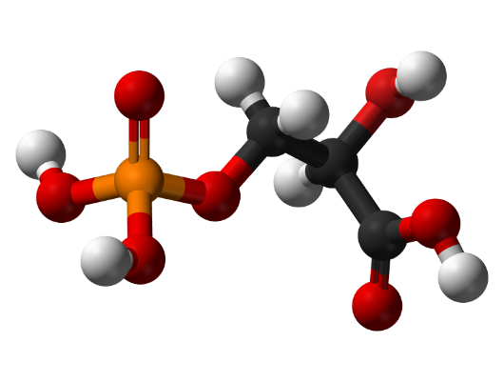
Figure L1. Glycerol-phosphate backbone fragment — 3D structure.
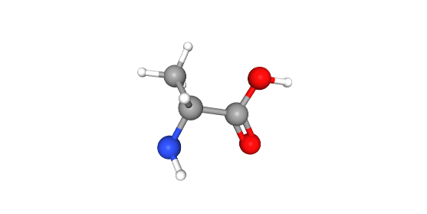
Figure L2a. D-alanine substituent — 2D structure.
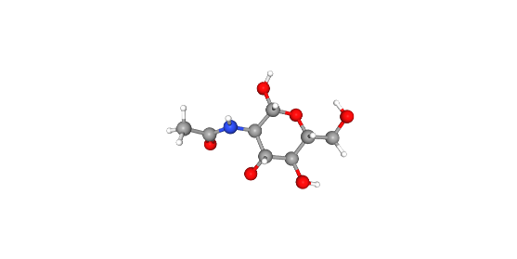
Figure L2b. GlcNAc substituent — 2D structure.

2.2 Pure/simulated fragment spectra vs. experimental (raw)
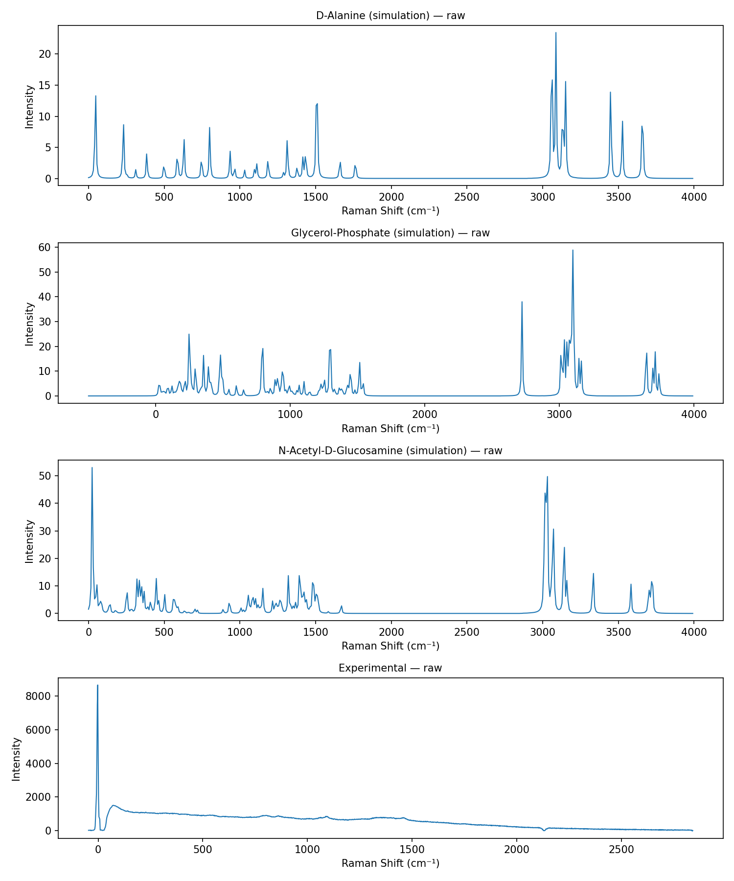
Figure L3. Simulated Raman spectra of the three LTA-related fragments (D-alanine, glycerol-phosphate, N-acetyl-D-glucosamine) and the raw experimental LTA spectrum.

2.3 Experiment — LTA across laser powers
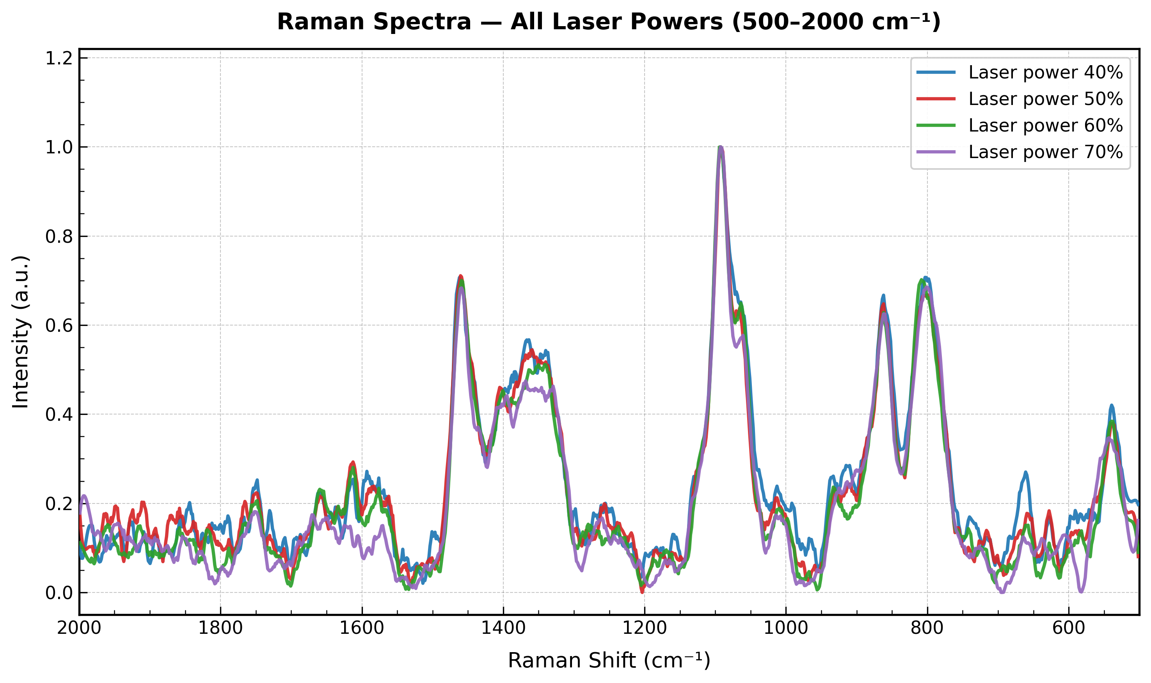
Figure L4. Experimental LTA Raman spectra at four laser power settings (40/50/60/70%), 500–2000 cm⁻¹ — reproducible band positions across all powers.

2.4 Merged — experimental vs. fragment-composite fit
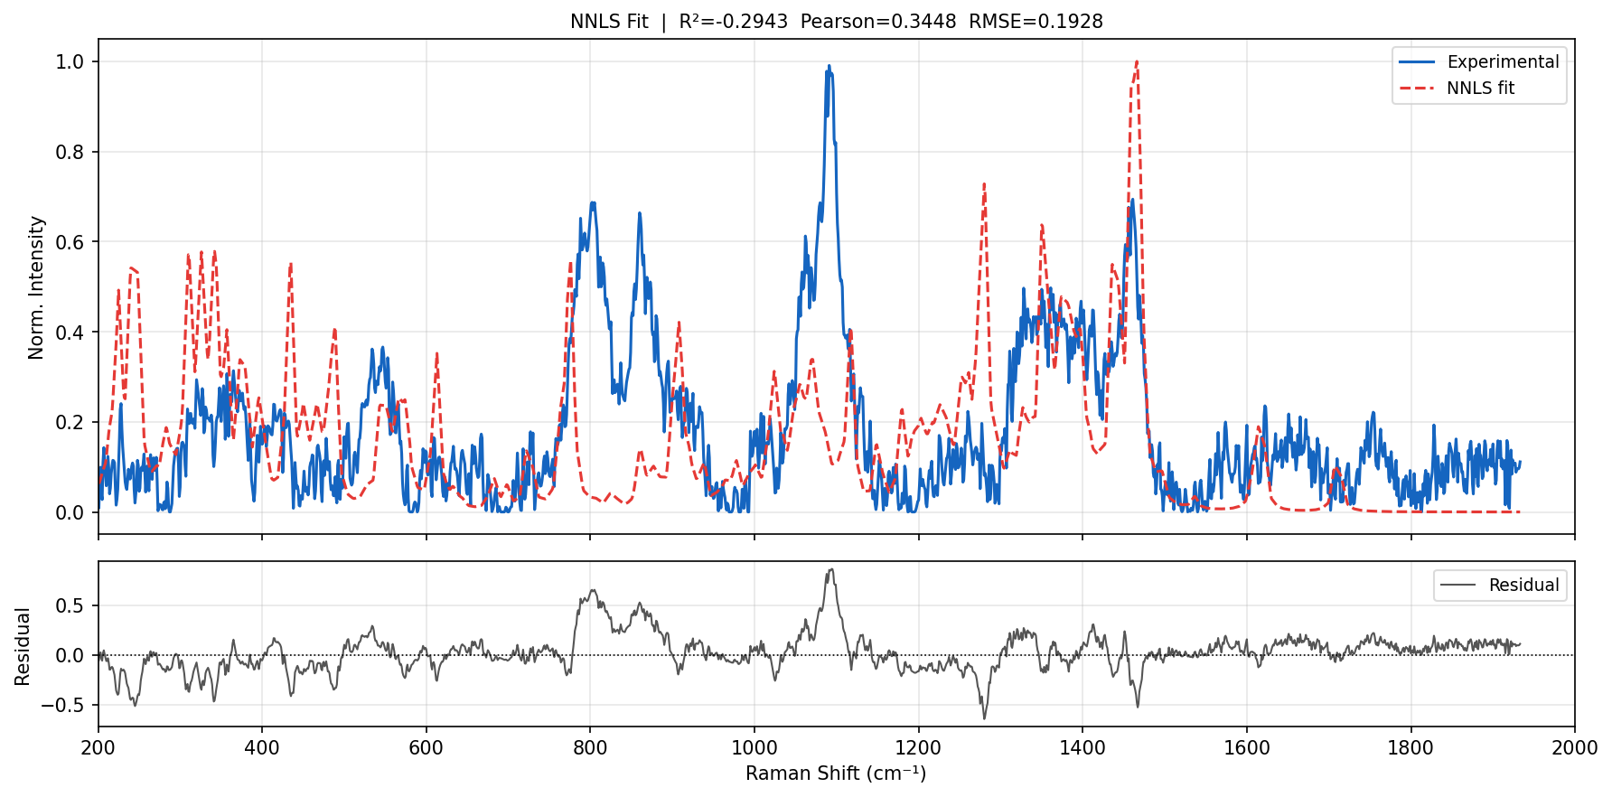
Figure L5. Experimental LTA vs. NNLS-optimised fragment-composite fit, with residual panel (R² = −0.294, Pearson r = 0.345, RMSE = 0.193).
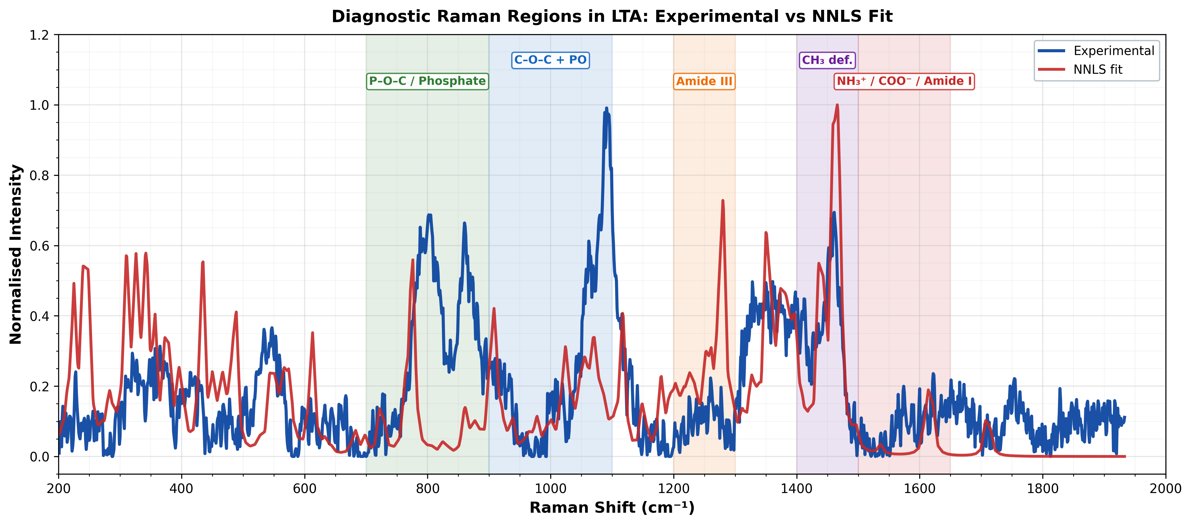
Figure L6. Diagnostic Raman regions in LTA — experimental vs. NNLS fit, with functional-group regions annotated (P–O–C/phosphate, C–O–C+PO, Amide III, CH₃ deformation, NH₃⁺/COO⁻/Amide I).
The fit is qualitatively informative in specific diagnostic windows (phosphate and C–O–C regions align reasonably well) but the overall fit quality is weak (R² negative, Pearson r ≈ 0.35), indicating the three-fragment composite model does not yet fully explain the experimental LTA spectrum — consistent with LTA being a large, heterogeneous polymer poorly represented by a small fragment set.

3. Lipopolysaccharide (LPS)
LPS (Lipid A + core oligosaccharide + O-antigen) was modelled using a five-fragment DFT approach: Kdo (3-deoxy-D-manno-octulosonic acid, core sugar), D-glucosamine (Lipid A backbone), L-glycero-D-manno-heptose (core oligosaccharide sugar), myristic acid (Lipid A fatty acid chain), and phosphoric acid (phosphate groups) — calculated at B3LYP/6-31G(d,p) with PCM + explicit water solvation.

3.1 Differentiation strategy and literature-referenced SERS protocol
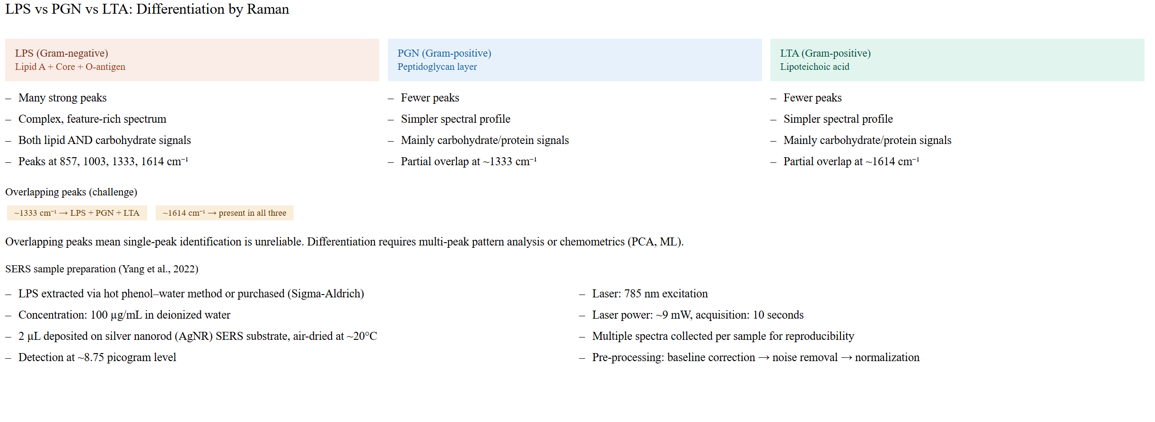
Figure P1. LPS vs. peptidoglycan (PGN) vs. LTA — differentiation by Raman fingerprint (peaks at 857, 1003, 1333, 1614 cm⁻¹ for LPS; overlap at 1333/1614 cm⁻¹ flagged as a limitation of single-peak identification), and the referenced SERS sample-preparation protocol (Yang et al., 2022: silver-nanorod substrate, 785 nm, ~9 mW, 2 µL of 100 µg/mL LPS, ~8.75 pg detection level).

3.2 Pure/simulated fragment spectra
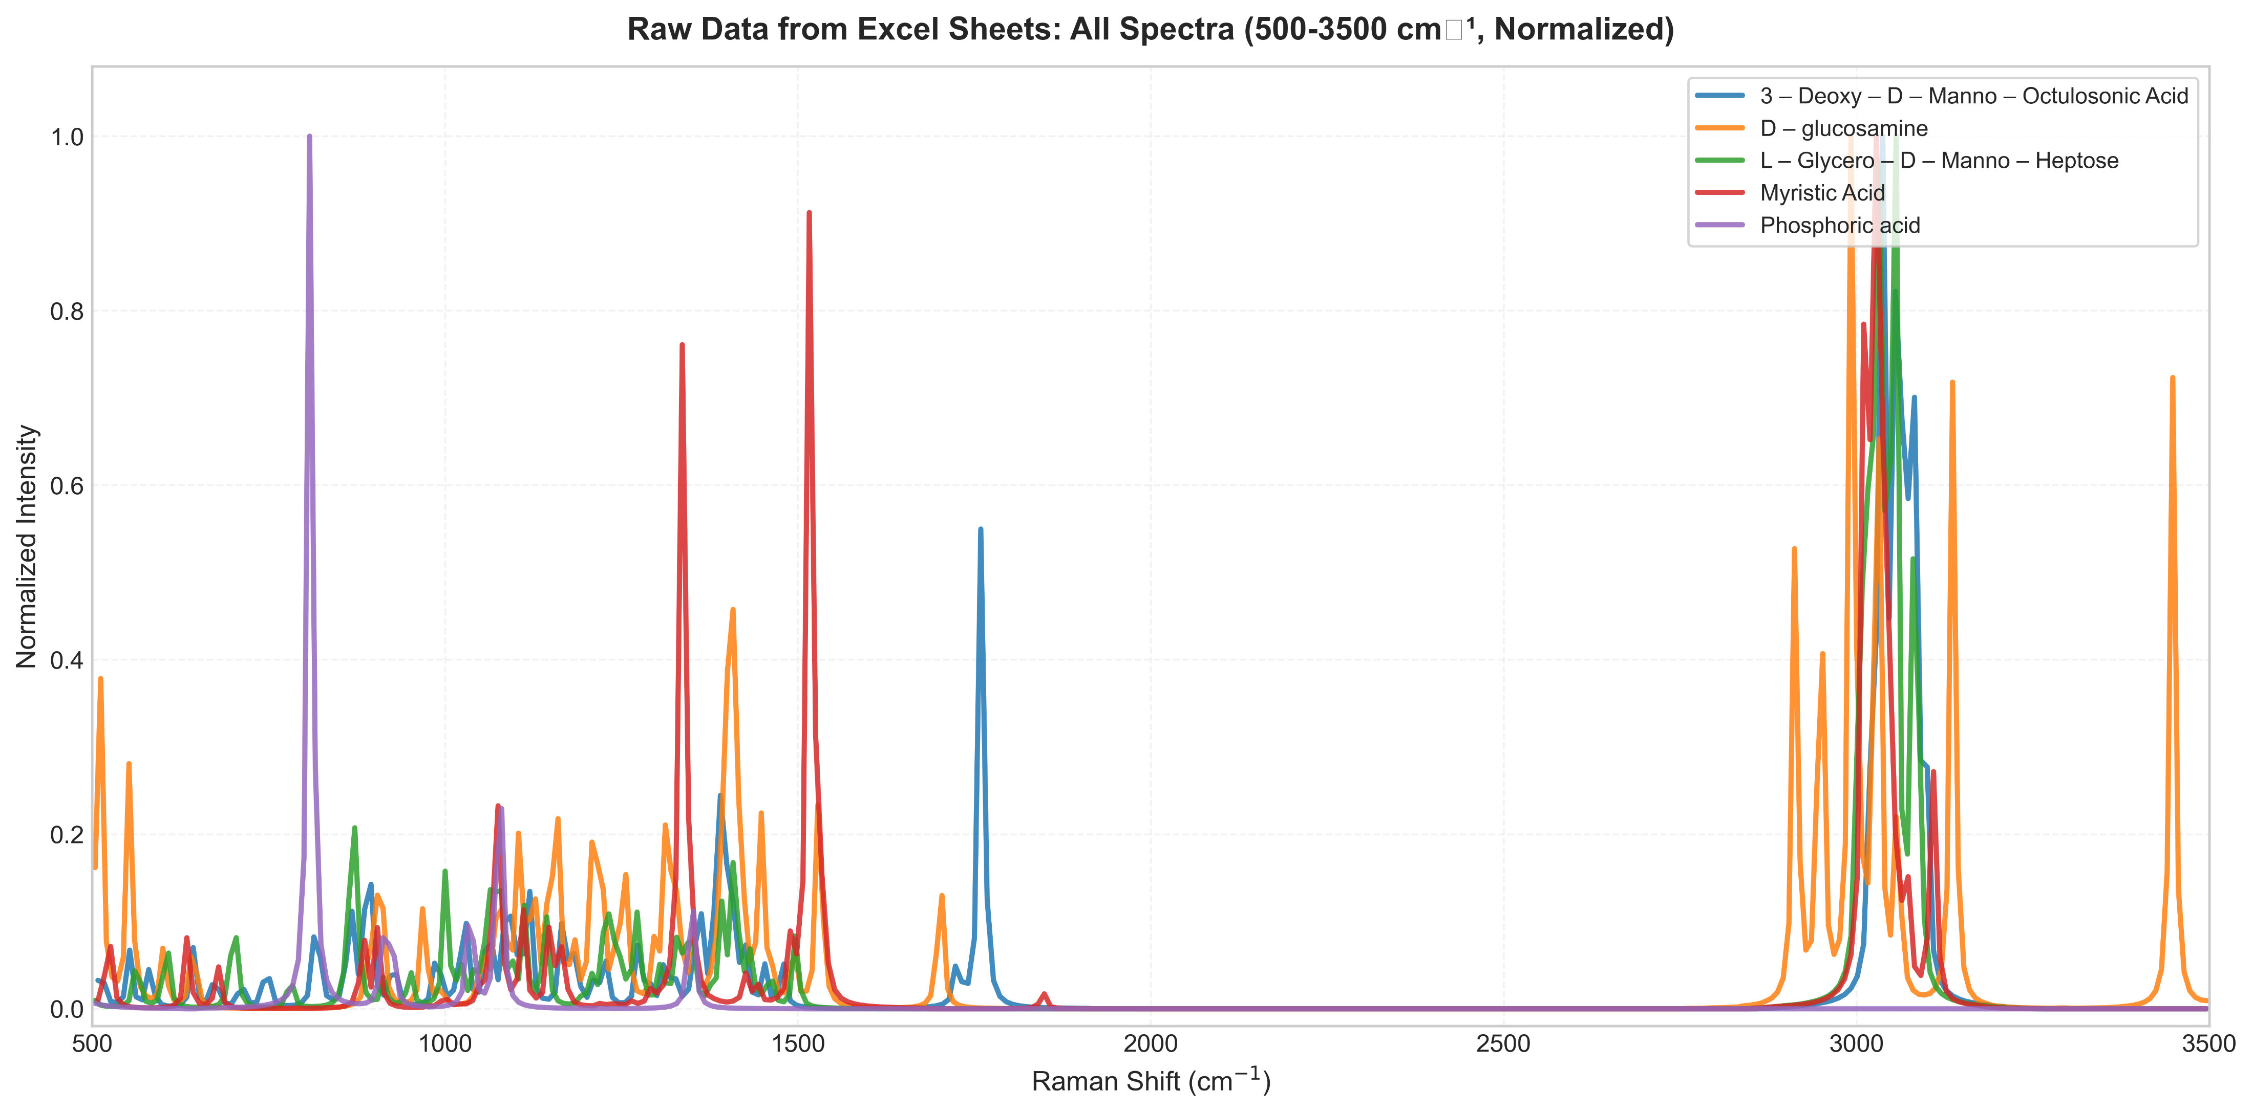
Figure P2. Simulated Raman spectra of the five LPS structural fragments (Kdo, D-glucosamine, L-glycero-D-manno-heptose, myristic acid, phosphoric acid), normalised, 500–3500 cm⁻¹.

3.3 Experiment — raw LPS powder vs. single-fragment simulation
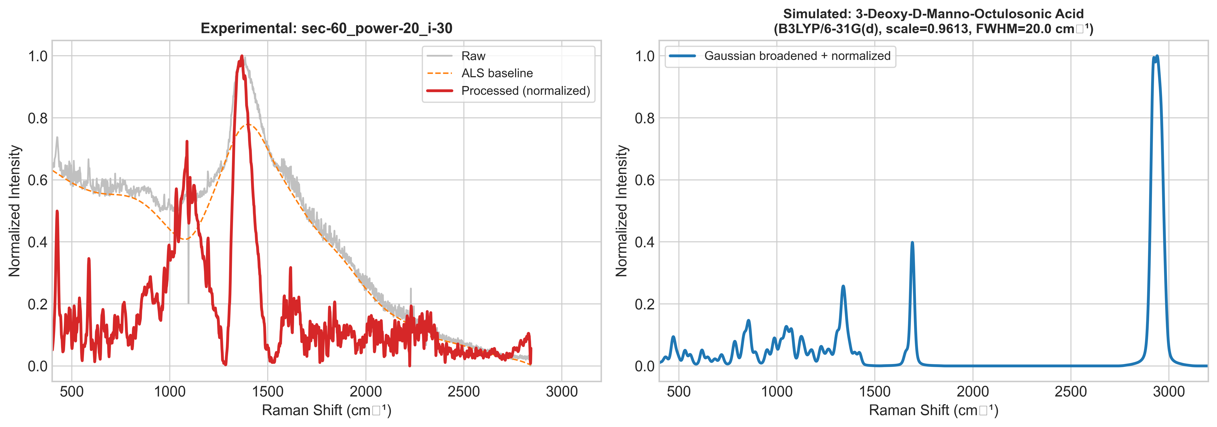
Figure P3. Experimental LPS powder Raman spectrum (raw, ALS-baseline-corrected and normalised) vs. simulated Kdo fragment spectrum.

3.4 Merged — composite model vs. experimental LPS
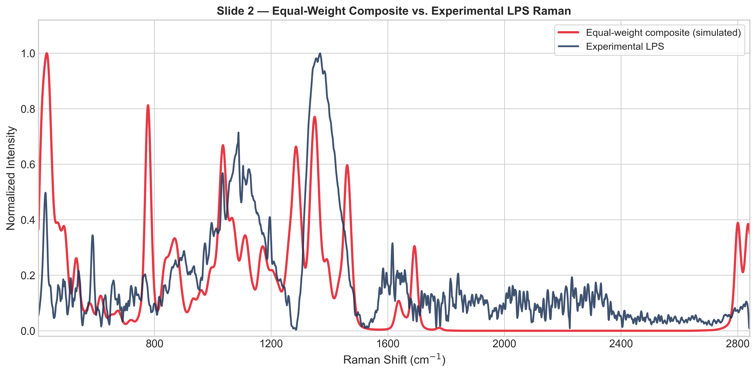
Figure P4. Equal-weight five-fragment composite (simulated) vs. experimental LPS Raman spectrum.
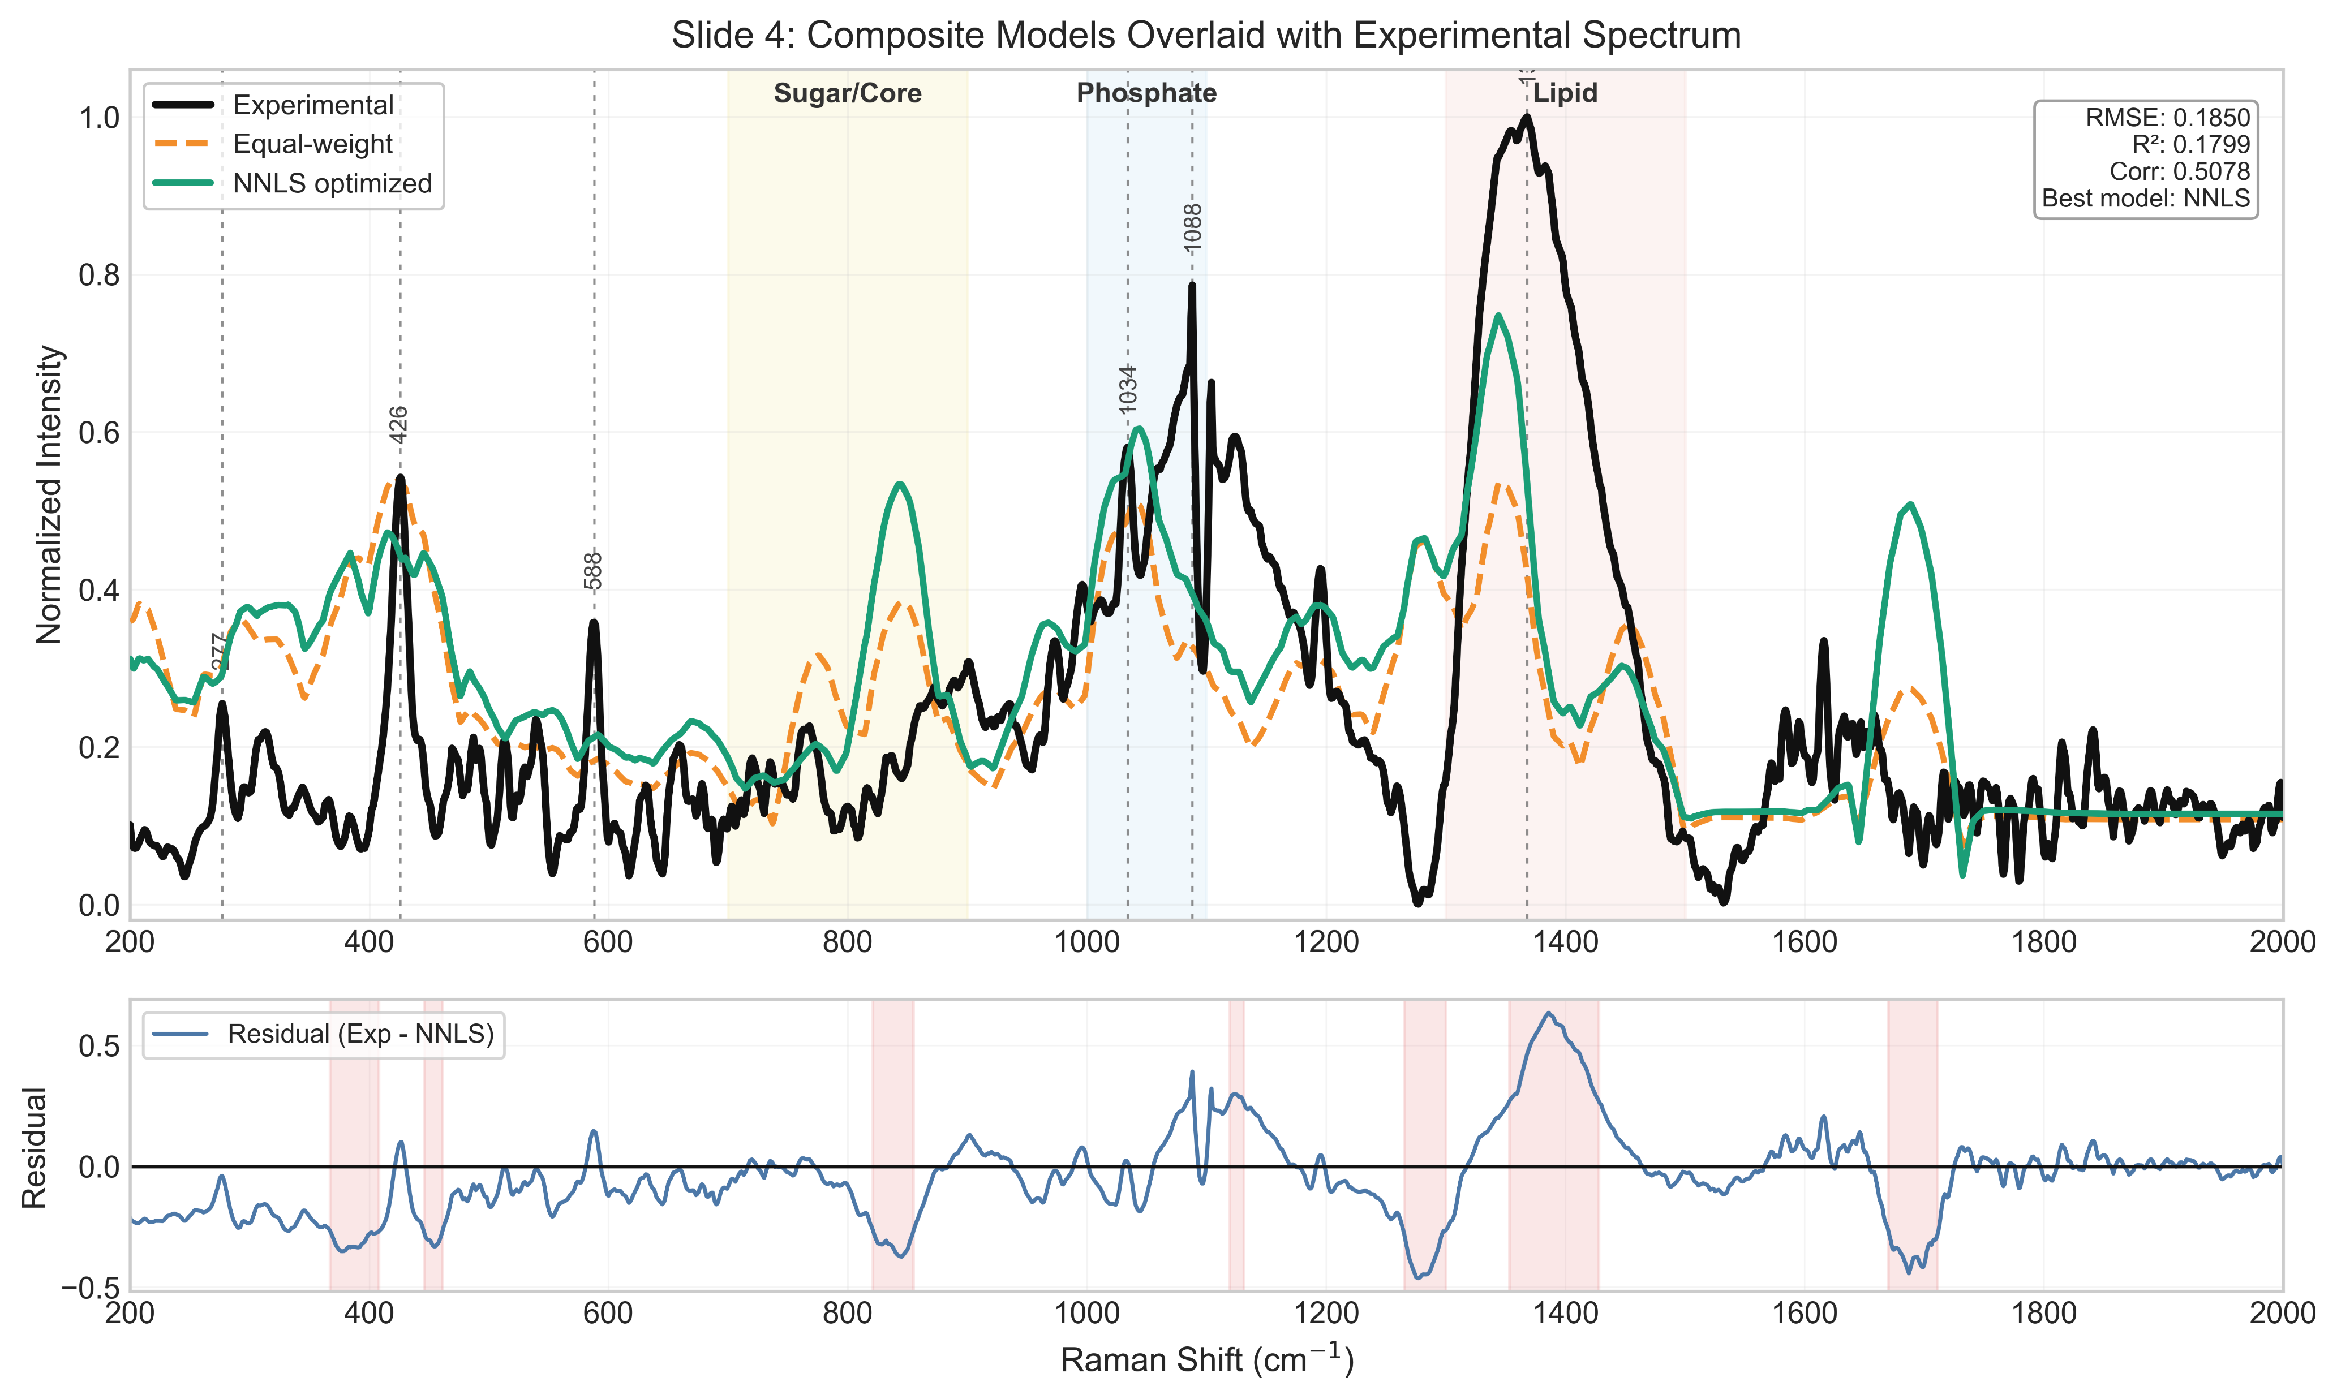
Figure P5. Composite models overlaid with experimental LPS spectrum — equal-weight vs. NNLS-optimised, with residual panel and diagnostic region shading (Sugar/Core, Phosphate, Lipid). NNLS: RMSE = 0.185, R² = 0.180, correlation = 0.508 (best model).
As with LTA, the NNLS-optimised composite captures several key regions (notably the phosphate region near 1000–1100 cm⁻¹) but does not fully reproduce the experimental spectrum, particularly the strong lipid-region band near 1350–1400 cm⁻¹ — the positive correlation (r ≈ 0.51) is a meaningfully better result than the LTA fragment model, but still leaves clear residual structure unexplained by the five-fragment model.

Summary
Biomarker | Structure/pure fragments | Experimental spectrum | Merged/composite fit
NAM | Available (3D structure) | Available (powder, multiple conditions — see Consolidated NAM Report) | Available — 51 matched peaks, RMSE 2.1 cm⁻¹
LTA | Available (2 fragments: D-alanine, GlcNAc, plus backbone unit) | Available (4 laser powers, reproducible bands) | Available — NNLS fit, R² negative, r ≈ 0.35 (weak)
LPS | Available (5 fragments: Kdo, glucosamine, heptose, myristic acid, phosphoric acid) | Available (raw powder, multiple acquisition settings) | Available — NNLS fit, R² = 0.18, r ≈ 0.51 (moderate)

This significantly updates the biomarker-imaging status previously recorded: pure-standard and experimental Raman data now exist for all three biomarkers, with DFT-based composite fits of varying quality (NAM strongest, LPS moderate, LTA weakest). None of this data has yet been collected on the project's own SERS substrates (Sensors 1/2) except where already reported — these figures are from off-substrate / pure-standard measurements and fragment-based DFT modelling.
NOT CONFIRMED — Not covered in this document (available in the source decks if needed): DFT simulation-parameter and peak-assignment detail slides (NAM), acquisition-parameter grids, and additional spectral-region reference slides. Let me know if these should be added as well.

