Experimental and DFT-Assisted Raman Characterisation of Isolated N-Acetylmuramic Acid: Vibrational Assignment, Photostability Limits, and a Reference Spectrum for Bacterial Cell-Wall Analysis
Sukesh P
Department of Electrical Engineering, Indian Institute of Technology Jodhpur
Jodhpur 342030, Rajasthan, India
N-acetylmuramic acid (MurNAc, NAM) is the defining amino sugar of bacterial peptidoglycan and underlies many of the vibrational features exploited in Raman-based microbial identification. Despite this, an experimentally benchmarked vibrational assignment for the isolated molecule has not been reported: existing assignments derive either from empirical force-field treatments of the crystalline monohydrate or from density functional theory (DFT) calculations validated only indirectly against whole-cell bacterial spectra. Here we report a reference Raman spectrum of isolated N-acetylmuramic acid powder, constructed from 22 independent measurements on fresh sample at 785 nm, together with harmonic Raman frequencies computed at the B3LYP-D3BJ/6-311++G(d,p) level. Forty-one reproducible bands were identified in the 400–1800 cm⁻¹ fingerprint region, of which thirty were matched to calculated normal modes with a mean absolute deviation of 9.3 cm⁻¹, a root-mean-square deviation of 10.3 cm⁻¹, and a correlation coefficient of 0.9996. Acquisition conditions were characterised across 227 spectra, yielding a laser-damage threshold: the sample is spectrally unchanged over ten consecutive scans at 90% laser power and 30 s integration, but is destroyed at the same power with 60 s integration. Normal-mode decomposition resolves two assignments that could not be reached from the experimental spectrum alone. The intense 872 cm⁻¹ band arises from hydroxymethyl wagging rather than ring breathing, and the calculated mode falling in the disputed $∼$730 cm⁻¹ bacterial marker region originates almost entirely from out-of-plane deformation of the carboxylic acid hydroxyl group (47.9% of the mode displacement) with negligible pyranose ring character (0.5%). Because this proton is absent in intact peptidoglycan, where the muramic acid carboxyl is amide-linked to the peptide stem, the result argues against attributing the bacterial 730 cm⁻¹ band to muramic acid.
Keywords: Raman spectroscopy; density functional theory; N-acetylmuramic acid ; peptidoglycan; vibrational assignment; photostability

Introduction
Raman spectroscopy provides label-free, non-destructive vibrational fingerprints of biological material with minimal sample preparation, which has made it attractive for rapid microbial characterisation . Bacterial Raman spectra are, however, superpositions of contributions from proteins, nucleic acids, lipids and the cell wall, so the interpretation of individual bands depends on the availability of reliable reference spectra for the constituent molecules.
Among cell-wall components, N-acetylmuramic acid occupies a distinctive position. Together with N-acetylglucosamine (GlcNAc) it forms the alternating glycan backbone of peptidoglycan, the polymer that confers mechanical rigidity on the bacterial cell wall in both Gram-positive and Gram-negative organisms . Unlike GlcNAc, which also occurs widely in eukaryotic glycans, muramic acid is essentially restricted to bacteria, and its D-lactyl ether substituent at C-3 is chemically unique to the bacterial cell wall. This specificity has made it an attractive target for Raman-based and surface-enhanced Raman (SERS) approaches to bacterial detection.
Raman spectra of structurally related amino sugars have been reported , and computational treatments of saccharide Raman spectra are well established . Vibrational studies of muramic acid itself nevertheless remain sparse. Early work combined infrared and Raman measurements on the crystalline monohydrate with harmonic dynamics based on empirical force fields , reaching an average agreement of approximately 4 cm⁻¹ between observed and calculated frequencies. More recently, Ma et al. computed Raman spectra of NAM and GlcNAc by DFT in order to construct a diagnostic model for Escherichia coli. In that work, however, NAM entered only as an in silico spectral component: the calculated spectrum was compared against whole-cell bacterial measurements, in which peptidoglycan bands are superimposed on strong protein, lipid and nucleic acid signals. The NAM assignments were therefore never validated directly against the isolated molecule.
A further open question concerns the band near 730 cm⁻¹, among the strongest and most frequently used features in bacterial SERS spectra. Its origin has been attributed variously to adenine and related nucleotide degradation products and, less frequently, to cell-wall components. Without a measured spectrum of isolated muramic acid the peptidoglycan contribution could not be assessed directly.
The present work addresses these gaps. We report a reference Raman spectrum of isolated N-acetylmuramic acid powder built from independent replicate measurements, establish the laser conditions under which the material is spectrally stable, and assign the observed bands using normal-mode decomposition of a dispersion-corrected DFT calculation.

Materials and methods

Materials
N-acetylmuramic acid (Sigma-Aldrich, product A3007-100MG, lot BCCK5768; CAS 10597-89-4; synthetic; $≥$98% by TLC; white powder; stated residual methanol $≤$1 mol/mol) was used as received without further purification or recrystallisation. The material was supplied in an amber glass bottle and stored at 2–8 $​^{∘}$C as specified. The molecular weight of 293.27 corresponds to anhydrous C$​_{11}$H$​_{19}$NO$​_{8}$, so the material is not a hydrate.
The supplier specification defines five stereocentres but leaves the anomeric configuration unspecified (SMILES CC(O[C@H]1[C@H](O)[C@@H](CO)OC(O)[C@@H]1NC(C)=O)C(O)=O; InChI stereo layer /t5-,7+,8-,9-,10-/m1/s1). The material is therefore an anomeric mixture rather than a single anomer, as is usual for a reducing sugar. This is relevant to Section 3.8.
For measurement, a small quantity of powder was deposited directly onto a clean glass microscope slide. Samples were handled under ambient laboratory conditions and stored at 2–8 $​^{∘}$C as supplied.

Raman instrumentation
Spectra were recorded on a B&W Tek i-Raman Plus system (model BWS465-785H) coupled to a BAC102-785E Raman microscope, through a 20$×$ Plan objective. Excitation was provided by a 785 nm diode laser (Class 3B); the instrument software reports an emission wavelength of 784.92 nm. Laser power is adjustable from 0 to 100% in 1% increments, and the power settings quoted throughout are percentages of the instrument maximum.
Three power figures apply to this system and should not be conflated. The laser safety label states a maximum output of 495 mW, this being the maximum accessible emission used for hazard classification. The manufacturer specification quotes 455 mW nominal at the laser port and 340 mW nominal exiting the fibre-optic probe. On the basis of the last of these, the power settings used here correspond to approximately 17, 136, 238 and 306 mW exiting the probe at 5, 40, 70 and 90% respectively.
Power incident on the sample is lower than these figures, because the measurements reported here were made through a BAC102-785E microscope and a 20$×$ Plan objective rather than directly from the probe. The transmission of this optical path was not measured, and the incident power at the sample is therefore not known in absolute terms. Taking published transmission values for comparable microscope optics and objectives (approximately 40–65% in combination) the power at the sample at the 70% setting is estimated to lie in the range 95–155 mW; with a diffraction-limited focus of about 2.4 $μ$m diameter for a 20$×$ objective of numerical aperture 0.40, this corresponds to an estimated power density of roughly 20–35 mW $μ$m$​^{−2}$. These figures are estimates derived from component specifications and are not measured values.
Power settings are therefore reported throughout as percentages of the instrument maximum. This is sufficient for reproduction on the same instrument model, and the nominal figures above allow approximate comparison with other systems, but absolute power densities should be regarded as indicative only.
Detection used a thermoelectrically cooled high-quantum-efficiency CCD array (sensor temperature $−2$ $​^{∘}$C) with 2048 pixels. The instrument is specified for 65–2800 cm⁻¹ at a spectral resolution better than 3.5 cm⁻¹ (measured at 912 nm using atomic emission lines). Recorded spectra spanned $−46$ to 2842 cm⁻¹, of which the 400–1800 cm⁻¹ fingerprint region was retained for analysis. Spectral sampling varies across the range, from 1.76 cm⁻¹ per pixel at 400 cm⁻¹ to 1.43 cm⁻¹ per pixel at 1800 cm⁻¹. A dark spectrum was recorded and subtracted by the instrument software for every measurement.

Measurement design
A total of 227 spectra were acquired in two sessions and grouped as follows.
Acquisition-parameter survey (98 spectra). A full factorial grid of five integration times (5, 10, 15, 20 and 25 s) and sixteen laser power settings (5–80% of nominal output in 5% steps), two detector readings averaged per spectrum. Detector saturation did not occur at any condition.
Replicate sets (104 spectra). Nine sets, each acquired at a single fixed condition with the stage moved to fresh powder between every measurement. The reference spectrum reported here is built from two of these sets, at 70% and 90% power, both at 10 s integration with five accumulations, giving 22 independent measurements.
These sets were selected for replicate number and internal consistency rather than for peak signal-to-noise ratio. Individual sets at longer integration reach higher SNR — the 70%/60 s set attains 789 — but contain only three spectra each, and that set also shows the lowest internal agreement of any fresh-spot set (mean pairwise correlation 0.969). The 10 s sets combine 22 independent measurements with a mean pairwise correlation of 0.986. For a reference spectrum, whose purpose is to represent the material reproducibly rather than to maximise signal in any single measurement, replication and agreement were judged the more important criteria. The three longer-integration sets (30 and 60 s, 11 spectra, SNR up to 789) were instead used where high SNR is decisive, namely in verifying weak bands (Section 2.6).
Photostability series (10 spectra). Ten consecutive scans at 90% power and 30 s integration acquired without moving the stage.
Laser-damage series (10 spectra). Two sets at 90% power and 60 s integration, one on a single spot and one on fresh spots. These spectra are reported in Section 3.3 and excluded from all vibrational analysis.
Substrate blanks (5 spectra). Empty glass slide. TO CHECK: These blanks were recorded at 5% power and 5 s only, which does not match the sample conditions. Three blanks at the reference condition should be added before submission.

Spectral processing
All spectra were processed through an identical pipeline. Dark-subtracted intensities were interpolated onto a uniform 1 cm⁻¹ grid spanning 400–1800 cm⁻¹. Baseline contributions from the substrate and residual fluorescence were removed by asymmetric least-squares fitting with smoothing parameter $λ={10}^{5}$, asymmetry $p=0.001$ and ten iterations. Baseline-corrected spectra were smoothed with a Savitzky–Golay filter (window 11 points, third-order polynomial), chosen to suppress detector noise without measurable distortion of band positions or widths, and min–max normalised. Signal-to-noise ratio was estimated as the ratio of maximum band intensity above the median to the noise standard deviation determined from successive differences above 1750 cm⁻¹. Processing used Python with NumPy, SciPy and pandas.

Band identification
Band positions were located by prominence-based peak detection on the averaged reference spectrum. Distinguishing genuine weak bands from correlated processing artefacts requires care: baseline correction and smoothing generate reproducible residual structure, so a feature appearing consistently across spectra is not by itself evidence that it is real. Each candidate was therefore evaluated against the local noise level, estimated from successive differences within a $±$50 cm⁻¹ window, using two independent criteria — peak prominence and peak height above the local median — each required to exceed three times the local noise.
Bands satisfying both criteria are reported as high confidence. Bands satisfying only one were additionally tested against the independent long-integration dataset (30 and 60 s, signal-to-noise ratio up to 796) and promoted to high confidence where they were confirmed there; otherwise they are reported as tentative. Five candidate features, at 424, 558, 800, 901 and 1629 cm⁻¹, failed both criteria and are not reported. A reproducibility value is quoted for each band, defined as the fraction of the 22 individual spectra in which a peak was independently detected within $±$4 cm⁻¹ of the mean position.

DFT calculations
Geometry optimisation and harmonic vibrational frequency calculations were performed with Gaussian 16 at the B3LYP level using the 6-311++G(d,p) basis set, with Grimme’s D3 dispersion correction and Becke–Johnson damping and Raman activities requested. Optimisation used tight convergence criteria with analytically computed initial force constants, an ultrafine integration grid, and tight SCF convergence with quadratic convergence enabled (opt=(calcfc,tight) freq=raman int=ultrafine scf=(tight,xqc)). Calculations treated the isolated molecule in the gas phase; no implicit solvation model was applied.
The starting geometry was the $β$ anomer of N-acetylmuramic acid taken from the PubChem 3D conformer record (CID 5462244). The optimisation converged to a stationary point and the job reached normal termination. The optimised structure comprises 39 atoms (C$​_{11}$H$​_{19}$NO$​_{8}$) and yielded 111 normal modes, none imaginary, confirming a true minimum on the potential energy surface. Harmonic wavenumbers were scaled by 0.980 below 1800 cm⁻¹ and 0.967 above, following the scheme applied by Ma et al. , permitting direct comparison with the only other modern DFT treatment of this molecule.
Simulated Raman intensities were obtained from the computed Raman activities $S_{i}$ using the standard Placzek expression,
$$I_{i} ∝ \frac{(ν_{0}−ν_{i})^{4} S_{i}}{ν_{i}\left[1−\text{exp}​\left(−hcν_{i}/k_{B}T\right)\right]},$$
with $ν_{0}$ the excitation wavenumber and $T=298.15$ K, then convolved with Lorentzian line shapes of 10 cm⁻¹ full width at half maximum.
Mode characters were determined from the calculated Cartesian displacement vectors. Bond connectivity was established from interatomic distances using covalent radii, and for each normal mode the fractional contribution of every atom, of the pyranose ring, and of individual bond-stretching coordinates was evaluated from mass-weighted displacements. This provides a quantitative and reproducible basis for the assignments in Table 1. It is not equivalent to a full potential energy distribution analysis, and principal assignments should be confirmed by inspection of the normal-mode animations.

Results and discussion

Optimised molecular geometry
The DFT-optimised structure is shown in Figure 1. The pyranose ring adopts the expected $​^{4}C_{1}$ chair conformation, with the acetamido group at C-2, the D-lactyl ether at C-3 and the hydroxymethyl group at C-5. Optimised Cartesian coordinates are given in the Supplementary Material.
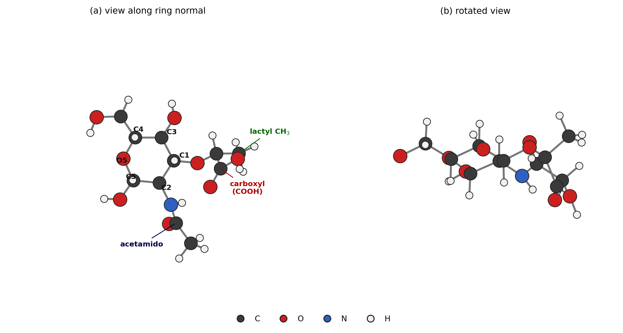
DFT-optimised geometry of $β$-N-acetylmuramic acid at the B3LYP-D3BJ/6-311++G(d,p) level. (a) View along the pyranose ring normal, with ring carbons and the three substituent groups labelled. (b) Rotated view showing the $​^{4}C_{1}$ chair conformation. The D-lactyl ether at C-3 and its terminal carboxyl group distinguish muramic acid from N-acetylglucosamine.

Acquisition conditions
Figure 2 summarises the signal-to-noise ratio across the acquisition grid. SNR increases monotonically with both integration time and laser power over the ranges examined, reaching approximately 287 at 25 s and 75% power. Band positions are unchanged across the entire grid: the 930 and 1451 cm⁻¹ bands remain within $±$1 cm⁻¹ of their mean positions from 5% to 80% power, and the full width at half maximum of the 930 cm⁻¹ band stays between 9 and 11 cm⁻¹. No broad carbonaceous background develops and no band structure is lost.
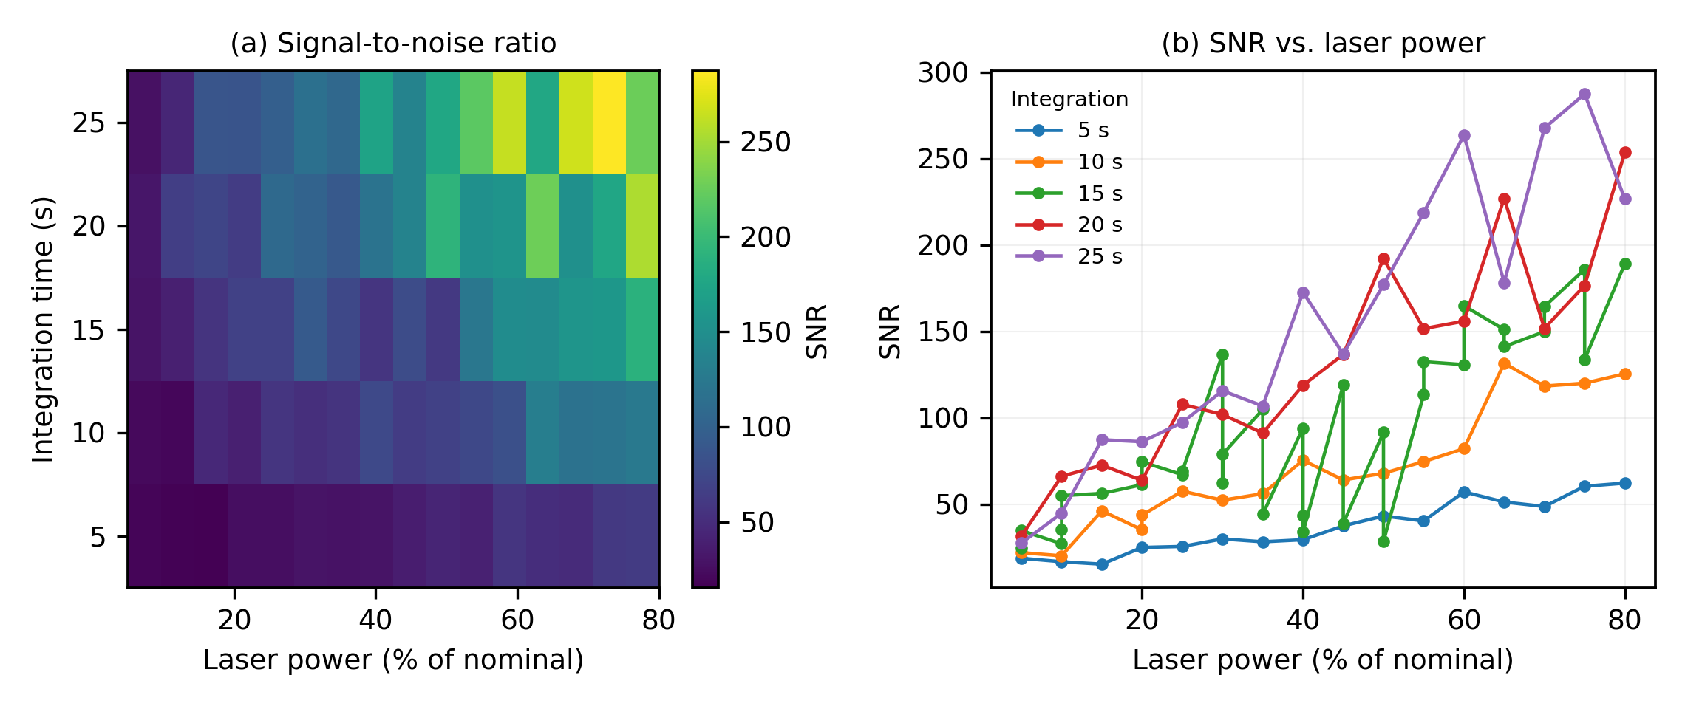
Acquisition-parameter survey for N-acetylmuramic acid powder across 98 spectra. (a) Signal-to-noise ratio across five integration times and sixteen laser power settings. (b) Signal-to-noise ratio as a function of laser power at each integration time.
We note that in this survey the power was stepped in ascending order within each series, so laser power and cumulative exposure are not statistically separable. The photostability measurements described next were designed to address this directly.

Photostability and the laser-damage threshold
Figure 3 shows two contrasting series acquired without moving the stage.
At 90% power and 30 s integration the spectrum is unchanged over ten consecutive scans. The normalised intensity of the strongest band, at 930 cm⁻¹, varies by less than 2% across the series, and the spectra overlay almost exactly.
At the same power with 60 s integration the material is destroyed. The intensity of the 930 cm⁻¹ band falls monotonically from 0.44 to 0.23 over five consecutive scans, the characteristic sharp features at 872, 930 and 956 cm⁻¹ collapse, and the spectrum degrades towards a broad, poorly structured profile. Correlation with the reference spectrum falls to $r=0.06$–$0.31$. The same behaviour is seen when fresh spots are used at this condition.
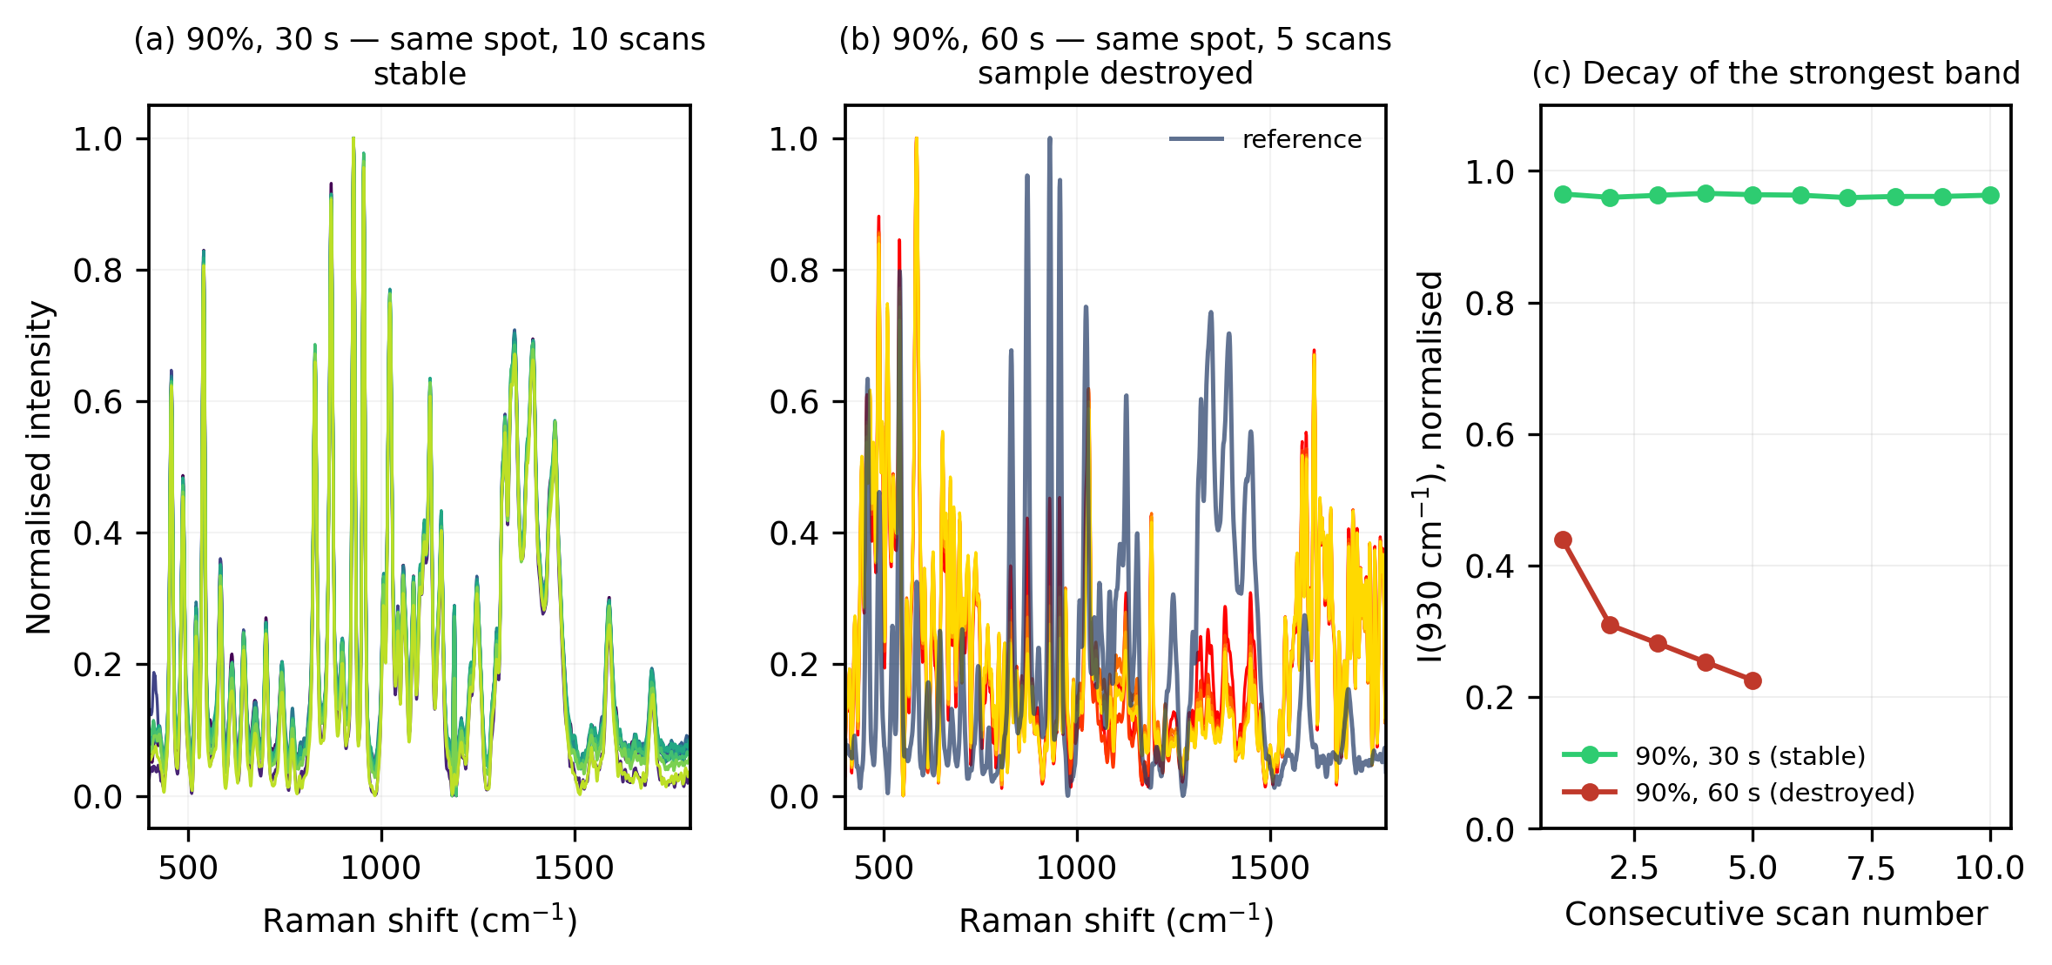
Photostability of N-acetylmuramic acid powder under 785 nm excitation. (a) Ten consecutive scans at 90% laser power and 30 s integration, same spot: the spectra are indistinguishable. (b) Five consecutive scans at 90% power and 60 s integration, same spot, with the reference spectrum shown for comparison: the sample is destroyed. (c) Normalised intensity of the 930 cm⁻¹ band across consecutive scans for both conditions.
Taken with the acquisition survey, these measurements define a working envelope for this material at 785 nm through a 20$×$ objective:
Condition | Outcome
$≤$80% power, $≤$25 s | stable
70% power, 30 s | stable ($r=0.977$)
70% power, 60 s | stable ($r=0.970$)
90% power, 30 s | stable over 10 consecutive scans
90% power, 60 s | sample destroyed
Reporting this limit explicitly seems worthwhile: carbohydrate powders are often assumed to tolerate near-infrared excitation indefinitely, and the transition here is abrupt rather than gradual.
The threshold is expressed here in terms of instrument settings, which permits exact reproduction on the same instrument. In absolute terms, and using the estimates given in Section 2.2, the damaging condition corresponds to a power density of order 25–45 mW $μ$m$​^{−2}$ sustained for 60 s, while the same power density for 30 s produced no detectable change. We emphasise that these absolute values are estimated from component specifications rather than measured, and that the exposure duration is as important as the power: the sample tolerated ten consecutive 30 s exposures at the same power that destroyed it in a single 60 s exposure.

Reference Raman spectrum
The reference spectrum, constructed as the mean of 22 independent measurements on fresh sample, is shown in Figure 4. The mean pairwise correlation coefficient among the contributing spectra is 0.986, and the two contributing sets — acquired at 70% and 90% power — agree with one another at $r=0.992$, confirming that band positions and relative intensities are independent of laser power within the stable regime.
Forty-one bands satisfy the confidence criteria in the 400–1800 cm⁻¹ region: 32 high confidence and 9 tentative. Two further bands, at 1007 and 1112 cm⁻¹, were promoted from tentative to high confidence by independent confirmation in the long-integration dataset. The most intense features occur at 930, 956, 872, 831, 1024 and 542 cm⁻¹.
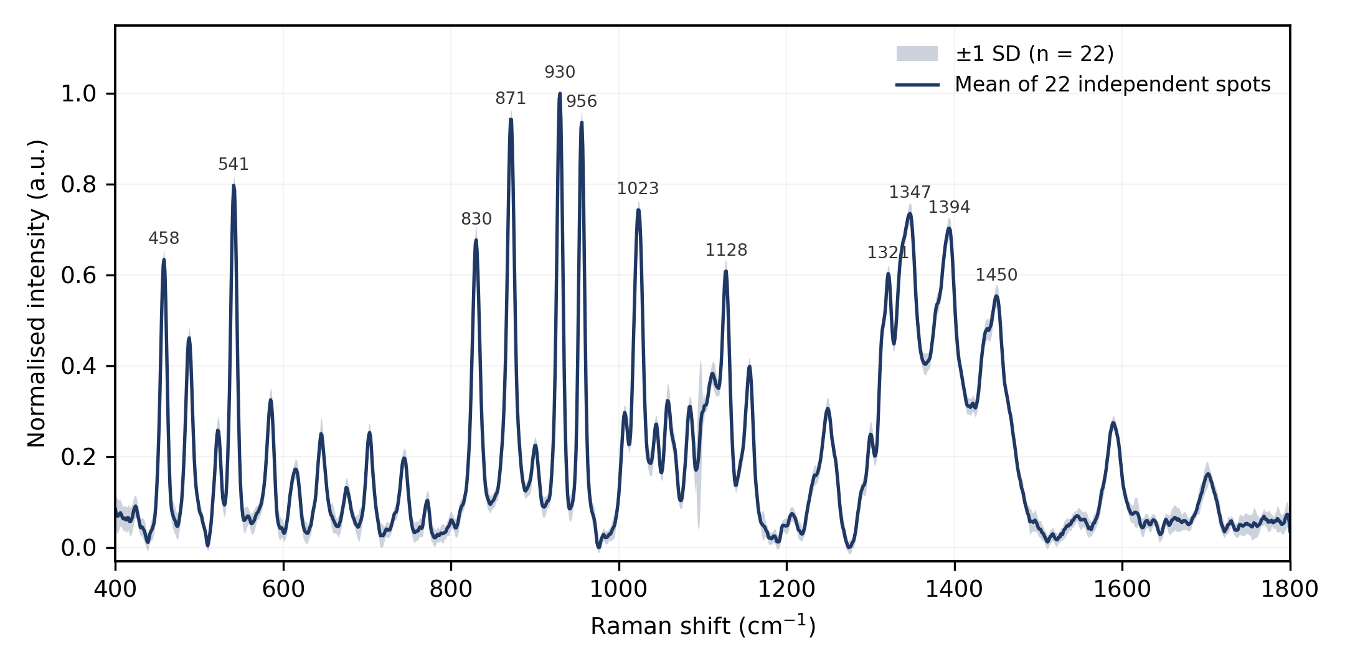
Reference Raman spectrum of isolated N-acetylmuramic acid powder. Solid line: mean of 22 independent measurements on fresh sample at 785 nm. Shaded band: $±$1 standard deviation. Principal band positions are labelled in cm⁻¹.
The spectrum divides into four regions. Below 700 cm⁻¹ the bands at 458, 488, 523, 542, 585 and 646 cm⁻¹ arise from skeletal bending and ring torsional motions of the pyranose framework. Between 700 and 1000 cm⁻¹ the strong features at 831, 872, 930 and 956 cm⁻¹ correspond to ring deformation, hydroxymethyl motion and ring breathing with coupled C–C–O stretching; the prominence of this region is characteristic of pyranose sugars. The 1000–1200 cm⁻¹ region, containing bands at 1024, 1059, 1085, 1128 and 1157 cm⁻¹, is dominated by C–O and C–C stretching of the ring together with C–O–H bending. Above 1200 cm⁻¹ the bands at 1321, 1346, 1395 and 1451 cm⁻¹ reflect C–H bending, methyl umbrella and methylene scissoring deformations, the last carrying substantial contribution from the lactyl methyl group.

Simulated spectrum
The simulated Raman spectrum obtained after scaling, intensity conversion and Lorentzian broadening is shown in Figure 5. Sixty-seven of the 111 computed modes fall within the 400–1800 cm⁻¹ window examined experimentally.
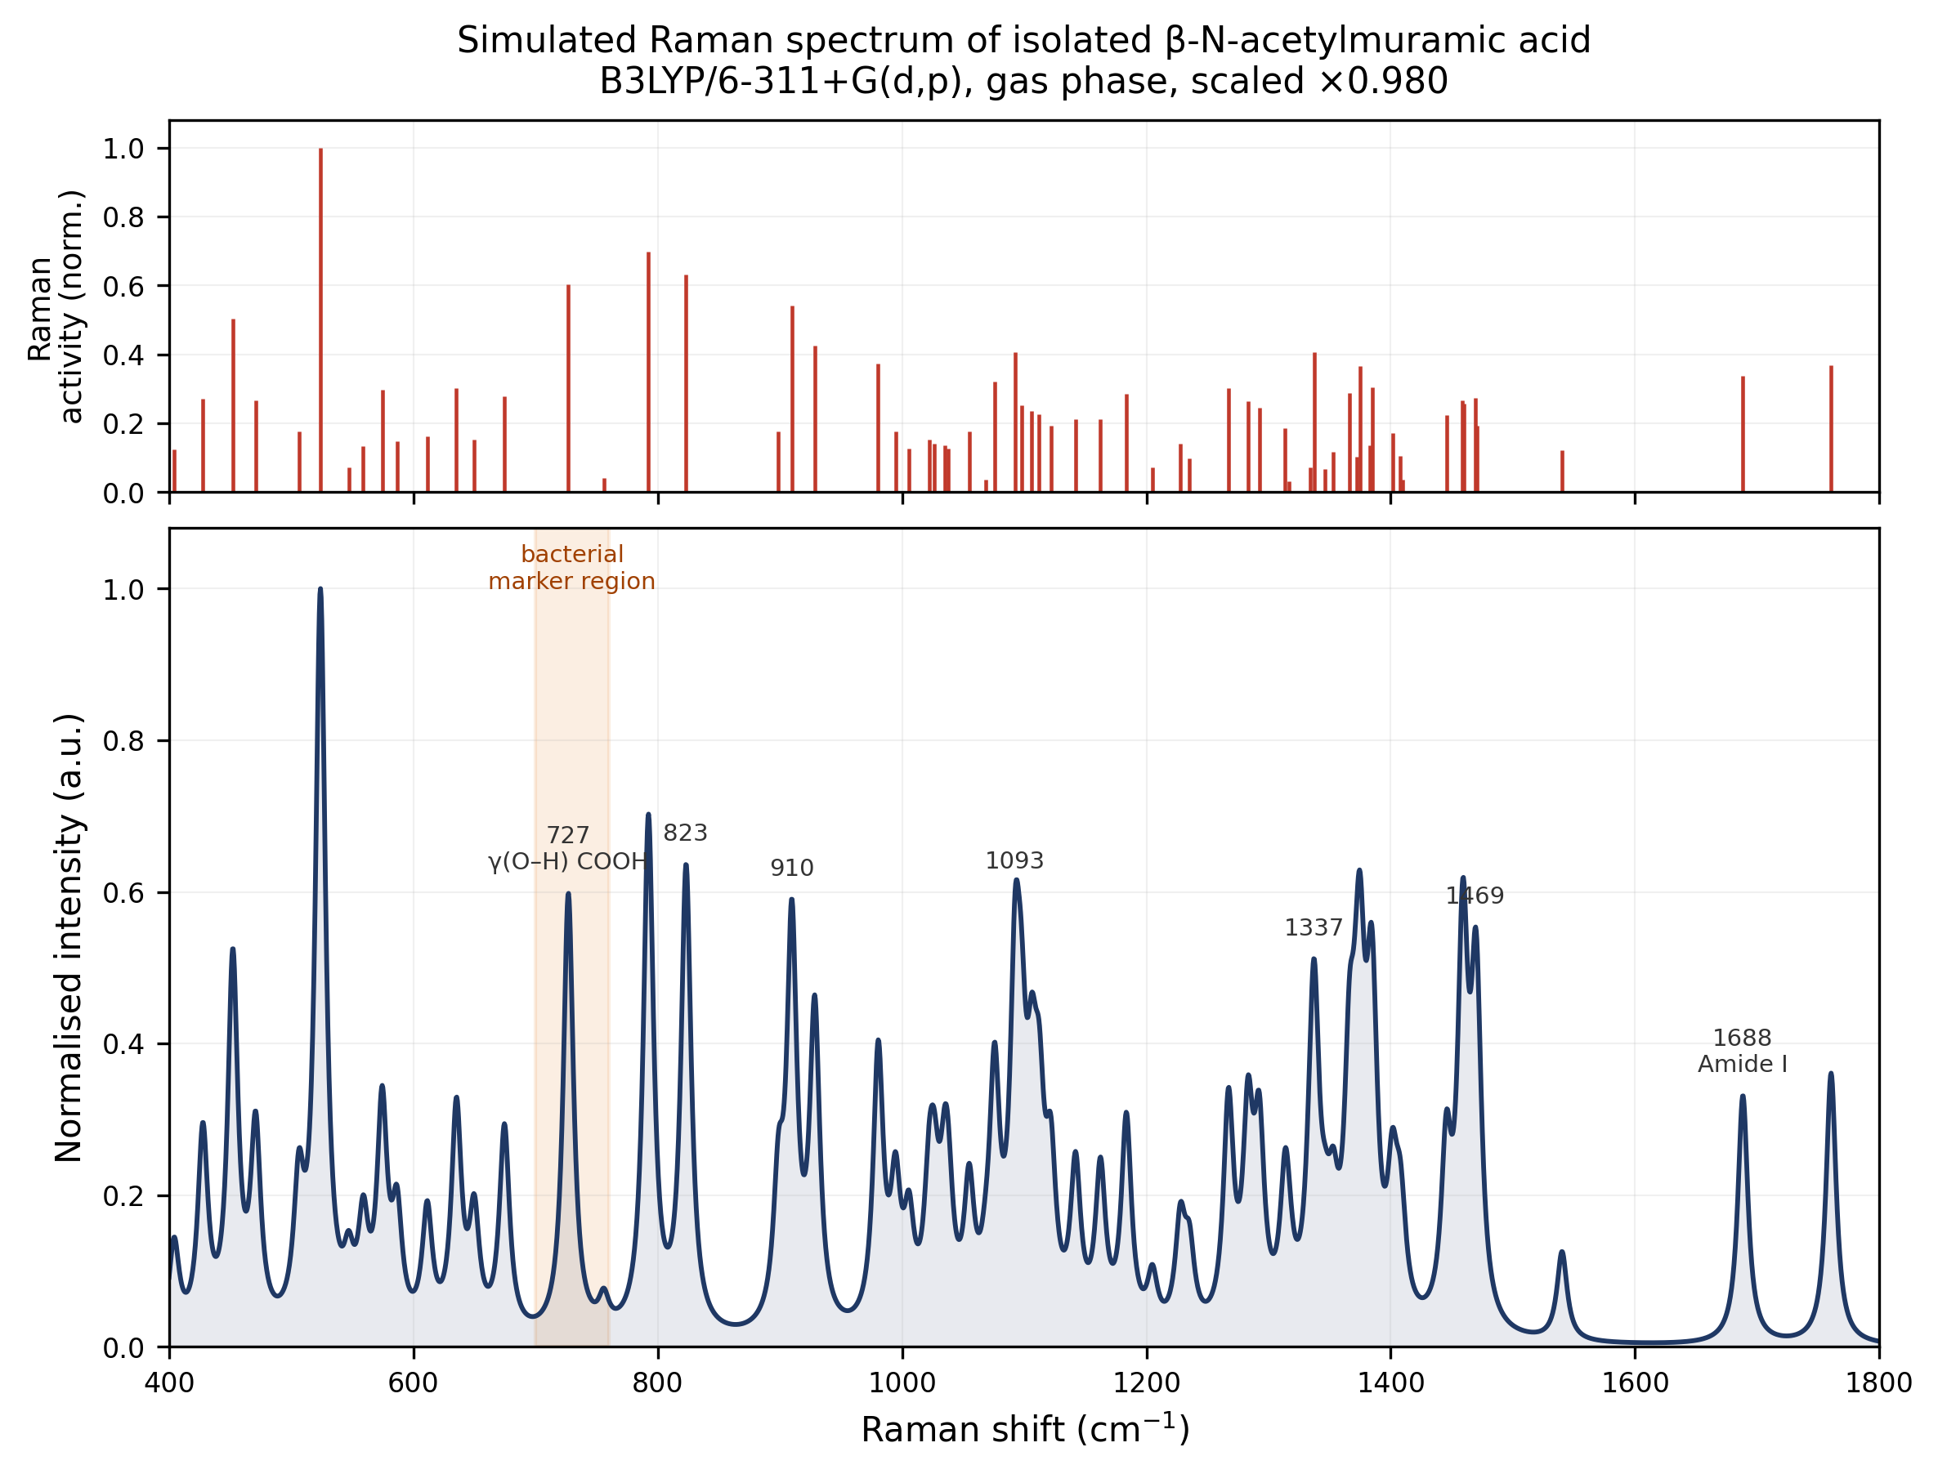
Simulated Raman spectrum of isolated $β$-N-acetylmuramic acid computed at the B3LYP-D3BJ/6-311++G(d,p) level. Upper panel: scaled harmonic frequencies with normalised Raman activities. Lower panel: Lorentzian-broadened spectrum (FWHM 10 cm⁻¹).

Comparison of experimental and calculated frequencies
Thirty of the forty-one observed bands were matched to calculated normal modes within a tolerance of $±$18 cm⁻¹, selecting in each case the candidate of highest Raman activity. The comparison appears in Table 1 and is displayed in Figure 6.
Agreement is good. The mean absolute deviation is 9.3 cm⁻¹, the root-mean-square deviation 10.3 cm⁻¹, and the largest individual deviation 17.2 cm⁻¹. The correlation between observed and calculated wavenumbers is 0.9996. The mean signed deviation is $+1.6$ cm⁻¹, indicating no strong systematic bias after scaling. Restricting the comparison to high-confidence bands alone gives essentially the same result (MAE 9.2 cm⁻¹, RMSE 10.2 cm⁻¹).
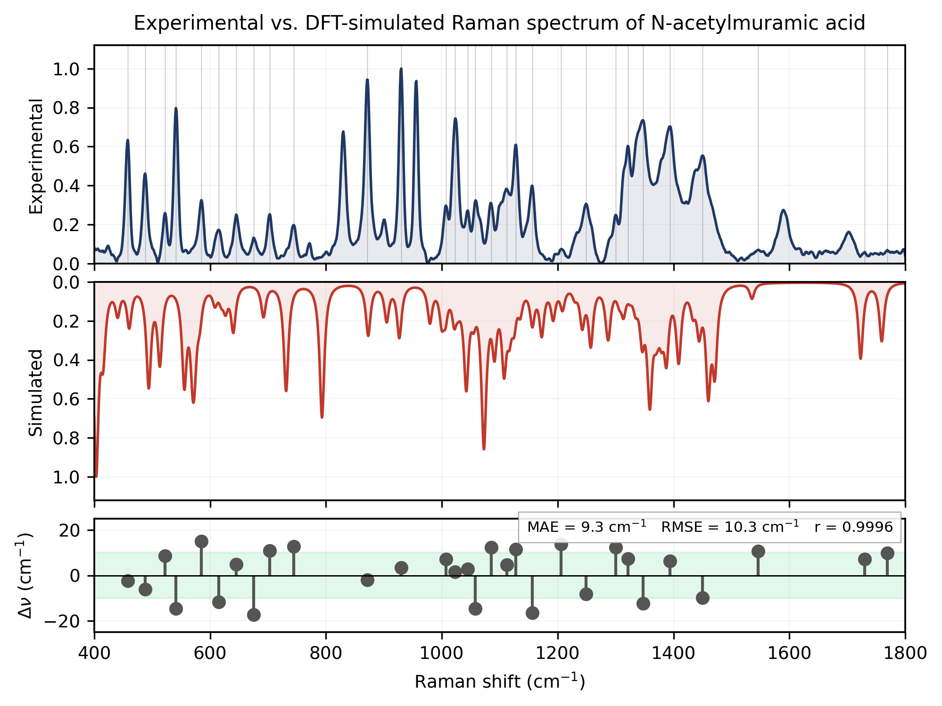
Comparison of experimental and simulated Raman spectra. Upper panel: experimental reference spectrum. Middle panel: DFT-simulated spectrum (inverted). Lower panel: deviation between observed and calculated wavenumbers for the 30 matched bands; the shaded region denotes $±$10 cm⁻¹.
Residual discrepancies have three well-understood sources. The calculation employs the harmonic approximation, whereas real vibrational potentials are anharmonic, and scaling corrects this only on average. More importantly, the calculation treats a single isolated molecule in vacuum while the measurement is of crystalline powder in which extensive intermolecular hydrogen bonding is present; modes involving hydroxyl, carbonyl and amide groups are most sensitive to this. Finally, the calculation models the $β$ anomer alone whereas the sample is an anomeric mixture.

Vibrational assignments
The assignments in Table 1 follow the conventional pattern for pyranose sugars, with two cases where normal-mode decomposition gives a result that could not be reached from the experimental spectrum alone.
The intense band at 872 cm⁻¹ is reproduced by the calculated mode at 873 cm⁻¹. Decomposition shows this mode to be dominated by motion of the hydroxymethyl hydrogens: a single hydrogen bonded to C-6 accounts for 45.9% of the mass-weighted displacement and a second for 17.4%, with the pyranose ring contributing only 5.0% and heavy atoms 8.9% in total. The band is therefore assigned to out-of-plane wagging of the hydroxymethyl group rather than to ring breathing, with which it would ordinarily be grouped on frequency alone. The neighbouring 930 cm⁻¹ band does correspond to a genuine ring-breathing mode (calculated 927 cm⁻¹).
The D-lactyl ether at C-3 distinguishes muramic acid from N-acetylglucosamine and is the structural basis for its bacterial specificity. Its methyl group contributes to the deformation modes near 1337–1385 cm⁻¹ and to the scissoring region near 1451–1470 cm⁻¹, while the associated carboxylic acid gives rise to the carbonyl stretching feature above 1750 cm⁻¹. Bands carrying lactyl character are therefore, in principle, the most promising candidates for distinguishing muramic acid from other amino sugars in complex spectra, although in intact peptidoglycan the carboxyl is amide-linked and its spectroscopic signature correspondingly altered.
The acetamido group produces amide II near 1544 cm⁻¹. This grouping is shared with GlcNAc and is not by itself diagnostic of muramic acid.

Unmatched bands
Eleven observed bands have no calculated counterpart within the matching tolerance: 772, 830, 956, 1517, 1589, 1637, 1652, 1663, 1702, 1785 and 1797 cm⁻¹. Nine of these lie above 1500 cm⁻¹, where the isolated-molecule model is least applicable.
Two limitations account for most of these. The first is the anomeric composition of the sample: the supplier specification leaves the anomeric configuration undefined, so the measured material is a mixture, whereas the calculation treats the $β$ anomer alone. The 820–980 cm⁻¹ window, which contains the unmatched 830 and 956 cm⁻¹ bands, is where $α$ and $β$ pyranoses differ most, through the anomeric C–H bending and coupled ring deformations.
The second is the treatment of the solid state. The calculation places the amide carbonyl stretch at 1723 cm⁻¹, some 21 cm⁻¹ above the observed 1702 cm⁻¹ band and outside the matching tolerance. This is the expected direction and magnitude of error for a gas-phase model: intermolecular hydrogen bonding to the amide carbonyl in the crystal lowers the stretching frequency substantially, and no isolated-molecule calculation reproduces that shift. The cluster of features between 1589 and 1663 cm⁻¹ falls in the same region.
TO CHECK: Optimising the $α$ anomer at the same level of theory and comparing a weighted combination of the two spectra with experiment would test the first explanation directly. It requires compute time only and would close the last substantial gap in the assignment.
A further consequence of the sample specification is that the material studied here differs in solid form from that of the earlier vibrational study, which examined the crystalline monohydrate . Band-by-band comparison with that work should be made with care. Finally, the supplier permits up to one mole of residual methanol per mole of product. Methanol has a strong Raman band near 1035 cm⁻¹ together with C–H stretching features at 2835 and 2945 cm⁻¹. The spectrometer used here is specified to 2800 cm⁻¹, so the diagnostic C–H stretching region is not accessible with this configuration and a contribution of residual methanol to the 1020–1050 cm⁻¹ region cannot be excluded. Testing this would require an instrument with extended spectral coverage.

The 730 cm⁻¹ region
The band near 730 cm⁻¹ is among the most prominent features of bacterial SERS spectra and is widely used in bacterial discrimination, yet its molecular origin remains contested . Because peptidoglycan is a major and bacterium-specific cell-wall constituent, a muramic acid origin has been considered plausible but could not previously be tested against a measured isolated-molecule spectrum.
Our calculations place a mode of appreciable Raman activity (5.29 Å$​^{4}$/amu) at 731 cm⁻¹ after scaling, apparently consistent with such an assignment. Decomposition of the calculated displacement vector, however, shows this interpretation to be incorrect. The mode is dominated by motion of a single hydrogen atom, contributing 47.9% of the total mass-weighted displacement, which the computed connectivity identifies as the hydroxyl proton of the carboxylic acid group (O–H bond length 0.97 Å; the parent oxygen is bonded to the carboxyl carbon at 1.35 Å, which in turn carries the carbonyl oxygen at 1.21 Å). The pyranose ring contributes only 0.5% of the displacement, and heavy atoms in total 24.0%. The mode is therefore an out-of-plane deformation of the carboxylic acid hydroxyl group, $γ$(O–H), coupled weakly to lactyl methyl motion, and not a ring or glycan-backbone vibration.
This distinction has a direct structural consequence. In intact peptidoglycan the carboxyl group of muramic acid is not free: it is amide-linked to the L-alanine residue that initiates the peptide stem. The hydroxyl proton responsible for the calculated 731 cm⁻¹ mode is therefore absent in the polymer, and the mode cannot contribute to the Raman or SERS spectrum of intact bacterial cell walls.
Experimentally, the corresponding region of the measured spectrum (Figure 7) shows only weak features, at 704 and 745 cm⁻¹, both substantially weaker than the principal ring bands, and neither coincident with 730 cm⁻¹.
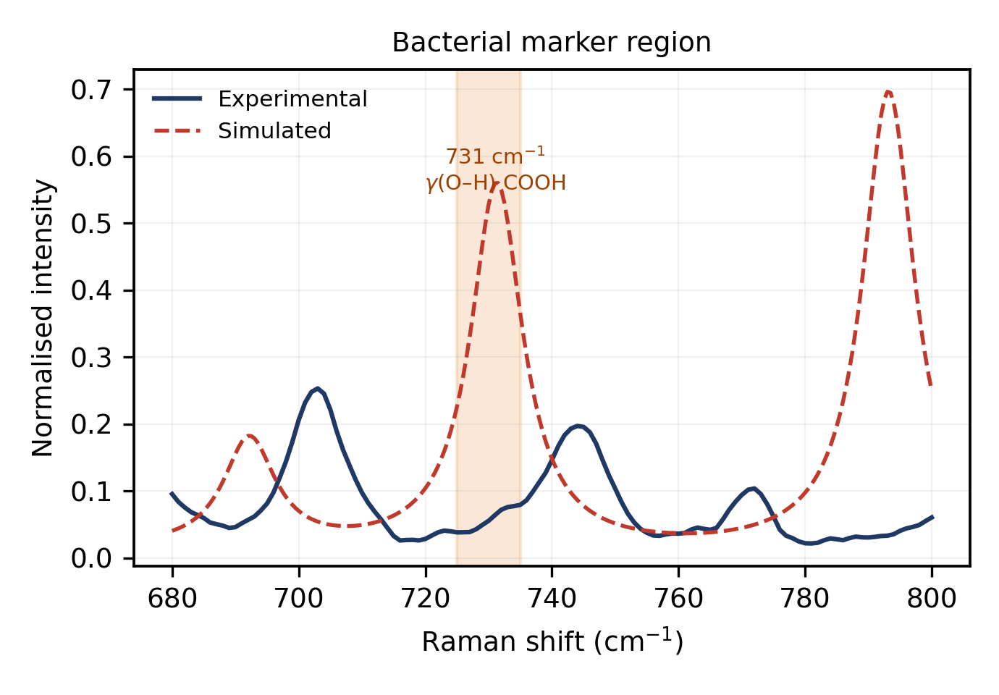
Experimental and simulated spectra in the 680–800 cm⁻¹ region. The shaded band indicates the disputed 730 cm⁻¹ bacterial marker position. The calculated mode at 731 cm⁻¹ is shown by normal-mode decomposition to be an out-of-plane carboxylic acid hydroxyl deformation.
Taken together, these observations provide direct evidence against attributing the bacterial 730 cm⁻¹ band to muramic acid, and by extension weaken the case for a peptidoglycan origin. The result is consistent with assignments favouring adenine-containing species . We note the limitations of the argument: the calculation describes the free acid as an isolated molecule, and a definitive test would require measurements on muramyl peptides or purified peptidoglycan.

Relevance to bacterial Raman and SERS analysis
The reference spectrum reported here supports the interpretation of bacterial measurements in three ways. It provides validated band positions against which candidate peptidoglycan features in whole-cell spectra can be checked. The assignments identify which bands carry lactyl character and are therefore capable in principle of distinguishing muramic acid from N-acetylglucosamine. And the 730 cm⁻¹ analysis removes one candidate explanation for a widely used bacterial marker band, narrowing the interpretive space.
For SERS applications these data provide the necessary non-enhanced baseline. Comparison of enhanced with non-enhanced spectra is what permits adsorption geometry to be inferred from surface selection rules, and such comparison requires a reliable reference of this kind. The photostability limits reported in Section 3.3 are also directly relevant, since plasmonic substrates concentrate the incident field and can lower the damage threshold considerably.
We emphasise that these measurements are of dry powder, and that extrapolation to bacterial suspensions, and still more to clinical matrices, requires separate validation.

Conclusions
A reference Raman spectrum of isolated N-acetylmuramic acid has been established from 22 independent measurements on fresh sample and compared with harmonic frequencies computed at the B3LYP-D3BJ/6-311++G(d,p) level. Forty-one reproducible bands were identified in the 400–1800 cm⁻¹ fingerprint region, of which thirty were assigned to calculated normal modes with a mean absolute deviation of 9.3 cm⁻¹ and a correlation coefficient of 0.9996.
Photostability measurements across 227 spectra define a working envelope for this material at 785 nm: the spectrum is unchanged over ten consecutive scans at 90% laser power with 30 s integration, but the sample is destroyed at the same power with 60 s integration.
Normal-mode decomposition resolved two assignments not accessible from the experimental spectrum alone. The intense 872 cm⁻¹ band arises from hydroxymethyl wagging rather than ring breathing. The calculated mode in the disputed 730 cm⁻¹ bacterial marker region arises from out-of-plane deformation of the carboxylic acid hydroxyl group, with negligible ring character; since this proton is absent in intact peptidoglycan, the result argues against a muramic acid origin for the bacterial 730 cm⁻¹ band.
Extension of this work to N-acetylglucosamine, to the $α$ anomer, to muramyl peptides and to surface-enhanced measurements would allow the peptidoglycan contribution to bacterial Raman spectra to be characterised more completely.
Observed and calculated Raman wavenumbers of isolated N-acetylmuramic acid with proposed vibrational assignments. Calculated values are scaled (0.980 below 1800 cm⁻¹). $Δ=ν_{exp}−ν_{calc}$. Reproducibility is the percentage of the 22 independent spectra in which the band was detected. $ν$: stretching; $δ$: in-plane bending; $γ$: out-of-plane bending. $​^{†}$Tentative: satisfies only one of the two signal-to-noise criteria of Section 2.6.
Exp. | Calc. | $Δ$ | Raman act. | Rel. | Repro. | Proposed assignment
(cm⁻¹) | (cm⁻¹) | (cm⁻¹) | (Å$​^{4}$/amu) | int. | (%)
458 | 460.5 | -2.5 | 1.0 | 0.63 | 100 | Skeletal bending / ring torsion
488 | 494.2 | -6.2 | 2.8 | 0.46 | 100 | Skeletal bending / ring torsion
522 | 513.4 | +8.6 | 2.3 | 0.26 | 100 | Skeletal bending / ring torsion
541 | 555.6 | -14.6 | 3.2 | 0.80 | 100 | Skeletal bending / ring torsion
585 | 570.0 | +15.0 | 2.3 | 0.33 | 100 | Skeletal bending / ring torsion
615 | 626.7 | -11.7 | 0.8 | 0.17 | 100 | Skeletal deformation + $δ$(C–C–O)
645 | 640.1 | +4.9 | 1.9 | 0.25 | 100 | Skeletal deformation + $δ$(C–C–O)
675 | 692.2 | -17.2 | 1.5 | 0.13 | 95 | Skeletal deformation + $δ$(C–C–O)
703 | 692.2 | +10.8 | 1.5 | 0.25 | 100 | Skeletal deformation + $δ$(C–C–O)
744 | 731.3 | +12.7 | 5.3 | 0.20 | 100 | $γ$(O–H) carboxylic acid out-of-plane
772 | – | – | – | 0.10 | 100 | unmatched
830 | – | – | – | 0.68 | 100 | unmatched
871 | 873.0 | -2.0 | 3.2 | 0.94 | 100 | $γ$(CH$​_{2}$) hydroxymethyl wagging
930 | 926.7 | +3.3 | 3.6 | 1.00 | 100 | Ring breathing / $ν$(C–C–O)
956 | – | – | – | 0.94 | 100 | unmatched
1007 | 999.9 | +7.1 | 2.4 | 0.30 | 100 | Ring breathing / $ν$(C–C–O)
1023 | 1021.5 | +1.5 | 2.3 | 0.74 | 100 | $ν$(C–O) + $δ$(C–O–H)
1045$​^{†}$ | 1042.2 | +2.8 | 7.7 | 0.27 | 100 | $ν$(C–O) + $δ$(C–O–H)
1058 | 1072.7 | -14.7 | 12.4 | 0.32 | 100 | $ν$(C–O) + $δ$(C–O–H)
1085$​^{†}$ | 1072.7 | +12.3 | 12.4 | 0.31 | 100 | $ν$(C–O) + $δ$(C–O–H)
1112 | 1107.4 | +4.6 | 6.6 | 0.38 | 100 | $ν$(C–O) + $δ$(C–O–H)
1128 | 1116.6 | +11.4 | 3.1 | 0.61 | 100 | $ν$(C–O) + $δ$(C–O–H)
1156 | 1172.4 | -16.4 | 4.4 | 0.40 | 100 | $ν$(C–O) + $δ$(C–O–H)
1206$​^{†}$ | 1192.1 | +13.9 | 3.0 | 0.07 | 95 | $ν$(C–O) + $δ$(C–O–H)
1249 | 1257.1 | -8.1 | 6.0 | 0.31 | 100 | $δ$(C–H) + $ν$(C–O) coupled
1300$​^{†}$ | 1287.6 | +12.4 | 4.5 | 0.25 | 95 | $δ$(C–H) + $ν$(C–O) coupled
1321 | 1313.6 | +7.4 | 2.7 | 0.60 | 100 | $δ$(C–H) + $ν$(C–O) coupled
1347 | 1359.3 | -12.3 | 11.0 | 0.73 | 100 | $δ$(C–H) / $δ$s(CH$​_{3}$) umbrella
1394 | 1387.6 | +6.4 | 7.8 | 0.70 | 100 | $δ$(C–H) / $δ$s(CH$​_{3}$) umbrella
1450 | 1459.7 | -9.7 | 7.6 | 0.55 | 95 | $δ$(CH$​_{2}$) scissoring / $δ$as(CH$​_{3}$)
1517$​^{†}$ | – | – | – | 0.03 | 100 | unmatched
1546 | 1535.2 | +10.8 | 2.2 | 0.07 | 77 | Amide II: $δ$(N–H) + $ν$(C–N)
1589 | – | – | – | 0.27 | 91 | unmatched
1637$​^{†}$ | – | – | – | 0.06 | 91 | unmatched
1652$​^{†}$ | – | – | – | 0.06 | 91 | unmatched
1663$​^{†}$ | – | – | – | 0.07 | 77 | unmatched
1702 | – | – | – | 0.16 | 100 | unmatched
1730$​^{†}$ | 1722.8 | +7.2 | 12.8 | 0.06 | 100 | Amide I: $ν$(C=O)
1769 | 1759.2 | +9.8 | 10.2 | 0.07 | 82 | $ν$(C=O) carboxylic acid
1785 | – | – | – | 0.06 | 68 | unmatched
1797 | – | – | – | 0.07 | 82 | unmatched

CRediT authorship contribution statement
Sukesh P: Conceptualisation, Methodology, Investigation, Formal analysis, Software, Visualisation, Writing — original draft. TO CHECK: Add co-authors and their contributions.

Declaration of competing interest
The authors declare no competing financial interests or personal relationships that could have influenced the work reported in this paper.

Data availability
Processed Raman spectra, the complete list of calculated frequencies and Raman activities, and the optimised molecular geometry are provided as Supplementary Material. Raw spectra and Gaussian output files are available from the corresponding author on request. TO CHECK: Consider depositing the full archive in Zenodo and citing the DOI.

Acknowledgements
The author thanks the Indian Institute of Technology Jodhpur for access to Raman spectroscopy and computational facilities. TO CHECK: Add supervisor, colleagues, funding sources and grant numbers.
99
Y. Wang, et al., Bacteria detection: from powerful SERS to advanced spectroscopic techniques, Biosensors 12 (2022) 210.
D. Ma, et al., Escherichia coli research on Raman measurement mechanism and diagnostic model, Vibrational Spectroscopy 132 (2024) 103670.
W. Vollmer, D. Blanot, M. A. de Pedro, Peptidoglycan structure and architecture, FEMS Microbiology Reviews 32 (2008) 149–167.
C. Y. She, et al., Laser Raman spectra of glucosamine and related amino sugars, Spectrochimica Acta Part A 30 (1974) 1387–1395.
J. Kaminský, et al., Simulation of Raman and Raman optical activity spectra of saccharides in water, Physical Chemistry Chemical Physics 22 (2020) 12345–12356.
M. Kouach, et al., Vibrational spectra and harmonic dynamics of N-acetyl-muramic acid monohydrate, Journal of Molecular Structure 317 (1994) 153–166. TO CHECK: VERIFY authors, volume and pages against the actual paper
W. R. Premasiri, et al., The biochemical origins of the surface-enhanced Raman spectra of bacteria, Applied Spectroscopy 70 (2016) 1136–1149.
P. Kubryk, et al., The origin of the band at around 730 cm$​^{−1}$ in the SERS spectra of bacteria, Analyst 141 (2016) 3986–3994.
M. J. Frisch, et al., Gaussian 16, Revision TO CHECK: X.XX, Gaussian, Inc., Wallingford CT, 2016.
A. D. Becke, Density-functional thermochemistry. III. The role of exact exchange, Journal of Chemical Physics 98 (1993) 5648–5652.
C. Lee, W. Yang, R. G. Parr, Development of the Colle–Salvetti correlation-energy formula into a functional of the electron density, Physical Review B 37 (1988) 785–789.
S. Grimme, S. Ehrlich, L. Goerigk, Effect of the damping function in dispersion corrected density functional theory, Journal of Computational Chemistry 32 (2011) 1456–1465.
P. H. C. Eilers, H. F. M. Boelens, Baseline correction with asymmetric least squares smoothing, Leiden University Medical Centre Report, 2005.
A. Savitzky, M. J. E. Golay, Smoothing and differentiation of data by simplified least squares procedures, Analytical Chemistry 36 (1964) 1627–1639.

Corresponding author: sukeshperiyasamy@gmail.com

