N-Acetylmuramic Acid (NAM) Research Programme
Consolidated Report — Reference Spectroscopy, Sensor Development and SERS Detection Trials
____________________________________________________________

Sukesh P (M24IM1007) | M.Tech, Joint IDRP, IIT Jodhpur & AIIMS Jodhpur
Work package within: "Intelligent Sensor System for Early Prediction of Sepsis in Neonates and High-Risk Adults" | PI: Prof. Ajay Agarwal, IITJ | Co-PI: Prof. (Dr.) Neeraj, AIIMS Jodhpur

Executive Summary
This report consolidates every piece of NAM-related experimental and computational work carried out in this project to date: the isolated-molecule reference Raman spectrum and DFT vibrational assignment of NAM, two generations of Ag-based SERS sensor tried for NAM detection, the unetched-silicon instrument reference dataset, and a related lipoteichoic-acid (LTA) detection attempt. It brings together data and analysis previously scattered across separate sessions and separate report documents into a single record, organised so that the SERS detection results can be interpreted against a validated, DFT-confirmed reference spectrum rather than in isolation.
KEY — Headline result: a reference Raman spectrum of isolated NAM has been established from 22 independent measurements and validated against DFT calculation (30 of 41 bands matched, r = 0.9996, MAE 9.3 cm⁻¹). Two generations of Ag-based SERS substrate have been evaluated for NAM detection. The earlier substrate showed one reproducible, tentative candidate feature near 243 cm⁻¹, outside the calibrated range of the reference spectrum and therefore not yet confirmable against it. The later black-silicon substrates, though strongly SERS-active for R6G (SNR up to 450), did not reproducibly detect NAM at any of the reference target bands. A surface-functionalisation strategy (4-MPBA recognition chemistry) is proposed as the next stage and is detailed in Part VI.

This work sits within, and is reported here against, the objectives, phases and deliverables of the parent project proposal "Intelligent Sensor System for Early Prediction of Sepsis in Neonates and High-Risk Adults" (see the Alignment section immediately below).

Alignment with the Parent Project Proposal
This report documents work carried out under the project "Intelligent Sensor System for Early Prediction of Sepsis in Neonates and High-Risk Adults" (PI: Prof. Ajay Agarwal, IITJ; Co-PI: Prof. (Dr.) Neeraj, AIIMS Jodhpur; Co-PIs: Dr. Paramita Kar Choudhury, Dr. Sujit Shinde, Dr. Sanjay Kimbahune, TCS; Dr. Sudipta Bhattacharyya, IITJ). The proposal's goal is an AI-powered intelligent sensor system for real-time pathogen detection in neonates and high-risk adults, built on SERS detection of bacteria-specific markers (LPS, peptidoglycan) rather than indirect host-response biomarkers (IL-6, PCT), executed across five phases and five specific objectives. This section maps the work reported in Parts I–VI against that structure, so progress and remaining scope are explicit rather than implied.

A.1 Status against the five specific objectives
Objective (proposal) | Status | Evidence in this report
(a) Biomarker Discovery — identify bacterial biomarkers (LPS, peptidoglycan) via Raman spectroscopy on pure commercial standards | Substantially advanced for one peptidoglycan-associated marker (NAM); not yet started for LPS or LTA as pure-standard Raman studies | Part I — full reference Raman spectrum and DFT vibrational assignment of isolated NAM, 41 bands, 30 DFT-matched, r = 0.9996
(b) SERS-Based Sensing Technology — develop a SERS nanosensor chip optimised for the discovered biomarkers | In progress — chip fabricated and validated as SERS-active, but not yet optimised for reproducible biomarker detection | Parts II–III — two sensor generations, R6G validation (SNR 345 and 450), NAM detection attempts not yet successful
(c) AI-Integrated Raman Analysis — ML/neural-network algorithms for automated spectral interpretation | Not started | No AI/ML work has been undertaken in this work package to date
(d) Clinical Validation — evaluate the sensor on clinical samples from neonates and high-risk adults | Not started — all measurements to date use pure commercial reference compounds, not clinical isolates or patient samples | Out of scope for the work reported here
(e) Prototype Development — point-of-care (PoC) device | Not started | Out of scope for the work reported here

A.2 Status against Phase 1 ("Biomarker Identification through Pure Standards")
All work reported here falls within Phase 1 of the proposal's five-phase methodology. Phase 1 has three sub-tasks:
Phase 1 sub-task (proposal) | Status | Evidence
(a) Selection of bacterial biomarkers — Gram-negative: LPS, outer-membrane proteins; Gram-positive: peptidoglycan, teichoic acids, surface proteins | Done for the markers pursued in this work package — NAM (peptidoglycan component, common to both Gram classes), LTA (Gram-positive teichoic-acid-related), LPS (Gram-negative) identified and literature-reviewed | Experiment_Plan_LPS / Experiment_Plan_LTA / LPS_Substrate_Strategy documents (literature basis); NAM selected as the primary target
(b) Procurement and Raman spectroscopy studies on pure standards; SERS substrate optimisation | NAM: complete (227 spectra, commercial Sigma-Aldrich standard, full acquisition-parameter optimisation). LTA: preliminary SERS attempt only, no pure off-substrate reference spectrum yet. LPS: not yet started experimentally. SERS substrate optimisation: complete for R6G on both sensor generations | Part I (NAM); Part III.5 (LTA attempt); Part III.1–III.2 (substrate optimisation via R6G)
(c) Establishment of a Raman spectral library of sepsis-related bacterial markers | One validated, DFT-confirmed library entry complete (NAM). LPS and LTA entries outstanding | Part I.4–I.5 (NAM reference spectrum and peak/assignment table)

RESULT — In proposal terms, this report represents a rigorous, DFT-validated completion of Phase 1(a)–(c) for a single biomarker (NAM), together with SERS-chip development and R6G-based optical validation that underlies Phase 1(b) for all future biomarkers. It does not yet include Phase 2 (cultured clinical isolates), Phase 3 (patient samples), Phase 4 (AI/ML), or Phase 5 (PoC prototype) work.

A.3 Status against the four proposal deliverables
Deliverable (proposal) | Status
(a) Structured Raman spectral library of Gram-positive/Gram-negative bacterial biomarkers | Partially delivered — NAM entry complete and DFT-validated (Part I); LPS and LTA entries not yet built to the same standard
(b) SERS chip optimised for detecting biomarkers from clinical isolates and patient samples | In development — chip fabricated and SERS-active (validated with R6G); biomarker-specific detection (NAM) not yet achieved; clinical isolates and patient samples not yet introduced
(c) AI-based algorithm for Raman spectral analysis | Not started
(d) Point-of-care prototype demonstration | Not started

The remainder of this report (Parts I–VI) presents the underlying data and analysis supporting the status assessments above, in the same technical detail as previously reported, followed by a forward plan (Part VI) that is a necessary precursor to Phase 1(b)/(c) completion and, subsequently, to Phase 2.

1. Introduction and Scope
N-acetylmuramic acid (NAM, MurNAc) is a peptidoglycan-specific amino sugar present in essentially all bacterial cell walls and absent from human cells, making it an attractive label-free biomarker for rapid, culture-independent sepsis diagnostics. Surface-enhanced Raman spectroscopy (SERS) offers a route to such detection provided a suitable plasmonic substrate is available and the target molecule's spectral signature is reliably known.
This report draws together four bodies of work:
- A reference Raman/DFT characterisation of isolated NAM powder, establishing a validated spectral fingerprint independent of any SERS substrate.
- Development and evaluation of a first-generation Ag-nanoparticle-on-silicon SERS sensor, including R6G concentration-response validation and an initial NAM detection attempt.
- Development and evaluation of a second-generation Ag/black-silicon SERS sensor fabricated by one-step metal-assisted chemical etching (MACE), including an etch-time study, NAM detection attempts, a full instrument/calibration reference dataset on unetched silicon, and an LTA detection attempt.
- A cross-study synthesis of why NAM has not yet been detected by SERS, and a proposed next-generation sensor architecture using 4-mercaptophenylboronic acid (4-MPBA) surface chemistry.
Sessions are referred to descriptively rather than by calendar date throughout this report.

Part I — Reference Raman Spectrum and DFT Vibrational Assignment of Isolated NAM
Before any SERS measurement can be interpreted, the intrinsic Raman signature of the target molecule must be known independently of the sensing substrate. This part reports a dedicated study of NAM powder alone (on plain glass, no metal enhancement), combined with quantum-chemical calculation, to establish such a reference.

I.1 Sample and instrument
Item | Detail
Compound | N-acetylmuramic acid (NAM, MurNAc, NAMA), C₁₁H₁₉NO₈
Supplier / catalogue | Sigma-Aldrich (Merck), A3007-100MG, CAS 10597-89-4, lot BCCK5768
Molecular weight | 293.27 g/mol (anhydrous)
Purity | ≥98% (TLC); ≤1 mol/mol methanol stated impurity
Form / preparation | White powder, placed directly on a clean glass microscope slide, used as received
Stereochemistry | α/β anomeric mixture (normal for a reducing sugar); DFT models the β anomer only
Instrument | B&W Tek i-Raman Plus, BWS465-785H spectrometer, BTC665N-785H-SYS probe, BAC102-785E Raman microscope, 20× objective
Laser | 785 nm (784.92 nm reported), Class 3B, 0–100% power in 1% steps; ≈340 mW nominal exiting the fibre probe at 100% (power at sample unmeasured)
Detector | 2048-pixel TE-cooled CCD (−2 °C); spectral range −46 to 2842 cm⁻¹; resolution < 3.5 cm⁻¹

I.2 Acquisition and processing methodology
227 spectra were acquired in total, organised into five sets:
Set | n | Purpose
Optimisation grid | 98 | 5 integration times (5–25 s) × 16 laser powers (5–80%); one spectrum per condition
Replicates (R1–R9) | 104 | Nine fixed-condition replicate series, fresh spot per measurement; reference spectrum built from sets R2 + R4 (70% and 90% power, 10 s, 5 accumulations, n = 22)
Photostability | 10 | Ten consecutive scans at 90% / 30 s, same spot, no stage movement
Glass blanks | 5 | Empty microscope slide, 5% / 5 s / 1 accumulation
Excluded — laser damage | 10 | 90% / 60 s; sample destroyed, retained only to establish the damage threshold

Every spectrum was processed identically: interpolation to a uniform 1 cm⁻¹ grid over 400–1800 cm⁻¹, asymmetric least-squares baseline correction, Savitzky–Golay smoothing, and min–max normalisation. Peak detection used two independent noise criteria (local-region SNR and prominence-based SNR, threshold SNR ≥ 3), with weak bands passing only one criterion cross-validated against an independent long-integration dataset (30 s and 60 s, SNR up to 796) before being promoted to "high confidence". Calculated modes were matched to experimental bands within ±18 cm⁻¹, preferring the match with highest computed Raman activity.

I.3 DFT calculation
Parameter | Value
Software | Gaussian 16, Revision C.01
Method / basis | B3LYP-D3BJ / 6-311++G(d,p)
Phase | Gas phase, isolated molecule, no solvation model
Starting geometry | β anomer, PubChem CID 5462244
Atoms / normal modes | 39 atoms (C₁₁H₁₉NO₈); 111 normal modes
Imaginary frequencies | 0 — confirmed true minimum
Frequency scaling | 0.980 below 1800 cm⁻¹, 0.967 above
Runtime | ≈4 h 41 min (3 h 42 min optimisation + 58 min frequencies), 16 processors / 48 GB

I.4 Reference spectrum and peak list
The reference spectrum (mean ± SD of 22 independent replicate measurements) contains 41 reproducible bands across the 400–1800 cm⁻¹ fingerprint region: 32 classified as high confidence and 9 as tentative. The strongest band is at 930 cm⁻¹ (ring breathing / ν(C–C–O), relative intensity 1.00), followed by 872 cm⁻¹ (hydroxymethyl wagging, 0.92) and 956 cm⁻¹ (0.96).
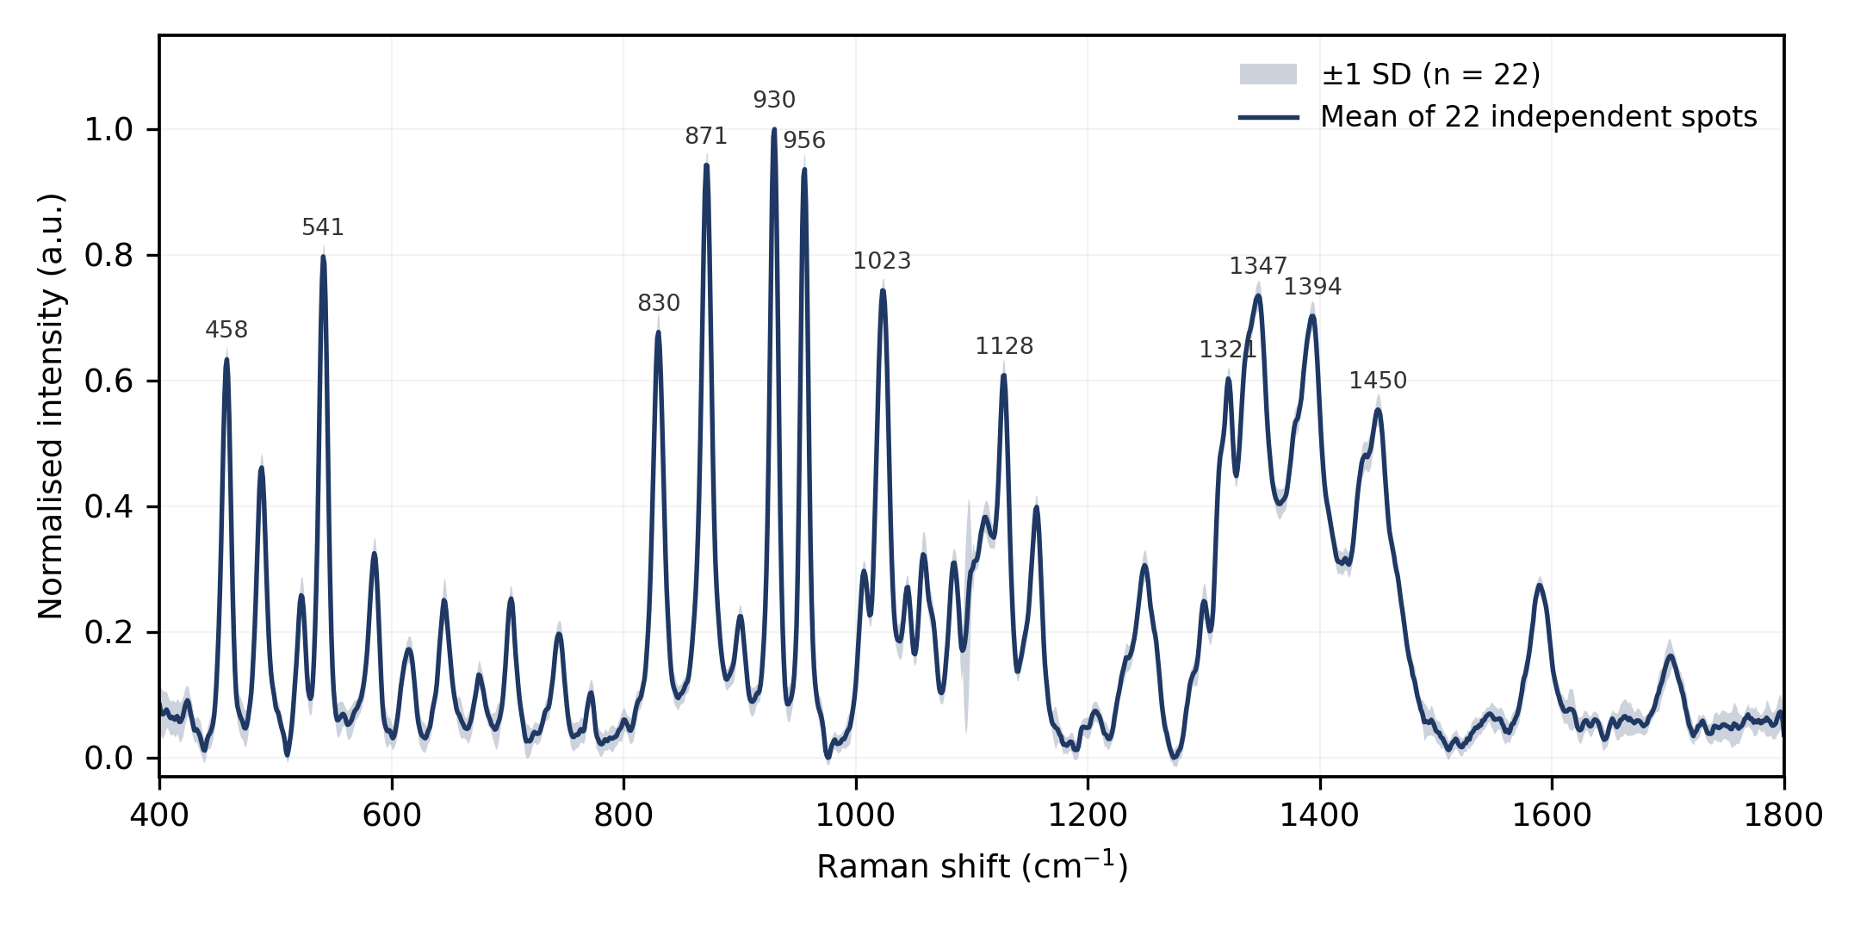
Figure I-1. Reference Raman spectrum of isolated NAM powder, mean ± SD from 22 independent measurements (sets R2 + R4).
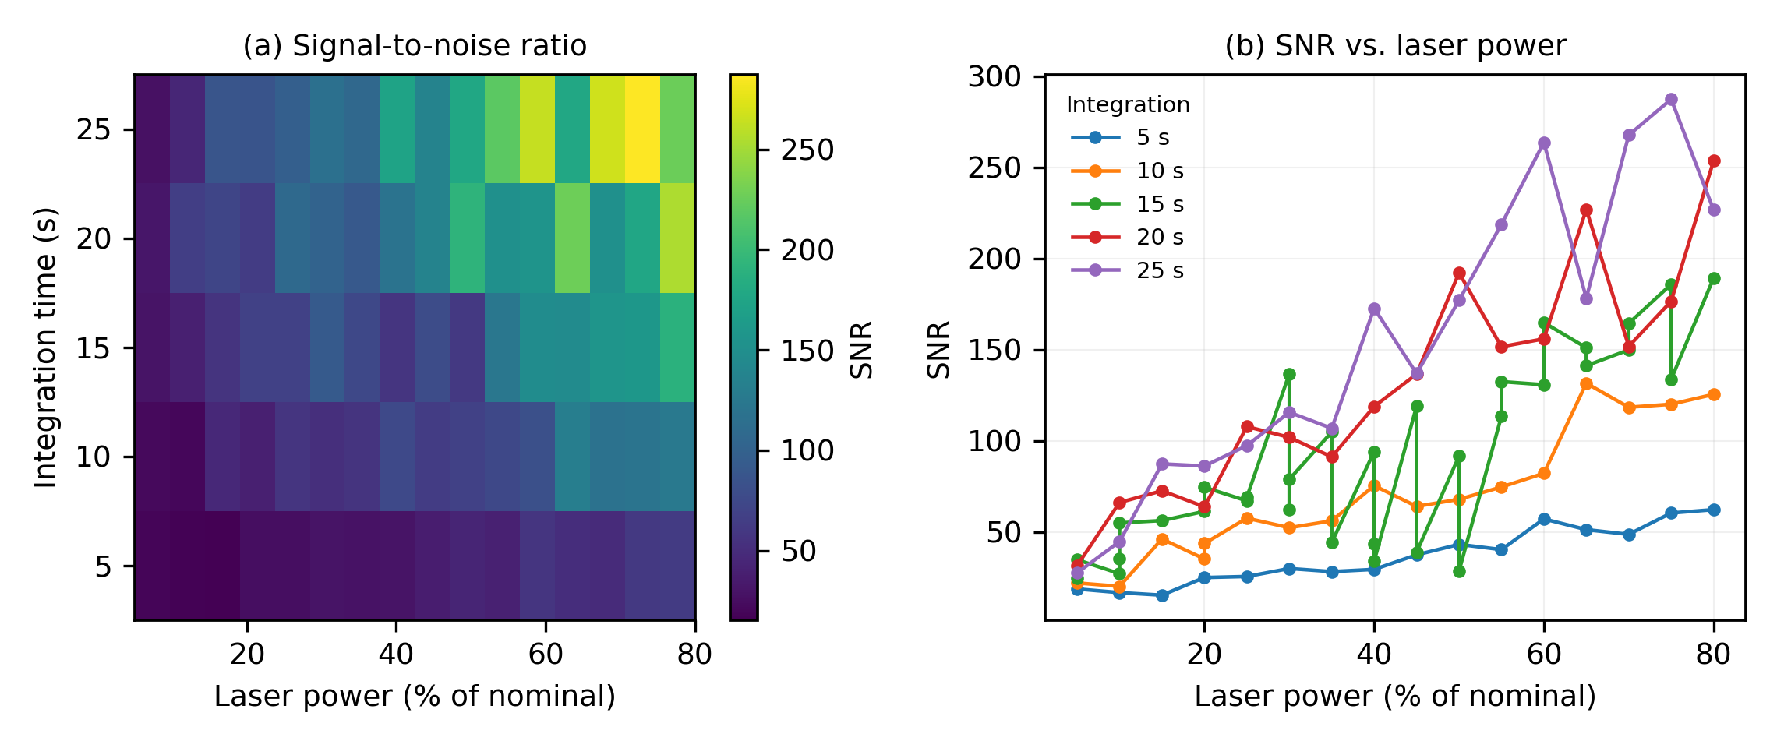
Figure I-2. Acquisition-parameter optimisation survey — SNR across the 5 integration time × 16 power-level grid.

I.5 Experimental band list and DFT assignment
High-confidence bands, with calculated (scaled) frequency, deviation, dominant normal-mode character, and relative intensity in the reference spectrum:
Exp (cm⁻¹) | Calc (cm⁻¹) | Δ (cm⁻¹) | Assignment | Rel. int.
458 | 460.5 | −2.5 | Skeletal bending / ring torsion | 0.63
488 | 494.2 | −6.2 | Skeletal bending / ring torsion | 0.46
523 | 513.4 | +9.6 | Skeletal bending / ring torsion | 0.27
542 | 555.6 | −13.6 | Skeletal bending / ring torsion | 0.80
585 | 570.0 | +15.0 | Skeletal bending / ring torsion | 0.34
616 | 626.7 | −10.7 | Skeletal deformation + δ(C–C–O) | 0.19
646 | 640.1 | +5.9 | Skeletal deformation + δ(C–C–O) | 0.26
677 / 704 | 692.2 | ∓12–15 | Skeletal deformation + δ(C–C–O) | 0.13 / 0.25
745 | 731.3 | +13.7 | γ(O–H) carboxylic acid, out-of-plane | 0.19
772 | unmatched | — | (no calculated mode within tolerance) | 0.10
831 | unmatched | — | (no calculated mode within tolerance) | 0.65
872 | 873.0 | −1.0 | γ(CH₂) hydroxymethyl wagging | 0.92
930 | 926.7 | +3.3 | Ring breathing / ν(C–C–O) [strongest band] | 1.00
956 | unmatched | — | (no calculated mode within tolerance) | 0.96
1024 | 1021.5 | +2.5 | ν(C–O) + δ(C–O–H) | 0.75
1059 / 1128 | 1073 / 1117 | −13.7 / +11.4 | ν(C–O) + δ(C–O–H) | 0.33 / 0.61
1157 / 1190 | 1172.4 | −15.4 / +17.6 | ν(C–O) + δ(C–O–H) | 0.40 / 0.17
1249 | 1257.1 | −8.1 | δ(C–H) + ν(C–O) coupled | 0.32
1321 | 1313.6 | +7.4 | δ(C–H) + ν(C–O) coupled | 0.48
1346 | 1359.3 | −13.3 | δ(C–H) / δs(CH₃) umbrella | 0.49
1395 | 1387.6 | +7.4 | δ(C–H) / δs(CH₃) umbrella | 0.47
1451 | 1459.7 | −8.7 | δ(CH₂) scissoring / δas(CH₃) | 0.49
1544 | 1535.2 | +8.8 | Amide II: δ(N–H) + ν(C–N) | 0.10
1590 / 1633 / 1652 / 1700 | unmatched | — | (no calculated mode within tolerance) | 0.28 / 0.08 / 0.07 / 0.17
1726 | 1722.8 | +3.2 | Amide I: ν(C=O) | 0.08
1751 / 1758 / 1768 | 1759.2 | ∓1–9 | ν(C=O) carboxylic acid | 0.07–0.08
1792 | unmatched | — | (no calculated mode within tolerance) | 0.06

30 of 41 bands matched to a calculated normal mode within ±18 cm⁻¹. Fit statistics: MAE 9.3 cm⁻¹, RMSE 10.3 cm⁻¹, mean signed deviation +1.6 cm⁻¹, r = 0.9996. Unmatched bands (772, 831, 956, 1590, 1633, 1652, 1700, 1792 cm⁻¹) are concentrated above 1500 cm⁻¹, where the isolated-gas-phase model is least applicable (crystal packing / hydrogen-bonding effects not captured).
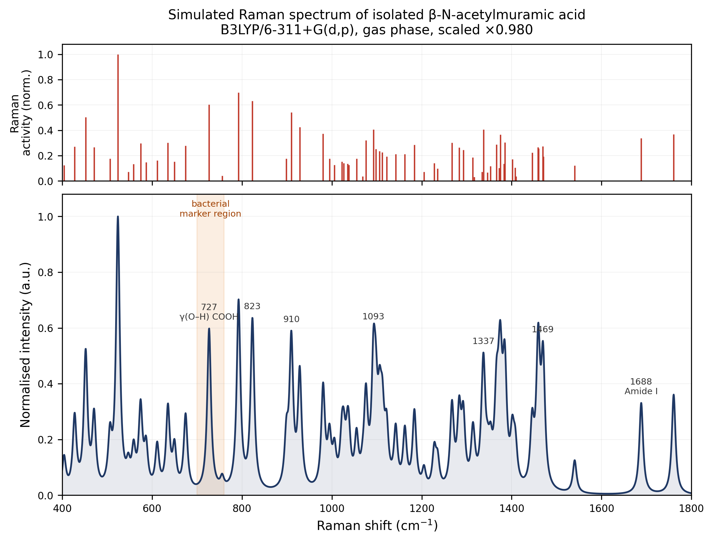
Figure I-3. DFT-simulated Raman spectrum (stick and Lorentzian-broadened), β-anomer, B3LYP-D3BJ/6-311++G(d,p).
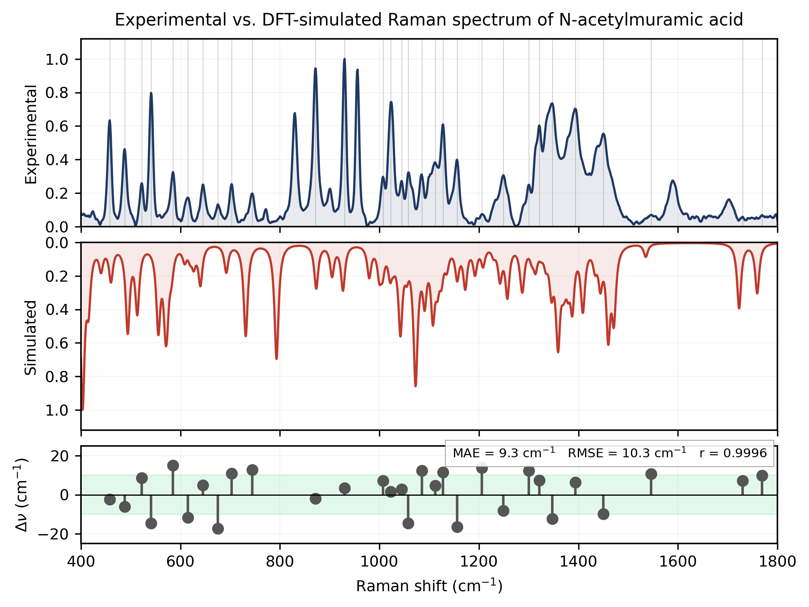
Figure I-4. Experimental reference spectrum vs. DFT-simulated spectrum, overlay with residual panel.

I.6 The 730 cm⁻¹ region — significance for bacterial SERS markers
A band near 730 cm⁻¹ is a commonly cited marker in whole-cell bacterial Raman and SERS spectra, and has sometimes been attributed to muramic acid / peptidoglycan. In this dataset, the corresponding calculated mode (731.3 cm⁻¹, matched to the experimental 745 cm⁻¹ band) is dominated by out-of-plane deformation of the carboxylic acid O–H group — 47.9% of the total mode displacement comes from this single coordinate, against only 0.5% pyranose-ring character.
CAUTION — Because this carboxylic-acid proton is absent in intact peptidoglycan — where the NAM carboxyl group is amide-linked to the peptide stem, not free — this result argues against attributing the bacterial ~730 cm⁻¹ SERS marker band to muramic acid specifically. This is a finding of direct relevance to interpreting any future SERS spectrum obtained from real bacterial cell walls on the sensors described in Parts II–III.

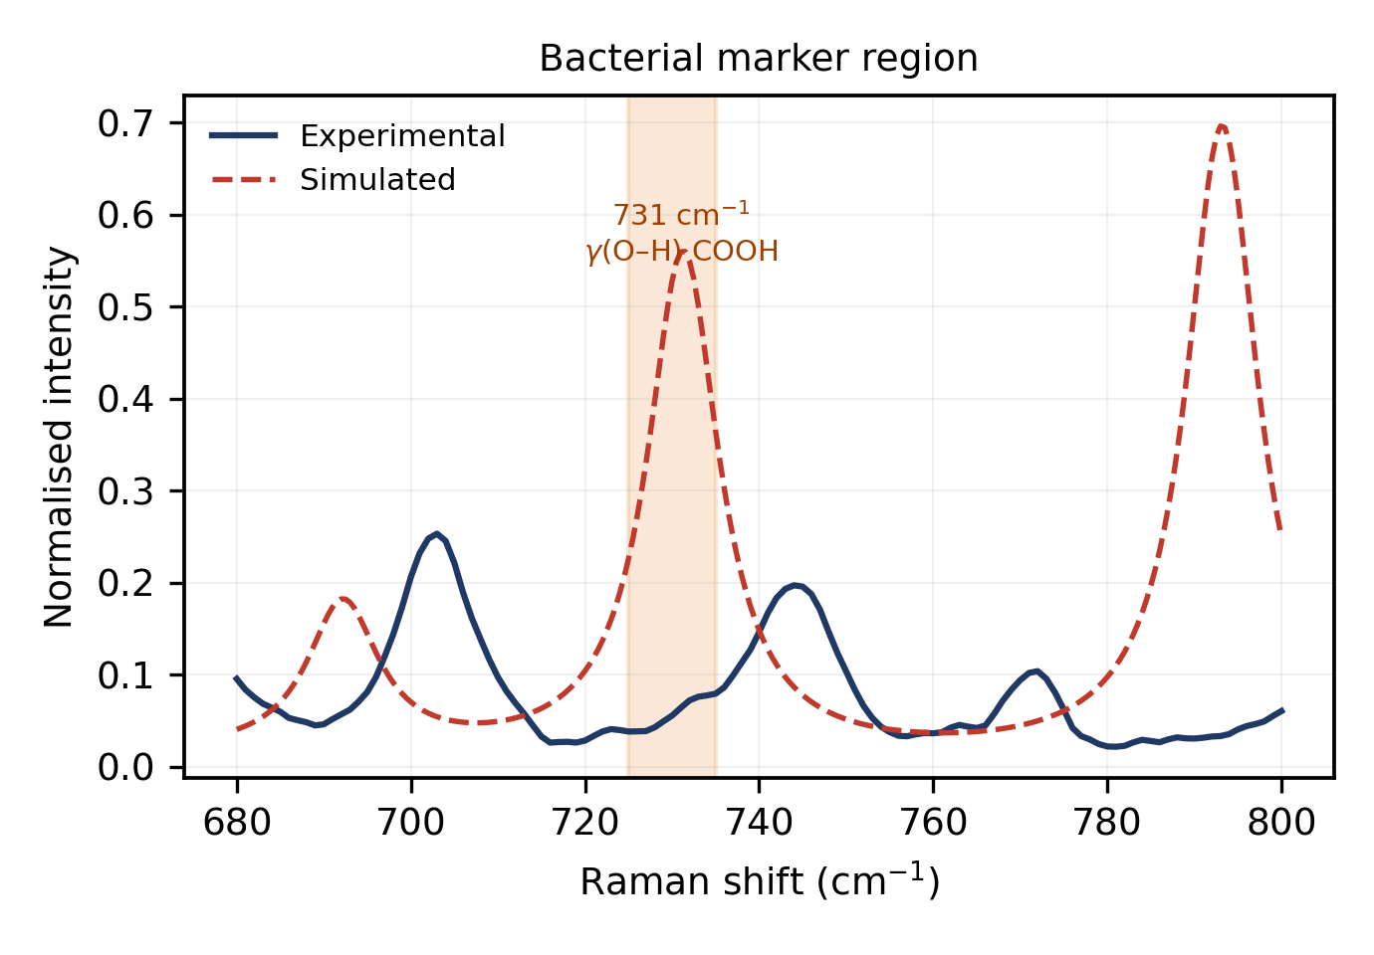
Figure I-5. Detail of the 700–780 cm⁻¹ region, experimental vs. calculated, with the carboxylic-acid O–H wag mode indicated.

I.7 Photostability and laser-damage threshold
Condition | Outcome
≤80% power, ≤25 s | Safe
70% power, 30 s | Safe (r = 0.977 vs. reference)
70% power, 60 s | Safe (r = 0.970)
90% power, 30 s | Safe (r = 0.948); 930 cm⁻¹ band varies < 2% over 10 consecutive same-spot scans
90% power, 60 s | SAMPLE DESTROYED — I(930) falls 0.44 → 0.23 over 5 scans, r drops to 0.06–0.31

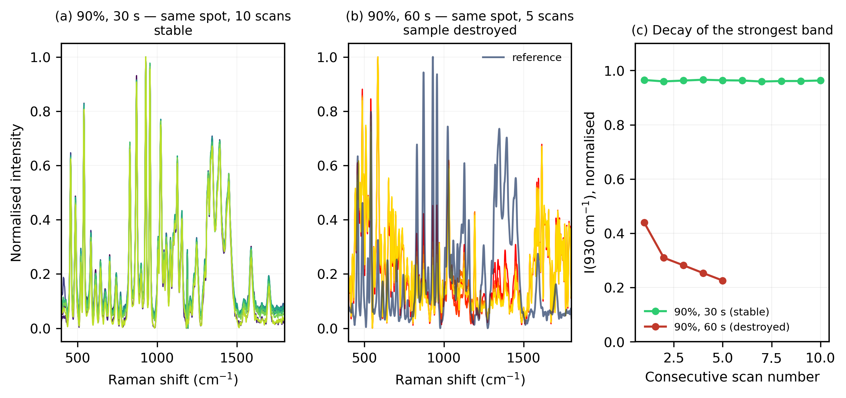
Figure I-6. Photostability series (90%/30 s, stable) and damage series (90%/60 s, decaying), with the 930 cm⁻¹ decay curve.
RESULT — This establishes a clear working envelope for future measurements on NAM-containing samples (including on the SERS substrates in Parts II–III): stay at or below 80% power for extended integration, or below 60 s integration at 90% power, to avoid sample degradation confounding the measurement.

Part II — Sensor 1: Early Ag/Si SERS Substrate
The first-generation sensor was a silicon substrate with silver nanoparticles formed by reduction of AgNO₃ on the surface (referred to here as the Ag/Si substrate). The exact etch time and reagent concentrations used for this particular substrate were not fully captured in the session's Raman metadata and are not restated here; a candidate best condition of 10% HF / 6 minutes etch is referenced in the project's fabrication notes for this period.

II.1 Blank substrate characterisation
Five blank Ag/Si substrate spectra were recorded before analyte deposition, showing a reproducible peak near 520 cm⁻¹ (crystalline silicon phonon) and a flat, low baseline.
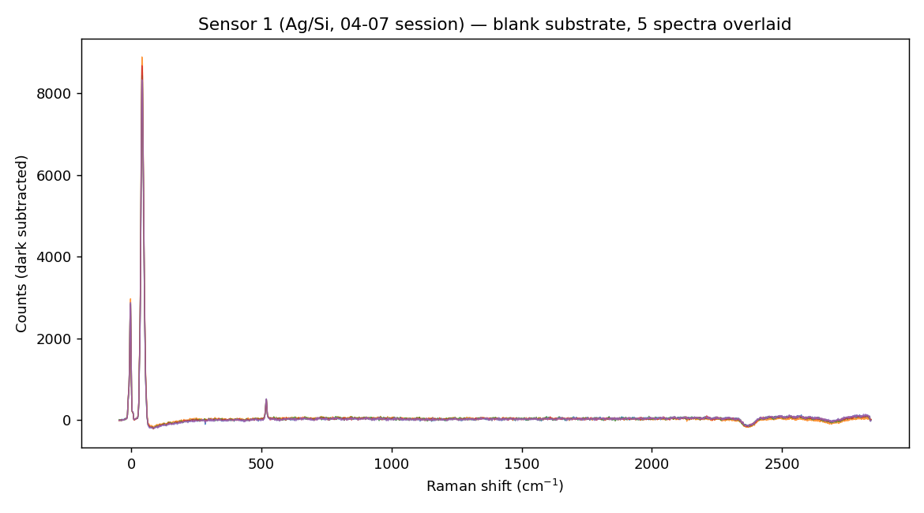
Figure II-1. Sensor 1 — five blank-substrate spectra overlaid.

II.2 R6G validation and concentration response
R6G was measured across a six-point concentration series from 1 nM to 1 mM (2–5 replicates per point). All eight standard R6G bands (612, 774, 1183, 1310, 1360, 1509, 1575, 1650 cm⁻¹) were observed.
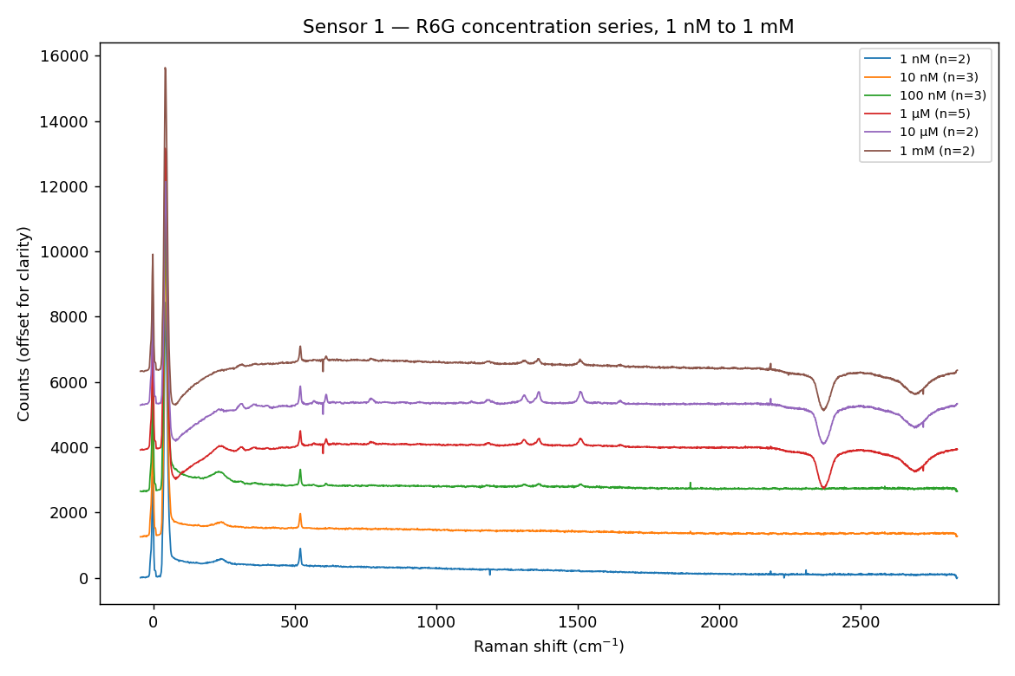
Figure II-2. Sensor 1 — average R6G spectrum at each of the six concentrations tested (offset for clarity).
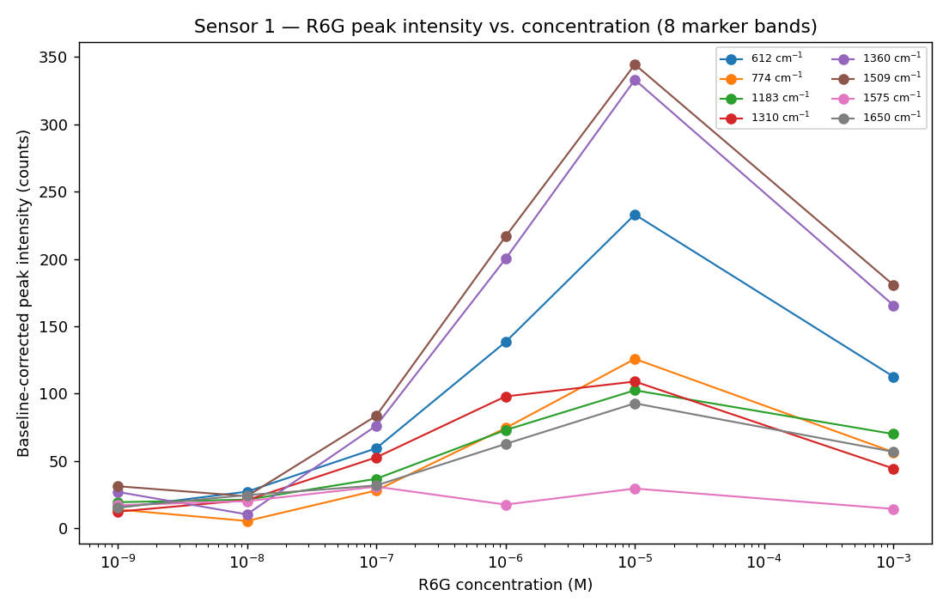
Figure II-3. Sensor 1 — baseline-corrected intensity of all eight R6G marker bands vs. concentration (log scale). Response rises from 1 nM and peaks at 10 µM, then falls at 1 mM.
The response was not monotonic across the full range: intensity increased from 1 nM to a maximum at 10 µM, then decreased at 1 mM. Candidate explanations include multilayer/aggregate formation, saturation of active surface sites, molecules displaced from the strongest electromagnetic hot spots at high loading, and self-absorption/fluorescence quenching effects. The usefully monotonic range on this substrate was therefore approximately 1 nM – 10 µM. R6G was experimentally observed down to 1 nM, though this has not been established as a formal, statistically-derived limit of detection.

II.3 Acquisition-parameter sweep
An additional 39 sequential spectra (the "rawr6g" set) were acquired while varying integration time and accumulation number, to probe acquisition-parameter effects independently of concentration. Signal changed in discrete steps consistent with parameter changes; this set was treated purely as an instrument-optimisation series rather than combined with the concentration data above.
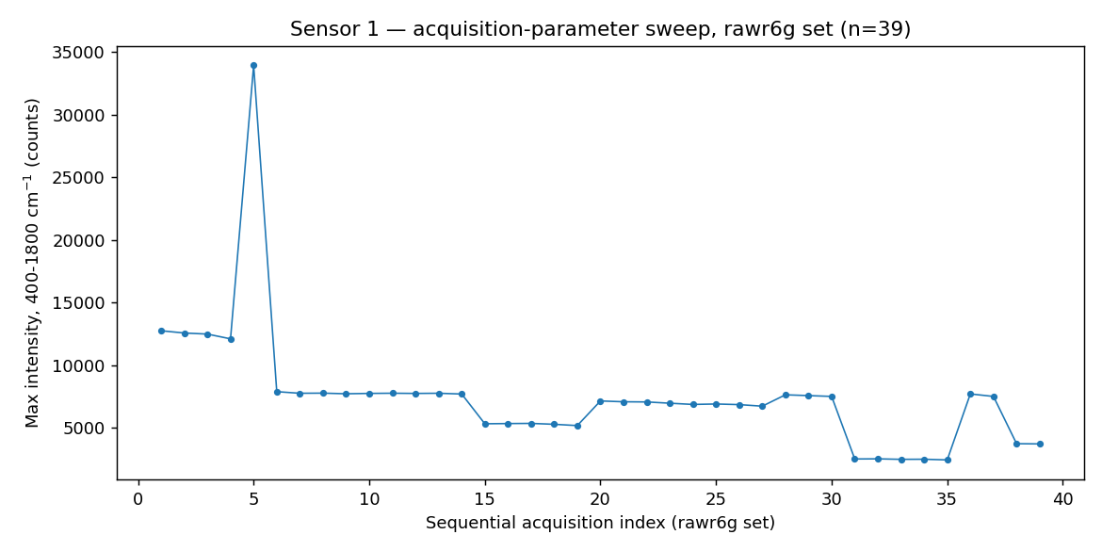
Figure II-4. Sensor 1 — maximum fingerprint-region intensity across 39 sequential acquisitions with varying integration/accumulation settings.

II.4 NAM detection attempt on Sensor 1
Seven NAM spectra were acquired on this substrate: 0.1 mg/mL (0.341 mM, n = 3) and 1 mg/mL (3.410 mM, n = 4), all under identical acquisition settings (10 s × 4 accumulations), directly comparable to each other and to the five blank-substrate spectra.
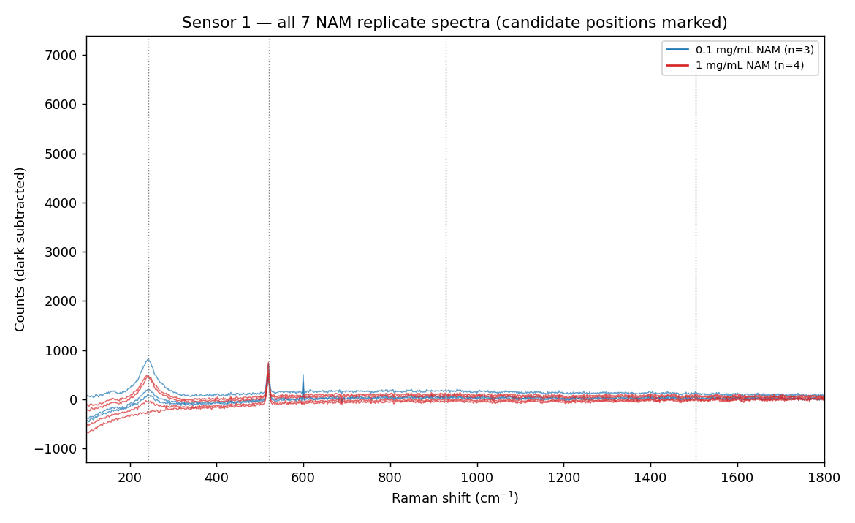
Figure II-5. Sensor 1 — all seven NAM replicate spectra with candidate positions marked.
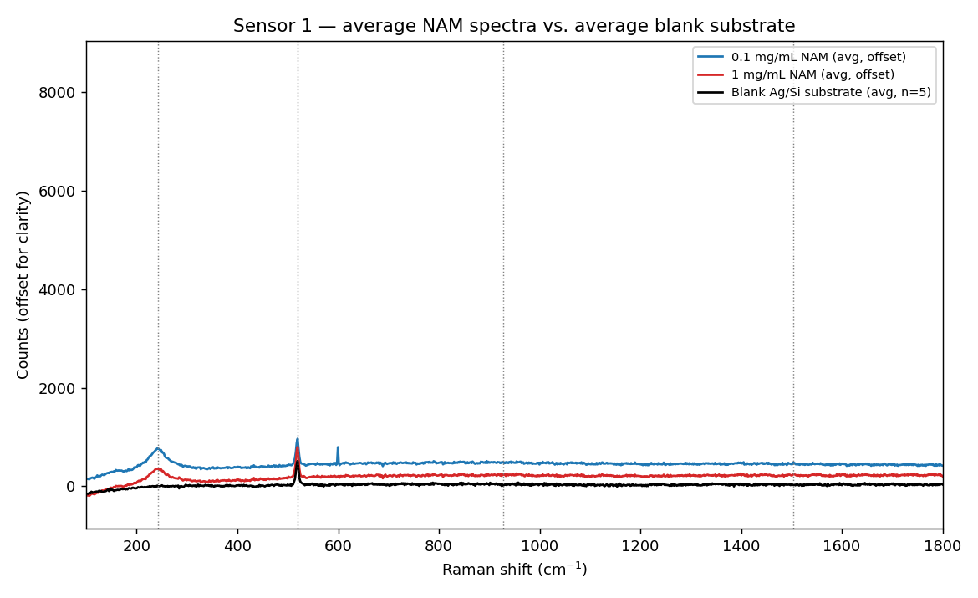
Figure II-6. Sensor 1 — average NAM spectra (both concentrations) vs. average blank substrate.
Candidate feature | Behaviour | Assessment
~243 cm⁻¹ | Present in 7/7 NAM replicates, absent from blank; SNR 5.8–39 | Only reproducible, high-SNR NAM-associated feature found on this substrate. Tentative — no confirmed NAM reference match available at the time of this session (see II.5)
~928 cm⁻¹ | Present above blank in most replicates, SNR ≈ 1.1–3.0 | Weak, at the noise threshold — tentative candidate only, not confirmed
~1504 cm⁻¹ | Present above blank in most replicates, SNR ≈ 1.1–3.0 | Weak, at the noise threshold — tentative candidate only, not confirmed
~520 cm⁻¹ | Present in NAM spectra and equally in the blank | Silicon substrate phonon, not NAM-related
~600 cm⁻¹ | Sharp, narrow, strong in the 0.1 mg/mL batch (SNR 19–23) but weak/absent in the 1 mg/mL batch (SNR 1.0–2.6) despite both being NAM on the same substrate type | Inconsistent between nominally identical sample types and single-pixel narrow — classified as a detector artefact, excluded from the peak list

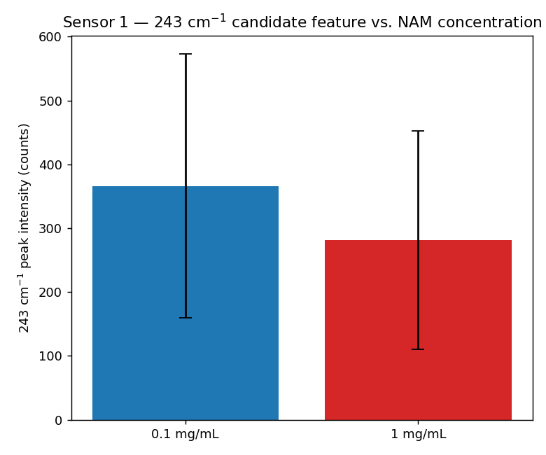
Figure II-7. Sensor 1 — 243 cm⁻¹ candidate feature intensity by NAM concentration (mean ± SD; n = 3 and n = 4). An unpaired t-test gives t = 0.58, p = 0.60 — not statistically distinguishable given the sample size and replicate-to-replicate scatter typical of SERS hot-spot heterogeneity.

II.5 Cross-check against the Part I reference spectrum
The Part I reference spectrum and DFT assignment (established from a later, independent session) covers the 400–1800 cm⁻¹ range only. The 243 cm⁻¹ candidate feature from Sensor 1 falls below this range and cannot be confirmed or excluded against the validated reference spectrum. The 928 and 1504 cm⁻¹ Sensor 1 candidates lie close to the confirmed reference bands at 930 cm⁻¹ (ring breathing, the strongest band in the reference spectrum) and — less closely — the reference set's 1451/1544 cm⁻¹ bands, but were only ever at SNR ≈ 1–3 on Sensor 1 and were not accepted as detections under this project's SNR ≥ 3, reproducibility-across-spots criteria.
NOT CONFIRMED — The ~243 cm⁻¹ feature remains an open question: it is reproducible and well above the noise floor on this substrate, but (a) it lies outside the range covered by the validated isolated-NAM reference spectrum, (b) no independent off-substrate NAM measurement in the 100–400 cm⁻¹ region exists to confirm it is intrinsic to NAM rather than a Ag-surface / charge-transfer mode, and (c) it was not reproduced or re-examined on the second-generation substrate (Part III), which used a 400 cm⁻¹ lower measurement bound. Extending future SERS acquisitions down to ~100 cm⁻¹ would settle this directly.

Part III — Sensor 2: Ag/Black-Silicon MACE Substrates
The second-generation sensor used silver-decorated black-silicon substrates fabricated by one-step metal-assisted chemical etching (MACE), with a defined, documented reagent recipe. This part summarises the etch-time study, NAM detection attempts, the silicon instrument-reference dataset, and an LTA detection attempt carried out on this substrate generation.

III.1 Fabrication
Silicon pieces were cleaned (acetone, 2-propanol, deionised water; 5 min ultrasonic each) and native oxide removed (≈10% HF, 30–60 s) immediately before etching. Substrates were fabricated by one-step MACE: 0.170 g AgNO₃ dissolved in deionised water, 8.6 mL concentrated HF added, made up to 50 mL (≈20 mM AgNO₃, ≈4.8 M HF). Three etch times were investigated at room temperature: 2, 5 and 10 minutes.

III.2 R6G validation across etch times
Etch time | Peak height at 1509 cm⁻¹ (counts) | SNR | Relative to 5-min substrate
2 min | 21,118 | 450 | ≈48×
5 min | 436 | 31 | 1× (reference)
10 min | 3,679 | 220 | ≈8×

The response did not vary monotonically with etch time — the 10-minute substrate outperformed the 5-minute substrate — indicating silver morphology, not etch duration alone, governs enhancement.
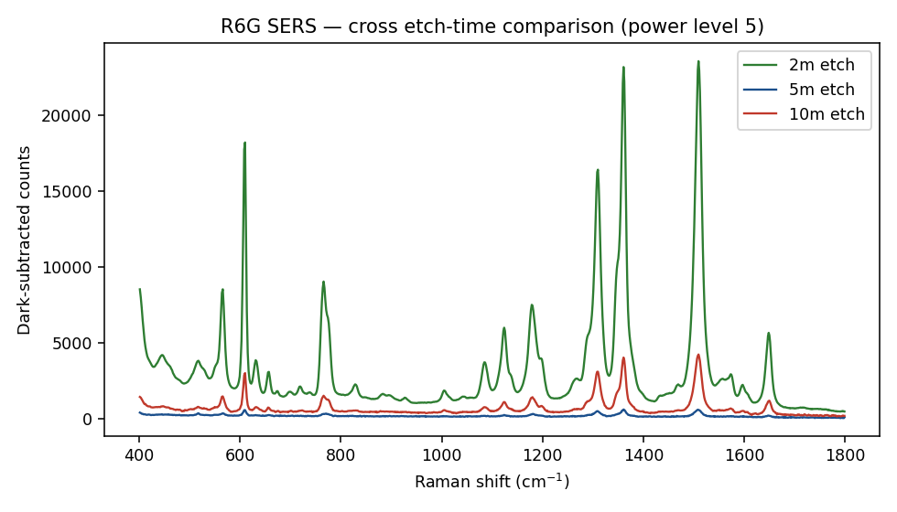
Figure III-1. R6G response compared across all three etch-time substrates.
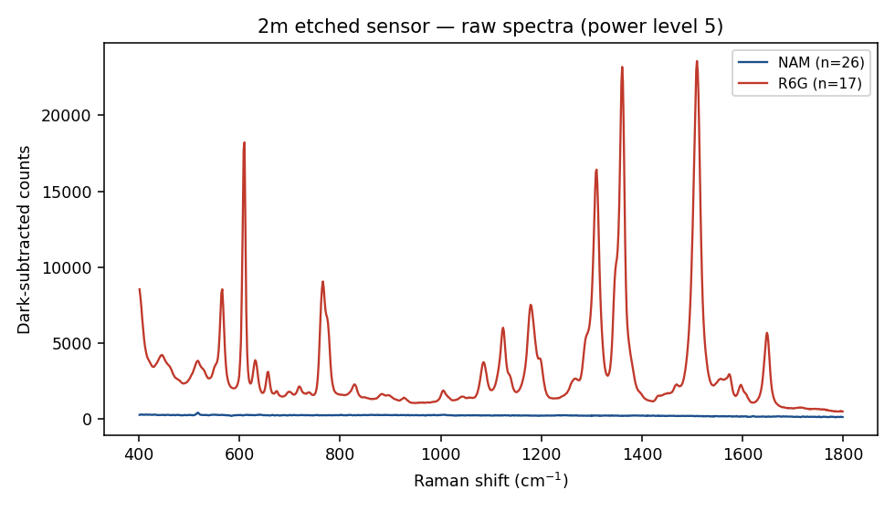
Figure III-2. R6G and NAM spectra overlaid on the 2-minute substrate — the best-performing condition.

III.3 NAM detection attempts
Substrate / power | Highest SNR at any NAM target band | Outcome
2 min, level 5 | 2.4 (541 cm⁻¹) | Not detected
2 min, level 10 | 3.0 (1023 cm⁻¹) | Isolated, not reproduced — not accepted
5 min, level 5 | 2.6 (541 and 1023 cm⁻¹) | Not detected
10 min, level 5 | 3.3 (930 cm⁻¹) | Isolated, not reproduced — not accepted
10 min, level 10 | 2.4 (1347 and 1394 cm⁻¹) | Not detected

Target bands (541, 871, 930, 1023, 1347, 1394 cm⁻¹) were taken from an earlier, less complete version of the Part I reference list; all are confirmed high-confidence bands in the full Part I reference spectrum (542, 872, 930, 1024, 1346, 1395 cm⁻¹ respectively — within the ±5 cm⁻¹ instrument calibration tolerance established in Part III.4). No target band reached SNR ≥ 3 reproducibly on any substrate, power level, or after blank subtraction.
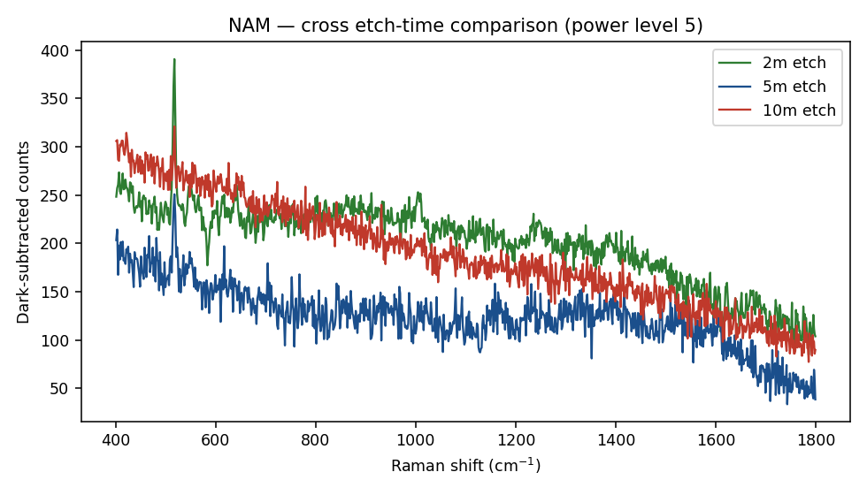
Figure III-3. NAM spectra compared across all three etch-time substrates — no reproducible band at any target position.
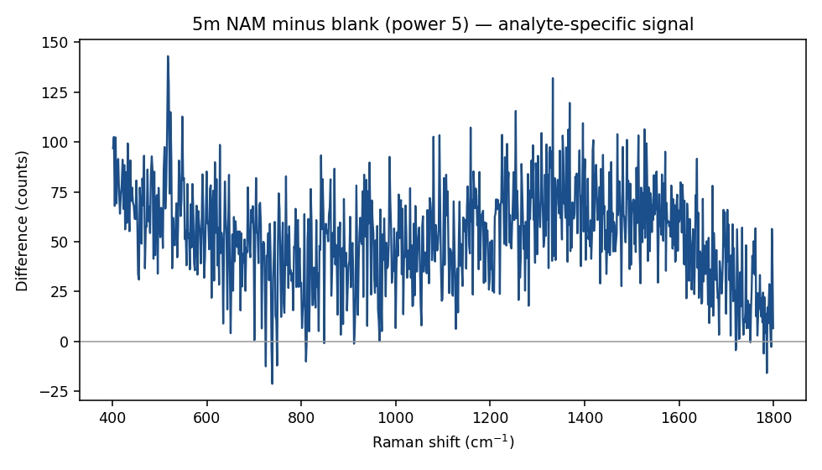
Figure III-4. NAM signal after substrate-blank subtraction, 5-min substrate — no feature exceeds threshold.

III.4 Silicon instrument reference and calibration
A dedicated 45-spectrum dataset on unetched silicon (13 power/integration combinations) confirmed correct, consistent instrument operation and characterised two systematic effects relevant to every measurement in this report:
- Wavenumber offset. The silicon TO phonon band appeared at a fixed 517.8 cm⁻¹ (vs. 520–521 cm⁻¹ literature) across all 13 conditions — a fixed instrument calibration shift. A ±5 cm⁻¹ tolerance is applied throughout this report when matching measured to reference/literature band positions.
- Noise scaling. SNR improved faster than the √t shot-noise law (5.9× for a 5× increase in integration time at one power level), indicating a fixed noise floor rather than pure photon statistics — extended integration is an effective strategy for weak analytes such as NAM.
- Peak width. The TO phonon FWHM (≈7.2 cm⁻¹, ≈4–5 pixels) defines the minimum peak-width criterion used to reject single-pixel detector artefacts (see III.5 and the Sensor-1 600 cm⁻¹ artefact in Part II.4).
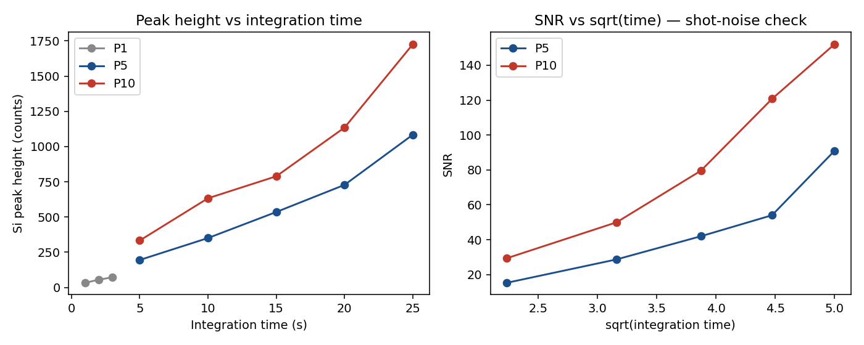
Figure III-5. Peak height vs. integration time (linearity) and SNR-vs-√t comparison, unetched silicon reference.

III.5 LTA detection attempt and pixel-artefact finding
An initial apparent LTA signal (SNR 7–9, 3 of 15 spots) at 1095 cm⁻¹ was found, on pixel-level inspection, to occupy exactly one detector pixel at an identical position across all three candidate spectra — the signature of a fixed-pattern detector artefact rather than a genuine Raman band (which spans 4–5 pixels on this instrument). Reclassified as not detected.
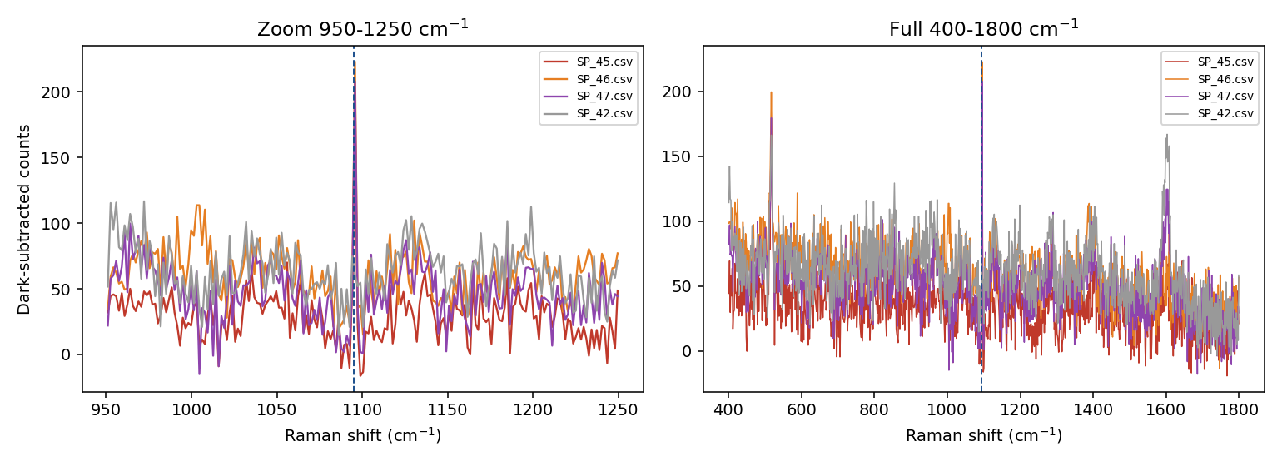
Figure III-6. Pixel-level zoom of the apparent 1095 cm⁻¹ LTA feature, showing the single-pixel origin.

Part IV — Sensor Types Tried: Comparison
 | Sensor 1 (Ag/Si) | Sensor 2 (Ag/black-Si, MACE)
Fabrication method | AgNO₃ reduction on Si; exact etch/reagent parameters not fully documented for this batch | One-step MACE, documented recipe: 0.170 g AgNO₃ + 8.6 mL HF in 50 mL (≈20 mM AgNO₃, ≈4.8 M HF)
Etch/process variable studied | Not systematically varied in the analysed dataset (candidate best condition noted as 10% HF / 6 min) | 2, 5, 10 min etch time, systematically compared
R6G validation | Concentration series 1 nM–1 mM; non-monotonic, peak at 10 µM | Etch-time series; non-monotonic, best at 2 min (SNR 450)
Best R6G SNR observed | ≈345 (1509 cm⁻¹, 10 µM) | 450 (1509 cm⁻¹, 2-min substrate)
NAM result | One reproducible tentative feature (~243 cm⁻¹, SNR 5.8–39), not statistically concentration-dependent, not cross-checked against a validated reference (didn't exist yet) | No reproducible detection at any of 6 validated reference target bands, any substrate, or power level
Blank/instrument control | 5 blank substrate spectra only | Full 45-spectrum, 13-condition unetched-Si instrument reference dataset
Artefact found | ~600 cm⁻¹ single-pixel spike, inconsistent between NAM batches — excluded | ~1095 cm⁻¹ single-pixel spike in LTA data — excluded
Status | Superseded — informs but is not the current working substrate | Current working substrate; basis for the Part VI forward plan

Part V — Consolidated Analysis: Status of NAM Detection

V.1 Why NAM is an intrinsically difficult SERS analyte
The Part I reference/DFT study makes it possible to state this quantitatively rather than qualitatively. NAM is a pyranose amino-sugar acid with no chromophore absorbing near 785 nm (no resonance enhancement available), no thiol or free amine for direct Ag affinity (the nitrogen is blocked as an amide), and calculated Raman activities for its strongest modes (e.g. 3.6 for the 930 cm⁻¹ ring-breathing mode) that are modest compared with a strong Raman/SERS reporter such as R6G. This is consistent with, and now quantitatively supports, the qualitative assessment reached independently in both sensor generations.

V.2 Ranked assessment of causes
Rank | Candidate cause | Assessment
1 | Weak/absent silver affinity and non-resonant, modest-cross-section Raman response of NAM (Part I) | Most probable primary cause, now supported by DFT-computed Raman activities, not just qualitative structure comparison
2 | Droplet spreading on the hydrophilic black-silicon surface (Sensor 2) reducing effective concentration in the measured region | Likely contributing factor, unlikely to be the sole cause
3 | Unconfirmed ~243 cm⁻¹ Sensor-1 feature — possible Ag-surface/charge-transfer mode outside the validated reference range, not yet re-tested on Sensor 2 | Open question — requires extending Sensor-2 acquisition range below 400 cm⁻¹
4 | Bulk NAM concentration too low | Unlikely — concentrations tested (0.34–3.4 mM) are high by SERS standards
5 | Substrate not SERS-active | Excluded on both sensor generations — R6G control confirms strong activity on each
6 | Instrument miscalibration or malfunction | Excluded — silicon reference dataset (Part III.4) and glass-blank series (Part I) confirm correct, consistent operation

Part VI — Proposed Future Work: 4-MPBA Surface Functionalisation
Since R6G validation has already demonstrated that both sensor generations can produce strong SERS enhancement, the open problem is no longer "can the substrate produce SERS?" but "how can NAM be brought into the SERS-active region of the substrate in a controlled, reproducible manner?" The proposed approach is to introduce a molecular recognition layer between the Ag surface and NAM.

VI.1 Proposed architecture
Black silicon → Ag nanostructures → 4-mercaptophenylboronic acid (4-MPBA) recognition layer → NAM → SERS detection. 4-MPBA offers a thiol group (–SH) for strong, well-established anchoring to Ag surfaces, and a boronic-acid group (–B(OH)₂) at the opposite end that can interact with diol/hydroxyl-containing carbohydrates such as NAM. This dual functionality — Ag anchoring plus candidate carbohydrate recognition — is why 4-MPBA is proposed rather than a simpler thiol linker.
CAUTION — Boronic-acid chemistry is not inherently NAM-specific — other carbohydrates and amino sugars can also interact with boronic-acid groups, and MPBA surface orientation/chemistry is known to be pH-dependent. This is a candidate recognition chemistry requiring experimental validation, not an established NAM-specific method.

VI.2 Literature basis
Study | System | Relevance
Li et al., 2015, Phys. Chem. Chem. Phys. 17, 17638 (DOI 10.1039/C5CP02409A) | 4-MPBA on assembled Ag nanoparticles, D-glucose | Directly demonstrates 4-MPBA + Ag + carbohydrate + SERS; shows MPBA orientation/chemical state depends strongly on pH
Pham et al., 2017, BioChip J. 11, 46 (DOI 10.1007/s13206-016-1107-6) | 4-MPBA-incorporated Ag nanoparticles on silica-coated graphene oxide, glucose | Methodological precedent for MPBA-functionalised Ag SERS substrates
Pham et al., 2021, Nanomaterials 11, 948 (DOI 10.3390/nano11040948) | 4-MPBA-immobilised Au–Ag core–shell silica nanostructure, glucose | Quantitative, selective glucose detection via MPBA-functionalised bimetallic SERS
Gao et al., 2021, ACS Appl. Nano Mater. (DOI 10.1021/acsanm.1c02216) | Graphene oxide + Ag nanoparticles + 4-MPBA, cerebrospinal-fluid glucose | Extends MPBA-based SERS to a biological-fluid sensing context
Sun et al., 2016, RSC Adv. 6, 53800 (DOI 10.1039/C6RA06223G) | 4-MPBA-decorated Ag nanoparticles, urinary glucose | Further support for combining MPBA recognition with Ag SERS enhancement

None of these studies establish 4-MPBA as a NAM-specific receptor on an Ag/black-silicon substrate — this is the identified research gap this project's next stage addresses.

VI.3 Proposed experimental sequence
- Reproduce the best-performing Ag/black-silicon substrate condition identified so far (Part III.2) as the starting point — recognising NAM may interact differently with the surface than R6G did.
- Characterise the bare substrate physically (SEM, EDS, AFM where available, UV-Vis) to obtain morphological evidence — Ag distribution, coverage, nanostructure geometry — explaining the optical SERS behaviour already measured.
- Re-establish direct (non-functionalised) NAM detection on this specific substrate batch as the baseline, using the validated Part I reference band list, before adding any surface chemistry.
- Functionalise with 4-MPBA (concentration, incubation time, solvent, pH and washing to be optimised experimentally rather than copied from the glucose literature) and verify functionalisation directly — bare Ag/black-Si vs. MPBA-functionalised substrate — before introducing NAM at all, so that substrate failure, functionalisation failure and NAM-binding failure remain distinguishable.
- Optimise MPBA surface coverage using a small concentration matrix, seeking a thin recognition layer (strong, reproducible MPBA SERS signal without suppressing the underlying Ag activity) rather than a thick organic layer that would push NAM out of the enhancement zone.
- Run the NAM-binding experiment: compare NAM response with and without the MPBA layer, looking for both direct NAM Raman bands and MPBA-band perturbation as two complementary detection strategies.
- Extend the acquisition range below 400 cm⁻¹ on the black-silicon substrate to directly test whether the unresolved Sensor-1 ~243 cm⁻¹ feature (Part II.5) reappears.
Completing this sequence for NAM, then repeating Part I–III for LPS and LTA to the same standard, would complete proposal Phase 1 in full and provide the validated spectral library and optimised chip (Deliverables a–b) needed before Phase 2 (cultured clinical isolates) can begin.

Conclusions
- A validated, DFT-confirmed reference Raman spectrum of isolated NAM has been established (41 bands, 30 matched to calculated normal modes, r = 0.9996), independent of any SERS substrate. This reference underlies the target band list used to evaluate every SERS detection attempt in this report.
- The calculated 731 cm⁻¹ mode is shown to be dominated by carboxylic-acid O–H out-of-plane deformation rather than pyranose-ring motion, arguing against assigning the widely-used bacterial ~730 cm⁻¹ SERS marker band to muramic acid.
- Two generations of Ag-based SERS substrate have been fabricated and validated using R6G, both showing strong, non-monotonic concentration/etch-time-dependent enhancement (best SNR 345 and 450 respectively).
- Sensor 1 showed one reproducible, tentative NAM-associated feature (~243 cm⁻¹) that could not be cross-checked against the reference spectrum (out of range) and was not re-examined on Sensor 2.
- Sensor 2, evaluated against the full validated reference band list under rigorous SNR and reproducibility criteria, did not reproducibly detect NAM under any tested condition.
- A full instrument-reference dataset on unetched silicon and a related LTA detection attempt (which uncovered and corrected a single-pixel detector-artefact failure mode) confirm that both sensor generations and the measurement/analysis pipeline are functioning correctly — the NAM null result is attributable to the molecule's intrinsic SERS properties and to methodological gaps (droplet control, unconfirmed low-wavenumber region), not to instrument or substrate failure.
- A 4-MPBA surface-functionalisation strategy, grounded in five independent literature precedents for MPBA/Ag carbohydrate SERS, is proposed as the next stage, with an explicit experimental sequence designed to keep substrate, functionalisation and binding failure modes distinguishable.
- Against the parent proposal, this work represents substantive progress on Objective (a) and Phase 1 for one biomarker (NAM) and on the chip-development strand of Objective (b), but Objectives (c) AI analysis, (d) clinical validation and (e) prototype development, and Phases 2–5, remain entirely unstarted and outside the scope of this report (see the Alignment section).

