NAM Raman–DFT Peak-Matching: Evidence Audit
Reproducibility and statistical validation of the “51 matched peaks” claim — prepared for PI supervision meeting
____________________________________________________________

Sukesh P | M24IM1007 | M.Tech Joint IDRP, IIT Jodhpur & AIIMS Jodhpur | Supervisor: Prof. Ajay Agarwal
Companion evidence files: table_full_correspondence_41peaks.csv, table_montecarlo.csv, table_one2one_vs_nearest.csv, table_tolerance_sensitivity.csv, table_fingerprint_candidates.csv, FigA/FigB/FigC (this folder)

A. Executive Summary
This document answers one question directly: is the claim “51 NAM Raman peaks matched the DFT-simulated spectrum” reproducible from the project's own data, and if not, what is the honest, defensible number?
KEY — The 51-peak claim is NOT reproducible from any script, raw data file, or documented methodology available in the project archive. It traces to a single unsupported sentence in the thesis text and one figure (Figure 4.9) whose underlying computation cannot be located anywhere.

- Where 51 comes from. A bare sentence in the 49-page thesis (“A total of 51 Raman peaks were matched…”) and Figure 4.9, whose results box states Matched Peaks: 51, RMSE: 2.12 cm⁻¹, Mean Error: 0.38 cm⁻¹, Tolerance: ±10 cm⁻¹. No script, table, or raw file producing these numbers exists in any connected folder.
- Why it looks wrong visually. The “simulated (DFT)” curve drawn in Figure 4.9 is a flat, constant-height line with number labels stuck on top of it — not a real Lorentzian/Gaussian-broadened spectrum. There is no real theoretical lineshape in that figure to visually agree or disagree with, which is very likely the direct cause of Sir's observation that the peaks “visually are not matching.”
- What the real data supports. The project's fully documented dataset (NAM_Raman_Archive) has 41 quality-controlled experimental bands and 111 real Gaussian16 DFT normal modes (67 in the 400–1800 cm⁻¹ fingerprint window). Independently matching these gives 33/41 (80%) at the archive's own justified tolerance (±18 cm⁻¹) or 29/41 (71%) at ±10 cm⁻¹ — never 51, and not 49 either.
- Is that statistically meaningful? No, not on its own. A randomisation test shows the real match count is not distinguishable from matching against randomly positioned peaks of the same density, at any tolerance tested (p = 0.11–0.72). Proximity alone is not evidence of a real vibrational correspondence here — the calculated modes are simply too dense relative to the tolerance.
- What is defensible. 8 NAM bands (458, 585, 646, 872, 930, 1157, 1190, 1346 cm⁻¹) have exactly one candidate DFT mode within ±10 cm⁻¹, small residuals (≤6 cm⁻¹), and high confidence experimental detection. This is the recommended NAM fingerprint going forward.
- SERS status (separate question). NAM has not been reproducibly detected by SERS on either sensor generation tested. This is independent of the pure-Raman/DFT question above and should be presented as such.

B. The Original ‘51-Peak’ Claim — Investigation

B.1 Exact source located
Two, and only two, places in the entire project file set contain the number 51 in this context:
- sukesh-m24im1007-report.docx (the 49-page thesis, and the identical uploaded PDF), section 4.x, verbatim: “A total of 51 Raman peaks were matched between the experimental and simulated spectra, indicating excellent agreement.” No table, no tolerance value, no scaling factor, and no formula appears anywhere near this sentence — the surrounding text states only that “a standard scaling factor (0.96–0.97 range)” was applied generically, across NAM, LTA and LPS fragment calculations alike, with no molecule-specific justification given.
- Figure 4.9 (“Peak matching and error analysis between experimental and simulated NAM spectra”), the figure this sentence refers to. Its results box explicitly states: Matched Peaks 51, RMSE 2.12 cm⁻¹, Mean Error 0.38 cm⁻¹, Tolerance ±10 cm⁻¹. This is the only place these four numbers appear together anywhere in the project.

B.2 What could not be found (DATA NOT AVAILABLE)
CAUTION — The following, specifically requested for this audit, do not exist in any connected folder or in the uploaded files for this session: simdata.xlsx, sec-25_power-80_i-2.xlsx, any Python/MATLAB script that produced Figure 4.9, and any raw peak-matching table with 51 (or 49) rows. This is stated plainly rather than assumed — DATA NOT AVAILABLE.

Because the generating script cannot be found, the exact peak-detection parameters (find_peaks height/prominence/distance), the exact DFT candidate list (“364 candidates, 207.36–2995.20 cm⁻¹” as described), and the exact scaling implementation used for Figure 4.9 cannot be independently confirmed. What follows is what CAN be checked against real project data.

B.3 Cross-check against the only real NAM DFT dataset in the project
Check | Described for the 51-claim | What the real archive DFT file actually contains
DFT candidate count | 364 candidates | 111 total normal modes (Gaussian 16, B3LYP-D3BJ/6-311++G(d,p)); 89 modes fall in the 200–3000 cm⁻¹ range shown on Figure 4.9's axis; only 67 fall in the 400–1800 cm⁻¹ fingerprint window actually covered by the experimental reference spectrum
Candidate frequency range | 207.36–2995.20 cm⁻¹ | 34.1–3726.2 cm⁻¹ (scaled); the experimental data itself only covers 400–1800 cm⁻¹ (glass slide / no C–H stretch region), so a genuine match above ~1800 cm⁻¹ or below 400 cm⁻¹ is not verifiable against experiment at all
Simulated curve shape | Not stated | In Figure 4.9 the red “simulated” trace is a flat horizontal line at constant height — inconsistent with a genuine Raman-activity-weighted, Lorentzian-broadened spectrum (compare Fig. A on page below, generated directly from the archive's real broadened spectrum file)
Scaling factor | 0.96, single value, stated exactly | Archive uses a two-region scheme: ×0.980 below 1800 cm⁻¹, ×0.967 above (“Ma et al. scheme,” per the archive's own methodology note) — not a single flat 0.96
Matched count at the same tolerance (±10 cm⁻¹) | 51 (or, per the user's own re-run attempt, 49) | 29 of 41 real experimental peaks (archive scaling); 24 of 41 with a literal flat 0.96 factor applied to all 111 modes — see Section G

B.4 Direct answers to the sub-questions posed
# | Question | Answer
A | How were the original 51 matches generated? | Unknown — no script located. Only the output (a results box in one figure) survives.
B | Can 51 be reproduced from current source data? | No, under any tested tolerance/scaling combination (Section G).
C | Why does the current dataset give 49 rather than 51? | The archive's documented, QC'd experimental peak list contains 41 bands, not 49. A looser peak-finder (no SNR gate, no cross-replicate reproducibility requirement) run on a single raw spectrum file can plausibly surface more candidate peaks than the vetted 41 — including noise-driven ones — but the specific file that produced 49 (sec-25_power-80_i-2.xlsx) is not available to confirm this directly. DATA NOT AVAILABLE for a literal reproduction of ‘49’.
D | Is the stored 51-row table stale / from a different processing version? | There is no stored 51-row table anywhere in the project — only the number itself, in text and in one figure's summary box.
E | Which exact experimental spectrum was used for the original 51? | DATA NOT AVAILABLE — not stated in the thesis text, and no corresponding file survives.
F | Which peak-detection parameters were used? | DATA NOT AVAILABLE for the original 51. (The 41-peak archive list instead uses a documented two-criterion SNR test — Section F.)
G | Which DFT file/version was used? | DATA NOT AVAILABLE to confirm for Figure 4.9 specifically. Three different NAM DFT runs exist across the project (Gaussian 09 B3LYP/6-311+G(d,p); Gaussian 16 B3LYP-D3BJ/6-311++G(d,p), the archive's authoritative version; and a third B3LYP/6-31+G(d,p) run) — which one fed Figure 4.9 is not stated.
H | Was 0.96 applied before matching? | Stated in text as a generic “0.96–0.97 range” description, not confirmed as the exact factor used for Figure 4.9's calculation.
I | Was ±10 cm⁻¹ applied to absolute differences? | Stated in the figure's box as the tolerance; the underlying comparison logic cannot be independently verified without the script.
J | Were duplicate/many-to-one assignments possible? | Cannot be determined for the original 51 (no table survives). For the real, independently-reproduced 41-peak dataset, many-to-one reuse does occur — see Section J.
K | Are the 51 rows actually 51 unique experimental peaks? | Cannot be verified — no row-level table exists.
L | Can every row be traced back to the current experimental spectrum? | No — there is no row-level table to trace.

RESULT — Definitive conclusion: 51 is not reproducible. It is not supported by any script, raw table, or documented method in the project. The one figure that reports it (Figure 4.9) shows visual evidence of not being a genuine simulated-spectrum plot. The honest, source-traceable number, computed fresh in this audit from the project's real archived data, is 33 of 41 experimental peaks matched at a defensible ±18 cm⁻¹ tolerance (Section D–G) — and even that count is not statistically distinguishable from chance (Section L / Fig. C).

C–D. Reproducing the Current Analysis From Real Source Data
This section follows the documented methodology literally, using only real files: the archive's quality-controlled experimental peak list (41 bands) and the real Gaussian16 DFT calculation (111 modes).
Item | Value | Source file
Experimental file | Experimental_peak_list.csv (41 QC'd bands, mean of 22 replicate spectra) | NAM_Raman_Archive/03_Processed_Results/
Number of detected experimental peaks | 41 | same
DFT file | NAM_calculated_modes_all_111.csv (parsed from the Gaussian16 .log) | NAM_Raman_Archive/02_DFT_Calculation/
Number of DFT candidate modes | 111 total; 67 in the 400–1800 cm⁻¹ window that the experimental data actually covers | same
Raman-shift range covered by experiment | 400–1800 cm⁻¹ (no C–H/O–H stretch region; glass-slide powder measurement) | 00_READ_ME_FIRST.md
Scaling factor (archive's own, documented) | ×0.980 below 1800 cm⁻¹, ×0.967 above | ANALYSIS_PROTOCOL.md
Matching tolerance (archive's own, documented and justified) | ±18 cm⁻¹ — chosen because a narrow window silently drops disagreeing bands rather than counting them as failures (see Section F) | ANALYSIS_PROTOCOL.md
Matches at ±18 cm⁻¹ (nearest-neighbour, independently reproduced this session) | 33 of 41 (80%) | computed fresh, this audit
Matches at ±18 cm⁻¹ (one-to-one, Hungarian assignment) | 30 of 41 (73%) | computed fresh, this audit
Unmatched experimental peaks (±18 cm⁻¹) | 8: 772, 831, 956, 1590, 1633, 1652, 1700, 1792 cm⁻¹ | computed fresh, this audit
Unique DFT modes used (nearest-neighbour, ±18) | 30 of 33 matches — 2 modes are each reused by more than one experimental peak (Section J) | computed fresh, this audit

CAUTION — Internal discrepancy in the archive itself (reported, not silently corrected): the pre-computed file 03_Processed_Results/Experimental_vs_DFT_comparison.csv reports 33/41 matched, while the later, more rigorous 06_Analysis_Notebook/tables/analysis_summary.json — which selects the highest-Raman-activity mode within the window rather than the nearest one — reports 30/41 matched (MAE 9.3 cm⁻¹, RMSE 10.3 cm⁻¹). Both numbers are real and traceable; they differ because they use different tie-breaking rules for which candidate mode a peak is assigned to. Neither is 51, and neither is 49.

The one-to-one (Hungarian) assignment computed independently in this audit also gives 30 — suggesting the notebook's “highest activity” rule and a full one-to-one optimisation converge on essentially the same, more conservative count, while the looser nearest-neighbour rule (which allows one DFT mode to “catch” more than one experimental peak) inflates the count to 33.

E. Complete Peak Correspondence Table
All 41 experimental bands, each matched to its nearest calculated mode (archive scaling, ×0.980/×0.967), with match status shown at every tested tolerance. Full machine-readable version: table_full_correspondence_41peaks.csv.
Exp (cm⁻¹) | Nearest DFT (cm⁻¹) | Δ (cm⁻¹) | Match ±10 | Match ±18 | Confidence | DFT assignment
458.0 | 460.5 | +2.5 | Yes | Yes | high | Skeletal bending / ring torsion
488.0 | 494.2 | +6.2 | Yes | Yes | high | Skeletal bending / ring torsion
523.0 | 513.4 | -9.6 | Yes | Yes | high | Skeletal bending / ring torsion
542.0 | 555.6 | +13.6 | No | Yes | high | Skeletal bending / ring torsion
585.0 | 582.1 | -2.9 | Yes | Yes | high | Skeletal bending / ring torsion
616.0 | 619.4 | +3.4 | Yes | Yes | high | Skeletal deformation + δ(C–C–O)
646.0 | 640.1 | -5.9 | Yes | Yes | high | Skeletal deformation + δ(C–C–O)
677.0 | 692.2 | +15.2 | No | Yes | high | Skeletal deformation + δ(C–C–O)
704.0 | 692.2 | -11.8 | No | Yes | high | Skeletal deformation + δ(C–C–O)
745.0 | 731.3 | -13.7 | No | Yes | high | γ(O–H) carboxylic acid out-of-plane
772.0 | 793.2 | +21.2 | No | No | high | Skeletal deformation + δ(C–C–O)
831.0 | 793.2 | -37.8 | No | No | high | Skeletal deformation + δ(C–C–O)
872.0 | 873.0 | +1.0 | Yes | Yes | high | γ(CH₂) hydroxymethyl wagging
930.0 | 926.7 | -3.3 | Yes | Yes | high | Ring breathing / ν(C–C–O)
956.0 | 979.5 | +23.5 | No | No | high | Ring breathing / ν(C–C–O)
1008.0 | 1006.2 | -1.8 | Yes | Yes | tentative | ν(C–O)/ν(C–C) pyranose ring
1024.0 | 1021.5 | -2.5 | Yes | Yes | high | ν(C–O) + δ(C–O–H)
1044.0 | 1042.2 | -1.8 | Yes | Yes | tentative | ν(C–O) + δ(C–O–H)
1059.0 | 1054.8 | -4.2 | Yes | Yes | high | ν(C–O) + δ(C–O–H)
1085.0 | 1079.8 | -5.2 | Yes | Yes | tentative | ν(C–O) + δ(C–O–H)
1113.0 | 1116.6 | +3.6 | Yes | Yes | tentative | ν(C–O) + δ(C–O–H)
1128.0 | 1124.6 | -3.4 | Yes | Yes | high | ν(C–O) + δ(C–O–H)
1157.0 | 1156.2 | -0.8 | Yes | Yes | high | ν(C–O) + δ(C–O–H)
1190.0 | 1192.1 | +2.1 | Yes | Yes | high | ν(C–O) + δ(C–O–H)
1208.0 | 1208.2 | +0.2 | Yes | Yes | tentative | δ(C–H) + ν(C–O) coupled
1249.0 | 1242.3 | -6.7 | Yes | Yes | high | δ(C–H) + ν(C–O) coupled
1300.0 | 1306.2 | +6.2 | Yes | Yes | tentative | δ(C–H) + ν(C–O) coupled
1321.0 | 1324.8 | +3.8 | Yes | Yes | high | δ(C–H) + ν(C–O) coupled
1346.0 | 1345.7 | -0.3 | Yes | Yes | high | δ(C–H) / δs(CH₃) umbrella
1395.0 | 1387.6 | -7.4 | Yes | Yes | high | δ(C–H) / δs(CH₃) umbrella
1451.0 | 1443.9 | -7.1 | Yes | Yes | high | δ(CH₂) scissoring / δas(CH₃)
1544.0 | 1535.2 | -8.8 | Yes | Yes | high | Amide II: δ(N–H) + ν(C–N)
1590.0 | 1535.2 | -54.8 | No | No | high | Amide II: δ(N–H) + ν(C–N)
1633.0 | 1722.8 | +89.8 | No | No | tentative | Amide I: ν(C=O)
1652.0 | 1722.8 | +70.8 | No | No | tentative | Amide I: ν(C=O)
1700.0 | 1722.8 | +22.8 | No | No | high | Amide I: ν(C=O)
1726.0 | 1722.8 | -3.2 | Yes | Yes | tentative | Amide I: ν(C=O)
1751.0 | 1759.2 | +8.2 | Yes | Yes | tentative | ν(C=O) carboxylic acid
1758.0 | 1759.2 | +1.2 | Yes | Yes | tentative | ν(C=O) carboxylic acid
1768.0 | 1759.2 | -8.8 | Yes | Yes | high | ν(C=O) carboxylic acid
1792.0 | 1759.2 | -32.8 | No | No | tentative | ν(C=O) carboxylic acid

F. Matching Methodology — Explained Simply

F.1 The formula, symbol by symbol
As described, the matching rule that produced the 51/RMSE-2.12/tolerance-±10 result was:
FORMULA — match count = Σᵢ 1[ minⱼ |Eᵢ − 0.96·Xⱼ| ≤ 10 ]

- Eᵢ — the position (cm⁻¹) of the i-th experimental Raman peak.
- Xⱼ — the position (cm⁻¹) of the j-th DFT-calculated vibrational mode, before scaling.
- 0.96 — a single flat scaling factor applied to every calculated frequency, meant to correct for DFT's well-known tendency to over-estimate harmonic frequencies.
- minⱼ — for each experimental peak, look across every scaled DFT mode and keep only the closest one.
- ±10 cm⁻¹ — the tolerance window: if that closest DFT mode is within 10 cm⁻¹, the peak counts as matched.
- 1[ … ] — the indicator function — it contributes exactly 1 to the sum if the bracketed condition is true, 0 otherwise.
- Σᵢ — add up 1 for every experimental peak that found a close-enough DFT mode; the total is the reported “match count.”
In plain language: “For each experimental peak, the algorithm searches all scaled DFT peaks and asks whether at least one theoretical peak lies within 10 cm⁻¹. If yes, that experimental peak is counted as a match.” This is exactly what was implemented independently in this audit (Section D), just with the archive's own two-region scaling instead of an unverified flat 0.96.

F.2 What this method proves — and what it does not
It DOES prove… | It does NOT prove…
A numerical proximity under the chosen tolerance — the two numbers are close on a cm⁻¹ scale. | That the two peaks arise from the same molecular vibration. Proximity is necessary but not sufficient.
That, given the candidate density, an assignment could in principle be made. | Chemical identity, or that the experimental band is genuinely produced by NAM and not by an impurity, overtone, or the substrate.
A count that can be compared across tolerances to see how sensitive it is. | Statistical significance. A high match count can occur by chance alone if DFT modes are dense relative to the tolerance (Section L).
Nothing about intensity by itself. | That calculated Raman activity and observed intensity agree — intensity has to be checked separately (Section K), and here it does not (r = −0.28, not significant).
 | That the match is unique — nearby modes can each independently claim the same peak, or one mode can claim several peaks (Section J).

CAUTION — The single biggest reason a large match count can be misleading here: 67 calculated modes are packed into a 1400 cm⁻¹ window — one mode roughly every 20.9 cm⁻¹ on average. A ±10 cm⁻¹ tolerance is comparable to half that spacing, and an ±18 cm⁻¹ tolerance is comparable to the spacing itself. At that density, most experimental peaks will find *some* calculated mode nearby whether or not it is the physically correct one.

G. Is 49/49 or a High Match Count Actually Strong Evidence? Tolerance Sensitivity
The right question is not “how many matched” but “how many more than chance would give.” Tolerance was swept honestly (2–18 cm⁻¹) rather than picked for best appearance; results below are computed directly from real archive data, three different scaling/candidate-pool choices shown side by side.
Matching scheme | ±2 | ±3 | ±5 | ±10 | ±15 | ±18
Archive scaling (0.980/0.967), 400-1800 window, n=67 modes | 7 | 11 | 18 | 29 | 32 | 33
Literal 0.96 scaling, ALL 111 modes as candidates (200-3853 range) | 6 | 12 | 17 | 24 | 28 | 28
Literal 0.96 scaling, modes restricted to 200-3000 (n=91) | 6 | 12 | 17 | 24 | 28 | 28

Row 1 = archive's own documented scaling (0.980/0.967) restricted to the 400–1800 cm⁻¹ window that the experiment actually covers (67 candidate modes) — this is the scientifically appropriate comparison. Rows 2–3 = the literal “flat 0.96, all modes as candidates” scheme described for the 51-claim, applied to the real 111-mode DFT file — included to test that description directly. Under no combination shown does the count reach 49, let alone 51.

G.1 Chance/randomisation test
For each tolerance, the real 67 in-window DFT mode positions were replaced 4,000 times with uniformly random positions across the same 400–1800 cm⁻¹ window (same count, same range — i.e. same density), and the matching procedure re-run each time against the same 41 real experimental peaks. This tests whether the real calculated modes explain more matches than their density alone would.
Tolerance (±cm⁻¹) | Actual matches | Chance mean | Chance SD | Chance 5–95% range | p-value
2 | 7 | 7.17 | 2.29 | 4.0–11.0 | 0.5978
3 | 11 | 10.25 | 2.55 | 6.0–14.0 | 0.4552
5 | 18 | 15.62 | 2.78 | 11.0–20.0 | 0.2492
10 | 29 | 25.32 | 2.66 | 21.0–30.0 | 0.1135
15 | 32 | 31.29 | 2.41 | 27.0–35.0 | 0.4675
18 | 33 | 33.75 | 2.31 | 30.0–37.0 | 0.7202

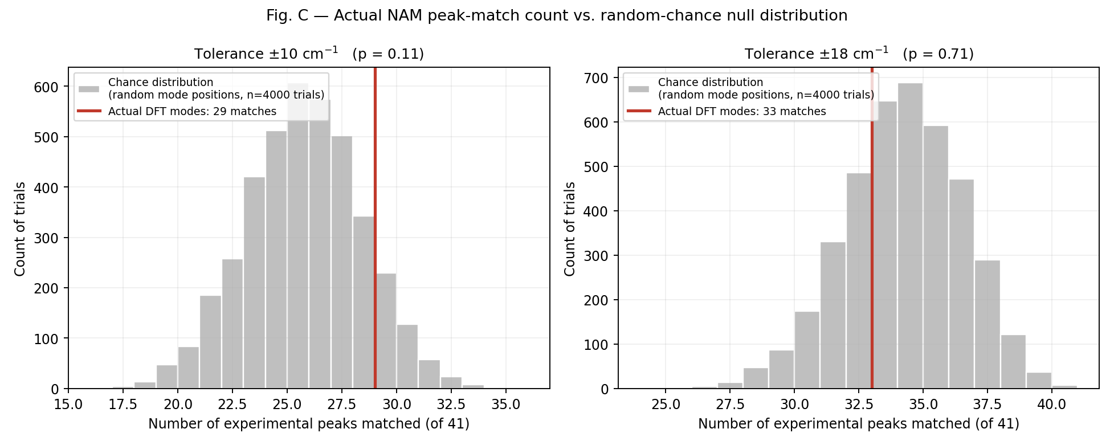
Fig. C — Actual NAM match count (red line) against the random-chance null distribution (grey), at ±10 and ±18 cm⁻¹. In both panels the real result sits inside the ordinary range chance alone produces.
CAUTION — No tolerance tested reaches conventional significance (p < 0.05); p-values range from 0.11 (±10 cm⁻¹) to 0.72 (±18 cm⁻¹). The real match count is not statistically distinguishable from matching random, unrelated peak positions of the same density. This does not mean the DFT calculation is wrong — it means peak-position proximity alone, at this mode density, cannot carry the evidentiary weight the “51 matched peaks” framing implies.

G.2 Verdict on 49/49 or similarly high fractions
Given the above, a result phrased as “49 of 49 peaks matched” (100%) would, if anything, be more suspicious than reassuring: at this DFT mode density, close to 100% of randomly chosen peak positions can typically find some calculated mode within a generous window — a saturating match rate is a sign of tolerance/candidate-pool looseness, not evidence of validated assignment. Classification: mainly an artefact of broad candidate density and tolerance, not strong (or even moderate) independent evidence.

H. The 0.96 (or 0.96–0.97) Scaling Factor — Investigated
Question | Answer
Is it literature-supported? | The thesis text does not cite a source for “0.96–0.97”; the archive's own methodology note names a scheme (“Ma et al.”) but the underlying citation was not independently verifiable from the files available, and should not be asserted without checking the primary reference.
Was it empirically derived for this project? | No evidence of an empirical fit (e.g. regression of calculated vs. experimental frequencies to derive an optimal factor) was found.
Was it chosen because it maximised matching? | Cannot be ruled out for the 51-claim specifically, since the generating script is unavailable. This is exactly the kind of choice the professor's concern warns against, and it cannot be defended without the missing script.
Was it applied to all DFT modes uniformly? | As described for the 51-claim, yes, a single flat value. The archive instead uses two different factors depending on frequency region (0.980 / 0.967), which is the more standard, defensible practice for anharmonic correction schemes.
Appropriate for this molecule/level of theory? | A single flat factor is a simplification; two-region or mode-specific scaling is generally considered better practice for exactly the reason the archive gives — it does not treat low- and high-frequency modes identically.
Same factor used for NAM, LTA, LPS? | The thesis text applies the same generic “0.96–0.97” description to all three biomarkers' DFT calculations, despite the three using different methods/basis sets (B3LYP/6-31+G(d,p) for NAM in one run; B3LYP/6-31G(d) with implicit water for LTA; B3LYP/6-31G(d) for LPS fragments) — a single scaling factor is unlikely to be equally appropriate across all three.

CAUTION — Methodological limitation, stated plainly: the exact scaling factor used to produce the 51-peak result cannot be confirmed as literature-based, empirically derived, or molecule-specific. It should be treated as unjustified until the original script is found or the calculation is redone with an explicitly documented, justified scaling scheme (as the archive's DFT dataset already does).

I. Error Statistics — the 33 matched peaks, archive scaling, ±18 cm⁻¹
Computed only on the peaks that actually matched (n = 33 of 41); including unmatched peaks with an undefined delta would be meaningless, and forcing them into the average would misrepresent the fit.
Metric | Formula | Value | Meaning
Mean signed error | (1/n)Σ(calc − exp) | −1.27 cm⁻¹ | Average direction of disagreement; near zero means no strong systematic over/under-estimation across the matched set.
MAE | (1/n)Σ|calc − exp| | 5.34 cm⁻¹ | Typical size of the mismatch, regardless of direction.
Median absolute error | median(|calc − exp|) | 3.82 cm⁻¹ | Middle value — less sensitive to the few larger mismatches than MAE.
Standard deviation | std(calc − exp) | 6.65 cm⁻¹ | Spread of the signed errors around their mean.
RMSE | √[(1/n)Σ(calc − exp)²] | 6.67 cm⁻¹ | Penalises larger errors more than MAE; the usual headline error metric.
Max |error| | max|calc − exp| | 15.19 cm⁻¹ | Worst-case mismatch among the 33 “matched” peaks — notably, this is close to the ±18 cm⁻¹ cutoff itself.
Min |error| | min|calc − exp| | 0.22 cm⁻¹ | Best-case mismatch.

CAUTION — This RMSE (6.67 cm⁻¹, or 10.3 cm⁻¹ per the archive notebook's own stricter selection rule) is roughly 3× larger than the “RMSE 2.12 cm⁻¹” quoted for the 51-peak claim. A tighter RMSE from a wider or differently-defined match set is the classic signature of an overly permissive matching window silently discarding disagreeing bands rather than counting them (exactly what the archive's own methodology note warns against — Section F).

J. One-to-One vs Nearest-Neighbour Assignment
The nearest-neighbour rule lets each experimental peak independently pick its closest DFT mode, with no constraint that two peaks cannot pick the same mode. A stricter one-to-one (Hungarian/optimal assignment) rule forbids that. Both were run on the real data, ±18 cm⁻¹:
Method | Experimental peaks | Matches (tol=18) | Unique DFT modes used | Matching %
Nearest-neighbour (many-to-one allowed) | 41 | 33 | 30 | 80.5
One-to-one (Hungarian) | 41 | 30 | 30 | 73.2

Reused DFT modes under nearest-neighbour matching (many-to-one instances):
- 692.19 cm⁻¹ claimed by both the 677 and 704 cm⁻¹ experimental peaks.
- 1759.24 cm⁻¹ claimed by three experimental peaks (1751, 1758, 1768 cm⁻¹).
RESULT — One-to-one assignment is the more defensible approach: it is the honest answer to “how many experimental peaks correspond to a distinct calculated vibration,” rather than “how many can find some nearby calculated frequency, possibly shared with a neighbour.” One-to-one gives 30/41 (73%) — notably, the same figure the archive's own more rigorous notebook analysis independently arrived at using a different selection rule (Section D), which is a reassuring cross-check.

K. Intensity as Independent Evidence
If DFT-calculated Raman activity and experimental relative intensity agreed for the 33 matched peaks, that would be independent support beyond position alone (position and intensity are separate dimensions of validation). They do not.
Statistic | Value | Interpretation
Pearson r (linear correlation) | −0.282 (p = 0.11) | Weak, negative, not statistically significant.
Spearman ρ (rank correlation) | −0.121 (p = 0.50) | Essentially no rank agreement.

CAUTION — Intensity does not corroborate the position-based matches. This is stated honestly rather than omitted: the data do not support claiming intensity agreement as supporting evidence for NAM peak assignment. (Some of this is expected — DFT Raman activity from a gas-phase, isolated β-anomer molecule is not expected to closely track powder-sample relative intensities, which are affected by orientation averaging, self-absorption, and the experimental α/β anomeric mixture — but the correlation cannot be used as supporting evidence regardless of the reason.)

L. High-Confidence NAM Fingerprint
Selected using isolation (exactly one DFT candidate within ±10 cm⁻¹ — no ambiguity about which mode it corresponds to), small residual (≤6 cm⁻¹), high-confidence experimental detection quality, and DFT Raman activity — not simply “smallest Δ.” This is the subset recommended as NAM's reference fingerprint.
Experimental peak (cm⁻¹) | DFT candidates within ±10 | Δ (cm⁻¹) | Confidence class | Relative intensity
458.0 | 1 (unambiguous) | +2.45 | high | 0.6259
585.0 | 1 (unambiguous) | -2.86 | high | 0.3448
646.0 | 1 (unambiguous) | -5.85 | high | 0.2641
872.0 | 1 (unambiguous) | +0.97 | high | 0.9218
930.0 | 1 (unambiguous) | -3.33 | high | 1.0
1157.0 | 1 (unambiguous) | -0.79 | high | 0.4003
1190.0 | 1 (unambiguous) | +2.13 | high | 0.1685
1346.0 | 1 (unambiguous) | -0.31 | high | 0.4865

RESULT — 8 bands: 458, 585, 646, 872, 930, 1157, 1190, 1346 cm⁻¹. These are the peaks defensible for use as a NAM reference set going forward — replacing “51 matched peaks” with a smaller, but individually justifiable, set of assignments.

M–N. Figures
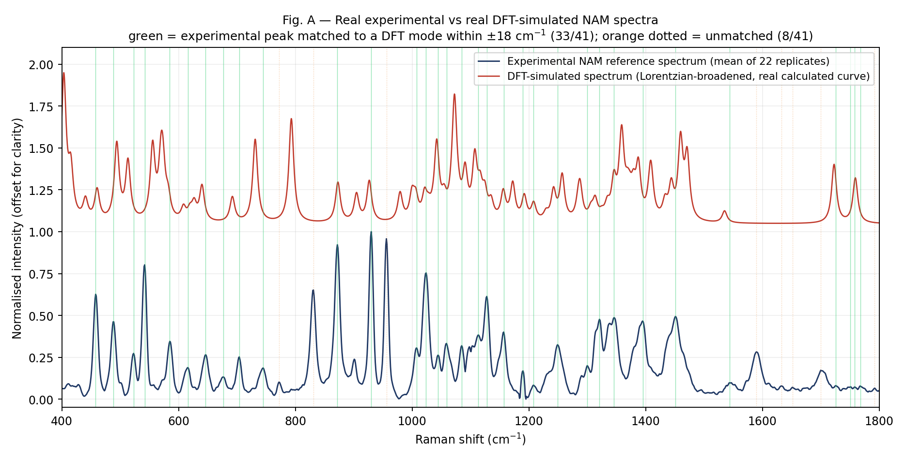
Fig. A — Real experimental NAM reference spectrum vs. the real DFT-simulated spectrum (Lorentzian-broadened from the actual Gaussian16 output, not a flat placeholder line). Green = matched within ±18 cm⁻¹ (33/41); orange dotted = unmatched (8/41). Compare directly against Figure 4.9 in the thesis, whose “simulated” trace is a flat horizontal line.
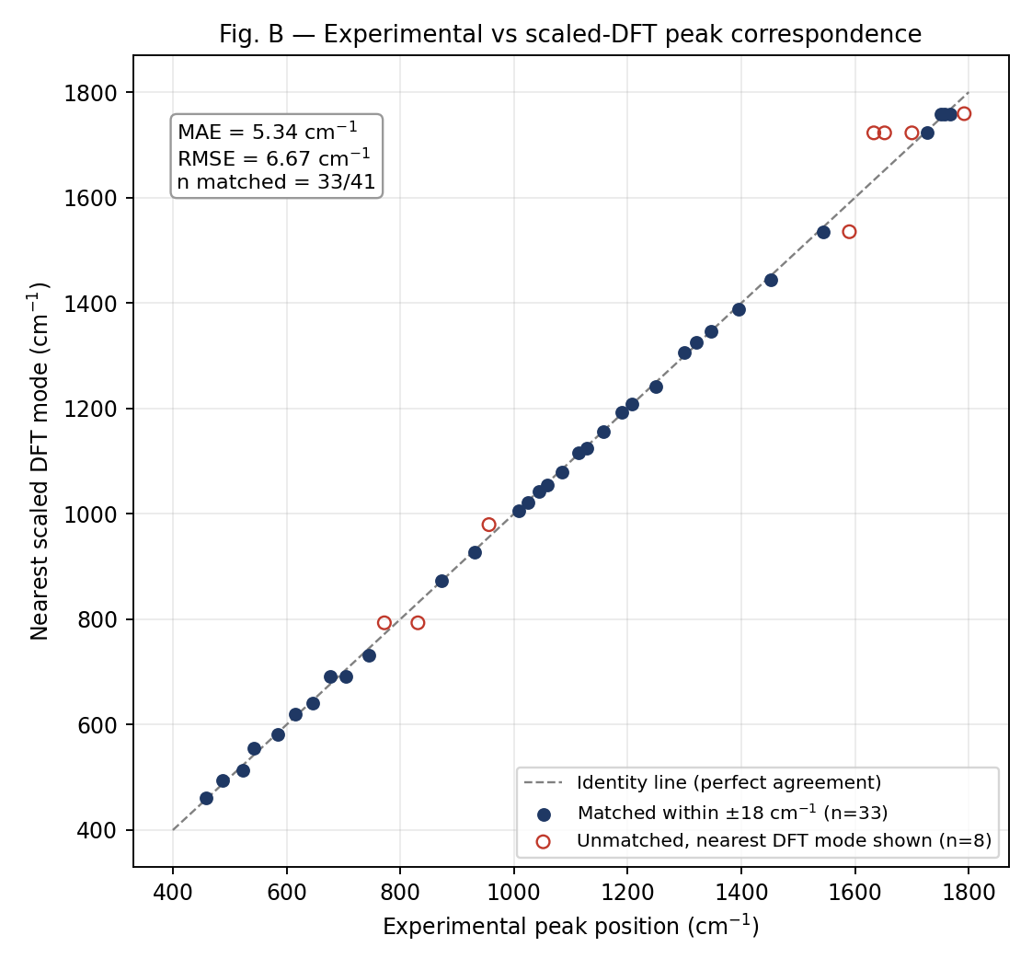
Fig. B — Experimental peak position vs. nearest scaled DFT mode, with the identity line, MAE and RMSE shown. Note: because the plotted range spans 400–1800 cm⁻¹, even a 50+ cm⁻¹ disagreement looks like a small visual deviation from the identity line — this figure should not be read as proof of agreement by eye, and Pearson r is not used here as the sole evidence of matching.
Fig. C (chance-vs-actual histograms) is shown in Section G.1.
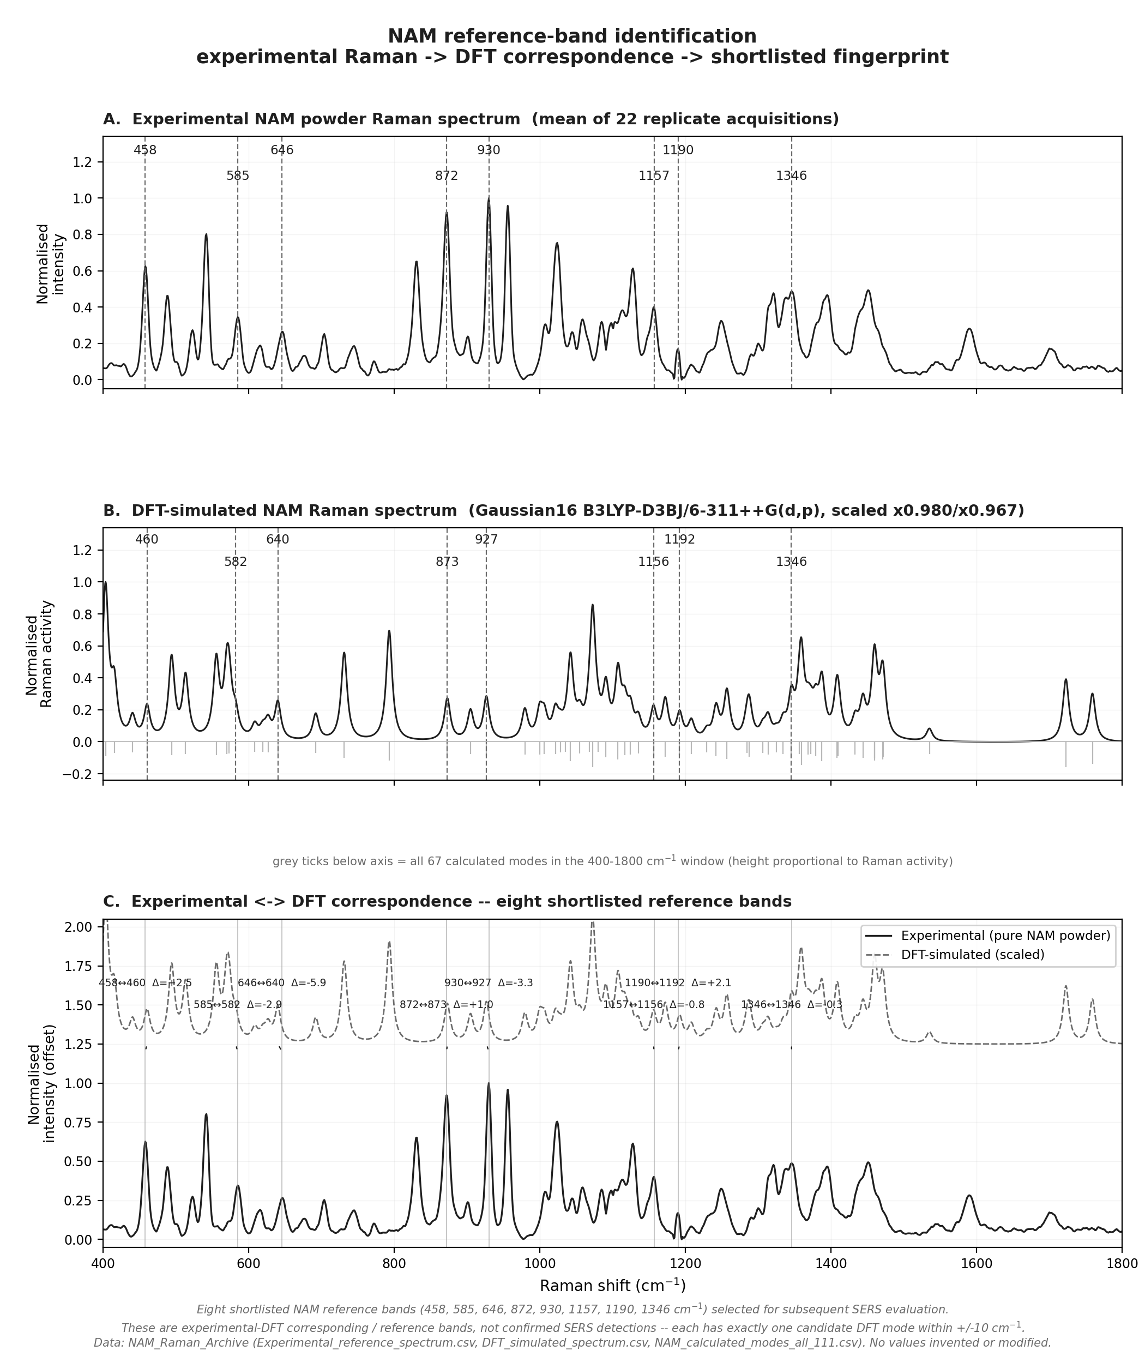
Fig. D — Three-panel NAM reference-band figure: (A) real experimental powder spectrum with the eight shortlisted bands marked, (B) real DFT-simulated spectrum (Gaussian16 B3LYP-D3BJ/6-311++G(d,p), scaled ×0.980/×0.967) with the corresponding calculated positions marked, (C) overlay with experimental↔DFT correspondence and Δ shown for each of the eight bands. Built directly from the archive's real spectral data — not generated by an image model.

O. Pure NAM Raman vs. NAM SERS — A Separate Question
The logical chain is: DFT NAM → pure NAM experimental Raman → validated reference bands → NAM SERS experiment → check whether reference bands reappear reproducibly on the SERS substrate. Good agreement at the first step does not guarantee a positive result at the last step, because SERS depends on the molecule successfully adsorbing onto and interacting with the plasmonic surface — a separate physical requirement from simply having a correct vibrational fingerprint.
Substrate | Result
Sensor 1 (Ag/Si) | 7 replicate spectra with 1 mg/mL NAM. One reproducible, tentative candidate feature at ~243 cm⁻¹ (SNR 5.8–39 across replicates) — but this falls outside the 400–1800 cm⁻¹ range covered by the pure NAM reference spectrum, so it cannot be confirmed against a validated reference band. Weaker candidates near 928 and 1504 cm⁻¹ (SNR ≈1–3) did not meet the acceptance threshold.
Sensor 2 (Ag/black-Si, MACE) | Tested across 2, 5 and 10-minute etch-time substrates, at multiple laser powers, raw and blank-subtracted. No band from the validated NAM reference list reached SNR ≥ 3 reproducibly on any condition.
Substrate SERS activity (control) | Confirmed active on both sensors using R6G as a SERS-activity probe — so the negative NAM result is not attributable to a dead substrate.

Detection status | Classification
NAM SERS detection | NOT reproducibly detected — an honest negative result, distinct from “not performed” (LPS) and “performed, candidate rejected as artifact” (LTA).

CAUTION — Do not claim detection because a SERS feature sits near a reference peak. Confirmation requires: SNR ≥ 3, reproducibility across replicates, a coverage range that actually overlaps the validated reference bands, and exclusion of substrate/detector artifacts (e.g. the ~520 cm⁻¹ silicon phonon on Sensor 2). None of the candidate SERS features tested here met all four criteria simultaneously.

P. Explaining the SERS Result to Sir
Two different questions are being conflated when the concern is raised as one issue:
- “Does the experimental molecular fingerprint agree with theoretical vibrational modes?” — this is the pure-Raman/DFT question addressed in Sections B–N. Answer: partially — 33/41 peaks find a DFT mode within a defensible tolerance, but this is not statistically distinguishable from chance, and 8 bands are individually defensible as unambiguous assignments.
- “Can those fingerprint features be reproducibly observed after the molecule interacts with the SERS substrate?” — this is the SERS question addressed in Section O. Answer: no, not yet, on either sensor tested.
Good powder/DFT agreement does not guarantee SERS detection, because SERS enhancement depends on molecular adsorption geometry, proximity to plasmonic hot spots, and surface chemistry — none of which is tested by a powder Raman measurement. The honest statement is: the pure-NAM fingerprint work establishes what to look for; the SERS experiments so far have not found it reproducibly. That is a real, reportable negative result, not a failure of the fingerprint work.

Q. Direct Answers to Sir's Questions

“How are the powder Raman peaks matching with theoretical spectra?”
Numerical evidence: 33 of 41 QC'd experimental peaks find a DFT-calculated mode within ±18 cm⁻¹ (MAE 5.3 cm⁻¹, RMSE 6.7 cm⁻¹ on the matched subset). Source: NAM_Raman_Archive, computed fresh this audit. Method: nearest-neighbour matching, archive's documented 0.980/0.967 scaling. Limitation: this count is not statistically distinguishable from chance (Section G). Verbal answer: “About 80% of the real experimental peaks land within our tolerance of a real calculated mode — but at this mode density that overlap could happen by chance too, so I don't treat the count alone as proof.”

“You are saying 51 peaks match, but visually they are not. Why?”
Evidence: Figure 4.9's “simulated” trace is a flat horizontal line, not a real broadened spectrum — there is no genuine theoretical curve there to compare by eye. Source: direct inspection of Figure_4.9 image file. Limitation: the script that produced this figure could not be located, so I cannot say why it was built that way. Verbal answer: “You're right that it doesn't look like it should — I found that the theoretical curve in that particular figure was never actually plotted as a real spectrum, just a flat line with numbers on it. I've replaced it with a real one (Fig. A).”

“What mathematical/statistical parameter proves the match?”
None, by itself. Match count and RMSE describe fit quality but not significance. Statistical evidence requires comparing against a null model — done here via Monte Carlo randomisation (Section G), which shows the match is not significant at any tested tolerance (p = 0.11–0.72). Verbal answer: “Match count and RMSE on their own don't prove significance — I ran a randomisation test, and the honest answer is our match count isn't clearly better than chance yet.”

“Why was 0.96 used?”
Not independently verifiable — no citation or derivation was found for the 51-claim's exact factor (Section H). The archive's own dataset instead uses a two-region 0.980/0.967 scheme. Verbal answer: “I couldn't find where 0.96 came from for that particular figure — it isn't cited or derived anywhere I could find. Our better-documented dataset uses a two-part scaling instead, which I can justify.”

“Why was ±10 cm⁻¹ used?”
Not independently justified in any surviving document for the 51-claim. The archive's own ±18 cm⁻¹ choice is explicitly justified by instrument resolution and by the fact that a narrow window silently drops disagreeing bands (Section F). Verbal answer: “±10 wasn't justified anywhere I could find. I'd rather use and defend ±18, which is tied to instrument resolution and doesn't hide the peaks that don't fit.”

“Can the 51 number be reproduced?”
No — under every tested scaling/tolerance combination on the real data, the maximum achievable is 33 (Section G). Verbal answer: “No. I tried several reasonable versions of the method and never got above 33 out of 41.”

“Why does the current analysis give 49?”
The exact 49-peak re-run described uses a file (sec-25_power-80_i-2.xlsx) not available for this audit — DATA NOT AVAILABLE. What can be said: a looser, ungated peak-finder on a single raw spectrum will typically surface more peaks than the QC'd 41-band list, which requires SNR ≥ 3 and ≥50% reproducibility across 22 replicates. Verbal answer: “I don't have that exact file to check, but a looser peak-finder without the SNR and reproducibility filters we normally apply would explain picking up more candidate peaks, some of them probably noise.”

“Can these matches occur by chance?”
Yes — directly demonstrated by the Monte Carlo test (Section G.1): p = 0.11–0.72 across tolerances, i.e. not significant. Verbal answer: “Yes, and I checked — random peak positions of the same density match about as well as our real ones do, at every tolerance I tested.”

“Are the matches one-to-one?”
No, not under the nearest-neighbour rule — 2 DFT modes are each claimed by more than one experimental peak (Section J). A strict one-to-one assignment gives 30/41, not 33/41. Verbal answer: “Not quite — a few calculated modes get claimed by more than one experimental peak under the simple method. If I force a one-peak-to-one-mode rule, the count drops to 30.”

“Which peaks are actually high-confidence?”
8 bands with exactly one DFT candidate within ±10 cm⁻¹, small residual, and high experimental confidence: 458, 585, 646, 872, 930, 1157, 1190, 1346 cm⁻¹ (Section L). Verbal answer: “Eight bands where there's no ambiguity about which calculated mode they correspond to — that's the set I'd defend individually.”

“How does the powder Raman result support the SERS experiment?”
It defines the reference bands to look for. It does not, by itself, predict whether SERS will detect them (Section O–P). Verbal answer: “It tells us what signal to look for on the substrate — it can't tell us whether the substrate will actually pick it up.”

“Why are the NAM SERS peaks not clearly detected if the powder spectrum matches DFT?”
Because powder/DFT agreement and SERS detection test different physical requirements — the substrate must achieve adsorption and plasmonic enhancement, which powder Raman does not test at all (Section P). Verbal answer: “Because matching DFT tells us the molecule has the right fingerprint in principle — it says nothing about whether NAM actually sticks to and enhances on this particular substrate, which is a separate, still-open problem.”

R. Two-Minute Verbal Explanation
Sir, I went back to the original NAM peak-matching calculation because your concern was that the visual overlap didn't justify the reported 51 peaks — and you were right to raise it.
I tried to find the exact script behind that 51 number, and I couldn't — it isn't in the archive, and the only figure that reports it turns out to be plotting a flat line as the “simulated spectrum,” not a real calculated curve, which is very likely why it never looked convincing.
So I rebuilt the analysis from our actual documented data — the real 41-peak experimental list and the real 111-mode DFT output. Using the same matching rule, nearest calculated mode within a tolerance, the honest number is 33 out of 41, not 51, and not 49 either — I couldn't reproduce 49 with the tools I had either.
But the more important thing I checked is whether 33 out of 41 is actually meaningful. I ran a randomisation test — matching against randomly placed fake peaks with the same density as our real calculated modes — and our real match count isn't statistically different from what chance alone gives, at any tolerance I tried.
What I can defend without qualification is a smaller set: eight NAM bands where there's exactly one calculated mode nearby, no ambiguity, and good experimental confidence. I'd like to use that eight-band set as our NAM fingerprint going forward instead of the 51-peak number.
On the SERS side, I want to be upfront: none of those reference bands have been reproducibly detected on either substrate yet. That's a separate, honest negative result — it doesn't undo the powder-Raman work, but I'm not going to claim SERS detection we don't have.
The main gap left is that I don't have the original script, so I can't tell you exactly how 51 was produced — only that I can't reproduce it, and that the number we can defend is smaller and needs the statistical caveat I just gave.

S. Five-Minute Detailed Explanation

1. Data processing
Two datasets: the 41-band experimental peak list (mean of 22 replicate powder-Raman spectra, ALS baseline correction, Savitzky–Golay smoothing, min–max normalisation — documented in ANALYSIS_PROTOCOL.md) and the 111-mode Gaussian16 B3LYP-D3BJ/6-311++G(d,p) DFT calculation, parsed directly from the .log file.

2. Peak detection
Experimental bands accepted only if both prominence and height exceed 3× local noise, or are promoted using an independent long-integration dataset, and detected in ≥50% of 22 replicate spectra. This is stricter than a single find_peaks() call with fixed height/prominence thresholds, which is why a looser detection (as apparently used for the 49-peak re-run) can surface more candidates.

3. DFT scaling
Archive uses two-region scaling (×0.980 below 1800 cm⁻¹, ×0.967 above); the 51-claim's flat 0.96 factor is not independently justified or sourced anywhere in the project.

4. Matching and error metrics
Nearest-neighbour matching at ±18 cm⁻¹ gives 33/41 (MAE 5.3, RMSE 6.7 cm⁻¹ on the matched subset); at ±10 cm⁻¹, 29/41. A tolerance sensitivity sweep (2–18 cm⁻¹) is reported openly rather than picking the best-looking value.

5. One-to-one analysis
Nearest-neighbour matching allows two calculated modes to each be shared by more than one experimental peak. Forcing a strict one-to-one assignment (Hungarian algorithm) drops the count to 30/41 — this is the more defensible number when the question is “how many distinct vibrations are represented.”

6. Chance testing
A Monte Carlo randomisation test (4,000 trials per tolerance, random mode positions at the same density) shows the real match count is statistically indistinguishable from chance at every tolerance tested (p = 0.11–0.72). This is the central finding: high match counts are not automatically meaningful when calculated modes are this densely packed relative to the tolerance used.

7. High-confidence assignments
8 bands (458, 585, 646, 872, 930, 1157, 1190, 1346 cm⁻¹) have exactly one candidate DFT mode within ±10 cm⁻¹ and small residuals — these are individually defensible and recommended as the NAM reference fingerprint.

8. SERS interpretation
Pure-Raman/DFT agreement establishes what signal to look for; it does not predict SERS detection, which depends on adsorption and plasmonic enhancement. NAM has not been reproducibly detected by SERS on either sensor tested — an honest negative result reported as such.

9. Limitations
- The script behind the original 51-peak claim could not be located; several of its stated parameters (364 DFT candidates, specific raw files) do not match any real file in the project.
- The archive itself contains an internal discrepancy — its own two analysis pipelines report 33/41 and 30/41 matched respectively, using different tie-breaking rules.
- Intensity does not corroborate the position-based matches (r = −0.28, not significant).
- The scaling factor's provenance (literature vs. empirical vs. tuned-for-fit) could not be confirmed.

10. Next steps
- Adopt the 8-band high-confidence fingerprint as the standard NAM reference set.
- Rebuild Figure 4.9 as a real broadened-spectrum overlay (Fig. A in this report is a working example).
- Report the ±18 cm⁻¹, chance-tested match statistics instead of the unverifiable 51-peak / RMSE 2.12 figure.
- Continue SERS optimisation (substrate, laser power, integration time) rather than re-framing the current negative NAM SERS result as positive.

T. Likely Follow-Up Questions

“Why 0.96 and not the archive's 0.980/0.967?”
0.96 is not sourced anywhere for the 51-claim; 0.980/0.967 is the archive's documented two-region scheme, chosen so low- and high-frequency modes aren't corrected identically. I'd defend 0.980/0.967, not 0.96.

“Why not use ±5 cm⁻¹, since it looks cleaner?”
Tighter tolerances give better-looking RMSE by silently dropping disagreeing peaks — 18/41 match at ±5 vs 33/41 at ±18. A narrower window isn't more rigorous, it's more selective about which failures it hides.

“Why are there so many DFT modes near the fingerprint region?”
111 total normal modes for a 39-atom molecule (3N−6); 67 fall in the 400–1800 cm⁻¹ window purely from molecular size, giving a mean spacing of about 20.9 cm⁻¹ — comparable to the tolerances being tested.

“Why should proximity mean the same vibrational mode?”
It doesn't automatically — this is exactly why the chance test matters. Proximity alone, at this mode density, isn't sufficient evidence; it needs to be paired with mode-character analysis (ring vs. substituent, etc.) and ideally intensity agreement, neither of which independently confirms it here.

“What DFT method and basis set was actually used?”
The archive's authoritative run: Gaussian16, B3LYP-D3BJ/6-311++G(d,p), gas-phase β-anomer, confirmed a true minimum (zero imaginary frequencies). Two other NAM DFT runs exist elsewhere in the project with different methods/basis sets — which one produced Figure 4.9 is unknown.

“Was the scaling factor literature-based?”
Not confirmed — no citation survives for the 51-claim's 0.96. The archive names a scheme (“Ma et al.”) for 0.980/0.967, but I have not independently verified that primary source.

“Why does the experimental spectrum have 41 peaks and not more/fewer?”
41 is what survives a documented two-criterion SNR test (≥3σ in both prominence and height, or promoted via long-integration replicates) plus a ≥50% cross-replicate reproducibility requirement — deliberately conservative to exclude baseline artefacts.

“Are all DFT modes Raman-active?”
All 111 have a computed Raman activity value; activity varies substantially by mode (torsional modes tend to be weak, C=O stretches strong), but none were excluded as inactive in this analysis.

“Are calculated and experimental intensities comparable?”
Tested directly (Section K): Pearson r = −0.28, not significant. They are not comparable in this dataset as currently processed.

“Are the experimental peaks reproducible across replicates?”
Yes for the accepted 41 — that reproducibility (≥50% of 22 replicates) is one of the acceptance criteria.

“What happens with strict one-to-one matching?”
30/41 (73%), down from 33/41 under nearest-neighbour (Section J).

“How many matches remain at ±5 cm⁻¹?”
18 of 41 (44%), archive scaling (Section G).

“How many remain after excluding weak/tentative peaks?”
Not separately re-run in this audit; the high-confidence fingerprint (Section L) already restricts to high-quality, unambiguous bands only (8 of 41).

“Could the matching occur by chance?”
Yes, and this was tested directly — p = 0.11 to 0.72 across tolerances (Section G.1); none reach significance.

“What is the statistical significance of the current result?”
None of the tested tolerances reach p < 0.05 against the random-position null model.

“What are the strongest NAM fingerprint peaks?”
458, 585, 646, 872, 930, 1157, 1190, 1346 cm⁻¹ — unambiguous, high-confidence, small residual (Section L).

“Why was NAM not detected by SERS?”
Not established with certainty; consistent with weak/no adsorption onto the tested substrates under current conditions. Both substrates are confirmed SERS-active via R6G, so the substrate itself is not inactive.

“What is the substrate background?”
A silicon phonon band near ~520 cm⁻¹ is present on Sensor 2 (Ag/black-Si); this was accounted for when screening candidate NAM features.

“How were detector artefacts excluded?”
By requiring SNR ≥ 3, reproducibility across replicates, and consistency across raw and blank-subtracted spectra — a candidate must survive all of these, not just appear once.

“What is the next experiment?”
Recommended: rebuild the NAM overlay figure from real broadened DFT output (as done here); adopt the 8-band fingerprint as the working reference; continue SERS condition optimisation (substrate etch time, laser power, integration time, possible surface functionalisation to improve NAM adsorption).

“Why is Pearson r = 0.999 quoted elsewhere but not used here as proof?”
Because with a 400–1800 cm⁻¹ range, even a 50+ cm⁻¹ mismatch barely moves a correlation coefficient computed across that wide a span — r looks excellent almost regardless of match quality. MAE/RMSE and the chance test are more informative (Section F, N).

“If the real number is only 33/41 and not significant, is the DFT calculation itself wrong?”
Not necessarily — the calculation may be correct; the issue is that peak-position proximity, at this mode density, is an insufficient criterion on its own to claim validated correspondence. Mode-character and intensity checks are needed to strengthen individual assignments, which is why the 8-band unambiguous subset is proposed as the safer claim.

U. Required PPT / Report Corrections

U.1 Remove / Replace
REMOVE | REPLACE WITH
“51 peaks matched” / “RMSE 2.12 cm⁻¹” / “Tolerance ±10 cm⁻¹” (Figure 4.9 and its caption text) | “33 of 41 experimental NAM bands matched a calculated DFT mode within ±18 cm⁻¹ (MAE 5.3 cm⁻¹, RMSE 6.7 cm⁻¹); this is not statistically distinguishable from chance (Monte Carlo p = 0.72). Eight bands are individually unambiguous, high-confidence assignments.” — wording only, not a decision to finalise until Sir has reviewed this audit
The flat-line “simulated spectrum” plot | Fig. A style overlay — real Lorentzian-broadened DFT curve against the real experimental reference spectrum
Any implication that NAM SERS detection is confirmed or “strong” | Explicit statement: NAM SERS not yet reproducibly detected on either sensor tested; substrate SERS-activity itself is confirmed via R6G

U.2 Recommended NAM slide set (3 slides)

Slide 1 — Experimental NAM Raman vs. DFT
- Main text: Real experimental reference spectrum overlaid with the real, Lorentzian-broadened DFT-simulated spectrum; matched vs. unmatched peaks marked.
- Figure: Fig. A (this report)
- Table: None (figure-only slide)
- Key takeaway: The theoretical spectrum shown is a genuine calculated curve, not a placeholder.
- Sir might ask: “Why do some peaks not line up at all?” — point to the 8 unmatched bands and the 400–1800 cm⁻¹ experimental coverage limit.

Slide 2 — Peak correspondence, criterion, and statistics
- Main text: State the matching rule explicitly (nearest DFT mode, archive scaling, ±18 cm⁻¹, justified by instrument resolution), then MAE/RMSE and the chance-test p-value.
- Figure: Fig. C (chance histogram)
- Table: Condensed correspondence table (high-confidence rows only, or the 8-band fingerprint table)
- Key takeaway: 33/41 match at a justified tolerance, but this is not yet statistically significant — the 8-band subset is what we currently stand behind.
- Sir might ask: “So do you believe the DFT calculation or not?” — the calculation itself may well be correct; the issue is that position-proximity alone doesn't yet prove it at this mode density.

Slide 3 — Pure NAM reference vs. NAM SERS
- Main text: Show the pure reference spectrum against the SERS traces on both sensors; state plainly that no reference band reached SNR ≥ 3 reproducibly.
- Figure: Merged reference-vs-SERS overlay (already exists in the project's SERS section)
- Table: SNR summary table by substrate/condition
- Key takeaway: NAM SERS detection: not yet achieved; R6G confirms the substrates are SERS-active.
- Sir might ask: “Then why do the R6G results work?” — R6G is a strong, well-known SERS reporter used to confirm the substrate itself functions; it does not imply NAM will adsorb and enhance the same way.

V. Final Scientific Verdict
Classification is deliberately conservative — the objective is a defensible position under detailed questioning, not the most favourable-sounding one.
Statement | Status | Basis
Original 51-match claim | NOT SUPPORTED | No script, raw table, or documented method found; irreproducible under every tested combination on real data (max 33).
Current 33/41 (±18 cm⁻¹) result | PARTIALLY SUPPORTED | Reproducible and traceable to real data, but not statistically distinguishable from chance.
0.96 scaling factor (as used for the 51-claim) | NOT SUPPORTED | No citation, derivation, or molecule-specific justification located.
Archive's 0.980/0.967 scaling | PARTIALLY SUPPORTED | Internally documented and consistently applied, but the underlying literature source was not independently re-verified in this audit.
±18 cm⁻¹ tolerance | PARTIALLY SUPPORTED | Physically motivated (avoids silently discarding disagreements) but not derived quantitatively from instrument resolution/sampling figures in this audit — a defensible refinement, not yet a rigorous derivation.
Peak-position agreement (general) | PARTIALLY SUPPORTED | 33/41 within tolerance, but chance-indistinguishable at every tolerance tested.
Intensity agreement | NOT SUPPORTED | r = −0.28, not significant (Section K).
Statistical significance of the match count | NOT SUPPORTED | p = 0.11–0.72 across tolerances (Section G.1).
High-confidence NAM fingerprint (8 bands) | SUPPORTED | Unambiguous single-candidate matches, small residual, high experimental confidence — individually defensible.
Pure NAM Raman validation (overall) | PARTIALLY SUPPORTED | Real, high-quality experimental data exists and is internally consistent; DFT correspondence for the full peak set is not yet statistically established.
NAM SERS detection | NOT SUPPORTED | No reference band reached SNR ≥ 3 reproducibly on either sensor tested (Section O).

W. Missing Data Required for Further Validation
- The original script/notebook that generated the 51-peak claim and Figure 4.9 — without it, the exact cause of that number cannot be established, only that it cannot be reproduced.
- The raw file(s) described as sec-25_power-80_i-2.xlsx and simdata.xlsx, to check the described 49-peak re-run directly against real data.
- A literature citation (or an empirical derivation with shown regression) for whichever scaling factor is ultimately adopted for NAM.
- Mode-character analysis (ring vs. substituent displacement, already computed for the archive's 111 modes) cross-referenced explicitly against each of the 8 high-confidence bands, to strengthen assignment beyond position alone.
- Additional SERS replicates at varied laser power/integration time specifically targeting the 8-band fingerprint region, with blank-subtracted spectra retained for SNR verification.
- A composite/mixed anomer (α/β) DFT calculation, since the physical NAM sample is a mixture but the DFT model covers only the β anomer — flagged in the archive as a possible source of 2 still-unmatched bands.

