Abstract

Introduction

The green revolution of the 1960s revolutionised the agricultural industry, allowing for faster, better crops with less of the damage and risk that they came with. Fertilisers, pesticides, and smart farming methods grew popular, and so did India’s agricultural output from the same. Now the second largest exporter of agricultural products and having a work force heavily dependable on the same, India has effectively utilised all available resources and mobilised rural talent towards agriculture.

The agricultural sector in India is, however, reaching a reckoning. The environmental problems associated with the industry are many, and with failing government policies such as the NFSA and PFAA acts, there is more produce being wasted than ever. Agriculture is causing the rapid and irreversible release of greenhouse gases – as the second largest industry in India after energy to do so – due to bad soil management, over usage of chemical fertilisers, inefficient fuel-driven farming implements, and many other farming methods. Soil erosion due to agriculture is causing rapidly dangerous calamities and the stripping of off minerals, and pesticide/fertiliser usage causes rapid water pollution as well as systematic reduction of biodiversity in ecosystems. Agriculture is also the largest user of water, and paddy farming, inefficient usage, wrong crops in arid climates, etc. are only making the problems worse, especially for cities such as Bangalore who are soon going to run out of fresh water. It is a vicious cycle of change that human implements and methods have unleashed – bad agricultural practices are causing the degradation of climate and land, which in turn is affecting agriculture in terms of climate and calamities like floods, reducing food security even as population grows at an unstable rate.

For these reasons, the topic of the agricultural sector in India has been chosen as its study is extremely imperative for India – only by solving the errors already committed in the agriculture industry can the country’s climate change goals be achieved and the problems most rural areas of the country face be eradicated. By changing the agricultural sector, making it more efficient, using less scarce resources, making it more responsible and using less chemical/man-made implements that cause more harm than good, the industry can make a large and sustainable impact on our environment and Sustainable Development Goals. The study will include an in depth analysis of which

**Research Methodology**

1. *Secondary sources*

Secondary sources of data and research are documents or recordings that relate or discuss information originally presented elsewhere and not originating from the author of the academic piece. For this project into the environmental study of the effects and sustainability of the agricultural sector, the secondary sources used include research papers (previously published academic papers), reports, online articles, published data and statistics, and whitepapers. This set of sources comes from various sites online and mainly concentrates on the history of the environmental impact of the agricultural sector, data on how it is impacting, the reasons for the same, and recommendations to solve the outlined problems.

1. *Primary sources*

For a primary source of information, the candidate that was studied has experience in the agricultural sector and has supplied information relating to his study and work with a specific crop, finger millet or ragi, and how he had done a detailed study of the same for designing a crop implement that would sow seeds and perform soil management for the same in a zero-tillage (less disturbance of soil structure and integrity) method with less water, fertiliser, and fuel-driven implement usage.

|  |  |
| --- | --- |
| Name | Uchit Mehta |
| Age | 26 years old |
| Occupation | Design engineer and product designer |
| Industry | Previously worked in agriculture, house ware, plastics, lightings and electronics in different projects |
| Relation with agricultural sector | Worked with farmers in northern Karnataka, India, to design a crop implement for finger millet crops |

The source of primary information had done a detailed study of ragi crops, the water usage in crops, how tillage methods destroy soil structure, and how a manually used, less effort implement could help farmers be more sustainable and efficient. Most of the farmers in the area he studied used fuel-driven implements that not only guzzled diesel or petrol but also cause carbon particles from exhaust fumes to settle on the crops and cause damage to the 8 same. Animals are also impacted through the same, as diesel, pesticide, and fertiliser chemical compounds and molecules entered plant ecosystems, which’s consumption by animals made food chains polluted by the same. Another major problem that was realised by the source was that most crops, such as finger millet, were heavily water absorbent and seasonal, which made their production in non-monsoon seasons much more risky and use at least 2/3 more water. Instead of crop rotation, most farmers stuck to one crop no matter the water usage and seasonal implementation, which caused damage to the soils studied, and used excessive fresh water that is already scarce.

The source also found through a detailed study of practices that weeds and other wasted plant materials were often uprooted magnanimously and not used by farmers, which can instead be directed to be used as fertilisers, for bio fuels, and for feed for livestock. Some farmers also burn excess crops and weeds due to slow sale of agriculture produce and less storage space for the same, as well as the need to start planting new crops as soon as old crops are uprooted and harvested. This contributes to not just the release of GHGs, but also the wastage of crops. Pesticides also were seen to kill insects and microorganisms in soil structure that contributed to healthy soil management and naturally healthy crops, which is a detrimental process.

This study of primary information from a source that has studied the growth and management of crops, in particular millet, has provided information related to soil management, water usage, pesticide and fertiliser usage, treatment of waste crops, biodiversity effects, and many other points that will enhance understanding of the agricultural industry and its environmental impacts.

**Literature Review**

1. *Agricultural sector of India*

India is booming – as one of the fastest growing economies in the world, industries in the Indian market are far spread and fast moving. Even though the secondary and tertiary sectors of the economy are large and booming, there is still a major focus on the agricultural industry, which accounts for $375 billion dollars of revenue, also being the second largest exporter of agriculture (Sector-wise GDP contribution, Statistics Times). There is a large conflict between India’s climate change goals and its food scarcity woes – this is because the larger is the agricultural production, the more is the impact on biodiversity, greenhouse gas emissions, freshwater and groundwater quantity, soil quality, and land usage (Raghu Murtugudde, 2018). The agricultural industry in India is not just a big contributor to greenhouse gas emissions, but also the degradation of soil and ruining of water sources and soil structure due to pesticide/fertiliser usage and practices such as monoculture, genetic engineering of crops, usage of fuel in the farming process, etc. (Lena Gamper, 2020).

Agriculture is the second largest emitter of greenhouse gases in India after energy. India’s annual GHG (greenhouse gas) emissions from agriculture and livestock are estimated to be around 600 megatonnes of carbon dioxide equivalent, 42% of which comes from crop production. Factors/practices that contribute to this the most are paddy cultivation, soil management, crop burning, and fuel powered trucks and farming implements.

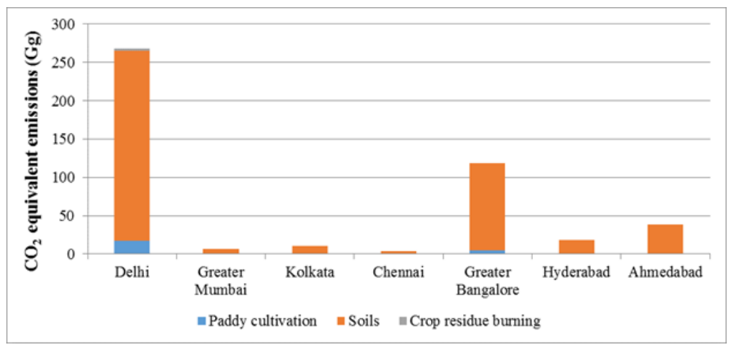

*Graph 1 - Greenhouse gases according to major cities and contribution to gas emissions Source: Indian Institute of Science*

Methane (CH4) is a greenhouse gas that is more lethal than carbon dioxide, having a global warming potential that is 56 times higher. This is a gas produced by the growth and division processes of bacteria, similar to ones found in livestock (the largest emitter of methane) and 10 ones that multiply in paddy fields, causing excessive methane emission and negatively impacting global warming (Neha Jain, 2019). Nitrous Oxide (NO2) is one of the major emissions from soil management, due to the conversion of nitrogen in the soil and decay that releases GHGs, adding to already toxic chemical components present in soil due to pesticides and fertilisers. This release of gas is constant, and more pronounced when tillage methods of agriculture are used (T.V. Ramachandra, Bharath H. Aithal and K. Sreejith, 2015). Crop burning and residue burning for clearing fields is a method followed across India, but more pronounced in the northern states of Delhi and Punjab – with around 500 MMT (million metric tonnes) of waste/residue in agriculture created annually, close to 350 MMT of it is burned due to the lack of use for the same. Agro-residue burn releases GHG, compromising majorly of methane and nitrogen oxide, equal to 4.4 MMT of carbon dioxide equivalents released, that contribute majorly to global warming year on year (S Murali, Rajnish Shrivastava, and Mohini Saxena, 2013).

Crop burning has been largely unregulated so far – and one thing that has increased demand and the need for more and quicker agriculture is the implementation of the National Food Security Act (NFSA) of India in 2013. The act called for increased agriculture intended to feed the lower income families of India adequately - the act also resulted in more land usage, faster crop production, and therefore more soil management practices that have produced an estimated 10 MMT more carbon dioxide equivalents annually since implementation and poorer soil quality in states dependant on wheat and pulse crops such as Uttar Pradesh (Priyam Sengupta and Kakali Mukhopadhyay, 2016). Soil quality is heavily impacted by agricultural practices such as monocropping, genetic engineering of plant species, pesticides and fertilisers, heavy uprooting, over-irrigation, etc. Soil is essential to ecosystems and agriculture – it is the combination of bacteria, fungus, and healthy organisms that keep it in good condition for agriculture. Solid soil structure also prevents mudslides, run off, and over flooding of areas, but is more often than not dangerously weakened.

Monocropping, which is the practice of growing the same crop on the same plot of land, year after year, depletes the soil of essential nutrients and minerals, causes erosion, and reduces the produce grown annually. Aimed to increase ease and productivity of agriculture, monocropping instead cause permanent, irreversible damage to soil structure and integrity (FoodPrint, 2019). Another practice that has made erosion and land degradation increase exponentially in the last few years is that of tillage agriculture, a method that involves usage of heavy implements and aggressive methods to uproot top soil agriculture remnants – and11 includes repeated ploughing, cultivating, planking and pulverizing – which destroys soil structure and increases the release of carbon particles and GHG emissions. A shift towards zero-tillage is being seen across countries, albeit in small movements and concentrated towards wheat, which usually is a heavy till crop (Jeetendra Prakash Aryal and Dalip Bishnoi, 2014). Tillage production, water run-off, pesticide usage, and deforestation/land clearing for agriculture are the main reasons for soil erosion due to agricultural activities.

Minerals and pH balance are essential in soil for agriculture, and these are stripped off at a rate 40 times higher than replacement due to bad agricultural practices. Excessive soil management has not only lead to a heavy release of carbon dioxide equivalents but has also caused soil structure in agriculture heavy areas to become weaker and unable to hold the high amount of chemicals and artificial fertilisers often dumped in it (Sanjai J. Parikh and Bruce R. James, 2012).

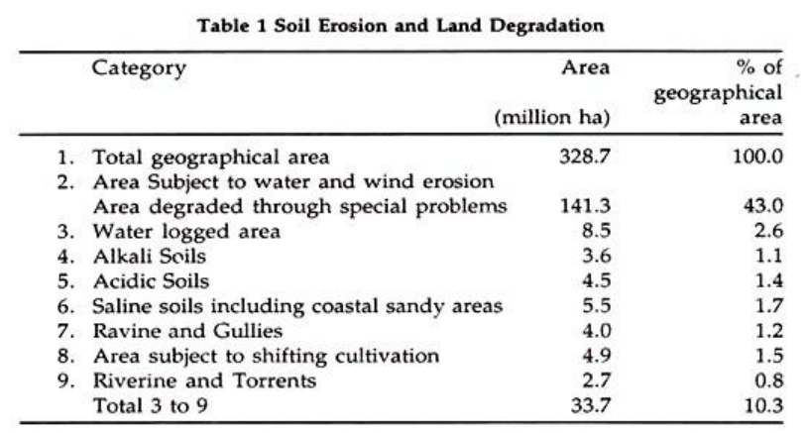

*Table 2 - Division of total used land in India for industrial and agricultural purposes Source: Economics discussion*

Landslides caused by rain and flowing water in steep areas and deforestation, overgrazing and faulty cultural practices in the forest and other plain areas expose the soil to water and wind erosions, furthering the damage caused by agricultural practices (Harsh Aditya, 2018). Table 1.2 shows the total degradation by the same, and the reasons for soil erosion by million hectares and percentage of geographical area used. The consequences of irresponsible agriculture on soil and land are therefore vast – not just restricted to GHGs released in soil management but also the irreversible damage done to soil layers essential for continued agriculture through generations.

One of the main factors that affect the environment as a consequence of agriculture is fertilisers and pesticides. Chemically composed, unnatural fertilisers and pesticides can cause a variety of problems. Fertilisers are rich in nutrients such as phosphorous and nitrates – they cause the release of GHGs and reduced soil strength, and run off from crops (due to poor top soil integrity) causes the pollution of water bodies. The nutrient rich fertilisers cause the excessive growth of microorganisms in water bodies that multiply and form layers on the surface of the same, cutting off oxygen supply to the marine life below – a process known as algae bloom or eutrophication (Mary Berg and Miranda Meehan, 2017).

Pesticides are chemical compounds that include insecticides, fungicides, herbicides, plant growth regulators and others, manufactured to limit the risk of infection and damage to crops. OC compounds in pesticides cause eutrophication in water bodies from run off, and also pose a direct, serious threat to human safety and health as well as biodiversity (Jeremiás Máté Balogh and Attila Jámbor, 2020). In India, pesticides are mainly used in cotton, paddy, and wheat crops, with on average 12% of these finding their way into different ecosystems and therefore into animal and plant compositions (Wasim Aktar, Dwaipayan Sengupta, and Ashim Chowdhury, 2009). Manure, a natural fertiliser, is also rich in nitrogen, phosphorous, bacteria and pathogens, which cause excessive eutrophication due to run-off and the release of GHGs in soil management (Anthony Meusch, 2019). Another invention which has increased ease for farmers but reduced biodiversity is chemical spraying of pesticides – albeit less popular in India, this method allows for surface contamination of crops and the passing on of harmful chemicals in different food chains – chemicals enter human, animal, and water systems that are adversely effected by the same and cause a systematic entry of chemicals into the ecosystem through prey-predator means (S.M. Mathur and J.K. Singh, 2006).

Excessive soil management and usage of chemical and natural pesticides and fertilisers has posed a serious threat to another essential commodity, water. Agriculture causes the depletion of aquatic water systems, water pollution, and over usage of scarce fresh water sources (J. A. Skinner, K. A. Lewis, and K. S. Bardon, 1996). Excessive usage of chemicals on crops, more than they can hold, can cause heavy water pollution of not just surface water but also groundwater sources through waterways, impacting both wildlife and humans (Paul Harrison, 2002). Agriculture in India accounts for 14% of the GDP, 60% of the workforce, and above 80% of the total land and freshwater usage. With the largest irrigated land area in the world at 88 million hectares, the agriculture industry uses water freely and without consequence with reduced efficiency – this is especially pronounced in crop selection by farmers, who plant 13 water thirsty crops in arid regions due to economy and ease of crop plantation, which increases the water usage by almost a quarter (India Water Portal, 2017).

Irrigation of fields for crop cultivation is one of the most water absorbing agricultural methods – this process involves flooding fields with water for crops such as rice that are highly absorbent, and these crops are dependent on humid and moist weather as well as rainfall. Minute changes in the same therefore cause higher risk and a much higher usage of water, something that will only increase in likeliness with climate change (The World Bank, 2020). With such high water usage by crops in India and quickly depleting fresh water sources due to usage of water and over pollution, there is a need for change in water usage and efficiency of returns and productivity for both higher yield to meet growing demands and environmental sustainability (Vibha Dhawan, 2017).

1. *Sustainable Development Goals and agriculture*

**Findings and Analysis**

1. *Greenhouse gases*

The highest emitted gas in India in GHGs is carbon dioxide, followed by methane and nitrates. After energy, agriculture is the second highest emitter of GHGs, and all data points to the fact that this is a sector needing serious change.

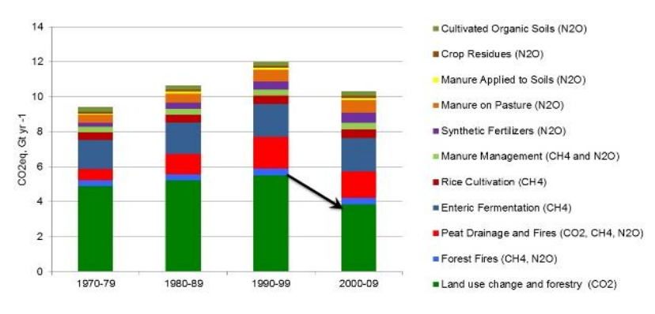

*Graph 2 – Period by period emission of CO2 equivalents due to agricultural practices Source: IPCC*

Data collected on GHG emissions due to agriculture clearly show that nitrates, phosphates, and carbon molecules released due to processes such as crop burning, irrigation methods, and most majorly, land clearing for agriculture, have an irreversible impact on the environment and sustainable change in certain specific structures and methods in agriculture is needed. Land clearance (releasing 3.9 MMT of CO2 equivalents), enteric fermentation/paddy cultivation used in many major crops (releasing close to 2MMT), and peat drainage and fires 15 due to drained carbon sinks that catch flames quickly and spread rapidly (releasing around 1.8 MMT) are the largest emitters of GHGs, and therefore need the most structured change.

1. *Soil management*

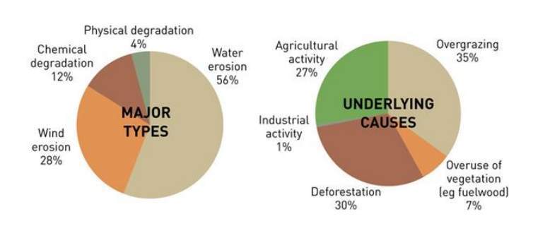

*Graph 3 - Degradation of soil sources in India, most of which can be traced to agriculture Source: UNEP*

Soil management is majorly lacking in India – not only does mismanagement cause the excessive release of GHGs, but also cause top-soil reduction and damage that leads to erosion of soil layers. This erosion cause floods, mudslides, and other calamities that in turn damage crops and allow for run-off of pesticides and fertilisers in soils, leading to water pollution.

1. *Pesticides and fertilisers*

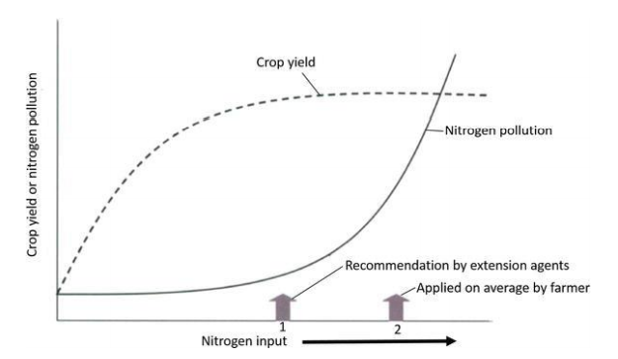

*Graph 4 – Crop yield & nitrogen pollution due to excessive use of fertilisers and pesticides Source: IntechOpen*

The graph above shows the intersection of two factors, the crop yield and nitrogen pollution. The crossover and flattening can point to one conclusive thing – the excess amounts of N&P 16 compounds farmers use are not only a waste of the same, but also detrimental to crop production and pollution through GHGs and water pollution.

1. *Water consumption*

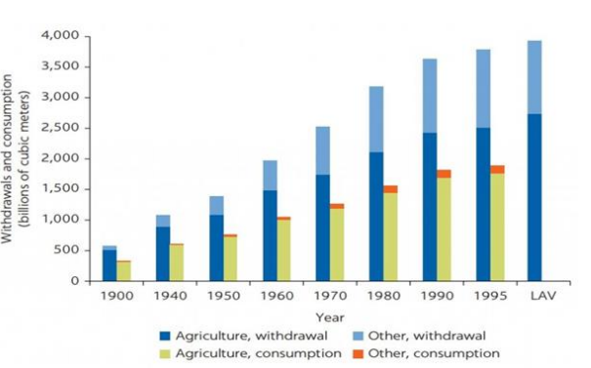

*Graph 5 – Water usage and withdrawal in India Source: Scheierling and Treguer* *2016*

Water usage and withdrawal from scarce sources is clearly more leaning towards uses in agriculture. India uses close to 350 MCM for just irrigation purposes as rice (a paddy crop) is one of the most consumed crops in the country. Although fresh water sources are depleting, India continues to withdraw from them, increasing by 5000 MCM in just 20 or so years.

**Recommendations**

Below are some of the recommendations for sustainable and innovative change in the agricultural sector that can be acted upon by organisations:

1. Nitrogen Fixation – this method involves the growth of leguminous crops and nitrogen absorbent crops that can fix the serious excess of nitrogen in soils due to soil management, over plantation, tillage methods, and most importantly, excessive use of N and P rich fertilizers and pesticides.
2. Carbon sequestration – carbon sequestration is the capture and long-term storage of atmospheric carbon dioxide (CO2) in soil and is currently one of the best ways to combat the increasing threat of climate change. Bad soil management has caused the increase in release of carbon and methane molecules, but through better management and regulated usage this can be implemented and agriculture used as a carbon sink instead of a major GHG emitter.
3. Crop burning and land clearance regulation – unless the government outright bans and heavily regulates land clearance for agriculture, which has become easier and easier even under protected forest and ecological areas by the ministry of EFCC, there is going to be very less protection of the same. Along with this, business organisations can invest in innovative techniques and R&D to improve usage of waste crops, excess crops, weeds, etc. to use them as manure or produce for biofuel amongst others.
4. Zero tillage – Tillage is the mechanical manipulation of soil for the purpose of crop production affecting soil characteristics such as soil water conservation, soil temperature, infiltration and evapotranspiration. When aggressive tillage methods are followed in crops such as soy, wheat, and cotton for weed upheaval, crop harvesting and planting of new crops, it permanently damages soil and can be replaced easily by zero tillage methods which follow less disturbance of soil structure.
5. Environment friendly fertilizers – EFFs are organically made fertilisers that include but are not restricted to manure in them, and are significantly better than chemical fertilisers for crops as they increase water retention, reduce nitrogen oxide emissions and adjust soil pH, which is a problem in excessive agriculture and monocropping.
6. The 4 point plan – The government of Scotland has a heavily publicised 4 step plan devised by SEPA to reduce water usage in agriculture and improve the smart usage of the same. The 4 points are reducing dirty water usage around farms, improving nutrient usage, carrying out a land risk assessment for slurry and manure, and managing water margins that are described in detail on their website. If implemented in India through social movements and awareness/rules for the same, it can regulate heavy water usage in agriculture.
7. Precision Agriculture - Precision agriculture uses Artificial Intelligence (AI) technology to aid in detecting diseases in plants, pests, and poor plant nutrition in farms. AI sensors can detect and target weeds and apply herbicides selectively and not in excess, which is a major problem in agriculture. Usage of precision agriculture techniques can majorly impact wastage, production and farming efficiency.

**Conclusion**

Through all the information seen in the above data and information drawn from various sources, it can be clearly seen that agriculture is becoming extremely detrimental to the environment even as it becomes more essential in times of reduced food security and a growing population. There are some things that can be conclusively drawn from the same – agriculture effects GHG emissions drastically, causes negative impacts on natural soil structure and minerals leading to increased natural calamities, cause water pollution and depletion, negatively impacts biodiversity, and the production of agricultural implements, fertilisers and pesticides is very harmful for the environment. It can be conclusively drawn that just from a few changes in usage of resources, shifts from highly water absorbent crops, and development/application of technology to help the same, many of these negative impacts on the environment from agriculture can be removed.

**References**

Aktar, W., Sengupta D., Chowdhury A. (2009) ‘Impact of pesticides use in agriculture: their benefits and hazards’, Interdisciplinary Toxicology, v2, p1-12. 2)

Aryal, J., Sapkota T., Bishnoi, D. (2014) ‘On-farm Economic and Environmental Impact of Zero-Tillage Wheat: A Case of North-West India’, Cambridge University Press, v1. 3)

Berg M., Meehan M. (2017) ‘Environmental Implications of Excess Fertilizer and Manure on Water Quality’, North Dakota State University Publications, v1. 4)

Dhawan, V. (2017) ‘Water and Agriculture in India’, South Asia expert panel during the Global Forum for Food and Agriculture, v1. 5) Harrison, P. (2002) ‘World agriculture: Towards 2015/2030 Summary Report’, Food and Agriculture Organization of the United Nations, v24. 6)

Jambor A., Balogh J. (2020) ‘The Environmental Impacts of Agricultural Trade: A Systematic Literature Review’, Journal of Sustainability, v12, p1-16. 7)

Mathur, S., Singh J. (2006) ‘Chemical Spraying in Agriculture and its Environmental Impact’, All India Seminar on Environmental Impact Assessment, v1, p50-57. 8)

Murali S. Shrivastava R., Saxena M. (2010) ‘Green House Gas Emissions From Open Field Burning of Agricultural Residues in India’, Journal of Environment, Science, and Engineering, v52 (4), p277-284. 9)

Sengupta P., Mukhopadhyay K. (2016) ‘Economic and Environmental Impact of National Food Security Act of India’, Agricultural and Food Economics, v4. 10)

Skinner, A., Lewis, K., Bardon K. (1996) ‘An Overview of the Environmental Impact of Agriculture in the U.K.’, Journal of Environmental Management, v50, p111 – 128.

Aditya, H. (2017) ‘5 Main Impacts of Agriculture on Environment’, Economics Discussion [online]. Available at: https://www.economicsdiscussion.net/india/agriculture-india/5-main-impacts-of-agriculture-on-environment/21654 2)

FoodPrint (2020) ‘How Industrial Agriculture Affects Our Soil’, FoodPrint [online]. Available at: https://foodprint.org/issues/how-industrial-agriculture-affects-our-soil/22 3)

Gamper, L. (2020) ‘What's the environmental impact of agriculture?’, DW [online]. Available at: https://www.dw.com/en/whats-the-environmental-impact-of-agriculture/av50284684 4) India Water Portal (2012) ‘Agriculture’, India Water Portal [online]. Available at: https://www.indiawaterportal.org/topics/agriculture 5)

Jain, N. (2019) ‘Agriculture is a big contributor to greenhouse gas in India. A study finds a way to fix that’, Scroll, 25 February [online]. Available at: https://scroll.in/article/914085/agriculture-is-a-big-contributor-to-greenhouse-gas-inindia-a-study-finds-a-way-to-fixthat#:~:text=Major%20greenhouse%20gas%20emitting%20states,58%25%20was%20em itted%20from%20livestock.

Murtugudde, R. (2018) ‘India needs to balance food production with climate goals’, Down To Earth, 14 November [online]. Available at: https://www.downtoearth.org.in/news/climate-change/india-needs-to-balance-foodproduction-with-climate-goals-62128 7)

Parikh, S. (2012) ‘Soil: The Foundation of Agriculture’, Nature Education Knowledge [online]. Available at: https://www.nature.com/scitable/knowledge/library/soil-thefoundation-of-agriculture-84224268/ 8)

The World Bank (2020) ‘Water in Agriculture’, The World Bank organisation, 8 May [online]. Available at: https://www.worldbank.org/en/topic/water-in-agriculture

Indian Institute of Science (2015) http://wgbis.ces.iisc.ernet.in/energy/paper/GHG_footprint/discussion.html ‘GHG footprint of Major cities in India’ [online]. Available at: 2)

Statistics Times (2019) ‘Sector-wise contribution of GDP of India’, 8 February [online]. Available at: http://statisticstimes.com/economy/sectorwise-gdp-contribution-of-india.php#:~:text=With%20production%20of%20agriculture%20activity,and%20worl d%20rank%20is%206.