**Report**- Customer Controller Design

# Diagram

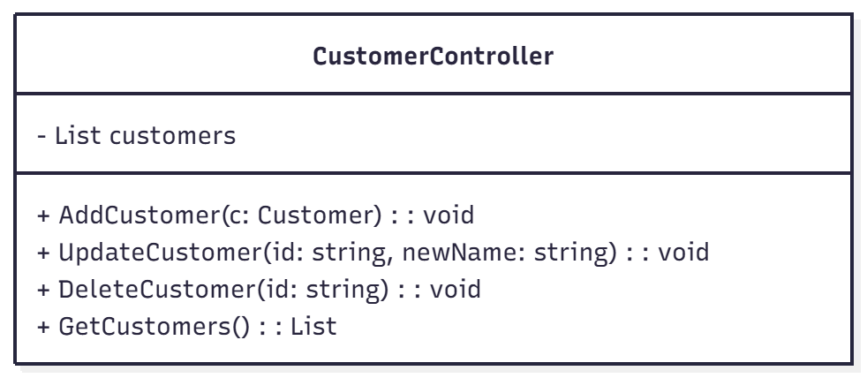

# Explanation

The task requirement for IT7744 task 1 was to make a customer management system to keep customer details. It should be simple and later we can use it with other types of screens like web or phone. So I made the design in a way that is easy to change later. I used the MVC pattern because it makes things neat. The Model keeps data, the View is the form the user sees, and the Controller joins both. It helps to keep the design and logic separate, so if we make a new interface later, the same code can still work fine.

In my project the CustomerController is the main part. It has a list that stores all customers like a small database. It has four methods. The first one, AddCustomer, adds a new customer after checking if ID and name are not empty. The UpdateCustomer changes the name when ID matches. The DeleteCustomer removes a record from the list. The GetCustomers shows all records back on the screen. All these methods use simple types and show small error messages if something wrong happens.

The design basically completes the task requirements because the form will pass data only to the controller but there is no logic inside the form. In this way, when the form is changed for web or mobile versions, the application will not be disturbed. The controller follows MVC pattern and the project can be expanded later.