JENKINS PIPELINE:
Introduction:
A Jenkins Pipeline is a set of automated steps that Jenkins follows to build, test, and deploy an application in a fixed order. Pipeline works in stages
Each pipeline is divided into stages like:
1. Build – Compiles the code
2. Test – Runs test cases
3. Deploy – Deploys the application

Steps to create and run Jenkins:

Step 1: Open Jenkins
Open a browser
Type: localhost:8082
Jenkins Dashboard page will open
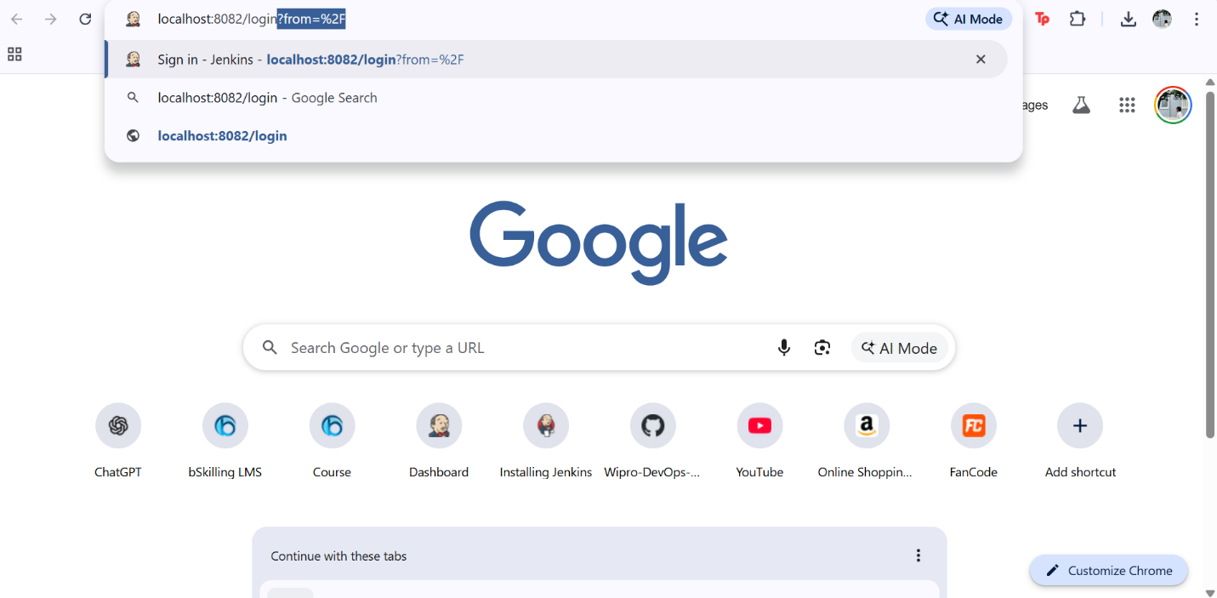
Step 2: Enter Username and Password
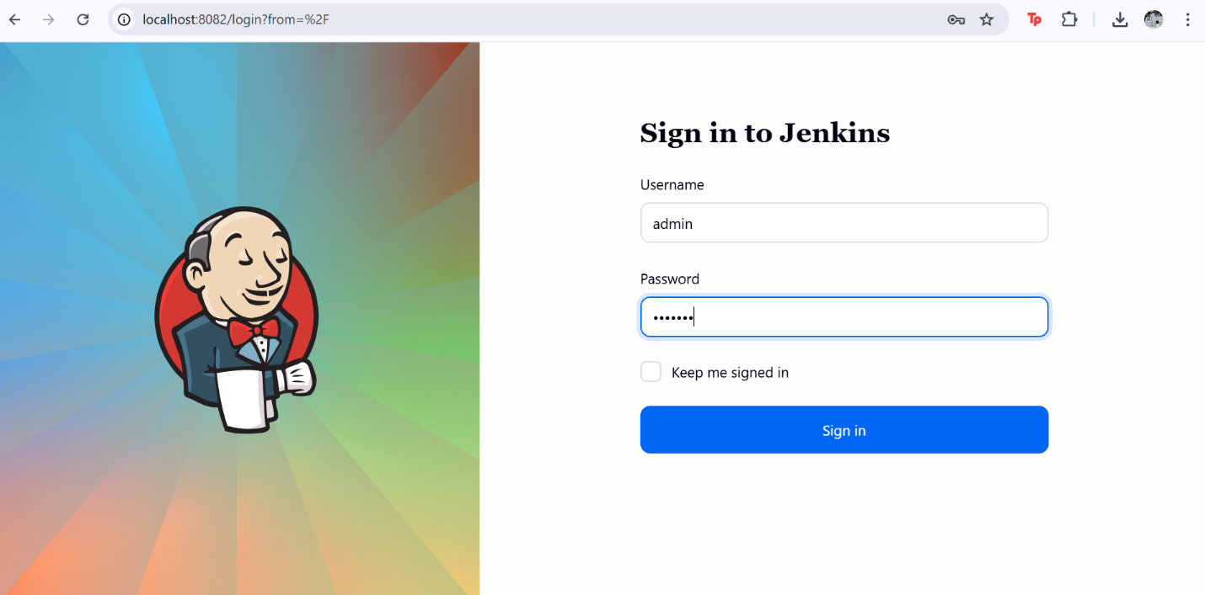
Step 3: Create a New Job
Click on New Item (left side )
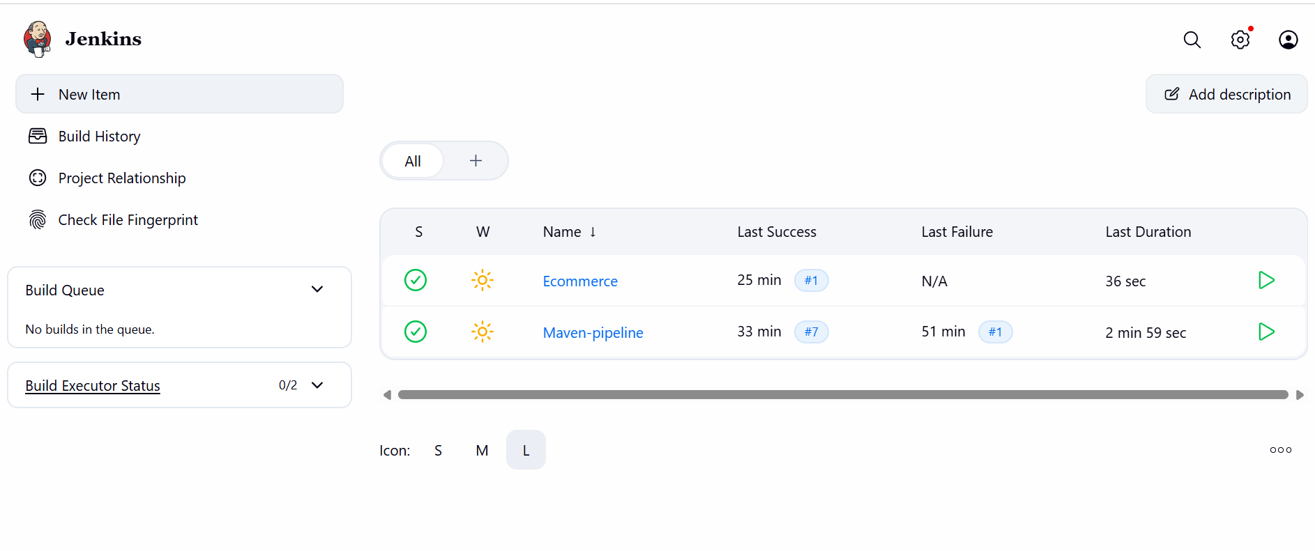

Step 4: Enter Job Details
Enter Item Name (Example: Maven)
Select Freestyle project
Click OK

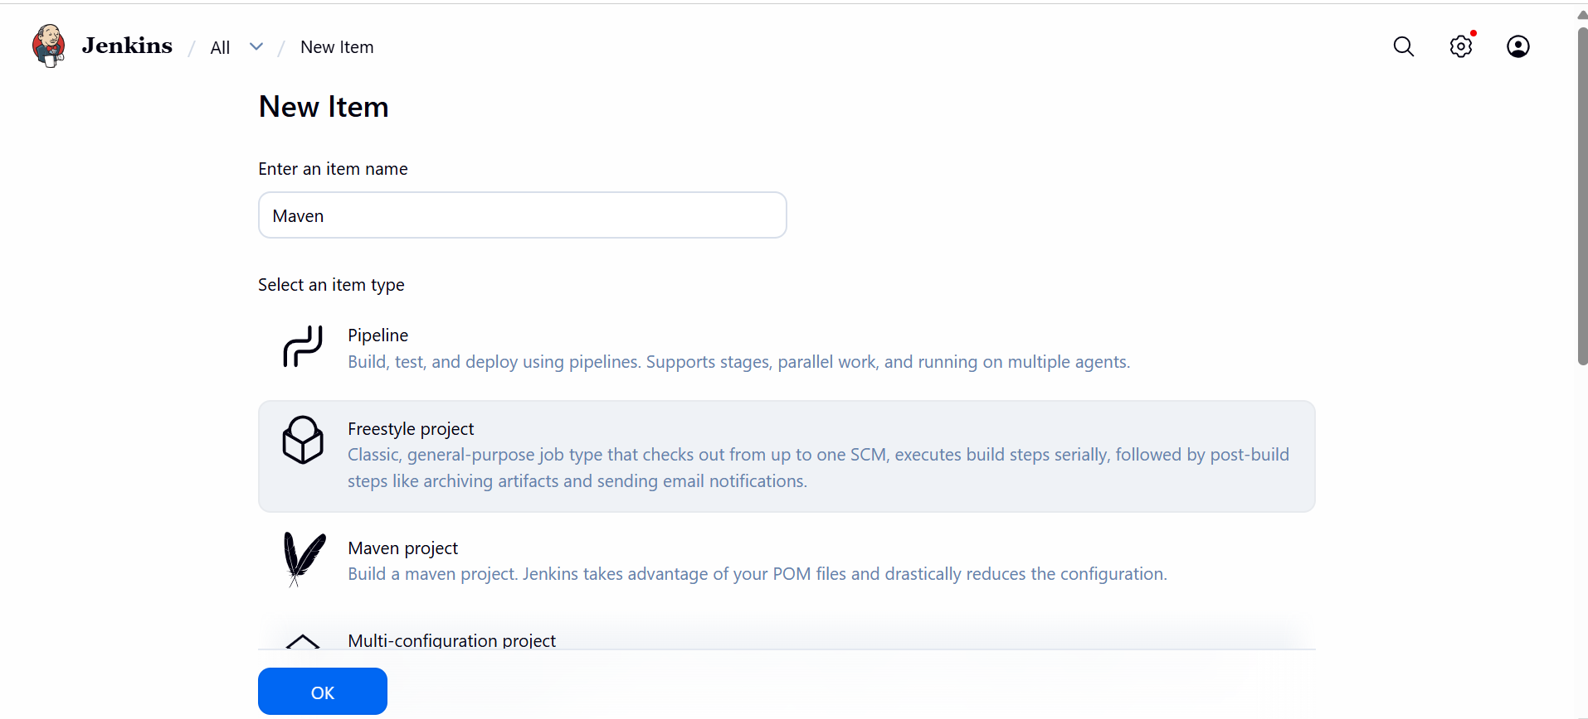
Step 5: Configure Source Code Management (Git)
Choose Git.
Enter the Repository URL: https://github.com/Msocial123/maven-web-application.git
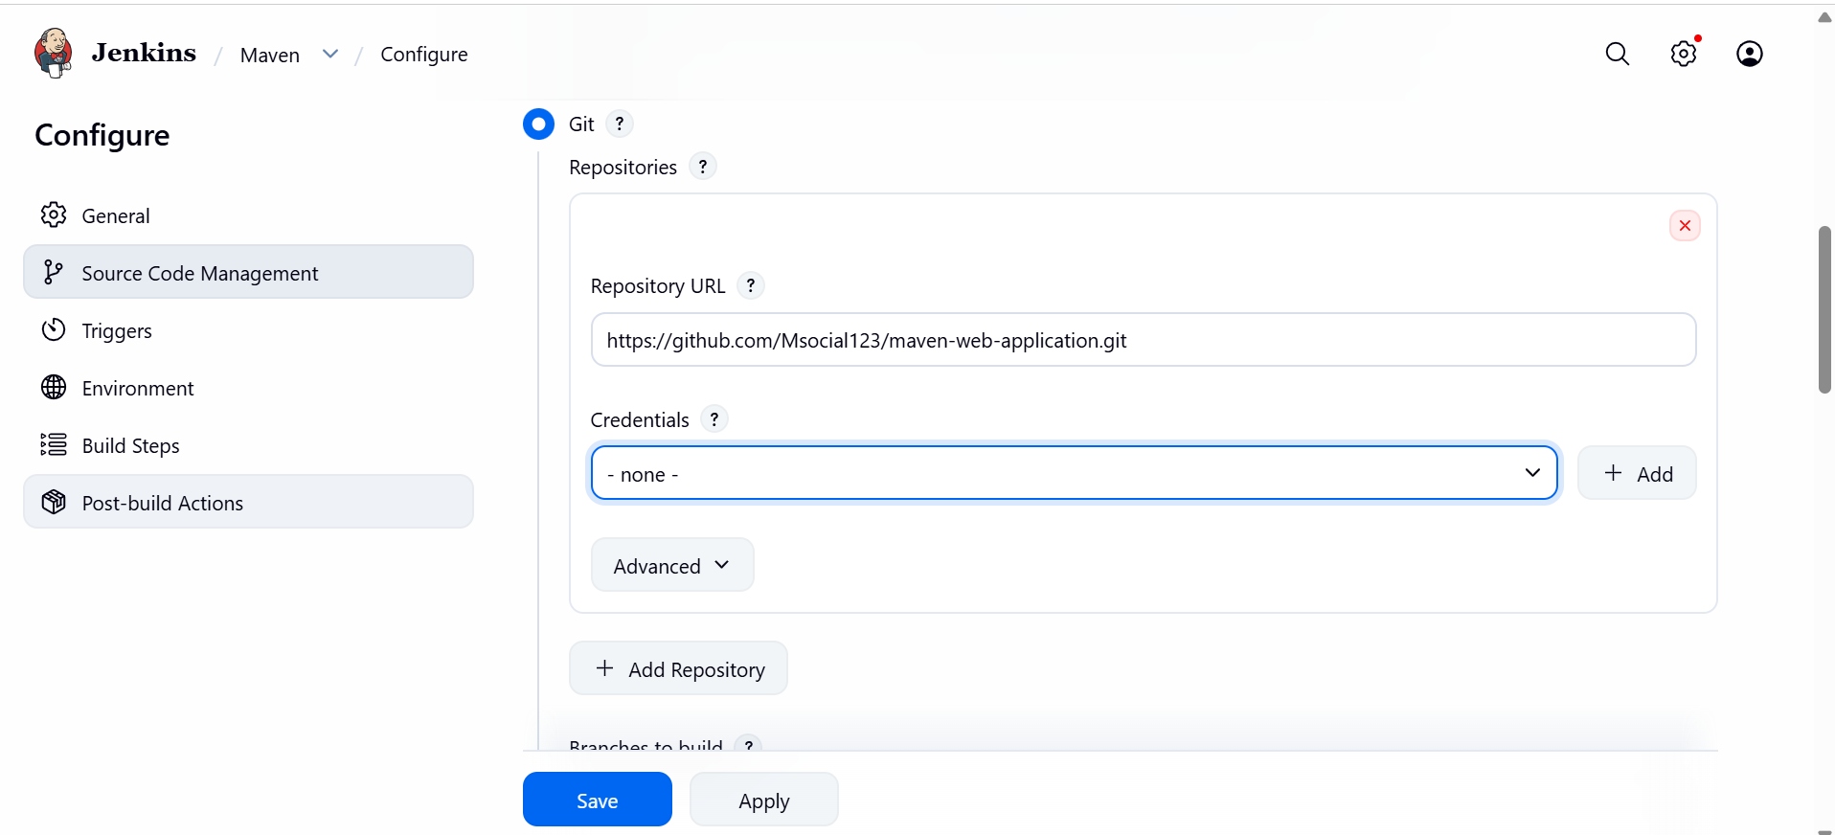Step 6: Configure Build Step (Maven Build)
Scroll down to Build Steps.Click on Add build step.
Select Invoke top-level Maven targets.

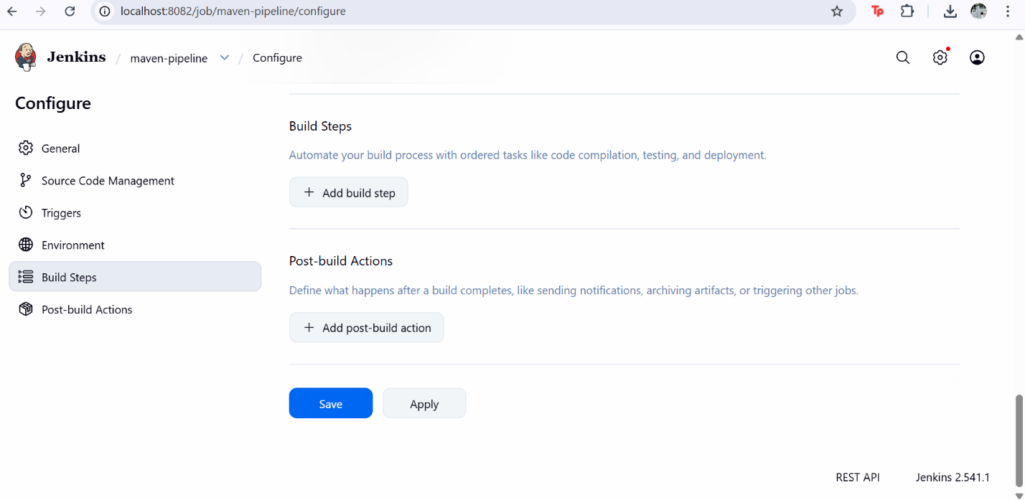

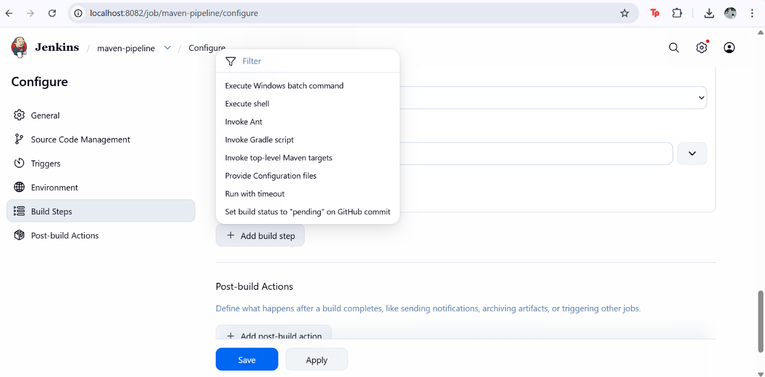
Step 7: In Post-build Action
Under Maven Version, select: Maven
In the Goals field, enter: clean package
This command cleans the project and creates the WAR file.
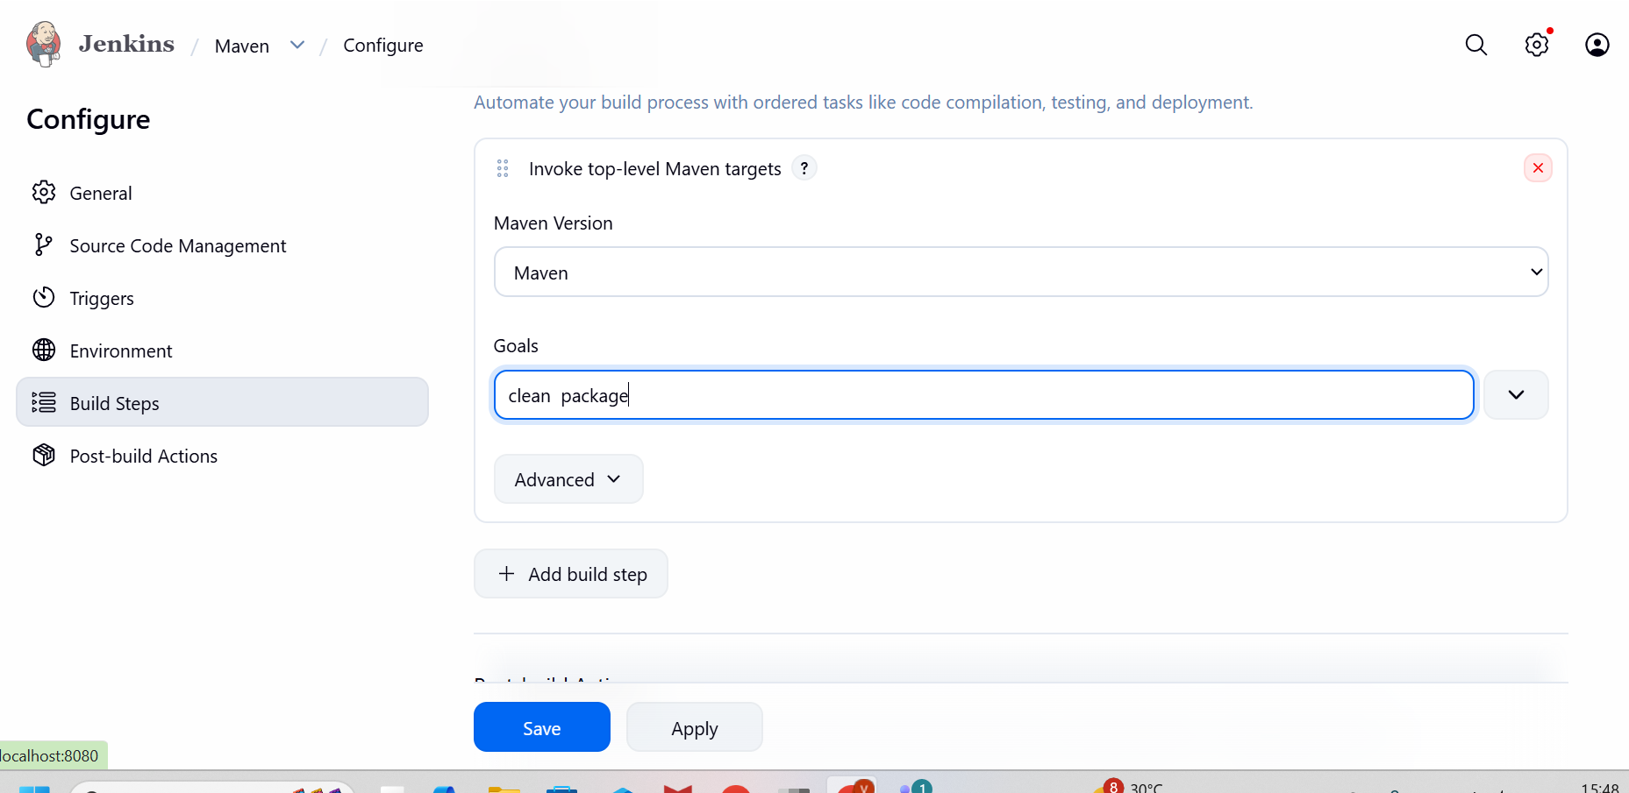

Step8: Scroll down to Post-build Actions.
Click Add post-build action.
Select Deploy war/ear to a container.

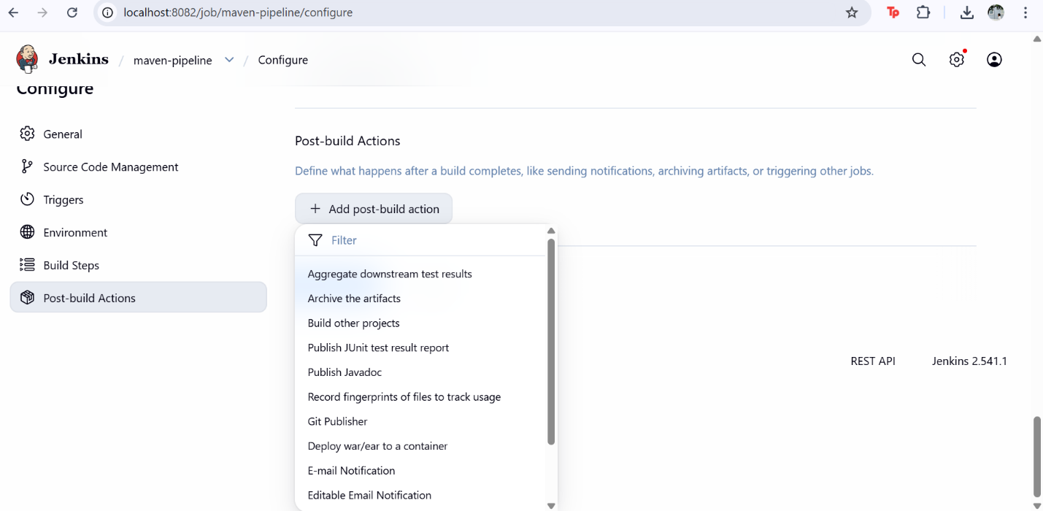

Step 9: Configure WAR File Path
In WAR/EAR files, enter:
**/*.war
Leave Context path empty.
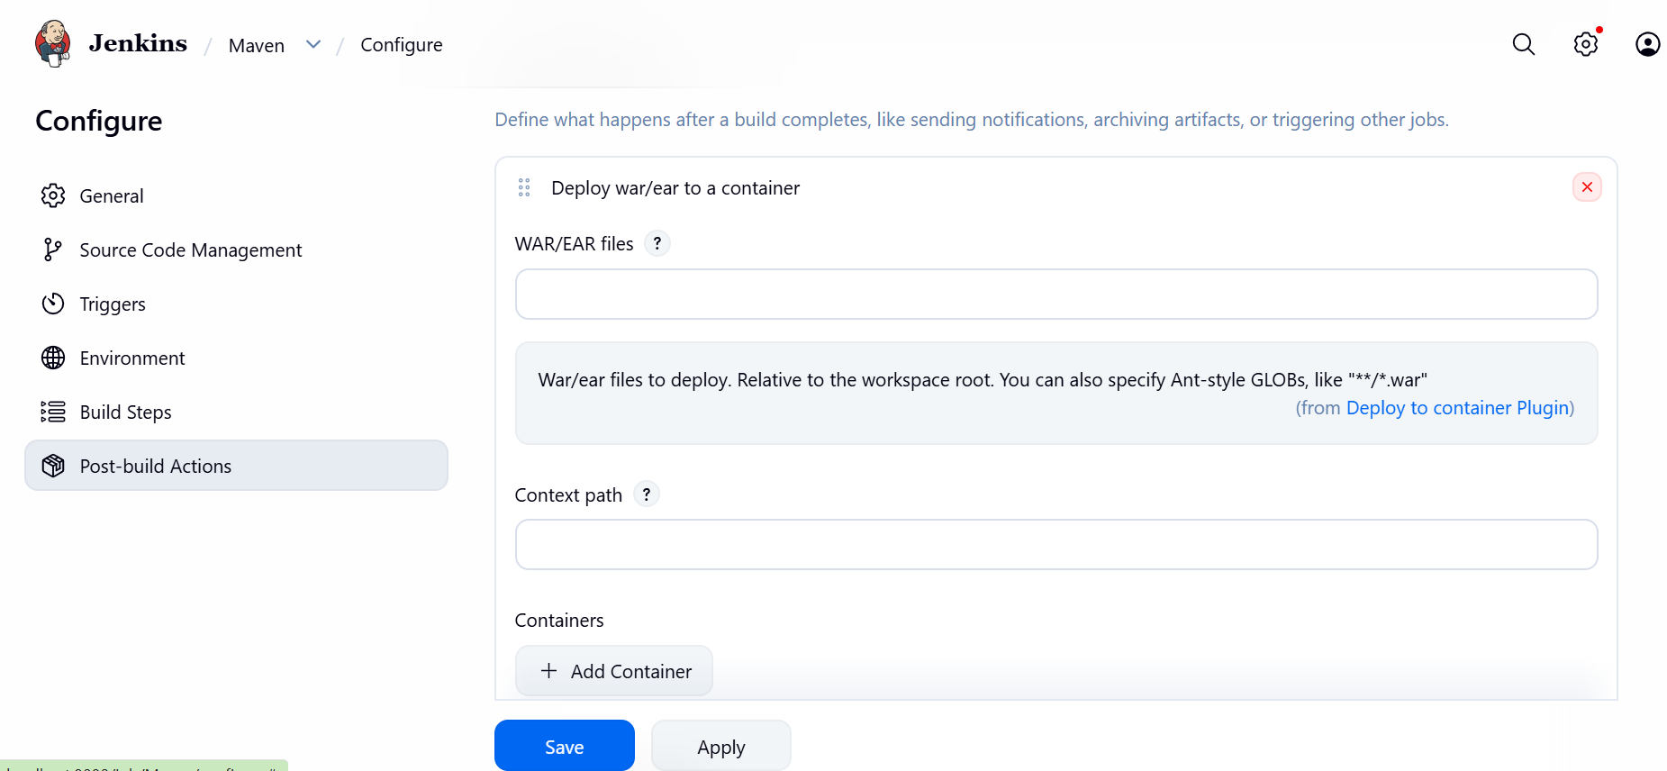
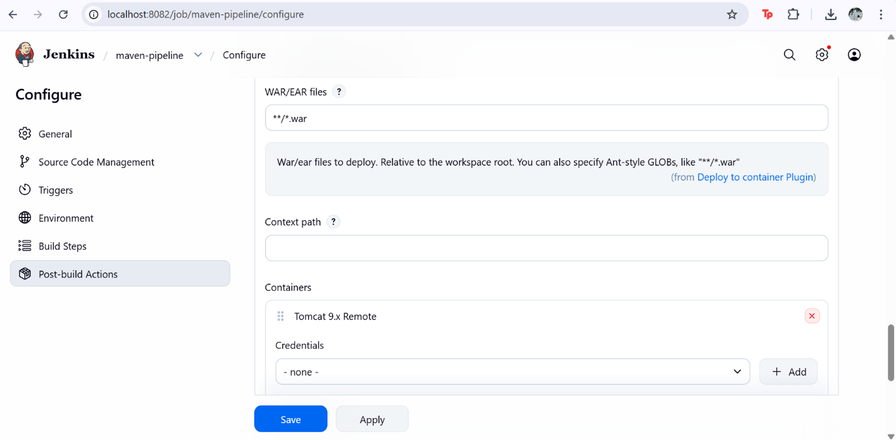
Step 10: Configure Tomcat Container Click Add Container.
Select Tomcat 9.x Remote. Choose Credentials: Sukhesh / ** (tomcat-credentials)
Enter Tomcat URL:https://localhost:8081
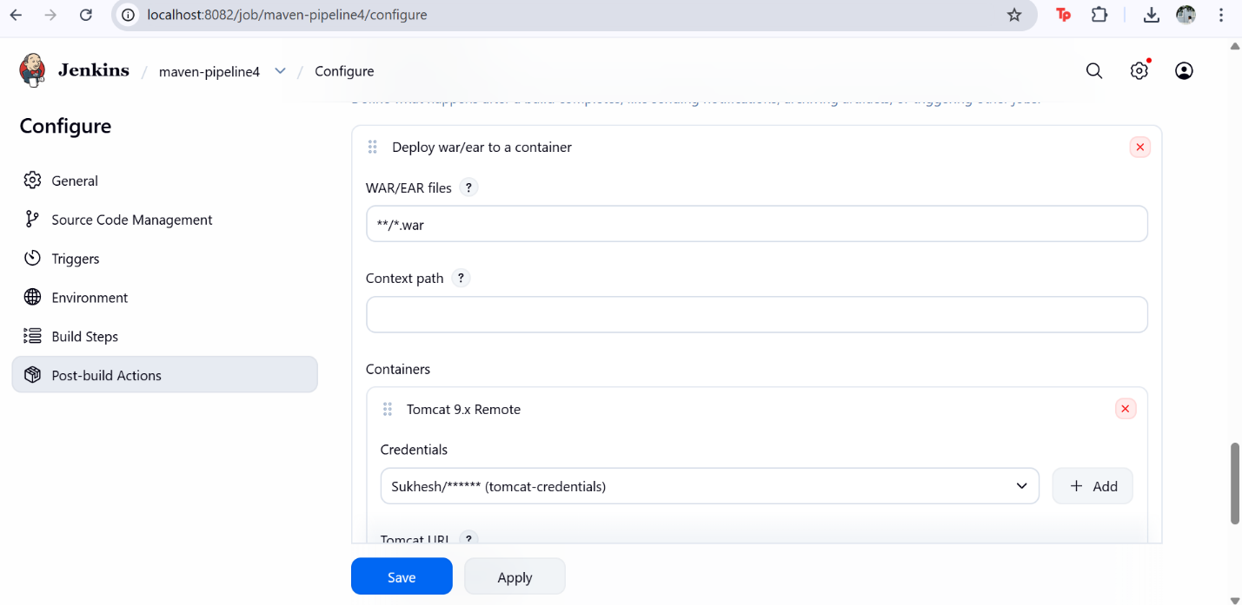
Step 11: Save Post-Build Configuration
Click Save.
Green Saved message appears.
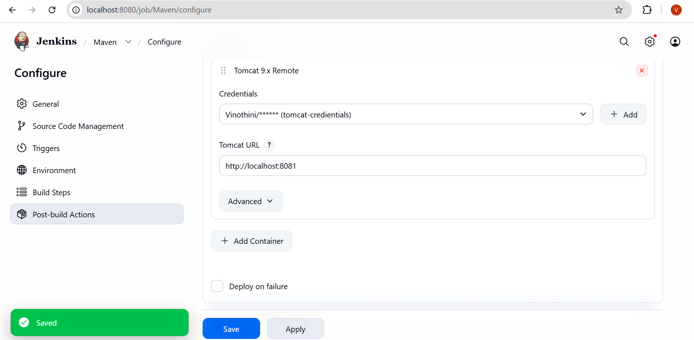
Step 12: Build the Job
Go back to the Jenkins job dashboard.
Click Build Now.
A build number (#1) will appear under Builds
Green tick means Build Success
Step 13: Check Build Status
Click on the build number
Open Console Output
Verify that:
Maven build is successful
WAR file is deployed to Tomcat

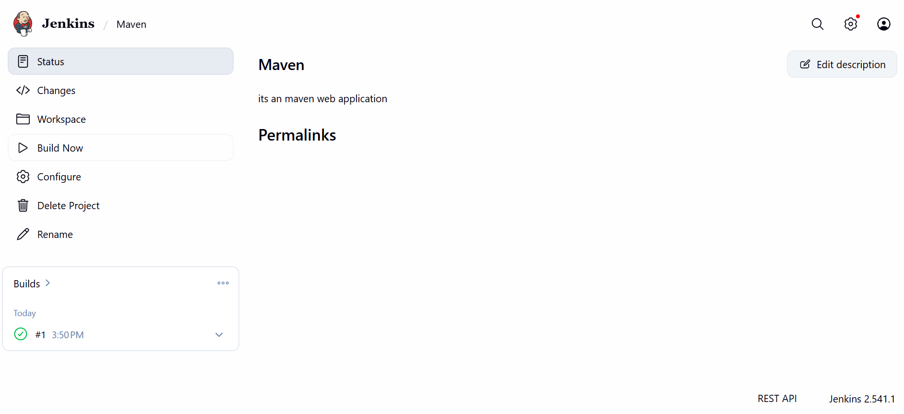
Step 14: Verify Application in Browser
Open browser
Enter URL: localhost:8082

Step 15: Click on the application name /maven-web-application
Application page should load successfully

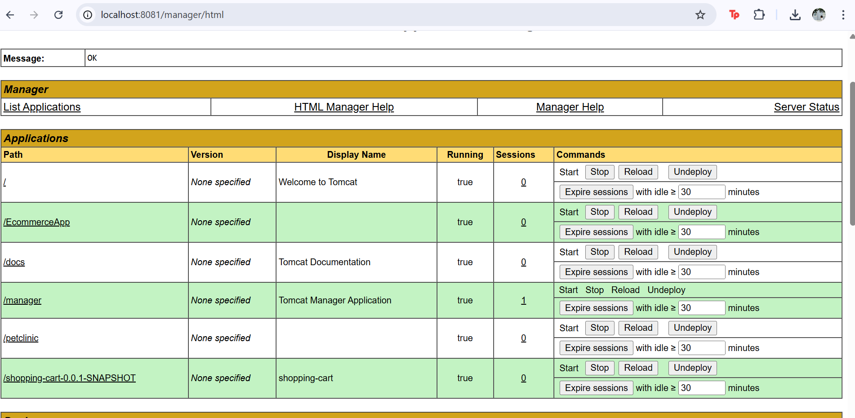
Step 16: Final Output
Jenkins build completed successfully
Application deployed on Tomcat server
Web application accessible through browser

