CLINICAL STUDY RESULTS REPORT
A Phase 3, Randomized, Double-Blind, Placebo-Controlled Study of Darbepoetin Alfa in Adults with Previously Untreated Extensive-Stage Small Cell Lung Cancer Receiving Platinum-Based Chemotherapy
Study Protocol: NCT00119613 / Amgen Study 20010145
Report Version 1.0 | June 2026 | DRAFT
Prepared by: Sukhesh Sudan, MPH, BDS
Secondary analysis of de-identified Phase 3 RCT data obtained from Project Data Sphere under data use agreement. Used for methodological demonstration purposes only. No novel clinical conclusions are intended.

Abstract
Background: Darbepoetin alfa (Aranesp) is an erythropoiesis-stimulating agent (ESA) hypothesized to improve overall survival (OS) in cancer patients through correction of chemotherapy-induced anemia. This report presents a secondary analysis of a Phase 3, double-blind, placebo-controlled randomized trial (NCT00119613) evaluating darbepoetin alfa versus placebo in adults with previously untreated extensive-stage small cell lung cancer (ES-SCLC) receiving platinum/etoposide chemotherapy.
Methods: Individual patient data (N=479; note: trial enrolled N=600, with N=479 patients in the data release from Project Data Sphere) were analyzed. The intent-to-treat (ITT) population was the primary analysis population for efficacy. Overall survival was analyzed using Kaplan-Meier estimation, log-rank test, and Cox proportional hazards regression. Safety was summarized in the safety population using treatment-emergent adverse events (TEAEs). Patient-reported quality of life (QoL) was assessed descriptively using FACT-F, FACT-G, HSI, and EQ-5D VAS. A per-protocol (PP) sensitivity analysis was pre-specified in the Statistical Analysis Plan.
Results: The primary OS analysis demonstrated no statistically significant difference between treatment arms (HR 1.122, 95% CI 0.921–1.367, log-rank p=0.2534). Median OS was 9.1 months (darbepoetin) versus 9.0 months (placebo). The PP sensitivity analysis (HR 1.05, 95% CI 0.851–1.296, p=0.6485) was directionally consistent. Despite pharmacological activity confirmed by a near 3-fold reduction in anemia incidence (12.1% vs 30.4%), darbepoetin did not improve patient-reported fatigue (FACT-F: 32.3 vs 31.4 at end of study) or general QoL. A clinically meaningful excess of cardiovascular and thromboembolic TEAEs was observed in the darbepoetin arm (23.0% vs 14.2%), with embolism/thrombosis occurring in 9.6% versus 4.6% of patients.
Conclusions: Darbepoetin alfa did not improve OS or patient-reported QoL in ES-SCLC patients receiving platinum/etoposide chemotherapy. The drug was pharmacologically active but was associated with a clinically important thromboembolic and cardiovascular safety signal. These findings are consistent with the evidence base that informed the FDA's 2008 black box warning for ESAs in oncology.

1. Background and Rationale
Darbepoetin alfa (Aranesp/NESP) is a long-acting erythropoiesis-stimulating agent that stimulates red blood cell production via erythropoietin receptor activation. Chemotherapy-induced anemia is a common and debilitating complication in patients receiving cytotoxic chemotherapy, associated with fatigue, reduced functional status, and potentially compromised treatment tolerance. ESAs were developed partly on the hypothesis that correcting anemia would improve both quality of life and, potentially, survival outcomes in cancer patients.
Extensive-stage small cell lung cancer (ES-SCLC) is an aggressive malignancy with poor prognosis, with median overall survival in the range of 8–12 months with standard platinum/etoposide chemotherapy. Anemia is highly prevalent in this population, making it a plausible target for ESA intervention.
This secondary analysis of Amgen study 20010145 (NCT00119613) was conducted to demonstrate application of Phase 3 clinical trial biostatistics methods, including CDISC-consistent dataset construction (ADSL, ADTTE), ITT/PP population definitions, Kaplan-Meier survival analysis, Cox proportional hazards regression, and clinical safety summarization, using real de-identified individual patient data from Project Data Sphere.

2. Methods
Full methodological detail is provided in the companion Study Protocol (v1.0) and Statistical Analysis Plan (SAP, v1.0). Key elements are summarized below.

2.1 Study Design
Phase 3, randomized, double-blind, placebo-controlled trial. Patients with previously untreated ES-SCLC were randomized 1:1 to receive darbepoetin alfa (NESP) or placebo in addition to standard platinum/etoposide chemotherapy.

2.2 Data Source
De-identified individual patient data were obtained from Project Data Sphere (projectdatasphere.org) under a data use agreement for non-commercial methodological research. The trial enrolled 600 patients (300 per arm); the Project Data Sphere data release contains individual patient data for 479 patients, which constitutes the analysis population for this report. This partial data release is noted as a limitation.

2.3 Analysis Populations
Population | Definition | Used For
Intent-to-Treat (ITT) | All 479 patients with available data, analyzed in assigned arm | Primary OS efficacy analysis; QoL analyses
Safety Population | All patients receiving ≥1 dose of assigned study treatment (darbepoetin or placebo) | All TEAE and safety analyses (N=239 darb, N=240 placebo)
Per-Protocol (PP) | Patients completing ≥2 chemotherapy cycles without major protocol deviation | OS sensitivity analysis (N=426)

2.4 Statistical Methods
- Overall survival: Kaplan-Meier estimation; log-rank test (two-sided α=0.05); Cox proportional hazards model with treatment arm as the sole predictor (randomization balances confounders)
- Proportional hazards assumption tested via Schoenfeld residuals (cox.zph)
- Subgroup analyses: pre-specified subgroups (ECOG 0-1 vs 2+; age <65 vs ≥65; sex) — exploratory, no alpha adjustment
- Safety: TEAEs summarized at patient level (unique patients per event category); denominators = safety population by arm
- QoL: descriptive means (SD) by arm and timepoint; no formal hypothesis testing (not powered per SAP Section 6.3)
- All analyses conducted in R v4.3.3; random seed set.seed(2026)

3. Results

3.1 Patient Disposition and Baseline Characteristics
Of 479 patients with available data, 239 were assigned to darbepoetin alfa and 240 to placebo. Baseline characteristics were well balanced between arms, consistent with successful randomization (Table 1). Mean age was 61 years in both arms; approximately one-third of patients were female; ECOG performance status 0-1 was present in approximately 80% of patients in each arm, with ECOG 2 in approximately 20%.

Table 1. Baseline Characteristics — ITT Population (N=479)
Abbreviations: ECOG, Eastern Cooperative Oncology Group performance status; SD, standard deviation. N=479 reflects patients in the Project Data Sphere data release (full trial enrollment N=600).
Characteristic | Darbepoetin Alfa (n=239) | Placebo (n=240) | Total (N=479)
Age, years, mean (SD) | 60.9 (9.2) | 61.4 (8.1) | 61.2 (8.7)
Sex, Female, n (%) | 88 (37%) | 76 (32%) | 164 (34%)
Sex, Male, n (%) | 151 (63%) | 164 (68%) | 315 (66%)
ECOG 0, n (%) | 48 (20%) | 37 (15%) | 85 (18%)
ECOG 1, n (%) | 143 (60%) | 151 (63%) | 294 (61%)
ECOG 2, n (%) | 48 (20%) | 52 (22%) | 100 (21%)

3.2 Primary Efficacy: Overall Survival
The primary analysis did not demonstrate a statistically significant difference in overall survival between darbepoetin alfa and placebo (Table 2). Median OS was 9.1 months (278 days, 95% CI: 260–311 days) in the darbepoetin arm and 9.0 months (275 days, 95% CI: 259–302 days) in the placebo arm. A total of 397 deaths were observed (192 in the darbepoetin arm [64.0%] and 205 in the placebo arm [68.3%]). The Cox proportional hazards model yielded a hazard ratio of 1.122 (95% CI: 0.921–1.367; p=0.2534), indicating a point estimate numerically favoring placebo, though not reaching statistical significance. The six-month OS probability was 77.4% for darbepoetin and 73.5% for placebo; twelve-month OS probability was 34.4% and 30.6%, respectively. The proportional hazards assumption was not violated (Schoenfeld residuals global test p=0.45).

Table 2. Primary and Sensitivity Analysis Results — Overall Survival
HR, hazard ratio; CI, confidence interval. HR >1.0 indicates higher hazard (shorter survival) in the darbepoetin arm. Primary analysis: ITT population. PP: per-protocol population (N=426).
Endpoint | Darbepoetin Alfa | Placebo | HR (95% CI) | p-value
N | 239 | 240 | — | —
Deaths, n (%) | 192 (64.0%) | 205 (68.3%) | — | —
Median OS, days (95% CI) | 278 (260–311) | 275 (259–302) | — | —
Median OS, months | 9.1 | 9.0 | — | —
6-month OS probability | 77.4% | 73.5% | — | —
12-month OS probability | 34.4% | 30.6% | — | —
Primary analysis (ITT) | — | — | 1.122 (0.921–1.367) | 0.2534
Sensitivity (Per-Protocol) | — | — | 1.050 (0.851–1.296) | 0.6485

The Kaplan-Meier curves (Figure 1) demonstrate overlapping survival trajectories throughout the 24-month follow-up period, with median OS intersecting at approximately 9 months in both arms. The curves run essentially parallel, with placebo numerically superior at most timepoints from approximately month 6 onward, consistent with the hazard ratio point estimate above 1.0. Widening confidence intervals at months 18–24 reflect decreasing numbers at risk (17 darbepoetin, 12 placebo at month 24) rather than a genuine late treatment effect.

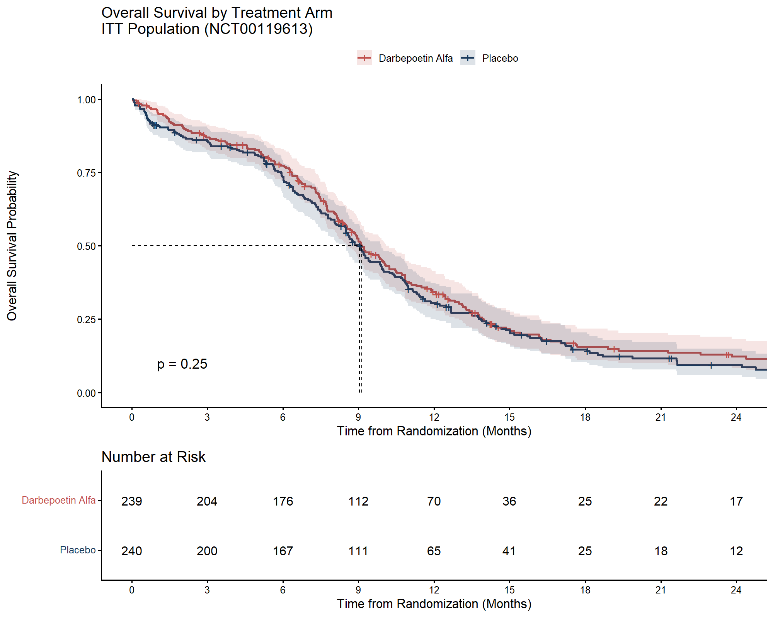
Figure 1. Kaplan-Meier Curves — Overall Survival by Treatment Arm, ITT Population
Dashed horizontal line marks S(t)=0.50 (median OS). Shaded bands represent 95% confidence intervals. Number-at-risk table shows patients remaining under follow-up at each 3-month interval. Log-rank p=0.25.

3.3 Subgroup Analyses
Pre-specified subgroup analyses were conducted for ECOG performance status (0-1 vs 2+), age (<65 vs ≥65 years), and sex (Figure 2). Consistent with the overall ITT result, all subgroups showed hazard ratios at or above 1.0, with no subgroup demonstrating a survival benefit favoring darbepoetin. The ECOG 2+ subgroup showed the highest point estimate (HR 1.293, 95% CI 0.846–1.978), suggesting potentially greater harm in patients with poorer functional status, though confidence intervals were wide given the small sample size (n=100). No statistically significant treatment-by-subgroup interaction was identified. These analyses are exploratory and should not be interpreted as confirmatory.

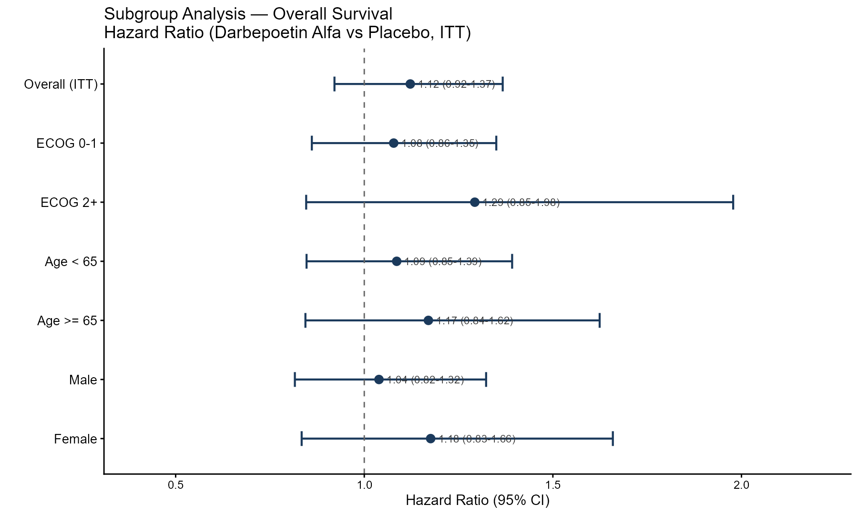
Figure 2. Forest Plot — Subgroup Analysis of Overall Survival (Darbepoetin Alfa vs Placebo, ITT)
Exploratory analyses only. Dashed vertical line at HR=1.0 denotes no treatment effect. All point estimates are above 1.0, consistent with the overall ITT finding. CI, confidence interval; ECOG, Eastern Cooperative Oncology Group.

3.4 Safety

3.4.1 Overview of Treatment-Emergent Adverse Events
Safety analyses were conducted in the safety population (N=239 darbepoetin, N=240 placebo). Overall TEAE rates were high in both arms (96.2% vs 97.5%), reflecting the substantial toxicity of platinum/etoposide chemotherapy (Table 3). Drug-related TEAEs were low and similar between arms (5.4% vs 5.8%), consistent with the chemotherapy regimen, rather than the study drug, driving most adverse events. The key safety differentiator between arms was the rate of cardiovascular and thromboembolic events.

Table 3. Treatment-Emergent Adverse Event (TEAE) Summary — Safety Population
Adverse events graded by investigator-assessed severity (Mild/Moderate; CTCAE Grade 1-5 not available in this dataset — noted as a data limitation). SAE, serious adverse event. All counts are unique patients (patient-level, not event-level). % = n/N safety population per arm.
AE Category | Darbepoetin Alfa (n=239) | Placebo (n=240)
Any TEAE | 230 (96.2%) | 234 (97.5%)
Any Moderate TEAE | 210 (87.9%) | 213 (88.8%)
Any Serious AE (SAE) | 109 (45.6%) | 97 (40.4%)
Any Drug-Related TEAE | 13 (5.4%) | 14 (5.8%)
Any TEAE Leading to Hospitalization | 86 (36.0%) | 80 (33.3%)
Any Cardiac/Cardiovascular TEAE | 55 (23.0%) | 34 (14.2%)

3.4.2 Cardiovascular and Thromboembolic Events
The most clinically significant safety finding was an excess of cardiovascular and thromboembolic TEAEs in the darbepoetin arm compared to placebo (23.0% vs 14.2%). Detailed subcategory analysis (Table 4) revealed that embolism and thrombosis accounted for the largest excess: 23 darbepoetin patients (9.6%) versus 11 placebo patients (4.6%) — a more than two-fold higher rate. Cerebrovascular accidents were also more frequent in the darbepoetin arm (11 vs 6 patients; 4.6% vs 2.5%), as were myocardial infarction/coronary artery disorders (8 vs 3 patients; 3.3% vs 1.3%). Arrhythmias were balanced between arms (12 vs 13 patients). Congestive heart failure was numerically higher in the placebo arm (5 vs 9 patients). The pattern of excess thromboembolic and ischemic vascular events in the darbepoetin arm is consistent with the known pharmacological mechanism of ESAs — stimulation of erythropoiesis increases hematocrit and blood viscosity, raising thrombotic risk — and is the primary safety concern underlying the 2008 FDA black box warning for this drug class in oncology.

Table 4. Cardiovascular and Thromboembolic TEAE Subcategories — Safety Population
Counts represent unique patients experiencing at least one event in each subcategory. Embolism/Thrombosis includes deep vein thrombosis, pulmonary embolism, and related events.
Cardiac/CV Subcategory | Darbepoetin Alfa (n=239) | % Darb | Placebo (n=240) | % Plac
Embolism / Thrombosis | 23 | 9.6% | 11 | 4.6%
Arrhythmias | 12 | 5.0% | 13 | 5.4%
Cerebrovascular Accident | 11 | 4.6% | 6 | 2.5%
Myocardial Infarction / Coronary Artery Disorders | 8 | 3.3% | 3 | 1.3%
Congestive Heart Failure | 5 | 2.1% | 9 | 3.8%

3.4.3 Most Frequent TEAEs
The most common TEAEs in both arms were consistent with the known toxicity profile of platinum/etoposide chemotherapy: nausea (46.9% vs 42.1%), neutropenia (37.7% vs 33.3%), vomiting (29.7% vs 32.1%), alopecia (23.8% vs 23.8%), and thrombocytopenia (20.5% vs 14.6%). The most notable between-arm difference in common TEAEs was anemia, which occurred in only 12.1% of darbepoetin patients versus 30.4% of placebo patients — a near 3-fold reduction confirming that darbepoetin alfa was pharmacologically active in raising hemoglobin and preventing anemia. This pharmacodynamic proof-of-activity, occurring in the context of no OS or QoL benefit and a meaningful CV safety signal, represents the central paradox of this trial.

3.5 Quality of Life

3.5.1 FACT-F Fatigue Score
FACT-F fatigue scores were similar between arms at baseline (31.2 vs 30.5) and at all subsequent timepoints (Table 5, Figure 3). Both arms showed improvement from baseline through Week 24 (darbepoetin: +3.1 points; placebo: +1.4 points change from baseline at Week 24), followed by decline at Week 50 and end of study. No between-arm difference reached or approached the pre-established Minimum Clinically Important Difference (MCID) of 3–4 points for FACT-F. End-of-study mean scores were 32.3 (darbepoetin) versus 31.4 (placebo). This analysis is consistent with a null fatigue treatment effect.

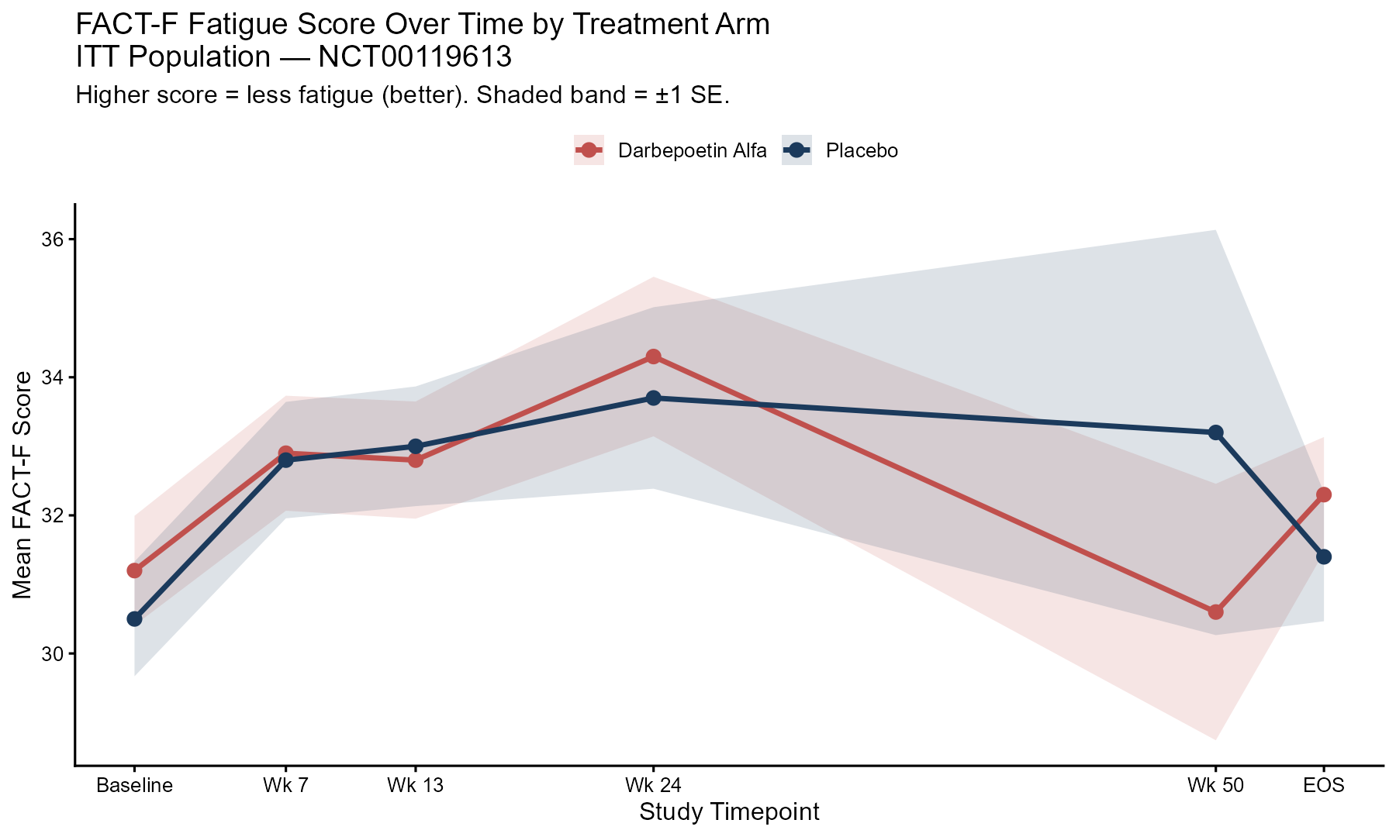
Figure 3. FACT-F Fatigue Score Over Time by Treatment Arm — ITT Population
Higher score = less fatigue (better). Shaded bands = ±1 SE. Declining patient numbers at later timepoints (Week 50: N=24 darb, N=17 placebo) reflect deaths and withdrawals; interpretation at Week 50 should be cautious given survivor selection bias. MCID for FACT-F = 3-4 points.

Table 5. FACT-F Fatigue Score by Arm and Timepoint — ITT Population
Mean (SD). Higher score = less fatigue. N declines over time due to deaths and study withdrawals. MCID = minimum clinically important difference (3–4 points for FACT-F).
Timepoint | Darb N | Darb Mean (SD) | Plac N | Plac Mean (SD) | Difference
Baseline | 203 | 31.2 (11.3) | 195 | 30.5 (11.6) | +0.7
Week 7 | 194 | 32.9 (11.6) | 186 | 32.8 (11.5) | +0.1
Week 13 | 165 | 32.8 (10.9) | 170 | 33.0 (11.3) | -0.2
Week 24 | 81 | 34.3 (10.4) | 89 | 33.7 (12.4) | +0.6
Week 50 | 24 | 30.6 (9.1) | 17 | 33.2 (12.1) | -2.6
End of Study | 200 | 32.3 (11.8) | 194 | 31.4 (13.0) | +0.9

3.5.2 FACT-G General QoL and EQ-5D VAS
FACT-G total scores were essentially identical between arms at all timepoints (Table 6). Baseline scores were 69.3 versus 69.1, with both arms showing modest improvement through Week 24 and remaining stable through end of study (70.0 vs 69.9), reflecting no treatment effect on general quality of life.
EQ-5D VAS scores (Figure 4) showed a small but consistent numerical advantage for the darbepoetin arm across Weeks 7 through 24 (e.g., Week 13: 68.5 vs 66.1; Week 24: 70.1 vs 67.9). End-of-study mean VAS was 67.0 (darbepoetin) versus 64.5 (placebo), a 2.5-point difference. This analysis is descriptive and exploratory; no formal hypothesis test was pre-specified for this endpoint. The small consistent difference is considered hypothesis-generating only and does not alter the overall conclusion of no clinically meaningful QoL benefit.
The Hemoglobin Symptom Index (HSI) was virtually identical between arms throughout the study (0.7 vs 0.6–0.7 at all timepoints), despite the near 3-fold reduction in anemia incidence in the darbepoetin arm. This is the most pharmacologically striking QoL finding: it directly demonstrates that hemoglobin correction, while biologically real, did not translate into meaningful patient-reported symptom relief — reinforcing that anemia incidence is an inadequate surrogate for patient-relevant outcomes.

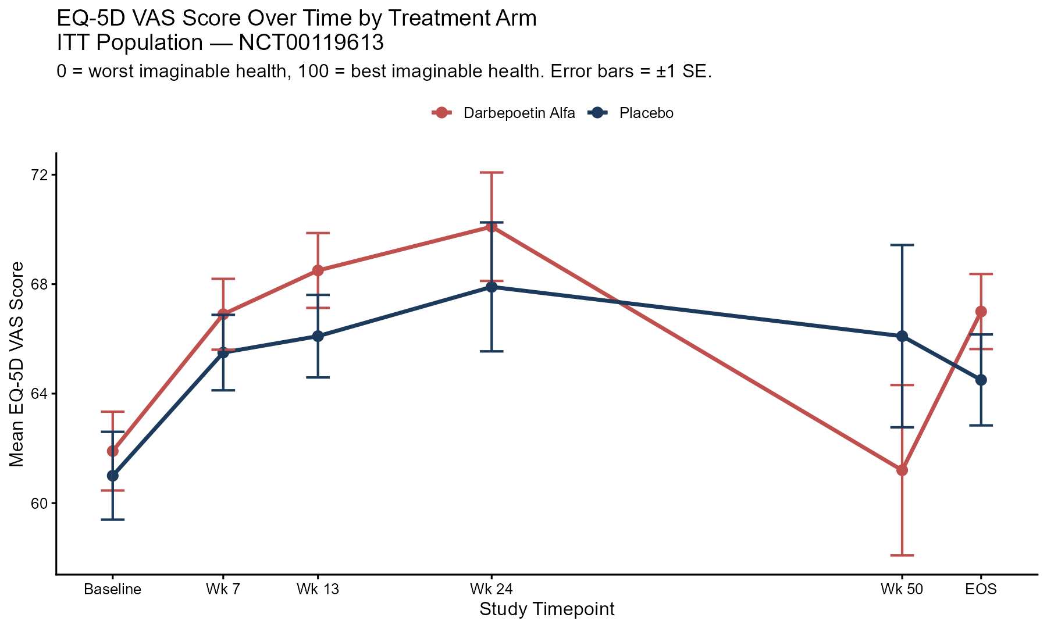
Figure 4. EQ-5D VAS Score Over Time by Treatment Arm — ITT Population
Scale 0–100; 100 = best imaginable health. Error bars = ±1 SE. Exploratory analysis only; no formal hypothesis testing pre-specified. Small consistent numerical advantage for darbepoetin arm is hypothesis-generating. HEOR note: EQ-5D VAS is used as input to cost-effectiveness models in HTA submissions (NICE, PBAC).

Table 6. FACT-G Total Score and EQ-5D VAS by Arm and Timepoint — ITT Population
All values: mean (SD). Higher = better. EQ-5D VAS 0–100 scale. Analyses descriptive only per SAP Section 6.3.
Timepoint | FACT-G Darb | FACT-G Plac | EQ-5D VAS Darb | EQ-5D VAS Plac
Baseline | 69.3 (16.1) | 69.1 (16.3) | 61.9 (20.0) | 61.0 (21.7)
Week 7 | 71.5 (18.0) | 71.8 (17.2) | 66.9 (17.7) | 65.5 (18.4)
Week 13 | 71.0 (17.1) | 71.2 (17.9) | 68.5 (17.3) | 66.1 (19.2)
Week 24 | 73.0 (16.2) | 74.2 (18.1) | 70.1 (17.5) | 67.9 (22.1)
Week 50 | 71.7 (13.2) | 69.5 (16.2) | 61.2 (14.6) | 66.1 (12.9)
End of Study | 70.0 (17.8) | 69.9 (19.8) | 67.0 (19.3) | 64.5 (22.9)

4. Discussion
This secondary analysis of a Phase 3 randomized controlled trial confirms that darbepoetin alfa did not improve overall survival in patients with previously untreated ES-SCLC receiving platinum/etoposide chemotherapy. The primary Cox model yielded HR 1.122 (95% CI 0.921–1.367, p=0.2534), with the point estimate numerically favoring placebo — a finding that, while not statistically significant, is directionally consistent with harm rather than benefit. The per-protocol sensitivity analysis (HR 1.05) was directionally concordant, supporting the robustness of the primary finding.
The central pharmacological paradox of this trial is now clearly quantified: darbepoetin alfa was unequivocally active in its primary pharmacological mechanism — anemia incidence was 12.1% in the darbepoetin arm versus 30.4% in placebo, a near 3-fold reduction confirming effective erythropoietic stimulation. Yet this biological activity failed to translate into survival benefit, patient-reported fatigue improvement (null FACT-F finding), or meaningful general QoL improvement (null FACT-G and HSI findings). This dissociation between surrogate endpoint response (hemoglobin/anemia correction) and patient-relevant outcomes (OS, QoL) is a textbook example of surrogate endpoint failure — a phenomenon that has driven regulatory reforms in oncology drug approval requiring evidence of direct patient benefit rather than biomarker surrogates alone.
The safety findings add a third dimension to this picture: not only did the drug fail to help, it was associated with a clinically meaningful excess of thromboembolic and cardiovascular events. Embolism and thrombosis occurred in 9.6% of darbepoetin patients versus 4.6% of placebo patients — a more than two-fold higher rate. Cerebrovascular accidents (4.6% vs 2.5%) and MI/coronary events (3.3% vs 1.3%) showed consistent directional excess. The pathophysiological mechanism is well-established: ESAs raise hematocrit and blood viscosity, increasing thrombotic risk, and may directly activate erythropoietin receptors on vascular endothelium, promoting vasoconstriction and platelet aggregation. This thrombogenic mechanism, observed consistently across multiple ESA oncology trials, ultimately drove the FDA's 2008 black box warning.
The subgroup forest plot is instructive: every pre-specified subgroup (ECOG status, age, sex) showed hazard ratios at or above 1.0, with no evidence of a patient subset deriving survival benefit. The directional consistency across subgroups strengthens the conclusion that the null primary result reflects a true treatment effect — or absence thereof — rather than heterogeneous effects canceling each other out.
The EQ-5D VAS analysis warrants brief mention: a small, consistent, descriptive advantage of 2–4 points was observed across several timepoints in the darbepoetin arm. This finding, pre-specified as exploratory and not tested statistically, should not alter the overall conclusion but is hypothesis-generating regarding potential perception-of-health benefit even in the absence of objective QoL or survival improvements. Future powered QoL studies, if conducted, would need to formally evaluate this signal.

4.1 Limitations
- The available dataset represents 479 of 600 randomized patients; the partial data release from Project Data Sphere may not be fully representative of the complete trial population, and original stratification factors (enrollment site) cannot be restored
- Adverse event severity was available only as 2-level Mild/Moderate coding; standard CTCAE Grade 1-5 classification was not available, precluding standard Grade 3/4/5 reporting used in regulatory submissions
- This is a secondary re-analysis; original Amgen analysis conventions, pre-specified stratification variables, and adjudicated event classifications may not be fully replicable from the available data dictionary
- QoL analyses are descriptive and not powered; the declining patient numbers at Week 50 (N=24 darbepoetin, N=17 placebo) reflect substantial survivor selection bias at late timepoints, limiting interpretation
- No data are available on post-discontinuation or post-study treatment that may have influenced OS outcomes

5. Conclusions
Darbepoetin alfa did not improve overall survival (HR 1.122, 95% CI 0.921–1.367, p=0.2534) or patient-reported quality of life in patients with previously untreated ES-SCLC receiving platinum/etoposide chemotherapy. The drug demonstrated clear pharmacodynamic activity through anemia reduction but this did not translate to patient-relevant benefit. The near 2-fold excess of thromboembolic events in the darbepoetin arm (9.6% vs 4.6%) and overall cardiovascular TEAE excess (23.0% vs 14.2%) are consistent with the ESA class safety signal that informed regulatory action. The totality of evidence from this analysis supports the conclusion that darbepoetin alfa provides no net clinical benefit and carries meaningful cardiovascular risk in this patient population.
Methodologically, this analysis demonstrates the application of end-to-end Phase 3 clinical trial biostatistics — CDISC-consistent dataset construction, ITT/PP population derivation, time-to-event primary analysis, pre-specified sensitivity analyses, patient-level safety summarization, and longitudinal QoL assessment — using real de-identified individual patient data from a regulatory-grade oncology trial.

