A PERSONAL MARKETING OPERATING SYSTEM
FOUNDRY
COLLECTIVE

Thirteen specialist agents. Thirty-seven skills. One system that thinks, plans, writes, designs, and reports across every marketing function.
BUILT BY

Vikram Ghatge
VERSION 3.7 · JULY 2026

01
WHAT IT IS
Foundry Collective is a portable marketing operating system built on top of Claude.
It functions as a full marketing department in software form. Each of its thirteen sub-agents represents a sub-function of that department. Together they cover strategy, research, editorial, creative, design, SEO, AI visibility, PR, social, podcast, lead generation, webinars, and analytics.
The system is designed to adapt. A single set of six context files, the brand brain, grounds every decision the team makes. Swap those files and every agent, every skill, every output adjusts automatically to a new brand context. That mechanism is what allows the system to move from one organization to another without a rebuild. It is ready to plug into Anchanto.

THE CORE IDEA
A marketing team is a set of specialists who share context and hand off work. Foundry Collective encodes that pattern. Thirteen specialists, one shared brain, and a set of atomic execution modules they call whenever a specific deliverable is needed.

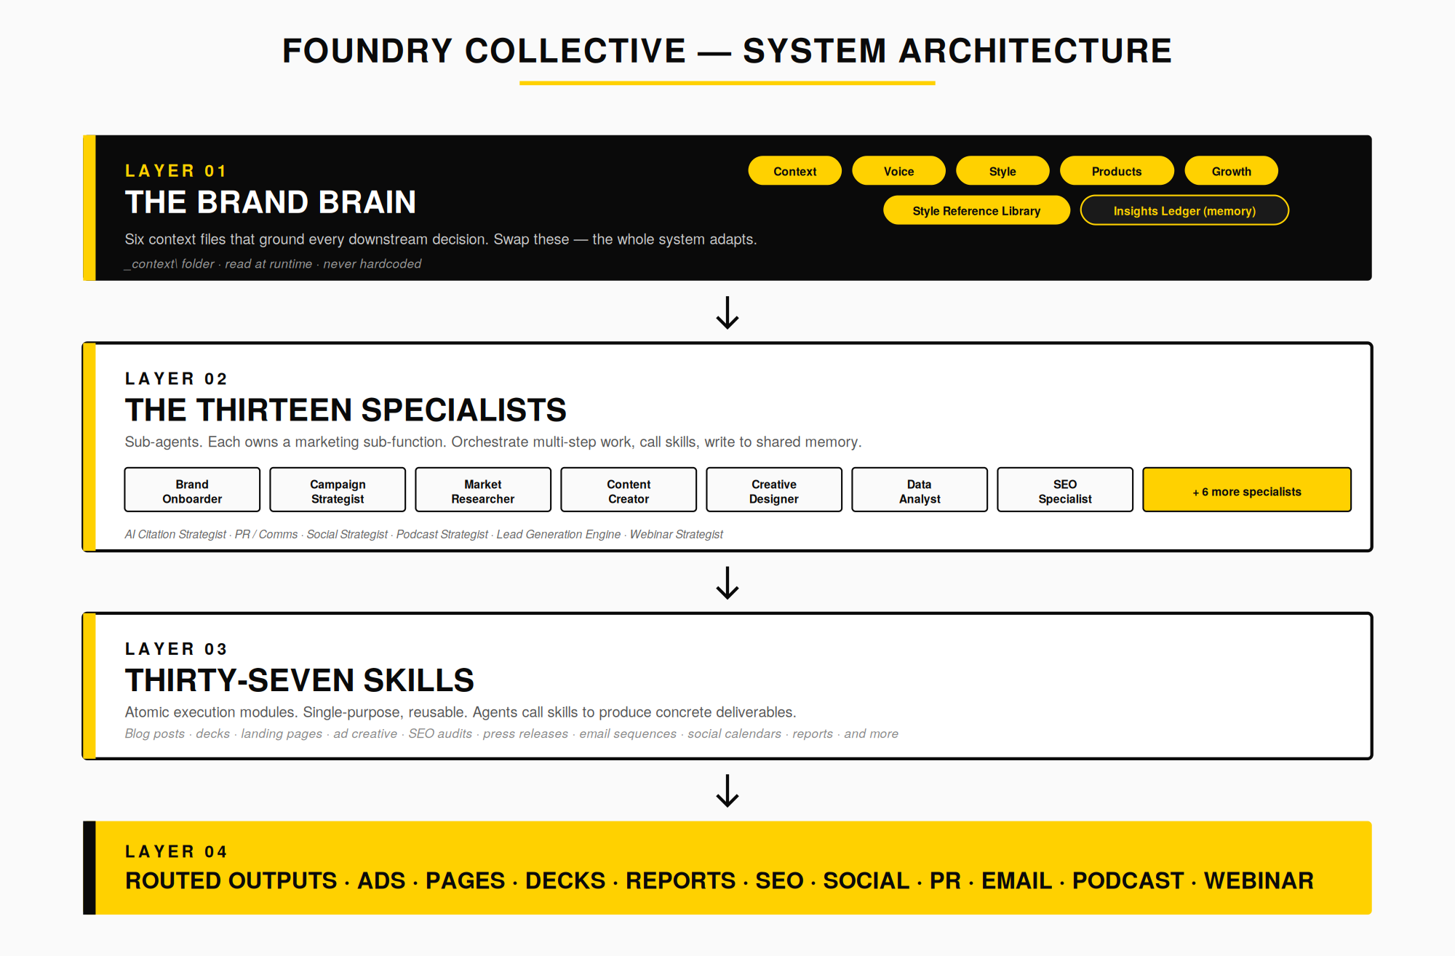
Figure 01: The four-layer architecture. The brand brain grounds every decision. Specialists orchestrate work and call skills. Skills produce deliverables. Deliverables are routed to output folders by type.

02
THE THIRTEEN SPECIALISTS
Each specialist owns a marketing sub-function. They orchestrate multi-step work, call skills to produce concrete outputs, and write learnings back into a shared memory so the team gets sharper over time.

THE SPECIALIST | DOMAIN | WHAT THEY OWN
Brand Onboarder | Intake & Setup | Scrapes a brand URL or ingests materials, then builds the six-file brand brain from scratch.
Campaign Strategist | Strategy | Turns marketing goals into full campaign strategies. Owns paid media, email, and ABM planning.
Market Researcher | Intelligence | Competitive intelligence and keyword research combined into one continuous signal.
Content Creator | Editorial | Multi-format content packages: blog + social + landing page + email in one coherent voice.
Creative Designer | Design | Visual direction, social graphics, ad creative specs, and image production.
Data Analyst | Analytics | Campaign performance analysis with visual reporting. Feeds insights back into strategy.
SEO Specialist | Organic Search | Technical site health, on-page optimization, and SEO strategy.
AI Citation Strategist | AI Visibility | Generative and Answer Engine Optimization. Wins recommendations from AI search.
PR / Comms | Earned Media | Media relations, AP-style press releases, crisis response, and executive thought leadership.
Social Strategist | Social Growth | Channel growth playbook, content calendar planning, and platform-native strategy.
Podcast Strategist | Podcast Program | Show positioning, guest research, scripting, and show notes.
Lead Generation Engine | Demand | Funnel architecture: channel mix, MQL / SQL scoring, and nurture flow design.
Webinar Strategist | Live Events | Concept, agenda, promotion, registration, and follow-up for the webinar program.

HOW THEY DECIDE WHO DOES WHAT
A single bounded deliverable with a clear brief goes straight to a skill. A multi-step effort that needs judgment across formats goes to an agent. "Write me a blog post on X" is a skill call. "We are launching X and need a full content push" is an agent call.

03
THE THIRTY-SEVEN SKILLS
Skills are the atomic execution modules. Each one does a single, bounded job. Agents call them; a marketer can also call them directly for one-off tasks.

BRAND BUILDING
build-brand-context | Refreshes Brand_Context.md
build-brand-voice | Refreshes Brand_Voice_Guide.md
build-brand-style | Refreshes Brand_Style.md
build-brand-products | Refreshes Brand_Product_Offerings.md
build-brand-growth | Refreshes Brand_Growth_Marketing_Context.md
build-brand-style-reference | Refreshes the generative visual style library
build-brand-deck-template | Builds the reusable deck template
sample-archive-index | Triage manifest for bulk brand-sample drops
CONTENT & EDITORIAL
blog-writer | Long-form SEO blog posts
lp-builder | Landing page copy and structure
social-copy | Social media captions and posts
email-copy | Welcome sequences and drip newsletters
copy-editing | Seven Sweeps edit pass with expert panel scoring
lead-magnet | Gated asset strategy plus content: checklists, whitepapers, PDFs
CREATIVE & DESIGN
ad-creative | Ad copy and paid creative briefs
branded-deck | Pitch, sales, and internal presentation decks
image | Blog heroes, OG images, banners, mockups, image optimization
social-creative-designer | Visual specs for social graphics
data-visualization | Charts and visual data outputs
STRATEGY & PLANNING
campaign-brief | Source-of-truth campaign brief documents
market-research | Competitive landscape reports
keyword-research | SEO keyword research reports
abm-account-plan | Account tiering, scoring, stakeholder maps
lead-gen-strategy | Funnel architecture and MQL / SQL scoring
webinar-plan | Webinar concept, agenda, promotion, follow-up
social-strategy | Platform calendars and channel campaigns
SEO & AI VISIBILITY
technical-seo-audit | Structured technical SEO audit reports
on-page-optimization | Copy and HTML on-page optimization checks
aeo-foundations | AI crawler rules, robots.txt, llms.txt maps
citation-audit | AI recommendation engine scorecard and fix pack
PR & COMMS
press-release | AP-style press releases for wire distribution
media-pitch | Personalized email pitches for journalists
crisis-response | Incident playbooks and holding statements
executive-thought-leadership | Opinion articles and executive LinkedIn pieces
PODCAST & MEASUREMENT
podcast-episode-plan | Podcast scripting and research sheets
podcast-show-notes | Podcast episode show notes and summaries
campaign-report | Formatted performance reports

04
HOW A NEW BRAND ENTERS THE SYSTEM
No marketing execution begins until the brand brain exists. Onboarding is the first, and only mandatory, step.

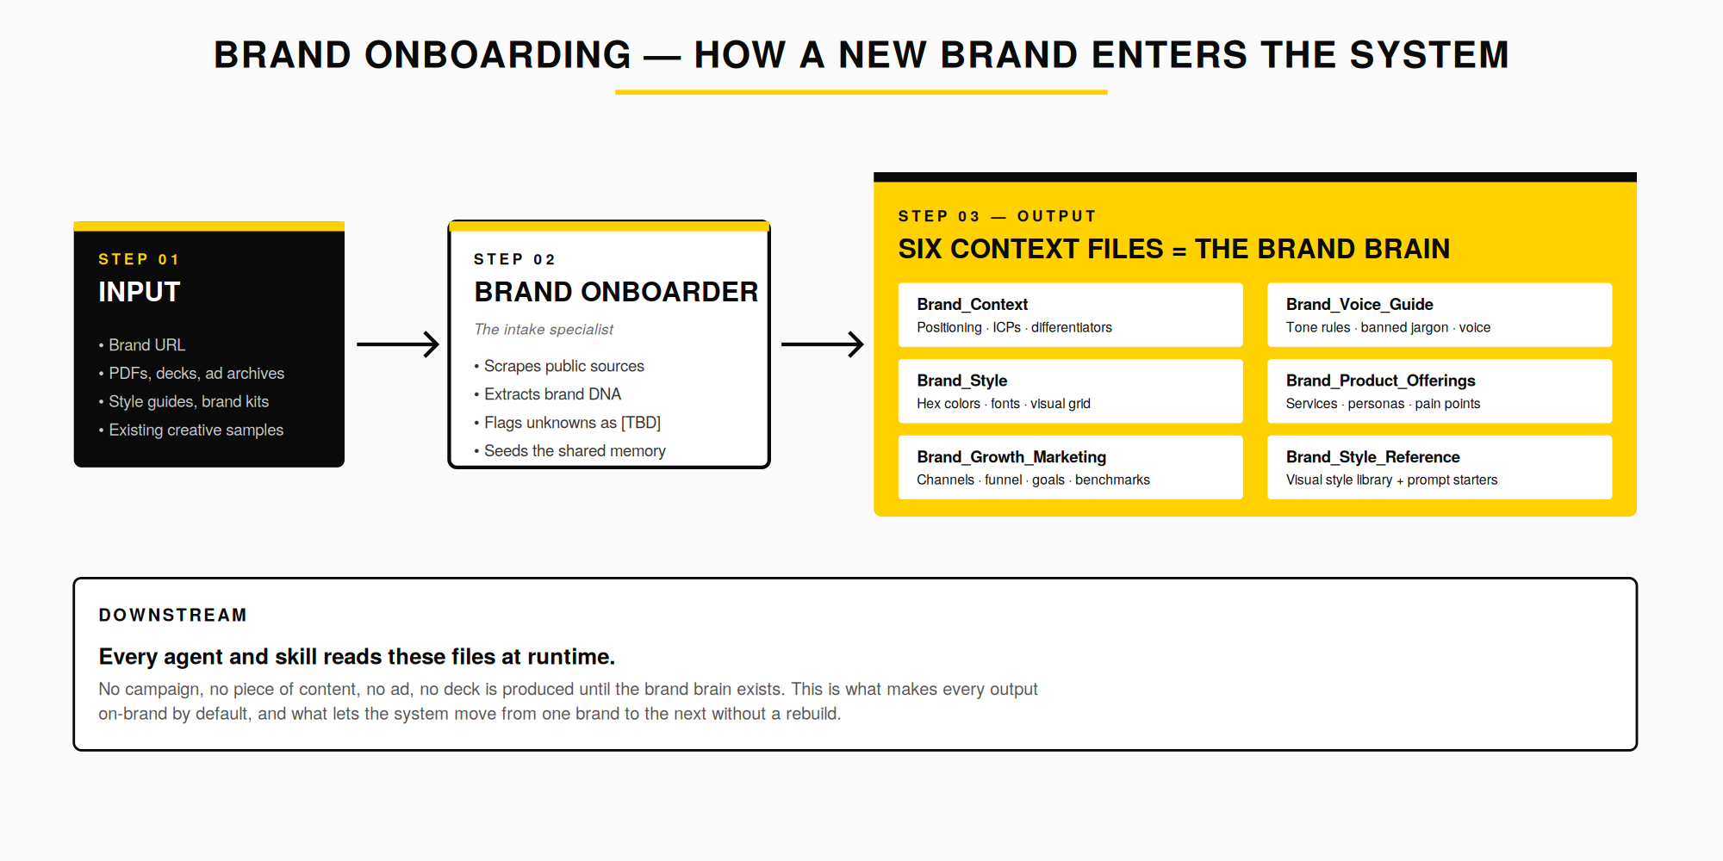
Figure 02: The onboarding sequence. Brand materials in, brand brain out. Every downstream agent reads these files at runtime.

The Six Files, Explained
Brand_Context Positioning, ideal customer profiles, and differentiators. The strategic why.
Brand_Voice_Guide Tone rules, banned jargon, and writing style. How the brand sounds.
Brand_Style Hex colors, fonts, and visual grid. How the brand looks.
Brand_Product_Offerings Services, buyer personas, and pain points. What the brand sells and to whom.
Brand_Growth_Marketing_Context Channels, funnel, goals, and benchmarks. The marketing operating environment.
Brand_Style_Reference Generative visual style library with prompt starters. The pattern library for AI creative.

05
HOW THE TEAM WORKS TOGETHER
Once the brand brain exists, the specialists hand off work through repeatable pipelines. These are five of the most common. Each mirrors how a real marketing team operates.

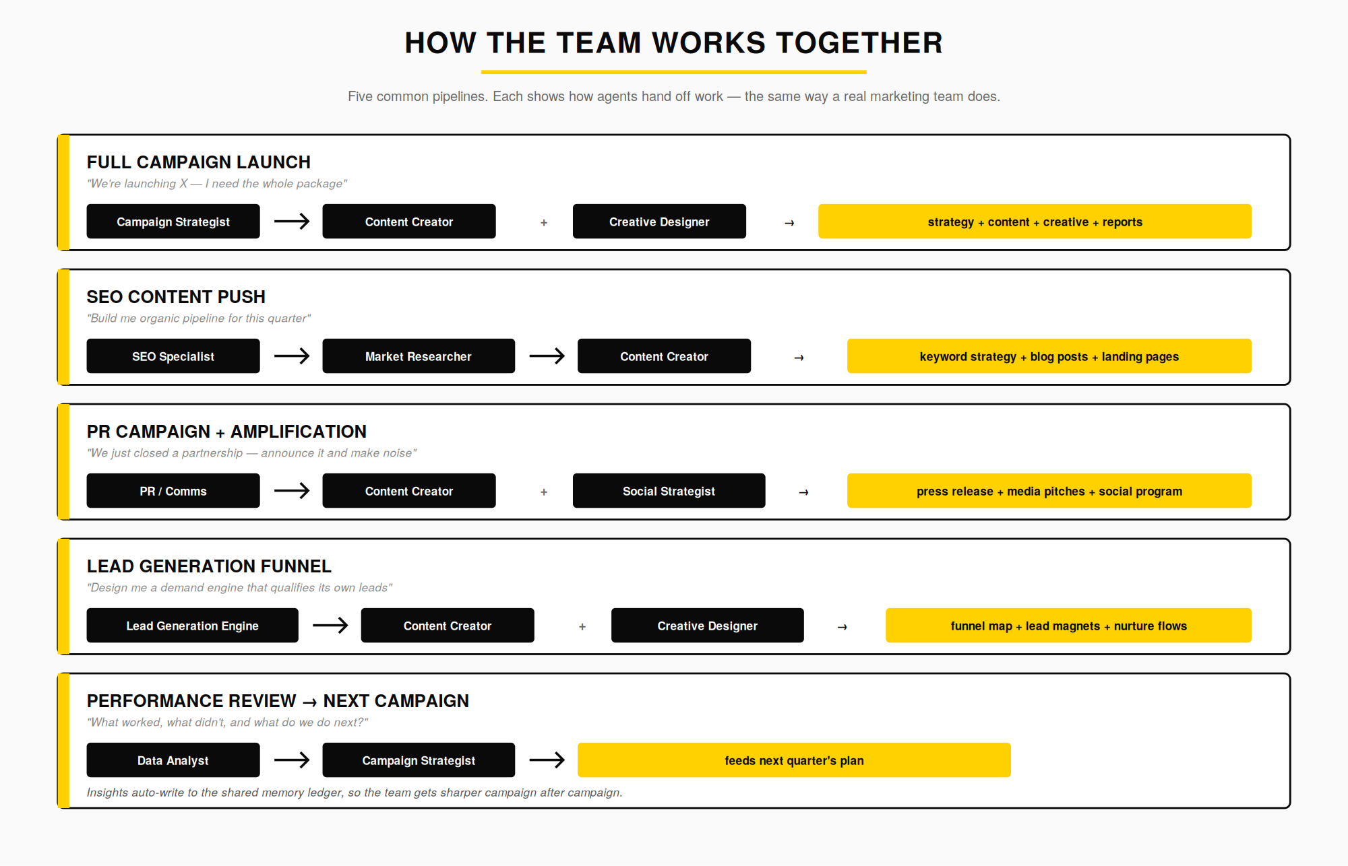
Figure 03: Five representative pipelines. Handoffs are explicit, deliverables are named, and every insight is written back into shared memory.

06
SHARED MEMORY — THE TEAM GETS SMARTER
Every specialist reads from and writes to a single shared file: the Brand Insights Ledger. Buyer objections uncovered by the strategist, voice preferences confirmed by the editorial lead, creative directions accepted or rejected, performance anomalies flagged by analytics: all of it accumulates in one place, in a structured way, across every session.
This is what turns a set of AI agents into an actual team. They remember what worked. They remember what a stakeholder said in the last review. They remember the ICP nuance that came up two campaigns ago. New campaigns build on old learnings instead of starting from a blank page.

WHAT LIVES IN THE LEDGER
Buyer personas and validated objections. Creative directions that landed and ones that flopped. Voice preferences confirmed in review. Performance baselines and recurring anomalies. Lead generation intelligence. Webinar audience patterns. Each section is owned by a specific specialist, so the memory stays organized rather than becoming a dumping ground.

07
THE TOOLS STACK
Foundry Collective is a marketing team, not a piece of software. It uses external tools where they add real leverage, and it has zero-setup fallbacks for every capability so nothing is blocked by a missing key. What follows is the current live integration set.

Ideogram · Flux · Nano Banana · GPT Image | AI image generation across four best-in-class models
Unsplash · Pexels | Licensed stock photography and video
Canva | Typography, layout assembly, brand-kit templates, export
Exa · Firecrawl | Neural search and clean web extraction for research
Windsor | 350+ marketing / ads / analytics / CRM / commerce connectors
NotebookLM | Multi-document analysis and synthesis

Every integration above is optional. Each connected capability has a built-in fallback path, which means the system degrades gracefully rather than failing. New tools can be added as they earn their place.

08
THE OPERATING PRINCIPLES
Six rules that the system holds even under pressure. They are what make the outputs trustworthy at scale.

01 | Brand voice is non-negotiable  Every customer-facing output must conform to the brand voice guide and visual style. No exceptions, no shortcuts.
02 | Cite every claim  If a claim is not grounded in the brand brain or a verifiable source, it is marked as a draft assumption. Nothing goes out with quiet fiction inside it.
03 | No invented proof points  No fake case studies, customers, or metrics. Placeholder tags are used until real data arrives.
04 | Read from context, never hardcode  Skills and agents pull the active brand context at runtime. Nothing is hardcoded to a specific brand, which is what makes the system portable.
05 | Written like a human wrote it  Editorial output avoids AI tells. No em dashes in editorial copy. No stock LLM buzzwords: delve, leverage, robust, seamless, revolutionize. If a real marketer would not write it, the system will not either.
06 | SOPs are law  When a workflow has been codified into a standard operating procedure, that procedure is the authority. If a recurring task has no SOP, the system suggests writing one.

Foundry
Collective

A marketing operating system built to think, plan, write, design, and report across every function of the discipline.

Vikram Ghatge
Creator and Author

