

**Experiment 1**

**Student Name: Sukhjinder Singh UID: 23BAI70078**

**Branch:** BE-AIT-CSE **Section/Group:** 23AIT-KRG-G2

**Semester:** 5th **Date of Performance:** 29th July, 2025

**Subject Name:** ADBMS **Subject Code:** 23CSP-333

1. **AIM: To design and manipulate a University Database using SQL that involves creating relational tables for Students, Courses, Enrollments, and Professors, inserting and retrieving data using JOINs, managing access control with GRANT/REVOKE, and handling transaction control using COMMIT and ROLLBACK.**
2. **Tools Used:**

MySQL Workbench in VS CODE.

1. **Experiment: 1. Easy-Level Problem: Author-Book Relationship Using Joins and Basic SQL Operations.**
   * **Design two tables — one for storing author details and the other for book details.**
   * **Ensure a foreign key relationship from the book to its respective author.**
   * **Insert at least three records in each table.**
   * **Perform an INNER JOIN to link each book with its author using the common**
   * **Select the book title, author name, and author’s country.**

**Medium-Level Problem: Department-Course Subquery and Access Control.**

* + **Design normalized tables for departments and the courses they offer, maintaining a foreign key relationship.**
  + **Insert five departments and at least ten courses across those departments.**
  + **Use a subquery to count the number of courses under each department.**
  + **Filter and retrieve only those departments that offer more than two courses.**

1. **Solution:**

**Easy-Level**

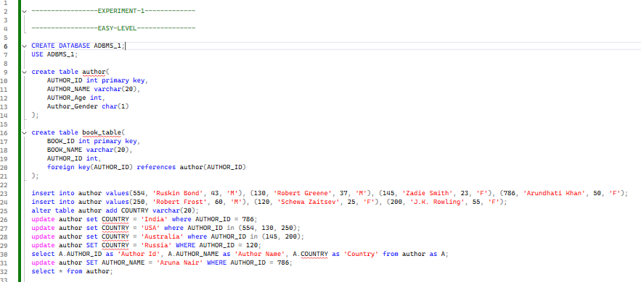

**Medium-Level**

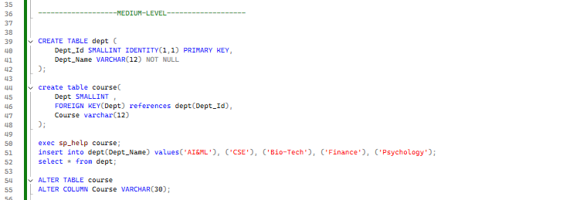

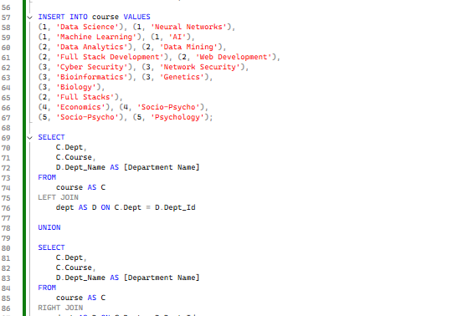

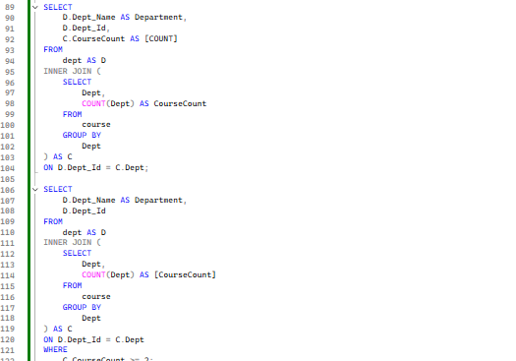

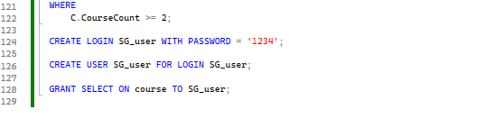

1. **Output: Easy-Level**

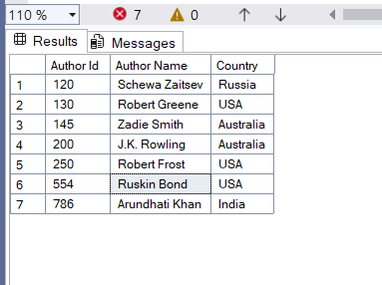

**Medium-Level**

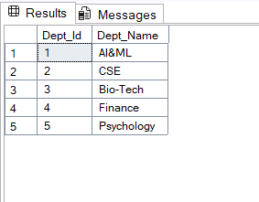

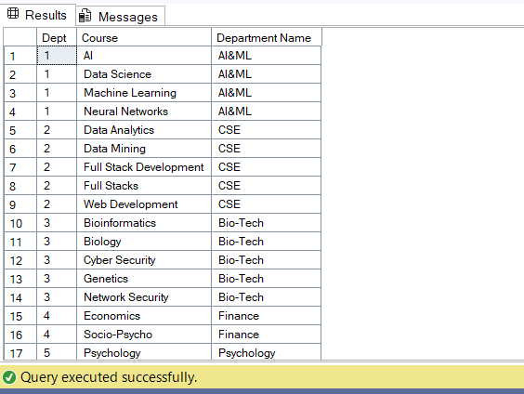

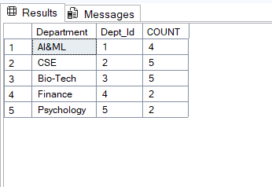

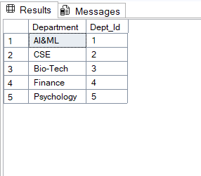

**6. Outcomes:**

* + Learnt about SQL Basic Operations.
  + Learnt about various types of JOINS such as FULL JOIN, INNER JOIN, LEFT & RIGHT JOIN.
  + Learnt about foreign key and its implementation in actual scenario.
  + Learnt how to perform subquery and implement filter along with subquery