

Experiment 3

**Student Name:** Sukhjinder Singh **UID:** 23BAI70078

**Branch:** BE-AIT-CSE **Section/Group:** 23AIT-KRG-G2

**Semester:** 5th **Date of Performance:** 19th Aug, 2025

**Subject Name:** ADBMS **Subject Code:** 23CSP-333

1. **AIM:** In a bustling corporate organization, each department strives to retain the most talented (and well-compensated) employees. You have access to **two key records:** one lists every employee along with their **salary & department**, while the other details the **names of each department**.

Your task is to identify the top earners in every department. If multiple employees share the same highest salary within a department, all of them should be celebrated equally. The final result should present the department name, employee name, and salary of these top-tier professionals arranged by department.

1. **Tools Used:**

SQL Server Management Studio 21 (SSMS) code editor.

1. **Experiment:**

**Medium-Level**

Your task is to identify the top earners in every department. If multiple employees share the same highest salary within a department, all of them should be celebrated equally. The final result should present the department name, employee name, and salary of these top-tier professionals arranged by department.

**Hard-Level**

Two legacy HR systems (A and B) have separate records of employee salaries. These records may overlap. Management wants to merge these datasets and identify each unique employee (by EmpID) along with their lowest recorded salary across both systems.

Objective

* 1. Combine two tables A and B.
  2. Return each EmpID with their lowest salary, and the corresponding Ename.

1. **Solution: Medium-Level**

CREATE TABLE department ( id IT flRIMARY KEY,

dept_name VARCAR(50)

);

CREATE TABLE employee (

id IT,

name VARCAR(50),

salary IT, department_id IT,

FOREIG KEY (department_id) REFERECES department(id)

);

ISERT ITO department (id, dept_name) VALUES (1, 'IT'),

(2, 'SALES');

ISERT ITO employee (id, name, salary, department_id) VALUES (1, 'JOE', 70000, 1),

(2, 'JIM', 90000, 1),

(3, 'ERY', 80000, 2),

(4, 'SAM', 60000, 2),

(5, 'MAX', 90000, 1);

select d.dept_name, e.name, e.salary

from employee e IER JOI department d on e.department_id = d.id where salary in

(

select max(e2.salary)

from employee e2 where e2.department_id = e.department_id

)

order by d.dept_name;

select d.dept_name, e.name, e.salary

from employee e IER JOI department d on e.department_id = d.id where salary in

(

select max(e2.salary)

from employee e2 group by e2.department_id

)

order by d.dept_name;

**Hard-Level**

create table tab_a( EmpID int primary key, Ename varchar(5), Salary int

);

create table tab_b( EmpID int primary key, Ename varchar(5), Salary int

);

insert into tab_a values(1, 'AA', 1000), (2, 'BB', 300);

insert into tab_b values(2, 'BB', 400), (3, 'CC', 100);

with res_set as

( select a.* from tab_a a UIO ALL

select b.* from tab_b b

)

select EmpID, Ename, min(Salary) as Salary from res_set r group by EmpID, Ename;

1. **Output: Medium-Level**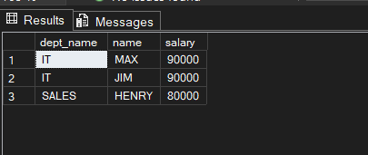

**Hard-Level**

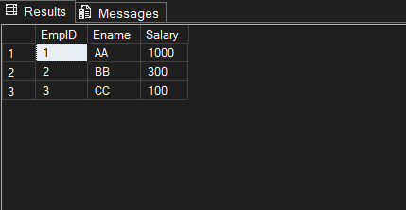

1. **Learning Outcomes:**

* Learn’t about Sub-Queries and it’s types.
* Learn’t about their use cases and execution procedure.
* Lean’t about how to apply Common Table Expression (WITH).
* Understood how to deal with large datasets.