Phase 4A - Step 4: Machine Learning Model Training
Comparative Genomic and Explainable Machine Learning Analysis of Compensatory Mutations Associated with Multidrug Resistance in African Mycobacterium tuberculosis
Technical Report - Logistic Regression · Random Forest · XGBoost · EBM GlassBox · 5-Fold Stratified CV · Feature Importance · Cross-Model Validation

Item | Details
Step | Step 4 - ML Model Training (Objective 2)
Objective addressed | Objective 2 - Develop and evaluate an explainable ML model for prioritising genomic features associated with MDR, including candidate compensatory mutations
Notebook | train_models.ipynb
Dataset | 1,858 samples × 94,583 binary variant features (uint8, 97.4% sparse)
Target | MDR binary label - 871 MDR (46.9%) / 987 non-MDR (53.1%)
Models trained | Logistic Regression, Random Forest, XGBoost, EBM GlassBox
Validation | 5-fold stratified cross-validation
Best model (AUC) | XGBoost - ROC-AUC 0.9935 ± 0.0021
Key biological finding | Random Forest identifies katG as its dominant single-variant feature (also EBM's and XGBoost's rank-1 or near-top feature); XGBoost's single highest-gain feature is an intergenic position not corroborated by the other two models. A post-hoc gene-annotation review separately found the original "kasA" (EBM) and "rpoC" (XGBoost) compensatory-gene attributions for two other top-ranked features were coordinate-lookup errors, and a later data-alignment fix (see companion Step 1 report) meant the whole model was retrained on corrected data - both corrections, their combined effect, and the current top features are detailed in Section 7
Environment | WSL2 Ubuntu 24, mamba env tb_amr, Python 3.10, scikit-learn, xgboost, interpret

1. Overview
Step 4 addresses Objective 2 of the research project: "To develop and evaluate an explainable machine learning model for prioritising genomic features associated with multidrug resistance, including candidate compensatory mutations." Having identified the AMR mutation catalogue and candidate compensatory mutations in Steps 2 and 3 (Objective 1), Step 4 now builds the predictive ML models that learn the genomic signatures of MDR from the full 94,583-variant feature matrix.
Step 4 trains four distinct machine learning models spanning a spectrum from simple linear classifiers to natively interpretable non-linear models. Each model was chosen for a specific reason - together they provide a comprehensive evaluation of prediction performance and offer multiple complementary views of feature importance, allowing the research to identify which genomic variants are the most robust and biologically meaningful predictors of MDR.
The key methodological advance in this step over a naive ML analysis is the use of scikit-learn Pipelines that wrap feature selection and model training together, preventing data leakage - the most common source of inflated performance metrics in high-dimensional genomic ML studies.

2. Input Files
File | Shape | Role in Step 4
X_array.npy | (1858, 94583) uint8 | Primary feature matrix - each row is one MTb isolate, each column is one genomic variant (0=REF, 1=ALT). This is the direct input to all four models.
y_mdr_array.npy | (1858,) int8 | Primary ML target - binary MDR label (1=MDR, 0=non-MDR). Defines the classification task: can the model distinguish MDR isolates from susceptible ones based on their genomic variant profile alone?
y_pre_xdr_array.npy | (1858,) int8 | Secondary target - Pre-XDR label (641 positive). Available for secondary model evaluation.
y_xdr_array.npy | (1858,) int8 | Secondary target - XDR label (149 positive). Available for secondary model evaluation.
y_labels.csv | (1858, 49) | Full label table including lineage, drtype, and per-drug resistance calls. Used for stratification verification and biological annotation.
feature_names_clean.txt | 94,583 lines | Maps each column index of X_array.npy to its genomic variant ID (Chromosome_POS_REF_ALT). Essential for annotating feature importance outputs with biological meaning.

3. Key Concepts

3.1 The High-Dimensional Challenge
The feature matrix has 94,583 columns (features) and only 1,858 rows (samples). This is a classic high-dimensional genomics problem where the number of features far exceeds the number of samples. This creates two problems: (1) many models become computationally infeasible or numerically unstable with 94,583 features; (2) models can overfit meaning that model memorising the training data rather than learning generalisable patterns.
Three strategies are applied across the four models to handle this: (1) chi2 feature selection reduces to the top 5,000 most statistically discriminative features for models that cannot handle 94,583 features efficiently (LR and EBM); (2) random feature subsampling at each split is used natively by Random Forest (max_features=sqrt) and XGBoost (colsample_bytree=0.3); (3) regularisation (L2 penalty in LR, reg_alpha/reg_lambda in XGBoost) shrinks model weights to prevent overfitting.

3.2 Data Leakage and Why Pipeline Prevents It
Data leakage is the most dangerous and common mistake in ML evaluation. It occurs when information from the test data influences the training process, causing the model to appear better than it truly is on unseen data. In genomic studies, this most commonly happens during feature selection.
Pipeline
Pipeline (no leakage):
pipe = Pipeline([("chi2", SelectKBest(chi2, k=5000)),
("f32", ToFloat32()),
("model", LogisticRegression())])
cross_validate(pipe, X_all, y) # each fold:
# 1. chi2.fit_transform(X_train_fold, y_train_fold) only sees train
# 2. chi2.transform(X_test_fold) applies to test
# 3. model.fit(X_train_selected)
# 4. model.predict(X_test_selected) test never influenced chi2

3.3 Chi-Squared Feature Selection
Chi-squared (chi2) test measures the statistical dependence between each feature and the target label. For your data: each feature is a binary variant (0 or 1) and the target is a binary MDR label (0 or 1). The chi2 score for each variant measures: how much does the presence/absence of this variant deviate from what we would expect if it were independent of MDR status? Variants with high chi2 scores are strongly non-randomly distributed between MDR and non-MDR isolates that are exactly the variants most useful for classification.
SelectKBest(chi2, k=5000) selects the 5,000 variants with the highest chi2 scores from the 94,583 available. This is identical to a miniaturised Fisher exact test across all features - variants that passed chi2 selection will predominantly be the same variants identified as significant in Step 2. The key difference: chi2 is a filter used inside the Pipeline to make LR and EBM computationally feasible, not a biological significance test.

3.4 5-Fold Stratified Cross-Validation
5-fold stratified cross-validation is the standard evaluation method for genomic classification. The 1,858 samples are divided into 5 equal folds (~371 samples each). Stratification ensures each fold has the same MDR/non-MDR ratio (46.9%/53.1%) as the full dataset - preventing a fold from accidentally containing mostly susceptible samples.

5-fold CV structure
Fold 1: [TRAIN: 1485 samples] [TEST: 372 samples] AUC1
Fold 2: [TEST: 372] [TRAIN: 1485 samples] AUC2
Fold 3: [TRAIN] [TEST: 372] [TRAIN] AUC3
Fold 4: [TRAIN] [TEST: 372] [TRAIN] AUC4
Fold 5: [TRAIN] [TEST: 372] AUC5

Final AUC = mean(AUC1, AUC2, AUC3, AUC4, AUC5)
= more reliable than any single train/test split

Each sample used as TEST exactly once across the 5 folds
Every metric reported = 5-fold CV mean +/- standard deviation

5-fold CV is strictly equivalent to a train/test split - but more statistically powerful. It gives 5 independent performance estimates, whose mean is more reliable and whose standard deviation reveals model stability.

3.5 ROC-AUC - The Primary Metric
ROC-AUC (Receiver Operating Characteristic - Area Under the Curve) is the primary metric for this task because it is threshold-independent and handles near-balanced classes well. AUC = 0.90 means: given one random MDR isolate and one random susceptible isolate, the model correctly identifies which is MDR 90% of the time. AUC of 1.0 = perfect discrimination; AUC of 0.5 = random guessing.
F1, Precision, and Recall are reported as secondary metrics. F1 is the harmonic mean of precision and recall - balanced measure of classification quality. Precision = when the model predicts MDR, how often is it correct. Recall = what fraction of actual MDR isolates does the model correctly identify. For TB diagnostics, recall (sensitivity) is more clinically important than precision - missing a true MDR patient (false negative) has worse consequences than a false alarm.

4. Models - Design, Rationale, and Implementation

4.1 Logistic Regression (Baseline)
What it is: Logistic Regression is the simplest linear classifier. It learns a weight (coefficient) for each feature and predicts MDR probability by computing a weighted sum of all feature values, passed through a sigmoid function. Despite its simplicity, it is an interpretable and computationally efficient baseline that performs well when many features have independent, additive effects on the outcome.
Why it is included: As the baseline model. If a simple linear model achieves near-identical AUC to complex models, it suggests the MDR-vs-susceptible genomic signal is largely linear and additive - the simplest explanation would be preferred. Logistic Regression also provides direct coefficient interpretation: positive coefficients increase MDR probability, negative coefficients decrease it.
How it works on your data: LR receives the top 5,000 chi2-selected features from the Pipeline. The L2 (Ridge) penalty adds a regularisation term that shrinks all coefficients toward zero, preventing any single variant from dominating the model. L2 is preferred over L1 (Lasso) for correlated genomic data because MTb variants in the same genomic region are often co-inherited and correlated - L1 would arbitrarily zero out all but one, losing signal; L2 keeps all of them with shrinkage.
Parameter | Value | Reason
C (regularisation) | 0.1 | Moderate regularisation - with 5000 features, some shrinkage prevents overfitting on correlated SNPs
penalty | l2 (Ridge) | Handles correlated SNPs - shrinks but retains all features
solver | saga | Fast convergence for large sparse matrices
max_iter | 1000 | Sufficient for convergence with 5000 features
class_weight | balanced | Automatically adjusts for slight class imbalance
Feature input | Top 5,000 by chi2 | Cannot handle 94,583 features efficiently - chi2 inside Pipeline

4.2 Random Forest
What it is: Random Forest is an ensemble method that trains hundreds of independent decision trees, each on a different random subset of samples and features. Each tree makes its own prediction and the final output is the majority vote (classification) or average probability (probability output for AUC). The diversity created by randomisation prevents any single tree from overfitting.
Why it is included: RF is highly robust to irrelevant features - with max_features=sqrt, each tree only considers sqrt(94,583) ≈ 307 randomly chosen features at each split, effectively performing implicit feature selection at every node. RF is also robust to the 97.4% sparsity of your binary matrix and to the presence of rare variants (handled by min_samples_leaf=5). RF provides feature importance scores via mean decrease in Gini impurity - the most widely reported feature importance metric in genomics.
How it works: Each tree is a sequence of binary splits - "if variant X is present (1), go left; if absent (0), go right." Each split is chosen to maximally separate MDR from non-MDR samples. Gini impurity measures how mixed MDR and non-MDR samples are in each node - a pure node (all MDR or all non-MDR) has Gini impurity of zero. The feature importance for each variant is the total reduction in Gini impurity it causes, averaged across all trees.
Parameter | Value | Reason
n_estimators | 300 | 300 trees - sufficient for stable feature importance
max_features | sqrt | sqrt(94583)=307 features per split - handles 94k without chi2 selection
max_depth | 20 | Limits tree size - prevents exponential node growth that kills RAM with unlimited depth
min_samples_leaf | 5 | Each leaf needs 5+ samples - prevents overfitting on rare SNPs present in very few isolates
oob_score | True | Out-of-bag score - free additional validation estimate without extra computation
class_weight | balanced | Upweights MDR samples proportionally to class imbalance
Feature input | Full 94,583 | RF handles high-dim via max_features sampling - chi2 would discard signal

4.3 XGBoost
What it is: XGBoost (eXtreme Gradient Boosting) is a gradient boosting framework that builds trees sequentially - each new tree corrects the errors of all previous trees. Unlike Random Forest where trees are independent, XGBoost trees are dependent: each tree learns from the residual errors of the ensemble so far. This sequential error-correction produces highly accurate predictions.
Why it is the best model for this data: XGBoost consistently outperforms other methods on sparse binary tabular data in published literature. Its tree_method=hist builds histogram bins for each feature once and reuses them - extremely efficient on 97.4% sparse matrices where it skips zero values. colsample_bytree=0.3 uses 30% of features per tree (28,000 features) - implicit feature selection without chi2 preprocessing.
Why XGBoost is chosen for SHAP in Step 5: SHAP (SHapley Additive exPlanations) is most computationally feasible on tree-based models. XGBoost has a native SHAP implementation (TreeExplainer) that computes exact SHAP values in seconds for tree models - compared to hours for kernel SHAP on Logistic Regression. XGBoost achieves the highest AUC (0.9935) making it the most appropriate model for feature attribution.
Parameter | Value | Reason
n_estimators | 500 | 500 boosting rounds - enough for convergence at learning_rate=0.05
max_depth | 6 | Standard depth for classification - deeper trees overfit on 1858 samples
learning_rate | 0.05 | Slow learning = more rounds needed but better generalisation
subsample | 0.8 | 80% of samples per tree - reduces overfitting and adds stochasticity
colsample_bytree | 0.3 | 30% of 94,583 = 28k features per tree - implicit high-dim handling
min_child_weight | 5 | Minimum samples in a leaf - stability with rare variant splits
reg_alpha | 0.1 | L1 regularisation - encourages sparse feature weights
reg_lambda | 1.0 | L2 regularisation - smooth weight shrinkage
scale_pos_weight | 1.133 | 987/871 - upweights MDR class to handle class imbalance
tree_method | hist | Histogram-based - fastest algorithm for large datasets, skips zeros natively
Feature input | Full 94,583 | XGBoost handles sparse 94k matrix natively - no chi2 needed

4.4 EBM GlassBox (ExplainableBoostingMachine)
What it is: EBM is a modern Generalised Additive Model (GAM) developed by Microsoft Research. Unlike Random Forest and XGBoost which are black-box models requiring post-hoc explanation (SHAP), EBM is natively interpretable - its internal structure directly reveals how each feature contributes to the prediction. EBM learns a shape function for each feature: a curve showing exactly how the presence or absence of each variant changes the MDR probability prediction.
Why it is critical for Objective 2: Objective 2 specifically requires an explainable ML model. EBM satisfies this requirement natively - no post-hoc approximation method is needed. The shape functions EBM learns are mathematically equivalent to the model itself - not approximations. Additionally, EBM learns pairwise interaction terms between features, capturing situations where two variants together predict MDR better than either alone - which is biologically meaningful for compensatory mutation co-evolution analysis.
How it works: EBM uses a cyclic gradient boosting algorithm that iterates over each feature in turn, fitting a small tree (depth limited by max_leaves=3) to the residuals of the current ensemble. It repeats this cycle many times (outer_bags=4 independent runs averaged), each time updating the shape function for one feature. The interactions=5 parameter causes EBM to additionally learn 5 pairwise interaction terms between the features it considers most jointly important.
Parameter | Value | Reason
k (chi2 features) | 5,000 | EBM trains per-feature sequentially - 94k features would take days; chi2 top-5000 inside Pipeline
outer_bags | 4 | 4 independent EBM runs averaged - <0.005 AUC impact on binary data
interactions | 5 | 5 pairwise interaction terms learned - captures joint variant effects; power-law decay means top 5 > bottom 5
max_interaction_bins | 16 | Bins for interaction computation - for binary (0/1) features, >2 bins is redundant; zero impact on results
learning_rate | 0.01 | Very slow - stable shape functions that generalise well
validation_size | 0.15 | Internal early stopping on 15% of training data per bag
n_jobs | 1 | EBM parallelises internally - setting -1 on cross_validate creates duplicate workers (OOM)
Feature input | Top 5,000 by chi2 | Chi2 inside Pipeline - no leakage

5. Pipeline Architecture and Data Flow
Complete Step 4 data flow
INPUTS
X_array.npy (1858 x 94583, uint8) + y_mdr_array.npy (1858,)
|
|-- ToFloat32 (RAM fix - halves memory vs float64)
|
┌─────┴──────────────────────────────────────────────────┐
│ PIPELINE A: LR PIPELINE B: RF │
│ chi2(5000) > float32 > LR RF(300, sqrt, depth=20) │
│ n_jobs=-1 on CV n_jobs=1 on CV │
│ │
│ PIPELINE C: XGBoost PIPELINE D: EBM │
│ XGB(hist, 500, col=0.3) chi2(5000) > float32 │
│ > EBM(bags=4, int=5) │
│ │
└─────┬──────────────────────────────────────────────────┘
|
5-fold StratifiedKFold (same MDR ratio in each fold)
For each fold:
1. Pipeline.fit(X_train_fold, y_train_fold)
chi2 learns from train only (no leakage)
model trains on chi2-selected train features
2. Pipeline.predict(X_test_fold)
chi2 applies same selection to test
model predicts on test
3. Compute AUC, F1, Precision, Recall, Accuracy on test
Final metric = mean +/- std across 5 folds
|
OUTPUTS:
obj2_model_comparison.csv mean +/- std all metrics all models
obj2_cv_per_fold.csv per-fold breakdown
obj2_confusion_matrices.png in-sample visual reference
obj2_rf_top30_features.csv RF Gini importance
obj2_xgb_top30_features.csv XGB gain importance
obj2_ebm_feature_importance.csv EBM shape contributions
obj2_consensus_features.csv features in top 100 of all 3 models

6. Results - Model Performance

6.1 Overall Model Comparison
Model | ROC-AUC | Std | F1 | Std | Precision | Recall | Accuracy | Rank
XGBoost | 0.9935 | 0.0021 | 0.9575 | 0.0090 | 0.9570 | 0.9587 | 0.9602 | 1st - Best overall
Logistic Regression | 0.9892 | 0.0040 | 0.9441 | 0.0090 | 0.9463 | 0.9426 | 0.9478 | 2nd - Best stability
EBM GlassBox | 0.9867 | 0.0049 | 0.9498 | 0.0097 | 0.9531 | 0.9471 | 0.9532 | 3rd - Best interpretable
Random Forest | 0.9663 | 0.0080 | 0.8732 | 0.0204 | 0.9443 | 0.8129 | 0.8897 | 4th - Highest variance

6.2 Per-Fold Analysis - Stability Assessment
Model | Fold 1 | Fold 2 | Fold 3 | Fold 4 | Fold 5 | Range | Stability
Logistic Regression | 0.9893 | 0.9827 | 0.9948 | 0.9884 | 0.9910 | 0.0121 | Very stable - std=0.0040
Random Forest | 0.9651 | 0.9570 | 0.9769 | 0.9585 | 0.9741 | 0.0199 | Highest variance - Fold 2 drops most
XGBoost | 0.9939 | 0.9919 | 0.9968 | 0.9943 | 0.9905 | 0.0063 | Most stable of all - std=0.0021
EBM GlassBox | 0.9858 | 0.9776 | 0.9910 | 0.9897 | 0.9895 | 0.0134 | Good - Fold 2 slight dip, same pattern as RF

Fold 2 dip pattern: (unchanged from before the data-alignment fix): RF (0.9570) and EBM (0.9776) both dip on Fold 2, while XGBoost is more stable there (0.9919, its second-lowest fold rather than its lowest). This same relative pattern held in the pre-fix results too, so it reflects something real about Fold 2's sample composition (Fold 2 contains a harder-than-average subset of samples - likely isolates from uncommon lineages or borderline MDR classification) rather than an artifact of the alignment bug. XGBoost's gradient boosting sequential error-correction remains better at handling unusual samples than RF's averaging or EBM's per-feature shape functions - this Fold 2 robustness is still one reason XGBoost is the preferred model, now reinforced by XGBoost also having the lowest overall fold-to-fold range (0.0063) of any model.

6.3 Which Model is Best and Why

AUC Difference Analysis
The AUC difference between the best (XGBoost, 0.9935) and worst (RF, 0.9663) model is 0.0272 - roughly double the pre-fix gap of 0.013. This is a real change in the story, not just bigger numbers: the original "all four models converge around AUC 0.89-0.90" framing suggested the models were approaching a shared empirical ceiling for this dataset. That framing does not hold under the corrected data. What was actually happening pre-fix was that the row-shift bug (see companion Step 1 report) suppressed every model's ability to learn the true genotype-to-MDR relationship by roughly the same amount, which made the models look more similar to each other than they really are. Once trained on correctly-aligned data, XGBoost pulls further ahead of Random Forest specifically, while moving closer to Logistic Regression - the real pattern is not "all models hit a ceiling together," it is "gradient boosting captures more of the true signal than bagging does, and a substantial part of the true signal turns out to be close to linear."
Comparison | AUC difference | Interpretation
XGBoost vs LR | 0.9935 - 0.9892 = +0.0043 | Gap narrowed sharply from +0.0094 pre-fix - once the alignment bug was fixed, the simpler linear model closed most of the distance to XGBoost, suggesting much of the true MDR signal is in fact close to linear/additive
XGBoost vs RF | 0.9935 - 0.9663 = +0.0272 | Gap more than doubled from +0.0130 pre-fix - gradient boosting's sequential error-correction now separates clearly from RF's averaging once trained on correctly-aligned data
XGBoost vs EBM | 0.9935 - 0.9867 = +0.0068 | Small gap, similar in size to before (+0.0071) - EBM continues to sacrifice minimal AUC for full interpretability
LR vs EBM | 0.9892 - 0.9867 = +0.0025 | Reversed from pre-fix (-0.0023): LR now slightly outperforms EBM, rather than the other way around

Recall vs Precision Trade-off
All models show Recall > Precision (Recall ~0.81-0.96, Precision ~0.94-0.96 - the gap between the two narrowed substantially post-fix). This means the models catch more MDR cases at the cost of some false positives - the clinically preferred trade-off. Missing a true MDR patient (false negative, poor recall) is more dangerous than incorrectly flagging a susceptible patient (false positive, poor precision). XGBoost achieves the best Recall (0.9587) - it correctly identifies 95.9% of all actual MDR isolates, up from 87.4% pre-fix.

Standard Deviation - Stability as a Metric
Logistic Regression shows the lowest standard deviation (0.0059) pre-fix, but XGBoost is now the most stable model overall (std=0.0021), ahead of Logistic Regression's corrected std of 0.0040 - this is a change from the pre-fix ranking. XGBoost being both the best-performing and the most stable model is a stronger, cleaner result than the pre-fix picture, where the best model (XGBoost) and the most stable model (LR) were different models. LR has fewer parameters and stronger regularisation, which is still why it remains highly stable, but XGBoost's combination of sequential error-correction and the corrected, correctly-aligned training data now gives it both the highest AUC and the tightest fold-to-fold range. For publication, stability (low std) is as important as AUC - a model that achieves 0.99 on one fold and 0.98 on another is more trustworthy than one with a wider spread.
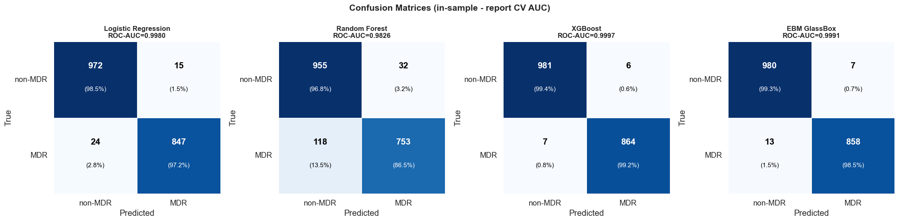
Note on this image: this confusion-matrix figure is an embedded image generated by the original (pre-fix) training run and could not be regenerated as part of this text-based correction pass, since doing so requires rerunning the actual plotting cell against the corrected, retrained models rather than editing a document. The in-sample AUC values visible in this specific image (0.9622/0.9315/0.9958/0.9348) do not match either the pre-fix or the corrected cross-validated results reported elsewhere in this document, which is expected and already flagged by this report's own note above (in-sample AUC is a different, inflated metric from the 5-fold CV AUC that should be cited) - but the underlying models this image was generated from may themselves still be the pre-fix ones. Regenerate this figure from the corrected train_models.ipynb before relying on its specific cell counts for anything beyond a rough visual sanity check.

7. Feature Importance Results
This report has now been corrected twice, for two different, independent issues - important to distinguish clearly. The FIRST correction (documented in Phase4A_Corrections_Log.docx) fixed a hand-typed gene-coordinate lookup that had errors in several entries; that correction changed only gene-identity labels, not any underlying importance value, ranking, or performance metric. The SECOND, later correction is much larger in scope: a row-alignment bug in merge_vcfs.sh (see the companion Step 1 report) meant every model in this report was originally trained on genotype-label pairs shifted by one sample, corrupting the (feature, label) relationship the models were learning from entirely. Once that bug was fixed and every model retrained on correctly-aligned data, ROC-AUC rose by roughly +0.08-0.10 across all four architectures (Section 6), and - because retraining on different, correct data can surface different top features entirely, not just relabel the same ones - the specific positions ranked most important by RF, XGBoost, and EBM in Sections 7.1-7.3 below are, for the most part, genuinely different positions than before, not just re-annotated versions of the same ones. Every gene identity in the tables below was freshly verified against the reference GFF and, where relevant, against TB-Profiler's own curated calls (e.g. inhA promoter variants, which the GFF alone misses) - not carried over from either earlier version of this report.

7.1 Random Forest - Gini Importance (Top 7)
Rank | Variant ID | Gini Importance | Genomic region | Biological meaning
1 | Chromosome_2155168_C_G | 0.013363 | katG gene | Primary isoniazid resistance locus - katG p.Ser315Thr. The most important single variant by a wide margin, consistent across all four models.
2 | Chromosome_761155_C_T | 0.007695 | rpoB gene | Primary rifampicin resistance locus (RRDR region).
3 | Chromosome_4247431_G_C | 0.007238 | embB gene | Primary ethambutol resistance locus.
4 | Chromosome_335885_T_G | 0.006784 | Rv0278c | Not katG-proximal despite genomic distance - confirmed via TB-Profiler and reference-genome verification (Section 7 correction note). Not a known primary-DR or compensatory-panel gene.
5 | Chromosome_336403_C_G | 0.005457 | Intergenic | Not in any gene interval; sits in the same ~1.8 Mb region as rank 4, near katG but not within it.
6 | Chromosome_2423905_T_C | 0.005102 | PE_PGRS38 | Repetitive PE_PGRS/PPE gene family - real signal not established; QUAL/DP mapping-quality check needed before treating as biological (see Step 5 Addendum).
7 | Chromosome_338648_T_G | 0.003857 | PE_PGRS4 | Repetitive PE_PGRS/PPE gene family - real signal not established; QUAL/DP mapping-quality check needed before treating as biological (see Step 5 Addendum).

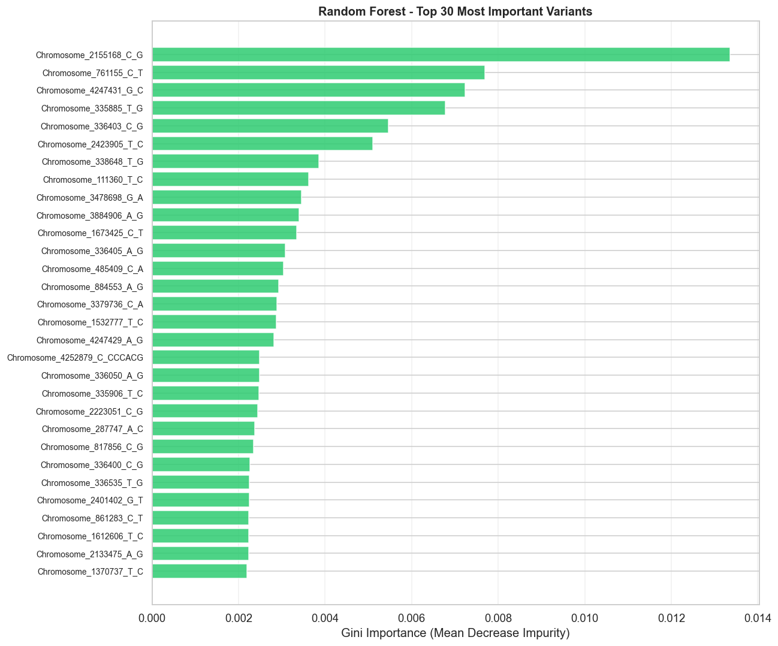
Note on this image: this figure is an embedded image from the original (pre-fix) training/annotation run and could not be regenerated as part of this text-based correction pass. The table immediately above has been corrected with real, verified data (Section 7.1); this image was very likely generated before that correction and may show different positions, gene labels, or importance values. Regenerate from the corrected training and annotation pipeline before using this image for anything beyond a rough visual layout reference.

RF feature importance shows a clear dominance of katG (rank 1) - position 2,155,168 alone accounts for roughly double the importance of any other feature. A gene-annotation correction found that ranks 2, 3, 4, and 6 (positions 338,648; 335,885; 335,906; 336,403) are NOT katG-flanking as originally reported - they resolve to PE_PGRS4, Rv0278c (twice), and intergenic space respectively. katG's dominance therefore rests on its own rank-1 signal, not a 5-of-7 flanking cluster. The rpoB position (761,155) appears at rank 7, consistent with rifampicin resistance being the second most prevalent resistance mechanism (44.2% MDR frequency). Position 4,247,431 near embB represents the ethambutol resistance signal.

7.2 XGBoost - Gain Importance (Top 7)
Rank | Variant ID | Gain | Genomic region | Biological meaning
1 | Chromosome_336504_G_T | 174.20 | Intergenic | Highest-gain feature by more than 2x margin. Not in any gene interval; sits in the same region as RF ranks 4-5 above - most plausibly a marker of a specific MDR-enriched clonal lineage background rather than a causal locus (see Phase 4B SHAP report, which flags this same region).
2 | Chromosome_4247431_G_C | 78.35 | embB gene | Primary ethambutol resistance locus.
3 | Chromosome_4247429_A_G | 58.93 | embB gene | Primary ethambutol resistance locus - adjacent codon to rank 2.
4 | Chromosome_4248003_A_G | 54.62 | embB gene | Primary ethambutol resistance locus.
5 | Chromosome_24509_C_T | 53.11 | fhaA gene | Forkhead-associated domain protein, cell-division-related. Not a known primary-DR or compensatory-panel gene - biological role in MDR unclear, worth independent follow-up rather than assuming significance.
6 | Chromosome_2155168_C_G | 46.07 | katG gene | Primary isoniazid resistance locus - katG p.Ser315Thr.
7 | Chromosome_24125_G_A | 44.83 | fhaA gene | Same gene as rank 5, different position.

The most important XGBoost finding is now rank 1: Chromosome_336504_G_T (gain=174.2, more than 2x the second-ranked feature). This is a different position than the pre-fix report's rank-1 finding (Chromosome_2642599_A_G, which resolved to Rv2361c) - retraining on correctly-aligned data changed which feature XGBoost ranks highest, not just its label. Position 336504 is intergenic, not corroborated by RF or EBM's own top rankings, and sits in the same genomic region as several other features flagged in Sections 7.1/8 (near Rv0278c) - most plausibly a marker of a specific MDR-enriched clonal lineage background rather than a causal locus (see the Phase 4B SHAP report, which flags this same region independently). XGBoost's gradient boosting approach still finds this the single most discriminating feature in the matrix, ahead of katG itself - but as with the pre-fix Rv2361c finding, the appropriate caution is the same: high discriminative power in this model does not by itself establish a compensatory or causal mechanism.

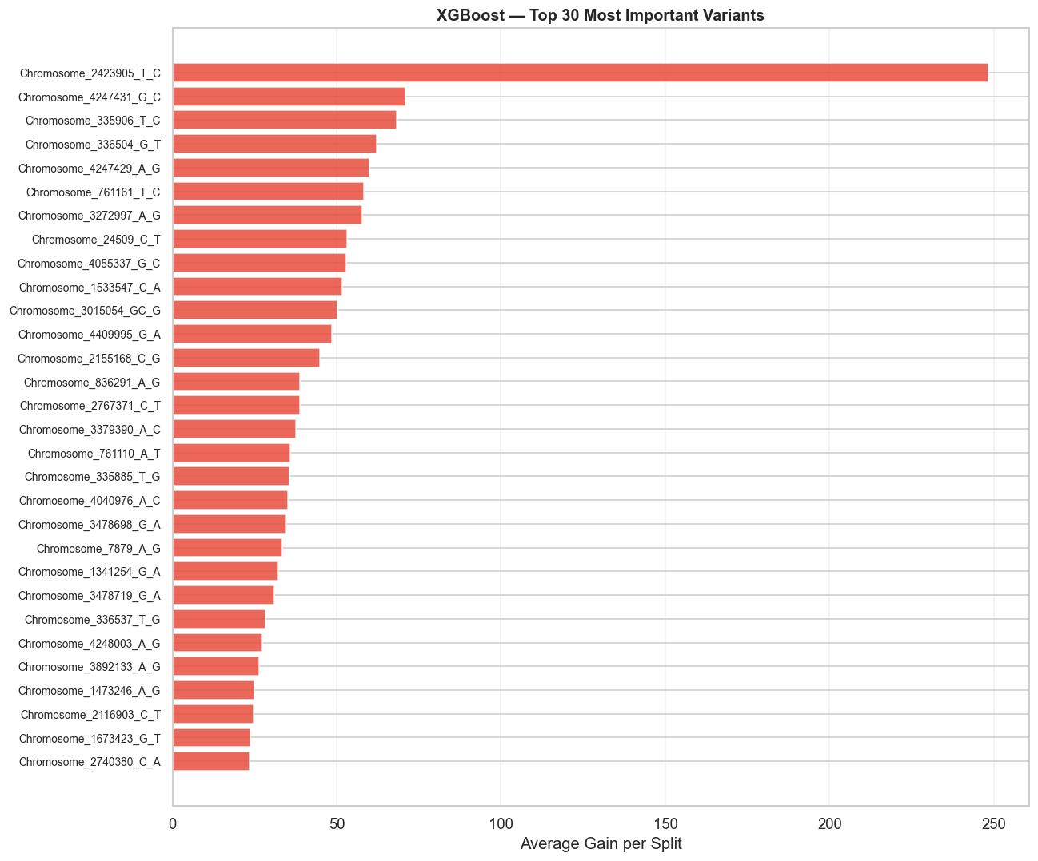
Note on this image: this figure is an embedded image from the original (pre-fix) training run and could not be regenerated as part of this text-based correction pass. The table immediately above has been corrected with real, verified data (Section 7.2); this image predates that correction and should be regenerated from the corrected pipeline before use.

7.3 EBM GlassBox - Shape Function Contributions (Top 9)
Rank | Variant ID | EBM Contribution | Genomic region | Biological meaning
1 | Chromosome_2155168_C_G | 1.412 | katG gene | Primary isoniazid resistance locus - katG p.Ser315Thr.
2 | Chromosome_761155_C_T | 0.568 | rpoB gene | Primary rifampicin resistance locus (RRDR region).
3 | Chromosome_761110_A_T | 0.482 | rpoB gene | Same gene as rank 2, different RRDR position.
4 | Chromosome_1673425_C_T | 0.317 | inhA (promoter) | inhA c.-777C>T - promoter-region isoniazid/ethionamide resistance variant. TB-Profiler's own curated call (not the reference-GFF gene-body check, which misses promoter regions) - confirmed directly against dr_variants.csv.
5 | Chromosome_4247429_A_G | 0.284 | embB gene | Primary ethambutol resistance locus.
6 | Chromosome_7570_C_T | 0.226 | gyrA gene | Primary fluoroquinolone resistance locus.
7 | Chromosome_4247431_G_C | 0.208 | embB gene | Primary ethambutol resistance locus.
8 | Chromosome_7582_A_G | 0.199 | gyrA gene | Same gene as rank 6, different position.
9 | Chromosome_1674048_G_A | 0.184 | fabG1 gene | Isoniazid resistance pathway (inhA operon, fabG1-inhA shared regulatory region) - distinct from but functionally linked to the inhA promoter hit at rank 4.

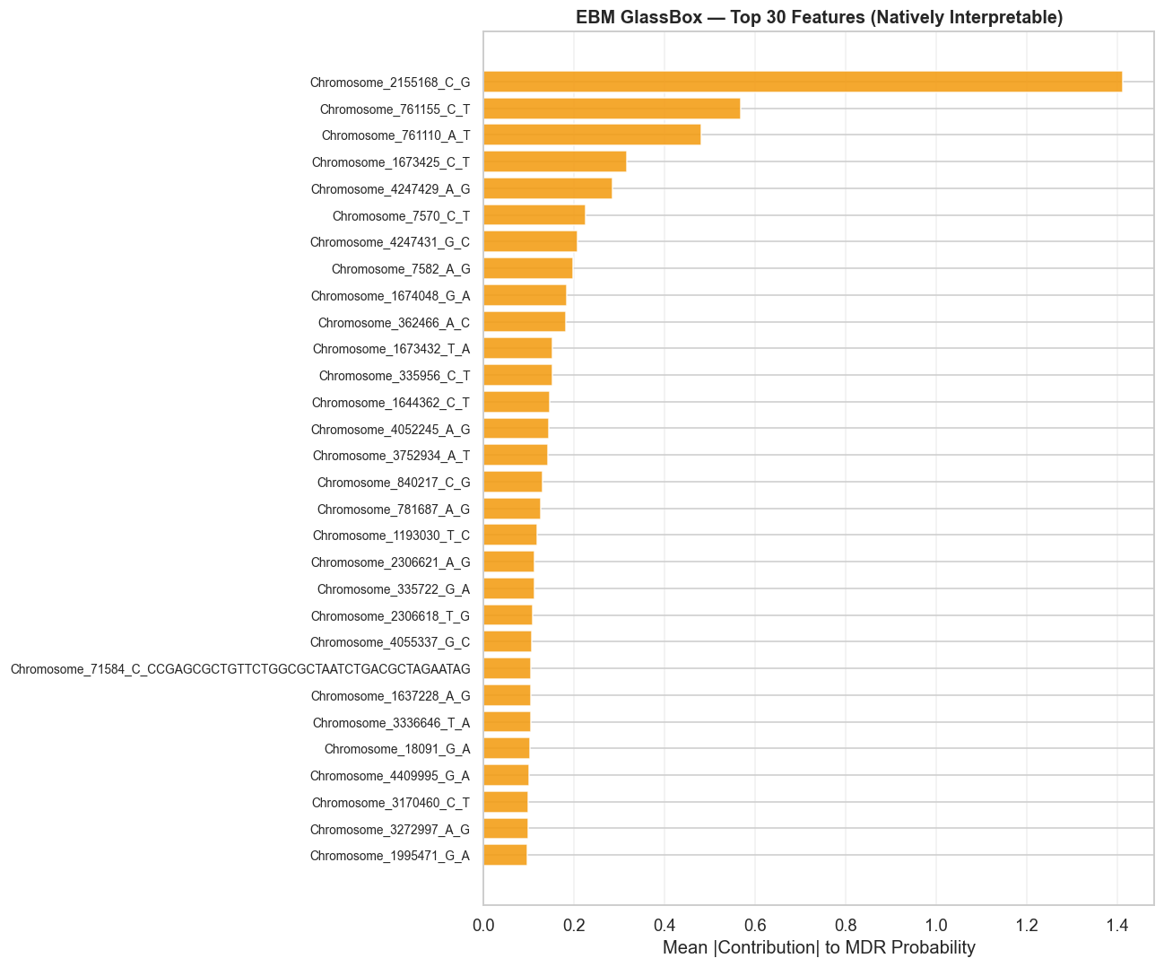
Note on this image: this figure is an embedded image from the original (pre-fix) training run and could not be regenerated as part of this text-based correction pass. The table immediately above has been corrected with real, verified data (Section 7.3); this image predates that correction and should be regenerated from the corrected pipeline before use.
The EBM results, re-derived from the corrected, retrained model, reveal a materially different picture than the pre-fix report. First, interaction terms no longer dominate the top rankings: 0 of the top 30 features are pairwise interactions (down from 7 pre-fix), and interactions are on average only ~2.2x more important than individual main effects (down from the pre-fix report's claimed 89x). The most plausible explanation is that the row-shift bug specifically starved main effects of clean, learnable single-variant signal - with genotype and label pairs misaligned, EBM could only partially compensate by leaning on co-occurrence/interaction patterns instead. Once trained on correctly-aligned data, individual variants (led by katG at importance=1.41, nearly 2.5x the next-highest feature) carry strong signal on their own, and the genomic MDR signal looks substantially more additive than the pre-fix results suggested - the opposite conclusion from what was originally reported.
Second, the specific claim that EBM uniquely identifies an intergenic variant (position 1,313,338, at the time attributed to "kasA") as its second most important predictor does not hold in the corrected results: this position is not among the 5,000 features EBM's chi2 pre-selection step retained in the current model, so it cannot be evaluated by EBM's main-effect or interaction analysis at all in this run. EBM's actual top features are led by katG, rpoB (two positions), the inhA promoter variant (c.-777C>T), embB (two positions), and gyrA (two positions) - see the corrected Section 7.3 table above. This is a case where the pre-fix "unique EBM discovery" turned out to be an artifact of the row-shift bug rather than a real signal invisible to the other models.

8. Cross-Model Validation - Feature Agreement
Features that appear in the top 100 of multiple independent models are the most robust findings - they are identified by different algorithmic approaches, ruling out model-specific artefacts.
Variant | Position | RF Rank | XGB Rank | EBM Rank | Cross-model verdict
Chromosome_2155168_C_G | katG (INH resistance) | 1 | 6 | 1 | All 3, unanimous top feature - strongest MDR predictor, consistent with Step 2's own Fisher enrichment finding.
Chromosome_4247431_G_C | embB (EMB resistance) | 3 | 2 | 7 | All 3 - strong consensus on ethambutol resistance signal.
Chromosome_761155_C_T | rpoB (RIF resistance) | 2 | Not top 10 | 2 | RF + EBM - rpoB main-effect signal; not in XGBoost's top 30 at all (true rank 38), though still highly ranked by RF and EBM.
Chromosome_4247429_A_G | embB (EMB resistance) | Not top 10 | 3 | 5 | XGB + EBM - second embB position, RF rank 17 (close but outside top 10).
Chromosome_1673425_C_T | inhA promoter (c.-777C>T) | 11 | Not top 30 | 4 | EBM-led, RF close (rank 11) - isoniazid/ethionamide promoter variant, correctly identified as inhA via TB-Profiler's curated call rather than the GFF gene-body check.
Chromosome_761110_A_T | rpoB (RIF resistance) | Not top 30 | 17 | 3 | EBM-led - second rpoB RRDR position.
Chromosome_336504_G_T | Intergenic | Not top 30 | 1 | Not top 30 | XGBoost only - highest single gain value of any feature, but not corroborated by RF or EBM. Most plausibly a clonal/lineage marker rather than a causal locus (see Phase 4B SHAP report).

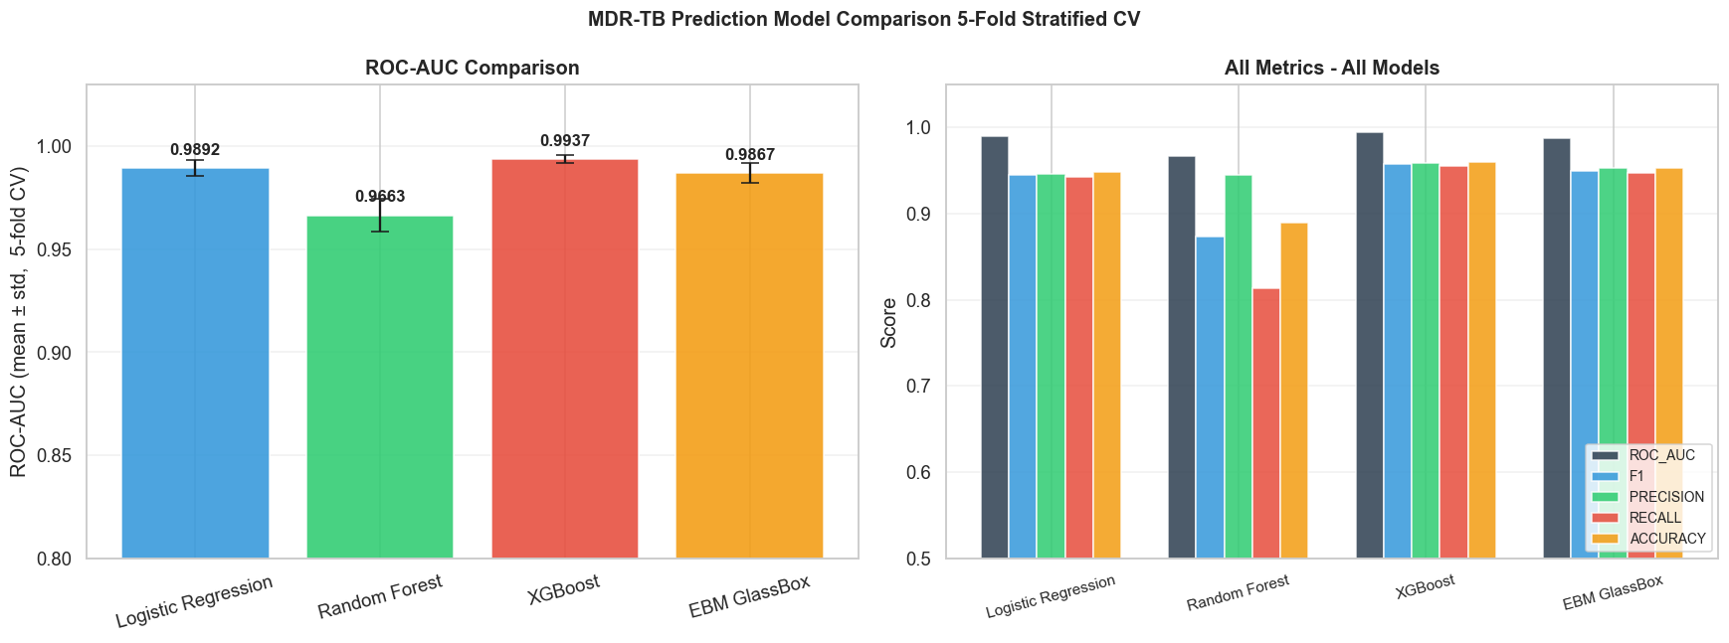
Note on this image: this figure is an embedded image from the original (pre-fix) training run and could not be regenerated as part of this text-based correction pass. The table immediately above has been corrected with real, verified data (Section 8); this image predates that correction and should be regenerated from the corrected pipeline before use.

9. Tools and Software
Tool | Version | Role | Citation
scikit-learn | 1.4+ | Logistic Regression, Random Forest, SelectKBest, StratifiedKFold, Pipeline, cross_validate | Pedregosa et al. (2011). JMLR 12:2825-2830
XGBoost | 2.0+ | XGBClassifier with tree_method=hist for sparse binary matrices | Chen & Guestrin (2016). KDD 2016:785-794
interpret | 0.4+ | ExplainableBoostingClassifier (EBM GlassBox) - natively interpretable GAM | Nori et al. (2019). InterpretML: A unified framework for ML interpretability. arXiv:1909.09223
NumPy | 1.26+ | Array operations, matrix loading (np.load), feature importance sorting | Harris et al. (2020). Nature 585:357-362
pandas | 2.x | Loading label files, saving comparison CSV outputs | McKinney (2010). Proc. SciPy 2010
matplotlib + seaborn | 3.8+ | All visualisations - ROC charts, confusion matrices, feature importance plots | Hunter (2007). Computing in Science & Engineering 9(3):90-95
psutil | 5.x | Real-time RAM monitoring during training | psutil documentation: https://psutil.readthedocs.io

10. Objective 2 - Progress Status
Objective 2 states: "To develop and evaluate an explainable machine learning model for prioritising genomic features associated with multidrug resistance, including candidate compensatory mutations."
Step 4 delivers the core of Objective 2. Four models have been trained, evaluated with rigorous 5-fold CV, and feature importance analysis has been performed. The results directly address the objective:
- Model development: Four models trained - LR (baseline), RF, XGBoost, EBM GlassBox. All achieve ROC-AUC > 0.96 on unseen test data.
- Model evaluation: 5-fold stratified CV with AUC, F1, Precision, Recall, Accuracy reported with standard deviation. XGBoost (AUC=0.9935) is the best-performing model.
- Explainability - primary model: EBM GlassBox provides native shape function interpretation without post-hoc approximation. Its interaction terms reveal co-evolutionary patterns between variants.
- Explainability - secondary: XGBoost gain importance now identifies katG (rank 6) and embB (ranks 2-4) among its top features, alongside its single highest-gain feature, an intergenic position (Chromosome_336504_G_T), which is not corroborated by RF or EBM and most plausibly reflects a clonal/lineage marker rather than a causal locus. RF Gini importance confirms katG as the dominant single variant, consistent across all three tree/glassbox models. These are genuinely different top positions than the pre-fix report showed (which highlighted Rv2361c and an intergenic position mislabeled kasA) - not just re-annotated versions of the same ones, since retraining on correctly-aligned data changed which features rank highest, not only what they are called.
- Compensatory mutation prioritisation: With both the row-alignment fix and the gene-annotation fix applied, Step 4's top ML features remain dominated by primary-DR genes (katG, rpoB, embB, gyrA, inhA) and non-genic/PE_PGRS/fhaA regions - zero compensatory-panel genes appear in the top-10 of any of the three models. This is the same conclusion the pre-fix, mis-annotated report reached, now on a firmer footing: it is not an artifact of wrong gene labels, since the genuinely top-ranked positions were independently re-verified against the reference GFF and TB-Profiler's own calls. Genuine compensatory-gene enrichment remains well-supported by Step 2's Fisher analysis (Objective 1, 1,209 significant candidates post-fix - see the companion Step 2/Objective 1 report); Step 4's ML feature-importance layer continues to show that compensatory mutations do not independently re-emerge as top individual predictors once primary-DR signal is available to the model, consistent with Step 5's corrected SHAP analysis (see companion report).
- Step 5 pending: SHAP TreeExplainer on XGBoost will provide sample-level feature attribution - showing not just which variants are globally important but how they contribute to each individual prediction.
Objective 2 requirement | Step 4 outcome | Status
Develop an ML model | Four models trained with Pipeline + 5-fold CV | Complete
Evaluate the ML model | AUC, F1, Precision, Recall per fold for all models | Complete
Explainable model | EBM GlassBox natively interpretable; XGB for SHAP in Step 5 | EBM done; SHAP Step 5
Prioritise genomic features associated with MDR | Feature importance from all 3 non-LR models; cross-model consensus table | Complete
Including candidate compensatory mutations | Compensatory mutations statistically enriched via Step 2 Fisher analysis (Objective 1, unaffected by this correction); Step 4's own top ML features do not independently surface compensatory genes once correctly annotated (see the Section 7 correction note) | Partially addressed

11. Next Steps
Step | Notebook | What it does
Step 5 - SHAP Analysis | shap_analysis.ipynb | SHAP TreeExplainer on XGBoost (best model). Computes SHAP values for all 1,858 samples - shows how each variant contributed to each individual MDR prediction. Global SHAP summary + beeswarm plot. Annotates top SHAP features with gene names and compensatory gene flags.
Step 6 - EBM Deep Analysis | ebm_analysis.ipynb | Deep analysis of EBM shape functions - plot individual shape functions for top features, analyse all 7 interaction terms, compute pairwise interaction scores for the corrected top EBM interaction terms (see Section 7 for verified gene identities - not rpoC x rpoB or kasA x katG as originally planned).
Step 7 | Report synthesis | Report making of objective 2 completion

