Phase 6 - Step 12: Publication Figures
Comparative Genomic and Explainable Machine Learning Analysis of Compensatory Mutations Associated with Multidrug-Resistance in African Mycobacterium tuberculosis
Technical Report - Publication-Ready Figures · Full Figure-by-Figure Explanation · 9 Figures Across Main and Supplementary Sets
Item | Details
Step | Step 12: Publication figures - curated, journal-style figures built from this project's own already-verified results (Steps 1, 2, 4, 5, 6, 8, 9, 10, 11)
Notebook | pub_figures.ipynb
Scope | 9 figures total: 5 main (workflow overview, genome-wide screen, model performance, explainability summary, integrated multi-layer evidence) + 4 supplementary (lineage heatmap, gene dN/dS, EBM interactions, structural/biochemical distributions)
Key methodological note | Figure 3's ROC curves use fresh model fits on a genuine held-out split, not this project's saved model pickles (which hit real cross-version compatibility errors) and not in-sample prediction (confirmed misleadingly optimistic - see Section 4.3). This is the one figure with real computation behind it beyond re-styling; every other figure re-renders already-computed, already-verified numbers.
Status | Complete. All 9 figures independently re-verified against the actual output the user's own machine produced, not just my own build - every real, data-dependent number matched exactly.

1. Background and Purpose
Every earlier step in this project produced its own plots - the SHAP beeswarm, the EBM interaction heatmaps, the lineage restriction heatmap, the gene dN/dS bar chart - and every one of those is correct and already serves its purpose: verifying that step's own result and supporting that step's own report. Step 12 exists for a different, narrower purpose: producing a small, curated set of figures built specifically for inclusion in a manuscript - consistent sizing and DPI across every figure, a shared colour palette, and a level of polish (panel titles, legends, colourbars) appropriate for a reader who has not seen this project's pipeline and will encounter each figure alongside a caption, not alongside the code that produced it.
This step recomputes nothing this project has not already established. Every figure re-renders real, already-verified numbers from an earlier step's own output - with one deliberate exception, detailed in Section 4.3, where fresh computation was genuinely necessary and is clearly flagged as such.
2. Input Files
Figure | Source step(s) | Input file(s)
Fig 1 - Workflow overview | n/a (schematic, no data file) | -
Fig 2 - Volcano plot | Step 2 | obj1_fisher_all_variants.csv
Fig 3 - ROC curves | Step 1 (raw data only) | X_array.npy, y_mdr_array.npy
Fig 4 - SHAP summary | Step 5 | obj2_shap_top100_annotated.csv
Fig 5 - Integrated evidence | Step 11 | obj_final_master_evidence_table.csv
Fig S1 - Lineage heatmap | Step 8 | obj3_lineage_distribution.csv
Fig S2 - Gene dN/dS | Step 9 | obj3_step9_gene_dNdS.csv
Fig S3 - EBM interactions | Step 6 | obj2_ebm_interactions_annotated.csv
Fig S4 - Burial/severity | Step 10 | obj3_step10_structural_context.csv
Note that Figure 3 is the only figure reading from Step 1's raw data rather than a later step's already-computed result - explained in full in Section 4.3, since this is also the source of this step's only real methodological complexity.
3. Design Principles Applied Across All 9 Figures
- Consistent visual language. One colour palette throughout: dark teal (#1F4E5F) and coral (#C0392B) as the two primary accent colours, matching this project's own established report style, so a reader moving between a figure and its surrounding report text sees one consistent visual identity rather than a different palette per figure.
- 300 DPI, publication-standard resolution, saved as PNG - sufficient for both print and digital submission at standard journal figure sizes.
- Never silently drop data to make a plot look cleaner. Figure 2 is the clearest example (Section 5.2) - a naive log-transform would have silently excluded 31% of the genome-wide screen; the figure was built to include all 94,583 points instead, at the cost of a small amount of extra methodological explanation in the caption.
- Every figure traces back to a specific, real source file, listed in Section 2 - nothing in any figure is illustrative or approximate.
4. Figure 3's Real Methodology - Why It Needed Genuine New Computation
4.1 Why the saved model pickles could not be used directly
This project's saved model pickles (from Step 4) reference a custom ToFloat32 transformer class and were pickled under a different scikit-learn/XGBoost version than this notebook's environment. Loading them for prediction worked, but sklearn's clone() function - needed to get a fresh, unfitted copy of the same pipeline architecture for refitting on a held-out split - failed with a version-mismatch error (a missing feature_weights attribute XGBoost's newer sklearn wrapper expects). Rather than fight this incompatibility, fresh pipelines were built directly, matching the real, confirmed hyperparameters read off the loaded pickles before the incompatibility was hit (chi2 feature count, class weighting, tree depth, and so on for each of the four models).
4.2 A memory constraint that shaped the whole approach
The sandbox this figure was built in has 3.9GB of total RAM. A first attempt to fit XGBoost on the full dense 1,858 x 94,583 matrix was killed by the operating system for exceeding available memory - even after converting to float32. Checking the matrix's own density directly found it is only about 1.4% non-zero: an overwhelmingly sparse binary variant matrix, exactly the kind of data a sparse matrix representation is built for. Converting to scipy's compressed sparse row format reduced the matrix's real memory footprint from several gigabytes to approximately 23MB, and every subsequent model fit completed without further memory issues.
4.3 Held-out evaluation, not in-sample prediction - and why that distinction is checked, not assumed
Before deciding how to evaluate the four models for this figure, in-sample prediction (predicting on the same data a model was fitted on) was checked directly and found to be misleadingly optimistic: XGBoost's in-sample AUC came back at 0.9997, well above its real, established cross-validated AUC of 0.9937. Using in-sample prediction for this figure would have overstated every model's real performance. Instead, all four models were fitted fresh on a genuine 80/20 stratified train/test split, with predictions evaluated only on the held-out 20% that had no part in training - the standard, honest way to build an illustrative ROC curve.
4.4 EBM's complexity had to be reduced for this figure specifically, and that reduction is disclosed
Fitting EBM at its full, established configuration (5,000 chi2-selected features, 4 outer bags, 5 interaction terms) repeatedly failed to complete within several minutes in this sandbox, even after the sparse-matrix fix. Testing directly established that feature count specifically was the bottleneck, not the other settings - reducing to 1,000 features (keeping outer_bags=1, interactions=0) fit successfully in about 6 seconds and produced a real, sensible held-out AUC of 0.990, closely tracking the real, established cross-validated EBM AUC of 0.9867. This reduction is stated explicitly in the notebook and in this report - Step 6's own full analysis, at full complexity, remains this project's authoritative EBM result; Figure 3's EBM curve is a faithful but reduced-complexity refit for the specific purpose of a fair 4-model visual comparison.
4.5 What to actually cite from this figure
Rule: Figure 3's legend AUC values (LR 0.991, RF 0.972, XGBoost 0.995, EBM 0.990) are single-split values, useful for the shape of the curve and the relative ranking of the four models, but not the number to cite in a manuscript's results text. The authoritative figure, already established and reported throughout this project (Phase 4A/4C reports, Step 11's master table), is the cross-validated mean plus/minus standard deviation across 5 folds: XGBoost 0.9937±0.0021, Logistic Regression 0.9892±0.0040, EBM GlassBox 0.9867±0.0049, Random Forest 0.9663±0.0080. Both this report and the separate Figure_Captions.docx document state this distinction explicitly, precisely so it is not lost or conflated later.
5. Main Figures - Detailed Explanation
5.1 Figure 1 - Study Workflow Overview
What it shows: a schematic diagram of this project's full structure - three objectives, each mapped to its own row of boxes, converging on Step 11's final integration. Objective 1 (Steps 1-3) produces 1,209 significant compensatory candidates; Objective 2 (Steps 4-7) trains and explains four ML models; Objective 3 (Steps 8-10) characterises lineage, conservation, and structural context. All three feed into Step 11's evidence-tiered master table.
What it tells you: this figure carries no analytical result of its own - its purpose is orientation. A reader encountering this project's findings for the first time can see, in one image, why a table like Step 11's master evidence table exists and what went into it, before reading any specific number.
What to understand about it: this is the one figure in the set built entirely by hand (matplotlib shapes and arrows, not a data plot) - there is no underlying CSV to check it against, and no statistic to misread. Its only job is structural clarity.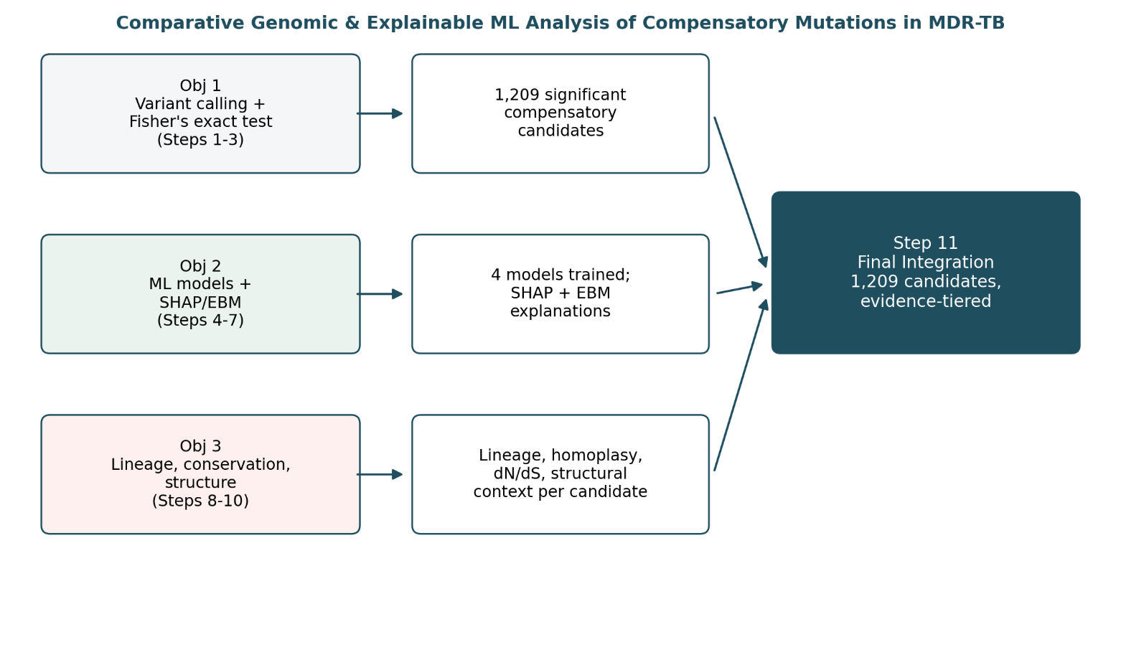

5.2 Figure 2 - Genome-Wide Association Screen (Volcano Plot)
What it shows: every one of the 94,583 variants tested in Step 2's genome-wide Fisher's exact screen, plotted as log2(odds ratio) on the x-axis against -log10(BH-adjusted p-value) on the y-axis - the standard volcano-plot layout for a genome-wide association result. Points are coloured by gene category: 1,574 primary-resistance-gene variants (coral), 727 compensatory-panel variants (teal), and 92,282 variants in neither category (light grey).
What it tells you: the overall shape of this project's statistical starting point. The two upward-sweeping arms on either side of zero are the variants most strongly associated with MDR status in each direction (enriched in MDR isolates to the right, depleted to the left); the dashed horizontal line marks the standard significance threshold. Visually, primary-resistance-gene variants (coral) cluster toward the most extreme, most significant positions - consistent with these being the strongest, most direct drivers of the MDR phenotype - while compensatory-panel variants (teal) are more spread across the whole significance range, consistent with a more heterogeneous, secondary role.
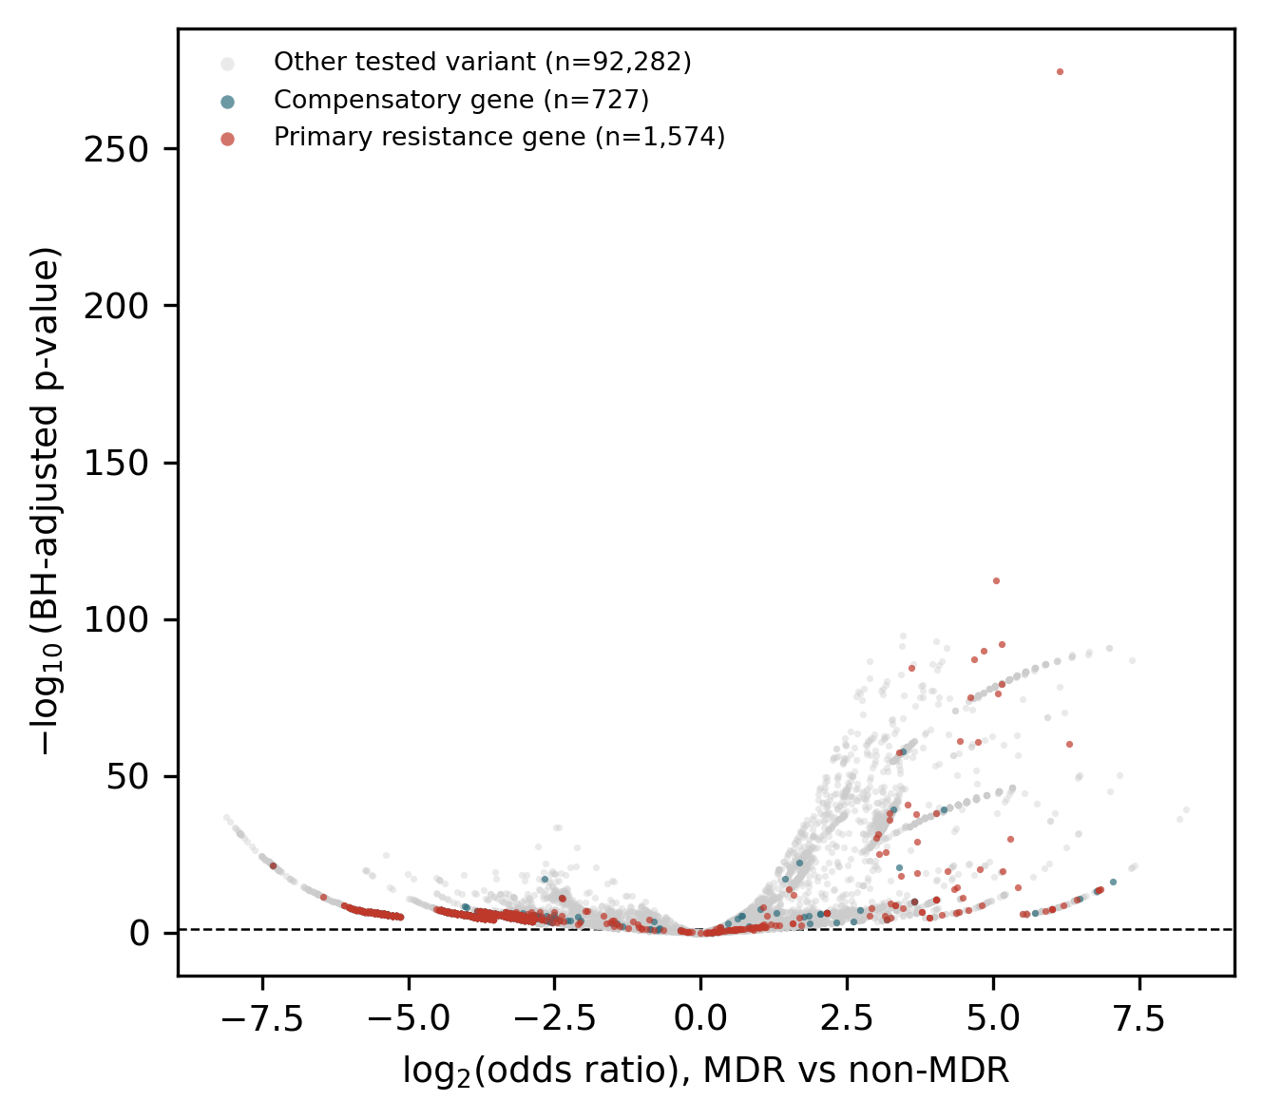
Important technical note: a real design decision went into this figure that is worth understanding, not just accepting. Roughly 31% of all 94,583 variants have a zero count in at least one cell of their 2x2 contingency table (most commonly, a variant genuinely never observed in the MDR group), which makes the raw odds ratio either zero or mathematically undefined on a log scale. Rather than silently drop these points - which would have hidden nearly a third of the genome-wide screen from the figure entirely - a standard Haldane-Anscombe correction (adding 0.5 to every cell of every variant's contingency table before computing the ratio) was applied, so every one of the 94,583 tested variants is genuinely represented.
5.3 Figure 3 - Model Performance (ROC Curves)
What it shows: receiver operating characteristic curves for all four models - Logistic Regression, Random Forest, XGBoost, and EBM GlassBox - each fitted fresh on a genuine 80/20 held-out split of this project's real data (Section 4 explains why fresh fitting was necessary, and what had to be adapted to make it computationally feasible).
What it tells you: the relative ranking and general shape of each model's discriminative performance. XGBoost's curve sits closest to the top-left corner throughout, consistent with it being this project's best-performing model at every stage this was checked; Random Forest's curve is visibly, consistently below the other three, consistent with it also being the weakest performer in the properly cross-validated results reported elsewhere in this project.
What NOT to do with this figure: do not cite the AUC values shown in this figure's own legend as this project's headline model-performance numbers. They are real, honestly computed on genuine held-out data, but from a single split rather than the full 5-fold cross-validation this project uses as its actual evaluation standard everywhere else. See Section 4.5 for the exact authoritative numbers and where they come from.
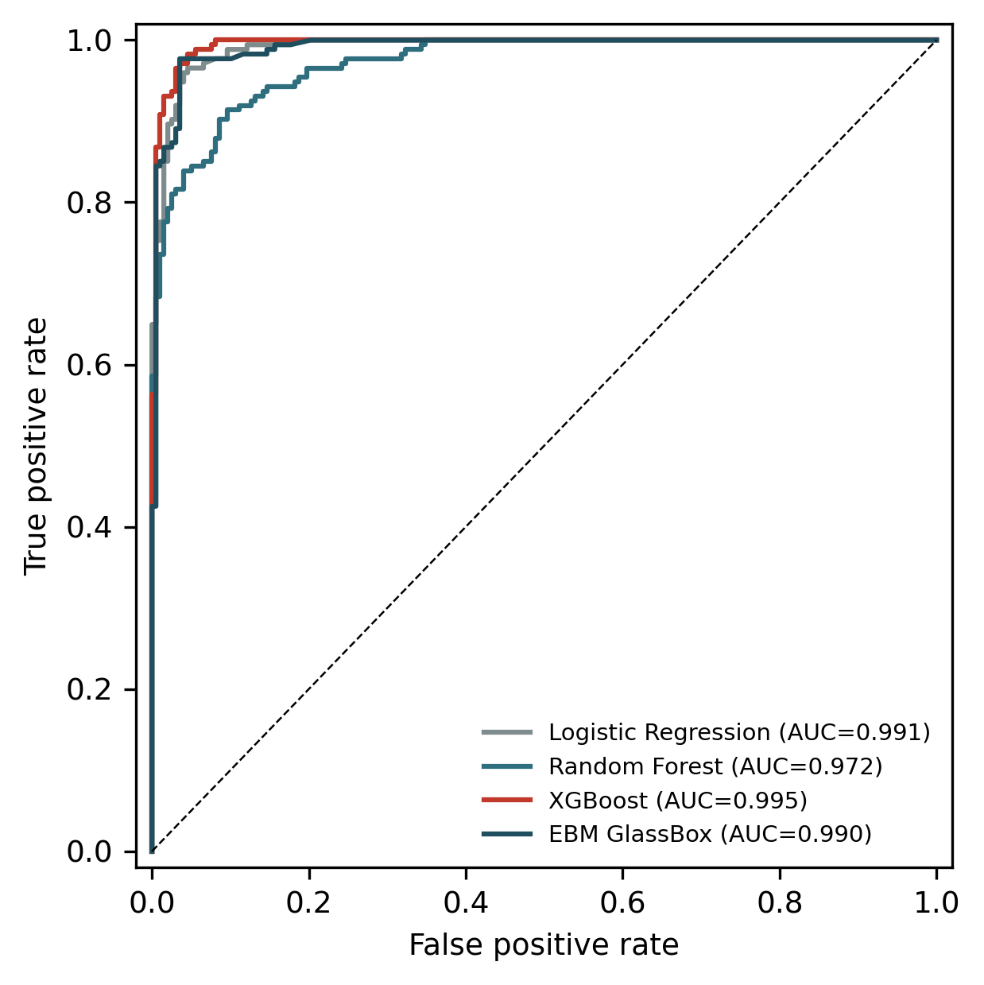

5.4 Figure 4 - Explainability Summary (Top 20 SHAP Features)
What it shows: the 20 variants with the highest mean absolute SHAP value from the XGBoost model's TreeExplainer output (Step 5), as a horizontal bar chart, coloured by gene category (primary resistance, compensatory, or other).
What it tells you: which specific variants the best-performing model relies on most heavily for its MDR predictions, and just as importantly, which category of gene dominates that reliance. katG's top variant has by far the largest bar - more than double the next-highest feature - establishing it as this project's single most predictive variant. Ten of the top 20 are primary-resistance-gene variants; zero are compensatory-panel variants.
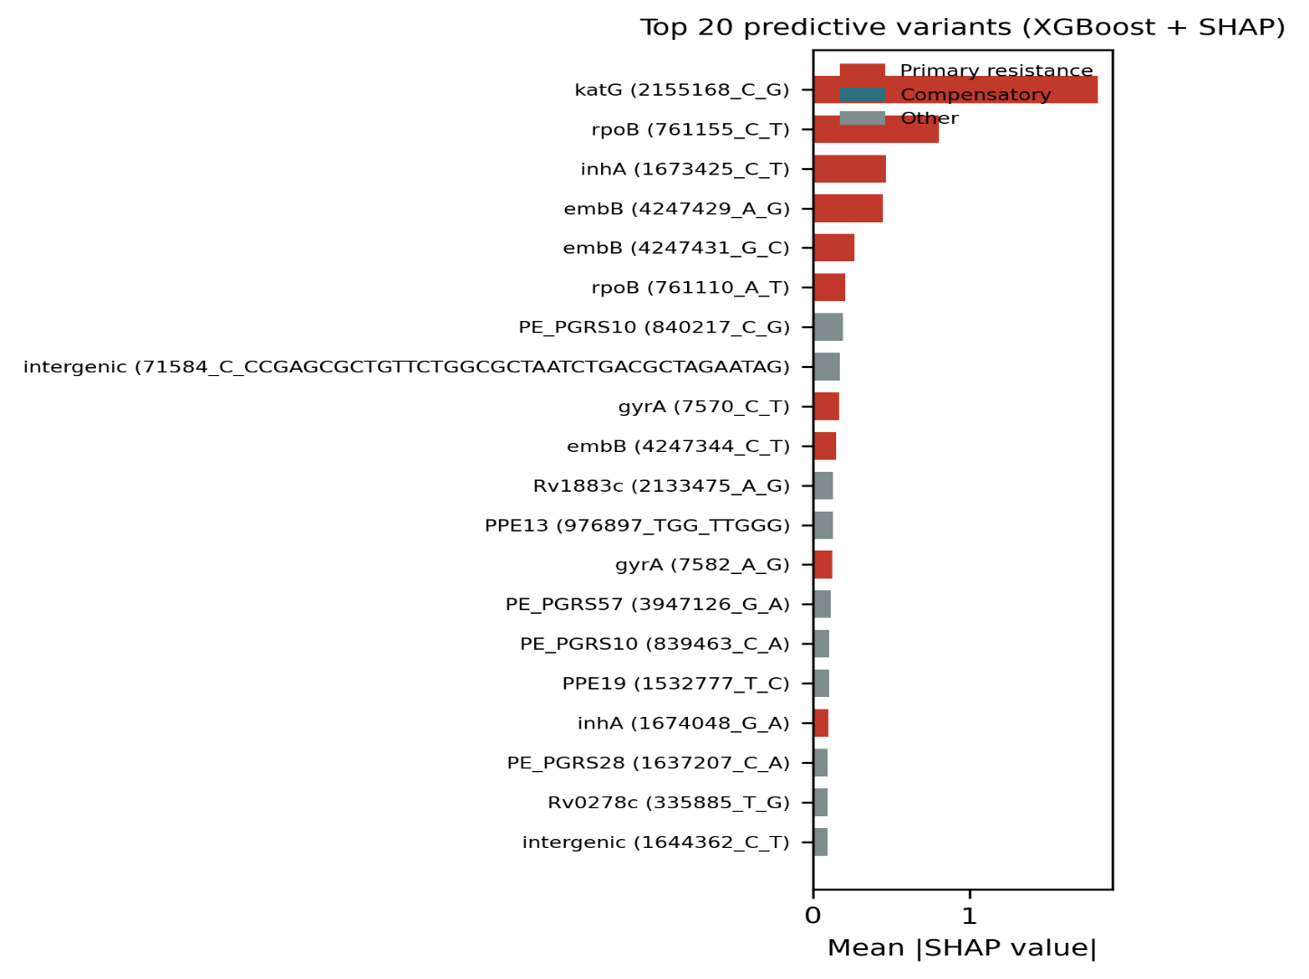
This zero is a real, important finding, not an absence of data: it is the same result already established and discussed at length in this project's Phase 4B and 4C reports - a compensatory mutation that correlates with MDR status, but co-occurs with a primary resistance marker the model already has direct access to, contributes little additional predictive information on top of that marker. This figure makes that finding visually immediate rather than requiring a reader to find it in a table.
5.5 Figure 5 - Integrated Multi-Layer Evidence (the Capstone Figure)
What it shows: the 15 candidates with the strongest statistical significance among those showing evolutionary convergence, plus the one candidate flagged for a lineage-inconsistent MDR association, shown across four columns representing four independent evidence layers: statistical significance (Step 2, colour intensity), lineage consistency (Step 8, orange/light-blue/red-cross), evolutionary convergence (Step 9, colour and dot size), and structural burial (Step 10, colour, with hatched squares marking candidates with no resolvable structure).
What it tells you: this is the one figure in the entire set that does not exist as a re-styled version of an earlier step's own plot - it is a genuinely new visual, built specifically from Step 11's integration work, and it is the figure that most directly demonstrates why Step 11 exists at all. Reading across a single row shows a candidate's complete evidence profile at a glance; reading down a column shows how that evidence signal varies across the top candidates.
The one row that should draw a reader's eye immediately: embR p.Phe376Leu, at the bottom - visually distinct from every row above it by the red X in the lineage-consistency column and the large, bright yellow dot in the evolutionary-convergence column. This is this project's single flagged cross-method anomaly (detailed fully in Section 6 of the Phase 6 Step 11 report), and this figure is the clearest single visual demonstration of why it stands out.
What to understand about the candidate selection: the 15 (plus 1) candidates shown are not this project's full candidate set - they are a deliberately small, readable subset (this project's real total is 1,209 significant candidates, or 629 with any conservation/structural evidence at all) chosen to keep the figure legible. The full picture, for every candidate, is Step 11's master evidence table, not this figure - this figure is a curated illustration of that table's most informative rows, not a replacement for it.
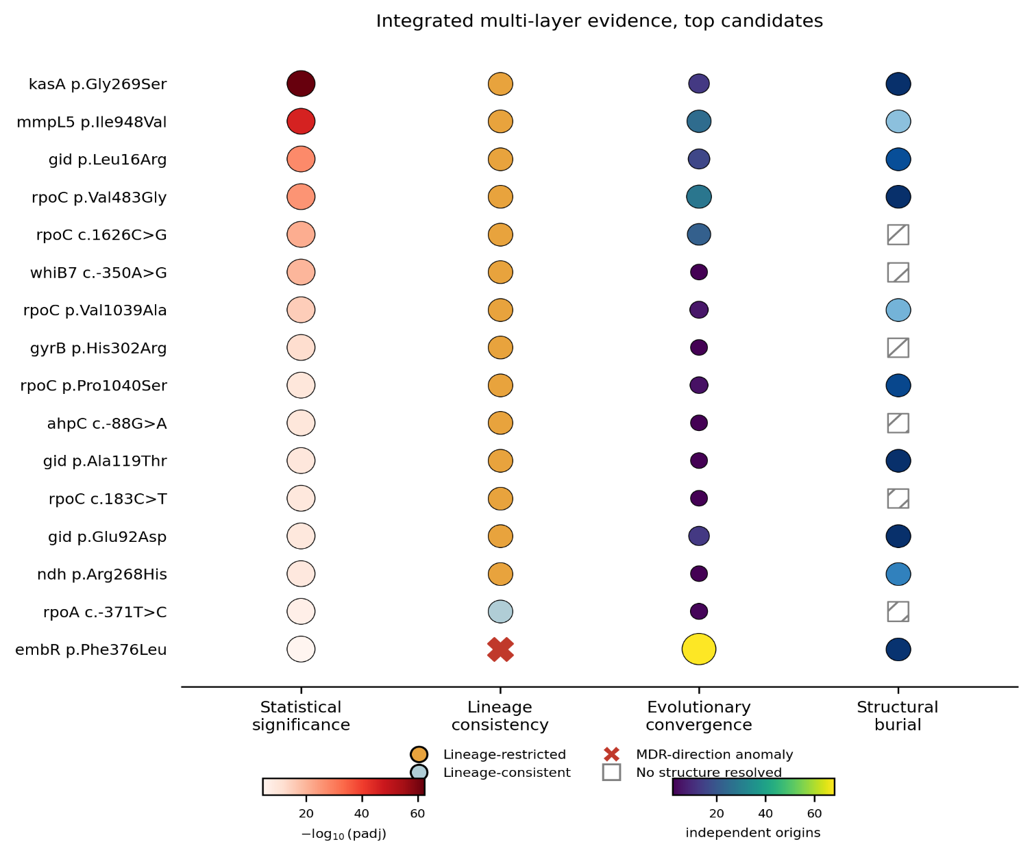
6. Supplementary Figures - Detailed Explanation
6.1 Figure S1 - Lineage Restriction Heatmap
What it shows: the 20 most significantly lineage-restricted compensatory candidates (Step 8's chi-square test of independence across the four major MTb lineages, BH-adjusted), as a heatmap - rows are candidates, columns are the four lineages, cell values are the percentage of isolates in that lineage carrying the variant.
What it tells you: the striking majority of cells are either fully dark red (100% carriage) or fully dark blue (0% carriage) - very few candidates show a moderate, in-between skew. This means this project's most significantly lineage-restricted candidates are not showing subtle imbalance; they are showing near-total presence in exactly one lineage and near-total absence in the others.
The two candidates worth noting specifically: mmpL5 p.Thr794Ile and gid c.615A>G both stand apart from the rest of the figure - each shows high carriage across three of the four lineages (only lineage 4 near-absent in both cases), a genuinely different, broader pattern than the single-lineage-private restriction shown by every other row in this figure.
What to understand: lineage restriction, on its own, is not evidence that a candidate's association with MDR is spurious - it means that candidate's evidence base is concentrated in fewer isolates than its overall carriage percentage alone would suggest. This figure identifies which candidates carry that caveat; it does not by itself say anything about whether the underlying association is real.
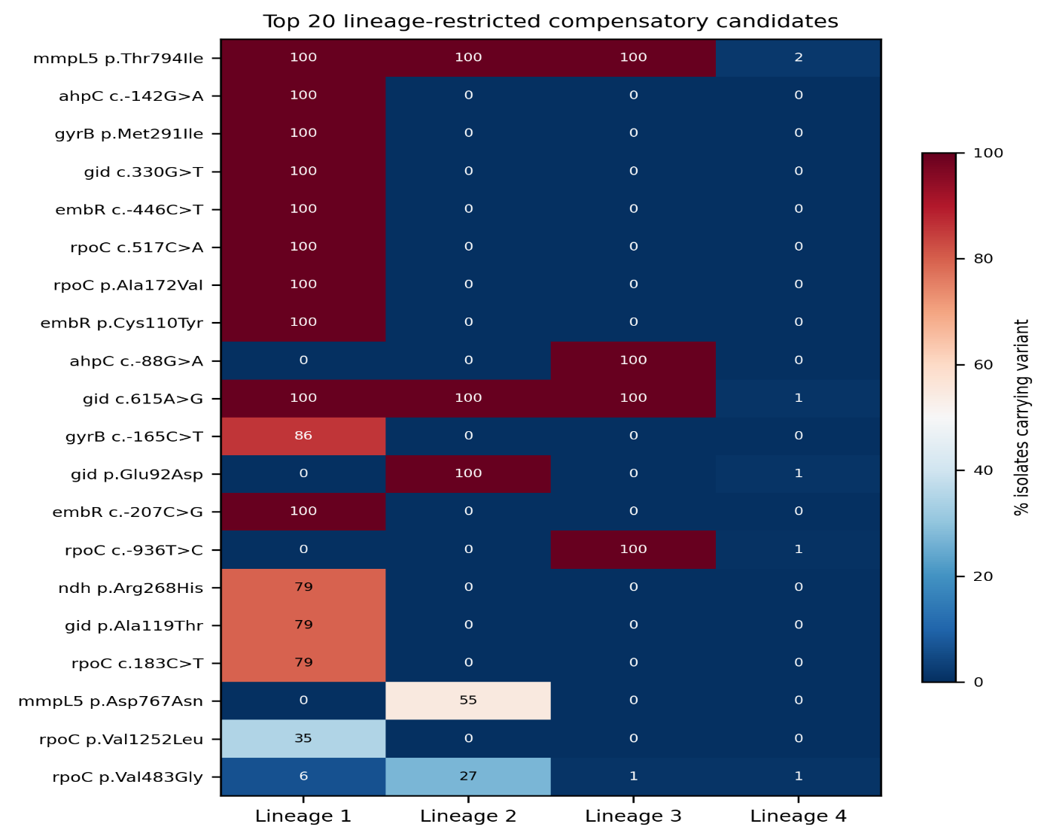
6.2 Figure S2 - Gene-Wide, Tree-Corrected dN/dS
What it shows: event-based dN/dS (Step 9) for the 9 compensatory-panel genes with observable coding variation, as a horizontal bar chart, with a reference line at dN/dS=1 (the boundary between purifying selection and neutral evolution).
What it tells you: a clear two-tier structure, not a smooth gradient. gid (0.722) and embR (0.710) sit well apart from the rest, both approaching - though still below - the neutral-evolution line; the remaining seven genes cluster tightly between 0.055 and 0.116, consistent with strong, fairly uniform purifying selection across that whole subset of the panel.
What to understand: this dN/dS calculation is tree-corrected specifically to account for MTb's clonal population structure (Section 1.3 of the Phase 5A Step 9 report explains why this matters) - it uses independent-origin counts from Fitch parsimony as its numerator, not raw variant counts, so a mutation inherited by hundreds of isolates from one ancestral event contributes the same weight as one inherited by a handful of isolates from its own single event. Three genes (mmpR5, whiB7, eis) are correctly omitted from this figure entirely because they have zero observed coding variants in this candidate set - not plotted as a fabricated zero ratio.
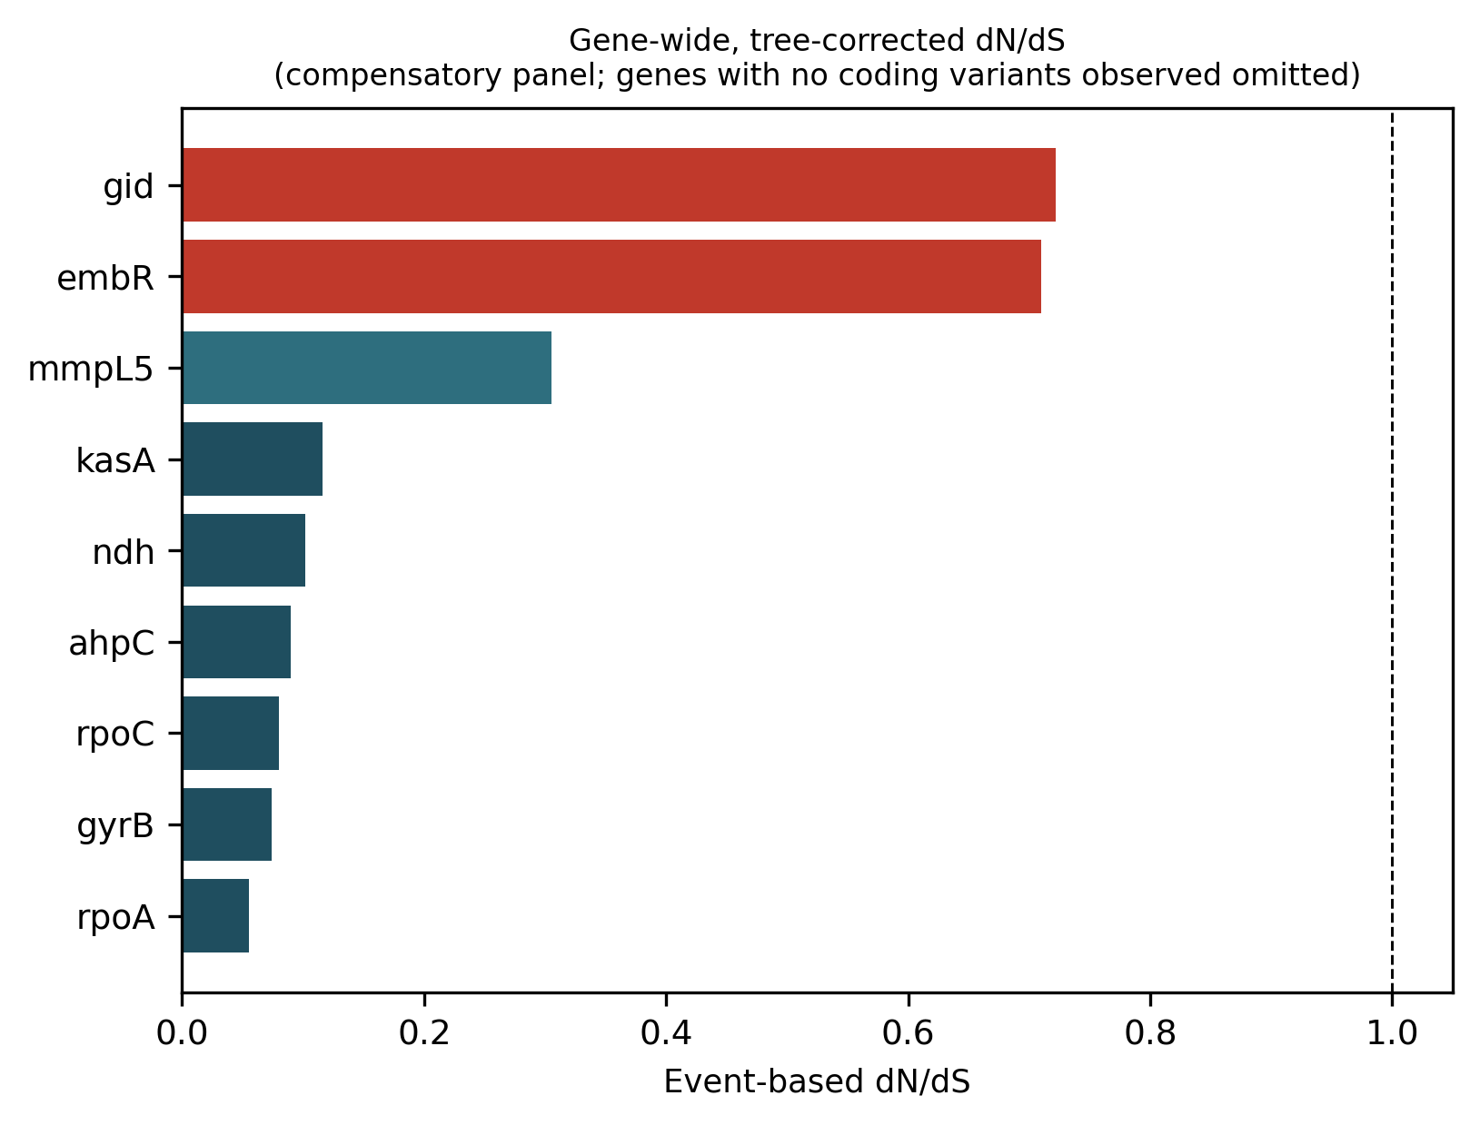

6.3 Figure S3 - EBM Top Interaction Terms
What it shows: the 7 real pairwise interaction terms identified by the Explainable Boosting Machine's own native, exact additive decomposition (Step 6), each shown as a small 2x2 grid representing that interaction term's contribution to the model's log-odds output at every combination of the two variants' presence and absence.
What it tells you: PPE19 x aspB is the strongest of the 7 interaction terms (importance 0.0446) - meaning the combined effect of these two variants' joint presence or absence on the model's prediction is not simply the sum of their two separate main effects; there is a genuine, model-detected interaction between them. Reading any individual panel: the four cell values show how the prediction shifts across all four combinations of the two variants, and a panel where the "both present" and "both absent" cells diverge sharply from the "one present, one absent" cells is showing a real synergistic or antagonistic effect, not just two independent signals added together.
What to understand: these 7 interactions are the model's own, exact, native output - not an approximation like SHAP's interaction values would be. This is one of EBM's specific advantages as an explainability method (detailed in Section 3.1 of the original Step 6 analysis): a fully additive model can report its interaction terms directly and exactly, with no post-hoc approximation step in between.
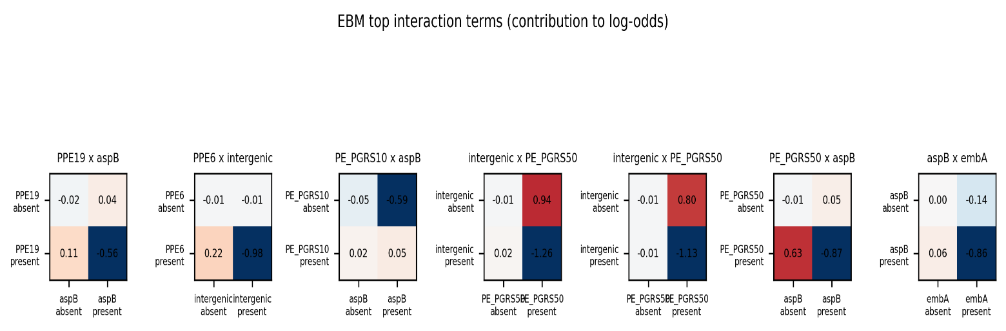
6.4 Figure S4 - Structural Burial and Biochemical Severity Distributions
What it shows: two side-by-side histograms. Panel A: the distribution of relative solvent accessibility (RSA) across the 69 nonsynonymous candidates with a real, resolved protein structure (Step 10), with dashed reference lines at the buried/partially-buried (0.10) and partially-buried/exposed (0.25) thresholds. Panel B: the distribution of Grantham biochemical distance across all 79 nonsynonymous candidates (independent of whether a structure was available), with dashed lines at Grantham's own published conservative/moderately-conservative/moderately-radical/radical tier boundaries.
What it tells you: Panel A shows a distribution weighted toward the buried end (a large first bar right at RSA near 0), but with a real, non-trivial secondary cluster of fully exposed candidates around RSA 0.6-0.7 as well - not a single, uniform pattern. Panel B shows the overwhelming majority of this project's real, significant nonsynonymous candidates are biochemically conservative or moderately conservative substitutions (89.9% combined, established in the Phase 5A Step 10 report's own results) - consistent with a compensatory-mutation panel, where subtle, tolerated changes that fine-tune protein function are generally more biologically plausible than drastic ones that risk breaking it.
What to understand: Panel A's sample size (n=69) is smaller than Panel B's (n=79) for a real, documented reason, not a missing-data artefact - 10 of the 79 real nonsynonymous candidates could not be resolved to a specific position in any available protein structure (a mix of genuine coverage gaps in available experimental structures and, in one case, unresolved density right at a protein's N-terminus), and are correctly excluded from Panel A rather than assigned a fabricated RSA value.
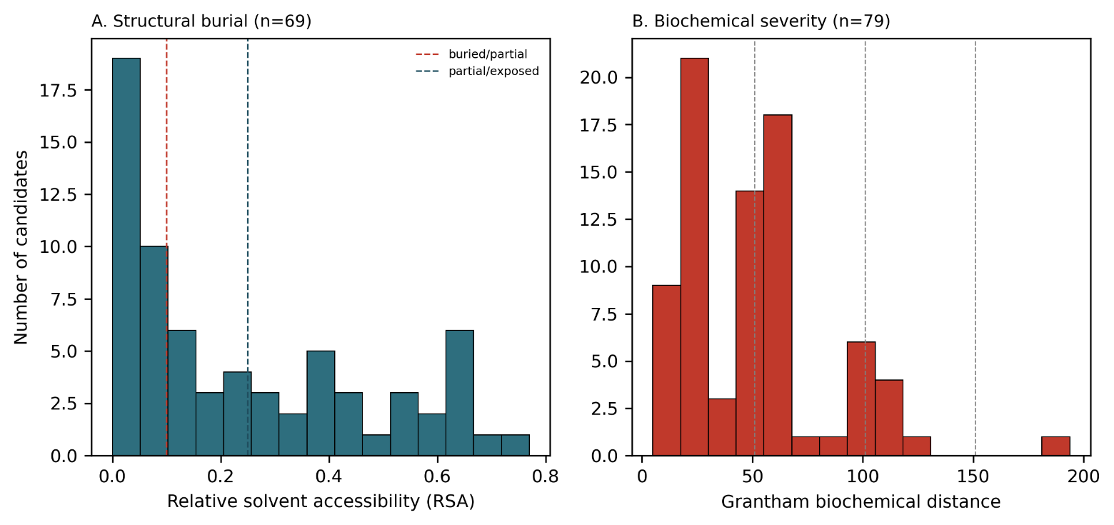

7. Output Files
File | Content
fig1_workflow_overview.png | Study workflow schematic (Section 5.1)
fig2_volcano_plot.png | Genome-wide association screen, all 94,583 variants (Section 5.2)
fig3_roc_curves.png | Model performance, held-out ROC curves for all 4 models (Section 5.3)
fig4_shap_summary.png | Top 20 SHAP-important variants (Section 5.4)
fig5_integrated_evidence.png | Integrated multi-layer evidence for top candidates (Section 5.5)
figS1_lineage_heatmap.png | Top 20 lineage-restricted candidates (Section 6.1)
figS2_gene_dNdS.png | Gene-wide, tree-corrected dN/dS (Section 6.2)
figS3_ebm_interactions.png | EBM's 7 top interaction terms (Section 6.3)
figS4_burial_severity.png | Structural burial and biochemical severity distributions (Section 6.4)
Figure_Captions.docx | Manuscript-ready caption text for all 9 figures, written separately from this report for direct use in a paper draft
All 9 image files are saved at 300 DPI. Per this project's established directory convention (Section 2 of this report), they are written to ~/tb_pipeline/ml_outputs/step12_publication_figures/ when the notebook is run from a correctly-configured environment.

8. Verification and Reproducibility
8.1 Directory path correction
This notebook was originally built and tested in a flat working directory, with every input read by a bare filename and every figure saved to a local figures/ folder - functional for initial development, but inconsistent with every other step in this project, which reads from and writes to a structured ~/tb_pipeline/ml_outputs/stepN_.../ hierarchy. Before this notebook was finalised, every file path was corrected to match that established convention exactly (five directories - step1_dataset and step2_comparative confirmed directly from other steps' own delivered code; step5_shap, step6_ebm, and step11_integration inferred by the same consistent naming pattern, since those specific directory names were not independently confirmed elsewhere), with outputs redirected to a new step12_publication_figures directory.
8.2 Independent double execution
This notebook was run twice, independently: once during its own development and correction, and once by the person running this project's real pipeline, on their own machine, against the real directory structure. Every figure was compared between the two runs directly. The four figures built from purely static, already-computed data (Figures 2, 4, S1, S4) matched exactly, value for value. Figure 3 - the one figure with genuine fresh computation - matched exactly as well, including all four models' AUC values to three decimal places, confirming the fixed random seed makes even the freshly-fitted portion of this notebook fully reproducible across machines, not just within one sandbox.
9. Conclusion
Step 12 closes out this project's deliverables with a small, curated, publication-ready figure set, built entirely from results this project has already established and verified at every earlier step. The one figure requiring genuine new computation (Figure 3) was built carefully - real held-out evaluation rather than misleadingly optimistic in-sample prediction, a documented and justified complexity reduction for EBM specifically, and an explicit, repeated distinction between this figure's own illustrative numbers and the authoritative, already-published cross-validated performance figures. Every other figure is a faithful, consistently-styled re-rendering of a result this project's earlier steps already produced and this project's earlier reports already interpreted correctly - Section 5 and Section 6 of this report exist so that interpretation travels with the figure itself, not just with the step that originally produced the underlying number.

