Windows Client Assignment
Course Code: | IT1B (WinClnt)
Course Name: | Windows Client Administration
Assignment: | Windows Project (Final Project 2)
Textbook: | Panek, William. (2023). MCA Microsoft 365 Certified Associate: Modern Desktop Administrator Complete Study Guide (2e). Sybex.
Software: | Windows 10, Windows 11, Windows Server 2019
Materials and Resources
Assignment Description
In this project, you deploy and configure Windows clients within an enterprise environment.
It is worth 40% of your final grade.

Assignment Steps
Activity Steps
- Optionally remove any existing virtual machines from the class within Hyper-V Manager on your Windows host (to prevent using unnecessary storage space).
- Ensure that you have the same two virtual switches within Hyper-V Manager that we used in class:
- An external virtual switch that is bound to the network interface on your host OS that provides Internet access
- A private virtual switch
- Create a Hyper-V virtual machine called DC01 (2GB of RAM minimum, connected to external virtual switch) and install Windows Server 2019 Standard Edition. (1 mark) 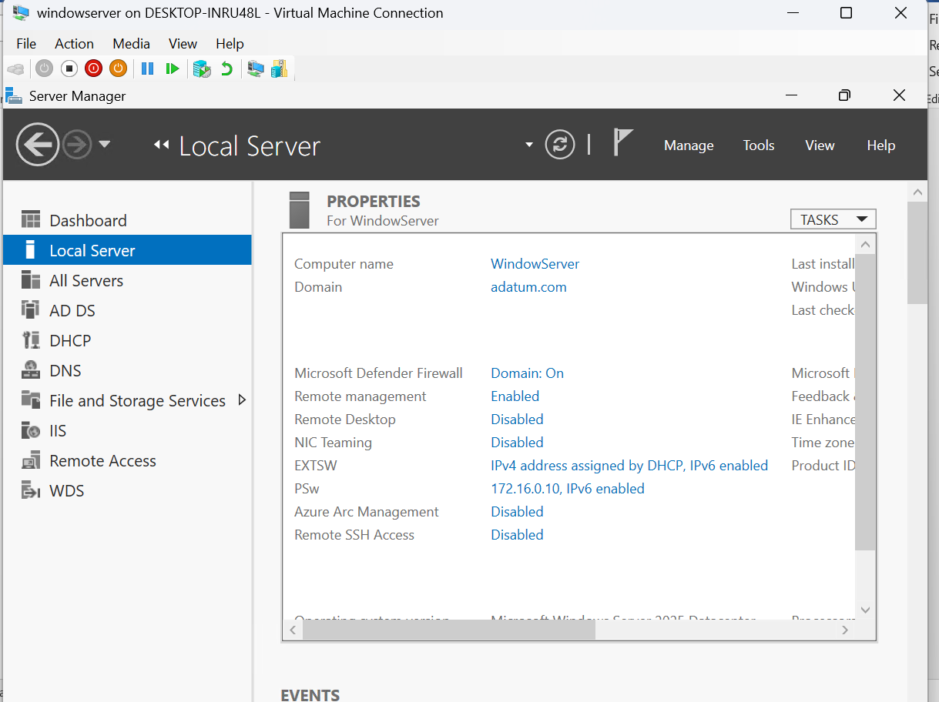
- On your DC virtual machine:
  - Set the correct time/zone and disable Windows Firewall for all profiles.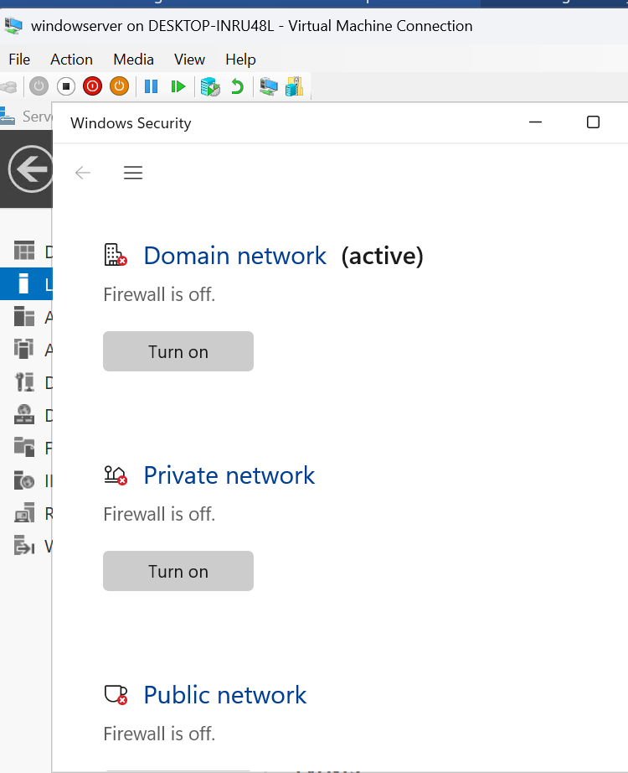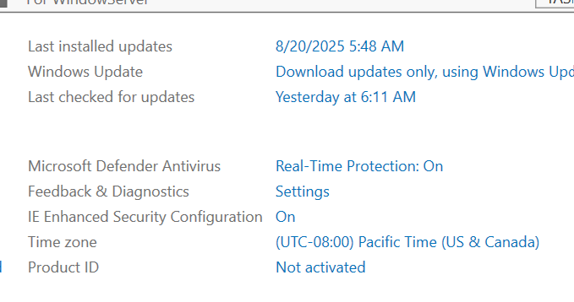

  - Rename your network interface to External. Note the IP address obtained from DHCP on this External IP for a later step: ___________.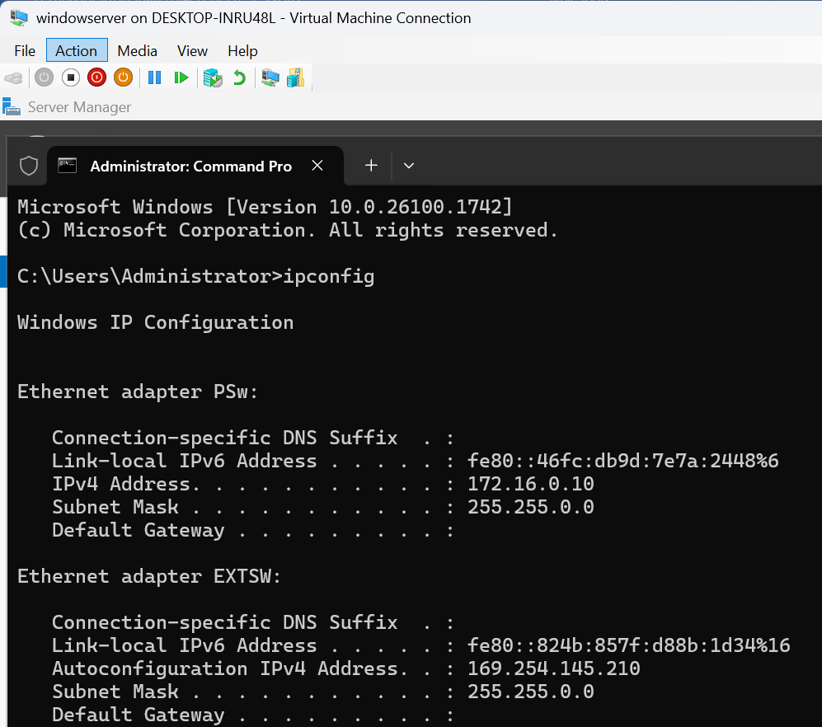
  - Change the computer name to DC01 (rebooting afterwards) : Cannot change name as its will disable my server installed and cannot install new virtual Machine due to storage issue.
  - Install AD DS and configure your system as a domain controller for a new forest and domain called yourname.com (where yourname is your full name). (4 marks, 1 for each task)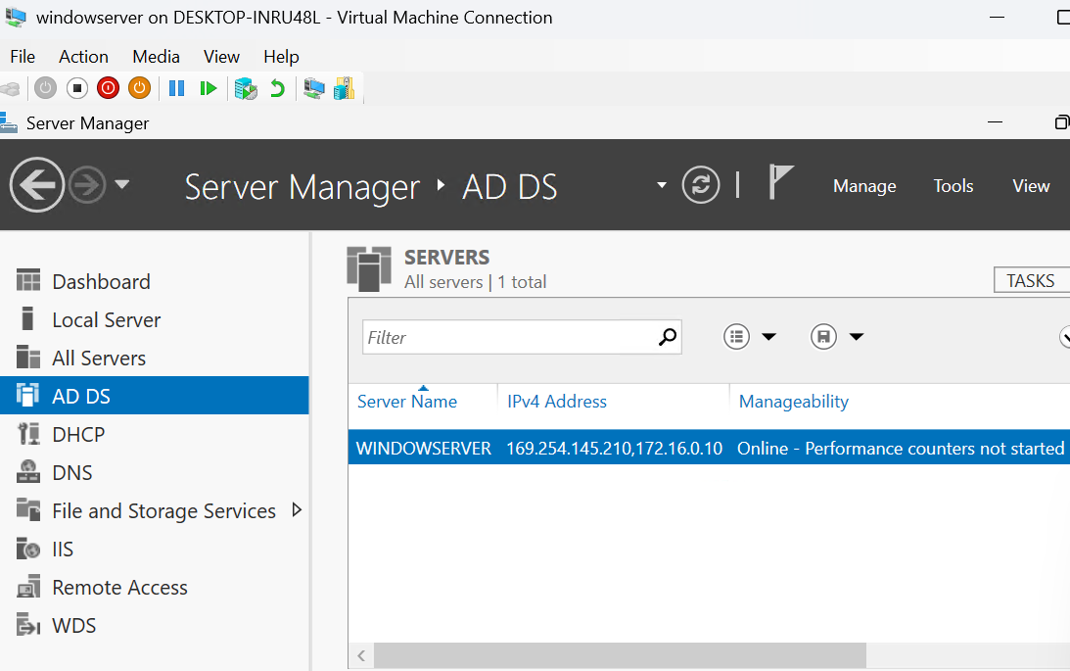
- Within the virtual machine Settings for DC01 in Hyper-V Manager, add a second network interface that is connected to the private virtual switch. (1 mark)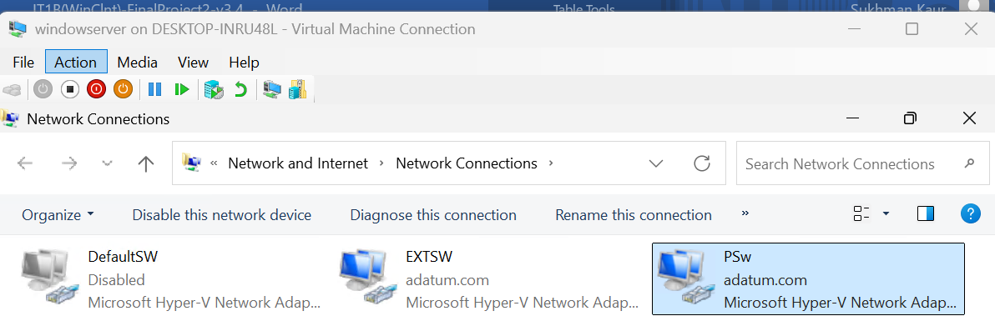
- Within your DC01 virtual machine:
  - Rename your second network interface to Private and configure a static IP address of 172.16.0.1 (subnet mask 255.255.0.0). (2 marks)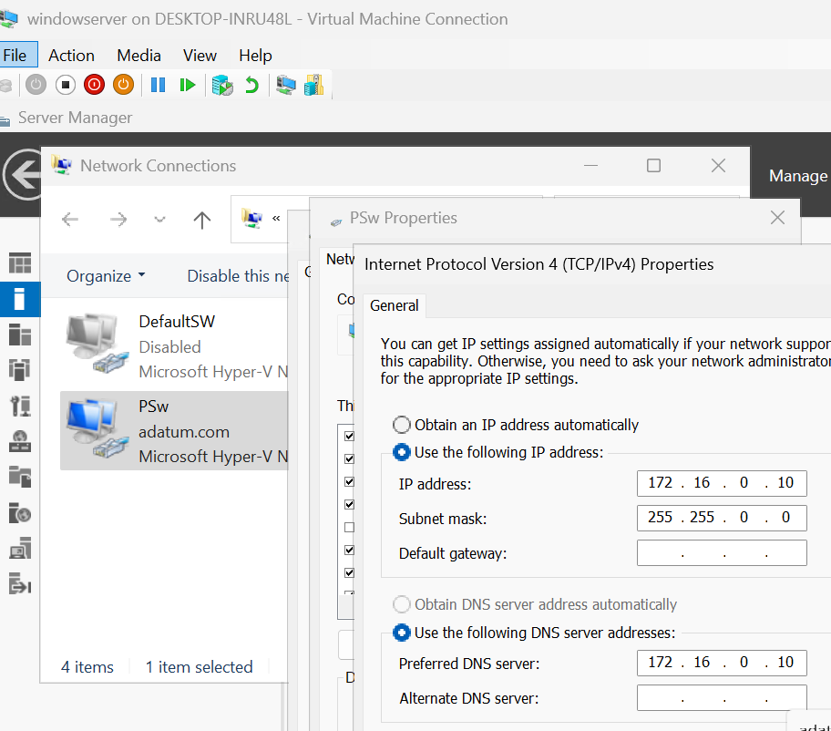
  - Install the DHCP Server role, authorize it in AD, and configure a new scope that hands out the range 172.16.0.100-172.16.0.200 (subnet mask 255.255.255.0). (3 marks)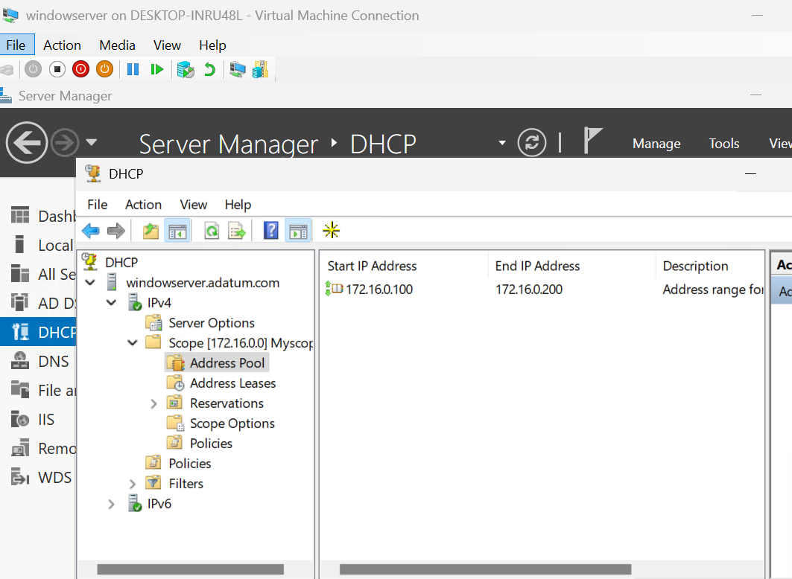
  - Install WDS and configure it to deploy the boot.wim and install.wim from your Windows 10 DVD ISO, ensuring that computers are not automatically joined to the domain following the imaging process. (3 marks)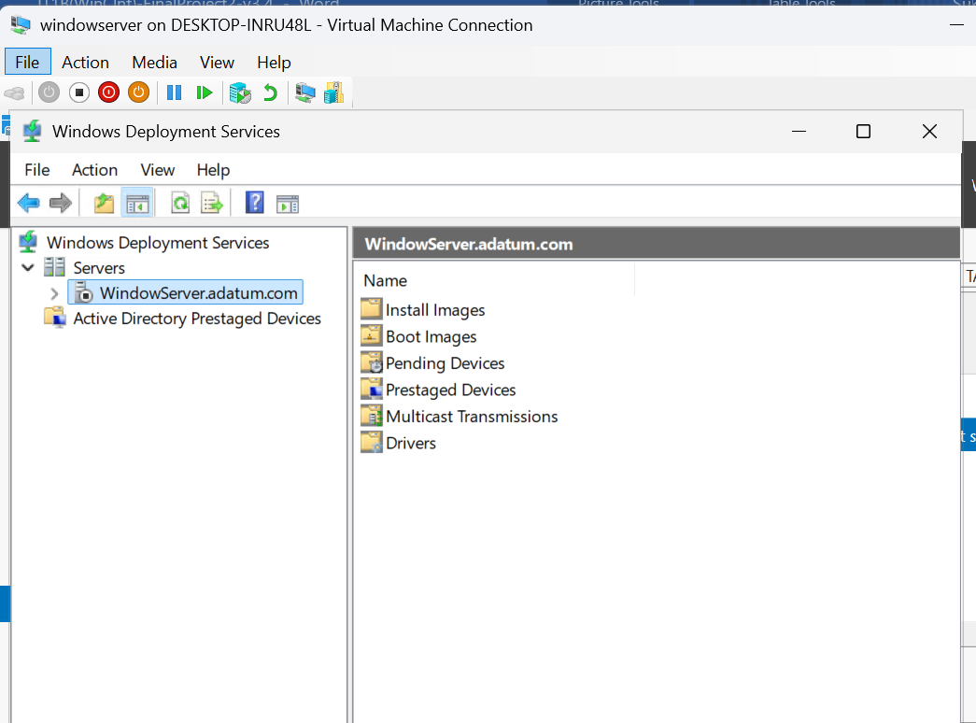
- Create a Hyper-V virtual machine called Wkstn01 (3GB of RAM minimum, connected to private virtual switch) and configure it to install an operating system from across the network. Proceed to boot this virtual machine and install Windows 10 from your WDS image. (1 mark)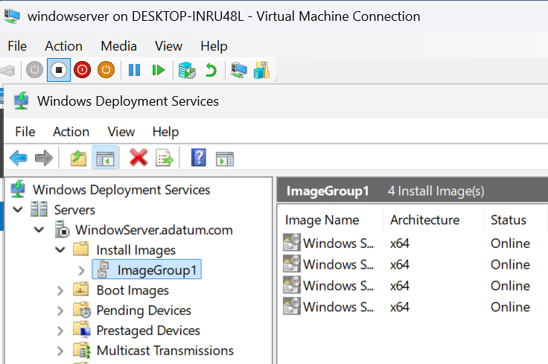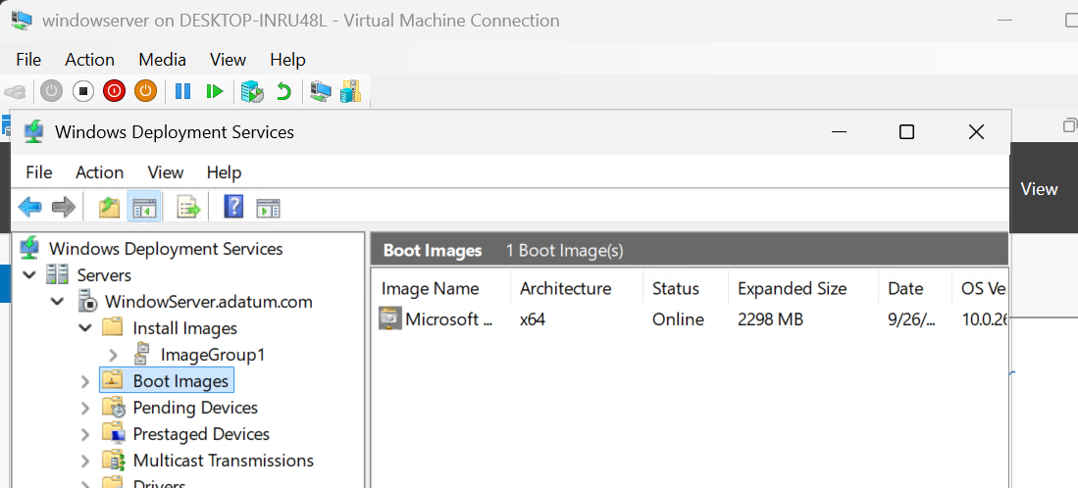
- Following the installation of your Wkstn01 virtual machine, change the network interface within virtual machine Settings in Hyper-V Manager to use the external virtual switch (instead of the private virtual switch). (1 mark)
- Perform an upgrade of your Windows 10 system to Windows 11. (1 mark)
- On your Wkstn01 virtual machine: performed in class on 9/12o
  - Set the correct time/zone.
  - Rename your network interface to External.
  - In the properties of your External network interface, configure a static DNS server address of IPofDC (where IPofDC is the IP address on the External interface on DC01 that you recorded earlier in Step 4).
  - Change the computer name to Wkstn01 (rebooting afterwards).
  - Join your Windows system to the yourname.com domain (where yourname is your full name: FirstnameLastname).
  - Log in to the domain using the domain Administrator account and install the Remote Server Administration Tools (RSAT). (6 marks, 1 for each task)
- Within Active Directory Users and Computers (either on DC01 or within RSAT):
  - Create a Marketing OU under your domain.
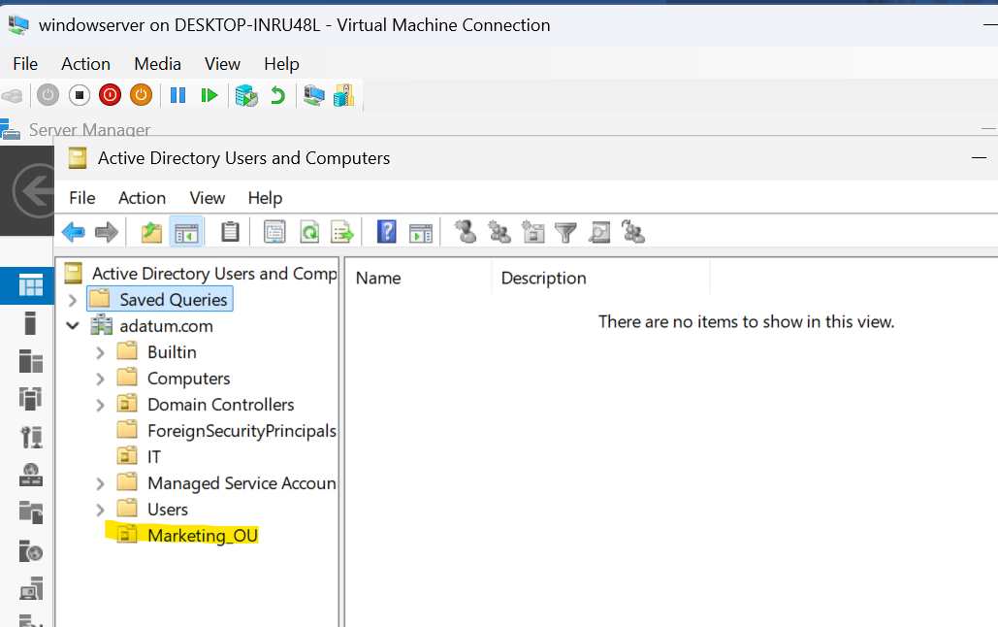

  - Create a user for yourself (Firstname.Lastname) within the Marketing OU that has a password of your choice.
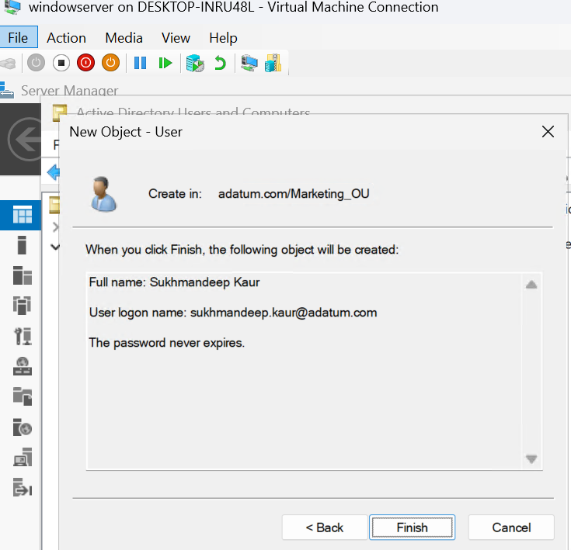
  - Create a Marketing Global group that includes your user account.
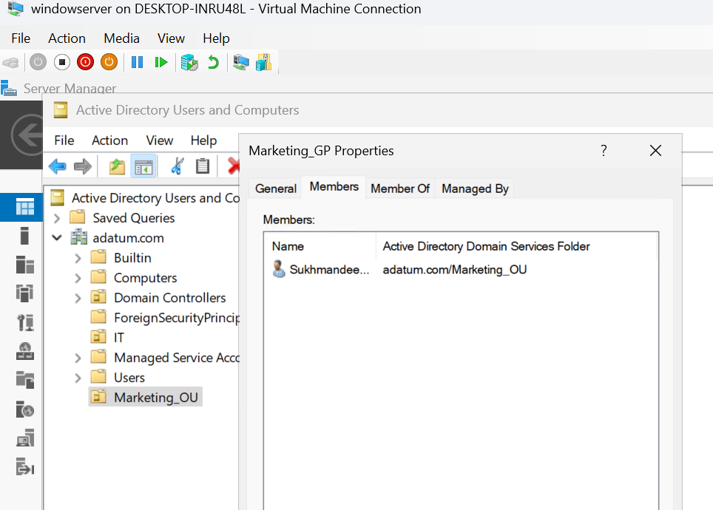

  - Move the Wkstn01 computer account into the Marketing OU. (4 marks, 1 for each task)
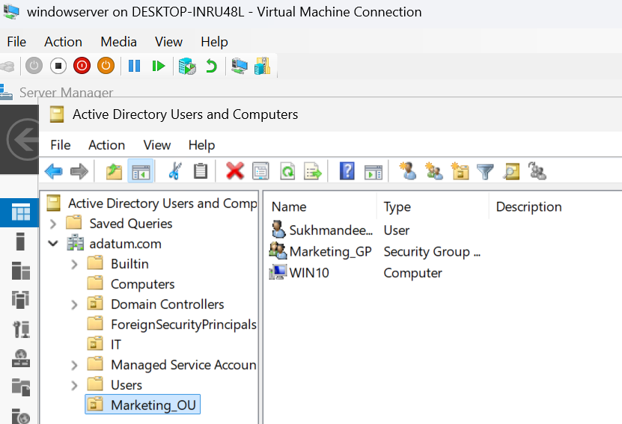
- Within Group Policy Management (either on DC01 or within RSAT):
  - Create a GPO called Marketing Lockdown. (1 mark)
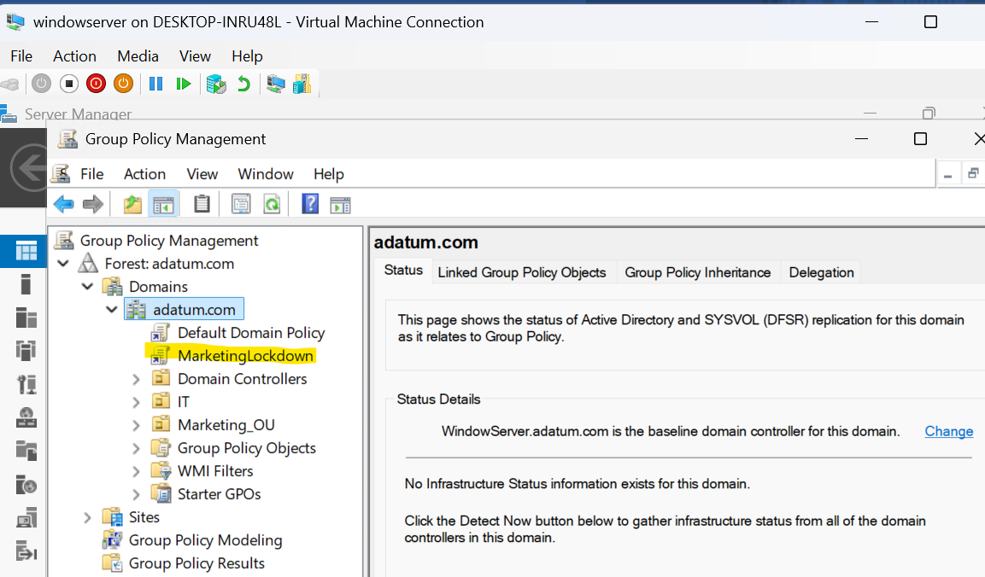
  - Configure the Marketing Lockdown GPO to restrict users from accessing Settings and Control Panel. (1 mark)
  - 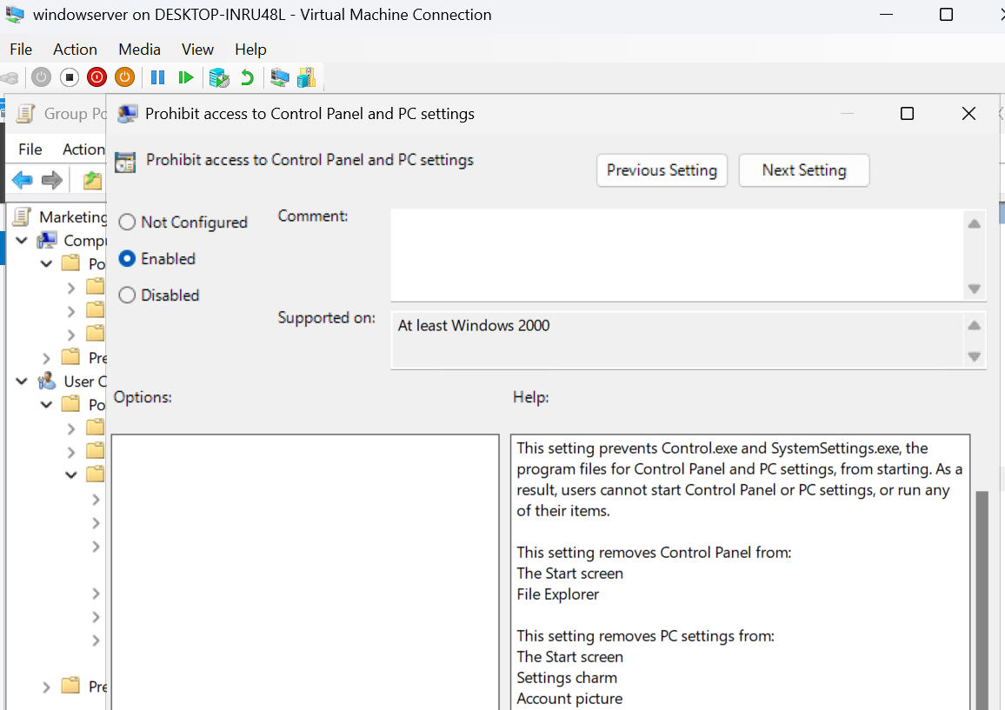
  - Link the Marketing Lockdown GPO to the Marketing OU. (1 mark)
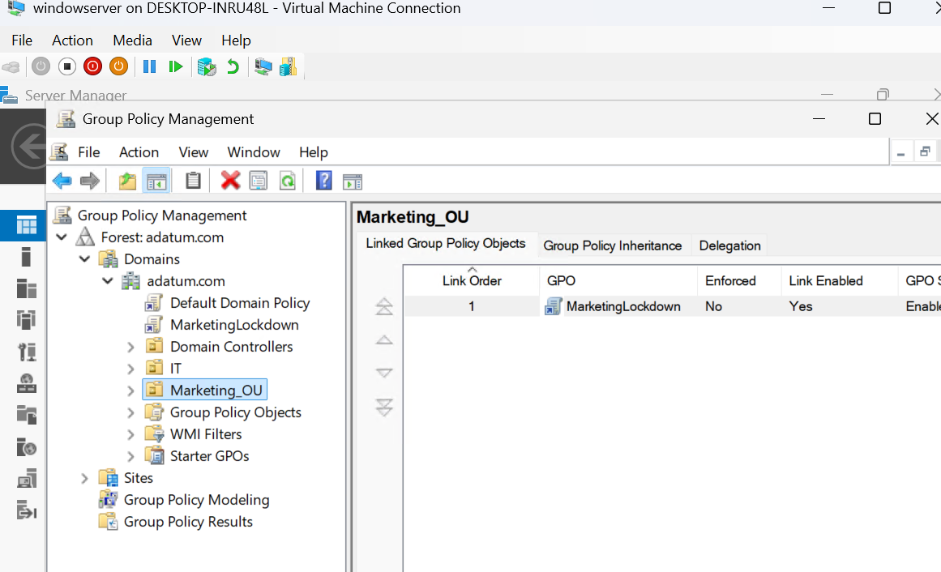
  - Modify the Default Domain Policy GPO to ensure that users in the domain must have complex passwords that are a minimum of 10 characters in length, and must be changed every 30 days. (3 marks)

- Log off Wkstn01, and log in again as your user (Firstname.Lastname). Attempt to access Settings, and run the control command from the Run dialog box to verify that the Settings and Control panel are inaccessible.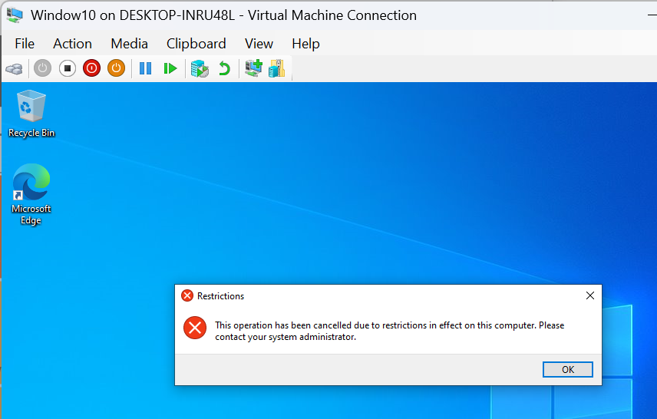
- Log off Wkstn01, and log in again as the domain Administrator.
  - Add your domain user account (Firstname.Lastname) to the local Administrators group.
  - 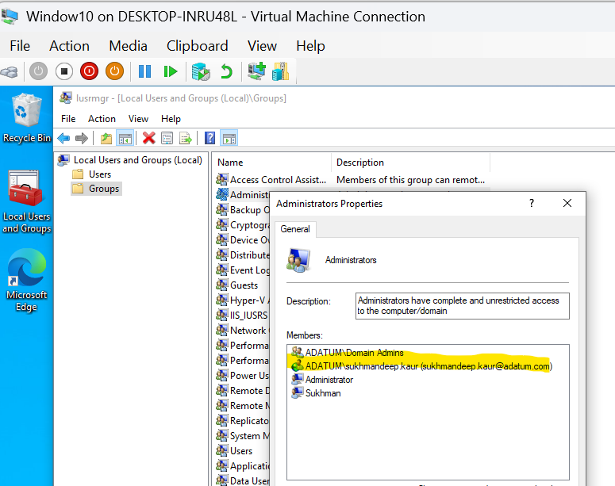
  - Create a folder called C:\FirstnameShare on your computer and share it, ensuring that only your domain user account has Full Control share permission.

  - Set the NTFS permissions on the C:\FirstnameShare folder to ensure that your domain user account (Firstname.Lastname) has Full Control (leaving existing permissions in place).
  - 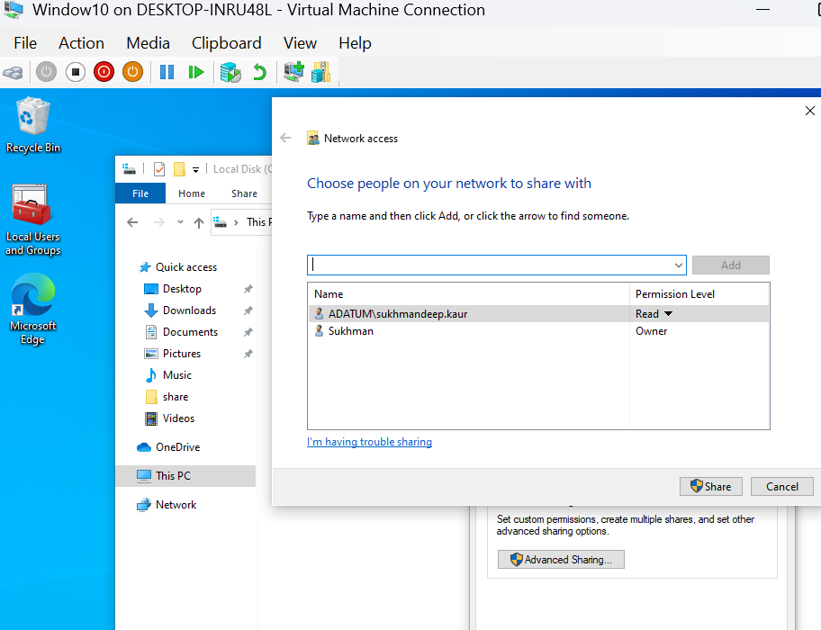
  - Create a System Restore checkpoint.
  - Create an exception in Windows Firewall for DOOM traffic (TCP port 666).
  - 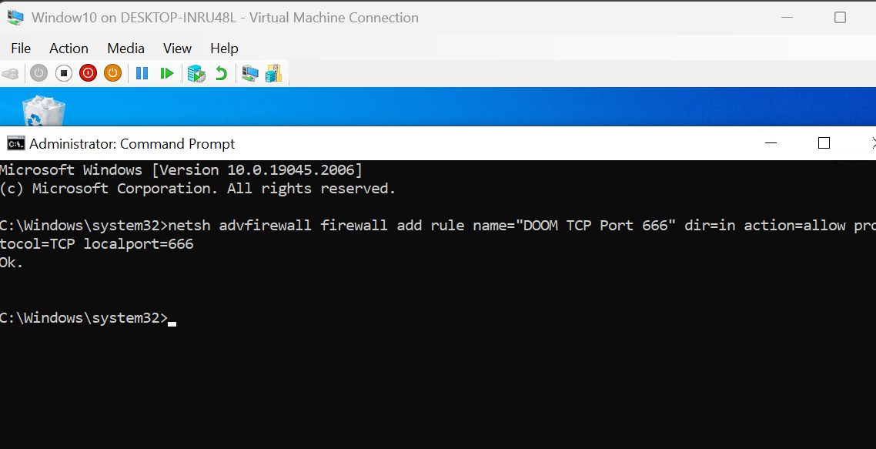
  - Enable WinRM (test remote PowerShell access using Enter-PSSession from DC01). (6 marks, 1 for each task)
  - 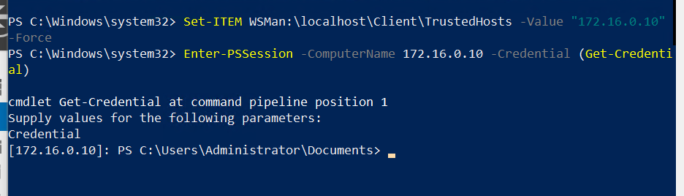
- Log off Wkstn01, and log in again as your user (Firstname.Lastname).
  - Access your shared folder and create a new file within it called SecretData.txt that contains a line of your choice. Next, encrypt the SecretData.txt file using EFS. (1 mark)
  - Open PowerShell as Administrator and run the following commands:
gpresult /r /z >c:\file9.txt
Get-TimeZone >c:\file10.txt
Get-NetIPConfiguration >c:\file11.txt
Gwmi win32_product >c:\file12.txt
net share firstnameshare >c:\file13.txt
icacls c:\firstnameshare >c:\file14.txt
Get-ComputerRestorePoint >c:\file15.txt
Get-NetFirewallRule >c:\file16.txt
test-wsman >c:\file17.txt
cipher c:\firstnameshare\SecretData.txt >c:\file18.txt
tar –a –c –f c:\yournameWkstn01.zip c:\file*.txt
- Log in to your DC01 virtual machine, open PowerShell as Administrator and run the following commands:
gpresult /r /z >c:\file1.txt
Get-TimeZone >c:\file2.txt
Get-NetFirewallProfile >c:\file3.txt
Get-NetIPConfiguration >c:\file4.txt
Get-DhcpServerv4Scope >c:\file5.txt
Get-WdsBootImage >c:\file6.txt
Get-WdsInstallImage >c:\file7.txt
Get-ADOrganizationalUnit >c:\file8.txt

tar –a –c –f c:\yournameDC01.zip c:\file*.txt
- Submit the yournameWkstn01.zip and yournameDC01.zip files to Brightspace.
Rubric
See the marks assigned to each question as outlined in the assignment steps/instructions.

