You have permission to investigate only the Ubuntu machine.
Part 1 – Identify the Ubuntu Machine
Step 1
Log into the Ubuntu machine.
Open a Terminal.
Display the IP address.
ip addr
Record the IP address.
Ubuntu IP Address : 192.168.198.128
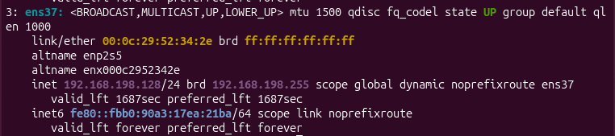
Step 2
Return to the Kali Linux machine.
Verify that the Ubuntu machine is reachable.
ping <Ubuntu_IP_Address>
Example
Ping
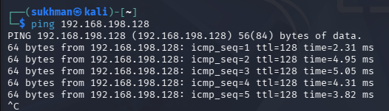

Part 2 – Discover Open Services
Run an Nmap scan from Kali.
Which ports are open?
22 ssh
80 http
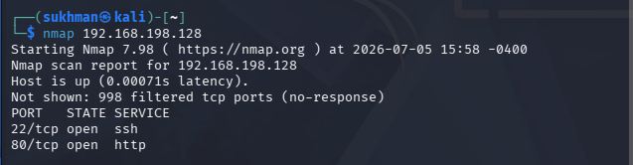

Part 3 – Identify Service Versions
Run a version scan.
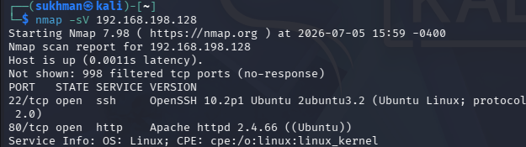

Part 4 – Capture Network Traffic

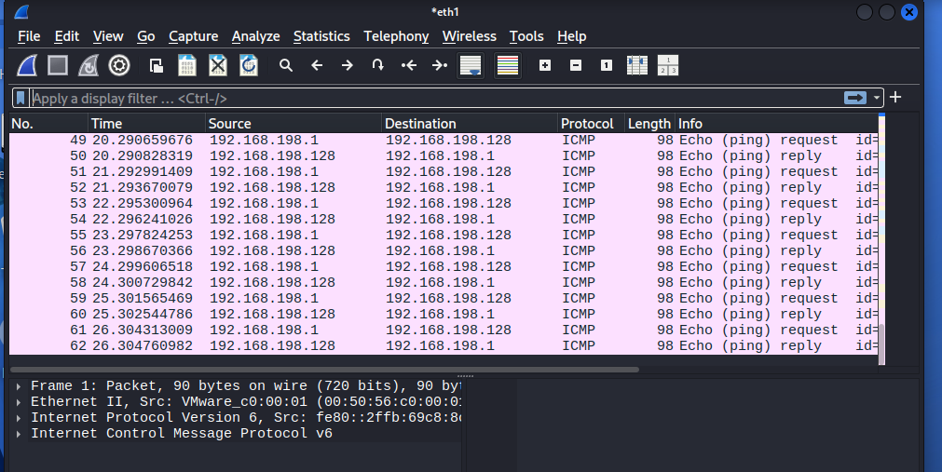

Part 5 – Analyse the Capture
Can you identify the ping requests and replies?
Yes
ARP
arp
Why do you think ARP packets appear before ICMP packets?
ARP packets appear before ICMP packets because the sending device must first determine the destination device's MAC address. ARP (Address Resolution Protocol) maps the destination IP address to its corresponding MAC address on the local network. Once the MAC address is known, the ICMP Echo Request (ping) can be sent.
TCP
tcp
How many TCP packets were captured?

Part 6 – Connect to the Ubuntu Machine
Which protocol is using Port 22?
OpenSSH
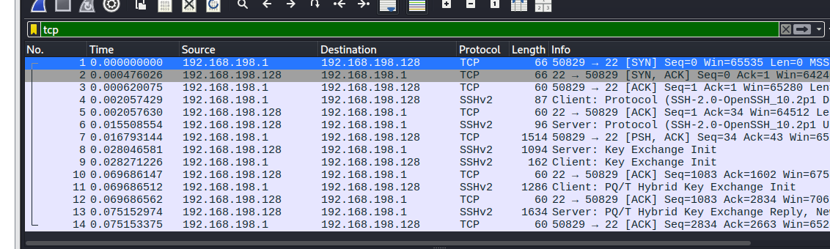

Part 7 – Investigating Network Activity

Part 7 – Identifying Suspicious Activity
Imagine you capture the following events:
- Hundreds of connection attempts within a few seconds.
- Connections to many different ports.
- Thousands of DNS requests.
- Traffic sent to unknown IP addresses.

These activities appear:
□ Suspicious
Explain your answer:
These activities may indicate port scanning, brute-force attacks, malware communication, or data exfiltration. Such behavior is unusual in normal network operations and should be investigated to determine whether it represents a security incident.

Advance Lab :
Phase 1– Initial Reconnaissance
Task 1 – Identify the Ubuntu Server
From Ubuntu:
ip addr
Ubuntu IP Address: 192.168.198.128
Task 2 – Verify Connectivity
From Kali:
ping <Ubuntu_IP>
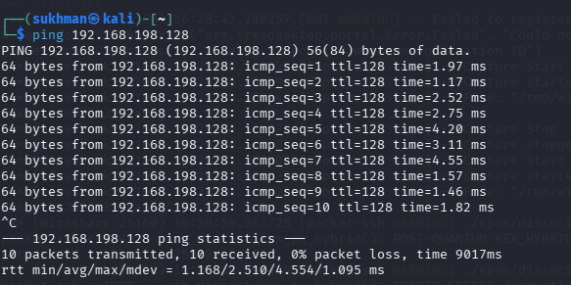
Task 3 – Host Discovery
Scan the network.
nmap -sn 192.168.56.0/24 (use ubuntu network ip address )
- How many hosts are online?
- Which host is the Ubuntu server?
- 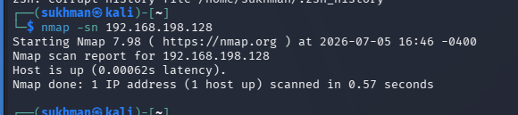
Phase 2 – Service Enumeration
- Record all open ports.
- Run version detection.
- 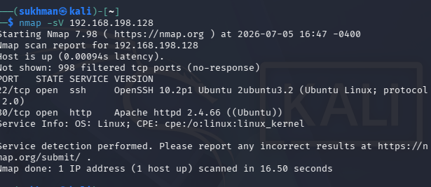

- Run an aggressive scan.
- 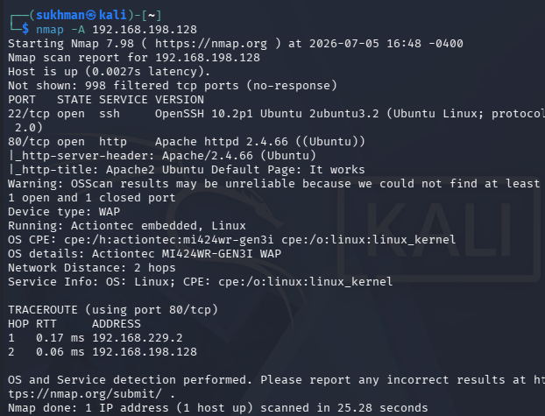

Phase 3 – Capturing Network Traffic
Activity 1
Ping Ubuntu.
ping <Ubuntu_IP>
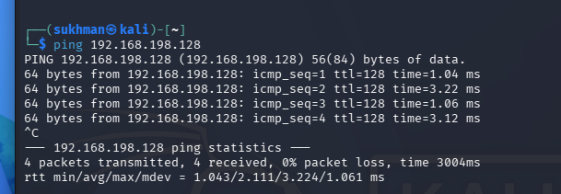
Activity 2
Connect using SSH.
ssh student@<Ubuntu_IP>
Remain connected for approximately one minute.
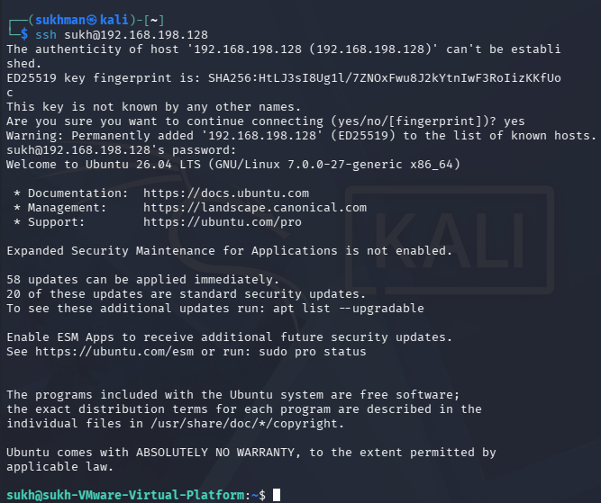

Activity 3
Transfer a file.
Create a small text file.
echo "Network Security Lab" > report.txt
Copy it to Ubuntu.
scp report.txt student@<Ubuntu_IP>:~
Stop the capture

Phase 4 – Packet Analysis
Use the following Wireshark filters.
ARP
arp
Questions
- Which MAC addresses communicated? 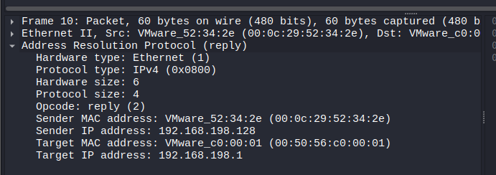
- Why were ARP packets generated?
- To connect with destination source for MAC address.

ICMP
icmp

- How many Echo Requests? 4
- How many Echo Replies? 4
- 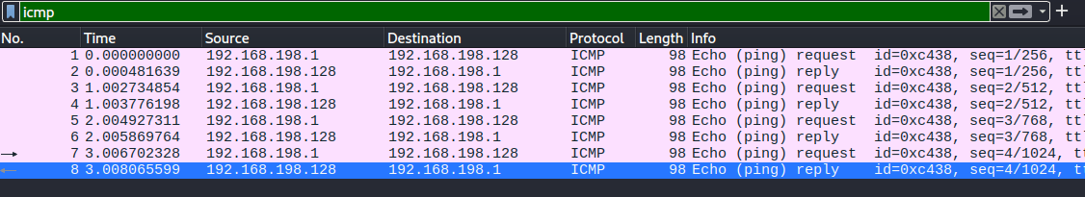 TCP
- Questions
- Can you identify the TCP three-way handshake?

- Locate:
- SYN
- SYN-ACK
- ACK

- SSH
- tcp.port == 22
- Can you read the SSH session?
- will not be able to read the file contents because SCP encrypts the data
- 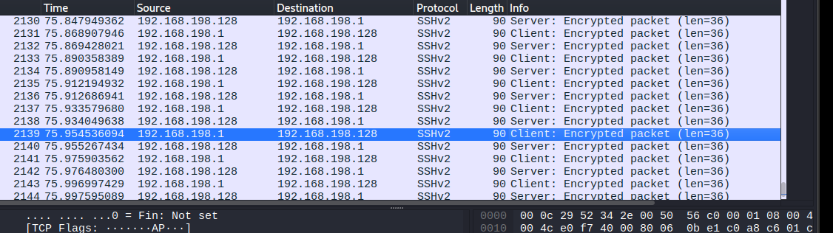
- Explain why.
- Were any DNS requests observed?
- What websites or systems were resolved?

