🧪 Ontario Skills Practical Lab Exam
IT Network Systems Administration (Beginner → Admin)
Time Allowed: 3–4 hours
Total Points: 100

🔵 SECTION 1 — Windows Server Lab (30 points)
Scenario
You are the network administrator for Ontario Skills TechLab.
You must set up a Windows Server 2022 Domain Controller, create user accounts, and apply group policies.

Task 1 — Install and Configure AD DS (10 pts)
Requirements:
- Rename the server to SRV-DC01
- Assign static IP:
  - IP: 10.10.10.10
  - Mask: 255.255.255.0
  - Gateway: 10.10.10.1
  - DNS: 10.10.10.10
- Install Active Directory Domain Services
- Promote server to a Domain Controller for domain:
  - skillslab.local
Deliverables:
- Screenshot: Server Manager → Local Server with hostname + IP
- 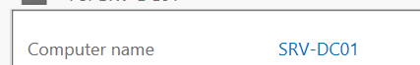
- 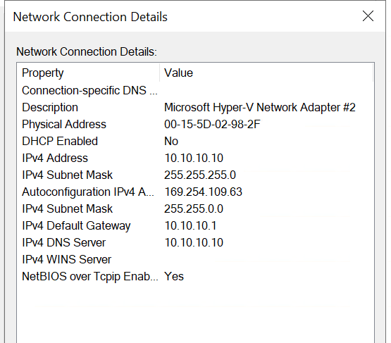
- Screenshot: Successful AD DS installation
- 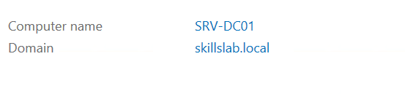

Task 2 — Create AD Users and Groups (10 pts)
Requirements:
In Active Directory Users and Computers (ADUC):
Create OU structure:
OntarioSkills
├── Staff
├── Students
└── IT
Create users:
- staff_user1
- 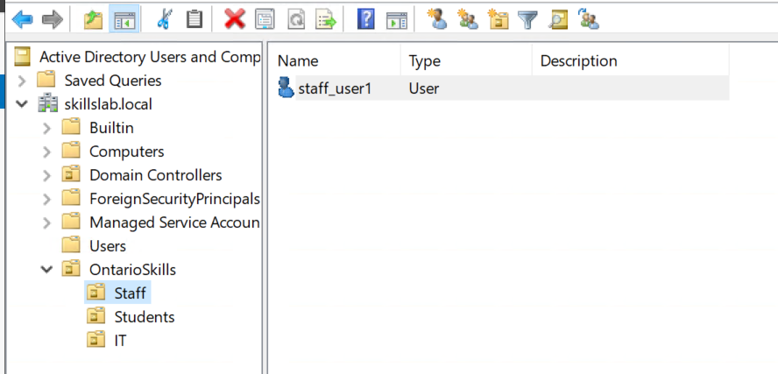
- student_user1
- 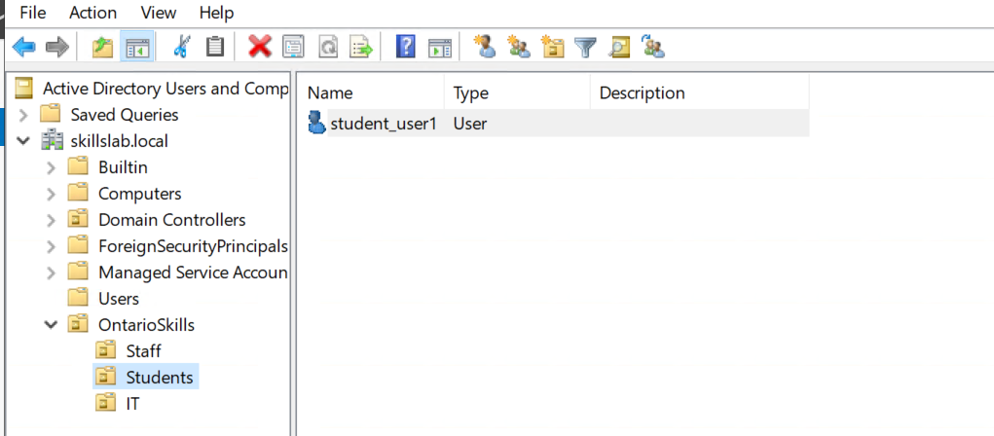
- Itadmin
- 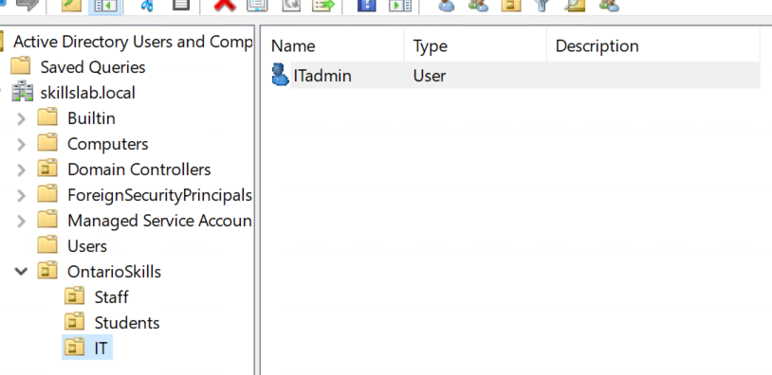
Create groups:
- ITAdmins
- StaffGroup
- StudentGroup
- 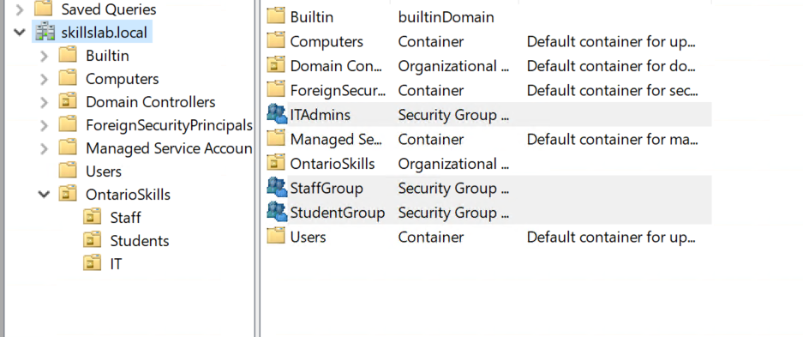
Add itadmin to ITAdmins (domain admin privileges).
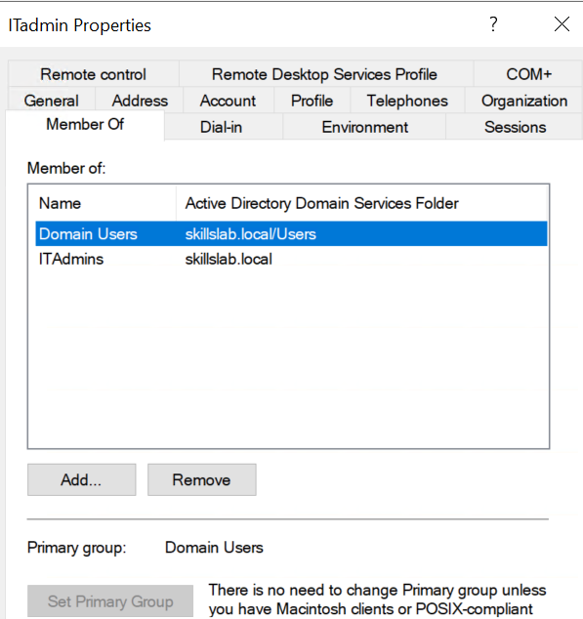
Deliverables:
- Screenshot: ADUC showing OU structure
- Screenshot: Group membership for itadmin

Task 3 — Group Policy Management (10 pts)
Requirements:
Create a GPO named SecurityPolicy linked to the Staff OU with:
- Disable Control Panel
- Enforce password complexity
- Set minimum password length to 10 characters
Deliverables:
- Screenshot: GPO settings
- 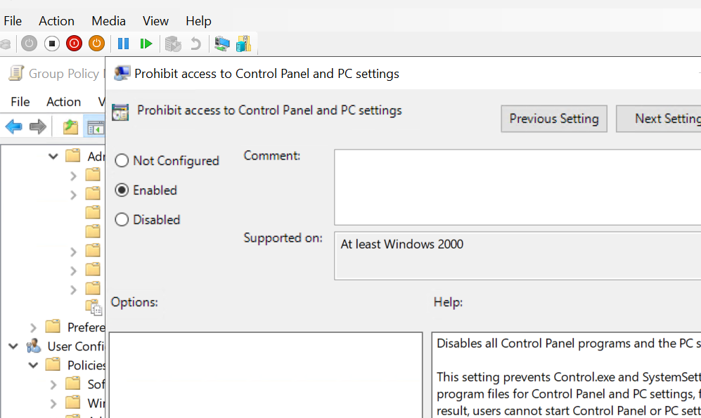
- 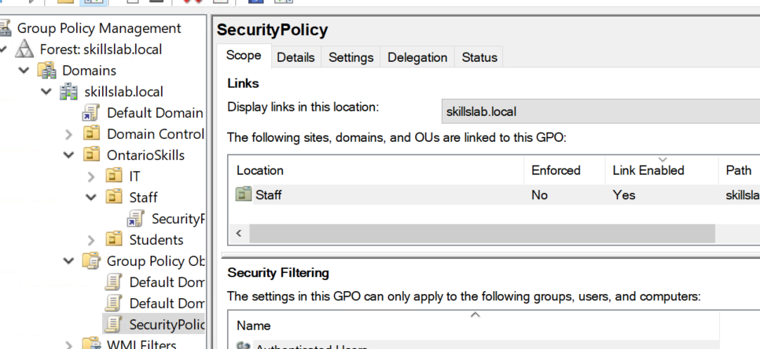
- Screenshot: gpresult /r on a staff workstation VM

🔵 SECTION 2 — Linux Administration Lab (25 points)
Scenario
You manage a Linux server running Ubuntu Server 22.04.
You must configure networking, users, and services.

Task 4 — Network and User Configuration (10 pts)
Requirements:
- Set a static IP using Netplan:
  - IP: 10.10.20.20/24
  - GW: 10.10.20.1
  - DNS: 1.1.1.1
- Create two users:
  - tech1
  - tech2
- Add tech1 to sudoers group
Deliverables:
- /etc/netplan/*.yaml screenshot
- 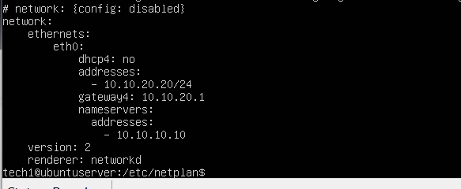

- Screenshot: id tech1 showing sudo membership
- 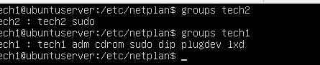
- Ping test to gateway

Task 5 — Install & Configure Apache Web Server (10 pts)
Requirements:
- Install Apache2
- Set custom homepage:
Location: /var/www/html/index.html
Content:
- <h1>Ontario Skills Practical Lab</h1>
- Start and enable service
Deliverables:
- Screenshot: systemctl status apache2
- 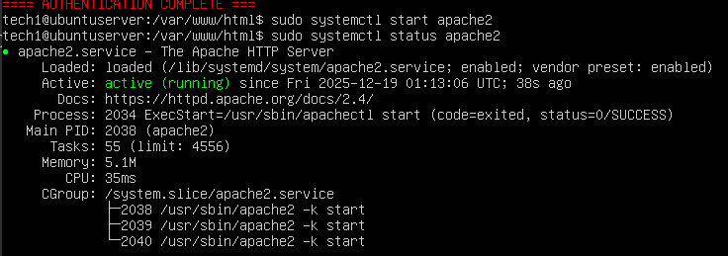
- Browser screenshot of webpage loading
- 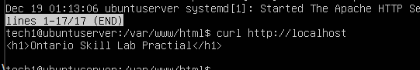

Task 6 — File Permissions and Archiving (5 pts)
Requirements:
- Create folder: /opt/skillsfiles/
- Create file: report.txt
- Set permissions so only tech2 can read/write
- Compress folder to /home/skills_backup.tar.gz
Deliverables:
- Screenshot: ls -l /opt/skillsfiles/
- Screenshot: Archive file

🔵 SECTION 3 — Cisco Networking Lab (35 points)
Scenario
You must configure VLANs, inter-VLAN routing, DHCP, and security on Cisco gear.
Equipment:
- 1 Layer 3 switch (CoreSW)
- 1 Layer 2 switch (AccessSW)
- 2 Client PCs

Task 7 — VLAN & Trunk Configuration (10 pts)
Requirements:
On CoreSW and AccessSW:
Create VLANs:
10 Staff
20 Students
30 IT
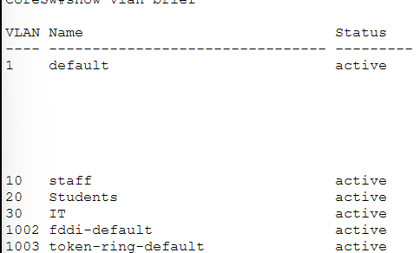

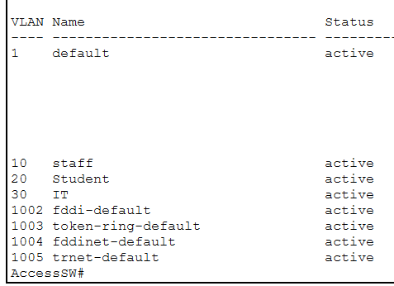
Configure trunk:
CoreSW g0/1 <--> AccessSW g0/1
mode trunk
allow vlan 10,20,30

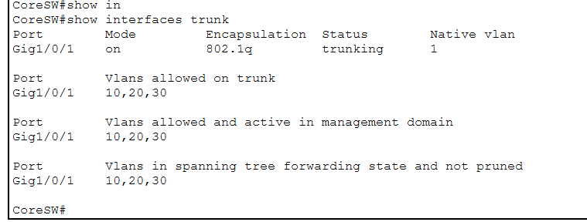
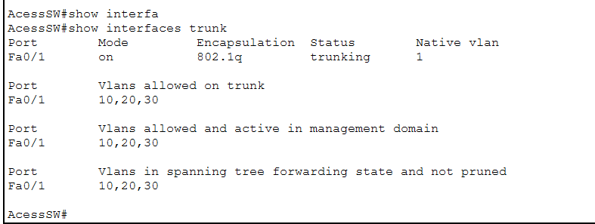
AccessSW client ports:
- fa0/2 → VLAN 10
- fa0/3 → VLAN 20
- 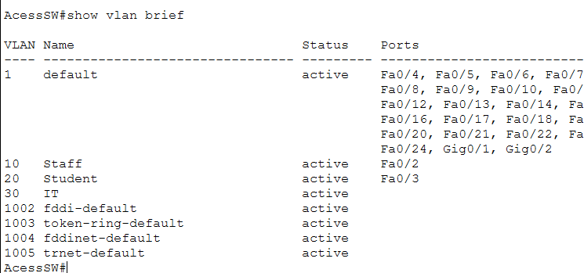
Deliverables:
- show vlan screenshot
- show interfaces trunk

Task 8 — Inter-VLAN Routing (10 pts)
Requirements:
On CoreSW:
Create SVI interfaces:
interface vlan 10
ip address 10.10.10.1 255.255.255.0
interface vlan 20
ip address 10.10.20.1 255.255.255.0
interface vlan 30
ip address 10.10.30.1 255.255.255.0
Enable routing:
ip routing
Clients in VLAN 10 and VLAN 20 must ping each other.
Deliverables:
- Screenshot: show ip interface brief
- 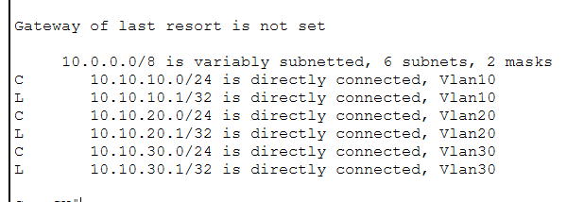
- 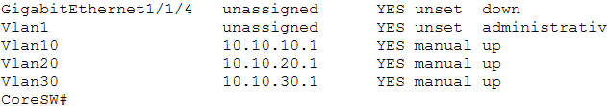
- Ping test between clients
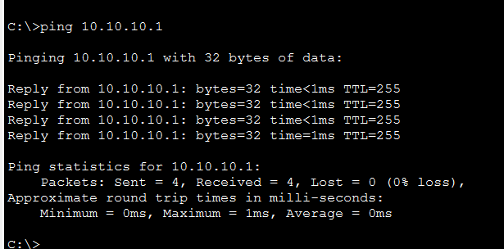

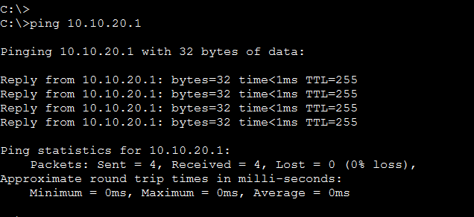

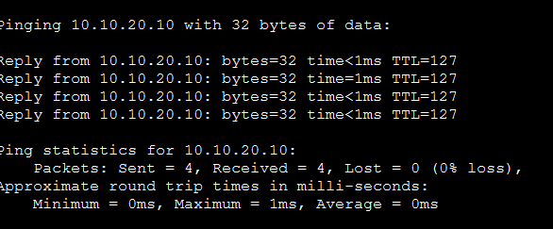

Task 9 — DHCP & Security Configuration (10 pts)
Requirements:
Configure DHCP pools:
ip dhcp pool STAFF
network 10.10.10.0 255.255.255.0
default-router 10.10.10.1

ip dhcp pool STUDENTS
network 10.10.20.0 255.255.255.0
default-router 10.10.20.1
Enable DHCP Snooping:
ip dhcp snooping
ip dhcp snooping vlan 10,20,30
interface g0/1
ip dhcp snooping trust
Deliverables:
- show ip dhcp binding screenshot
- 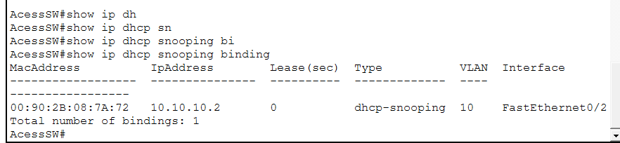
- show ip dhcp snooping screenshot
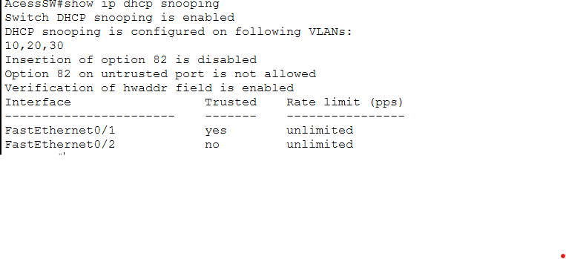

Task 10 — SSH Remote Management (5 pts)
Requirements:
Configure SSH on CoreSW:
ip domain-name skills.local
crypto key generate rsa 2048
username admin secret Skills2025!
line vty 0 4
transport input ssh
login local
Deliverables:
- Screenshot: SSH login from a PC
- 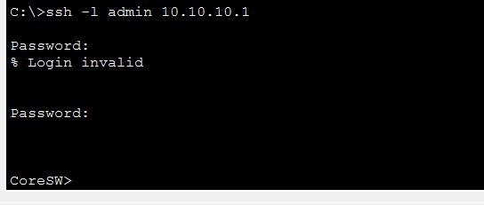
- show ip ssh output
- 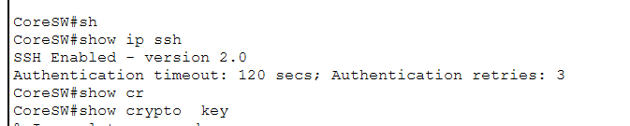

🟩 SCORING RUBRIC (100 Points)
Section | Points
Windows AD DS Setup | 10
Windows Users/Groups | 10
Windows GPO | 10
Linux Networking | 10
Linux Apache | 10
Linux Permissions | 5
Cisco VLANs | 10
Cisco Routing | 10
Cisco DHCP & Security | 10
Cisco SSH | 5
Total | 100

