🧠 Ontario Skills IT Network Systems Administration (S/PS)
Practical Challenge — Duration: 60 minutes
Title: Configure Windows Server Domain with DHCP, DNS, and File Sharing

🔧 Scenario
You are a Network Systems Administrator tasked with setting up a small network for a new department within a company called TechNova Ltd.. You are provided with one Windows Server 2022 virtual machine and two Windows 10 client VMs. Your goal is to create a fully functional domain environment with centralized name resolution (DNS), dynamic IP addressing (DHCP), and a secure file-sharing structure.

🗂️ Tasks
Part A — Active Directory & Domain Configuration (15 marks)
- Rename the server to SRV-TN01 and assign a static IP address:
  - IP: 192.168.10.10
  - Subnet Mask: 255.255.255.0
  - Gateway: 192.168.10.1
  - DNS: (self-referencing IP)
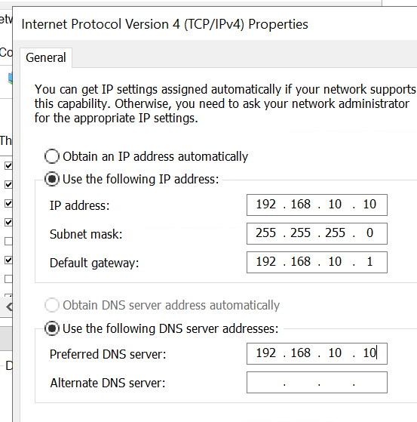
- Install and configure Active Directory Domain Services (AD DS) to create a new forest and domain:
  - Domain name: technova.local
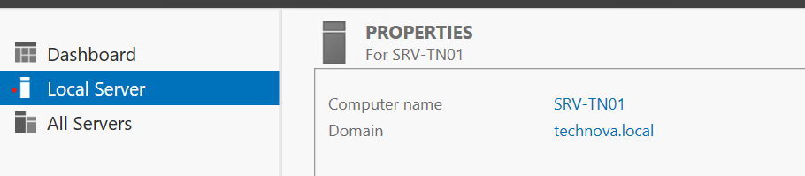
- Create the following Organizational Units (OUs):
  - Departments
  - Inside Departments, create sub-OUs: IT, HR, and Finance.
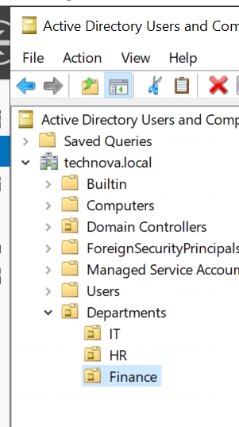
- Create the following user accounts:
  - itadmin (member of Domain Admins)
  - 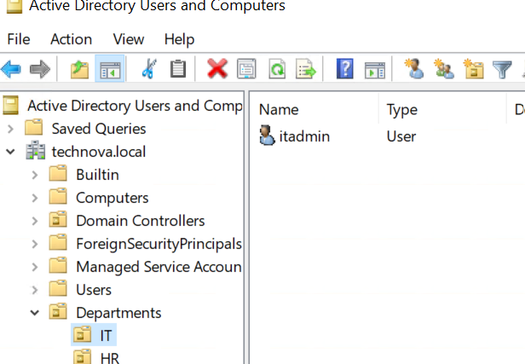
  - hruser (member of HR OU)
  - 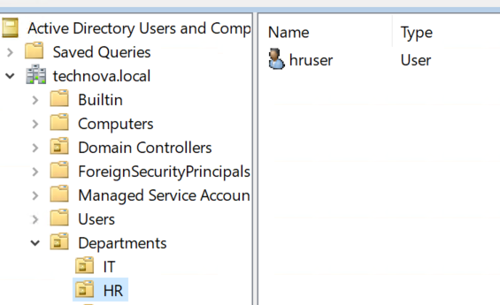
  - finuser (member of Finance OU)
  - 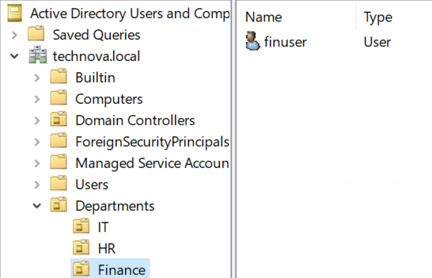

Part B — DNS and DHCP Configuration (15 marks)
- Install and configure DNS to support the technova.local domain.
- Verify forward and reverse lookup zones are functioning correctly.
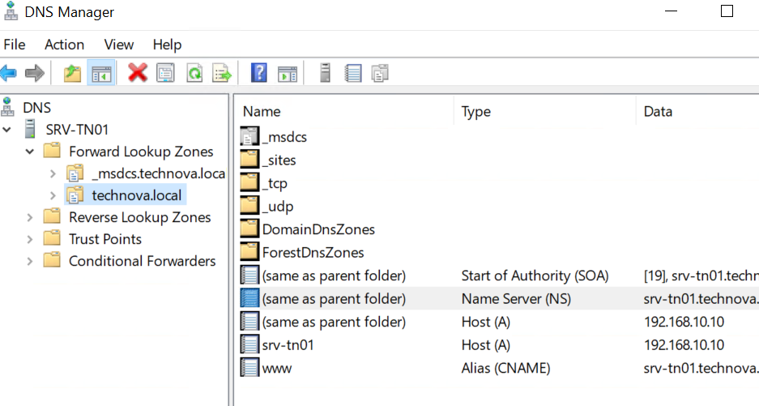
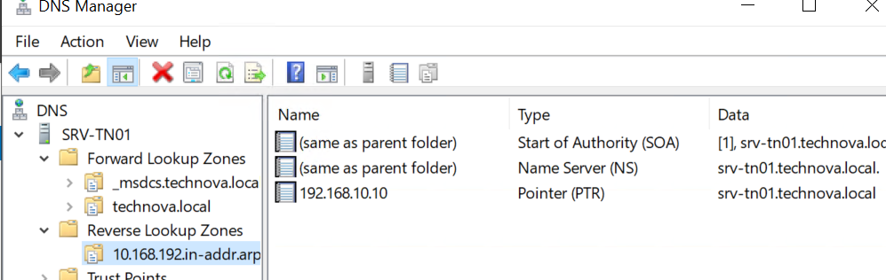
- Install and configure DHCP Server with the following scope:
  - Scope Name: TechNova_Scope
  - Range: 192.168.10.100 – 192.168.10.200
  - Subnet Mask: 255.255.255.0
  - Gateway: 192.168.10.1
  - DNS Server: 192.168.10.10
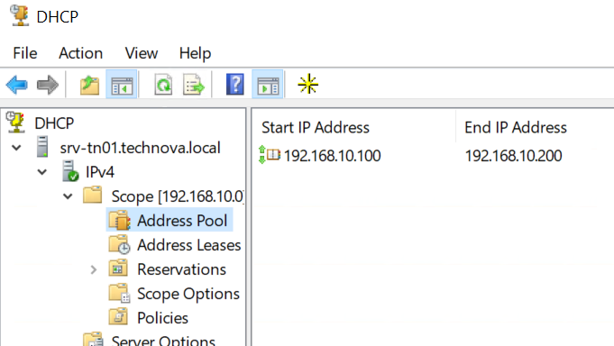
- Authorize the DHCP server in Active Directory.
- Confirm client machines can obtain valid IP addresses and resolve domain names.

Part C — File Sharing and Permissions (15 marks)
- Create a folder named SharedData on drive C:\.
- Create three subfolders within SharedData:
  - IT_Files
  - HR_Files
  - Finance_Files
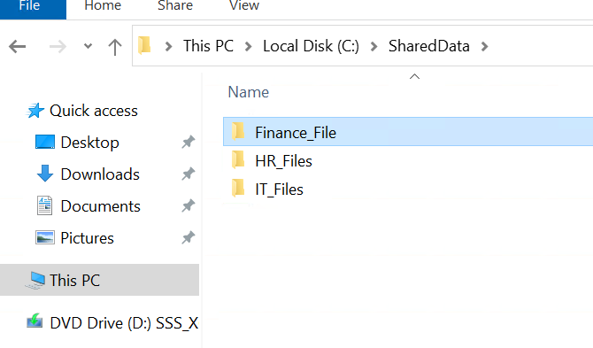
- Share each folder with the following permissions:
  - IT_Files: Full Control to IT OU members only
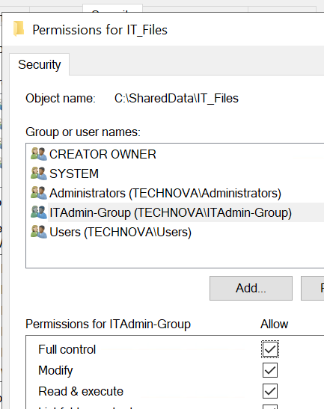
  - HR_Files: Modify access to HR OU members
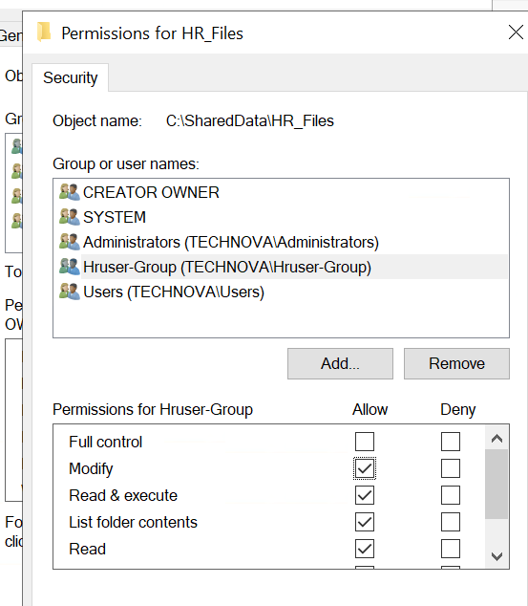
  - Finance_Files: Read/Write access to Finance OU members only
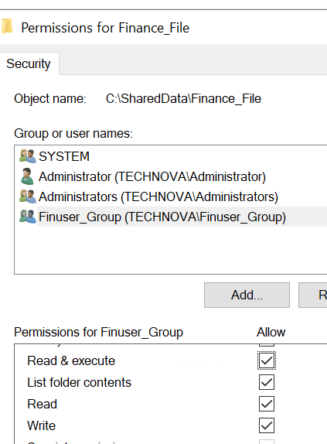
- Verify that each user has access only to their respective department folder.

Part D — Verification and Documentation (15 marks)
- Join both Windows 10 clients to the technova.local domain.

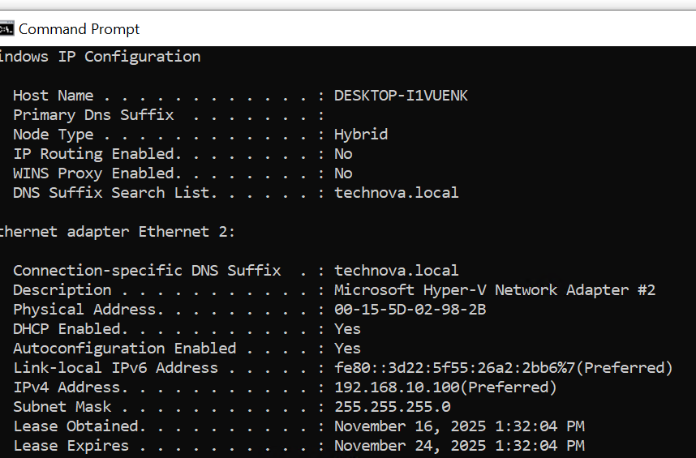
DNS:
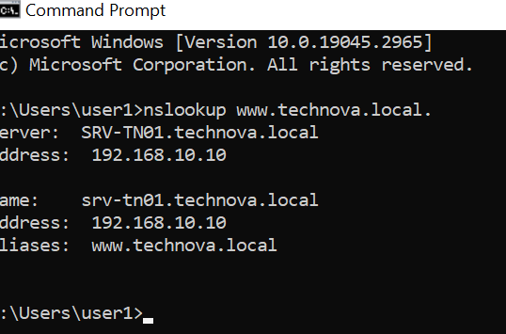

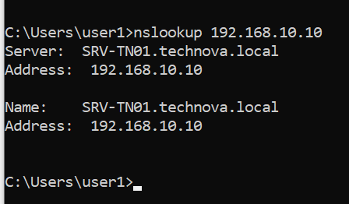
- Log in as each departmental user to verify:
  - Successful domain authentication
  - Correct DHCP-assigned IP configuration
  - Proper DNS name resolution
  - Correct file share access based on permissions
- Use PowerShell or screenshots to document:
  - Domain setup (Get-ADDomain)
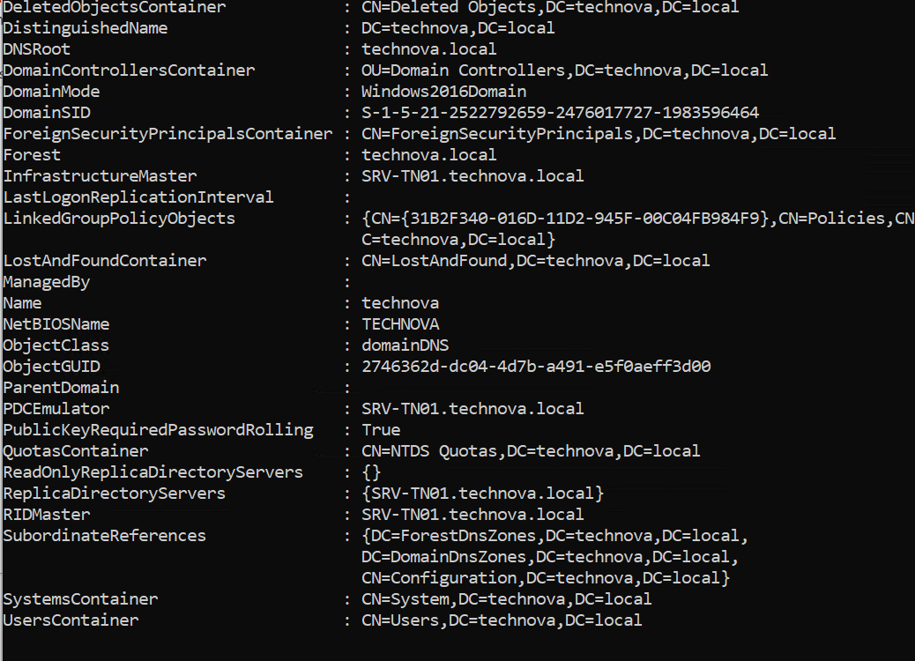
  - DHCP scope configuration (Get-DhcpServerv4Scope)
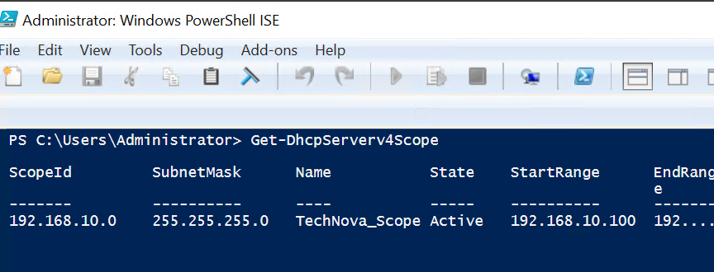

  - DNS zone verification (Get-DnsServerZone)

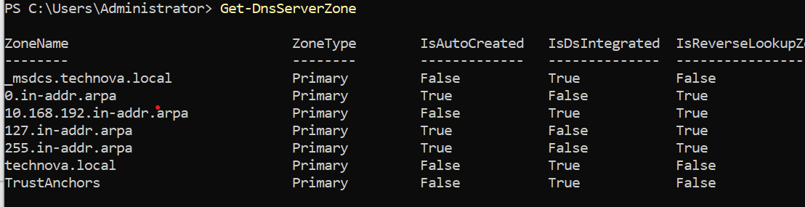
  - Share permissions (Get-SmbShareAccess)

🕒 Time Allocation
- Active Directory setup — 15 min
- DNS & DHCP configuration — 15 min
- File sharing & permissions — 15 min
- Verification & documentation — 15 min

📊 Evaluation Criteria (Total: 60 Marks)
Category | Marks | Description
Domain and OU structure | 15 | Proper naming, organization, and user setup
DHCP & DNS configuration | 15 | Functional and correctly authorized servers
File sharing & permissions | 15 | Correct access levels per department
Verification & documentation | 15 | Proof of successful implementation

