✅ Practical Scenario Question — Windows Server 2022 (IT Admin)
Scenario:
You have been provided with a clean installation of Windows Server 2022 Standard. Your task is to configure the server to operate as a secure domain controller and file server for a small organization with 50 users.

Tasks
1. Active Directory & DNS Configuration
- Rename the server to OPS-SRV01.
- 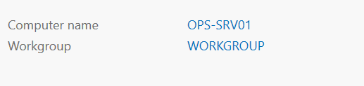
- Configure a static IP address according to the addressing information provided in your workstation instructions.
- 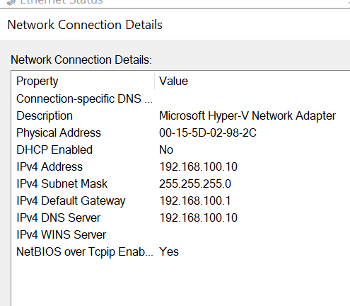
- Install the Active Directory Domain Services role and promote the server to a new forest with the following details:
  - Domain Name: ops-skills.local
  - 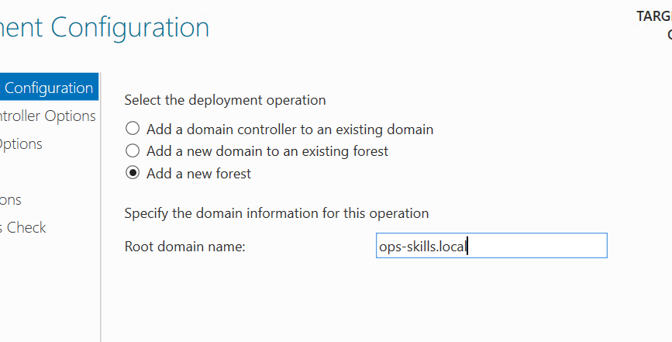
  - NetBIOS Name: OPSSKILLS
  - 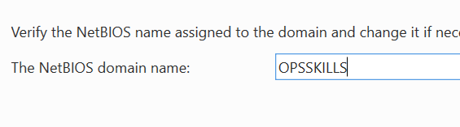
  - Configure DNS to integrate with AD.
  - Set the forest and domain functional level to Windows Server 2022.

2. Group Policy Configuration
Create a new Group Policy Object named WorkstationSecurity and apply it to all domain computers.
The GPO must meet the following requirements:
- Disable local administrator account on domain-joined workstations.
- 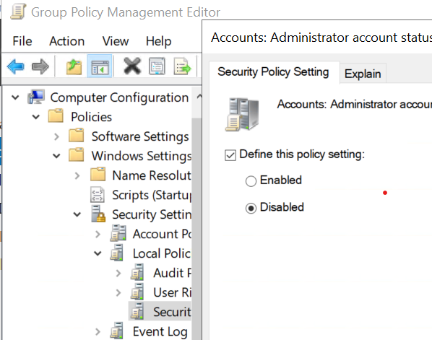
- Enforce password policy:
  - Minimum length: 12 characters
  - 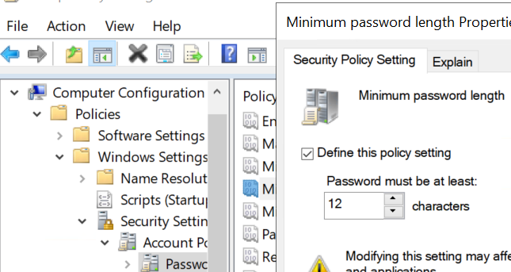
  - Maximum password age: 45 days
  - 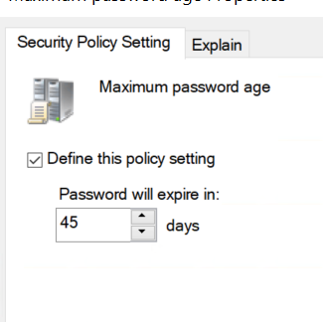
- Disable USB storage devices.
- 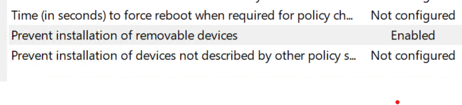

3. User & Group Management
Create the following Organizational Units (OUs):
- OPS_Users
- OPS_Groups
- OPS_Computers
Create user accounts based on the spreadsheet provided (names and usernames).
- All user accounts must:
  - Require password change at next login
  - Be members of the OPS_Users OU
  - 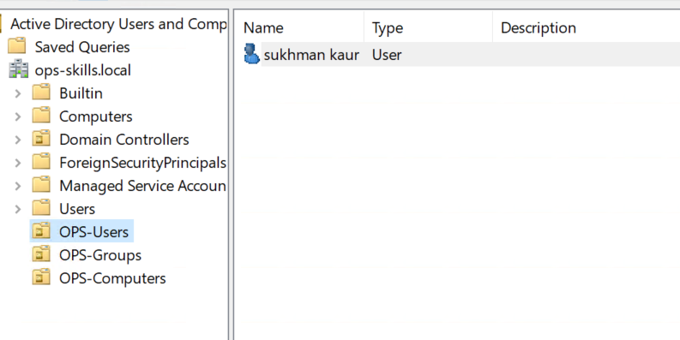
Create security groups:
- Accounting
- Engineering
Place them in OPS_Groups OU and add users to the appropriate group.
- 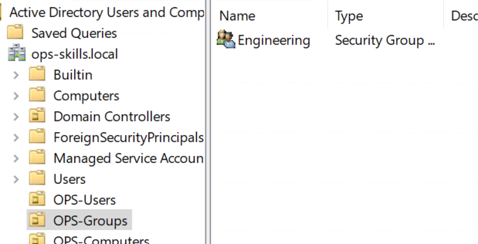

4. File Services & Permissions
Create a shared folder named DepartmentShares on the D: drive.
Inside it create two subfolders:
- Accounting
- Engineering
Apply NTFS and share permissions as follows:
- Users in Accounting group: Read/Write access to Accounting folder
- Users in Engineering group: Read/Write access to Engineering folder
- Users must not see folders for departments they are not part of (“Access-Based Enumeration” must be enabled).
- 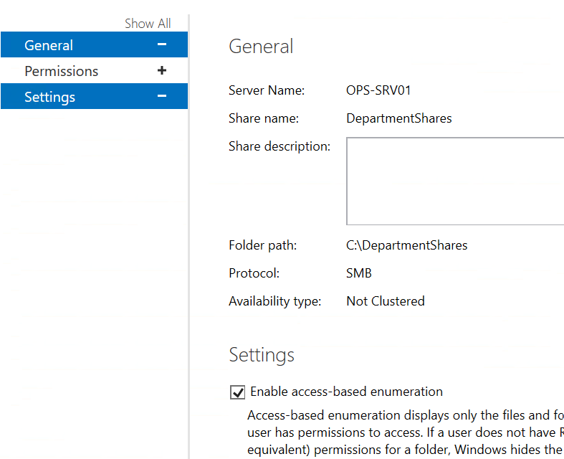

5. Bonus Task (Optional)
Configure Windows Server Backup to perform a daily backup of:
- System State
- DepartmentShares directory
Backups should be saved to a provided virtual disk.

Deliverables
Competitors must submit:
- A functional domain controller with all configurations applied
- A screenshot or demonstration verifying:
  - AD structure
  - GPO results using gpresult /r
  - Share permissions
  - Backup configuration settings

