🧠 Ontario Skills Competition – IT Network Systems
Question Title: Windows Server Network Infrastructure Deployment & Configuration
Scenario:
You are the network systems technician for MapleTech Solutions, a small IT services company preparing for expansion. Management wants you to deploy and configure a Windows Server 2022 environment that will serve as the company’s domain controller, DHCP, and DNS server, and connect properly to the existing network infrastructure.
Your task is to design and implement a functional Active Directory domain with working network services and a connected Windows 10 client.

Network Topology Overview
Device | Role | Interface | IP / VLAN | Notes
Router | Gateway | G0/0 | 192.168.100.1/24 | Provides Internet access
Windows Server 2022 | DC, DNS, DHCP | NIC1 | 192.168.100.10/24 | Static IP
Windows 10 Client | Domain Member | NIC1 | DHCP | Should receive IP from DHCP server

Configuration Requirements
Part A: Server Configuration (Windows Server 2022)
- Assign a static IP address of 192.168.100.10/24 and set the default gateway to 192.168.100.1.
- Rename the computer to SRV-DC1.
- Install and configure Active Directory Domain Services (AD DS) with the domain name:
mapletech.local
- Configure DNS to support the domain.
- Install and configure DHCP:
  - Scope name: MainOffice
  - IP Range: 192.168.100.50 – 192.168.100.100
  - Gateway: 192.168.100.1
  - DNS Server: 192.168.100.10
- Activate and authorize the DHCP server in Active Directory.

Part B: Client Configuration (Windows 10 Workstation)
- Configure the network adapter to obtain IP and DNS automatically.
- Verify that it receives a valid IP from the DHCP scope.
- Join the domain mapletech.local using credentials provided.
- Log in using a domain user account (e.g., student1@mapletech.local) and verify domain connectivity (ping, nslookup, etc.).

Verification Tasks
- ipconfig /all on both server and client shows correct settings.
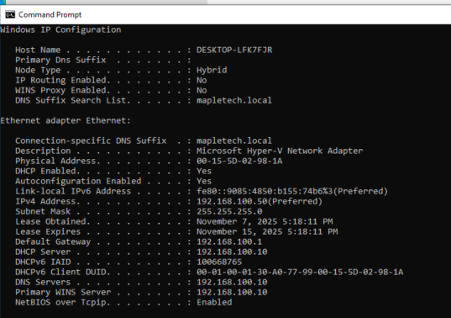
- The Windows 10 client can resolve the domain controller by name.
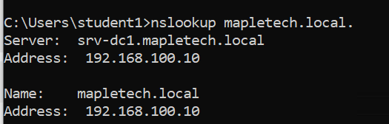
- The domain login works successfully.
- DHCP and DNS services are operational and verified.
- Server is reachable from the client via hostname (e.g., ping srv-dc1.mapletech.local).
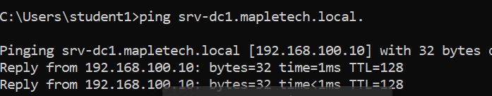



Deliverables
- Screenshots or CLI outputs showing:
  - AD DS setup summary
  - DHCP scope configuration
  - DNS zone contents
  - ipconfig /all from both server and client
- A brief written explanation (max 150 words) of how DHCP, DNS, and AD DS interact to enable domain logins.
When a computer joins a domain, DHCP assigns it an IP address and provides the address of the DNS server. DNS then resolves the domain name (e.g., mapletech.local) to the IP address of the Active Directory Domain Services (AD DS) domain controller. During login, the client contacts the domain controller using this resolved address to authenticate the user’s credentials. AD DS verifies the username and password against its directory database, applies group policies, and provides access to domain resources. In summary, DHCP connects the client to the network, DNS locates the domain controller, and AD DS handles authentication and authorization—together enabling secure domain logins.

Evaluation Criteria (100 Points Total)
Area | Points
Server configuration (AD DS, DNS, DHCP) | 35
Client configuration and domain join | 25
Network connectivity and verification | 20
Documentation and explanation | 20

