Hospital Ward Project Report

**Title: Hospital Ward**

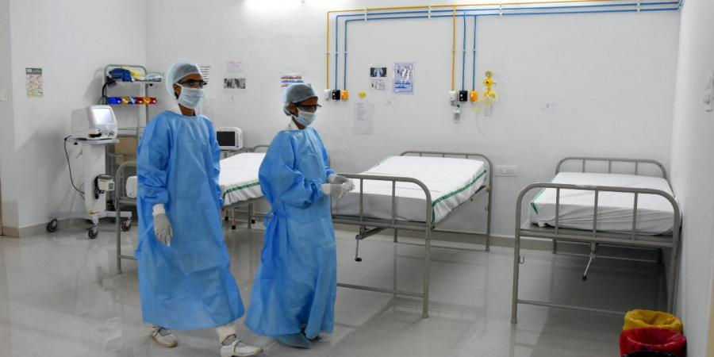

Abstract

Increasing use of data communications over hard papers is leading to widespread application software development. At the same time, the proliferation of technologies has consolidated the major market, making a wholesale migration to per-sonal internet services unlikely in the near future.

This report describes the design, implementation and evaluation of seed management for application control. Several specific solutions al-ready exist for maintain seed management data. However, commercial opportunities for these applications are growing rapidly.

The project developed in this project addresses these problems by creating interface to maintain data online instead of hard papers. The applications developed during the project to evaluate the effective use of these services.

**Schedule Matrix of 20 Days**

|  |  |
| --- | --- |
| Study | 02 |
| Requirement Gathering | 06 |
| Designing | 02 |
| Development | 8 |
| Testing and Implementation | 4 |

Home Page



This is the welcome Screen where two option can be seen after login 1. New Project 2. New Story.

Doctor Page: Here you can view the list of doctors in the hospital and also do add, update and delete.

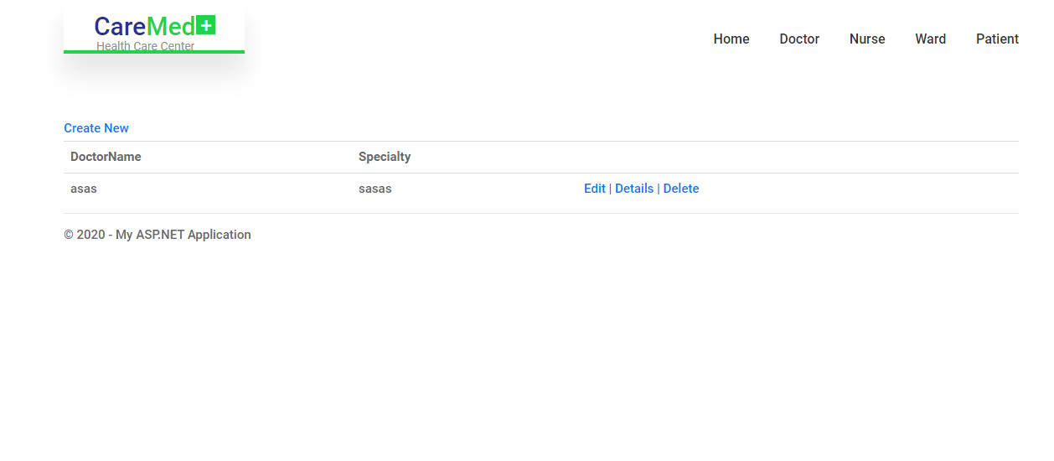

Nurses Page: Here we can save the records of nurses.

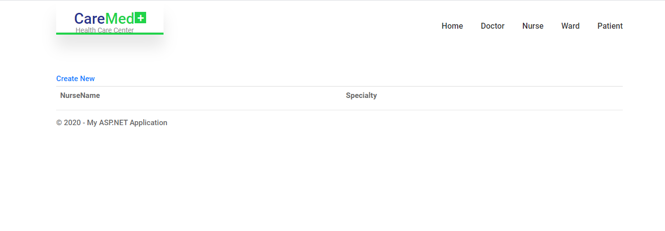

Ward Page: Here we can view the wards available in hospital and also add and update these.

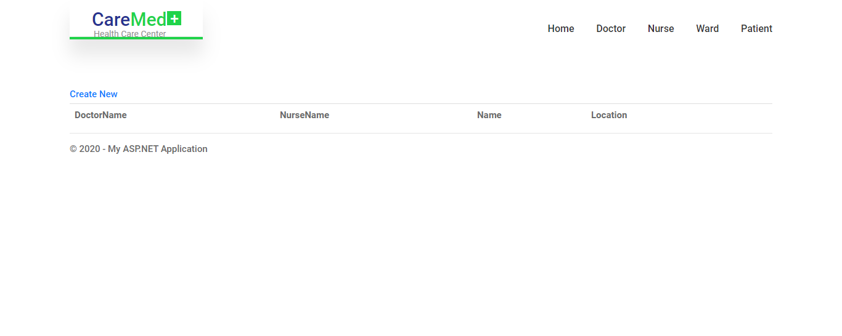

Patient Page: Here we can save the records of patients.

