**Step 1**

Create a Git Account

* <https://github.com/>



* Click Sign up

**Step 2**

Create a folder. Right Click and select Git Bash Here

**Step 3**

**Configure and Initialize**

Link for Reference:

https://docs.github.com/en/get-started/getting-started-with-git/setting-your-username-in-git



**ssh-keygen -t ed25519 -C** [**your_email@example.com**](mailto:your_email@example.com)

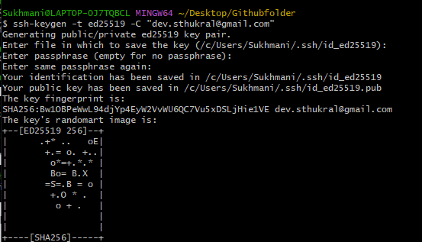

eval "$(ssh-agent -s)"

ssh-add ~/.ssh/id_ed25519

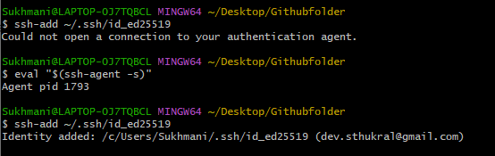

clip < ~/.ssh/id_ed25519.pub

;;;;;;;;;;;;;;;;;;;

Additional notes

Markdown resume template