<https://drive.google.com/file/d/1zVO65QK8t0CUzD7vjcMbLwOTtRi1AFYO/view>

<https://docs.python.org/3/tutorial/index.html>

<https://replit.com/languages/python3>

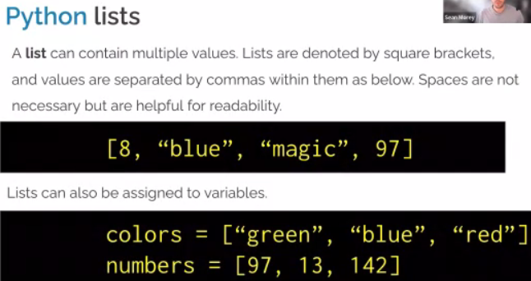

Def for the word define.

<https://github.com/hdsingh/Brain-Explorer/blob/master/app.ipynb>

