**Step 1 (Ensure node is installed)**

npx create-react-app my-app



Note: This will generate a folder structure

**Step 2**

**Note:** Default port 3000 will have the app running

**Step 3**

**Use src folder – create a** Component in the given **Src** Folder

Next create a file Greet.js

**Step 4**

Next we install a snippet generator

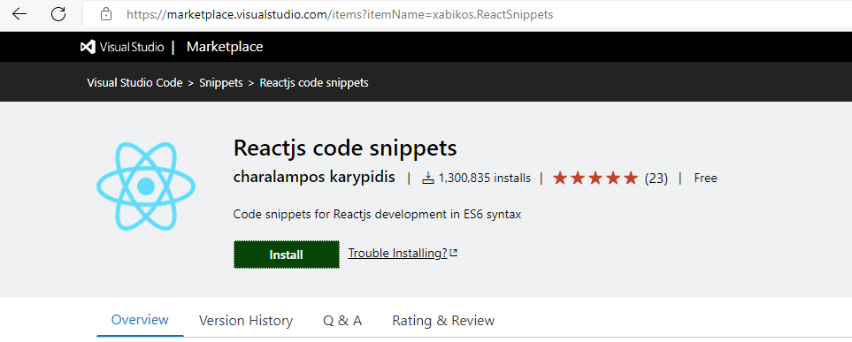

**Step 5**

**Create a component in the file: type rcc tab**