**I) Development process:**

**I.1) Concept:**

A watermarking system is usually divided into three distinct steps, embedding, attack, and detection. In embedding, an algorithm accepts the host and the data to be embedded, and produces a watermarked image.

Then the watermarked digital image is transmitted or stored, usually transmitted to another person. If this person makes a modification, this is called an attack. While the modification may not be malicious, the term attack arises from copyright protection application, where third parties may attempt to remove the digital watermark through modification.

Detection (often called extraction) is an algorithm which is applied to the attacked image to attempt to extract the watermark from it. If the image was unmodified during transmission, then the watermark still is present and it may be extracted. In robust digital watermarking applications, the extraction algorithm should be able to produce the watermark correctly, even if the modifications were strong. In fragile digital watermarking, the extraction algorithm should fail if any change is made to the image.

Types of Watermarks: Visible Watermarks – These watermarks are visible. Invisible Watermarks – These watermarks are embedded in the media and use steganography technique. They are not visible by naked eyes.

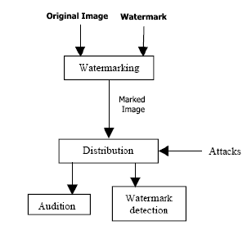

Watermarking process

**I.2) Overall architecture:**

Watermarking procedure is usually divided into two steps: embedding and verification. In the embedding process, an embedding algorithm E embeds pre-defined watermarks W into the carrier data C, which is the data to be protected. After the embedding, the embedded data (e = E(W, C)) are stored or transmitted. During the watermark verification process, a decryption algorithm D attempts to extract.

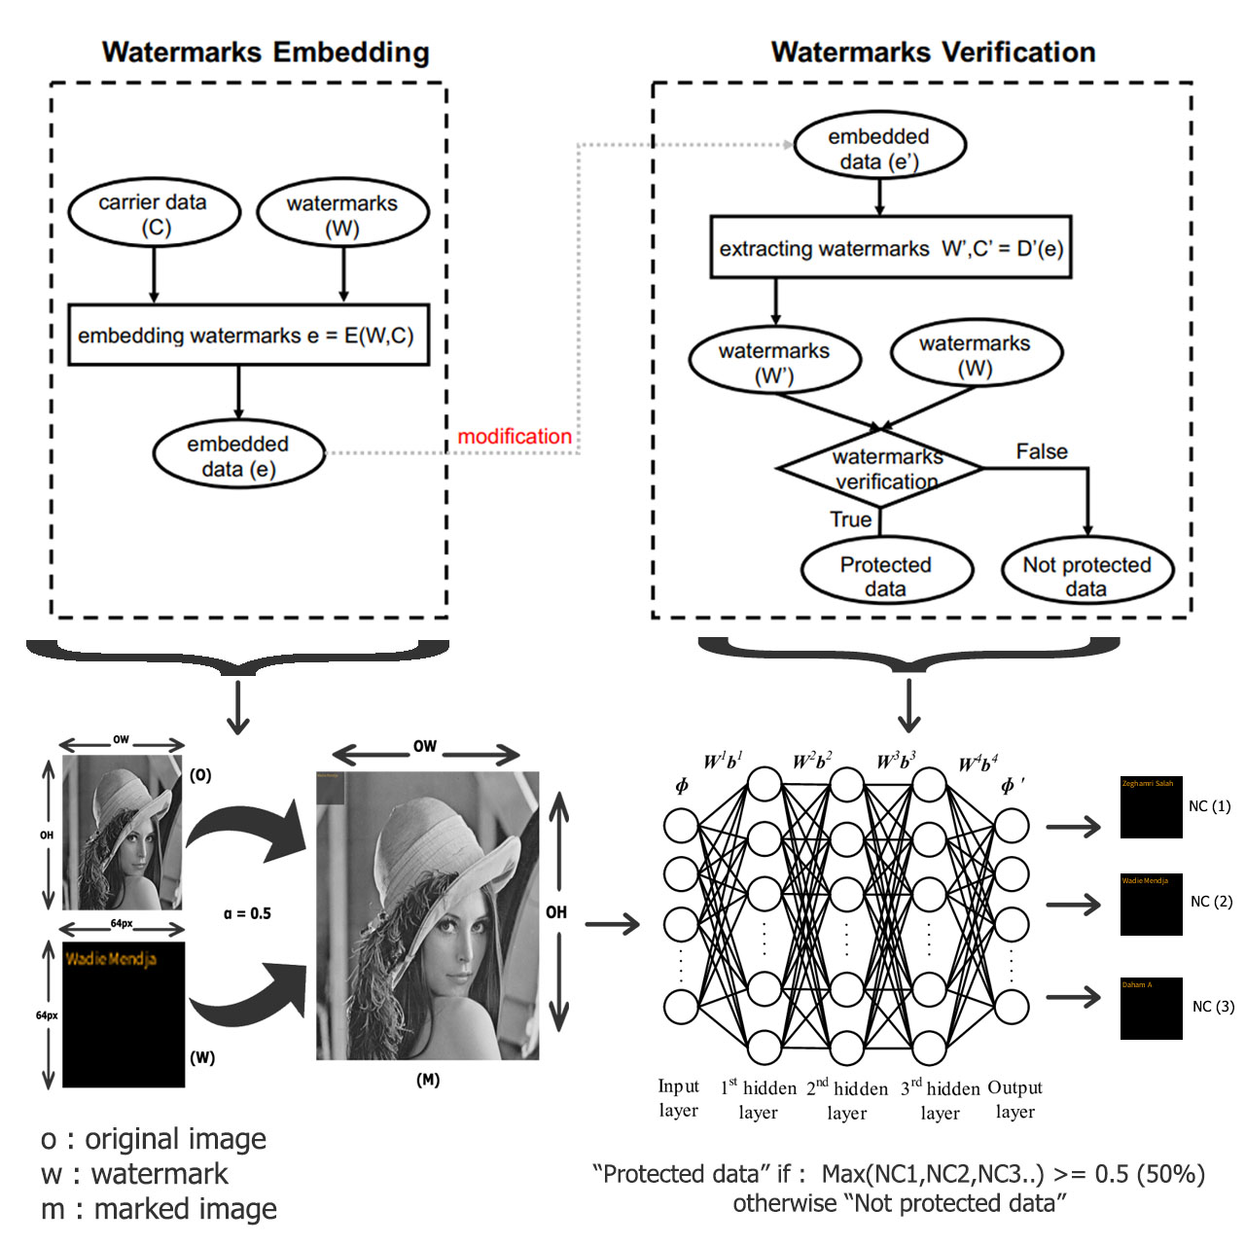

Overall architecture

NC (Neuron Coverage) bisects a neuron’s state into activated and non-activated. Given an input, a neuron is activated if its output value is above a predefined threshold. NC measures the ratio of activated neurons of a DNN. [1]

**I.2) Embedding a watermark:**

We developed our app using JavaScript programming language, and this language offers a great image processing and manipulation APIs, so in our case we’re using the “canvas fill text “API to embed certain text as a watermark on the input image. But how this actually works someone might ask?

Well, let us assume that an original image **O** has a width of **OW** and a height of OH and the watermark **W** is basically a 64x64 frame filled with a text (signature) which is going to be overlapped on **O** with a predefined opacity **α** which varies between (0.1 to 1), and with all that being performed a marked image **M** is going to be produced as given in Eq. 1

**m = O + αW** ……………. (1)

Illustration:

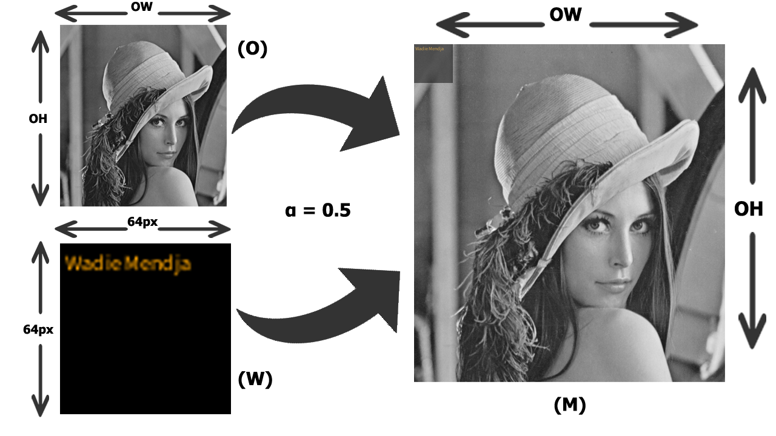

Embedding Process

**a) CanvasRenderingContext2D.fillText() method:**

The CanvasRenderingContext2D method fillText(), part of the Canvas 2D API, draws a text string at the specified coordinates, filling the string's characters with the current fillStyle. An optional parameter allows specifying a maximum width for the rendered text, which the user agent will achieve by condensing the text or by using a lower font size.

This method draws directly to the canvas without modifying the current path, so any subsequent fill() or stroke() calls will have no effect on it.

The text is rendered using the font and text layout configuration as defined by the font, textAlign, textBaseline, and direction properties. [2]

Syntax:

CanvasRenderingContext2D.fillText(text, x, y [, maxWidth]);

Here is an example of how it works, in the screenshot below we have on the left side the original image and the watermarked image on the right side, the “Select Watermark” text field contains the text that we should embed on the image as a watermark, we did that using the syntax that we talked about earlier

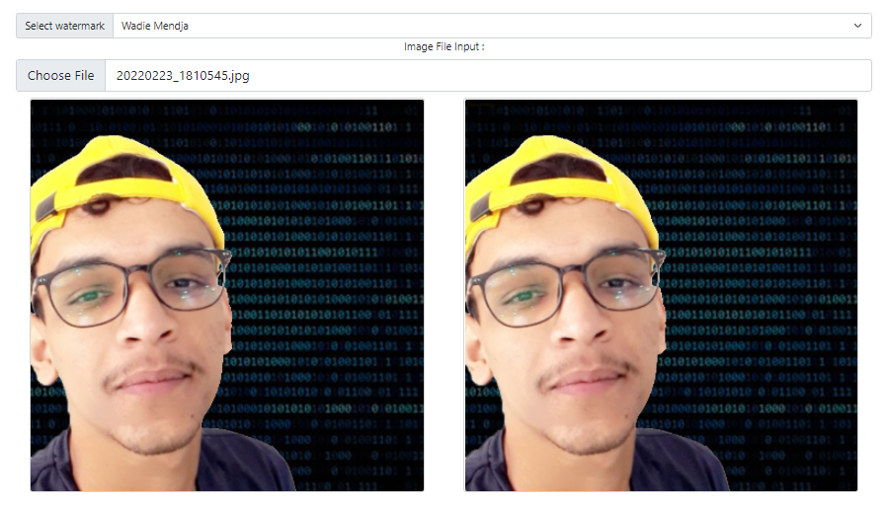

You may not notice any differences between the two images and that’s because we’re embedding an invisible watermark(α=0.1), but if we try to make the watermark visible(α=1) it’s going to look like that:

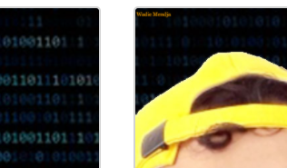

And here is the function that does all this work:

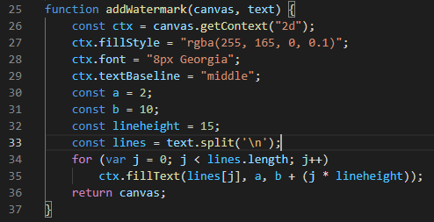

In which the “fillStyle” property specified the color and the opacity (alpha component) of the text that we’re trying to insert into the image, also we have “font” property which specifies the size of the text and its font, the constants “a” & “b” defines the position of the text on the inserted image.

Now that we’re done with the watermarking part lets skip up to the good parts which are generating a dataset of image (watermarks) and training a neural network to be able to detect it.

**I.3) Generating a dataset:**

Before generating a dataset of watermarks, we should first create them, so in our app we’re using three

different watermarks basically images that are filled with the following texts “Wadie Mendja”, “Zeghamri Salah” and “Daham A” which they look like this:

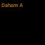

Those are the original watermarks, now we need to images similar to them by changing the text opacity, position and background color, so for this task we’re using a programming language called processing which is a graphical library and integrated development environment built for the electronic arts that’s going to help us generate multiple frames (images) and save them in our machine so we can use them in the training process, here you can take a look at the program:

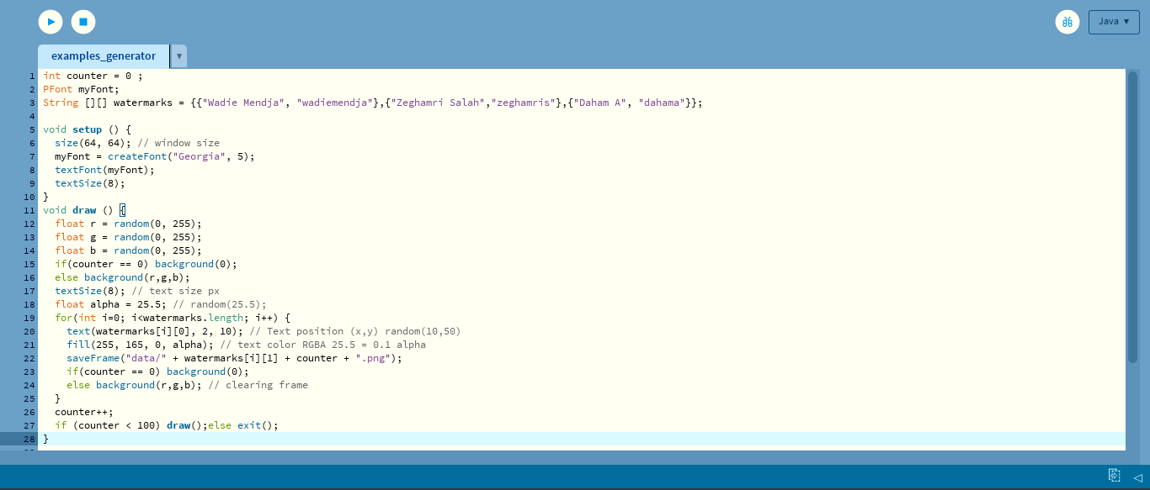

All what this program does is generate a bunch (100 in this case) of frames (images) with a size of 64x64 pixels that contains the watermarks above that we talked about (Wadie Mendja | Daham A | Zeghamri Salah) but with different sizes, positions, opacities and background colors, and finally save them as png files in a folder called “data”, that’s it.

Here is a screenshot of the “data” folder after the execution in done:

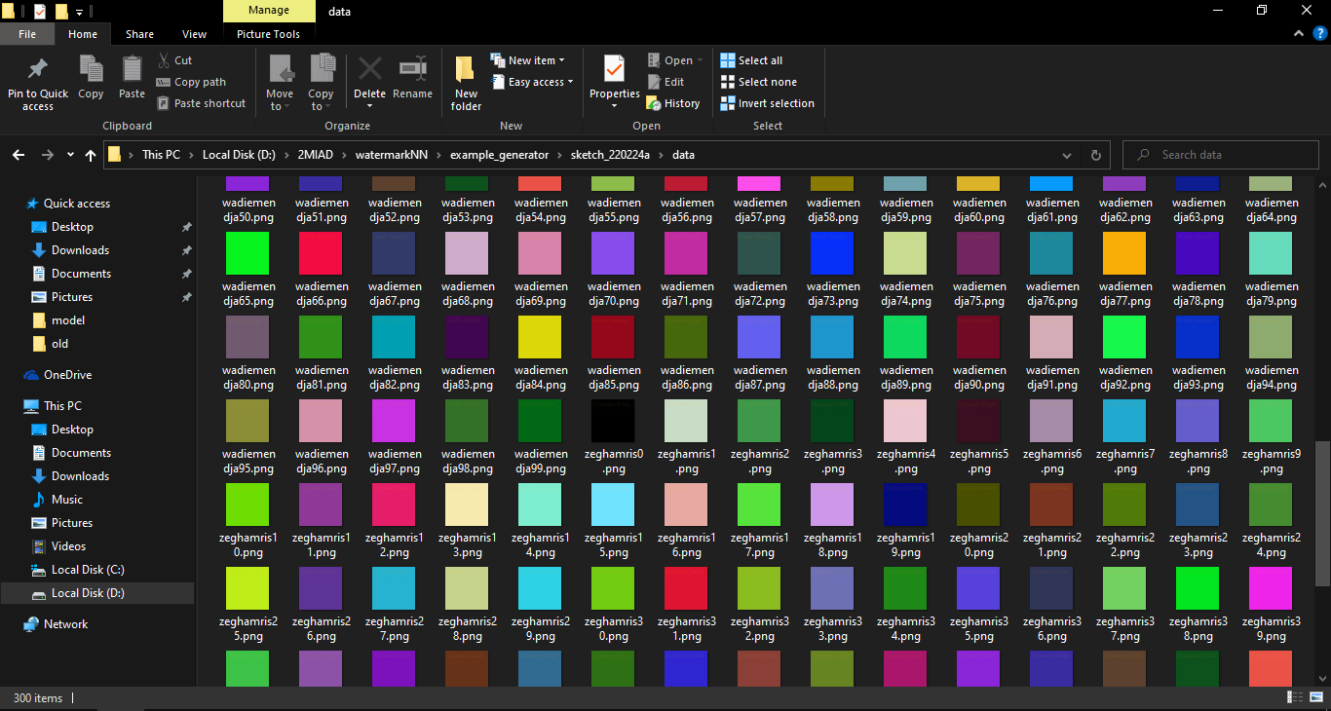

**I.4) Training the dataset:**

Our DNN is going to take each image’s individual pixel (RGBA) value as an input to the first layer of our DNN, the total number of inputs should be 64*64*4 which is 16384 inputs and 3 outputs since we have three pre-defined watermarks:

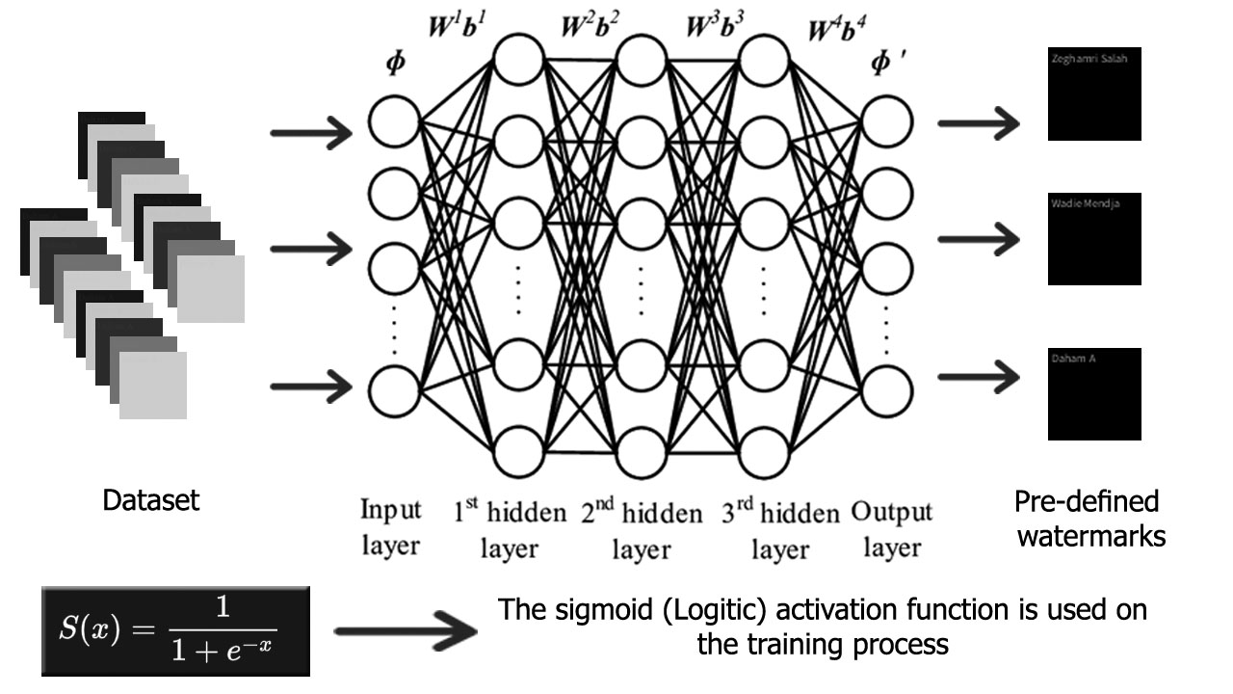

Training process

So, in this particular step we’re going to be using a library called “ml5.js” which uses the TensorFlow framework and has a predefined neural network class which will allow as to train a model and do the classification after the training process, all we have to do is give it the dataset and a label for each particular watermark, in general the steps for using the ml5.neuralNetwork look something like:

Step 1: load data or create some data

Step 2: Set your neural network options & initialize your neural network

Step 4: add data to the neural network

Step 5: Normalize your data

Step 6: Train your neural network

Step 7: use the trained model to make a classification

Step 8: do something with the results

Our dataset (100 sample for each watermark) will be trained with 500 epochs, here is the code that does the training process:

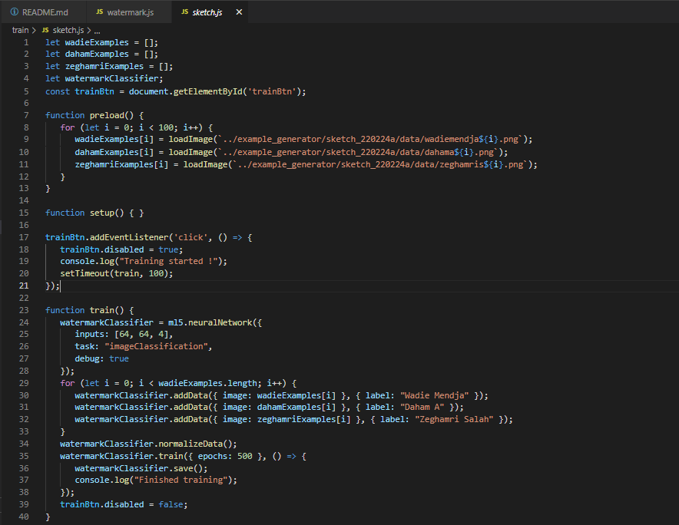

Training performance:

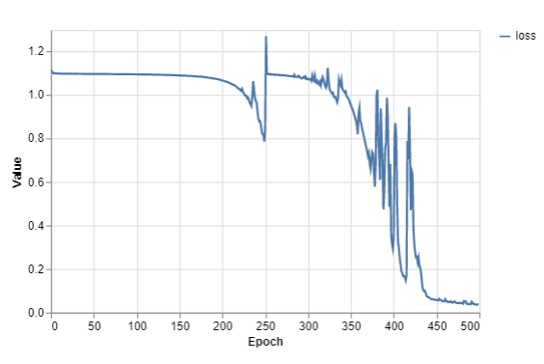

Training performance

An epoch in machine learning simply means one complete pass of the training dataset through the algorithm. This epochs number is an important hyperparameter for the algorithm. It specifies the number of epochs or complete passes of the entire training dataset passing through the training or learning process of the algorithm. [3]

**I.5) Watermark extraction:**

After we’d finished training our DNN and got our model files (weights and meta data files), now it’s time to try it out and see if it will give us some decent results or not, so to do that we need to load our pretrained model to our app and trigger the “classify” method and see the results. Here is a piece of the code that does that:

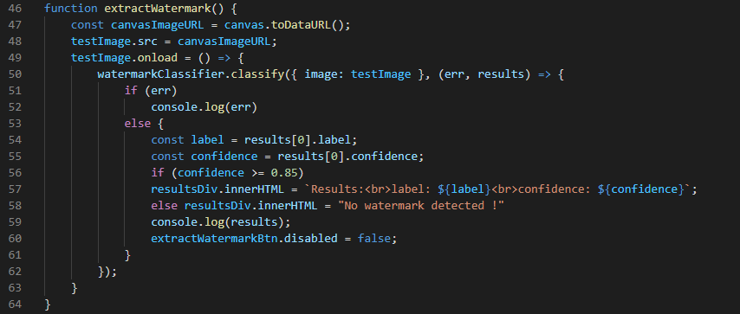

Results with a confidence score of 99.94% and an error of 0.06% which is a good indicator of a well-trained model, although we applied a compression attack on the image (Vectorial Quantization) but still the results turned out to be pretty good:

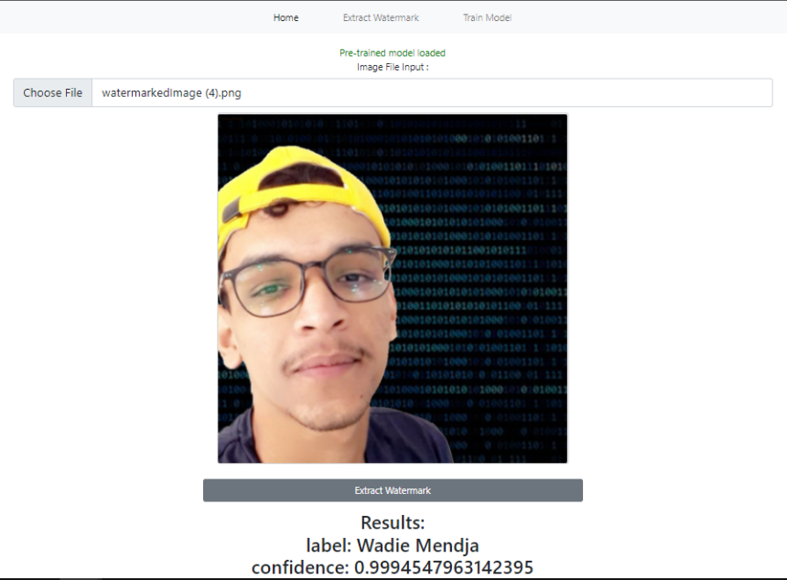

**I.6) Testing:**

**I.7) Conclusion:**

Although we got great results on the example above that we applied, however there are some cases were the image get damaged by some attack or compression algorithms in a way that even a well-trained neural network cannot be able to detect the embedded watermark or even if it did it will be with a low confidence score which means a higher error, and the higher the error goes the less we are sure about whether a certain watermark exists in an image or not.

[1] : Zhiyu Wang et al 2020 J. Phys.: Conf. Ser. 1693 012017

[2] : https://developer.mozilla.org/en-US/docs/Web/API/CanvasRenderingContext2D/

[3] : https://radiopaedia.org/articles/epoch-machine-learning