git init
git add .
git commit -m "first commit"
git remote add origin https://github.com/sukhmankhangura/jsassign5.git
git push -u origin master

npm init
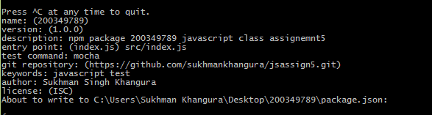
Is this ok? (yes) yes
npm install mocha chai http-server browserify --save
npm install -g mocha chai http-server browserify --save
npm install mocha chai http-server browserify --save-dev
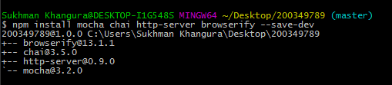
mocha
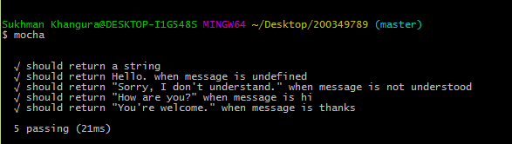
npm test

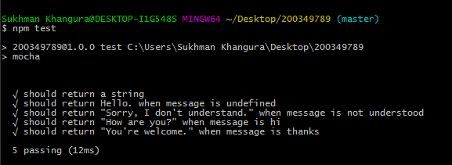
npm run build

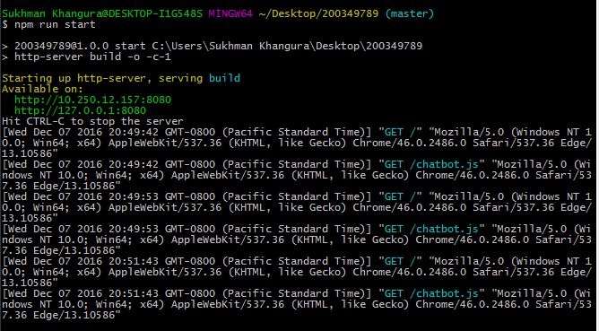

May press Ctrl+c to exit and again run the server using 'npm run start'.

