The Course Project

Part 1:

Develop a Mapper and Reducer application to calculate the *average* of *wind direction* (degree) for *each observation month* *from each year* (e.g. 195001) from NCDC records (note: 999 indicates missing value, and [01459] indicate good quality value).

python vy3059_part1.py -r local Project_Data/*.gz

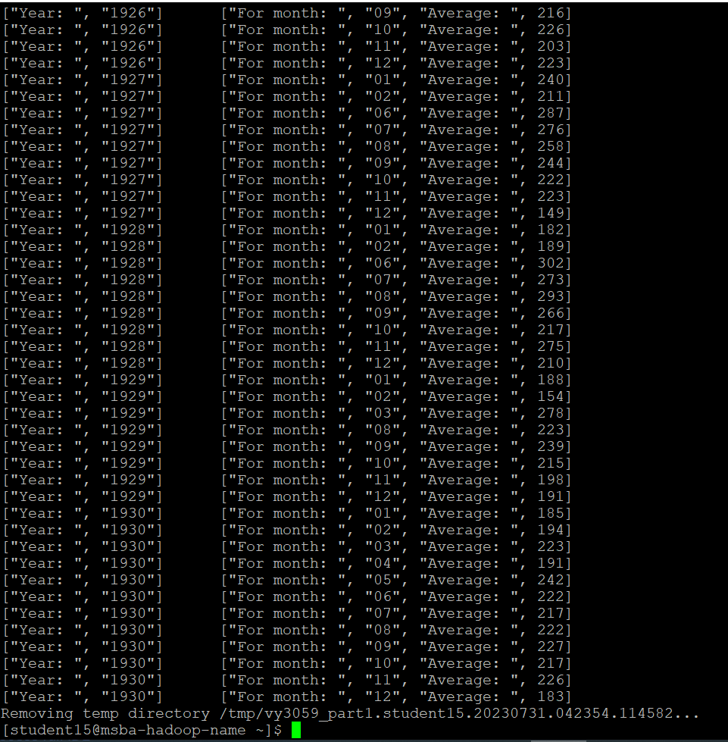

python vy3059_part1.py -r local Project_Data/*.gz --output-dir=./output_Project1

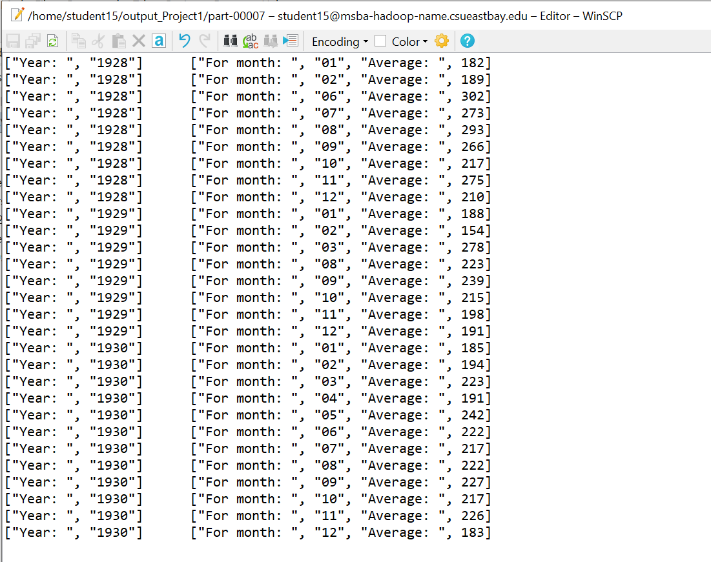

Part 2:

Develop a python application that can be implemented in PySpark to calculate the *range* (the difference between max and min values) of *sky ceiling height* (meters) for *each USAF weather station ID* from NCDC records (note: 99999 indicates missing value, and [01459] indicate good quality value).

hdfs dfs -mkdir /user/student15/input_ProjectPart2

hdfs dfs -copyFromLocal Project_Data /user/student15/input_ProjectPart2/



spark-submit --master local vy3059_part2.py

hdfs dfs -ls /user/student15/output_ProjectPart2-1/

hdfs dfs -cat /user/student15/output_ProjectPart2-1/*

Part 3:

Develop a Mapper and Reducer application to retrieve *USAF weather station ID* and *visibility distance (meters)* from NCDC records (note: 999999 indicates missing value, and [01459] indicate good quality value) and then *write* the USAF weather station ID and visibility distance data into *a text file*.

python vy3059_part3.py -r local Project_Data/*.gz

python vy3059_part3.py -r local Project_Data/*.gz > VisibilityAndStation_data.txt

Part 4:

Load the text file into Pig and get the range of *visibility distance* for each USAF weather station ID.

pig -x local

Visibility_records = LOAD 'VisibilityAndStation_data.txt'

AS (station_id:int, visibility_dist:int);

DUMP Visibility_records;

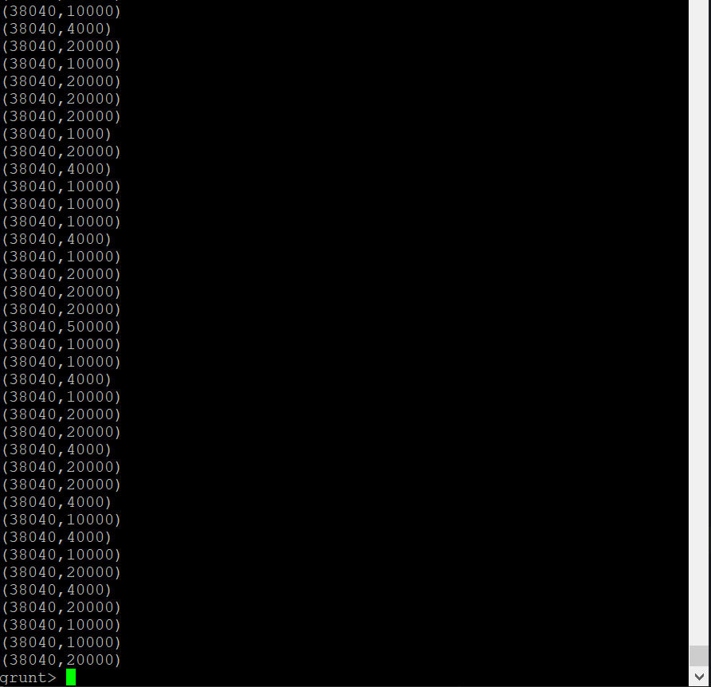

grouped_records = GROUP Visibility_records BY station_id;

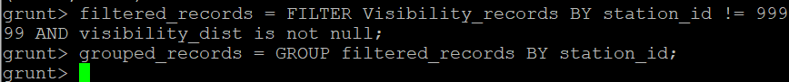

DUMP grouped_records;

Visibility_range = FOREACH grouped_records GENERATE group AS station_id, MAX(Visibility_records.visibility_dist) - MIN(Visibility_records.visibility_dist) AS visibility_dist_range;



DUMP Visibility_range;

STORE Visibility_range INTO 'output_Project4';

Part 5:

Load the text file into Hive and get the average *visibility distance* for each USAF weather station ID.

DROP TABLE IF EXISTS VisibilityAndStation1000;

CREATE TABLE VisibilityAndStation1000 (station_id INT, visibility_dist INT)

ROW FORMAT DELIMITED

FIELDS TERMINATED BY '\t';

LOAD DATA LOCAL INPATH 'VisibilityAndStation_data.txt'

OVERWRITE INTO TABLE VisibilityAndStation1000;

SELECT station_id, AVG(visibility_dist)

FROM VisibilityAndStation1000

WHERE station_id != 99999 AND visibility_dist IS NOT NULL

GROUP BY station_id;

