**Bank Loan Personal Loans**

Documentation

**Sukhman Singh**



Introduction Banking Loan

**Borrowing Money**

Do you need to borrow money to buy a car or maybe a house? If so, you might be thinking about getting a **bank loan**. A bank loan is a debt that a person, better known as the **borrower**, owes to a bank. It's basically an agreement between the borrower and the bank about a certain amount of money that the borrower will borrow and then pay back in specific increments at a specific interest rate. **Interest** is basically a fee you pay to borrow the money.

So let's say you need to buy a car. You go down to your bank and ask them for a loan. The loan officer will look at your overall financial situation - how much income you have, how much debt you have, and your credit score, so they can determine if you're a good risk to loan money to. These things all influence the interest rate you'll be charged, as well.

**Purpose :**

Purpose is make manage data online through portal after logging into admin area admin can view, update, delete the changes that admin needs to do with the database.

**Minimum Requirements:**

If you are using a custom named instance of Microsoft SQL Server Express, you will need to browse the **web.config** files in the demos for **connectionString** parameter entries, and replace any occurrence of the default instance name ("SQLEXPRESS") with your custom instance name.

Starting with version 13.2, for most popular database engines, the DevExpress .NET Demo Center automatically recognizes available database engines on the machine. When launching a particular demo that requires SQL Server from the Demo Center, it automatically locates available DBMS instances in the following order:

1. .\SQLEXPRESS
2. (localdb)\vX
3. (local)

**ASP.net Features**

ASP.NET MVC provides the following features −

* Ideal for developing complex but lightweight applications.
* Provides an extensible and pluggable framework, which can be easily replaced and customized. For example, if you do not wish to use the in-built Razor or ASPX View Engine, then you can use any other third-party view engines or even customize the existing ones.
* Utilizes the component-based design of the application by logically dividing it into Model, View, and Controller components. This enables the developers to manage the complexity of large-scale projects and work on individual components.
* MVC structure enhances the test-driven development and testability of the application, since all the components can be designed interface-based and tested using mock objects. Hence, ASP.NET MVC Framework is ideal for projects with large team of web developers.
* Supports all the existing vast ASP.NET functionalities, such as Authorization and Authentication, Master Pages, Data Binding, User Controls, Memberships, ASP.NET Routing, etc.
* Does not use the concept of View State (which is present in ASP.NET). This helps in building applications, which are lightweight and gives full control to the developers.

Index Page :

This index page information about the small business loans for daily expenses that is suitable for everyone and person can choose from these plans.



About page:

About page is discussing about the choosing the rate and loan and get funds for need



Contact Us :

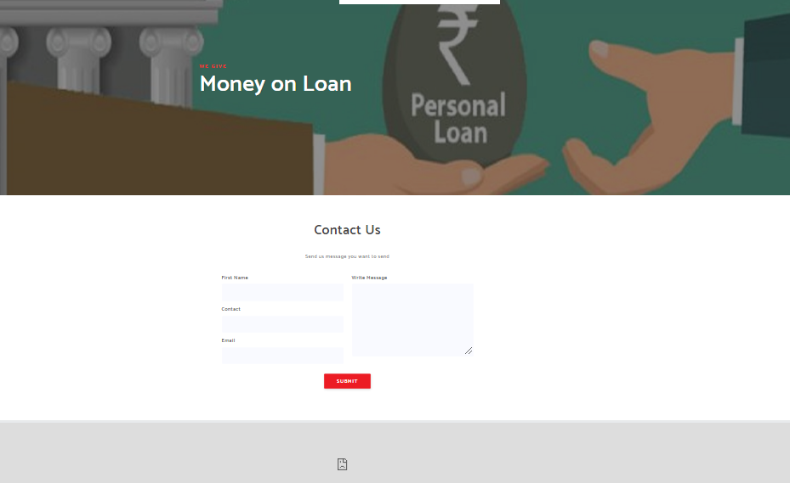

For any enquires user can contact on contact us page and admin will reply as early as possible

**Admin Area:**

After clicking on the admin login admin login into account for adding other details like staff and customer names and details.

**Username: admin**

**Password: admin**

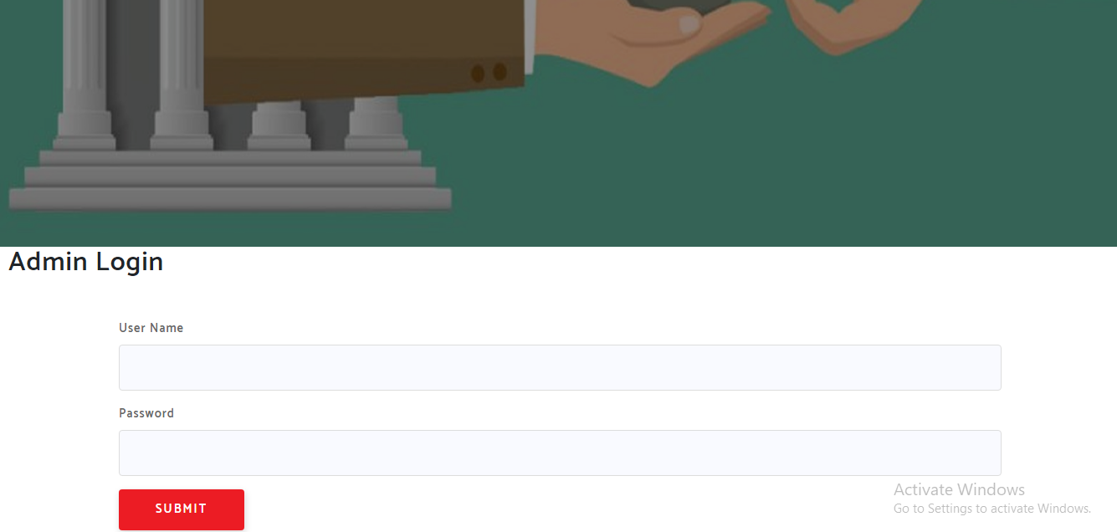

If wrong username & password added then it will display following messages



ADMIN PANEL

After logging in successfully admin will be see the following details on the screen to View, Update and Delete



Adding Loan details

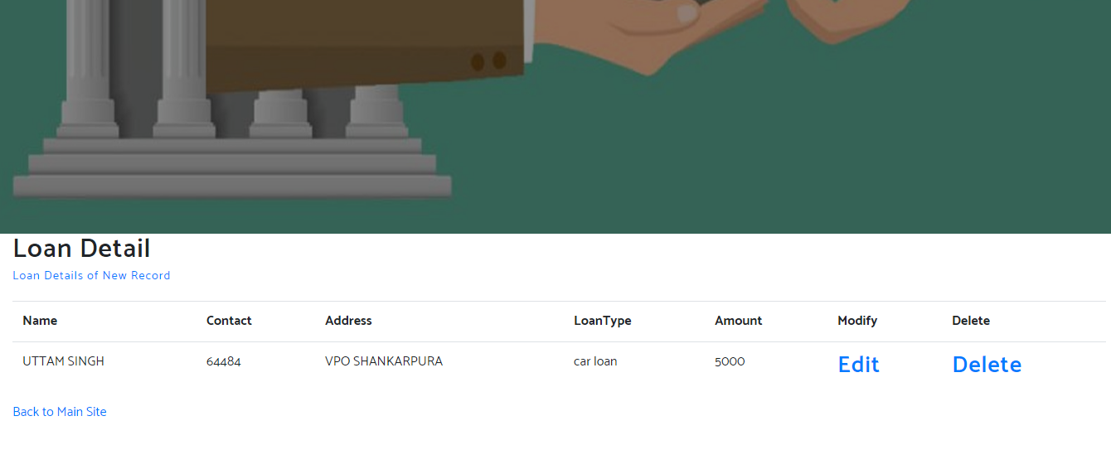

Installment details

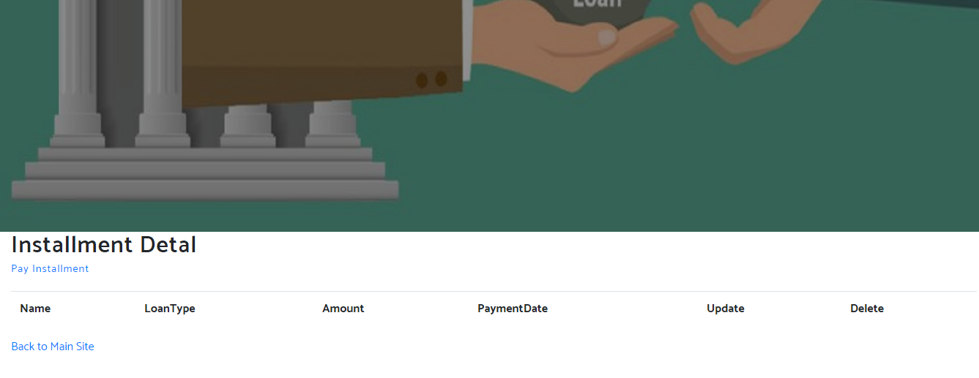

# User Manual

### System Overview

Bank loan is a project for bank usability based on the bank loan use that will mainly work for Admin bases . Admin can edit, delete and update the details admin want. After successfully logging into the account admin can do these details.

### System Configuration

Bank loan is a application developed using Microsoft Visual Studio 2019. It will run by clicking on SLN file given in the folder and no other special configurations are required.

### User Access Levels

* Only admin having ID Password of the account and login into the admin area