**Angular 5**

**Section 4**

**Section 4: Lecture 55 //Understanding Angular Error Messages**

No need for notes

**Section 4: Lecture 56 //Debugging code in the browser using Source maps**

1. Go into sources and web pack to access various files in your angular application and also check their values.
2. You can also debug line by line here.

Section 4: Lecture 57 //Using Augury to dive into Angular Apps

1. Google Angular Augury - it’s a tool for debugging.
2. Once you click on install it will add the Augury extension to your crome browser.

**Section** **5**

**Section 5: Lecture 59 //Module Introduction**

1. Understanding Components and Databinding – now we will dive deeper into components and data binding.
2. We will understand deeper connection between components and databinding.
3. Then we will modify our app.

**Section 5: Lecture 60 //Splitting app into components**

1. We need to split the app into components to reuse the components as our app grows bigger and this also focuses on separation of concerns and reusability of various components.
2. Let’s create a new cockpit component:

ng g c cockpit --spec false

1. Let’s create one more component i.e. server element:

ng g c server-element –spec false

1. Add below code to cockpit.component.html

<div class="container">

<div class="row">

<div class="col-xs-12">

<p>Add new Servers or blueprints!</p>

      <label>Server Name</label>

      <input type="text" class="form-control" [(ngModel)]="newServerName">

      <label>Server Content</label>

      <input type="text" class="form-control" [(ngModel)]="newServerContent">

      <br>

      <button class="btn btn-primary"

          (click)="onAddServer()">Add Server</button>

      <button class="btn btn-primary"

          (click)=" onAddBlueprint()">Add Server Blueprint</button>

</div>

</div>

</div>

1. Add below code to cockpit.component.ts
2. import { Component, OnInit } from '@angular/core';
3. @Component({
4. selector: 'app-cockpit',
5. templateUrl: './cockpit.component.html',
6. styleUrls: ['./cockpit.component.css']
7. })
8. export class CockpitComponent implements OnInit {
9. //serverElements = [];
10. newServerName = '';
11. newServerContent = '';
13. constructor() { }
14. ngOnInit() {
15. }
16. onAddServer(){
18. this.serverElements.push({
19. type: 'server',
20. name: this.newServerName,
21. content: this.newServerContent
22. });
23. }
25. onAddBlueprint(){
26. this.serverElements.push({
27. type: 'blueprint',
28. name:this.newServerName,
29. content: this.newServerContent
30. });
31. }
32. }

6. Put below code in server-element.component.html:

<div

class="panel panel-default"

>

<div class="panel-heading">{{ element.name }}</div>

<div class="panel-body">

<p>

<strong *ngIf="element.type === 'server'" style="color: red">{{ element.content }}</strong>

<em *ngIf="element.type === 'blueprint'">{{ element.content }}</em>

</p>

</div>

</div>

7. Add below code to app.comonent.ts :

import { Component } from '@angular/core';

@Component({

selector: 'app-root',

templateUrl: './app.component.html',

//styleUrls: ['./app.component.css']

styles: [`

h3{

color: dodgerblue;

}

`]

})

export class AppComponent {

serverElements = [];

name = '';

}

8. Below code would be there in app.compomnent.html

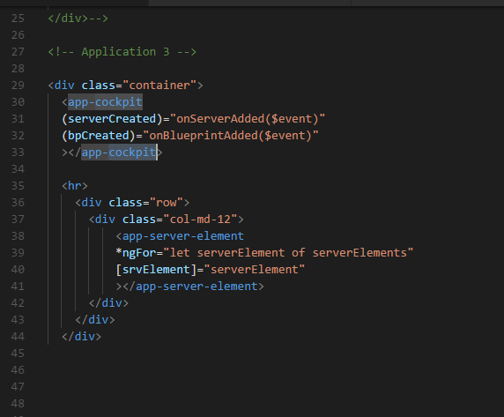

**Section 5: Lecture 61 //Property and Event Binding overview**

1. In the last lecture we split up our app into components, but one issue is that we need to pass the data into these components.
2. In the event binding, when we click to a button something happens i.e. an event gets emitted to which we are able to listen, and we can use that data with **$event.**
3. Now we need the above behaviour from our components i.e. we need to send data into a component or receive data/event from the component.
4. We need to send and receive an event, and Angular gives us the great tools to implement this flow.
5. We can use property and event binding not only in the HTML elements but also in Directives and finally we can also use this in our own components, as shown in the screenshot below:

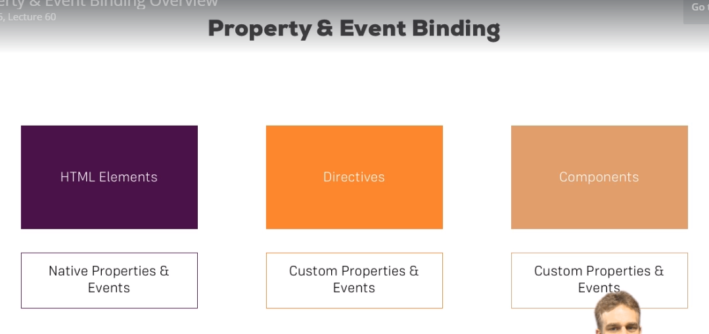

1. We can have our own custom properties and custom events. We can emit our own events.

**Section 5: Lecture 62 //Binding to custom properties**

1. Now, we have learnt that we can use property binding to bind to our custom properties, properties of our own components.
2. Add the below code in server-element.component.ts :
3. import { Component, OnInit } from '@angular/core';
4. @Component({
5. selector: 'app-server-element',
6. templateUrl: './server-element.component.html',
7. styleUrls: ['./server-element.component.css']
8. })
9. export class ServerElementComponent implements OnInit {
10. element: {type: string, name: string, content: string};
11. constructor() { }
12. ngOnInit() {
13. }
14. }
15. element is the property of server-element.component.ts, so, we cannot access it from outside.
16. Add below code in app.component.ts :
17. import { Component } from '@angular/core';
18. @Component({
19. selector: 'app-root',
20. templateUrl: './app.component.html',
21. styleUrls: ['./app.component.css']
22. // styles: [`
23. // h3{
24. // color: dodgerblue;
25. // }
26. // `]
27. })
28. export class AppComponent {
29. serverElements = [{type: 'server', name: 'Testserver', content: 'Just a test!'}];
30. name = '';
31. }

5. We have app.component.ts as shown above; now we will have app-server-element defined in the app.component.html as shown below:

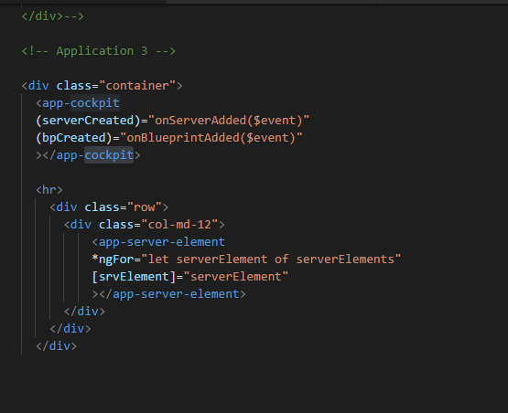

1. We need to access app.component.html from outside; it would be great if we are able to bind to it. In true sense all the properties of a component are only accessible only inside that component and we also don’t want all our properties bendable from outside – we would be very explicit about which property we want to expose.
2. Now, if we want to allow parent component to be able to bind to this property i.e. element property of server-element.component.ts - then we need to add something to that element property. We need to add a decorator. We know that the decorators era not only available for the classes. The decorator we need to add here is **@Input() element**.
3. Now, to allow the parent component to be able to bind to this property, you need to add a decorator; as we know that the decorators are not only available for the classes. **@Input()** now needs to be imported from ‘@angular/core’
4. Now, we are successfully exposing this property to the world i.e. element property.

Below is the decorator we need to add:

import { Component, OnInit, Input } from '@angular/core';

@Input() element: {type: string, name: string, content: string};

1. So the contents of the server-element.component.ts become as below:
2. import { Component, OnInit, Input } from '@angular/core';
3. @Component({
4. selector: 'app-server-element',
5. templateUrl: './server-element.component.html',
6. styleUrls: ['./server-element.component.css']
7. })
8. export class ServerElementComponent implements OnInit {
9. @Input() element: {type: string, name: string, content: string};
10. constructor() { }
11. ngOnInit() {
12. }
13. }

**Section 5: Lecture 63 //Assigning an Alias to Custom Properties**

1. In the last lecture we learnt how to bind our own properties with @Input() decorator.
2. You can also give the name in the parenthesis of the Input that you want to use outside i.e. when this property is used by some other component as below :

@Input('srvElement') element: {type: string, name: string, content: string}; //srvElement is an alias to the property named here for element

1. Now, here 'srvElement' will work and element will no longer work.
2. Above is the way in which we can assign an alias to the any property of a component.
3. Now the code of server-element.component.ts becomes like below:
4. import { Component, OnInit, Input } from '@angular/core';
5. @Component({
6. selector: 'app-server-element',
7. templateUrl: './server-element.component.html',
8. styleUrls: ['./server-element.component.css']
9. })
10. export class ServerElementComponent implements OnInit {
11. @Input('srvElement') element: {type: string, name: string, content: string};
12. constructor() { }
13. ngOnInit() {
14. }
15. }
16. And the code of app.component.html becomes as below:
17. <div class="container">
18. <app-cockpit></app-cockpit>
19. <hr>
20. <div class="row">
21. <div class="col-md-12">
22. <app-server-element
23. *ngFor="let serverElement of serverElements"
24. [srvElement]="serverElement"
25. ></app-server-element>
26. </div>
27. </div>
28. </div>

**Section 5: Lecture 64 //Binding to the custom events**

1. We learnt how to pass information from one component down (i.e. to the child component) to another component i.e. we learnt how to pass information from parent component down to other component if something is changed.
2. Now, we will learn how to pass the communication from the child component to the parent component. Here the parent component which implements the other component i.e. child component.
3. Here, from the child component i.e. cockpit.component.ts to app.component.ts that something is changed in cockpit.component.ts i.e. child to parent component.
4. Here we want to inform our parent component i.e. the app.component in this case new server was created, because the code which would have simply executed is commented out.
5. Now in the cockpit.component we want to implement the above methods.
6. Update the code of app.component.ts as below, now in onServerAdded and onBlueprintAdded, we expect to get event i.e. serverData and bluePrintData repectively.
7. import { Component } from '@angular/core';
8. @Component({
9. selector: 'app-root',
10. templateUrl: './app.component.html',
11. styleUrls: ['./app.component.css']
12. // styles: [`
13. // h3{
14. // color: dodgerblue;
15. // }
16. // `]
17. })
18. export class AppComponent {
19. serverElements = [{type: 'server', name: 'Testserver', content: 'Just a test!'}];
20. name = '';
21. onServerAdded(serverData: {serverName: string, serverContent: string}){
23. this.serverElements.push({
24. type: 'server',
25. name: serverData.serverName,
26. content: serverData.serverContent
27. });
28. }
30. onBlueprintAdded(bluePrintData: {serverName: string, serverContent: string}){
31. this.serverElements.push({
32. type: 'blueprint',
33. name: bluePrintData.serverName,
34. content: bluePrintData.serverContent
35. });
36. }
37. }

7. Update the code of app.component.html as below:

<div class="container">

<app-cockpit

(serverCreated)="onServerAdded($event)"

(bluePrintCreated)="onBluePrintAdded($event)"

></app-cockpit>

<hr>

<div class="row">

<div class="col-md-12">

<app-server-element

*ngFor="let serverElement of serverElements"

[srvElement]="serverElement"

></app-server-element>

</div>

</div>

</div>

8. Now, we need to make both serverCreated and blueprintCreated as the events that we will emit from cockpit.component.ts, this we will do by assigning the property to new EventEmitter<> ; There are greater than and smaller than sign behind the EventEmitter because the event emitter is a generic type. So here we need to define the type of event we are going to emit. EventEmitter should be imported from ‘@angular/core’

serverCreated = new EventEmitter<{serverName: string, serverContent: string}>();

blueprintCreated = new EventEmitter<{serverName: string, serverContent: string}>();

7. Now, we need to add the decorator to make the property listenable from outside i.e. @Output(); Import @Output() from ‘@angular/core’ below is the code for the same with the decorator:

@Output() serverCreated = new EventEmitter<{serverName: string, serverContent: string}>();

@Output() blueprintCreated = new EventEmitter<{serverName: string, serverContent: string}>();

8.There we will use addServer() methodused to emit the event. So, here we are emitting our own events and we are passing our own data. Contents of cockpit.component.ts will become:

import { Component, OnInit, Output, EventEmitter } from '@angular/core';

@Component({

selector: 'app-cockpit',

templateUrl: './cockpit.component.html',

styleUrls: ['./cockpit.component.css']

})

export class CockpitComponent implements OnInit {

//serverElements = [];

@Output() serverCreated = new EventEmitter<{serverName: string, serverContent: string}>();

@Output() blueprintCreated = new EventEmitter<{serverName: string, serverContent: string}>();

newServerName = '';

newServerContent = '';

constructor() { }

ngOnInit() {

}

onAddServer(){

this.serverCreated.emit({serverName : this.newServerName,

serverContent: this.newServerContent});

}

onAddBlueprint(){

this.blueprintCreated.emit({serverName : this.newServerName,

serverContent: this.newServerContent});

}

}

9. Contents of app.component.ts will become:

import { Component } from '@angular/core';

@Component({

selector: 'app-root',

templateUrl: './app.component.html',

styleUrls: ['./app.component.css']

// styles: [`

// h3{

// color: dodgerblue;

// }

// `]

})

export class AppComponent {

serverElements = [{type: 'server', name: 'Testserver', content: 'Just a test!'}];

name = '';

onServerAdded(serverData: {serverName: string, serverContent: string}){

this.serverElements.push({

type: 'server',

name: serverData.serverName,

content: serverData.serverContent

});

}

onBlueprintAdded(blueprintData: {serverName: string, serverContent: string}){

this.serverElements.push({

type: 'blueprint',

name: blueprintData.serverName,

content: blueprintData.serverContent

});

}

}

10. Content of server-element.component.html will become:

<div

class="panel panel-default"

>

<div class="panel-heading">{{ element.name }}</div>

<div class="panel-body">

<p>

<strong *ngIf="element.type === 'server'" style="color: red">{{ element.content }}</strong>

<!-- <strong *ngIf="element.type === 'blueprint'" style="color: blue">{{ element.content }}</strong> -->

<em *ngIf="element.type === 'blueprint'" style="color: blue">{{ element.content }}</em>

</p>

</div>

</div>

11. Here we made our components communicable. Component communication is very important in any app.

**Section 5: Lecture 65 //Assigning an Alias to custom events**

1. Just like @Input(), you can also assign alias to @Output() as shown in the example below:

@Output('bpCreated') blueprintCreated = new EventEmitter<{serverName: string, serverContent: string}>();

1. App.component.html will get updated as below:
2. <div class="container">
3. <app-cockpit
4. (serverCreated)="onServerAdded($event)"
5. (bpCreated)="onBlueprintAdded($event)"
6. ></app-cockpit>
8. <hr>
9. <div class="row">
10. <div class="col-md-12">
11. <app-server-element
12. *ngFor="let serverElement of serverElements"
13. [srvElement]="serverElement"
14. ></app-server-element>
15. </div>
16. </div>
17. </div>

**Section 5: Lecture 66 //Custom properties and event binding summary**

1. We will use services when the distance between the component will grow too much i.e. there are chains of components communicating.

**Section 5: Lecture 67 //Understanding view encapsulation**

1. Now the properties applied in the app.component.css file will not work for the child components as it clearly belongs to the app.component.html template. The blue color was defined in the .css file of the app.component. Now, it is not defined inside the cockpit.component.
2. The behaviour that the properties defined in the CSS file of a particular component will be applied to that component only – is the behaviour given to us by angular and not default behaviour.
3. This is the default behaviour of the view encapsulation in Angular.
4. Now, we will copy the blue color for paragraph in the server-element.component
5. The styles defined inside the particular component are defined in the .css file of that component; and those will be applied to that particular component only.

**Section 5: Lecture 68 //More on view encapsulation**

1. In the last lecture we learnt that how angular encapsulates your styles, now you can overwrite this encapsulation though.
2. If we add the below code in a component, then that component will not use view encapsulation; ViewEncapsulation is imported from the ‘@angular/core’:

encapsulation: ViewEncapsulation.None

1. Once we use ViewEncapsulation.None, for any component the encapsulated IDs will not be added for that particular component. As we know that the encapsulation IDs are added by angular for each component by angular by default.
2. Now the code of server-element.component.ts becomes as shown below:

import { Component, OnInit, Input,ViewEncapsulation } from '@angular/core';

@Component({

selector: 'app-server-element',

templateUrl: './server-element.component.html',

styleUrls: ['./server-element.component.css'],

encapsulation: ViewEncapsulation.None

})

export class ServerElementComponent implements OnInit {

@Input('srvElement') element: {type: string, name: string, content: string};

constructor() { }

ngOnInit() {

}

}

1. The default is Emulated which means that only your component will receive the style which you define for that component.
2. Now, we can also use ViewEncapsulation.Native which uses shadow DOM technology //this should give same result as ViewEncapsulation.Emulated but most browsers don’t support it.
3. But, be aware we can also choose to .None and .Native too.
4. This is how you can change it and how view encapsulation works.

**Section 5: Lecture 69 //Using local references in templates**

1. In the cockpit.component we are using @Output and @Input to move data around – our own custom property and event binding.
2. Now, in the cockpit we are using the 2 way databinding to get the server name and content; now there is nothing wrong with that to use the 2 way databinding since I only want to save or use the data only when I click the button i.e. Add Server or the Add server blue print button. It would be enough to get the value of the input at this point of time.
3. There is the other option which we have is that we can use the local references only inside our HTML template, but not inside the typescript by using the # key as shown below; here we are putting a local reference on the input element, however, we can put local reference on any of the HTML elements.
4. As, shown below we can add the local reference by adding a # tag. Here, we can add the #serverNameInput – this doesn’t hold the reference to the value but it holds the reference to the element.
5. Now, in onAddServer(serverNameInput) – here we added serverNameInput
6. Local reference can only be used inside the template and not inside the .ts file.
7. type="text"
8. class="form-control"
9. #serverNameInput>
10. Now, we can use any local reference anywhere in the app, updated code in cockpit.component.html is shown below:
11. <div class="container">
12. <div class="row">
13. <div class="col-xs-12">
14. <p>Add new Servers or blueprints!</p>
15. <label>Server Name</label>
16. <!-- <input type="text" class="form-control" [(ngModel)]="newServerName"> -->
17. <input
18. type="text"
19. class="form-control"
20. #serverNameInput>
21. <label>Server Content</label>
22. <input type="text" class="form-control" [(ngModel)]="newServerContent">
23. <br>
24. <button class="btn btn-primary"
25. (click)="onAddServer(serverNameInput)">Add Server</button>
26. <button class="btn btn-primary"
27. (click)="onAddBlueprint(serverNameInput)">Add Server Blueprint</button>
28. </div>
29. </div>
30. </div>
31. Updated code of cockpit.component.ts is as below:
32. import { Component, OnInit, Output, EventEmitter } from '@angular/core';
33. @Component({
34. selector: 'app-cockpit',
35. templateUrl: './cockpit.component.html',
36. styleUrls: ['./cockpit.component.css']
37. })
38. export class CockpitComponent implements OnInit {
39. //serverElements = [];
40. @Output() serverCreated = new EventEmitter<{serverName: string, serverContent: string}>();
41. @Output('bpCreated') blueprintCreated = new EventEmitter<{serverName: string, serverContent: string}>();
42. newServerName = '';
43. newServerContent = '';
45. constructor() { }
46. ngOnInit() {
47. }
48. onAddServer(nameInput: HTMLInputElement){
49. console.log(nameInput.value);
50. this.serverCreated.emit({serverName : nameInput.value,
51. serverContent: this.newServerContent});
52. }
54. onAddBlueprint(nameInput: HTMLInputElement){
55. this.blueprintCreated.emit({serverName : nameInput.value,
56. serverContent: this.newServerContent});
57. }
58. }

//with comments

1. nAddServer(nameInput: HTMLInputElement){ //here we get the element with all its properties given by the local variable
2. console.log(nameInput.value); //we can fetch value out of it
3. this.serverCreated.emit({serverName : nameInput.value,
4. serverContent: this.newServerContent});
5. }

8. So, local reference is very good way to get some input from the template and we can use the same inside the template also.

**Section 5: Lecture 70 //Getting Access to the Template& DOM with @ViewChild**

1. In the last lecture we learnt about the local references, now, there is another way of getting access to local references of any element from of our template directly from out typescript code.
2. Right now we are passing the reference when we call a method, but sometimes you want to get the access before you call a method; and there is a nice little decorator we can use in typescript to get this access.
3. Now, let’s do the same for the server content. In cockpit template instead of using 2 way binding we will use local reference. As shown below:
4. <div class="container">
5. <div class="row">
6. <div class="col-xs-12">
7. <p>Add new Servers or blueprints!</p>
8. <label>Server Name</label>
9. <!-- <input type="text" class="form-control" [(ngModel)]="newServerName"> -->
10. <input
11. type="text"
12. class="form-control"
13. #serverNameInput>
14. <label>Server Content</label>
15. <!-- <input type="text" class="form-control" [(ngModel)]="newServerContent"> -->
16. <input type="text"
17. class="form-control"
18. #serverContentInput>
19. <!-- It has local refernce now instead of two way data binding -->
20. <br>
21. <button class="btn btn-primary"
22. (click)="onAddServer(serverNameInput)">Add Server</button>
23. <button class="btn btn-primary"
24. (click)="onAddBlueprint(serverNameInput)">Add Server Blueprint</button>
25. </div>
26. </div>
27. </div>
28. Now, in the cockpit.component.ts we will comment out the old newServerContent property, I will add a new property called serverContentInput; but we can add decorator @ViewChild() in front of it and we need to import ViewChild from ‘@angular/core’;
29. @ViewChild like this won’t work; we need to add an argument in front of it. And this argument actually is the selector of the local reference i.e. here our local reference is #serverContentInput. So. It will become as shown below in cockpit,component.ts(Note here we can pass the name of the component also directly to access the first occurrence of the cockpit component in the app.component):
30. Here the local reference type is ElementRef i.e. the reference to the element. ElementRef need to be imported from ‘@angular/core’. ElementRef has an important property we can use it’s the native element property.
31. We can use this.serverContentInput.nativeElement.value to get access to the underlying element.
32. Now, we have made the add server functionality without 2 way binding but with the local reference.
33. We have given below the final – cockpit.component.ts file:
34. import { Component, OnInit, Output, EventEmitter, ViewChild, ElementRef } from '@angular/core';
35. @Component({
36. selector: 'app-cockpit',
37. templateUrl: './cockpit.component.html',
38. styleUrls: ['./cockpit.component.css']
39. })
40. export class CockpitComponent implements OnInit {
41. //serverElements = [];
42. @Output() serverCreated = new EventEmitter<{serverName: string, serverContent: string}>();
43. @Output('bpCreated') blueprintCreated = new EventEmitter<{serverName: string, serverContent: string}>();
44. //newServerName = '';
45. //newServerContent = '';
46. @ViewChild('serverContentInput') serverContentInput: ElementRef;
48. constructor() { }
49. ngOnInit() {
50. }
51. onAddServer(nameInput: HTMLInputElement){ //here we get the element with all its properties given by the local variable
52. // console.log(nameInput.value); //we can fetch value out of it
53. // this.serverCreated.emit({serverName : nameInput.value,
54. // serverContent: this.newServerContent});
55. console.log(this.serverContentInput);
56. this.serverCreated.emit({serverName : nameInput.value,
57. serverContent: this.serverContentInput.nativeElement.value});
58. }
60. onAddBlueprint(nameInput: HTMLInputElement){
61. // this.blueprintCreated.emit({serverName : nameInput.value,
62. // serverContent: this.newServerContent});
63. this.blueprintCreated.emit({serverName : nameInput.value,
64. serverContent: this.serverContentInput.nativeElement.value});
65. }
66. }

**Section 5: Lecture 71 //Projecting into components with ng-content**

1. We learnt a lot throughout this section; we learnt how to pass data around, to get access to data or DOM, how to use local references in our application.
2. Our application is now much more dynamic, we’ve got much more tools to interact between different pieces within our app.
3. There is one more way by which we can pass the data around. In our server element component right now we check if we have a type server or a type blueprint server – nothing wrong with that but sometimes we have some complex HTML code which we want to pass in a component from outside.
4. Suppose we want to pass below code from server-element.component.html to app.component.html
5. Server-element.component.html:
6. <div
7. class="panel panel-default"
8. >
9. <div class="panel-heading">{{ element.name }}</div>
10. <div class="panel-body">
11. <p>
12. <!-- <strong *ngIf="element.type === 'server'" style="color: red">{{ element.content }}</strong> -->
13. <!-- <strong *ngIf="element.type === 'blueprint'" style="color: blue">{{ element.content }}</strong> -->
14. <!-- <em *ngIf="element.type === 'blueprint'" style="color: blue">{{ element.content }}</em> -->
15. </p>
16. </div>
17. </div>

6. Commented code in server-element.component.html and moved to app component.html as shown below – app.component.html :

<!-- Aplication one -->

<!--<input type="text" [(ngModel)]="name">

<p>{{ name }}</p>-->

<!--<div class="container">

<div class="row">

<div class="col-xs-12">

<h3>I am in the AppComponent!!!</h3>-->

<!-- <div app-servers></div>-->

<!--<app-header></app-header>-->

<!--<div class="app-servers"></div>-->

<!-- </div>

</div>

</div>-->

<!-- Application 2 -->

<!--<app-header></app-header>

<div class="container">

<div class="row">

<div class="col-md-12">

<app-recipes></app-recipes>

<app-shopping-list></app-shopping-list>

</div>

</div>

</div>-->

<!-- Application 3 -->

<div class="container">

<app-cockpit

(serverCreated)="onServerAdded($event)"

(bpCreated)="onBlueprintAdded($event)"

></app-cockpit>

<hr>

<div class="row">

<div class="col-md-12">

<app-server-element

*ngFor="let serverElement of serverElements"

[srvElement]="serverElement"> <!-- This is the name of the property in the server-element.ts -->

<p>

<strong *ngIf="serverElement.type === 'server'" style="color: red">{{ serverElement.content }}</strong>

<em *ngIf="serverElement.type === 'blueprint'" style="color: blue">{{ serverElement.content }}</em>

</p>>

</app-server-element>

</div>

</div>

</div>

7. now, we want to pass above code from app.component.html to server-element.component.html, this can be done by using a directive in server-element.html – so, this is a special directive which we can add.

8. In the server-element.component.html where I want to render the component, I can use the special directive i.e. <ng-content></ng-content>

9. It still is a directive just using element like selector as a hook you can place in your component to mark the place for angular – where angular can add any content that it will find in the opening and closing tag of the other component.

10. So, here we projected one component into other as shown in the app.component.html below:

<!-- Aplication one -->

<!--<input type="text" [(ngModel)]="name">

<p>{{ name }}</p>-->

<!--<div class="container">

<div class="row">

<div class="col-xs-12">

<h3>I am in the AppComponent!!!</h3>-->

<!-- <div app-servers></div>-->

<!--<app-header></app-header>-->

<!--<div class="app-servers"></div>-->

<!-- </div>

</div>

</div>-->

<!-- Application 2 -->

<!--<app-header></app-header>

<div class="container">

<div class="row">

<div class="col-md-12">

<app-recipes></app-recipes>

<app-shopping-list></app-shopping-list>

</div>

</div>

</div>-->

<!-- Application 3 -->

<div class="container">

<app-cockpit

(serverCreated)="onServerAdded($event)"

(bpCreated)="onBlueprintAdded($event)"

></app-cockpit>

<hr>

<div class="row">

<div class="col-md-12">

<app-server-element

*ngFor="let serverElement of serverElements"

[srvElement]="serverElement"> <!-- This is the name of the property in the server-element.ts -->

<p>

<strong *ngIf="serverElement.type === 'server'" style="color: red">{{ serverElement.content }}</strong>

<em *ngIf="serverElement.type === 'blueprint'" style="color: blue">{{ serverElement.content }}</em>

</p>

</app-server-element>

</div>

</div>

</div>

1. Property binding (which always would be an alternative) is not very good at this place, because here we have some complex HTML code; so, property binding is not the best solution. Here if we use property binding because angular will escape HTML content from there and cross side scripting attacks from happening - we could find work around that but <ng-content> is the correct method how we want to display this.

**Section 5: Lecture 72 //Understanding the component Lifecycle**

1. Before we come to the end of the section there is one thing you might have recognized before where we weren’t sure what **ngOnInit()**{} method does.
2. ngOnInit(){} is a lifecycle method, and angular supports a couple of lifecycle methods.
3. Let’s have a closer look, if a new component is created in angular and of course angular is responsible for creating these components once it finds our selector for example it will create new version of this component and add it into the DOM.
4. So, once the new component is created angular goes through different phases in this creation process and it actually gives us a chance to hook into these phases and execute some code.
5. We can hook into these faces by implementing some methods – angular will call these methods if they are present.
6. The first phase we can hook into is **ngOnChanges(){}** – called for a bound input property changes and this may actually be executed multiple times. It is executed right at the start when the new component is created but right after it always gets called when one of our bound input property changes i.e. properties decorated with @Input() i.e. whenever these properties receive a new value.
7. **ngOnInit(){}** – called once the component is initialized. When angular finishes the basic initialization I.e. our properties can be accessed and initialized for example now – so the object was created we can say. And if we are interested ngOnInit will run after constructor.
8. **ngDoCheck(){}** – called during every change detection run. This method will actually will be executed al lot. This method will run every time the change detection runs. Change detection is just a system by which angular determines whenever there is something changed on the template of the component or inside the component – ex. some property value changes from 1 to 2 let’s say and the property is output on the template, well of course angular needs to re-render that part of the template. And ngDoCheck(){} is a hook executed on every check that angular makes. A lot of times ngDoCheck(){} will run because you clicked some button which doesn’t change anything but still it’s an event and on events angular has to check if something changed or not. It has to check on certain triggering events like you clicked somewhere or some timer fired or an observable was resolved. On these all occasions it will check your code and ngDoCheck(){} will be executed.
9. Angular does this in a very efficient way, so, change detection works with angular very well and doesn’t cost a lot of performance. ngDoCheck(){} is a very good method if you want to do something on every change detection cycle. Maybe tell angular some other change which it may not be able to detect otherwise.
10. **ngAfterContentInit(){}**  Called after content (ng-content) has been projected into view. This is called whenever the content projected by ng content has been initialized. Not the view of the component itself but instead view of the parent component specially the part which will get added to our component through **ngContent.**  ngAfterContentInit(){} will run after the change detection checked this is the content we are projecting into our component.
11. **ngAfterViewInit(){}** called after the component’s view (and child views) has been initialized.

once the view of our own component has been finished initializing or once our view has been rendered we can say

1. **ngAfterViewChecked(){} -** called every time the view (and child views) have been checked. Once we check that all the changes that we wanted to display are shown in the view or no changes were detected by angular.
2. Finally, if you destroy a component, if you placed ngIf on it then this gets then set to false therefore it removes it from the DOM and **ngOnDestry(){}** is called. This is as great place to do some clean-up work because this is called right before an object is destroyed.
3. 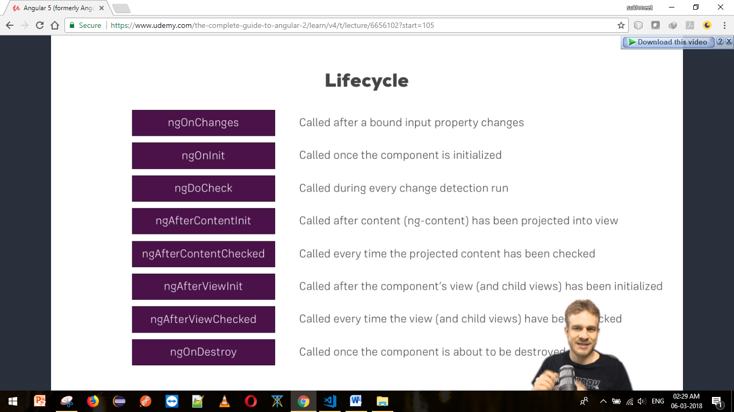

**Section 5: Lecture 73 // Seeing Lifecycle Hooks in action**

1. Adding to hooks in server-element.ts
2. Now, we will add another hook in this file i.e. ngOnChanges. This hook runs first. This hook actually receives an argument; it’s the only hook that does receive an argumrnt.
3. ngAfterContentInit is called only once, because here content got loaded only once. Note that content is the thing we injected through ngContent.
4. ngAfterContentChecked is called after each change detection cycle.
5. server-element.component.html:
6. <div
7. class="panel panel-default"
8. >
9. <!-- <div class="panel-heading">{{ element.name }}</div> -->
10. <div class="panel-heading">{{ name }}</div>
11. <div class="panel-body">
12. <p>
13. <!-- <strong *ngIf="element.type === 'server'" style="color: red">{{ element.content }}</strong> -->
14. <!-- <strong *ngIf="element.type === 'blueprint'" style="color: blue">{{ element.content }}</strong> -->
15. <!-- <em *ngIf="element.type === 'blueprint'" style="color: blue">{{ element.content }}</em> -->
16. <ng-content></ng-content>
17. </p>
18. </div>
19. </div>

6. server-element.component.ts:

import { Component,

OnInit,

Input,

ViewEncapsulation,

OnChanges,

SimpleChanges,

DoCheck,

AfterContentInit,

AfterContentChecked,

AfterViewInit,

AfterViewChecked,

OnDestroy} from '@angular/core';

@Component({

selector: 'app-server-element',

templateUrl: './server-element.component.html',

styleUrls: ['./server-element.component.css'],

encapsulation: ViewEncapsulation.None

})

export class ServerElementComponent implements

OnInit,

OnChanges,

DoCheck,

AfterContentInit,

AfterContentChecked,

AfterViewInit,

AfterViewChecked,

OnDestroy

{

@Input('srvElement') element: {type: string, name: string, content: string};//srvElement is an alias to the property named here

@Input() name;

constructor() {

console.log("Constructor Called!!");

}

ngOnChanges(changes: SimpleChanges){ //here also implement OnChanges interface on class

console.log("ngOnChanges Called!!");

console.log(changes);

}

ngOnInit() {

console.log("ngOnInit Called!!");

}

ngDoCheck(){ //this method will run on every change

console.log('ngDoCheck Called!!!');

}

ngAfterContentInit(){

console.log('ngAfterContentInit is Called!!!');

}

ngAfterContentChecked(){

console.log('ngAfterContentChecked is called!!');

}

ngAfterViewInit(){

console.log('ngAfterViewInit called!!');

}

ngAfterViewChecked(){

console.log('ngAfterViewChecked called!!');

}

ngOnDestroy(){

console.log('ngOnDestroy Called !!');

}

}

7. app.component.html:

<!-- Aplication one -->

<!--<input type="text" [(ngModel)]="name">

<p>{{ name }}</p>-->

<!--<div class="container">

<div class="row">

<div class="col-xs-12">

<h3>I am in the AppComponent!!!</h3>-->

<!-- <div app-servers></div>-->

<!--<app-header></app-header>-->

<!--<div class="app-servers"></div>-->

<!-- </div>

</div>

</div>-->

<!-- Application 2 -->

<!--<app-header></app-header>

<div class="container">

<div class="row">

<div class="col-md-12">

<app-recipes></app-recipes>

<app-shopping-list></app-shopping-list>

</div>

</div>

</div>-->

<!-- Application 3 -->

<div class="container">

<app-cockpit

(serverCreated)="onServerAdded($event)"

(bpCreated)="onBlueprintAdded($event)"

></app-cockpit>

<hr>

<div class="row">

<div class="col-md-12">

<button class="btn btn-primary" (click)="onChangeFirst()">Change First Element</button>

<button class="btn btn-danger" (click)="onDestroyFirst()">Destroy first Component</button>

<app-server-element

*ngFor="let serverElement of serverElements"

[srvElement]="serverElement"

[name]="serverElement.name"

>

<p>

<strong *ngIf="serverElement.type === 'server'" style="color: red">{{ serverElement.content }}</strong>

<em *ngIf="serverElement.type === 'blueprint'" style="color: blue">{{ serverElement.content }}</em>

</p>

</app-server-element>

</div>

</div>

</div>

1. App.component.ts:
2. import { Component } from '@angular/core';
3. @Component({
4. selector: 'app-root',
5. templateUrl: './app.component.html',
6. styleUrls: ['./app.component.css']
7. // styles: [`
8. // h3{
9. // color: dodgerblue;
10. // }
11. // `]
12. })
13. export class AppComponent {
14. serverElements = [{type: 'server', name: 'Testserver', content: 'Just a test!'}];
15. name = '';
16. onServerAdded(serverData: {serverName: string, serverContent: string}){
18. this.serverElements.push({
19. type: 'server',
20. name: serverData.serverName,
21. content: serverData.serverContent
22. });
23. }
25. onBlueprintAdded(blueprintData: {serverName: string, serverContent: string}){
26. this.serverElements.push({
27. type: 'blueprint',
28. name: blueprintData.serverName,
29. content: blueprintData.serverContent
30. });
31. }
32. onChangeFirst(){
33. this.serverElements[0].name = 'Changed!';
34. }
35. onDestroyFirst(){
36. this.serverElements.splice(0,1);
37. }
38. }

**Section5: Lecture 74//Lifecycle Hooks and TemplateAccess**

1. Before concluding this module there is one more thing related to our hooks here, we learnt about @ViewChild – this is used to get access to an element from our template.
2. Let’s do the same in the server-element.component.html:
3. <div
4. class="panel panel-default"
5. >
6. <!-- <div class="panel-heading">{{ element.name }}</div> -->
7. <div class="panel-heading" #heading>{{ name }}</div>
8. <div class="panel-body">
9. <p>
10. <!-- <strong *ngIf="element.type === 'server'" style="color: red">{{ element.content }}</strong> -->
11. <!-- <strong *ngIf="element.type === 'blueprint'" style="color: blue">{{ element.content }}</strong> -->
12. <!-- <em *ngIf="element.type === 'blueprint'" style="color: blue">{{ element.content }}</em> -->
13. <ng-content></ng-content>
14. </p>
15. </div>
16. </div>
17. Server-element.component.ts:
18. import { Component,
19. OnInit,
20. Input,
21. ViewEncapsulation,
22. OnChanges,
23. SimpleChanges,
24. DoCheck,
25. AfterContentInit,
26. AfterContentChecked,
27. AfterViewInit,
28. AfterViewChecked,
29. OnDestroy,
30. ViewChild,
31. ElementRef
32. } from '@angular/core';
33. @Component({
34. selector: 'app-server-element',
35. templateUrl: './server-element.component.html',
36. styleUrls: ['./server-element.component.css'],
37. encapsulation: ViewEncapsulation.None
38. })
39. export class ServerElementComponent implements
40. OnInit,
41. OnChanges,
42. DoCheck,
43. AfterContentInit,
44. AfterContentChecked,
45. AfterViewInit,
46. AfterViewChecked,
47. OnDestroy
48. {
49. @Input('srvElement') element: {type: string, name: string, content: string};//srvElement is an alias to the property named here
50. @Input() name;
51. @ViewChild('heading') header: ElementRef;
52. constructor() {
53. console.log("Constructor Called!!");
54. }
56. ngOnChanges(changes: SimpleChanges){ //here also implement OnChanges interface on class
57. console.log("ngOnChanges Called!!");
58. console.log(changes);
59. }
60. ngOnInit() {
61. console.log("ngOnInit Called!!");
62. console.log('Text content: '+this.header.nativeElement.textContent);
63. }
64. ngDoCheck(){ //this method will run on every change
65. console.log('ngDoCheck Called!!!');
66. }
67. ngAfterContentInit(){
68. console.log('ngAfterContentInit is Called!!!');
69. }
70. ngAfterContentChecked(){
71. console.log('ngAfterContentChecked is called!!');
72. }
73. ngAfterViewInit(){
74. console.log('ngAfterViewInit called!!');
75. console.log('Text content: '+this.header.nativeElement.textContent);
76. }
77. ngAfterViewChecked(){
78. console.log('ngAfterViewChecked called!!');
79. }
80. ngOnDestroy(){
81. console.log('ngOnDestroy Called !!');
82. }
83. }

**Section 5: Lecture 75 //Getting Access to ng-content with @ContentChild**

1. server-element.component.ts:

import { Component,

OnInit,

Input,

ViewEncapsulation,

OnChanges,

SimpleChanges,

DoCheck,

AfterContentInit,

AfterContentChecked,

AfterViewInit,

AfterViewChecked,

OnDestroy,

ViewChild,

ElementRef,

ContentChild

} from '@angular/core';

@Component({

selector: 'app-server-element',

templateUrl: './server-element.component.html',

styleUrls: ['./server-element.component.css'],

encapsulation: ViewEncapsulation.None

})

export class ServerElementComponent implements

OnInit,

OnChanges,

DoCheck,

AfterContentInit,

AfterContentChecked,

AfterViewInit,

AfterViewChecked,

OnDestroy

{

@Input('srvElement') element: {type: string, name: string, content: string};//srvElement is an alias to the property named here

@Input() name;

@ViewChild('heading') header: ElementRef;

@ContentChild ('contentParagraph') paragraph: ElementRef;

constructor() {

console.log("Constructor Called!!");

}

ngOnChanges(changes: SimpleChanges){ //here also implement OnChanges interface on class

console.log("ngOnChanges Called!!");

console.log(changes);

}

ngOnInit() {

console.log("ngOnInit Called!!");

console.log('Text content: '+this.header.nativeElement.textContent);

console.log('Text content of paragraph: '+this.paragraph.nativeElement.textContent);

}

ngDoCheck(){ //this method will run on every change

console.log('ngDoCheck Called!!!');

}

ngAfterContentInit(){

console.log('ngAfterContentInit is Called!!!');

console.log('Text content of paragraph: '+this.paragraph.nativeElement.textContent);

}

ngAfterContentChecked(){

console.log('ngAfterContentChecked is called!!');

}

ngAfterViewInit(){

console.log('ngAfterViewInit called!!');

console.log('Text content: '+this.header.nativeElement.textContent);

}

ngAfterViewChecked(){

console.log('ngAfterViewChecked called!!');

}

ngOnDestroy(){

console.log('ngOnDestroy Called !!');

}

}

1. app.component.html:
2. <!-- Aplication one -->
3. <!--<input type="text" [(ngModel)]="name">
4. <p>{{ name }}</p>-->
5. <!--<div class="container">
6. <div class="row">
7. <div class="col-xs-12">
8. <h3>I am in the AppComponent!!!</h3>-->
10. <!-- <div app-servers></div>-->
11. <!--<app-header></app-header>-->
12. <!--<div class="app-servers"></div>-->
13. <!-- </div>
14. </div>
15. </div>-->
16. <!-- Application 2 -->
17. <!--<app-header></app-header>
18. <div class="container">
19. <div class="row">
20. <div class="col-md-12">
21. <app-recipes></app-recipes>
22. <app-shopping-list></app-shopping-list>
23. </div>
24. </div>
25. </div>-->
26. <!-- Application 3 -->
27. <div class="container">
28. <app-cockpit
29. (serverCreated)="onServerAdded($event)"
30. (bpCreated)="onBlueprintAdded($event)"
31. ></app-cockpit>
33. <hr>
34. <div class="row">
35. <div class="col-md-12">
36. <button class="btn btn-primary" (click)="onChangeFirst()">Change First Element</button>
37. <button class="btn btn-danger" (click)="onDestroyFirst()">Destroy first Component</button>
38. <app-server-element
39. *ngFor="let serverElement of serverElements"
40. [srvElement]="serverElement"
41. [name]="serverElement.name"
42. >
43. <p #contentParagraph>
44. <strong *ngIf="serverElement.type === 'server'" style="color: red">{{ serverElement.content }}</strong>
45. <em *ngIf="serverElement.type === 'blueprint'" style="color: blue">{{ serverElement.content }}</em>
46. </p>
47. </app-server-element>
48. </div>
49. </div>
50. </div>

**Section 5: Lecture 76//Wrap up**

1. So, throughout the section we learnt a lot about components. We really had a deep dive on them.
2. We had data binding with custom properties and events, how to pass data around, how to access elements in your DOM, how to use local references, how to really create a dynamic app, how to use lifecycle hooks, to run some code at specific point of time.
3. With this a lot of core features of Angular have been set now.