

G-Mac: Introduction Document

Version 1.0

**Document History**

| **Version** | **Date** | **Author** | **Description of Change** |
| --- | --- | --- | --- |
| 1.0 | 5th February, 2024 | Digvijay Singh Thakur | Drafted the first version |

**Approvers List**

| **Name** | **Role** | **Approver** | **Approval / Review Date** |
| --- | --- | --- | --- |
| Arun Sharma | Sr. Technical Solutions Architect | Reviewer | Feb 10, 2024 |
| Sukhraj Singh | Sr. Marketing Automation Specialist | Reviewer | Feb 23, 2024 |

# 

# Table Of Contents

**Table Of Contents 2**

**1. Introduction 3**

**2. Business Challenges 4**

2.1. Time-Consuming Content Creation 4

2.2. Integration Complexity 4

2.3. Limited Customization 4

**3. Features 4**

3.1. Drag-and-Drop Editor 4

3.2. ~~AI Translation 4~~

~~3.3. Content Generation 4~~

3.4. Integration with Marketo & Hubspot 5

3.~~5. Content Enhancement 5~~

~~3.6. Responsive Design 5~~

~~3.7. Multilingual Support~~ 5

3.8. Preview Mode 5

3.9. User-Friendly Interface 5

**4. Target Persona 5**

**5. Use Cases 5**

5.1. Asset Template Editor 5

5.2. HTML Creation for Email Template and Landing Page Assets 6

5.3. Copy HTML for Asset 6

5.4. Create MA Tool Compatible HTML and Sync Asset 6

5.5. ~~Save Asset~~ 7

5.6. Preview Asset 7

5.7. ~~Asset Listing~~ 7

5.8. Drag-and-Drop Functionality 7

5.9. Undo and Redo Option 7

5.10. Section Duplication and Restore to Original 8

5.11. Different Layout Options 8

5.12. Sample Email Templates 8

5.13. ~~Clone Existing Template~~ 8

5.14. ~~Preview Mode~~ 8

5.15. Integration with Marketo and HubSpot 9

5.16. ~~AI Capabilities~~ 9

**6. Business Benefits 9**

6.1. Reduced time to market for marketing campaigns 9

6.2. Improved consistency and quality of marketing assets 9

6.3. Increased efficiency and productivity of marketing team members 9

6.4. Reduced reliance on external resources 10

6.5. Increased Conversion Rates 10

6.6. Increased Cost Savings 10

**7. Supported Platforms** **10**

**8****. Step By Step Working 10** **11**

# 

# Introduction

G-Mac is an innovative drag-and-drop email template and landing page designed to empower businesses to create visually appealing and engaging marketing content effortlessly. With seamless integration capabilities with Marketo and HubSpot, this editor aims to streamline the content creation process, enhance marketing campaigns, and maximize user productivity.  
  
This versatile editor redefines the landscape of email marketing by offering a user-friendly interface that simplifies the design process. With its robust capabilities, users can effortlessly create visually stunning email templates and landing pages without the need for extensive technical expertise.  
  
Furthermore, the G-Mac Editor goes beyond basic design functionalities by enabling seamless integration with major marketing automation platforms. This includes Marketo and HubSpot, enabling users to synchronize their campaigns effortlessly. The editor's compatibility with these platforms ensures a frictionless workflow, allowing marketers to deploy campaigns with efficiency and precision.

# Business Challenges

## Time-Consuming Asset Creation

Traditional methods of crafting landing pages and email templates are time-consuming and often require coding skills.

## Requires Coding and Design Skills

Lack of Accessibility Due to Dependency on Coding and Design Skills

* 1. **Hinder Marketers from quickly producing visually Appealing and Responsive Email Campaigns**

Inhibiting Marketers' Ability to Rapidly Generate Visually Engaging and Responsive Email Campaigns

## Lack of Creative Freedom for Email Template Creation

## Integration Complexity

Integrating with marketing platforms like Marketo & HubSpot often involves technical challenges.

## Limited Customization

Need for a tool that facilitates marketers for flexible and customized designs without extensive coding.

# Features

## Asset Management

* + - Effortlessly design stunning landing pages and email templates with our intuitive drag-and-drop editor.
    - Seamlessly arrange elements and graphics to craft visually captivating landing pages and email templates.
    - Achieve professional-grade designs without the need for technical expertise using our intuitive drag-and-drop editor.

## Integration with Marketo

* + - Seamlessly integrate your campaigns by connecting directly to your Marketo accounts for streamlined efficiency.
    - Enhance campaign management with direct integration to Marketo ensuring seamless coordination across platforms.
    - Streamline your marketing efforts by seamlessly connecting to Marketo for integrated campaign management and optimization.

## Content Enhancement

* + - Incorporate a variety of content types such as text, images, videos, and interactive elements to make the content more engaging and informative.
    - Use formatting tools to enhance the visual appeal of the content, including font styles, colors, and layouts, to make it more visually appealing and easier to read.
    - Utilize collaboration features to allow multiple users to contribute to and review the content, ensuring accuracy and relevance.

## Responsive Design

* + - Ensure your designs shine across all devices with seamless responsiveness, captivating both desktop and mobile audiences.
    - Achieve flawless visual experiences on every screen with responsive design, guaranteeing stunning presentations on desktops and mobile devices alike.
    - Seamlessly adapt your designs to any device, ensuring they dazzle both desktop and mobile users with unparalleled responsiveness.

## Preview Mode

* + - Gain confidence in your designs with our preview mode, allowing you to visualize creations before they go live.
    - Ensure perfection before publishing by previewing your creations with our intuitive preview mode.
    - Fine-tune your designs with ease by visualizing them before publishing them using our convenient preview mode.
  1. **Configuration to add custom CSS**
     + Access the editor's settings or preferences menu to locate the option for adding your custom CSS.
     + Set your CSS attributes like padding, font size, and color.
     + Save your changes and refresh the editor to see the applied custom styles.

## User-Friendly Interface

* + - Experience simplicity with our user-friendly interface, eliminating the need for coding skills.
    - Seamlessly navigate our platform with an intuitive user interface that requires no coding expertise.
    - Empower creativity without barriers – our user-friendly interface makes coding skills obsolete.

# Product Workflow

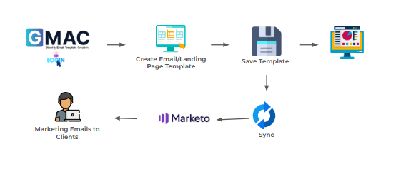

# Target Persona

The primary audience for G-Mac includes marketing professionals, asset creators, and campaign managers striving to enhance efficiency in asset creation and marketing automation.

# Use Cases

## Assets Template Editor

**Description:**

* Users can access a template editor to create, modify, and manage assets for both email templates and landing pages.

**Actions:**

* Create and design templates using a drag-and-drop interface.
* Save the designed assets for future use.

## HTML Creation for Email Template and Landing Page Assets

**Description:**

* Generate HTML code for the designed email template and landing page assets.

**Actions:**

* Convert the visually designed assets into HTML code.
* Ensure compatibility with email templates and landing pages.

## Create MA Tool Compatible HTML and Sync Assets

**Description:**

* Generate HTML code compatible with Marketing Automation (MA) tools like Marketo and synchronize assets seamlessly.

**Actions:**

* Optimize HTML code for compatibility with MA tools.
* Sync the asset with Marketo and HubSpot.

## Save Assets

**Description:**

* Save the designed asset for future use or modifications.

**Actions:**

* Save the asset to a user's library for easy access.

## Preview Assets

**Description:**

* Preview the appearance of the designed asset before finalizing or sending it.

**Actions:**

* View a preview of the asset in a simulated environment.

## Assets Listing

**Description:**

* Display a list of all saved assets for easy navigation and management.

**Actions:**

* View, search, and organize assets within the listing.

## Drag-and-Drop Functionality

**Description:**

* Enable users to drag and drop various elements to create a customized design.

**Actions:**

* Easily move and rearrange elements within the editor.

## Undo and Redo Option

**Description:**

* Provide the ability to undo and redo actions within the editor.

**Actions:**

* Reverse or redo changes made during the editing process.

## Section Duplication and Restore to Original

**Description:**

* Allow users to duplicate sections within an asset and revert changes to the original design.

**Actions:**

* Duplicate a section and restore it to the original layout.

## Different Layout Options

**Description:**

* Offer various layout options for users to choose from during asset creation.

**Actions:**

* Select from different predefined layouts.

## Sample Email Templates

**Description:**

* Include pre-designed sample email templates for users to use as a starting point.

**Actions:**

* Access and customize sample email templates.

## Clone Existing Template

**Description:**

* Duplicate an existing template for efficient reuse.

**Actions:**

* Create a new asset by cloning an existing template.

## Preview Mode

**Description:**

* Provide a preview mode for users to see how the asset will appear to recipients.

**Actions:**

* Switch to a preview mode to review the asset's final appearance.

## Integration with Marketo

**Description:**

* Enable seamless integration with Marketo for direct deployment.

**Actions:**

* Connect the editor with Marketo accounts.

# Business Benefits

## Reduced time to market for marketing campaigns

By eliminating the need for manual creation of marketing assets like email campaigns and Landing pages, we can significantly reduce the time it takes to get marketing campaigns launched.

## Improved consistency and quality of marketing assets

Our product will ensure that all marketing assets are created using a consistent style and format.

## Increased efficiency and productivity of marketing team members

By providing a central repository for all marketing assets, our product will make it easier for team members to find and reuse existing assets.

## Reduced reliance on external resources

By providing our solution for marketing asset creation and management, we will reduce our reliance on external resources.

## Increased Conversion Rates

The combination of user-friendly design tools, integrated marketing automation contributes to higher conversion rates by delivering more engaging and relevant content.

## Increased Cost Savings

The efficiency gained in content creation and campaign management can result in cost savings for businesses, reducing the resources required for marketing efforts.

# Supported Platforms

G-Mac is compatible with major web browsers, including Chrome, Firefox, Safari, and Edge. Additionally, it seamlessly integrates with Marketo and HubSpot.

# Step By Step Working

* We will make email template using drag and drop feature

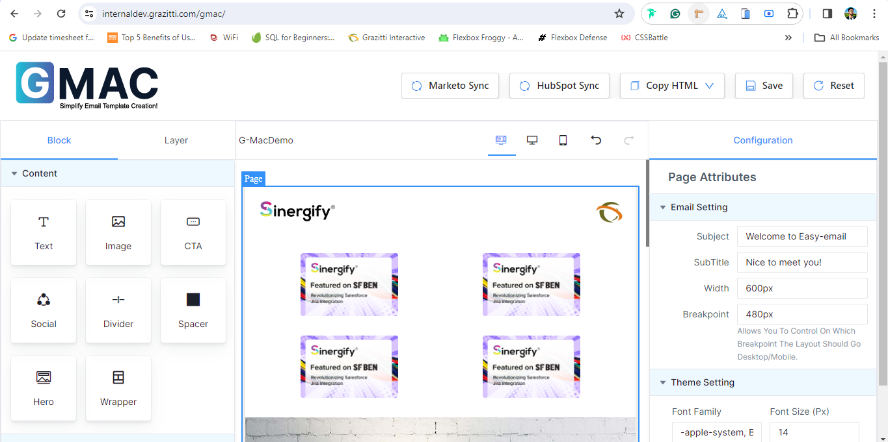

* Then we will sync it to the Marketo Platforms

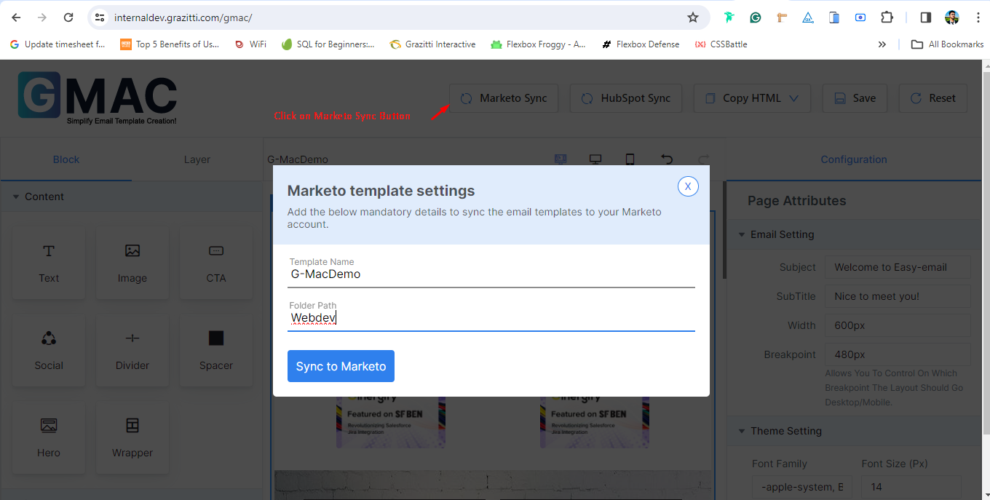

* You will get a confirmation message that your template has been synced

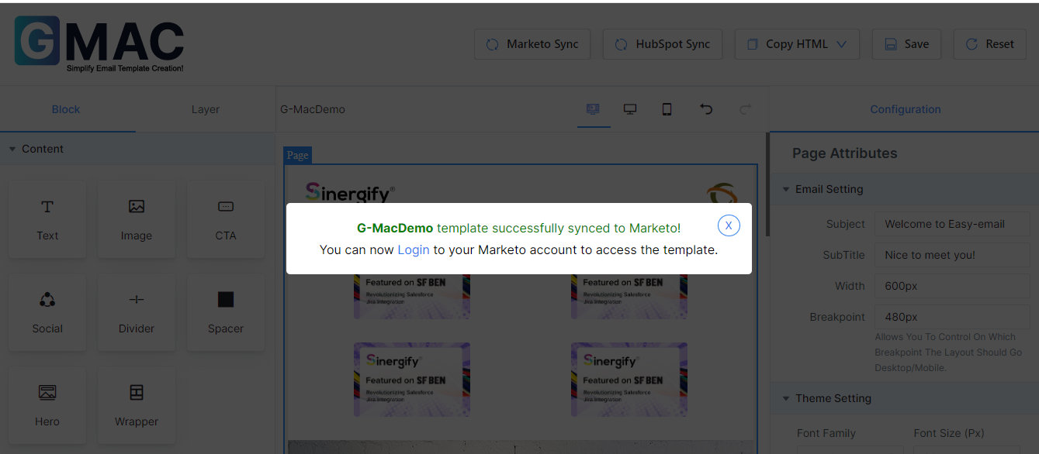

* Now we can see it in the specified folder in the marketo platform where it was synced

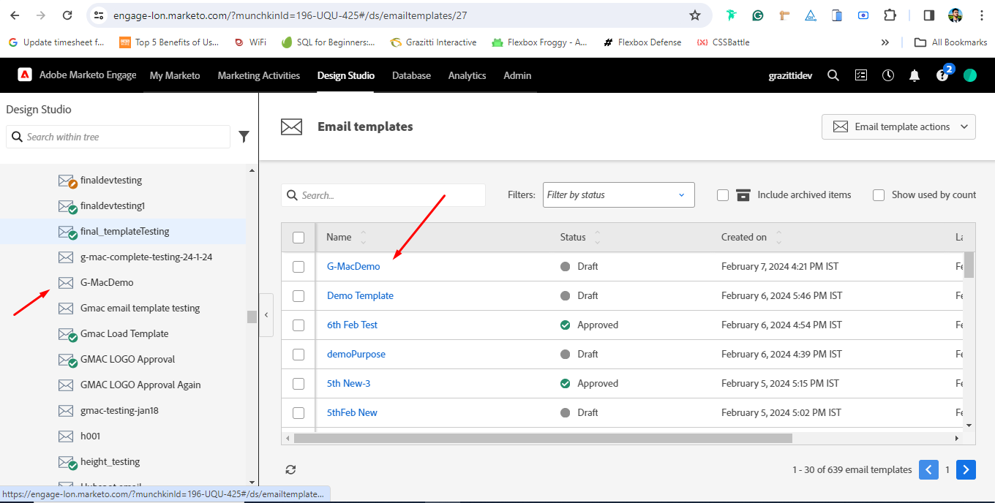

* By clicking on preview you can preview the template as well



 