NAND2TETRIS ASSIGNMENT
HACK ASSEMBLY
Name: Sukhvinder Kaur | Roll No: 2501020272

1. Addition
Hack Assembly operation: D=D+A
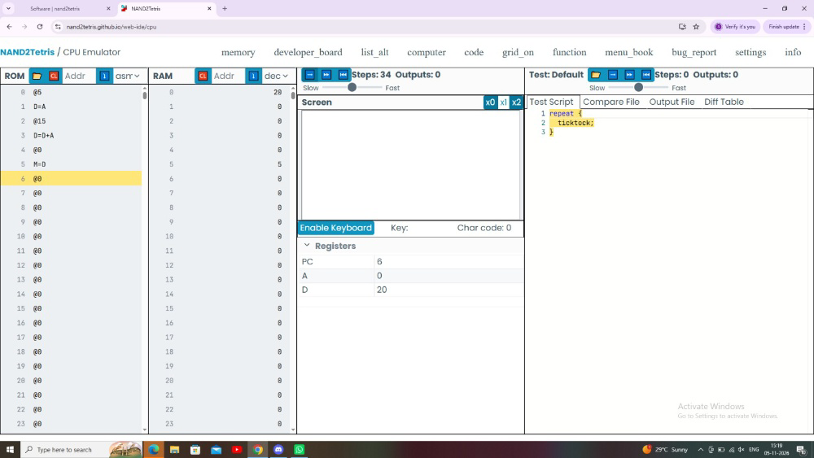

2. Subtraction
Hack Assembly operation: D=D-A
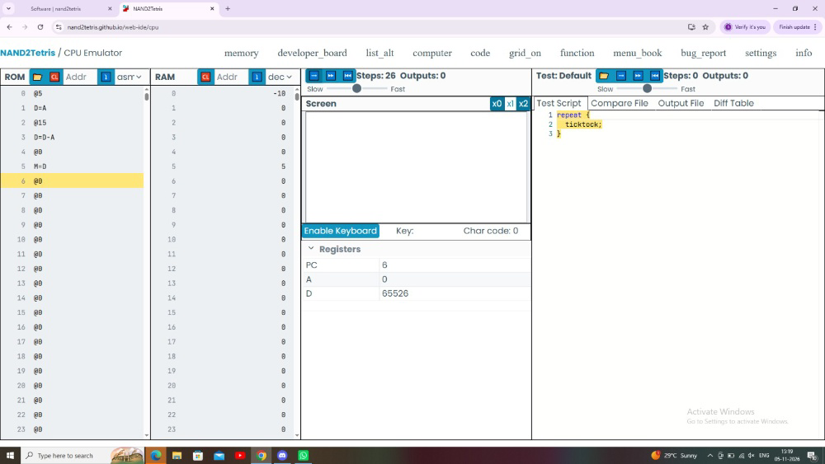

3. Increment
Hack Assembly operation: D=D+1
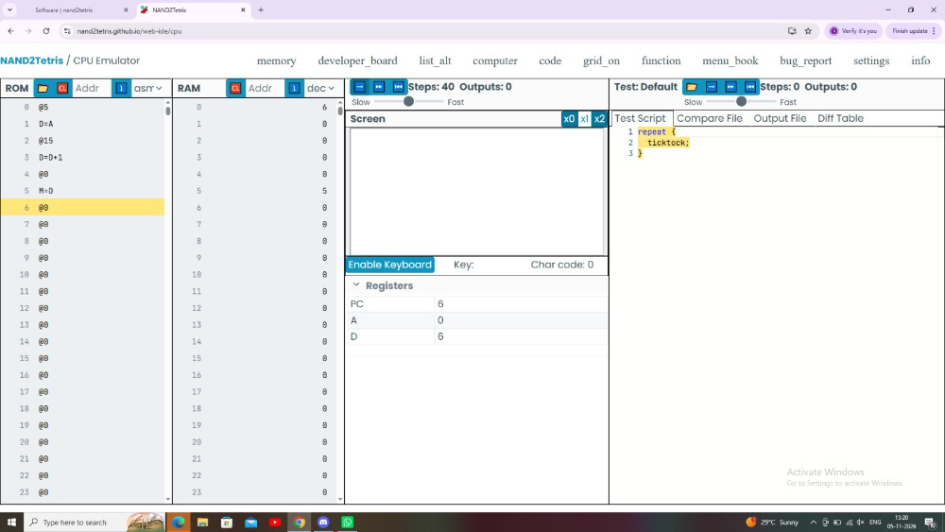

4. Decrement
Hack Assembly operation: D=D-1


